COMM 320 Midterm Exam Notes

Chapter 2- The Entrepreneurial Process

Entrepreneur: Someone who perceives an opportunity and builds an organization to pursue
that opportunity.

Entrepreneurship: The process of starting a business or other organization. The entrepreneur chooses/develops a business model, acquires the human and other required resources and is fully responsible for its success or failure.

The entrepreneurial process:
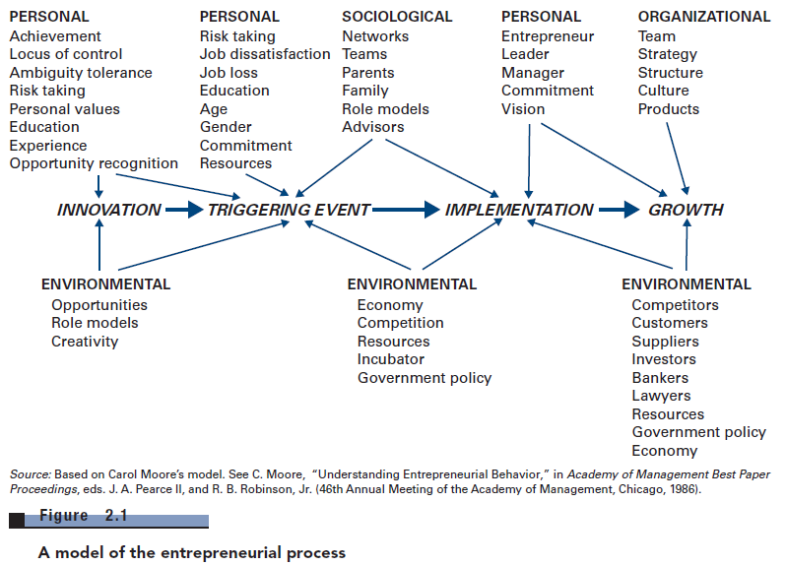

Critical factors for starting a new enterprise:
- Personal
- Higher internal locus of control (how much people believe they have ability to control events that affect them)
- Sense of achievement
- Sociological
- Family responsibility
- Talent triangle – business acumen (skills +expertise), operational experience, domain knowledge
- Need social capital + social network

- Organizational
- Environmental
- Role models

People are motivated by three principle needs:
  - Need for Achievement;
  - Need for Power;
  - Need for Affiliation.

Entrepreneurs tend to have a high need for achievement, high need for power, and low need for affiliation.

The 10 D’s of entrepreneurship (important characteristics of an entrepreneur)

- Dream – have vision of future, ability to implement dreams
- Decisiveness – no procrastination, make decisions fast
- Doers – implement course of action asap
- Determination – implement ventures with commitment
- Dedication
- Devotion
- Details – must be on top of critical details
- Destiny
- Dollars – money is a measure of success
- Distribute – distribute ownership with key employees

Evaluating Opportunities for New Businesses – Timmons entrepreneurship framework

Opportunity
Resources
Entrepreneur
Fits & Gaps Business plan
Uncertainty
Uncertainty
Uncertainty

- Opportunity = is it clear and concise for you? (seeing the potential in the company, in your vision)
- Entrepreneur (and management team) = do we have the capabilities, experience and knowledge, equipment, technology to exploit this gap and make it work??
- Resources = do you have the resources expand and actually apply it?

More in detail… three (3) components:
- Opportunity
- Impossible to evaluate idea if too secretive about it
- Doesn’t have to be unique
- Developing idea, implementing, building business is what’s important
- Customer
- Must perceive that new business will give them better value
- Can receive valuable feedback
- They are your market
- Provide positive feedback loop
- Provide proof of concept
- Timing
- Should avoid fads – brief timing
- Entrepreneur and Management Team
- Won’t be successful if not developed by someone who has strong management skills + entrepreneurial skills
- Talent triangle
- Management experience
- Operational experience – at least 1 person needs knowledge on how to build business + solution
- Resources
- Need to know what resources are crucial for success
- Everything business will need

Entrepreneurs come up with ideas in 3 ways:
Solving a Problem
  - Sometimes identifying opportunities simply involves noticing a problem and finding a way to solve it.
Observing Trends
  - Trends are a result of changes in the macro-environment, more on trends later.
Identifying “Market Gaps”
  - Market Gaps represent “unmet needs” and are linked to changes in the macro-environment as well.
**PEST Factors= Subgroups of trends that can be found in the marketplace (political, environmental, social, technological)

Key Forms of Start-Up Capital

- Debt: Going to the bank and asking for money (leading money is a loan), but the bank doesn’t own the company (potential higher risk for entrepreneur)

- Equity: Loan me the money and you will own part of the business (equity is not liquid)

9 Fs for entrepreneurial success:
- Founders – must have first class entrepreneur
- Focused – focus on niche markets
- Fast – make decisions quickly & swiftly
- Flexible – keep an open mind, respond to change
- Forever innovating – tireless innovators
- Flat – have few management layers
- Frugal – keep overhead low, productivity high, costs down
- Friendly – friendly to customers, suppliers, employees
- Fun – fun to be associated with entrepreneurial company

Chapter 3- Opportunity Recognition, Shaping, and Reshaping

Four Characteristics of an opportunity:

- Timely: the market is ready for it, is the timing right?
- Durable: will the idea last? Will the product last? = will last long enough to generate ROI, it is not a fad
- Attractive: will people like it? Will I make money? Do people need it?
- Customer Centric : it solves a real pain, many Entrepreneurs get ideas from something they themselves are dissatisfied about

It is important to understand the difference between an opportunity and an idea. An idea is a thought but it may not meet the criteria of an opportunity. Not all ideas are great ideas. It is crucial to make sure that an idea fills a need and meets the criteria for opportunity.

Visualizing Opportunity = Finding your passionSeeing the competition Testing the market

Four basic steps of idea multiplication:
- Gather stimuli (Beware the leading question- ask, observe, record)
- Multiply stimuli (Build upon the input of others brainstorm, write down, no judging)
- Create customer concepts (Build prototypes)
- Optimize practicality (Add/remove features editing)

S-CURVE (Product development stages)

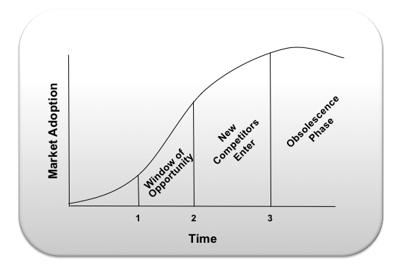

Setting Prices

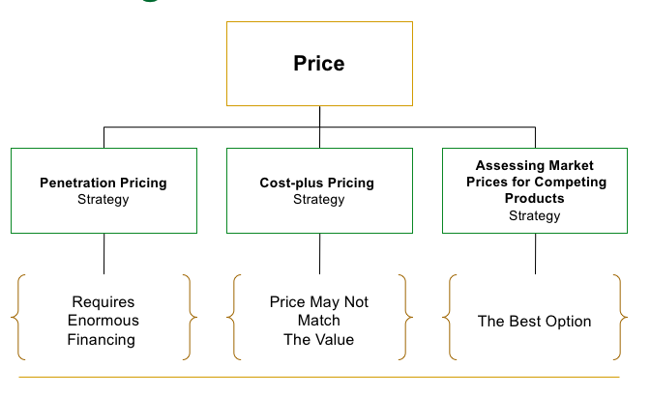

Chapter 4- Prototyping Your Ideas

Prototyping: The iterative process of quickly putting together working models in order to represent ideas, test various aspects of a design, and gather early customer feedback, over and over again until obtaining the most suitable product.

There is often a large gap between what the entrepreneur believes is valuable and what the target customer perceives
= Prototyping, both products and services alike, is one strategy to test key assumptions about what a customer will value and be willing to buy

The Prototyping Process
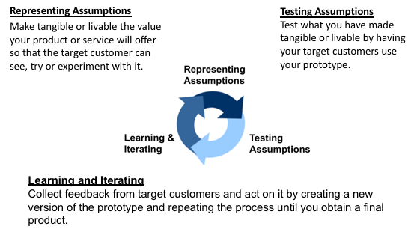

Low-fidelity prototypes – expresses the rough product concept, either in two-dimensional or three-dimensional form, often in basic material, such as paper. **simple, low-fidelity prototyping = best place to start**
High-fidelity prototypes – designed to look like a final completed product concept, representing detailed assumptions about the product.

Some types of prototyping: Paper Prototyping, 3D printing, Electronic prototyping, Service simulators, Minimum Viable Product (MVP)

The most valuable step of prototyping is to design with, meaning alongside, your target audience to not only validate their needs but also to discover unexpected entrepreneurial opportunities.
  - Customer engagement is at the center of the product design process.
  - Target customers must be engaged early and continuously in the process of idea generation and product development.
  - Co-Creation relies on building trust and intimacy with your target customers such that they can guide and shape the innovation process.

Chapter 5- Understanding Your Business Model and Developing Your Strategy

First steps are to:
- Select a business model
- Determine a basic strategy category (differentiation, low cost, niche)

Revenue Model: Breaks down all the sources of revenue that your business will generate.
- Ex.: Basic revenue model in a restaurant will separate food and beverage into two main sources of revenue.
- The more detailed your categories, the more visibility you obtain on your business performance.

Cost Model: The cost model identifies how you are spending your resources to make money.
- It includes your costs of goods sold (COGS) and your operating expenses, which can be found in a company’s income statement.
- Some products have very small COGS, e.g. software production, consulting services.
- As we do with revenues, we categorize COGS by product categories and directly tie those COGS to the revenue generated by each product category.

First Mover advantage is:

Very difficult and expensive because:
  - Firms have to quickly capture a large part of the available market
  - Educating customers on why they need the product in the first place is also expensive and time-consuming
- But not impossible
  - Google’s innovative eco-system
- Added danger: you may get it wrong

A winning strategy = Winning is more about implementing your strategy than about formulating some grand strategy that nobody has ever thought of before
(cheaper, faster, better)

You need to obtain a competitive advantage and create some value for which people are willing to pay.

Competitive advantage=

- You need to create an atmosphere that encourages people to bond to the company, i.e. make them believe in the mission, in the product, in each other. = VALUES
- It’s important to hire the right person the first time = SELECTION
- By creating a flexible organization structure you will be in a better position to adjust your strategy. = STRUCTURE

Founders need to create a culture and align the employees they select with the values and structure of the company

Developing the entry strategy:

Benchmark Devise Initial Market Test Create a Platform

- Benchmark competitors and learn “best practices” from firms that operate inside and outside your industry of interest
- Devise your initial market test once you have a strong understanding of the competition and adjust your strategy in accordance with its results
- Construct a schedule of escalating market tests
- Based upon the feedback, you might continue with more beta tests
- Create a platform for gaining experience and learning

Growth Strategy:
- Franchising
- Franchising is a strong growth strategy if you can make your business model replicable and maintain control of how your brand is being used.
- Most often used with retail concepts, such as McDonald’s or Mail Boxes Etc.
Three main benefits:
- Replicability
  - Established and proven methods
- New sources of revenue
  - Royalties and fees from franchisees
- New capital to fund growth

- Product Mix Expansion
- Tangential & Adjacent Products
  - What new products make sense with your current offerings? Current customers?
- Spread Existing Costs Over Larger Product Base
- Accelerate Revenue Faster than Increase in Costs
- Leverage your Firm’s Experience
  - Distribution Channels
  - Supplier Relationships
  - Customer Relationships

- Geographic Expansion

- Expanding geographically is another common growth strategy: reach new markets and increasing revenue.
- The world is becoming increasingly connected, entrepreneurs need to look beyond their home borders to see whether they can expand.
- Underlying assumption: customers should like your product or service elsewhere if they like it in the location you founded the company.

RECAP

- Determine revenue and cost structure
- Choose a strategy
- Create a culture
- Seek and select people who fit culture and goals
- Plan entry approach, including benchmarks
- Plan growth drivers

