ECO2142 Introduction

The Study of Macroeconomics

Macroeconomics: the study of issues related to the behavior of the whole (aggregate) economy or economic systems (countries, regions,...) instead of the behavior of individuals (which is studied in Microeconomics).

Macroeconomic questions:
o How do countries use resources to produce goods and services?
o What determines economic fluctuations (business cycles)?
o What causes unemployment? What causes changes in prices and inflation?
o What is the effect of economic (monetary and fiscal) policies?
- Macroeconomic Variables
o GDP, prices/inflation, unemployment rate, interest rates,...
- A simplified version of the economy: macroeconomic models
o endogenous variables
§ variables that the model wants to explain, they are determined INSIDE the model;
o exogenous variables
§ variables that are taken as given, they are determined OUTSIDE the model.

Examples of Macro Models I
1. Model of demand, telling us how much quantity y^{d} is demanded at each given price level p:
2y^{d} = 26 − 4p
· Two variables, y d and p. I
· Endogenous and exogenous variables?
o y^{d} is endogenous, p is exogenous.

Examples of Macro Models II
2. Model of demand and supply:
2y^{d} = 26 − 4p
y^{s} = −3 + 2p
y = y^{d} = y^{s}
· Two variables, y (= y^{d} = y^{s} ) and p.
· Endogenous and exogenous variables?
o both y and p are endogenous;
o equilibrium values: y = 5; p = 4.

Measuring output – GDP
- GDP (Gross Domestic Product): the dollar value of all final goods and services newly produced within an economy in a given period of time.
- To keep in mind from this definition:
o final goods and services: no intermediate goods;
o newly produced: no old goods;
o within an economy (within the territory) by everybody, even non-citizens;
o in a given period of time: typically, a quarter or a year.

GDP - Remarks
Ø GDP is not an absolute measure of well-being
o it does not measure non-market activities (home production, leisure, or black market transactions);
o it does not measure other elements that might affect quality of life (environmental quality, life expectancy, health, crime,...)
o It does not account for issues related to resource depletion;
o it does not consider issues related to income distribution.
Ø However, GDP is still a good measure of how well an economy is performing

Measuring GPD
Ø Three ways of computing GDP:
o 1. the total value of the goods and services produced in the economy;
o 2. total expenditure on the economy’s output (the good and services that are produced);
o 3. total income of everyone in the economy.
Ø Clearly, the total expenditure on the economy’s output equals the total value of this output (1. and 2. are equivalent).
Ø In addition, total expenditure approximately equals total income (3. is equivalent to 1. and 2.)
o statistically small difference, due to domestic residents working abroad, and to the fact that not all machines and factories used for production are owned by domestic residents

Computing GDP - Production approach
- GDP is the dollar value of all final goods and services newly produced within an economy in a given period of time.
o 1.Goods and services are evaluated using market prices. For goods and services that don’t have a market price (because not sold on the market), we use an estimate (imputed value).
o 2.Only the value of final goods is included. Used goods are not included. Intermediate goods are not included.
o 3.Inventories: goods that do not spoil are included, but they are later considered as used goods. Goods that do spoil are not included.

Example 1
Ø A country only produces bread and butter. In the month of March, the country produces 50 loaves of bread and 10kg of butter.
Ø There is also one policeman in this country, working for a total of 140 hours each month.
Ø The market prices are $3 per loaf for bread and $4 per kg for butter. The imputed value of each hour of police service is $40.
Ø Compute the March GDP for this country.
o (Answer: $150 + $40 + $5600 = $5790)

Example 2
Ø I have sold my old pair of boots to Anna for $50. Is this transaction included in this year’s GDP?
o (Answer: no)
Ø Mark bought a used car. He paid a total of $3000: $2400 for the car, $500 for some repairs that the car needed and $100 for transporting the car from the store in Toronto to Mark’s house in Ottawa. Is this transaction included in this year’s GDP?
o (Answer: $500 for the repairs and $100 for the transportation service are included)
Example 3
Ø In the month of July 2015, an hot dog cart bought hot dogs for $1000, bread for $300, and condiments for $100.
Ø The cart sold hot dog sandwiches for $2000.
Ø What is included in the July 2015 GDP?
o (Answer: only the final value of the sandwiches sold is included, i.e. $2000)
Ø What if the hot dogs, bread and condiments had been purchased by all of us at the supermarket for our ECO2142 party?
o (Answer: in this case they would have been included in GDP, because we would have been the final consumers).
Computing GDP - Expenditure approach
Ø This approach uses the National Identity :
o Y = C + I + G + NX
§ Y is total expenditure on produced output;
§ C is consumption spending by households;
§ I is investment spending by businesses and households;
§ G is government purchases of goods and services;
§ NX is net exports

In more detail.
- Consumption ©
  - sum of durables, non-durables and services purchased domestically by individual consumers (non-businesses and non-Governments). For instance, it includes washing machines (durables), cheese (non-durables) and haircuts (services).
  - It does not include purchases of new housing
- Investment (I)
  - sum of durables, non-durables and services purchased domestically by businesses. It includes business and residential construction, and inventory investment.
  - It does not include land and stock purchases, which are not part of GDP (land is not produced and stock transactions represent savings, not production).
- Government Spending (G)
  - goods and services purchased by the domestic government (at all levels, federal and local).
  - It does not include welfare and social security which are just transfers.
- Net Exports (NX)
  - net exports are defined as the difference between exports (X) and imports (M): NX = X − M
  - exports (X) are the amount of domestically produced goods sold abroad; I imports (M) are the amount of foreign goods purchased domestically

Nominal and Real GDP
- Nominal GDP: the value of final goods and services measured at current prices.
  - changes over time happen because of changes in quantities but also changes in prices.
- Real GDP: the value of final goods and services measured at constant prices
  - REAL GDP USED IN MACRO
  - changes over time happen only because of changes in quantities produced.
- (Note: the concept of nominal vs. real is also applied to other variables, in particular wages and interest rates).

Example
- A country only produces bread and butter. There is also one policeman in this country.
- Production and prices in the months of March and April are:
- Compute Nominal and Real GDP for March and April, using March as the base year.
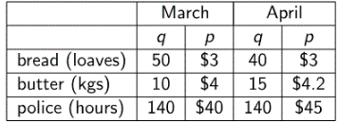
  - (Answer: Nominal March $5790 and April $6483; Real March $5790 and April $5780)
    - For Nominal GDP multiple Q and P and add up
    - For Real GDP for march it will be the same because its the base year ( same because same quantity and base year)
      - For april use the quantity of april and the price of march)

Chain weighted real GDP
- Chain weighted real GDP: the base year changes continuously over time.
  - Example: average prices in 2010 and 2011 are used to compute real GDP growth between 2010 and 2011, average prices in 2011 and 2012 are used to compute real GDP growth between 2011 and 2012 and so on.
- This measure has been introduced to avoid issues related to prices becoming too out of date as time goes by.

Other measures of income
- GNP (Gross National Product): measures the total income earned by the residents of a nation.
  - GNP = GDP + receipts of wages, profits and rents from abroad - payments of wages, profits and rents to abroad.
- NNP (Net National Product): a net measure of the total income earned by residents. It accounts for depreciation, which is a cost of producing the output of the economy.
  - NNP = GNP – Depreciation

Measuring Inflation
- Inflation rate: a positive percentage change in the price level (a negative change is called deflation).

Measuring the price level - GDP deflator
- GDP Deflator (or implicit price deflator for GDP): the price of output relative to its price in the base year. It is a measure of the overall level of prices in the economy.
- Nominal GDP measures output at current prices, while real GDP measures output at the prices in the base year.
- Then: GDP deflator = nominal GDP
real GDP × 100
- What is the GDP deflator in the base year?

Measuring the price level - CPI
- CPI (Consumer Price Index): an index measuring the overall price level in the economy.
- The CPI is computed using a basket of goods and services consumed by a typical customer.
- For a given year, the CPI is the price of this basket relative to its price in the base year.
- Different measures of CPI (core, excluding specific classes of goods or services,...)
- Criticisms: changes in quality; decreases in prices due to technology improvements; substitution of goods as a response to price changes
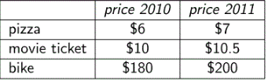
Example
- The CPI Basket of a country Includes 3 pizzas, 2 movie tickets and 1 bike. Prices for 2010 and 2011 are…
- Compute the CPI for 2010 and 2011 Using 2010 as the base year
- Answer
  - The price of the basket for 2010 is
    - 3 x $6 + 2 x $10 + 1 x $180 = $218
  - Price Basket for 2011 is
    - 3 x $7 + 2 x $10.5 + 1 x $200 = $242
  - CPI FOR 2010 IS
    - ($218 / $218) x 100 = 100
  - CPI for 2011 is
    - ($242/$218) x 100 = 111
Computing Inflation
- Inflation is defined as the percentage change in the price level
- To measure the price level we can use a price index, for instance the GDP deflator or the CPI
- The formula to compute inflation is simply
  - Inflation_{t =} Price Index_{t} - Price Index _{t -1}
Price Index _{t-1}

- Example : Using the CPI computed in the previous slide
Inflation₂₀₁₁ = (CPI₂₀₁₁ - CPI₂₀₁₀) / CPI₂₀₁₀
= (111-100) / 100
= 11%

Computing the Inflation Rate
- As we said, the inflation rate can be computed using either the GDP deflator or the CPI
- What are the main differences
  - Produced vs. consumed goods and services
  - Imported goods
  - Changing vs fixed quantities

Measuring Unemployment
- Unemployment rate : a measure of the fraction of workers who are unemployed
- Labour force = number of unemployed + number of employed
- Unemployment rate = Number of unemployed x 100
Labor force
- Labour force participation rate = Labor force x 100
Adult Population

Measuring Growth and Okuns Law
- The Growth rate is the percentage change in real GDP
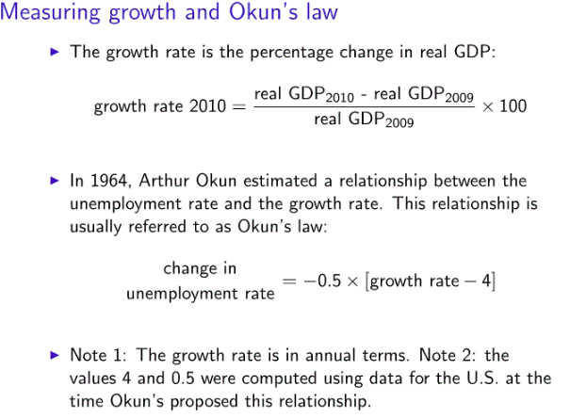
- Arthur Okun estimated the relationship between unemployment and the growth rate. This relationship is usually referred to as Okuns Law
- Change in unemployment rate = -0.5 x [ Growth Rate - 4]
  - *** Growth rate is in annual terms
  - *** The values 4 and 0.5 were computed from data during okun’s proposal

Okun’s Law Example
- EX
  - Assume that at the end of 2012 the unemployment rate was 5% and the growth rate for 2013 is 6%. According to Okun’s law what should the unemployment rate at the end of 2013 be?
  - Recall the formula
    - Change in unemployment = -0.5 x [ growth rate - 4]
  - So the change in unemployment rate is
    - = -0.5 x [6-4] = -1
  - Unemployment at the end of 2013 is
    - 5% - 1% = 4%

