
Experiment 3: COMPETITION STUDIES OF SUBSTITUTION & ELIMINATION REACTIONS
TA:Emily Schaefer


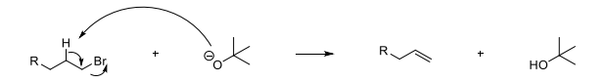
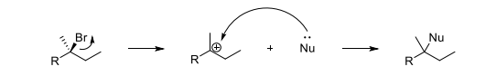
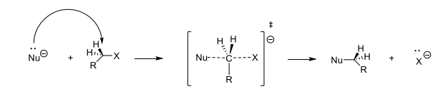
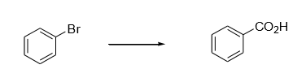
Mechanism of sample E2 reaction

Mechanism of sample SN2 reaction
Introduction:
Competing reactions are necessary to identify in order to be able to maximize the yield of one desired reaction over an undesired one.
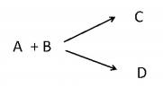
Theory:

Common reaction:

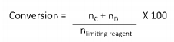
It is important to understand the conversion of reactants to products as it is the ratio of all products produced to the total that could have theoretically been produced. This helps us better comprehend the final yield. The resulting formula is:

It is also relevant to calculate the selectivity of your desired product in relation to all undesired products obtained. This helps us understand if we performed the right reaction or if there were competing reactions that created other products. If C is the desired product, the formula for selectivity is:
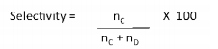

SN2 and E2 reactions must also be understood. SN2 and E2 reactions are bimolecular (involving two molecules equally) and are concerted, meaning they happen in one step.
Heat and protic solvents like EtOH favor the Elimination E2 reaction due to its higher energy activation while less heat and aprotic solvents such as DMSO favor the Substitution SN2 reaction.
SN2 requires a good nucleophile while E2 needs a strong base which can be small or bulky. And for E2, the Beta hydrogen must be antiperiplanar to the leaving group, which in both cases must be strong (Cl, Br, etc)

Experimental goals:
The main goal of this experiment is to study the competition between an SN2 and E2 reaction of KOH with 1-bromobutane and 2-bromobutane. There are several possibilities:
SN2 with
Br
Br
1-bromobutane:
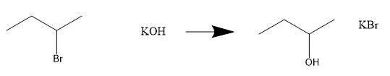
SN2 with
+
+
2-bromobutane:

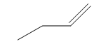
E2 with
1-bromobutane:
80%
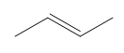
E2 with
Major
Br
Br
2-Butene
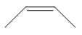
2-bromobutane:
Br
Minor
20%
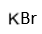
1-Butene
+
Methodology:
The experiment begins by preparing a reflux set-up with 8 g of KOH dissolved in 35 mL of 95% ethanol inside of a 100-mL round bottom flask. A thermometer adapter must be placed at the top of the reflux condenser.
Next, a eudiometer tube must be filled with water to the brim and placed into a 1L beaker with water upside down. The eudiometer and thermometer adapter must be connected using a tygon tube.
When bubbles have stopped forming in the eudiometer, dissolve 1.5 mL of 1-bromobutane in 5 mL of 95% ethanol and add into the top of the eudiometer.
Gas will form and water will be displaced in the eudiometer. Note the final volume of water displaced when there is no significant change.
Disconnect the tygon tube while removing the heat source then filter the cooled KBr by suction filtration, determining its mass after drying it.
Repeat the experiment using 1.5 mL of 1-bromobutane with heating at 50 degrees Celsius in a metal water bath then using 0.7 mL of 2-bromobutane using reflux.

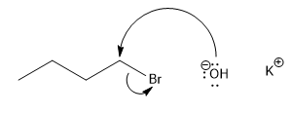
Mechanisms:
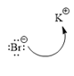
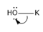
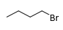
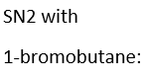
..
..
..
..
..
..
..
..
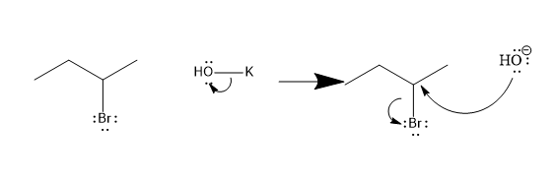
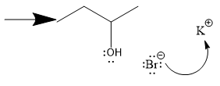
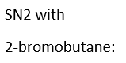

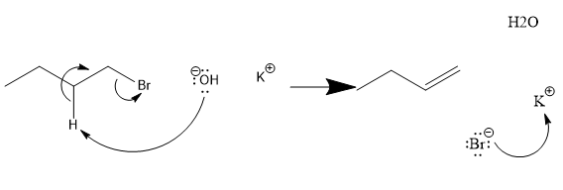
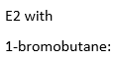
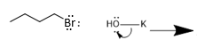
..
..
..

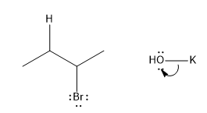
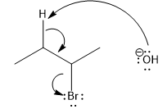
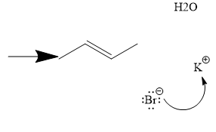
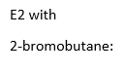

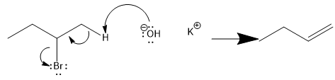
OR

Protocol:
For the protocol we followed, please refer to the lab manual (p. 49-50).
We followed everything as outlined, but we retrieved step 20 data from a fellow labmate (Rayan El Hamra) as instructed by our TA due to time constraints.

Table of Reagents:
Reagent or solvent | Molar mass (g.mol) | Quantity | Density (g/mL) | mol | Equiv
Ethanol (EtOH solvent) | 46.07 | 40 mL | 0.79 | 0.685 | N/A
1-bromobutane | 137.02 | 1.5 mL | 1.27 | 0.0139 | 1 (limiting reactant)
2-bromobutane | 137.02 | 0.7 mL | 1.27 | 0.00649 | 1 (limiting reactant)
Potassium Hydroxide (KOH) | 56.11 | 8 g | 2.12 | 0.14 | 22 with 2-bromo; 11 with 1-bromo

n_{EtOH} = (Density x Volume) / Molar mass = (0.79 x 40) / 46.07 = 0.685 mol;
n_{1bromo} = (Density x Volume) / Molar mass = (1.27 x 1.5) / 137.02 = 0.0139 mol ;
n_{2bromo} = (Density x Volume) / Molar mass = (1.27 x 0.7) / 137.02 = 0.00649 mol ;
n_{KOH} = m / Molar mass = 8/56.11 = 0.14 mol
2-bromobutane is limiting reagent in its reaction, and 1-bromobutane is limiting reagent in its reaction.
So equiv_{2 bromobutane} = 1. (reacts with KOH)
Equiv_{1-bromobutane} = 1. (reacts with KOH)
Equiv_{KOH} = 0.14/0.00649 = 22 (for 2-bromobutane reaction)
Equiv_{KOH} = 0.14/0.0139 = 11 (for 1-bromobutane reaction)
Results & Observations:
Reaction conditions | Pressure of gas (atm) | Volume of gas (mL) | Moles of butene (mol) | Mass of KBr (g) | Moles of KBr (mol) | Moles of butanol (mol) | Yield
1-bromobutane at reflux | 0.956 | 53 | 0.00209 | 1.49 | 0.0125 | 0.0113 | 89.9%
1-bromobutane at 50 degrees Celsius | 0.951 | 8.3 | 0.000321 | 1.59 | 0.0134 | 0.0130 | 94.1%
2-bromobutane at reflux | 0.943 | 48.2 | 0.00187 | 0.52 | 0.00437 | 0.00250 | 67.3%

n_{KBr} = m/Molar mass = 1.49/119.002 = 0.0125 mol.

Observations:
Observation 1 – (step 1) | KOH is in solid form and looks like small white pebbles.
Observation 2 - (step 13) | Bubbles have stopped forming in eudiometer meaning reaction with 1-bromobutane can be performed.
Observation 3 – (step 15-16) | T_{room} = 21.6 degrees Celsius. P_{atmospheric} = 7655.06 mmHg. V_{water displaced} = 73.5 mL.
Observation 4 – (step 18) | 1-bromobutane became pale yellow and clear after reflux reaction with KOH and EtOH as solvent.
Observation 5 – (step 19) | Dried and filtrated KBr was of the form of white crystals.

Calculations (1-bromobutane at reflux):
P gas: Our height of gas measured was 26.3 cm. And since 13.6 mm H20 = 1 mmHg, P*= 1 x 263/13.6 = 19.3 mmHg.
Also since T_{room} = 21.6 degrees Celsius = 294.75 K which we can approximate to 295 K, P_{water} that corresponds to 295 K is 19.5 mmHg.
Now P_{gas} = P_{atm} – P_{water} – P* =765.06 mm Hg – 19.5 mmHg – 19.3 mmHg = 726.27 mm Hg.
1 atm = 760 mm Hg, so P_{gas} = 726.27/760 = 0.956 atm.
Moles of butene: Using the ideal gas law, P_{gas} x V = n x R x T. R = 0.0821 (L x atm) / (mol x K)
So n = (P_{gas} x V) / (R x T) = (0.956 x 0.053) / (0.0821 x 294.75) = 0.00209 mol = 2.09 mmol.
Moles of butanol: Both SN2 and E2 produce KBr as a side product, so measuring the amount of KBr produced is equivalent to measuring the amount of bromobutane consumed. Similarly, the amount of butanol formed corresponds to the amount of SN2 product formed. We therefore derive this equation: n_{KBr} = n_{gas} + n_{Butanol} = n_{E2} + n_{SN2}
So n_{Butanol} = n_{KBr} - n_{gas} = 0.0125 – 0.00209 = 0.0104 mol
Conversion:

In the reaction that our group performed (1-bromobutane at reflux), the limiting reagent is 1-bromobutane. So conversion = (n_{butanol} + n_{Butene}) / n_{1bromo} = n_{KBr} / n_{1bromo} = 0.0125 / 0.0139 = 0.899 = 89.9%.
Selectivity:

Selectivity towards SN2:
n_{Butanol}/(n_{Butanol} + n_{Butene}) = 0.0104/(0.0104 + 0.00209) = 0.844 = 84.4%
Selectivity towards E2:
100% - 83.3% = 16.7%.
Discussion:
Data Analysis:
During the 1-bromobutane reflux experiment, we obtain an 89.9% conversion which is rather favorable and proves that most of the reaction went as expected in forming our SN2 and E2 products.
Our selectivity towards SN2 was 84.4% while our selectivity towards E2 is 16.7 %. This reaction largely favors SN2 because potassium hydroxide is considered a small but strong base and the alpha-carbon is unhindered and the least substituted (next to primary halide bromine leaving group). Due to the large amount of heating occurring as well as the protic solvent at play (EtOH), there is some E2 happening as well since it requires a higher activation energy than SN2.
For the 1-bromobutane at 50 degrees Celsius experiment, there is a 94.1% conversion of reactants to products which is higher than during the reflux experiment. This could be because the heat is more controlled here and allows for less error.
Or selectivity towards SN2 is a staggering 97.6% and that of E2 is only 2.4%. This can be explained by the fact that the heat during this experiment is a constant and low 50 to 60 degrees Celsius so the reaction never really reaches the activation energy an E2 reaction requires to get produced in larger quantities. Also, we are still using 1-bromobutane which means that it is a primary halide and the alpha-carbon next to the bromine is unhindered allowing it to be attacked by a strong base (KOH), thus becoming a carbocation and allowing the SN2 reaction to take place in large proportions.
For the 2-bromobutane experiment, the yield is a rather low 67.3% which could be due to experimental error (maybe some gas escaped during the reflux heating).
The selectivity towards SN2 is of 57.2% while that of E2 is much closer than for the others with a 32.8% selectivity. The selectivity has increased for E2 due to the increased reflux heating (E2 necessitating a higher activation energy in order to take place) and also because 2-bromobutane is a secondary halide, so the secondary alpha-carbon is more hindered and less likely to be attacked in an SN2 situation.
Also, there are two elimination products that have formed this time, 1-butene and 2-butene. It wasn’t possible for the other two experiments because 1-bromobutane has a primary alpha-carbon. We can assume that 2-butene was produced in higher quantities in the 2-bromobutane experiment as it allows for the most substituted alkene product which is more stable and therefore needs less energy to be produced than the least substituted alkene in 1-butene.

Key Steps:
The first key step is to dissolve KOH in the necessary EtOH solvent so that during the reflux heating, an elimination and substitution reaction between KOH and 1-bromobutane or 2-bromobutane can occur.
The second key step is to heat at very high temperatures for the reflux reactions in order to attain the energetic levels necessary for an E2 reaction since it takes more energy to fully eliminate leaving groups and create alkenes than replace a halide leaving group with an alcohol.
The third key step is filling the eudiometer tube with water since the displacement of water is equivalent to the butene gas forming during this reaction, meaning that elimination products are being formed, and by using the ideal gas law PV = nRT, knowing the room pressure, the temperature, the R constant and the volume of water displaced, we can determine the quantity of moles of butene gas, which we can use for our selectivity equation and see which experiment has higher selectivity for SN2 reactions producing butanol, or E2 reactions producing 1-butene and 2-butene.

Error Analysis:
Our main errors arise during the 2-bromobutane reflux as we only got a conversion of 67.3% of reactants to products. (We got the values for 2-bromobutane from fellow classmate as instructed.) This could be due to mistakes made in the reflux set-up (maybe the heating was not set as high as it should for the prioritized high energy E2 reaction to occur).
The other problem is that we were supposed to get SN2 in majority during the 2-bromobutane reflux but we got 57.2% SN2 and 32.8% E2 which again comes back to the idea that the heating may have not been as high as it should for more E2 Elimination reaction to happen.
One thing that could be done to maximize SN2 during the 2-bromobutane experiment is to reduce the heat to 50 or 60 degrees Celsius and using a controlled heat bath instead of the higher temperature reflux apparatus. Likewise, the alpha-carbon should be unhindered and a good nucleophile is needed for dehalogenation. The nucleophile used should be small and strong as opposed to bulky, or else E2 numbers will increase. The solvent should also be aprotic like perhaps DMSO which increases the nucleophilicity.

To maximize E2 reaction, reflux can be performed on very elevated heat, and a polar protic solvent can be used like EtOH, with a strong small base like KOH, NaOH or LiOH reacting with the alkyl halide. This small strong base makes sure that we get the most substituted alkene product which is the more stable one possible and requires less energy.

