Student name: Theresa Quek
Student number: 300016149

Verification of Boyle’s law

CHM1311 Section Z06
Laboratory day: September 19, 2018

Demonstrators:
Fadi Oussta

University of Ottawa

Introduction

Variables such as temperature, pressure, mass, and volume are related to one another, and they are essential to determine the state of a gas.
Boyle’s law states that for a given gaseous sample held at constant temperature, the volume of the gas is inversely proportional to its pressure. Ultimately, the product of pressure and volume is exactly constant for an ideal gas.
PV=k or P₁V₁=P₂V₂ _{[1]}
An ideal gas is an hypothetical gas that occupies no volume and has no intermolecular forces.
The ideal gas law shows the relationship among four variables that define a sample of gas:
PV=nRT _{[2]}
The basis of this experiment is to validate Boyle’s law using dependent (pressure) and independent (volume) variables.
The outcome of this experiment will most likely validate Boyle’s law.

Procedure

As described in the lab manual (‘’Do I dare disturb the universe?’’: Verification of Boyle’s law, Dr. Rashmi Venkateswaran, 2018, Exp. 1, p. 5-10).

Data, observations and results

Table 1. Independent and dependent variables in the verification of Boyle’s law (raw data).

Trial 1
Independent variable  Volume (mL) | Dependent variable  Pressure (kPa)
6.0 | 100.68
8.0 | 75.47
10.0 | 62.34
12.0 | 51.58
14.0 | 44.52
16.0 | 39.46
18.0 | 35.71
20.0 | 32.08

Electronic version (raw data)
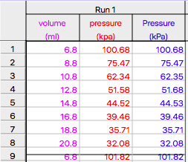
Observations:
There is 0.8 ml of space inside the pressure sensor itself; therefore, measured volume differs from the actual volume (see a. under ‘’Calculations’’ and Table 2).
In this experiment, we measured the pressure of the initial starting volume twice, but just the first point at the same volume was kept. (see explanation under ‘’Discussion’’)
It was hard to move the plunger of the plastic syringe while choosing our independent values.

Calculations

- Measured volume (Vm)Actual volume (Va)
Vm + 0.8mL= Va
6ml + 0.8mL = 6.8 mL

Table 2. Independent and dependent variables in the verification of Boyle’s law. An additive factor (0.8 mL) was added to each of the original volumes in order to obtain the actual volume.

Trial 1
Independent variable  Volume (mL) | Dependent variable  Pressure (kPa)
6.8 | 100.68
8.8 | 75.47
10.8 | 62.34
12.8 | 51.58
14.8 | 44.52
16.8 | 39.46
18.8 | 35.71
20.0 | 32.08

Figure 1. A plot of the pressure of air as a function of volume using Table 2 values.

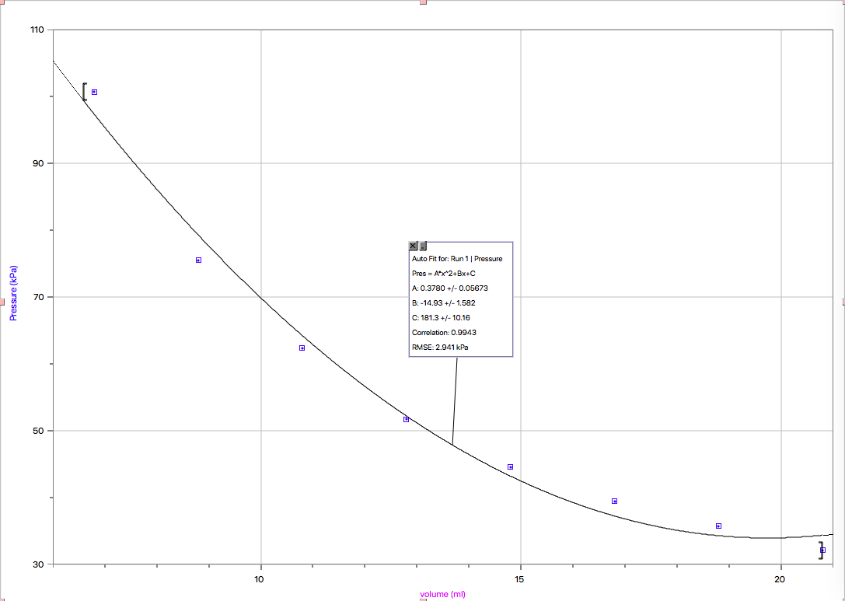

Boyle’s law constant
PV=nRT PV=k P=k(1/V) P=k/V
P: pressure
V: volume
N: amount of substance of gas (in moles)
R: is the ideal gas constant
T: is the absolute temperature of the gas

Calculating the reciprocal of the volume (1/V) (1/mL)
1/V= 1/Vn (1/mL)
1/V= 1/6.8 mL
1/V=0.147

Table 3. Reciprocal volume (1/V) and pressure for trial.

Trial 1
1/Volume (1/mL) | Pressure (kPa)
0.147 | 100.68
0.114 | 75.47
0.093 | 62.34
0.078 | 51.58
0.068 | 44.52
0.060 | 39.46
0.052 | 35.71
0.048 | 32.08

Figure 2. Pressure versus 1/Volume. Linear relationship, the slope value represents the constant k
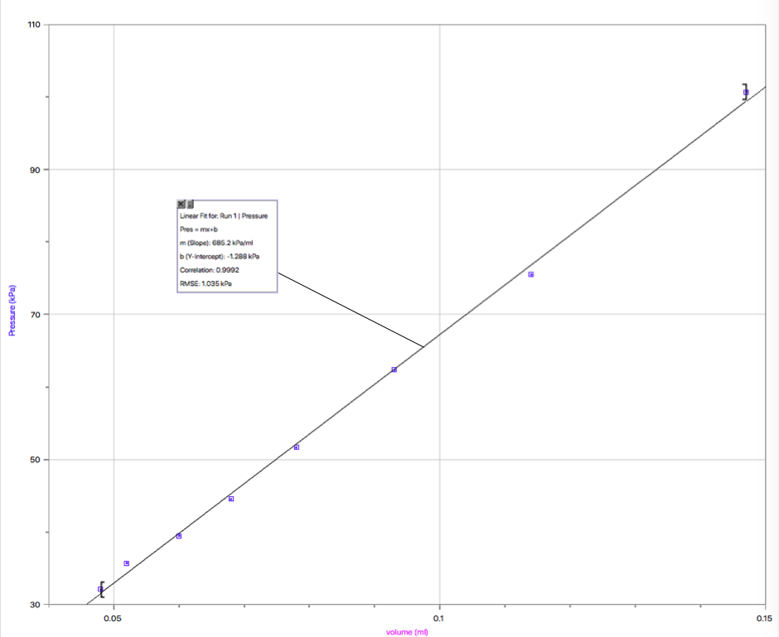
1/volume (1/mL)

- The slope is 685.2 kPa*mL according to LoggerPro. Therefore, the constant k using a graphical analysis approach equals to 685.2 kPa*mL.
y=mx+b y=P, m=k, x=(1/v) P=k(1/V)

- Algebraic approach to obtain the average of k using the values from Table 2.
P=k(1/V)
k=PV
k= [(6.8 mL x 100.68 kPa)+(8.8 mL x 75.47 kPa)+(10.8 mL x 62.34 kPa)+(12.8 mL x 51.58 kPa)+(14.8 mL x 44.52 kPa)+(16.8 mL x 39.46 kPa)+(18.8 mL x 35.71 kPa)+(20.8 mL x 32.08 kPa)]/8
k= 667.8 kPa*mL

Discussion

During this experiment, we measured the pressure of the initial starting volume twice for both trials. We got 2 different pressures for the same volume, and this should not have happened.
One of the possible reasons of error is that we were holding the syringe with our hands. In other words, at the beginning, the syringe was at room temperature, but after a while holding it in our hands, its temperature changed, so it did not remain constant and as a consequence the Boyle’s law was not completely obeyed. For this reason, the first point at the same volume was chosen to be incorporated in our raw data since it is more likely that the temperature of the syringe was not altered yet. This illustrates that taking multiple readings of the pressure for the same volume is important as it is a good way to find out whether other variables such as temperature, remained constant throughout the experiment. Besides this experimental error, the experiment successfully demonstrated Boyle’s law.
It can be inferred from Figure 2 that by plotting pressure against the reciprocal of the volume (1/V) a straight line is obtained, the gradient of which is the constant (k) in Boyle’s Law.
When volume decreases, there are more collisions on the syringe walls, and this increases the force per area; hence, a greater pressure.

P ∝ (1/V)
P = k(1/V)
P = k/V
k=PV

Conclusion
To conclude, even though both of our trials were affected by the change of temperature, the plotted data shows that volume is inversely proportional to its pressure which verifies Boyle’s law, and therefore, it might be assumed that the difference between final temperature and initial temperature was minimal.
Using calculations and graphs, the constant k was found to be around 667.8 kPa*mL

Works cited
Stone, Alexandre. MCAT General Chemistry Review. Kaplan, 2016.



