In Focus



This first picture was taken in Tim Hortons. The purpose of this picture is to indicate the relationship between the environment and the economic aspects that Tim Hortons has used with the cup holders. Firstly, this business demonstrates that it is making changes in order to benefit the environment. As indicated on the cup sleeves, it is made from “100% recycled content including 85% post-consumer fibre”. With this environmental aspect in play, Tim Hortons has also been able to profit economically. This business has decreased the amount of “fibre” that they use with the addition of these recyclable cup sleeves, meaning that they have been able to save more. In addition, Tim Hortons has also been able to gain more customers as they continue to prompt the environmental changes that they are making while maintaining the consistent satisfaction of their food and beverages.

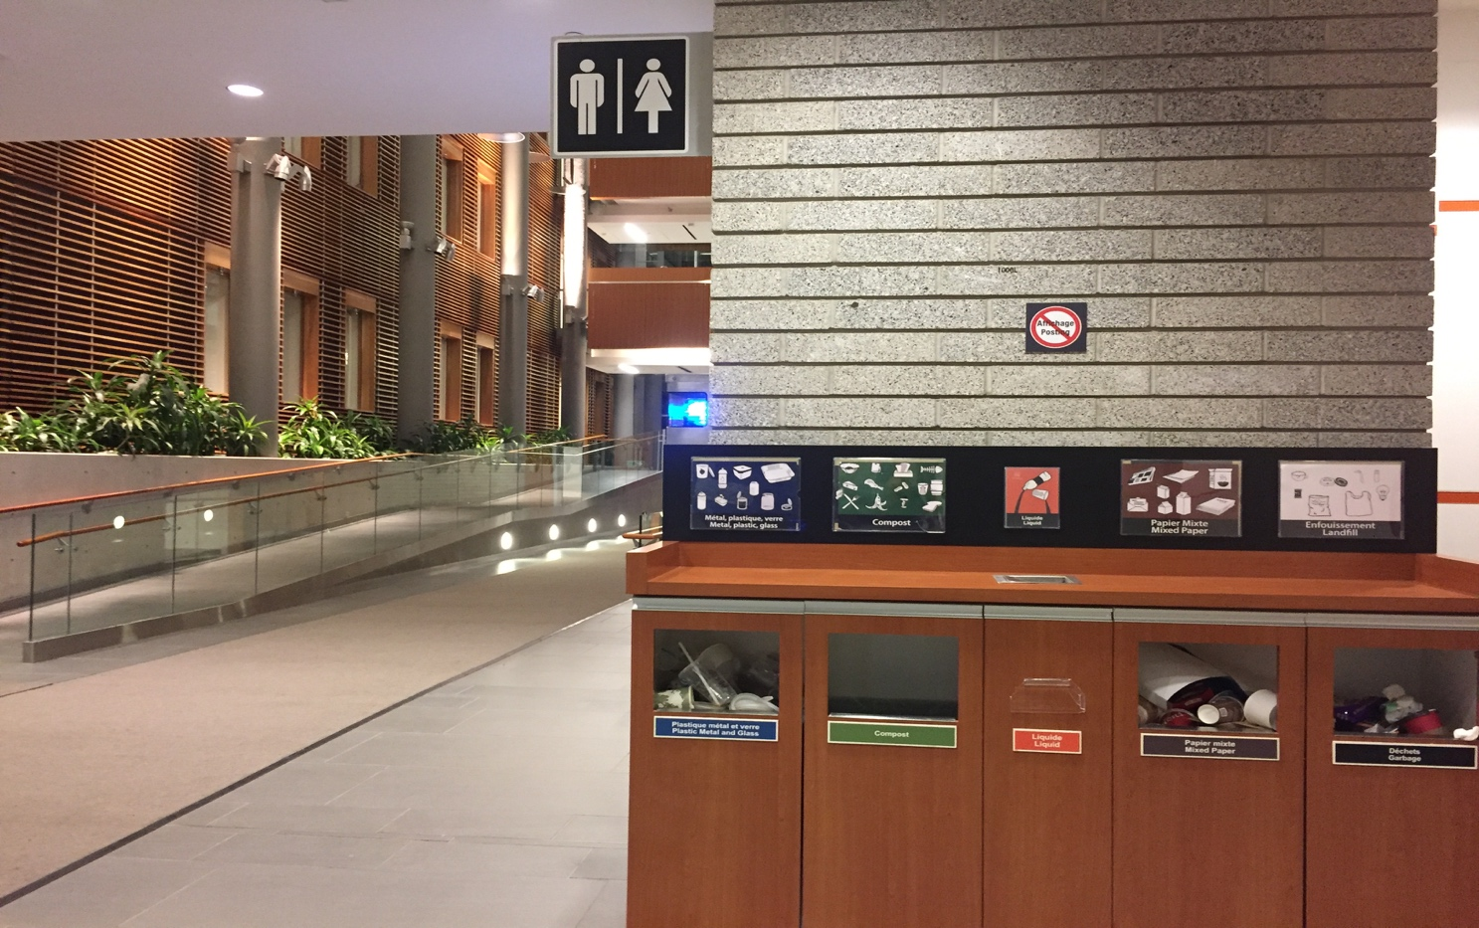

This second picture was taken inside the University of Ottawa Faculty of Social Sciences Building. Primarily, it is important to note that the university was taken into consideration as a business. As students pay to study at this institution, the University of Ottawa is a well-rounded business. This photo highlights the disposable bins next to the study space in the university. The photo targets the environmental aspect that the university wants to showcase. By having these disposable bins for different types of garbage in a variety of different spots throughout the building, the importance of maintaining a clean space and environmental sustainability is clearly shown. This ties together with social and economic aspects that this business wanted to target. These bins are strategically placed inside this innovative building, near the washrooms and study spaces. This means that it is able to attract more students into this building by promoting the environmental aspects. As well, this building can also be used as a centre piece for the university to attract more students and gain more money. This can be done by showcasing the greenery inside the building, such as the bio filter wall. In addition, there is also a small food store inside the building, so the more students that are attracted to this particular area, the more purchases that are made. The benefit that the university receives by attracting more students, is given back to those that come to these study spaces and washrooms.

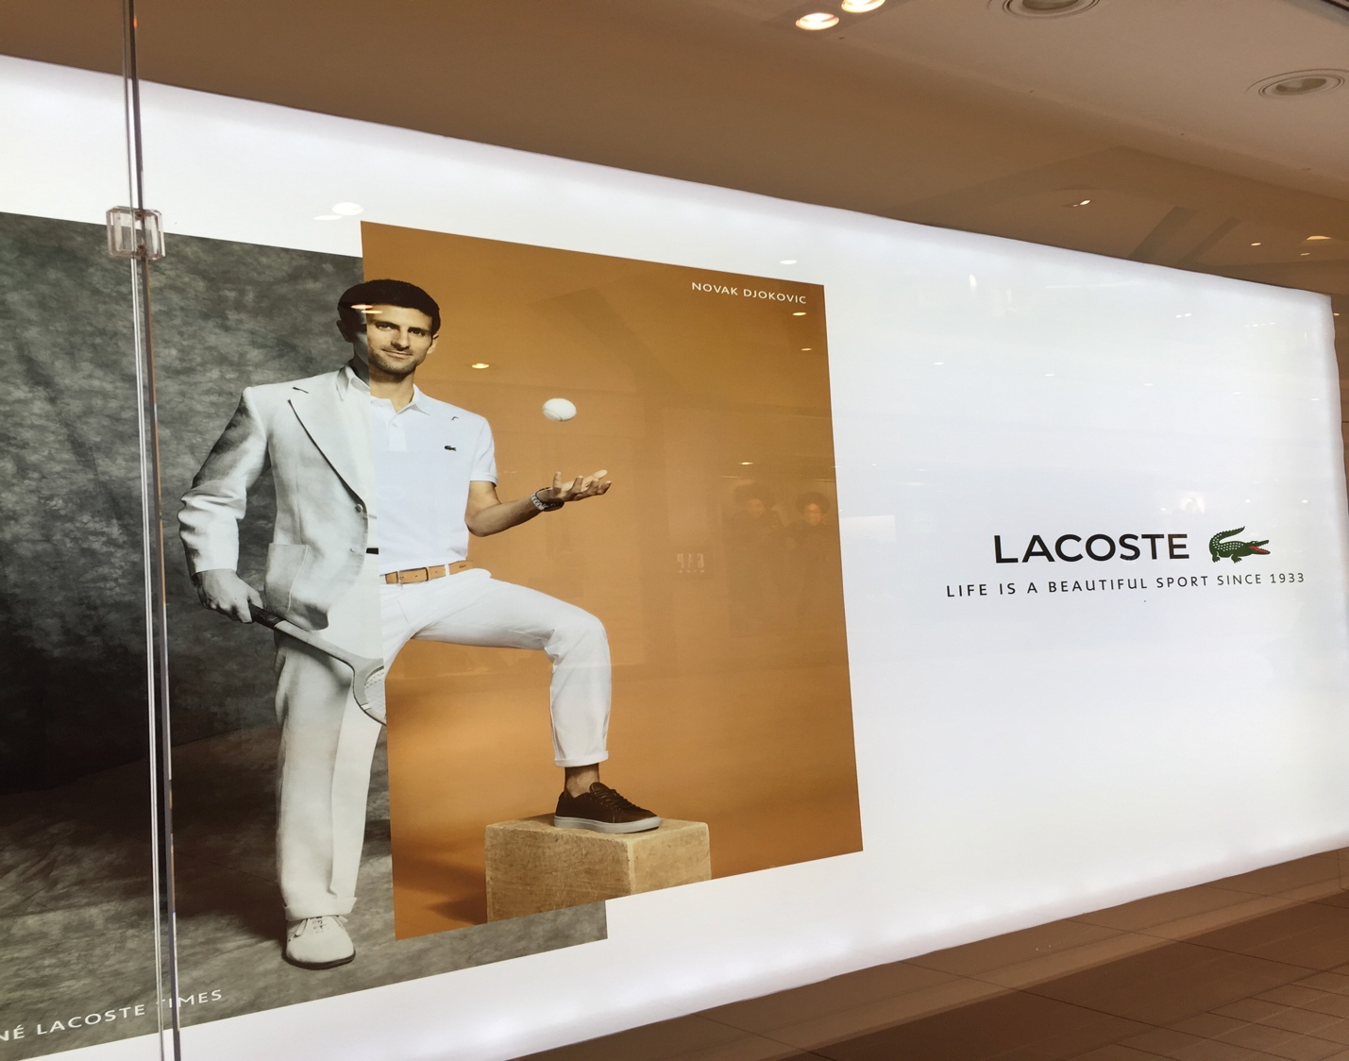

This last image shows an advertisement of Lacoste featuring the tennis star, Novak Djokovic. The business in this situation carefully uses both social and economic aspects in order to broaden their reach and profit. Primarily, Djokovic has recently won the US Open. His popularity in the sport of tennis is due to the many accomplishments that he has had in his career. This has resulted in millions around the world following him throughout his career. This social aspect combines together with their economic strategy as they use Novak to showcase the brand. In this picture, he is wearing the Lacoste brand from head to toe. This branding strategy attracts many of his followers to the Lacoste brand and purchase the clothing that he is promoting. Both the society and the business are profiting in this situation as they both relate to Novak being a star that is promoting a particular brand. As well, from an economic standpoint, the business had surely gained profit as they have used a tennis star to promote to customers worldwide.

