Chapter 2 Foundation of Recruitment and Selection I: Measurement, Reliability and Validity
The Recruitment and Selection Process - An employer’s goal is to hire an applicant who possesses the knowledge, skills, abilities, or other attributes (KSAOs) required to perform the job
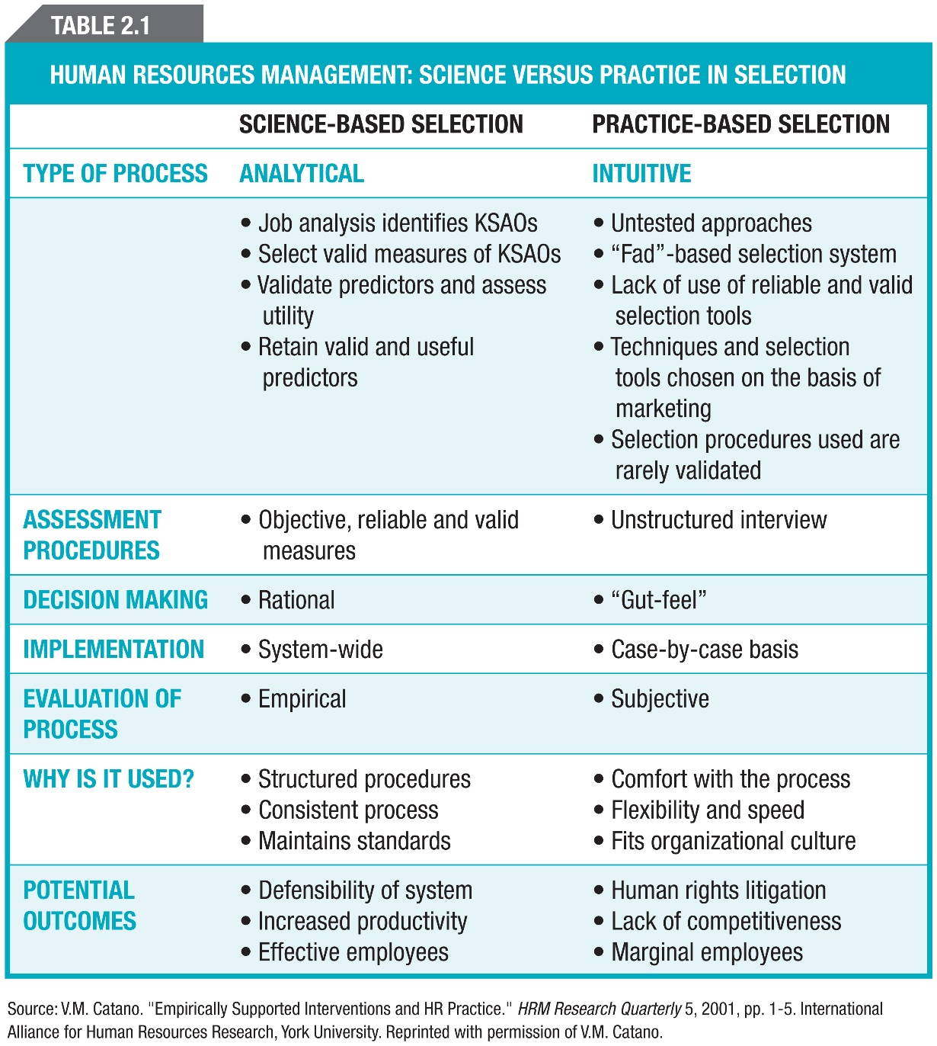
Prefer Analytical type because is more scientific. In court –we can justify analytical system because is fair. Practise based – I’m doing it in a way I feel is right. Do no drop out your intuition even though is not a preferred type. Here the basic idea is “I” and “feel”.
Construct – a psychological term referring to the traits, characteristics and other attributes that are measured by assessments. When evaluating whether an assessment will improve hiring decisions, all that we really need to know is whether it predict job performance.
Building a Foundation - Reliability refers to the consistency of a set of measurements when a testing procedure is repeated on a population of individuals or groups. In terms of testing, a test should provide approximately the same information each time it is given to that person. Factors Affecting Reliability - Temporary Individual Characteristics: factors such as health, motivation, fatigue, and emotional state introduce temporary, unsystematic errors into the measurement process. Lack of Standardization: changing the conditions under which measurements are made introduces error into the measurement process. Chance: factors unique to a specific procedure introduce error into the set of measurements.
Methods of estimating using two different, but parallel, measures of the characteristic or attribute:
- Test and Retest: the identical measurement procedure is used to assess the same characteristic over the same group of people on two different occasions.
- Alternate Forms: having a person take the same interview twice may lead to a false estimate of the reliability of the interview process. To prevent the intrusion of effects from the first interview, the manager asks the applicants alternate questions during the second interview; the correlation between both experience scores again estimates reliability, with high correlations once more indicating strong reliability.
- Internal Consistency: consider any two questions in the interview to be an example of a test-retest situation, and determine the correlation between scores given to each item in that pair; logic behind establishing reliability through internal consistency. Rather than select any particular pair of items, the correlations between the scores of all possible pairs of items are calculated and then averaged; this average estimates the internal consistency, the degree to which all the questions in the set are measuring the same thing.
- Inter-Rater Reliability: measurement in personnel selection is often based on the subjective assessment, or rating, of one individual by another.
Choosing an Index of Reliability: have to estimate the degree of variability in a set of scores that is caused by measurement error; obtain this estimate by Index of Reliability; the HR specialist chooses an appropriate index of reliability and determines the level of reliability that is acceptable for use of a specific measure.
The HR Specialist must consider the consequences of the decisions based on the measure; the need for accuracy increases with the seriousness of the consequences for the employee.
Validity: the legitimacy or correctness of the inferences that are drawn from a set of measurements or other specified procedures; the degree to which accumulated evidence and theory support specific interpretations of test scores in the context of the test’s proposed use. I’m testing what I say I’m testing (looking for instruments that measure a predictable ability that says the person is matching the job. Construct, Content, Criterion-Related Validity - Construct and content validity: validation strategies that provide evidence based on test content. Criterion validity: related validity provides evidence based on relationships to other variables
Discuss why it is better to base a selection system on science than a “gut feeling”? Table 2.1 + could include info below.
Different Ways of Knowing: Non-Scientific Methods - Tenacity – held from the beginning of the time; that is the way it is; Authority – someone important told you it was true; sometimes those things that you learn first; Rationalization – comes through the process of thinking; it may makes sense to you but no to others; it’s our best guess, not reality; Intuition Scientific Method (Better way to handling things; not crazy objective, reasonably objective; we’re concerned with reality; self-correcting, someone else may do the same study and proof reliability) : Characteristics: Concerned with reality; Accepts causality; Empirical; Made public – other may correct it, make it bias free; Provides method; Therefore, is self-correcting; Statement of Problem; Hypothesis; Reasoning and Deduction; Observation/Test/Experiment–Operational Definitions; Variables; Research Plan

Research Designs - Observation Studies (when you don’t know anything about it you watch); Correlation Studies (things that move together, don’t give cause); Experiment Designs (everything is constant except one element and measure the result – get result) ; Quasi-Experimental Designs (is it ethical, especially when we’re dealing with humans)

Measurement - Nominal Scales (put people into categories); Ordinal Scales (gives the order); Interval Scales (put the even intervals- simple math no “0”; Ratio Scales
Figure 2.4 Validation Strategies - illustrates different sources of evidence for validity using the cognitive ability data collected by the HR manager
Other Factors to Consider- Bias: systematic errors in measurement, or inferences made from those measurements, that are related to different identifiable group membership characteristics such as age, sex, or race; Fairness: the value judgments people make about the decisions or outcomes that are based on measurements - Principle that every test taker should be assessed in an equitable manner (Different Views of Fairness: Fairness as equitable treatment in the testing process; Fairness as lack of bias; Fairness in selection and prediction)
Chapter 3 Foundations of Recruitment and Selection II: Legal Issues
Four Legal Sources Affecting Canadian Employment Practices – 1.Constitutional law; 2.Human rights law; 3.Employment equity legislation; 4.Labour law, employment standards, and related legislation
Constitutional law: the Supreme Law of Canada. It has a pervasive impact on employment practices, as it does on all spheres of Canadian society. Canadian Charter of Rights and Freedoms: every individual is equal before and under the law and has the right to the equal protection and equal benefits of the law without discrimination and, in particular, without discrimination based on race, national or ethnic origin, colour, religion, sex, age, or mental or physical disability.
Human rights legislation: prohibits discrimination in both employment and the provision of goods and services (e.g., rental housing, service in restaurants). Legislation generally establishes human rights commissions or tribunals to deal with complaints, including those involving employment discrimination. Vary from one province to another. Section 8 of the Canadian Human Rights Act refers to a “a prohibited ground of discrimination.” The following are grounds on which discrimination is prohibited: Race, national or ethnic origin, colour, religion, age, sex (including pregnancy and childbirth), marital status, family status, mental or physical disability, pardoned conviction, sexual orientation
GOOD DESCRIMINATION – allowed only in regards of job fit or organization fit
Employment equity: the elimination of discriminatory practices that prevent the entry or retention of members from designated groups in the workplace, and the elimination of unequal treatment in the workplace related to membership in a designated group (e.g., women, visible minorities, Aboriginal peoples, and people with disabilities) Developing and Implementing an Employment Equity (EE) Plan (she doesn’t want it but may be used for answering the question below) – 1. Obtain support of senior management for the EE effort; 2. Conduct a survey to determine the present representation of designated groups in the organization’s internal workforce; 3. Set future representation targets for designated groups based on availability of qualified workers in the labour market; 4.Remove systemic employment barriers to increase representation for designated groups in the internal workforce; 5.Monitor the changing composition of the internal workforce over time; 6.Make necessary changes to the EE intervention to bring designated group representation up to future targets
!!! Benefits of Implementing Employment Equity - A workforce representative of Canadian culture and diversity; An increase in global competitiveness and productivity; High employee morale and decreased absenteeism; Amicable relationships with customers and clients; Enhanced corporate reputation; Increased profitability and a better bottom line
You are the president of your company. How would you encourage your managers to promote employment equity in their department?
Labour Law - Federal/provincial labour laws: stipulate the rights of the employees to organize trade unions and to bargain collective agreements with employers; Collective agreements: set out the conditions for unionized employees (e.g., promotion, lateral transfer, demotion)(union can’t agree to break the law)
Employment Standards - federal/provincial laws to regulate minimum age of employment, hours of work, minimum wages, statutory holidays, vacations, work leaves, and termination of employment
Discrimination: refers to any refusal to employ or to continue to employ any person on the basis of that individual’s membership in a protected group. All Canadian jurisdictions prohibit discrimination at least on the basis of race or colour, religion or creed, age, sex, marital status, and physical or mental disability.
Key Legal Concepts in Recruitment and Selection - Direct discrimination: occurs where an employer adopts a practice or rule that, on its face, discriminates on a prohibited ground; Indirect discrimination: occurs when an employer, in good faith, adopts a policy or practice for sound economic or business reasons, but when it is applied to all employees it has an unintended negative impact on members of a protected group; Protected groups: those who have attributes that are defined as “prohibited grounds” for discrimination under the human rights act that applies to the employing organization; Designated groups: The Employment Equity Act defines these groups as women, visible minorities, Aboriginal peoples, and persons with disabilities; Employment equity: refers to the elimination of discriminatory practices that prevent the entry or retention of members from designated groups in the workplace’(Employment equity--also includes the elimination of unequal treatment in the workplace related to membership in a designated group); Adverse impact: occurs when the selection rate for a protected group is lower than that for the relevant comparison group; Bona fide occupational requirement (BFOR): requirement(s) that a person must possess to perform the essential components of a job in a safe, efficient, and reliable manner (an employer must show that the practice or policy was adopted in an honest and good-faith belief that it was reasonably necessary to ensure the efficient and economical performance of the job without endangering employees or the general public)(done it in a good faith; show that this make difference; has to be fair); Accommodation: the duty of an employer to put in place modifications to discriminatory employment practices or procedures to meet the needs of members of a protected group being affected by the employment practice or procedure (As part of a BFOR defence, an employer must demonstrate that such accommodation is impossible to achieve without incurring undue hardship in terms of the organization’s expense or operations); Sufficient risk: an employer may argue that an occupational requirement that discriminates against a protected group is reasonably necessary to ensure that work will be performed successfully and in a manner that will not pose harm or danger to employees or the public; Undue hardship: the limit beyond which employers and service providers are not expected to accommodate a member of a protected group (Undue hardship usually occurs when an employer cannot bear the costs of the accommodation)
Adverse Effect Discrimination - refers to a situation where an employer, in good faith, adopts a policy or practice that has an unintended, negative impact on members of a protected group.
- What does it mean to accommodate someone to the point of undue hardship? Undue hardship covers the limits that the employer is legally required to go to in order to accommodate a members of a protected group. The relevant factors that may be consider when assessing an employer’s duty to accommodate include: financial cost; the disruption of operations; the relative changeability of the workforce and facilities; the prospects of substantial interference with the rights of other employees; the impact on a collective agreement and health and safety concerns. The financial cost of accommodation is frequently cited as a significant hardship by employers. Such costs should be: quantifiable, tied to accommodation measures, sufficient substantial as to be prohibited. Other factors that may influence decision: size of organization and its relative financial means; the timing of the costs and the employer ability to spread the costs over time and/or across the organization; availability of outside sources, such as government grands, tax incentives, etc.
- When can an apparently discriminatory selection practice be justified on the grounds of “sufficient risk”? – definition + example – hospitals – applicants with HIV virus or AIDS, but should show objective data that people are a sufficient risk, all of them present risk, etc.
Effective Practices for Nondiscriminatory Recruiting: In employment office, post in a conspicuous spot complete, objective, and specific information on all available jobs; Advertise job openings in media that are read, viewed, or listened to by protected or designated group members; Train employment clerical staff and recruitment officers in outreach recruiting; Use opportunities to visually present protected or designated group members in positive employment roles; Establish networks with community groups from which protected or designated group members are drawn; Set and advertise objectively determined selection criteria for the job; Base selection criteria on bona fide occupational requirements
Ineffective Practices for Nondiscriminatory Recruiting: Permit receptionists and recruiters in employment offices to “pre-screen” applicants on the basis of informal criteria (e.g., appearance, dress); Rely on word-of-mouth advertising; Post job advertisements only in-house; Rely solely on seniority when promoting employees without regard for meeting the qualifications need for the position ; Allow each recruiter to use and communicate idiosyncratic criteria for selecting among job applicants; Categorize and stream job applicants based on stereotyped assumptions about protected or designated group membership (e.g., that women are not physically strong enough for certain work)
Chapter 6: Recruitment: The First Step in the Selection Process
Attracting Job Applicants - Recruitment: the generation of an applicant pool for a position or job in order to provide the required number of qualified candidates for a subsequent selection or promotion process (identifying, contacting, and attracting the talent pool)(Issues include sources and costs of recruitment, external versus internal candidates, recruiting protected classes, and planning the recruitment effort); Applicant pool: the set of potential candidates who may be interested in, and who are likely to apply for, a specific job
Recruitment Strategy –
External Factors: Labour markets and recruiting: the overall nature of the economy may influence an organization’s decision to hire or not to hire, but once a decision to hire is made, the nature of the labour market determines how extensively the organization will have to search to fill the job with a qualified candidate. When qualified labour is scarce, the organization must broaden its recruiting beyond its normal target population. Organizations must be prepared to alter their recruiting strategy to match labour market conditions. Part-time labour markets and recruiting: more companies are employing low-wage, entry-level workers on a part-time basis. Temporary or contingent jobs have shown tremendous growth over the last decade. Temporary work is serving as a training ground for more permanent positions.) Outsourcing: contracting with an outside agent to take over specified HR functions; Legal environment: any organizational recruitment program must comply with the legal and regulatory requirements that apply to its operation. Systemic discrimination: in employment, the intentional or unintentional exclusion of members of groups that are protected under human rights legislation through recruiting, selection, or other personnel practices or policies. Diversity recruitment: many organizations are dealing with employment equity issues to eliminate discrimination in the workplace for women, visible minorities, Aboriginal peoples, and people with disabilities. Diversity makes good business sense.
Internal Factors: Business strategy/plan: an organization’s business plan addresses those aspects of the external environment that affect how the organization does business. An organization’s business plan also influences the degree to which the organization fills vacancies with internal or external applicants. It is common to bring someone in from the outside to fill an entry level position. Job level and type: both the type of occupation and the nature of the industry in which it is involved may influence an organization’s recruiting strategy. Recruiting strategy and organizational goals: different organizational goals lead to different recruitment strategies. One must decide whether to concentrate recruiting efforts on internal/external candidates. Describing the job: duties and responsibilities and skills required for the job.
Human resources planning: the process of anticipating and providing for the movement of employees into, within, and out of an organization

Elements in a Recruitment Action Plan
- Develop Recruitment Strategy: Establish selection committee; Review organization’s goals and objectives; Establish budget for the recruitment process; Establish time lines for recruitment and selection activities; Review job description for position; Develop selection criteria; Develop profile of “ideal” applicant; Develop job advertisement/recruiting materials. WRITE AN AD - name & location of organization; type of business performed; brief description of duties; main qualifications: education, experience, skills; other: salary range, listing of major benefit plans, size of organization, company atmosphere and working conditions, highlights of why your company is a good place to work; STYLE: AIDA - A attention; I interest; D desire; A action. Identify Best Means of Communication: Paid & unpaid media (Social media, print media, radio, television, e-devices. Gather key information about outlet: Policies, contacts, prices, deadlines. Generate a newsworthy story. Use buying organizer for paid media. Direct contact. Events
- Develop the Applicant Pool: Review state of the labour market; Consider employment equity issues; Determine if recruitment will be internal or external; Identify target applicant pool; Identify recruitment methods to be used; Place ad/recruiting materials in agreed upon media
- Review the Applicant Pool - Determine whether applicant pool is large enough; if not, renew recruitment efforts; Screen job candidates’ application forms and resumes; Conduct short screening interview; Select “long list” of candidates for further review
- Conduct Review in Job Applicants- Selection committee develops shortlist of candidates; Arrange visits of shortlisted candidates to company; Conduct realistic job preview for candidates; Conduct employment tests; Conduct selection interview; Identify leading candidate(s) for position; Complete reference and background checks on leading candidates; Make hiring recommendation; Contingent on offer of employment, arrange for any required medical or physical examinations
- Evaluate the Recruiting Effort - Review the recruiting process: what went right, what went wrong; Review the outcome of the recruiting process; Review the performance of people who were hired. Measuring the Effectiveness of a Recruitment Effort
- Behavioural measures: Turnover; Within 6 months; Within 12 months; Within 24 months; Absenteeism
- Performance measures: Performance ratings; Sales quotas; Performance potential
- Attitudinal measures: Job satisfaction; Job involvement; Satisfaction with supervisor; Commitment to organization; Perceived accuracy of job descriptions

Recruitment Sources for Internal Candidates - Internal candidates: provide the organization with a known source of labour. Internal job postings: internal candidates provide the organization with a known source of labour. Internal applicants are likely to have more realistic expectations about the job or organization and to have more job satisfaction and organizational commitment. Succession plans/replacement charts: organizations expect that vacancies will occur through death, illness, retirement, resignation, or termination, and as part of the HR planning function develop a succession plan for filling vacancies with existing employees. Replacement charts list each job with respect to its position in the organizational structure. The replacement chart lists the incumbent for the position and the likely internal replacements for the incumbent. The chart includes information on the present job performance of each potential successor. Human resources information systems (HRIS): involve the creation of a comprehensive, computerized database that contains the job analysis information on each position, including information on the required KSAOs. Nominations: occur when someone who knows about a vacancy nominates another employee to fill it. In most cases, supervisors nominate one or more of their employees for a vacant position.
Recruitment Sources for External Candidates - Job Advertisements; Newspapers; Professional Periodicals and Trade Journals; Radio and Television; Public Displays; Direct Mail; Open Houses; Job Fairs; Employee Referral; Networking; Walk-Ins; Employment Agencies; Service Canada Centres; Private Employment Agencies; Executive Search Firms; In-house Recruiters; Temporary Help Agencies
Recruiting at Educational Institutions - Seeking entry-level technical, professional, and managerial employees; Placement services provided in the educational institutions; Well-established campus recruiting programs
Do you think the Internet is a good vehicle to look for a job? Discuss the advantages and disadvantages.
E-Recruiting: Use of the Internet and Social Networks - the use of the Internet to match candidates to jobs through electronic databases that store information on jobs and job candidates. Advantages of Internet recruiting: company can reach a potentially limitless talent pool at minimal cost and beyond its normal geographical location; the company can provide more information about the position to job seekers than does a typical print ad; companies can provide up-to-date information on their corporate image; new jobs can be posted as the need arises; it speeds up the recruiting process; and it provides more opportunities for smaller firms, automated applicant tracking (careful with words – discrimination), test can be administered by computer Disadvantages to Internet recruiting: large volume of applications/résumés and all of them are qualified for the position (to avoid them pay attention how to word job posting); time consuming to screen; not all companies want applicants to complete a standardized online résumé, logistical problems (if applicant is not serious about relocating the company lose time and money)
Social Network Recruiting - Internet sites that allow users to post a profile with a certain amount of information that is visible to the public
The Organizational Context - Interests and values: an individual’s likes and dislikes and the importance or priorities attached to those likes and dislikes; Job search: the strategies, techniques, and practices an individual uses in looking for a job (Individuals become job applicants after forming an opinion on the desirability of working in a particular job within a specific organization. Organizational characteristics such as location, size of the enterprise, and type of industry may steer individuals away from applying for jobs no matter how attractive the job or how qualified they are to do it. Jobs providing autonomy, decision-making authority, and opportunities for self-development win out over those that lack these attributes. Organizations that offer special accommodations and flexible work arrangements gain competitive advantages in recruiting.)
Corporate Image and Applicant Attraction - Reputation of an organization is an important concern to job applicants. Corporate image predicts the likelihood of interest on the part of a job seeker. Familiarity with the company. Competitive compensation package
Image advertising: advertising designed to raise an organization’s profile in a positive manner in order to attract job seekers’ interest
Guidelines for Effective Recruiting: Ensure that candidates receive consistent and noncontradictory information about important features of the job and its environment. Recognize that the behaviour of recruiters and other representatives gives an impression of the organization’s climate, efficiency, and attitude toward employees. Ensure that all recruiting information and materials given to job applicants present accurate and consistent information. Present important information on the job and the organization to job candidates by several different, reliable, and credible sources. Give serious consideration not only to the content of information presented to candidates but also to the context in which it is presented
The Person-Organization Fit: Person-job fit: when a job candidate has the knowledge, skills, abilities, or other attributes and competencies required by the job in question Person-organization fit: when a job candidate fits the organization’s values and culture and has the contextual attributes desired by the organization. An applicant’s résumé plays an important role in determining whether the applicant will proceed to the next stage of the hiring process. Organizational recruiters use the content of job applicants’ résumés to make inferences about the suitability of applicants. Both the perceptions of person-job fit and of person-organization fit predict whether the company will make a job offer.
Communication and Perception - If perceptions are positive, a job offer is made and accepted. If the perceptions of one do not match those of the other, a job offer is either not made or, if made, not accepted. Perceptions are based on communication. Inaccurate, incomplete, or distorted information leads to misperceptions and inaccurate decisions.
Realistic job preview: a procedure designed to reduce turnover and increase satisfaction among newcomers to an organization by providing job candidates with accurate information about the job and the organization
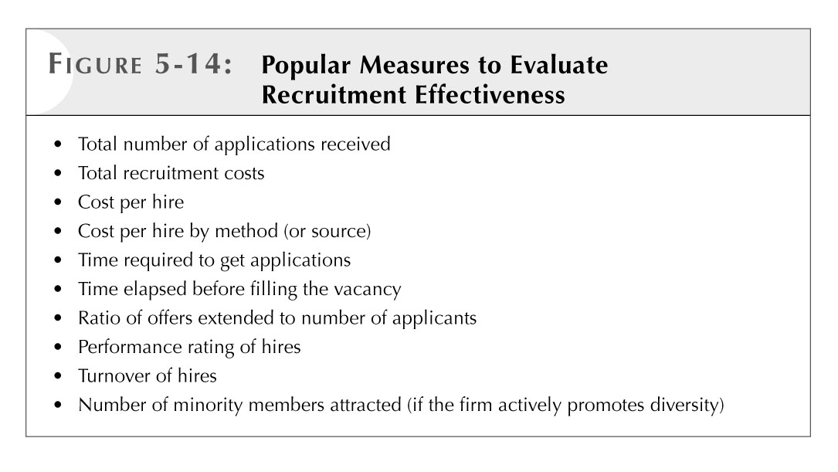
A key aspect of the recruitment effort: external vs. internal candidates; sources and cost of recruiting; planning the recruitment effort; recruiting legally protected groups.
Chapter 7: Selection I: Applicant Screening
Applicant Screening - the first step of the selection process; involves identifying individuals from the applicant pool who have the minimum qualifications for the target position(s). Candidates “passing” this first hurdle then undergo more extensive assessments. Minimum qualifications (MQ): knowledge, skills, abilities, experiences, and other attributes and competencies deemed necessary for minimally acceptable performance in one or more positions; designed for making the “first cut” in screening job applicants; sometimes referred to as selection criteria. Designated targeted groups: the four groups (women, visible minorities, Aboriginal peoples, and people with disabilities) designated in the federal government’s Employment Equity Act that receive legal “protection” in employment policies and practices because of their underrepresentation in the workplace
Recruitment, Screening, and Selection - Selection ratio: the proportion of applicants for one or more positions who are hired. False positives: individuals who are predicted to perform successfully in a given position (based on pre-selection assessment scores), but who do not perform at satisfactory levels when placed on the job. False negatives: individuals who are predicted to perform unsuccessfully in a given position (based on pre-selection assessment scores), but who would perform at satisfactory levels if hired
Screening Methods - Application Forms (Blank); Weighted Application Blanks; Biographical Data; Biodata; Biographical Information Blank (BIB); Résumés; Reference Checks; Background Checks
Application blank: a form completed by job candidates to provide an employer with basic information about their knowledge, skills, education, or other job-related information. Application forms consist of a series of questions aimed at securing information on the general suitability of the applicants to the target position. They are used to provide a preliminary pre-employment screen, allowing the employer to determine whether the applicant is minimally qualified for the position. They collect information in a consistent format. Employers cannot ask for information that is prohibited on discriminatory grounds under human rights legislation unless it can be established that the information is a bona fide occupational requirement (BFOR).
Weighted application blanks: a method for quantitatively combining information from application blank items by assigning weights that reflect each item’s value in predicting job success. Criterion measures: measures of employee work-related outcomes typically important to an organization--including, for example, turnover, absenteeism, and supervisory ratings--are used to establish the validity of screening and selection tools.
- Benefits - Good predictors for many types of work behaviour. e.g., absenteeism, accidents, and turnover; WABs are also easy and economical to use; WABs have been shown to reduce employee turnover in the hospitality industry.
- Concerns - May not adequately represent a job’s complex performance domain. WABs require data from a large number of employees to obtain percentages that are reliable, stable estimates of the appropriate weights; WABs provide the basis for good empirical predictions but they do not explain these relationships.
- When to Use - Often used for rapid screening and may be combined with other predictors. e.g., personality or cognitive ability; to improve selection decisions; often used for positions requiring long and costly training where turnover is high.

Biographical information blank (BIB): a pre-selection questionnaire that asks applicants to provide job-related information on their personal background and life experiences. Biodata: biographical data for job applicants that have been gathered from BIBs, application blanks, or other sources. BIB dimensions: based on the view that past behaviour is the best predictor of future behaviour: Dimensions appear relatively stable; Explain why certain applicants are more successful than others. Concerns Over the Use of Biodata - Questions of legality, invasiveness, affability, and generalizability; Many BIB items may request personally sensitive information on family background and experiences that borders on violating human rights legislation, When to Use BIBs - Appropriate for organizations hiring large number of employees; For similar kinds of jobs; Where large numbers of applicants are competing for few positions (e.g., when there is a low selection ratio)
Résumés
Intent of the résumé is to introduce the applicant to the organization through a brief, written self-description: Applicants voluntarily provide autobiographical information in their résumés; Résumés are not standardized; Résumés are unique; Electronic résumés are more popular today
First Impressions with Résumés/Covering Letters - Résumés create the first impression of the applicant and they should be accompanied by a well-written covering letter. Covering Letters Guidelines: 1. Address your letter to the specific hiring manager rather than including a generalized introduction. 2. Research the company online and clearly communicate how your knowledge and skills fit the job and could benefit the organization. 3. Address any potential concerns (e.g., employment gaps). 4. Limit your cover letter to two or three short paragraphs. 5. Show your excitement for the position and conclude by identifying next steps (e.g., “I’ll follow up next week to discuss in person”). 6. Review (and have others review) your cover letter for typos and grammatical errors. When applying through online job boards, always choose the option to add your cover letter to your résumé. When emailing application materials to a hiring manager, paste your cover letter within the body of your message.
Writing a Résumé - A résumé should include: The applicant’s name, address, and phone number; Education and training; Employment history; Names of references and their contact information; A brief statement of employment goals and objectives; Information on hobbies and interests. It should be well organized. It should highlight key information. It should use a typeface size (usually a 12-point font) that is easy to read
Five Steps to Writing an Effective Business Résumé
  - Complete a self-assessment and create a skills inventory
  - Define your accomplishments: use the STAR method (situation, time, action, result)
  - Use résumé sections/headings to emphasize your value
  - Ensure your résumé is easy to read and error-free; review the packaging, positioning, power information, personality, and professionalism
  - Ensure your résumé reflects exactly what you want to represent to the employer. Consider: Does my résumé reflect the brand I want to represent, and does it effectively communicate this brand to employers?
Note: a Facebook URL is not recommended because Facebook is a social network rather than a professional organization

What do recruiters look for in a résumé and a covering letter?
Screening Résumés: Difficult today because of the volume of résumés - Organizations have had to develop procedures for efficiently and systematically processing résumés. Considerations when screening résumés: Think of what the company needs for excellent job performance in terms of its job performance criteria; Read each résumé with reference to the organization’s criteria of job performance; Check résumés for work experience, chronology, and history; Examine résumés for concrete accomplishments and identifiable skills. What to Look for When Examining a Résumé: Unexplained gaps in work or education chronology; Conflicting details or overlapping dates; Career regression, or a “downward” trend; Use of qualifiers such as “knowledge of” and “assisted in” to describe work experience; Listing of schools attended without indicating receipt of a degree or diploma; Failure to provide names of previous supervisors or references; Substantial periods in a candidate’s work history listed as “self-employed” or “consultant”. In a highly competitive labour market, job candidates may be more prone to “fudging” the truth about their credentials. There is often a fine line between presenting yourself in the “best possible light” and intentionally misrepresenting your background. Human resources managers must learn how to “read between the lines.”
Elements of resume (her slides): Organization of CV (Is the CV clear to read and understand? Does it follow a format or pattern? Is it grammatically correct?) Does the applicant have experience in the position for which they are applying? Does the applicant have the required skills required on the job (including languages, computer, and the like)? Academic degrees and professional certificates (Does the applicant’s educational background correspond with the position? Is the applicant being misleading with educational information?) Achievement and Awards (Has the applicant being awarded or commended? - This demonstrates initiative and motivation.) Volunteer/Extra-curricular activities (Does the applicant participate in volunteer groups, sport teams - This demonstrates teamwork, commitment & motivation. Does the applicant hold an important position/office in these groups? - This demonstrates leadership.) Look for Red Flags (Dates, specifics omitted, vagaries, hedgers. Ignore Discriminatory Information. Be Reasonable – know your biases)
Reference Checks - information gathered about a job candidate from supervisors, coworkers, clients, or other people named as references by the candidate. The information is usually collected from the references through telephone interviews. Many employers are hesitant to make strong, negative statements about current or former employees; they may be afraid of a lawsuit. Check references regarding job titles, duties, and responsibilities, and when the applicant was employed. Telephone references are most popular as people are often reluctant to put references in writing. Guidelines for Avoiding Negligent Hiring: Train staff on selection and hiring; Implement a hiring and reference check policy; Require applicants to sign an authorization form; Conduct reference checks in keeping with employment and human rights legislation; Ask about past job performance; Ask questions on recent job performance; Verify all licences (e.g., driving records); Verify degrees/certificates; Check references by telephone; Verify gaps in résumé (e.g., work experience); Use qualified professionals or trained staff to check references; Avoid invasive/discriminatory questions
Reference check (her slides )- Gathering qualitative information about a candidate’s performance, skills, strengths and weaknesses, etc. Employment verification confirms accuracy of information given by applicant (in application, resume, or verbally). “Qualified privilege - referee believes what he says is true (even if it’s not). “negligent misrepresentation” – knowingly hold back negative information esp. where employee is subsequently hired and causes harm to the employer or its clientele. Failure to give a favorable reference can be a problem. Secure permission in writing to contact references. Credibility depends on: Length of time prospective worked for referee; Direct contact between these two parties in their employment relationship; How similar previous job is to one being applied for now. NEGLIGENT HIRING: Where an employer paces an unfit or unqualified person in an employment situation which puts others at an unreasonable risk of harm. Establishing liability for negligent hiring stems primarily from whether the employer knew or should have know it=f an individual was unfit for the job at the time of hiring. Guidelines for avoiding Negligent Hiring: Use behavioral questions; Information gather from Cyber-Profiling; Low Validity of Personal References
Employment Equity (her slides) is an important element in hiring. To ensure that the designated groups are considered equitably, please keep in mind the following when reviewing CV’s. Are you de-valuing or minimizing a candidate’s expertise if the experience or education is from a foreign organization? Are you assuming breaks in employment necessarily mean unemployment? Breaks should be further investigated with the applicant. Often, new immigrants to Canada are under-employed (i.e. employed below expertise level). In these cases, do not hold the Canadian experience to be the standard for further consideration and evaluation. Designated Protected Groups include: Women; Aboriginal people (members of Indian, Inuit or Metis peoples of Canada); Visible minorities; Persons with disabilities.
Writing resume and cover letter (her slides) –
- APPEARANCE – First impressions - Paper Color and Quality - 81/2 x 11; white or ivory – plain or water mark (make sure it reads correctly); matching paper and envelope (as well as for cover letter). Font: Times New Roman; Unjustified right margin; Serif faces (easier to read); 12 (10 at the smallest) Organization Top: Name – bold and larger font - + other contact information Recent graduates: education next (unless experience is more important). Make it EASY to read: Leave lots of white space; write in columns or table form without the lines. Proofread with care – NO mistakes; no grammatical/punctuation errors
- TYPES of RESUMES – Chronological - Currently or recently working and if your most recent experiences relate to your desired field. No gaps in work history. State in reverse chronological order. Functional - Focuses on skills and strengths that your most recent jobs do not necessarily reflect, while de-emphasizing job titles, employers, etc. Useful if no work experience, have been out of the work force for a long time or are changing careers. Be ready to answer questions because some recruiters may think you are trying to hide something. Skills summary at top may be useful in some cases.
- CONTENT - STYLE: Be yourself – stick to facts; be honest. Job history – last 10-15 years. Be concise – avoid “I”. Begin with action verbs. Present tense for current jobs; past tense for previous jobs. No unnecessary words. Avoid catch phrases, jargon, excessive words. Improve general descriptions by listing actual projects and goals; RESULTS No abbreviations. Use bullets (periods in a bulleted list are optional). PERSONAL INFORMATION: No, beyond contact information. Hobbies only if related to job type you are seeking. JOB OBJECTIVE – what you can do for them. Take from Job Description/Posting. EDUCATION: Degrees, Honors, special awards, Unnecessary to list courses taken for degree; Certifications if applicable; Professional affiliations – yes; High School – optional and sparingly; Only if directly related to job applying for. WORK EXPERIENCE: Name of employer, time worked there, responsibilities, skills developed. BE SPECIFIC: distinguish yourself through accomplishments not job duties. SKILLS – Computer – programs from strongest to weakest. Languages – from strongest to weakest OMIT: “References Upon Request” Length: Two pages maximum
- SKILLS EMPLOYERS MAY SEEK: Supervising/managing skills mean you can take responsibility for the work of others. Coordinating/organizing skills allows you to plan events or see projects to completion. Negotiating skills allow you to bring about compromise and resolve differences. Customer service/public relations skills enable you to be a spokesperson for your organization. Training/instructing skills allow you to show newcomers the ropes. Interviewing skills enable you to ask tough questions, then listen to get insight from the answers. Speaking skills involve presenting your ideas verbally in a coherent fashion. Writing skills enable you to express your ideas convincingly on paper. Deadline-meeting skills enable you to work under pressure. Budgeting skills involve the ability to save your employer money.
- ELECTRONIC RESUMES - Bring paper copy to interview FORMAT: Keep it simple; One page; No abbreviations (beside degrees); 12 point Times or Helvetica; Capital letters for heading. CONTENT: Key words in noun forms; Plain Text file; plain-text, DOS, or ASCII; Left align; 65 characters per line or fewer; e-mail your résumé to yourself or a friend; Paste your résumé into body of e-mail; Follow up with individual you sent it to or HRD
- COVER LETTER - For e-mail résumés, too. Overview of your capabilities and show why you’re a good candidate for the job. Why you have interest in job. First Paragraph - State job/position and source. Second Paragraph - What you can add; Qualifications. Third - Noteworthy accomplishments. Fourth - Look forward to hearing from them. Fifth - Complimentary close. Polite, formal style, confidence. Enthusiastic. List tangible, relevant skills. Proofread carefully

