Questions:
- Make and Model of the Laptop: Dell XPS 13 9370

- Operating Systems and Edition Type: Windows 10 Home
Insert screenshot of your processor information here

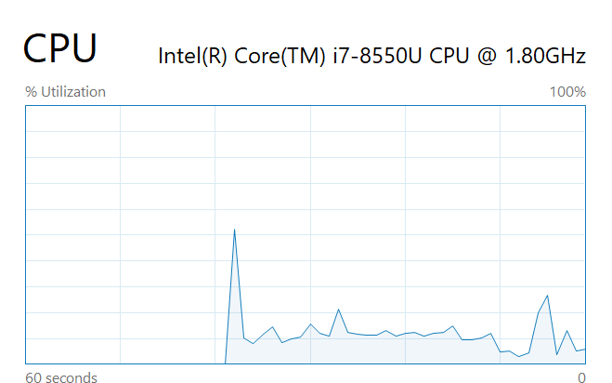
- Processor type and Speed: Intel (R) Core ™ i7-8550 CPU @ 1.80 Hz

- Number of Processor Cores:
- Socket: 1
- Cores: 4
- Logical: 8

- Is Virtualization Enabled: Yes/No
Yes

- What is Virtualization? (google it):
Virtualization: In computing terms, creating a virtual resource such a server, virtual computer or operating system

- Installed memory (RAM): 8 GB
Insert screenshot of your RAM here
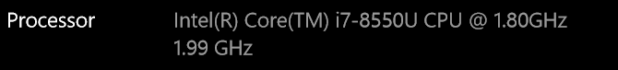

- Storage Capacity: 224 GB
- Storage Type(s): SSD
- What is the file system in Windows 10? (google it): New Technology File System
- Optical Drive: Yes/No
No
- What is an optical drive? (google it)

What computer use to read and process a DVD, blurry and CDs.

Insert screenshot of your Device manager here

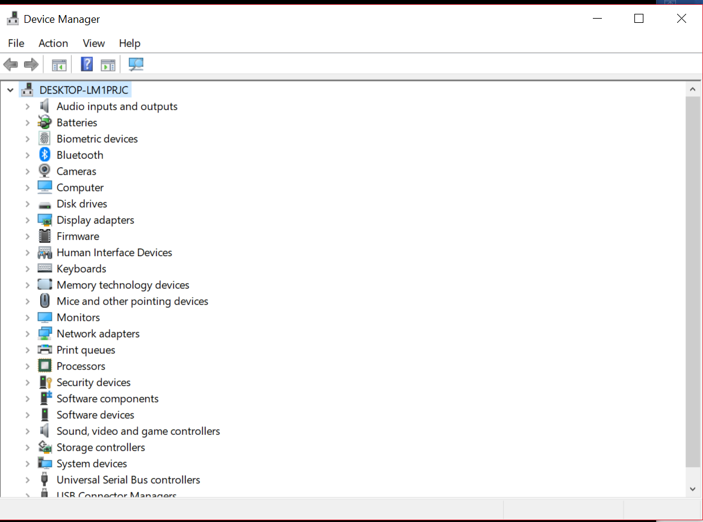
- USB Ports: USB type C How many: 3 Type: example: 2.0/3.0

- VGA Port: Yes/No
No
- HDMI Port: Yes/No
No
- Web Camera: Yes/No
Yes
- Ethernet port: Yes/No
no
- What is an Ethernet port? (google it)
Ethernet port is used to hard wire a laptop to the network via ethernet cables (aka Cat 5 / Cat 6 )

- Screen size: how do you measure your screen size? (google it)
Measure diagonally from corner to corner with a ruler or measuring table. My laptop’s screen size is 13.3 inches
- Miscellaneous – These are items/features that your laptop has but are not listed above:
- 10 hour battery life
- Turbo to 1.99 GHz

- Now that you have had your laptop for a while, what do you like about it? What do you dislike about it?
I like how fast it is and the thin bezels. It is also my first time have a i7 laptop and I love the speed. My laptop is only 8GB ram so it isn’t the exact power I require but it is doing the job

