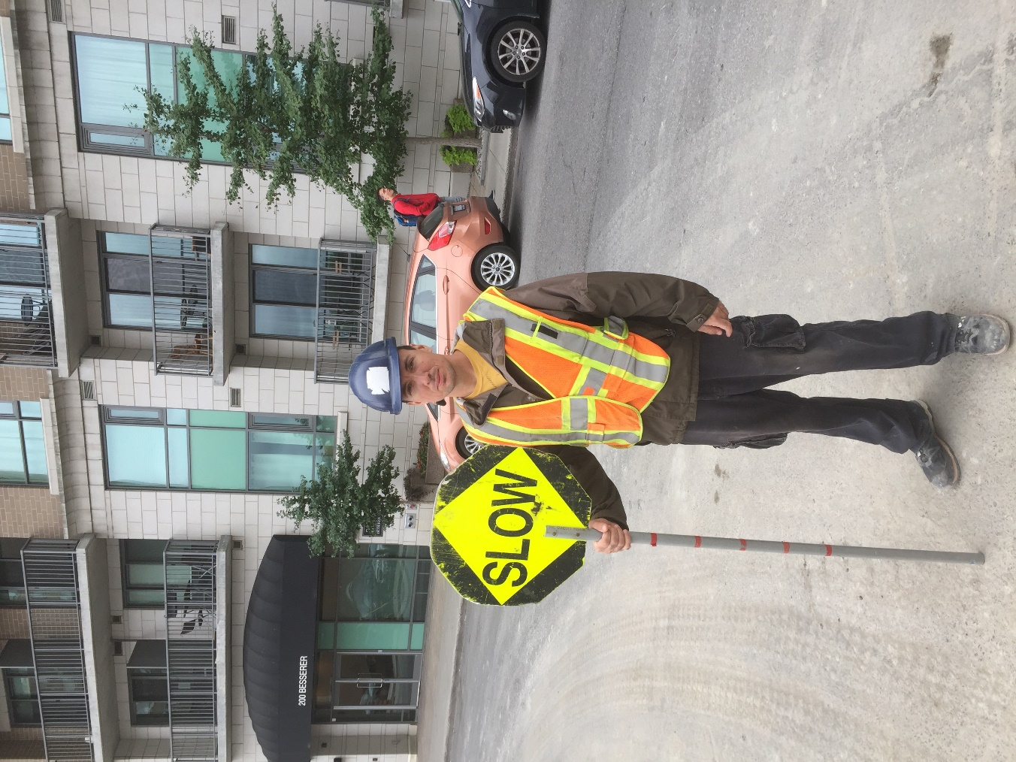
1st Picture (Construction Picture)
The Picture On the left signifies a business social interface. The man presented in the picture is holding a slow vehicle sign since Ottawa’s demographic’s and Ontario’s laws and federal laws have to be followed in any case the company on the left proves that these companies have to follow these set rules or there social interface will fall and cause the company to collapse.

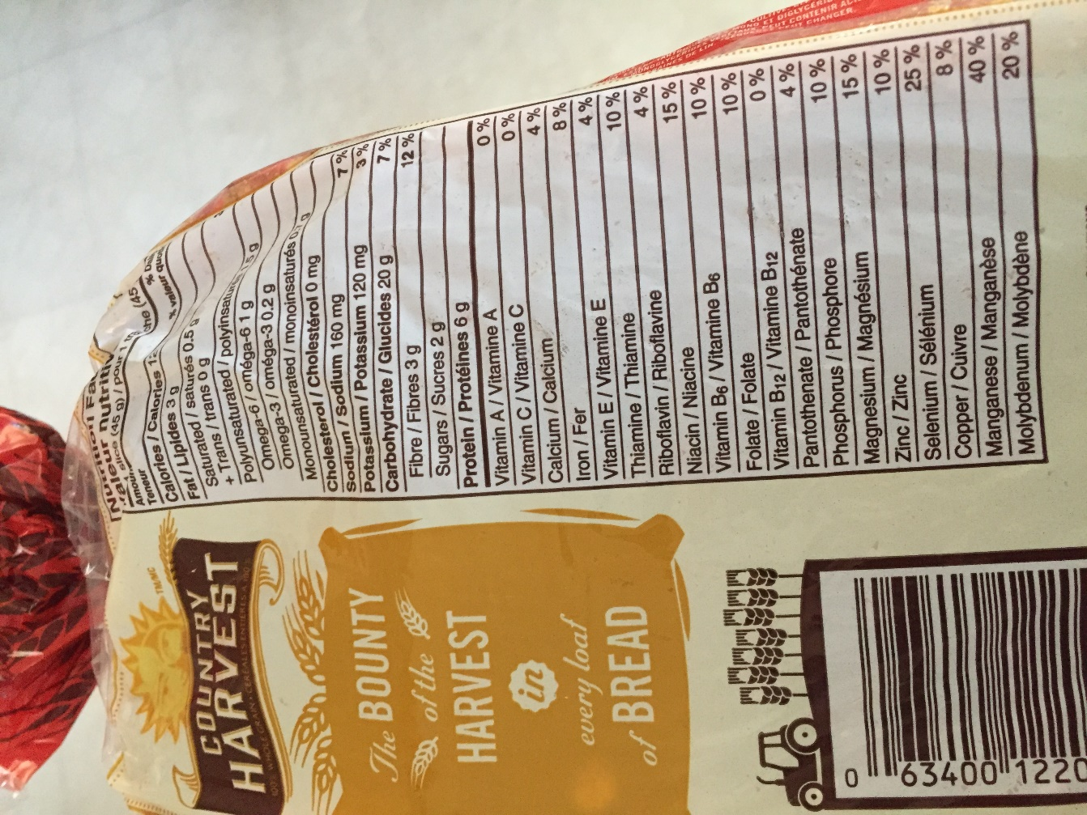
#2 (Nutrition Facts)
It is now law to keep a nutrition label on every food that you buy anywhere you go whether it be restaurants fast food places etc. This raises some economic issues as more and more people are moving away from fast foods and eating more healthier foods which lower fast food companies’ sales down the roof.

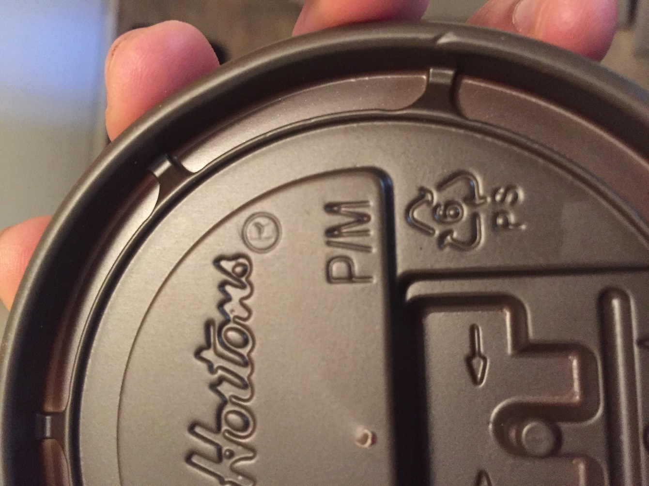
#3 (Tim Hortons Picture)
Due to globalization and peoples need to become more environmental friendly, companies have gone out of there way to create recyclable cups straws etc., this sudden turn over was caused by the sudden need for business’s to get green, if they didn’t they would dissolve into dust as people become more and more educated In the matters of the environment more and more companies like Tim Hortons create these cups to strengthen there global perspective.

