Lab#1
Verification of Boyle’s Law

Student Name #1: Zina Benazzouz
Student Number: 300025665

Student Name#2: Carol Graham
Student Number: 3786521

Demonstrator’s Name: Hana Dureckova

Lab Date: Tuesday September 12th, 2017
Due Date: Tuesday September 19th, 2017

Department of Chemistry
Faculty of Science
University of Ottawa

Introduction:
Robert Boyle (1627-1691) and his assistant Robert Hooke conducted an experiment where they used a J-tube to observe the relationship between pressure and volume. Robert Boyle and Robert Hooke were able to trap an amount of gas in the closed end of the j-tube and poured mercury through the open end of the tube, as they added more mercury they noticed that as the mercury was filling up the tube, the pressure was increasing while the volume of the gas was decreasing (4). This experiment is known as Boyle’s law and it shows the relationship between pressure and volume but the only condition is that there must be a constant temperature(T) and amount of gas (n). Additionally, we can describe this law as an inversely proportional relationship, this means that if we double the pressure it will reduce the volume by ½, and in the contrary by quadrupling the volume it will reduce the pressure by ¼ (3). Mathematically we can express this relationship as,
P ∝ 1/V or PV=k

Where P represents pressure, V represents Volume and k representing the constant (keeping in mind that different gases have different constants). If we were to examine the pressure and volume in two particular states and of course keeping in mind that temperature is constant Boyle’s law can be expressed as follows.

P1V1= P2V2 or P1/P2=V1/V2
As I mentioned before if the temperature is constant we will notice that as the pressure increases the volume decreases and vice versa and because of that these two variables create a hyperbola.
Real gases do not behave like ideal gases for two reasons. One reason is that there is some attraction between the molecules within a gas, and in ideal gases there is none. Additionally, gas particles are not all the same size, whereas in ideal gases, they are the same. (1)

The purpose of this lab is to observe the relationship between the pressure and volume of a gas.

Procedure:
Equipment:
- LabQuest 2
- Vernier Gas Pressure Sensor
- 20mL gas syringe
- USB stick
Methods: Please refer to lab manual (2)

Observations/Results:

It was observed that as the plunger was being moved away from the tip of the gas syringe, it became more difficult to push it to the next volume measurement. Once we had a measure at each interval, it was very easy to push the syringe back into place, except for the last four to five mL, when it again became difficult to move it back to its initial volume of 2.8mL. It was crucial for us to push it back to the 2.8mL point, so we could compare the two 2.80mL pressures and pick which one was more accurate.
Graph for Run #3
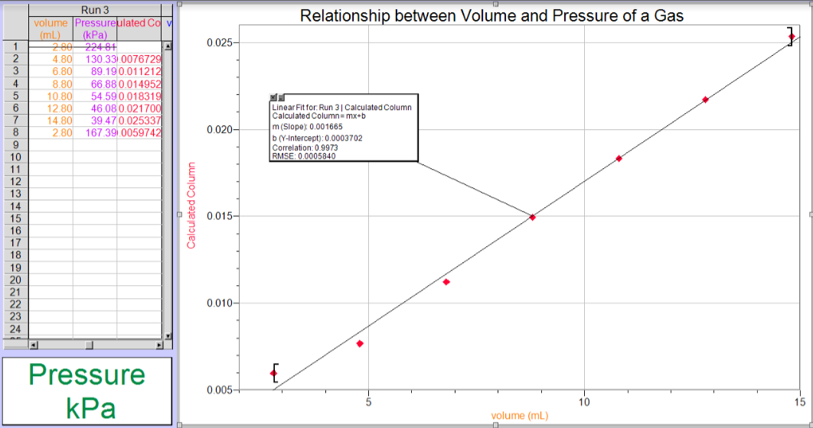
* In the graph, it shows that the slope is m=0.001665
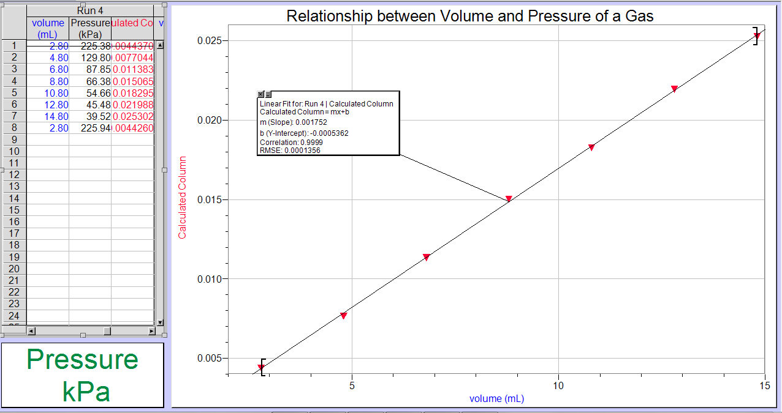
Graph for Run #4
*In the graph, it shows that the slope is m=0.00175
Data Tables

Volume vs Pressure (Trial #3)
Volume(mL) | Pressure(kPa)
2.80 | 167.39
4.80 | 130.33
6.80 | 89.19
8.80 | 66.88
10.80 | 54.59
12.80 | 46.08
14.80 | 39.47

Volume vs Pressure (Trial #4)
Volume (mL) | Pressure(kPa)
2.80 | 225.94
4.80 | 129.80
6.80 | 87.85
8.80 | 66.38
10.80 | 54.66
12.80 | 45.48
14.80 | 39.53

Calculations:

Volume(mL) | Average Pressure(kPa) | Calculated constant(k)
2.80 | Avg.= (trial 3+ trial4)/2  = (167.39+225.94)/2  = 196.665 | PV=K  = (196.665kPa) (2.80mL)  =551
4.80 | 130.065 | 624
6.80 | 88.520 | 602
8.80 | 66.630 | 586
10.80 | 54.625 | 590
12.80 | 45.780 | 586
14.80 | 39.500 | 585
Average K value= 551+624 + 602+586+590+586+585 /7
= 589
*Please refer to the tables above to see the values for pressure
Using our average data for trial #3 and #4 we can conclude that our overall equation is PV=589

Discussion:

By looking at the slopes from trial # 3 and #4 it’s evident that they are close but there is still an 8.5x10^-5 difference meaning there must have been some experimental sources of error including:
- Not reading the syringe properly causing volume to be a little above or below the target volume. It also became increasingly difficult to hold the syringe tightly enough. In this case, the syringe would slip slightly and this would affect the pressure measurement.
- Not attaching the pressure sensor tubing properly. Attaching too tightly will affect results but attaching it loosely may cause gas leakage making the whole experiment inconstant.

These sources of error could be avoided by having better sensors that could take a better reading of the pressure. Also, if my partner and I had a better understanding of the procedure and knew what to expect when using the syringe, our results would have been a lot more accurate. When we started the experiment, our first two trials were eliminated because we forgot to push the plunger back to 2.80mL so we could not find a more accurate pressure for that volume. By doing the experiment again, for trials #three and four, we were able to be more accurate than the first two trials, thus using those trials as they were correct. Furthermore, if we were mentally prepared for how difficult the pull of the plunger would be, we would have had more control over it. Lastly, if there is anything that can be done to improve this lab it will be to measure the room temperature through out the experiment, the temperature is supposed to be constant but if it increased or decreased slightly it would have changed the results because if the temperature changes the volume will also change effecting the pressure thus failing to prove the inversely proportional relationship between pressure and volume.

Conclusion:
In conclusion, the k-value turned out to be PV=589, the slopes obtained were 0.00179 for trial#3 and 0.001728 for trial # 4. These two slopes had a slight difference between them but there must have been an influence from the sources of error. Aside from that, Boyle’s law was indeed proven as the pressure and volume were inversely proportional. As seen from the graphs and the tables it’s clearly shown that as Volume increases the Pressure decreases.

References:

- Petrucci, Ralph H., et al. “General Chemistry: Principles and Modern Applications,” Saddle River, NJ: Prentice Hall, 2007.
- Dr. Rashmi Venkateswaran, “Verification of Boyle’s Law,” EXP.1, p.4, 2017
- Berry,George S.,Boyle’s Law,VOL 43,No23(1081)(1896), pp. 382-383
- https://www.youtube.com/watch?v=zUpoZ0QIOJY, Ben Church, Youtube

Carol Graham’s Raw Data

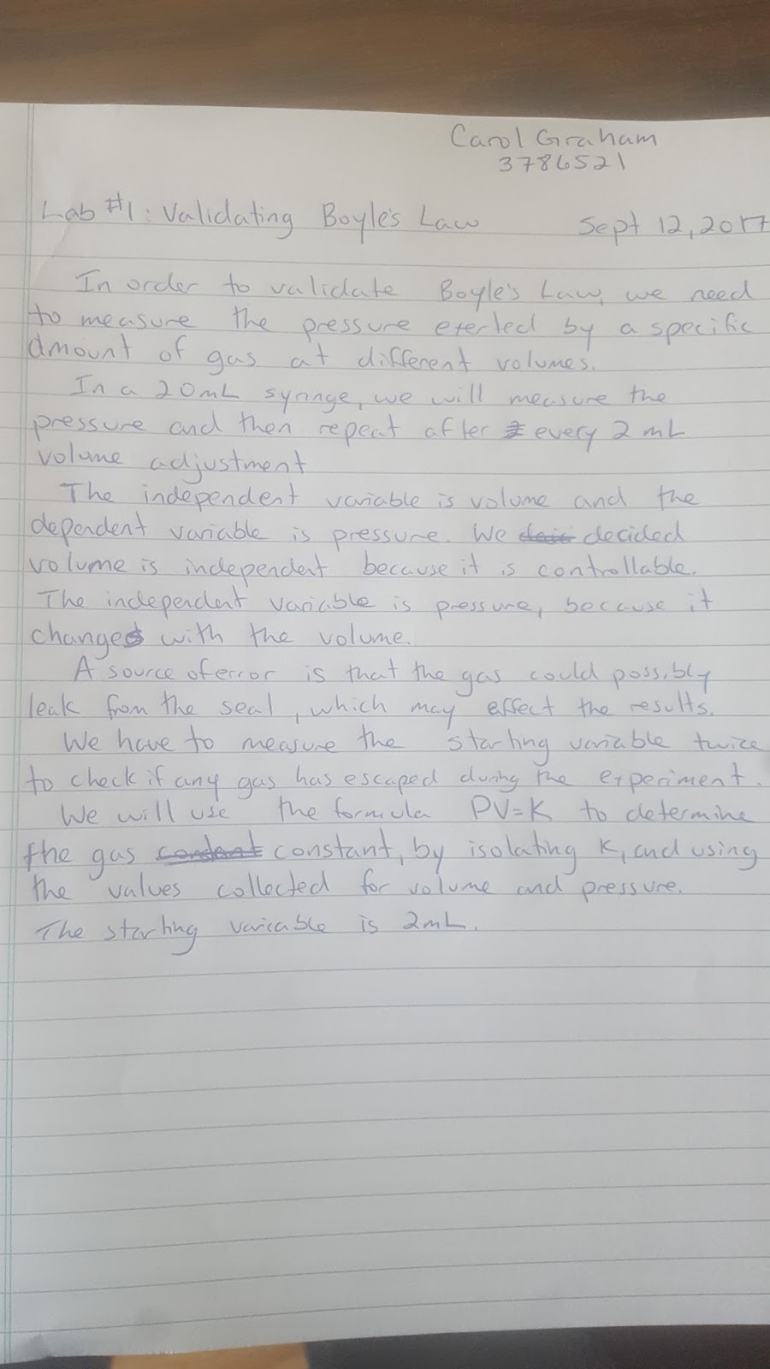

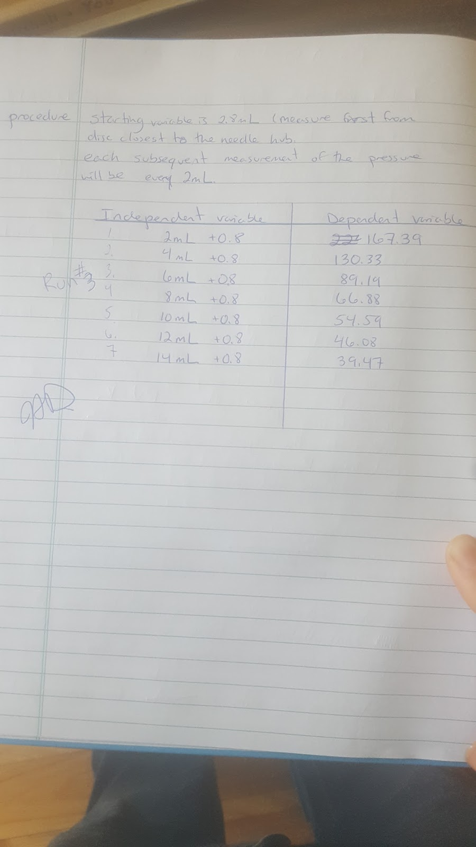

Zina Benazzouz’s Raw Data

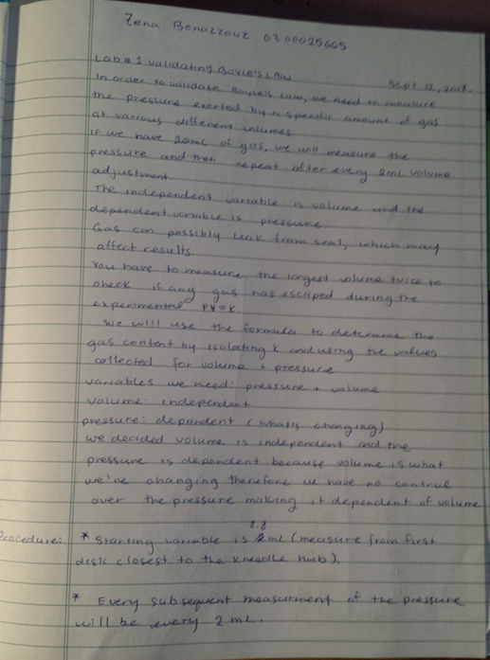

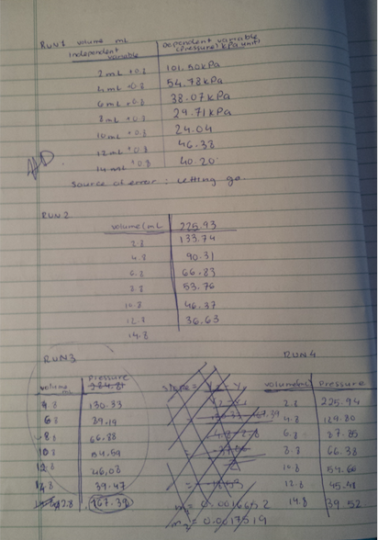

Peer Evaluation for Carol Graham and Zina Benazzouz
COURSE: _CHM1311-F TA Name: Hana Durekhova
YOUR NAME (PRINT): Zena Benazzouz and Carol Graham SIGNATURE:

CONFIDENTIAL PEER EVALUATION FORM FOR EXPERIMENT __1__
Each team member must submit one assessment. Teams may consist of 2-18 members.
You may edit this form.
Do not share or discuss the contents or possible contents of this assessment with others.

In assessing the work of your fellow team members, consider the following aspects:
- Quality of work • Ability to get along with others
- Contribution to the work as a whole • Improvements when asked to correct

Team member name | Comments | Grade
Carol Graham | During this lab, I found Carol to be very organized and prepared as she completed all her work and had a general understanding of what we were doing. We did have some difficult in the very beginning of the lab but slowly worked through our struggles and found the answers to what we were doing wrong. In the near future, I would advise us to start the lab report a little earlier as that will help reduce stress but other than that I thought she was very helpful throughout the lab/lab write up. | 4
Zina Benazzouz | Zina probably did a larger portion of the work. She really kept me motivated to do a good job and to finish in a timely fashion. She took the lead on the work, and I think we compliment each other’s strengths. | 4
A – Excellent (5) B: Great (4) C: Good (3) D: Fair(2) F: Poor (1)

Assessment Criteria for Planning the Boyle’s Law Investigation

Ta Name: | Hana  Dureckhova | Names of Students in Group: | - Carol Graham
- Zena
Benazzouz
 |  | Date: Sept 19th 2017
Criteria: | Marks Possible | Assessment  Self: | TA: Hana Dureckhova
Identify the problem and state it clearly in a way it can be tested. | 1 | 1
Use proper apparatus, techniques and safety precautions. | 1 | 1
Materials are easily available. | 1 | 1
Plan to vary only one independent variable at a time. | 1 | 1
Controls on other variables are clearly stated. | 1 | 1
Measurement errors are minimized by appropriate procedures or apparatus. | 1 | 1
The methods are clear enough to be followed by other students. | 1 | 1
No invalid assumptions are made. | 1 | 1
Reagents that need accurate measurement are identified. | 1 | 1
Lab trials are stated. | 1 | 1
Repeats are stated. | 1 | 1
Chemistry vocabulary used correctly. | 1 | 1
Limitations of the experimental design are described. | 1 | 1
Total: 13 |  | 13

