GEOG 220

Chapter 1, 2, 3

The evolution of human geography: Part 1

The beginnings

- Many geography books tell us that geography began with the Ancient Greeks
- But if we define geography as 1) an interest in knowing where we are 2) an interest describing the characteristics our world 3) a knowledge of who/what lies beyond our own world
- Then almost all early peoples (not only Europeans) were geographers

Example 1 of other geographers: Canada’s Aboriginal peoples

- Example: Map drawn in 1810 by a member of the Chipewyan people (for Hudson’s Bay employees)
- Important to illustrate that geographic skills were shared by all (both male and female)
- It is obvious that early peoples would have a good sense of the surroundings and the world around them in order to survive

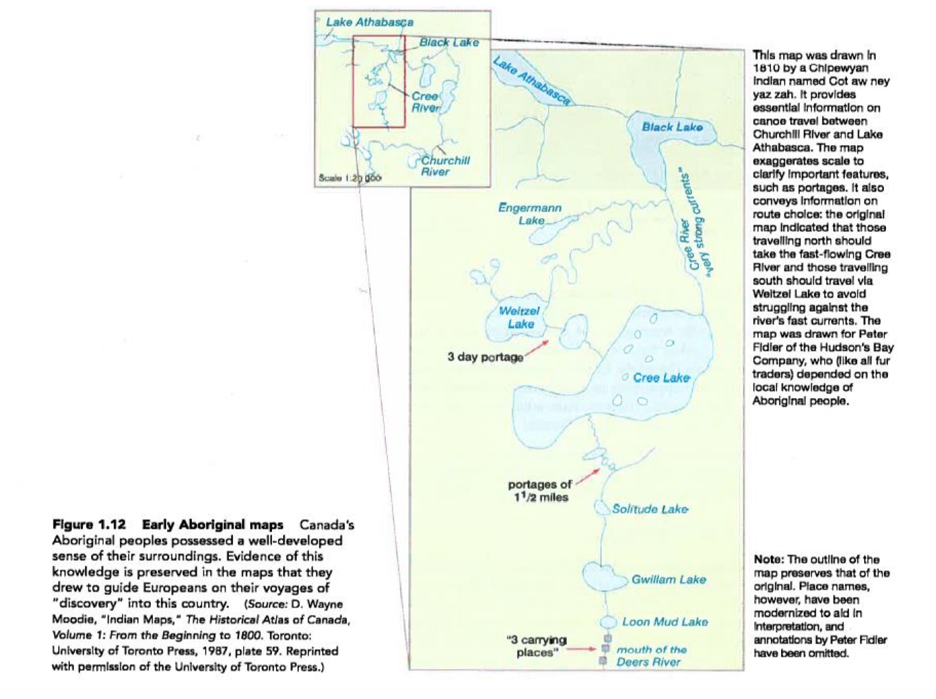

Example 2: The Inuit and their navigation abilities

- John MacDonald, The Arctic Sky: Inuit Astronomy, Star Lore and Legend (Iqaluit Inuit Research Institute; Toronto: Royal Ontario Museum, 2000)
- Snow drifts known as “Uqalurait” align themselves according to the prevailing wind’s direction
- Uqalurait: image that show tongue-shaped directional snowdrifts
- Remarking on the abilities of the Inuit woman Iligliuk, an early 19th Century secretary said: “To her alone is the merit due to the discovery of the extreme northern boundary of America”

Example 3: Polynesian star navigation
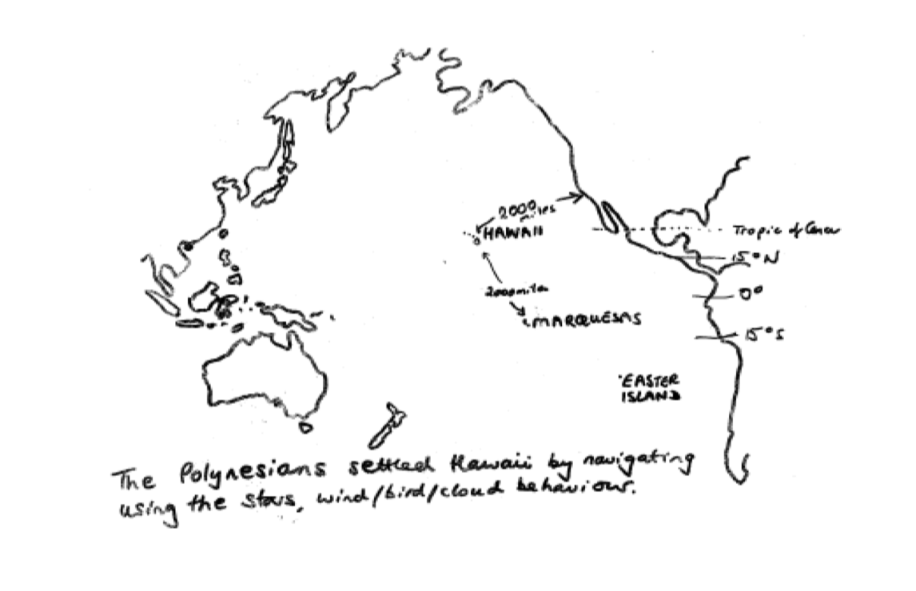

Finally – The Ancient Greeks

- Legend has it that the word “geography” was first coined by Eratosthenes (273-193BC)
- “ge” = the earth
- “grapho” = to describe
- The Greeks build on older Mesopotamian ideas

Two main geographic interests: Topographic description and Mathematical observations

- Topographical description

- “Topos” = Topographic? = A type of map
- Herodotus: the author of Histories in which he writes about the history of the Greeks’ conflict with the Persians and, in doing so, includes descriptions about the Mediterranean world

- Climate zones
- One of the results of this interest in regional description was the belief that the Earth is divided into 5 zones (FRIGID, TEMPERATE, OT, TEMPERAT, FRIGID) and only the TEMPERATE can support human life

- Mathematical and astronomical observations

- Belief that the earth is a sphere

- Eratosthenes (273-192 BC)
- Calculates the circumference of the world as 40,000 km
- Produces one of the earliest “maps” of the known world

- Ptolemy (90-168AD)
- Takes the ability to estimate latitude and longitude to calculate positions of places on a sphere of the size Eratosthenes calculated
- Ptolemy’s “Atlas” of the known world is based on his calculations – which assume that the world is circular (360 degrees)

*SEE MORE INFORMATION OF ERATOSTHENES AND PTOLEMY

Middle Ages

In Europe:

- Ancient Greek knowledge rejected in favour of medieval church’s view of the world:
- The T-O Map
- Known as the Mappae Mundi (=Maps of the world)
- The function was primarily to provide a visual narrative of Christian history cast in a geographical framework, not to communicate geographical or cosmological facts”
- Some even argue that the earth is flat
- Kosmas Indicopleustes argue it because the idea of a sphere implied perfection or eternity and he believed the Bible taught that the world would end

- Marco Polo (1254-1323)
- Venetian traveller who visits China
- His book dictated while in prison in Genoa describes his many adventures

In the Arab World:

- Developed a strong geographic tradition, built on the knowledge of the Ancient Greeks – which was preserved and built upon long after forgotten in W. Europe

- Ibn Batuta (1304-1368)
- Visits China and Africa
- Travels with a Tangerine: A Journey in the Footnotes of Ibn Battutah, by Tim Mackintosh-Smith

- Al-Idrisi (1100-1165)
- Born in Morocco
- Prepares world map for Roger II of Sicily (1097-1154)
- Was engraved on a silver disc for his palace in Palermo, Italy
- He follows Ptolemy but adds information from Arab and Norman knowledge

In China:

- From 2nd century BC to 1500s AD China was most advanced geographically
- Invention of the compass (first used in Feng-shui)
- Zhu Siben’s (1273-1377) map of China

The evolution of human geography: Part 2 and 3

The periods of “European Discoveries” from 1400-1500

Prince Henry the Navigator (early 1400s)

- Portugal
- End of the Middle Ages begins to see Western European voyages of discovery
- He enabled Portugal to become an early leader in exploration – helped Vasco da Gama to reach India (1497-98); Magellan to go round world 1521-1522

Christopher Columbus (1492)

- Discorvers America
- Important for Geography in Europe
- Copies of Ptolemy’s Atlas re-discovered in Istanbul, taken to Venice and translated from Arabic into Latin in 1410
- It is on calculations made by Ptolemy in this atlas (made 1400 years before) that Columbus bases his view of the world’s size

The need for a new world vision

- So much info was coming back and forth to Europe from all of the various voyages of exploration that newer ways of thinking about the world, of being geographers, was needed
- One answer was supplied by a new world map – that of Mercator (1569)

Mercator’s new map projection

- New developments such as his new world map projection allowed people to see the world – with almost all of its newfound lands (besides Australia)
- Mercator’s world map was specifically designed as a navigational chart of the world:
- It preserves the correct directional information between places and you can use the map to plot the compass bearing between places – these bearings will be straight lines between places but distorts a lot of areas especially around the poles

Baron Alexander von Humboldt (1769-1859)

- Important early nineteenth century geographer and wealthy explorer of S. America
- He wrote a multi-volume work of world geography called the Cosmos (published over 1845-1862)
- He developed an innovative method of organizing all of the material, that uses a comparative method, and has sometimes been called the ecological framework as it stressed the association between phenomena (rock, soil, plants, etc.)

Charles Darwin

- Replaced Humboldt’s ideas by Darwin’s more persuasive ideas on evolution which are presented in his book On the Origin of Species (1859)
- Darwin is NOT a geographer he is a biologist but he was an explorer and his ideas really influenced the 19th Century Geography
- The could not only account for where things were (the associations of phenomena that Humboldt described
- Explained how they were related – one type of association (an ecosystem, or even a region)
- But they also predicted how things (species, ecosystems could change or evolve into another)

Environmental Determinism 1

- Darwin’s ideas slowly transformed 19th Century geography but not in a good way
- The belief arose that:
- The environment always dictated/determined what happened
- Just as in nature, natural selection (survival of the fittest) which drove the process of evolution was an outcome of an organism’s suitability to the environment
- Same thing for humans…
- Environmental determinists stated that in very productive tropical environments, humans did not have to do much to survive and became lazy (so-called primitive). In colder environments, people had to work harder and became more inventive (advanced)

Refutation of it:

- It is logically flawed because human societies cannot be put on an evolutionary framework if they all exist today
- Based on a colonial, racist ideology that uses colonial categories of “race” which are biologically meaningless

Response/reaction/solution in regards to the weakness of environmental determinism:

- REGIONAL APPROACH
- Main components are Carl Ortwin Sauer and the idea of Cultural Landscape (Paul Vidal de la Blache 1845-1918 – p. 165)
- Over time, people and nature adapt to each other, like a snail and its shell
- The regional approach was therefore
- Inductive
- Historical
- Concerned with the unique
- Believed that the environment did not dictate but rather set some boundaries to what was possible and recognized the importance of human culture in providing solutions to environmental challenges

Broke down in 1950

- Too descriprive
- Impossible to teach anyone how to do it
- No longer “cutting edge” in a post-war era of computers, social science and academic disciplines involved in planning or in prediction of world events/phenomena
- Somehow geography needed to remake itself again

Environmental Determinism 2

- Geographers took Darwin’s ideas of:
- Natural evolution to mean that human societies (cultures or even regions) also could be seen as evolving and that human societies could be ranked according to their level of development (“primitive”, advanced”) that this justified the dominance of the advanced over the “primitive” (they were more evolved) and to predict that the primitive could eventually become advanced in the right circumstances and with the right help

Environmental Determinism 3

- These dangerous ideas were known as “Environmental Determinism” because it argued that people’s achievements were only to be explained as the consequences of natural conditions
- It is a fallacy known more broadly as a deterministic view

FAST FORWARD TO THE “NEW GEOGRAPHY” IN RESPONSE TO THE REGIONAL APPROACH

- The new geography dates from Fred K. Schaefer’s paper “Exceptionalism in geography” a methodological examination in the Annals of the American Association of Geographers
- His main point was that geography has to be conceived as the science concerned with the formulation of the laws governing the spatial distribution of certain features on the surface of the earth

New Geography breaks up: Part 1

- Begins to fall apart from the 1980s onwards as people find it too unengaged with real world problems
- Is replaced by more socially-relevant themes
- The geography of under-development and social inequality based on world system theory ideas
- The geography of gender based on ideas about how cultural constructions of gender also structure space for people
- See chapter 1 p.9 - Geographers at work

New Geography breaks up: Part 2

- This new direction becomes Postmodernism
- Rejects the rationality and science-based approach of spatial geography arguing that it didn’t work
- Rejects all over-arching theories including universalism
- Favours the study of the unique and the local (so the study of place as unique phenomena, and of “space” as subjective constructions, are rekindled in the study of geography)
- Since 2002, there has been favour for one’s own feelings and reactions

To observe for the past lectures:

- There have been so many changes in the history of human geography
- It wasn’t possible to stay with one framework/theory about the world

The fundamental concepts of geography: Part 1 and 2

In the textbook

- Chapter 1
- Pay attention to:
- Why place matters (p.4-8)
- Basic tools of human geographers (p.8-11)
- Maps (p.11-17)
- Spatial analysis (p.17-24)
- Regional analysis (p.24-29)

*KUHN?

8 fundamental concepts – the importance of the concepts have varied over the history of geography’s development

- Location
- Distance
- Space
- Accessibility
- Spatial interaction
- Scale
- Region
- Place

Location

- Absolute (i.e. latitude and longitude)
- Absolute location can be measured today by using GPS information
- In middle ages, European navigators relied on instruments such as the astrolabe – Champlain’s astrolabe:
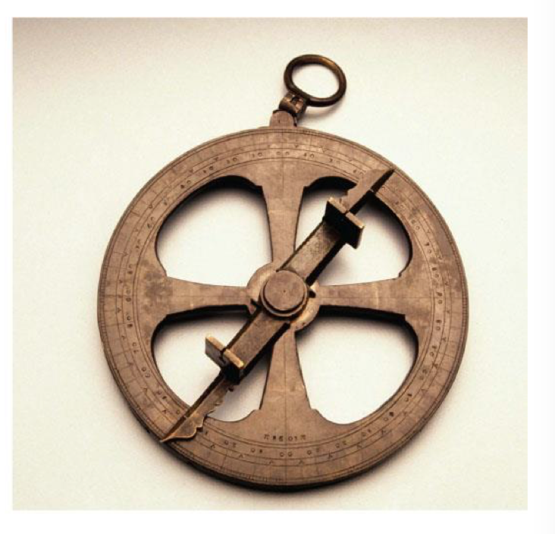

- Latitude was easy to fix because you could use height of the sun (that’s what the astrolabe does)
- Longitude was much harder by the 18th Century, European navigators were experimenting with astronomical phenomena such as the “Transit of Venus” (which is why Captain Cook was sent to Hawaii)

- Relative (i.e. “near the #24 bus stop”)
- Cognitive (where a place seems to be on a mental map – you use your head to deduct something)
- Example: “To learn one’s longitude at sea, one needs to know what time it is aboard ship, and also at the home port…at that same moment” … “the two clock times enable the navigator to convert the hour difference into a geographical separation” – Dava Sobel, Longitude

Distance

- Absolute (measure in km)
- Relative (measured in time)
- Cognitive distance (how far it seems to us)

- Most important thing to note is that the effects of distance almost always mean that the influence or the importance of a centre diminishes as we get further away from it
- Usually, that influence will diminish rapidly at first, and then more slowly the further we get away from the centre of influence
- Importance was described by Waldo Tobler as “the first law of geography” which he stated as: “Everything is related to everything else, but near things are more related than distant things”

Space

- Absolute

- A view that sees space as a “geometric container”, mathematically defined – an area defined by longitude and latitude

- Relative

- A view that sees space as malleable, changeable
- In socio-cultural space, the countries of the “West” are all found close together irrespective of their absolute location
- In economic space, the “North-South” divide serves as another relative measure of where a country is
- Henri Lefebvre states that there are 3 main processes by which space is socially constructed
- Spatial practice: different economic systems construct space differently so capitalism creates a market in land that create geographic inequalities across countries/cities
- Representations of Space: how power is inscribed in space i.e. municipal zoning regulations
- Representational spaces: the role of spatial allusions in art or language

- Cognitive

- A view that sees space in terms of people’s beliefs, values or perceptions
- Ex: Mental map which shows people’s like and dislikes
- Where would you most/least like to go on holiday?
- Where would you most/least like to retire?
- We are trying to use an individual’s own subjective experience to try and make some more general statements about a group’s perceptions
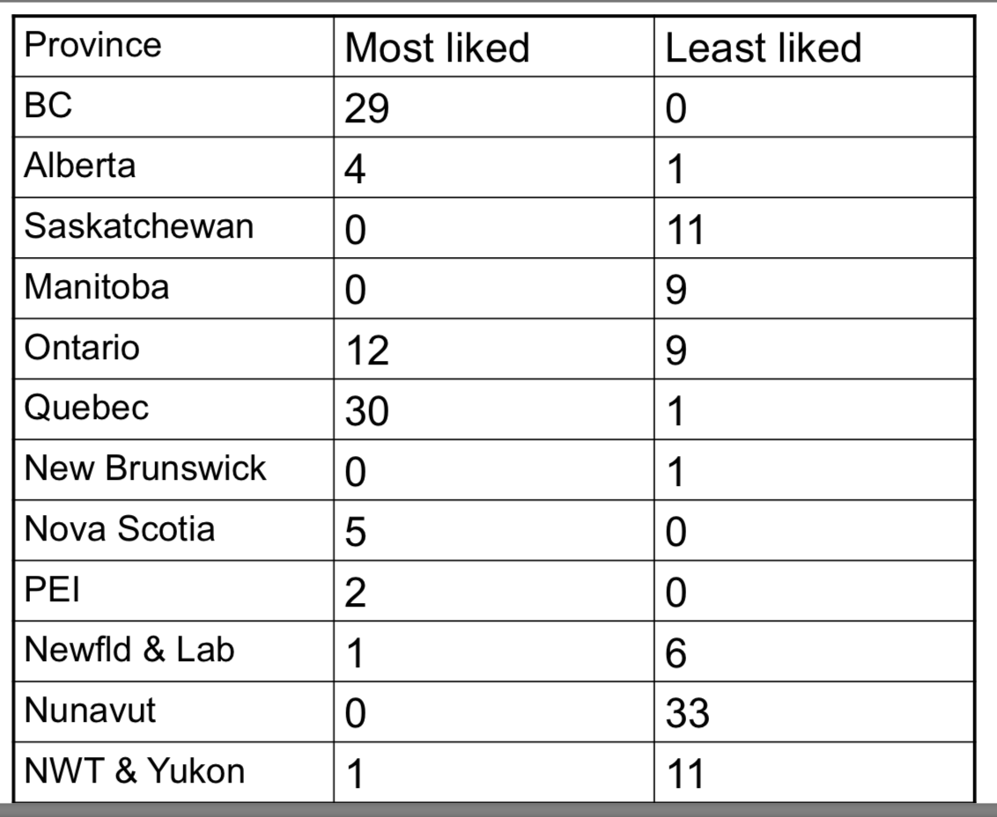

Accessibility

- Defined as the opportunity for contact or interaction from a given point or location in relation to other locations
- Effective accessibility is not only a product of distance but also the connectivity of networks of communication

Spatial Interaction

- Geographers use the term spatial interaction as a shorthand for all kinds of movement and flows involving human activity
- Term is divided into 4 categories
- Complementarity: i.e. can we meet the needs of one place with the products of another?
- Transferability: i.e. can we move that product?
- Intervening opportunities: i.e. can we sell that product to an intervening place?

DIFFUSION IS PART OF THIS BUT IT IS THE MOST IMPORTANT PART AND HAS MANY COMPONENTS!!!!

- Spatial diffusion: defined as the way that things spread through time and over space
- The things that spread can be objects either visible (plants or people) or invisible (viruses) or intangible things (ideas, innovations, fashions, news)
- As these “things” (phenomena) spread, so they alter the places they spread to, and are themselves altered as they move
- Geography was concerned with the spread of phenomena (things, people, ideas, diseases) over space from region to region, place to place which is what geographers call DIFFUSION – and the study of that spread’s consequences (as examples of cultural diffusion, disease diffusion)
- There are a couple main types of spatial diffusion:
- Relocation diffusion
- The simple spread of a physical object from place to place
- Could be something highly valued such as a spice in the Middle Ages traded all the way from the Far East to Europe
- Could even be people themselves (migration is a special case)
- Expansion diffusion
- Most phenomena in a rural society spread this way
- We are looking at something that spreads out from a place, while leaving a trace of itself in that original place so in a sense it moves out like a wave across space)
- Example: Cholera in the 19th Century
- The Cholera spread by simple contagious diffusion in 1832 & 1849, but by 1866 it began to spread hierarchically
- A hierarchical diffusion is how most phenomena in a modern urban society spreads
- It is the flow of information “down” an urban hierarchy from city to town to village so it is important to know that a diffusion can occur more quickly through the urban hierarchy than across simple space itself

*SEE WHAT ELSE THERE IS TO KNOW ABOUT DIFFUSION IN DETAIL

Scale

- Scale has 2 different sets of implications for geographers:
- A map scale – the ratio between linear distance on a map and linear distance on the Earth’s surface
- The concept that there are various levels of scales of analysis (local, regional, national, global), that they are linked, and that the processes operating at one scale can have significance at other scales
- Can be global, national, regional, local

Region

- The concept Region is defined as a larger sized territory that encompasses many places, all or most of which share similar attributes in comparison with the attributes of places elsewhere
- The definition is based on 4 points:

- The idea of region is used to distinguish a region from another
- Regions are distinguished on the basis of specific characteristics
- Regions minimize the variation of the chosen characteristic within their boundaries, and maximize the variation of that characteristic across their boundaries
- Regions can be defined on the basis of any characteristic, or group of characteristics

Place

- Place is defined as a concept with two levels of meaning:
- An objective location that has both uniqueness and interdependence with other places
- A subjective social and cultural construct – somewhere that has personal meaning for individuals or groups
- It is a subjective concept because places can be personal constructs which means each of us has a different take on place
- Because of personal views, we can imagine different cultures’ views of place and there can even be non-places
- PLACE DIFFERS FROM SPACE! – think of Yi-Fu Tuan’s quote – “Place is space filled with meaning”
- Place-making: any activity that enables place to acquire meaning so it could be a shopping mall a restaurant a theme park

World System theory & Population seen through World system lens

In the textbook:

- Chapter 2 “The Changing Global Context” – Pages 36-71
- Chapter 3 “Population Geography” – Pages 72-111

World system theory

- Was first developed by the American economic historian Immanuel Wallerstein
- Def: An Interdependent system of countries linked by economic and political competition

- It tells us that the world is structured into a series of spaces:

The core, periphery and semi-periphery (p.48)

- The core: regions that dominate trade, control technology, have high productivity within diversified economies

- The periphery: regions with dependent and disadvantageous trading relationships, obsolete technologies and undeveloped economy with low productivity

- The semi-periphery: regions that are able to exploit peripheral regions but are themselves exploited and dominated by core regions

- The core and the periphery are co-dependent à

- The periphery creates the core
- The core creates the periphery
- Both depend on each other to exist and neither can do without the other
- The core actively undevelops the periphery and the periphery cannot become more developed than the core

- These spaces are nested

- The core-periphery can be “nested” at a global national or regional level
- You can be core at one level and periphery at a next
- At each scale level, the core-periphery processes will create geographical inequalities

- They interact and create each other

A simplified model of the world system:

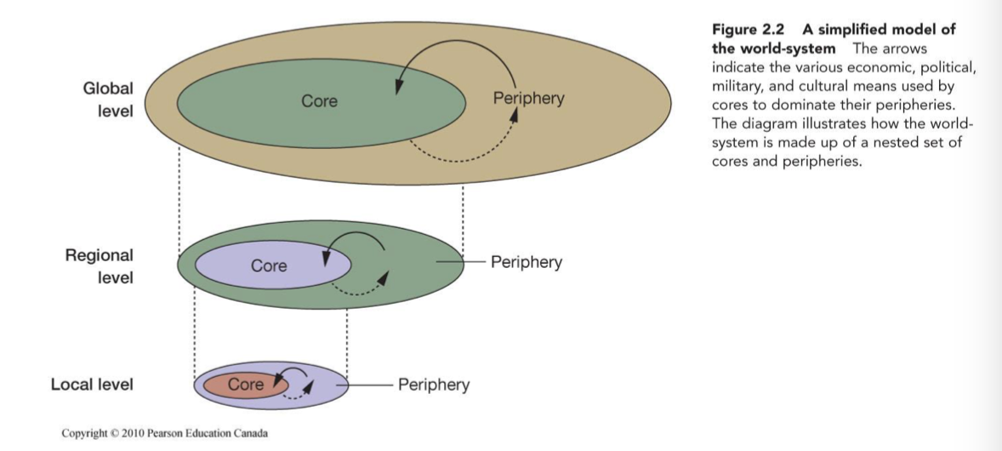

Our World System (the reality):

- Began in the 1400s with the European expansion
- This was not an accident, Wallerstein says it is because of 2 factors in Western Europe
- Economic growth
- Political change

In Canada (see p. 51-52)

- Canada is both core and periphery
- It has been exploited by colonial/imperial powers such as Britain and the US
- Canada also exploits other countries
- Canadian banks in the Caribbean
- Canadian mining and oil companies operating overseas

Key processes that enable the world system to maintain its control and to continue in the future

Hegemony (p.51):

- Domination over the world economy, exercised by one national state in a particular historical period of time through a combination of economic, military, financial aid and cultural means

Globalization (p.56):

- The increasing interconnectedness of different parts of the world through common processes of economic, environmental, political and cultural change
- It’s the continued operation of the world-system model into the present

The core perpetuates itself and and continues to dominate the periphery over time

- Economically

- Core uses periphery for
- Cheap labour
- Cheap materials or resources
- A large market
- Core keeps profits made in the periphery
- Core eliminates industries in the periphery
- Ex: Commodity Chains (p.58-59)

- Result: see pages 62-63

- Politically
- The core intervenes in the periphery direct or covert military action
- The core maintains colonial ties (i.e. La Francophonie, Commonwealth)
- Core keeps periphery in a dependent relationship (i.e. overseas aid)
- Core keeps control of world bodies (i.e. UN, World Trade Organization)

- Culturally

- The core establishes itself as the “cultural leader” in popular and mass culture

- Post-colonialism: a set of artistic and political approaches that examine the consequence of the end of colonialism

- Western and Cultural Imperialism (i.e. use of the internet)

- The Subaltern theory:

- Theory that examines the way the colonized margin is culturally dominated by the colonizing centre
- Most important way through the use of the language of the colonizer himself (either English, French, Spanish)
- Another way is through ideas
- The solution is to examine the centre from the periphery through the periphery’s own terms

Population

- World population pattern can be divided into the core and the periphery divisions of the world
- The explanation for the broad patterns of difference between the core and the periphery can be found in the ideas of the Demographic Transition Theory

Demographic Transition Theory (p.89-91)

- It is the replacement of high birth rates and high death rates by low birth rates and low death rates
- See graphs for this

The 4 stages of the DT model

Phase 1: Pre-Industrial:

- High birth rates, high death rates (35/1000)
- Large families, low life expectancies, zero total population growth

Phase 2: Transitional

- High birth rates, declining death rates
- Total population growth is highest

Phase 3: Transitional**********

- Declining birth rates, low death rates, total population growth still strong but not as fast or high as in phase 2

Phase 4: Industrial

- Low birth rates, low death rates (15/1000)
- Small families, high life expectancies, zero growth

Why does transition occur? (There are numerous explanations)

- The death rates fall first so simple sanitation is important
- Most suggest that people realize that they don’t need so many children to help them on the farm, to support their old age and to compensate for high rates of infant mortality of pre-industrial society
- The major causes for this are:
- Industrialization (provides more work off the farm)
- Urbanization
- Modernization (changing attitudes towards childbearing, contraception)
- Social programs like pensions and health care are created

The second transition that occurs in core: “baby boom” and then “aging” (p.82-84 for Canadian example)

- After explain the Demographic transition we need to explain the baby boom:
- In many western countries, the birth rate was higher than in current developing countries
- This birth rate increase was followed by a very rapid decline called the “baby bust”
- The result of this is that in many western countries now, we have below replacement fertility levels and “aging” societies

Disparities

- We know from the World System Model that disparities in life-opportunities exist at many scales (global, regional, intra-urban)
- Canada in terms of life expectancy rates provide a good example of this (see pages 106-108 for the Geography of Canadian Health)
- Disparities between core and periphery drive migration flows

Migration

- Caused by “push” and “pull” factors and can be divided into “voluntary” and involuntary” types (p.91-101)

- Voluntary:

- Canadian immigration is comprised of a considerable flow of voluntary migrants
- There have arrived under Canada’s various Family Reunification and Selected Work Economic Programs

- Involuntary:

- Slave trade (historical example)
- Internally displaced people (Indigenous groups?)
- Political refugee movements defined as those fleeing a fear of repression in their country (based on race, religion, nationality, politics, social group)
- Environmental refugees

END OF CHAPTER 1, 2, 3

Chapter 4

Ecological Imperialism – October 3rd 2018

In the textbook:

- Pages 128-133 (“European Expansion and Globalization”)

Ex on this effect:

Antigua
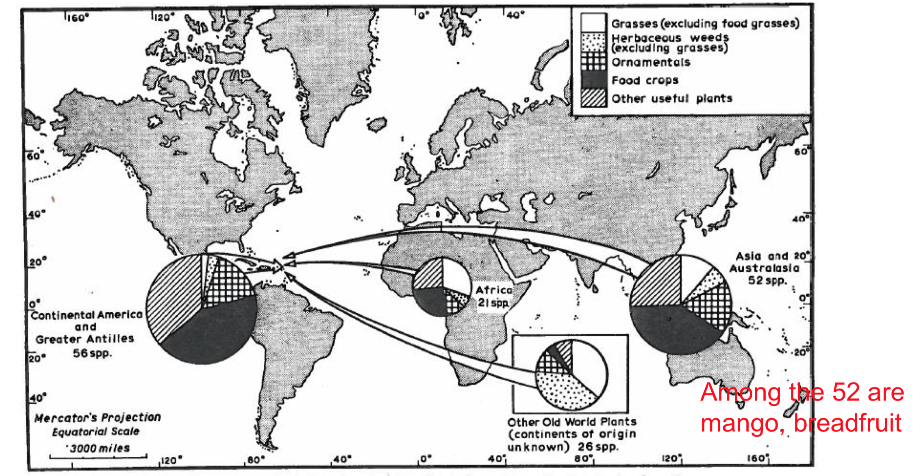

Columbian exchange:
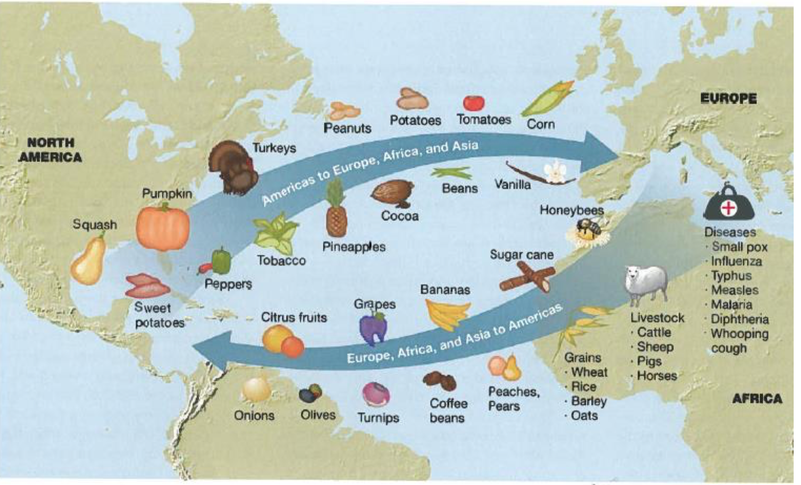

Humans have had a long history with plants & animals

- They were involved in the manipulation of plants and animals with the process of domestication (10,000 years ago)
- Wheat, sheep, goats in the Middle East
- Pigs, rice in China
- Maize, guinea pig, in South and Central America

- Plants and their products were traded long distances in the medieval period
- Spices
- Sugar cane

The Columbian exchange

- Crosby uses the term Columbian Exchange to deal with the movement of plants and animals across the Atlantic, following the travels of Columbus (who discovered the US Virgin Islands)

Breadfruit

- From Tahiti to saint Vincent in the Caribbean where it was put into the botanic garden
- British who were running slave plantations

