Experiment 2: A Tall Cold Drink of Water¹
Prelab Exercise
(to be done INDIVIDUALLY BEFORE coming to lab; can be revised in group)
- Give a complete definition for each of the following enthalpy changes. In each case, please include an equation that represents the process to which the enthalpy change applies:
  - Enthalpy of dissolution of the ionic compound X⁺Y⁻
X⁺Y⁻_{(s)} + water -> X⁺_{(aq)} + Y⁻_{(aq)}
  - Lattice energy of the ionic compound X⁺Y⁻
X⁺_{(g)} + Y⁻_{(g)} -> X⁺Y⁻_{(s)}
  - Enthalpy of hydration of the gaseous ion Z⁺ (g)
Z⁺_{(g)} -> Z⁺_{(aq)}

- Explain how the above three enthalpy changes are related. Use a diagram to explain if appropriate.
To dissolve a salt 2 factors must be taken into consideration. 1 is the energy required to vaporize 1mol of the salt to form gaseous ion, which is the lattice energy. And 2 is the energy released when 1mol of gaseous ions is solvated by water to form aqueous ions, which is hydration energy. These together sum up to enthalpy of solution.

- The enthalpy of solution of an ionic compound can be calculated from its lattice enthalpy and the enthalpies of hydration of the individual ions. Use the information shown below to calculate:
  - The enthalpy of solution of solid ammonium chloride
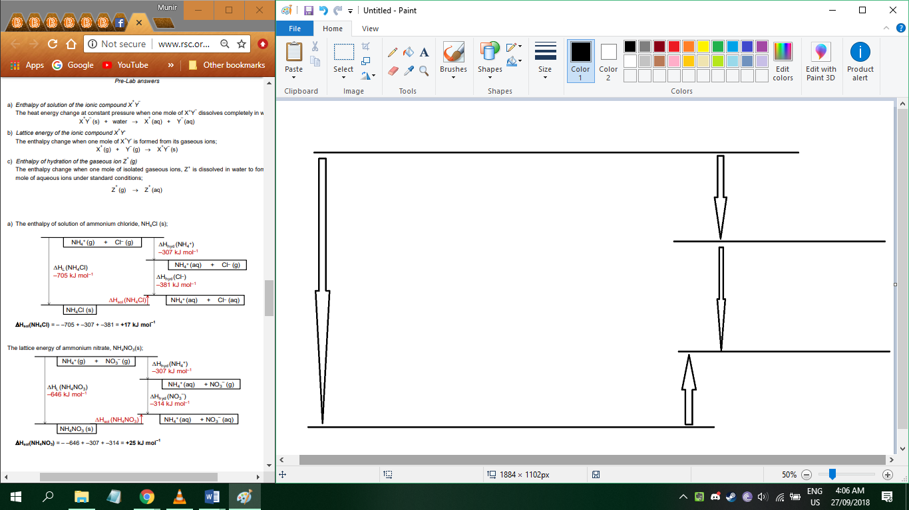
∆H_{hyd} (NH₄⁺)
-307 kJ mol⁻¹
NH₄⁺_{(g)} + Cl⁻_{(g)}

∆H_{L} (NH₄Cl)
705 kJ mol⁻¹
NH₄⁺_{(aq)} + Cl⁻_{(g)}

∆H_{hyd} (Cl⁻)
-381 kJ mol⁻¹

NH₄⁺_{(aq)} + Cl⁻_{(aq)}

NH₄ Cl_{(s)}

∆H_{sol}(NH₄Cl) = - 705 + - 307 + -381 = +17 kJ mol⁻¹

  - The enthalpy of solution of solid ammonium nitrate
∆H_{hyd} (NH₄⁺)
-307 kJ mol⁻¹
NH₄⁺_{(g)} + NO₃⁻_{(g)}

∆H_{L} (NH₄ NO₃)
646 kJ mol⁻¹
NH₄⁺_{(aq)} + Cl⁻_{(g)}

∆H_{hyd} (NO₃⁻)
-314 kJ mol⁻¹

NH₄⁺_{(aq)} + NO₃⁻_{(aq)}

NH₄NO_{3(s)}
ΔH_{sol}(NH₄NO₃) = – 646 + –307 + –314 = +25 kJ mol^{–1}

Quantity | Enthalpy Change (kJ/mol)
Lattice energy of solid ammonium chloride | 705
Lattice energy of solid ammonium nitrate | 646
Enthalpy of hydration of the gaseous ammonium ion | -307
Enthalpy of hydration of the gaseous chloride ion | -381
Enthalpy of hydration of the gaseous nitrate ion | -314


- *In 2001, Nescafe launched a self-heating can of coffee, called Hot When You Want. To heat up the coffee, a button was pressed which mixed the heating ingredients in a shell outside the can containing the coffee. The can warmed up 210 cm³ of coffee by 40 °C. A single step mixed calcium oxide and water to produce calcium hydroxide and generate heat according to the reaction:
CaO (s) + H₂O (l) → Ca(OH)₂ (aq) ΔH = -82 kJ/mol
a) Assuming that the heat capacity for coffee is the same as that of water, 4.18 Jg⁻¹K⁻¹, calculate the energy needed to warm 210 cm³ of coffee by 40 °C.
40°C = 313K $Q=210g ×4.18 Jg^{-1}K^{-1}×313K=274751.4J=274.7514kJ$
b) Use this value to hence calculate the minimum mass of CaO in the can for it to function as specified.

1mol of CaO produces 82 kJ of energy
# mols of CaO to react to heat the can = 274.7514kJ ÷ 82 kJmol^{–1} = 3.4mols
Mass of 3.4mols of CaO (M, 56.1gmol^{–1}) = 3.4mols × 56.1gmol^{–1} = 188g

