International Business Final
10 questions = 50%

- What is culture? What are the determinants of culture?
The collective programming of the mind which distinguishes the members of one human group from another (Geert Hostede). That complex whole which includes knowledge, belief, art, morals, law, custom and other capabilities acquired by man as member of society. Multinational and cross-cultural teams are likewise becoming ever more common, meaning businesses can benefit from an increasingly diverse knowledge base and new, insightful approaches to business problems. However, along with the benefits of insight and expertise, global organizations also face potential stumbling blocks when it comes to culture and international business.

Determinants of culture:
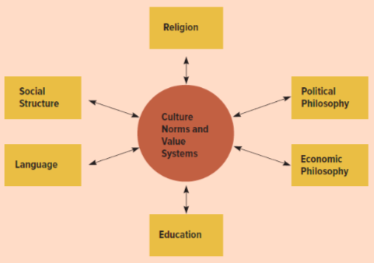

- What are the different trade policy instruments?
Tariffs:
- Increase government revenues
- Force consumers to pay more for certain imports
Subsidies:
- Government payment to a domestic producer in order to encourage the production of goods and services (Cash grants, Low interest loans, tax breaks)
Impot quotas and voluntary export restraints:
- Restricting the quantity of some good that may be imported into a country (Quota rent & Tariffs rate quotas)
Local content requirements:
- Requires some specific fraction of a good to be produced domestically
- Developed countries beginning to implement
Antidumping policies:
- Selling goods in a foreign market below teir costs of production, or selling goods in a foreign market below their (fair) market value.
- What are the both inward and outward FDI encouraging policies?

Home country policies: Encouraging outward FDI (investir dans d’autre pays):

- Government backed insurance program: Type of risks (expropriation, war losses & Inability to transfert profit home.
- Eliminated double taxation of foreing income: Taxation of income in both the host country and the home country
- Capital assistance: Several advanced countries also have special duns or banks that make government loans to firm wishing to investin developing countries
- Political preassure: Used their political influence to persuade host countries to relax their political influence

Host country policies: Encouraging inward FDI (investir dans notre pays):

- Government offer incentive to foreign firms to invest in their country (Tax concession, Low interest loans, Grants or subsidies)

- Why is foreign currency market important for international business? Define fixed and flexible exchange rate regime. Explain in detail the advantages of each regime.

Foreign Exchange market:
It’s a market for converting the currency of one country into that of another country.
The foreign exchange market has two main functions:
- To convert the currency of one country into the currency of another.
- To provide some insurance against foreign exchange risk.

Flexible:
- Monetary policy autonomy: A country’s ability to expand or contract its money supply as it sees fit is limited by the need to maintain exchange rate parity.
- Trade balance adjustments: If a country developed a permanent deficit in its balance of trade (importing more than exported), that could not be corrected by domestic policy, the IMF would have to agree to a currency devaluation.

Fixed:
- Monetary discipline: The need to maintain a fixed exchange rate parity ensures that government do not expand their money supplies at inflationary rates.
- Speculation: Causes fluctuation in exchange rates and trends. It has destabilizing tendencies which distort export and import pricing.
- Uncertainty: Country are less likely to invest in uncertain market do to volatility exchange rates because international business do not know how to react to the changes.

- What is international capital market? Who are the players and what is their role in globalisation?

A capital market is basically a system in which people, companies, and governments with an excess of funds transfer those funds to people, companies, and governments that have a shortage of funds. This transfer mechanism provides an efficient way for those who wish to borrow or invest money to do so. For example, every time someone takes out a loan to buy a car or a house, they are accessing the capital markets. Capital markets carry out the desirable economic function of directing capital to productive uses.

PLAYERS: Governments, businesses, and people that save some portion of their income invest their money in capital markets such as stocks and bonds, Banks

Roles: Two ways:
Debt: is money that’s borrowed and must be repaid
Equity: is money that is invested in return for a percentage of ownership but is not guaranteed in terms of repayment.

- What was the arrangement of nominal exchange rate under Bretton Woods System? How did it expect to manage the bank run? Was it successful?

After world war 2, The new monetary system was hoped to foster full employment and price stability while allowing countries to attain external balance without restrictions on international trade . Named Bretton Woods cause that was the location where 44 countries meet to fix exchange rate policied by the International monetary found (IMF) and the World bank (help less develop countries grown). All countries were ensure to a foreign exchange rate system, prevent competitive devaluation and promote economics growth. Only dollar remained convertible to gold. They manage the bank run with the international monetary fund(IMF) and World bank. The IMF was created to monitor exchange rates and lend reserve currencies to nations. The World bank was set up to provide financial assistance for countries during the reconstruction post World War 1 phase.

Successful? Everything worked well until the late 1960s… the U.S. dollar's fixed value against gold, under the Bretton Woods system of fixed exchange rates, was seen as overvalued. A sizable increase in domestic spending on President Lyndon Johnson's Great Society programs and a rise in military spending caused by the Vietnam War gradually worsened the overvaluation of the dollar. This system was successful during 27 years (1944 - 1971)

- How is exchange rate between two currencies defined(1)? What is the law of one price(2)? What is purchasing power parity (PPP)(3)? If PPP holds, how is exchange rate—price of Euro in terms of Canadian dollar—determined? What happens to the value of Canadian dollar vis-a- vis Euro if Canada’s money supply rises faster than that of the EU? (319...)
- Purchasing power parity(PPP)

- Law of one price: States that in competitive markets free of transportation costs and barriers to trade (tariffs), identical products sold in different countries must sell at the same price when their prices is expressed in the same currency. (Un iphone vendu au Canada ou en chine, il vaut le meme prix)

- PPP: Exchange rate between two currencies is defined by PPP purchasing power parity. If the law of one price were true for all goods and services, the PPP exchange rate could be found from any individual set of prices. By comparing the prices of identical products in different currencies, it would be possible to determine the real or PPP exchange rate that would exist if markets were efficient.
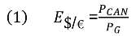
***The price divided by the price of the other currencies egal = exchange rate
Reasons why PPP may not be accurate: the law of one price may not hold because of
1.Trade barriers and non-tradable products
2.Imperfect competition
3.Differences in measures of

- What is real exchange rate (RER)? Show the formula for the calculation of real exchange rate between Canada and the EU. If the EU basket costs €100, the Canadian basket costs $120, and the nominal exchange rate is $1.40 per euro, show that the RER (denoted by q), q$/€ = 1.17 Canadian basket per EU basket. What does this mean? If RER rises to 1.5, what it means for Canada in terms of competitiveness? Given the formula, what can cause RER to change?
Economic theorie tell’s us that intrest rates reflect expectation about likely future inflation rates. In countries’, where inflation rate is expected to be high interest rates will also be high (Vice-Versa)
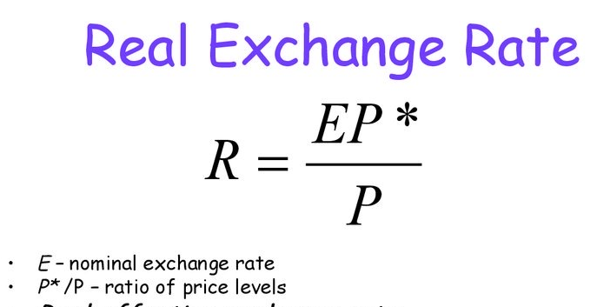

- Show how real exchange rate depreciation of a country’s currency can increase competitiveness? How RER combines both the “environment” and the “strategy”, the two things that the firm has to operate with? (p311-324)

Real exchange rates: tells how much the goods and services in the domestic country can be exchanged for the goods and services in a foreign country.

*If RER decrease: Compeiitiveness increase because the goods are becoming less expensive in relative to competitors. (Canadian firms needs to be more competitive than us to increase the level of product purchase by Canadian citizen.

- What is Bretton Woods System? What were its main characteristics of the exchange rate under BWS? Why did it fail?

Who: 44 countries

What: The Bretton Woods Agreement is a system for monetary and exchange rate policied by the International monetary found (IMF) and the World bank

Where: It was developed at the United Nations Monetary and Financial Conference held in Bretton Woods, New Hampshire.

When: After world war 2, established in 1944 (July 1 to July 22)

Why: Under the agreement, currencies were pegged to the price of gold, and the U.S. dollar was seen as a reserve currency linked to the price of gold.
- US exchange rate was fixed with gold and other countries’ exchange rate was fixed with the US.
- Only dollar remained convertible to gold.

Why It Failed:
US kept running deficit projects. Also the amount of money was increasing and the amount of gold we’re decreasing. In 1971, nobody was able to claim gold in exchange for your US dollars
- What was the role of WTO, IMF and World Bank historically and what is today?

- World trade organisation(WTO): They are trade negociation under a provisional set of rules that became known as the general agreement on Tarrifs and trade. This principle is implemented with following four specific principles.
1. Non discrimination
2. transparency
3. Reciprocity
4. Consensus decision making

- (IMF): Try to avoid a repetition of chaos through a combinaison of discipline and flexibility

- World Bank: Help finance the building of Europe’s economy by providing low-interest loans

- What is a firm’s main objective? What is a firm’s strategy? What are the primary and supportive activities of a firm in its different value creation tasks?(p371)
Value creation:
Two basic conditions determine a firm’s profits
- The amount of value customers place on the good (sometimes perceived value)
- The firms costs of production.
In general, the more value customers place on a firms products, the higher the price the firm can charge for those products. However, the price a firm charges for a good or service is typically less than the value placed on that good or service by the customer (customer surplus).
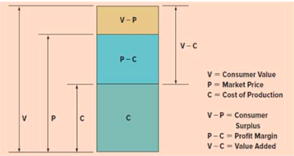
- The firm can either use:
    - Low Cost strategy: focuses on lowering the cost of a good compared to competitors
    - Differentiation strategy: having products that are different so they can be sold at a higher price.
The bottom line of the role of strategy is to make things cheaper than the competitor and to make things good enough to be of interest to the consumer.

Strategic positioning:
The firm must chose the strategy and configure its internal structure to support the strategy. The firm must decide where it wants to be in the efficiency diagram. The bottom line is that firms, strategies, operations and organization must be consistent to attain the comparative advantage and get a higher profit.
Primary activities:
R&D development – Production - Marketing and Sales – Service

Support Activities: Materials Management function - Human Resources function - Information systems - Firms infrastructure

- What are the different ways, a global firm can increase its profit that the domestic firm cannot? What are economies of scale? What are economies of scope?
Global firms have many different opportunities that domestic firms cannot take advantage of. Firstly, with global expansion, firms are able to use optimal locations for various activities to reduce costs. Also, they can create greater returns by leveraging valuable skills developed in foreign operations. Overall, global firms can allocate resources and skills to various locations to optimize their operations and reduce costs. Global firms can also tailor to different host countries needs and preferences as needed.

Economies of Scale refers to the reduction of per unit costs achieved by producing a large volume of products.

Economies of Scope refers to producing more than one product. Firms who produce more than one product are generally are more productive than single product firms. Since they have other products to rely on, it can help leverage profit until newly launched products take off.

- For a firm, what are the different entry modes in the foreign exchange market? In general, countries with which characteristics are considered better places to enter? What are the pros and cons of different entry modes?
Strategic alliances refer to cooperative agreements between potential or actual competitors. In this section, we are concerned specifically with strategic alliances between firms from different countries.
- Strategic alliances may facilitate entry into a foreign market
- Strategic alliances also allow firms to share the fixed costs (and associated risks) of developing new products or processes.
- An alliance is a way to bring together complementary skills and assets that neither company could easily develop on its own.
- Technological sharing reasons
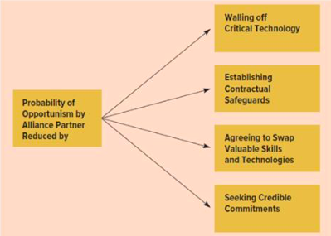
For a firm in a country to take foreign market, it needs better business environment in the country- mostly related to overall policies of the country.
Entry mode = Strategie
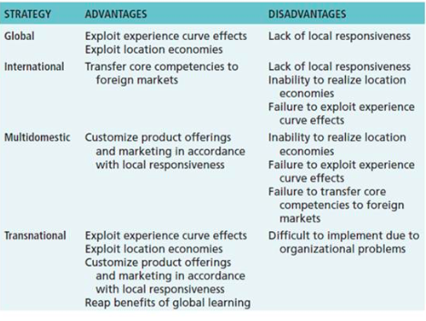
- What are the challenges and opportunities of exporting? In Canada, what is the participation rate of the firms in exporting? Why export participation rate among firms is low? How concentrated is export activities?
Opportunities:
- Gradual decline in trade barriers
- Reduction in transport cost
- Modern communication and ease in logistics
- WWW

Challenges:
- Exporting remains a challenge for many firms
- Smallers enterprises can find the process intimidating
- Host of unanticiped problems often associated with doing business in a foreign market

In Canada, only 55,000 firms out of 1 million firms export (5.5%). About 23,000 firms are both exporters and importers ( two way traders (TWT)).

Exportation is so low for many reasons including:
- Not many firms are two way traders,
- Firms cannot start exporting,
- Firms cannot survive for more than 1 year in foreign markets.
Export activities are quite concentrated, to be exact the top 1% of exporters contribute to 77% of total exports.

- Whether a global firm takes different country and different market as one market, it has to adopt strategy on four marketing fronts? What are they?

Product: characteristics that define a particular product that will affect the consumer’s purchase decision.
Cultural differences:
- Economic development ( Example: American products have much more extra performance attributes to their products *less basic)
- Product and technical standard: differing governments have different rules and standards that can rule out mass production and marketing of a standardized product,

Place: The means it choose for delivering the product to the consumer.

Differences between countries:
- Retail Concentration: only a few retailers supply most of the market
- Fragmented Retail System: many retailers, no one firm having major market share.
- Channel Length: refers to the number of intermediaries between the producer (or manufacturer) and the consumer.
- Channel Exclusivity: an exclusive distribution channel is one that is difficult for outsiders to access. Example: new firms trying to get prime shelf space at grocery stores.

Promotion: Communicating attributes the attributes of the product to prospective customers
*Barriers to international communication including: cultural barriers, source and country of origin effects, and noise levels.
Push: marketing strategy that emphasizes on personal selling rather than mass media advertising.
    - Good for industrial or complex new products
    - When distribution channels are short
    - When few print of electronic media are available
Pull: a marketing strategy emphasizing mass-media advertising as opposed to personal selling.
    - For consumer goods
    - When distribution channels are long
    - When sufficient print and electronic media are available to carry the marketing message.

Pricing strategy: International pricing strategy is an important component of the overall international marketing mix. There are 3 types of pricing strategies ( price discrimination, strategic pricing and regulatory factors that affect prices.
- What is price discrimination? Show that if the demand elasticity of a firm’s product is different between two countries and there is no arbitrage, the firm can maximize its profits by charging different prices in two countries.
Price discrimination:
- Whenever consumers in different countries are charged different prices for the same product.
- Price are generally lower where there is more competition and more where there is no competition
- Price discrimination helps firm to maximize its profit

Two condition are necessary for profitable discrimination:
- There should not be arbitrage across markets
- Different countries should have different price elasticities of demand

Price elasticity of demand: a measure of the responsiveness of demand for a product to changes in its price.
- Demand is said to be elastic when a small change in price produces a large change in demand.
- Demand is said to be inelastic when a large change in price only produces a small change in demand.
- In general, a firm can changer higher prices where the demand is inelastic.
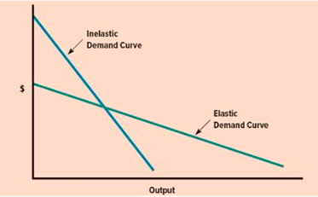

- What is import tariff? What is the impact of proposed US tariff of steel and aluminum proposed by the US for these industries, various other industries that use these as inputs, to US consumers and overall employment?
Import Tariff: are used to restrict imports by increasing the price of the good and services being purchases from abroad to make them less attractive to the consumers.

The impact of the proposed US tariff on steel and aluminum mean that the countries that are exporting theses two products to the US will face higher prices and imports would fall. By applying this tariff, there would be cuts of imports of steel and aluminum to the USA. Overall this would result into a lose-lose situation. The WTO has ruled that the national security rationale is baseless. Although it could take years to settle, it could end up being a negative effect for jobs in the USA even though the goal was to protect said jobs because it would increase jobs in the metal industry, but it would decrease in other fields. Manufacturing companies would also be hit because they depends on steel and aluminum to make their products therefore the would have higher costs, so they have to either cut costs elsewhere or charge more.
- What determines the production location of a firm? What factors promotes for decentralization of production and which ones promote the concentration of production? What type of products are better to have proximity and what types products to have concentration and why?

- Where to produce: an essential decision facing an international firm is where to locate its manufacturing activities to achieve the goals of minimizing costs and improving product quality.
- The first goal is to lower costs: dispersing production activities to various locations where each activity can performed most efficiently.
- The second goal is to increase product quality: by eliminating defective products from both the supply chain and the manufacturing process.

- Country factors about where to produce can include economy, culture, relative factor costs that defer from country to country. Political economy and national culture influence the risks, costs and benefits of doing business. Exchange rates are also a key important factor about choosing the host country.

Technological factors are about the technology a firm uses in the manufacturing can be pivotal when choosing locations.

Two product factor determine location decisions:
- Products value to weight ratio
- The nature of the needs that the product fulfills: the more common the product, the less need to diversity manufacturing.

Decentralization of manufacturing is appropriate when:
- Differences between countries in factor costs, political economy, and culture do not have substantial impact.
- Trade barriers are high
- Location externalities are not important
- Volatility in exchange rates is expected
- Production technology has low fixed costs, low minimum efficient scale, and flexible manufacturing technology is not available
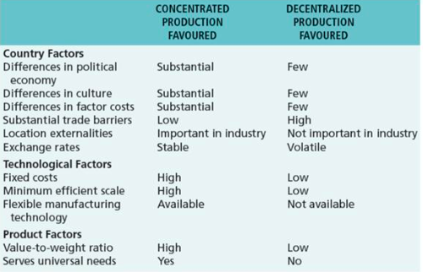

Concentration is better ( makes the most sense) when:
  - Differences exist between countries in factor costs, political economy and culture.
  - Trade barriers exist
  - Externalities arising from the concentration of like enterprises favour certain locations.
  - The products value to weight ratio is high
  - The product serves universal needs,

- The level of output at which most plant-level scale economies are exhausted is referred to as the minimum efficient scale of output.
- This is the scale of output a plant must operate at to realize all major plant level scale economies.

  - The larger the min. efficient scale of a plant, the greater the argument for centralizing production in a single location (or limited # of locations).
  - Otherwise it might be better to manufacture a product in a different location.
- Flexible manufacturing and mass customization:
- The central idea of economies of scale is that the best way to achieve efficicent production is through mass production of a standardized unit.
- The trade off is between unit costs and product variety
- According to this view, the way to increase efficiency is to limit product variety and produce a standardized product in large volumes.
- This view has been challenged by the rise of flexible manufacturing technology ( lean production)
  - Which reduces setup times for complex equipement
  - Increases utilization fo individual machines and better scheduling
  - Improves quality control at all stages of the manufacturing process.
- Flexible manufacturing technologies allow the company to produce a wider variety of end products at a unit cost that at one time could be achieved only through the mass production of a standardizes output.

- How to run a successful business? What type of economic and business environment and firm strategies are required to run a successful business?
To run a successful business you need good business environment and good firm strategy.
Business environment:
- Large domestic market
- Abundance of entrepreneurs
- Skilled work force
- Smart regulation

Firm strategy:
- Whether remain domestic or enter foreign
- Leader of the follower in the industry
- Single plant of multi-plant
- Make or buy intermediate inputs

- What is offshoring? What are global value chains (GVCs)? What are its benefits and costs? What are its implications in income distribution for both countries (sending and receiving offshoring services)?

Offshoring:
- The practice of basing some of a company’s processes or various parta overseas, so they can take advantage of lower costs.

Global value chains(GVC’s):
- Different stages of the production process are located across different countries. This includes all the people and activities involved in the production of a good and its global level.

Implication income distribution:
Suppose there are two types of labor in production: High skill and low skill in both countries
Take the initial equilibrium and suppose that an additional task is offshored from developed (home) to developing (foreign) countries. It happens the firm will offshore the task that is the least skill intensive in home country and most skill intensive in the host (foreign) country
Labor market equilibrium changes in both countries.
- Relative demand for high skill rises in both countries at each relative wages.
- Inequality rises in both countries

