CEG3155 Quiz 2 Notes
- Process blocks are considered a concurrent statement (concurrent_stmts)
- PB contents run in parallel with other concurrent statements
- PB only allow three components
  - Signal assignments
  - If statements
  - Case statements
- We only use the PB that deals with the sensitivity list (NO wait statements)
  - Sensitivity Lists list input signals to sub-circuit
- We have 5 Golden Rules:
  - All signals read with PB must be in sensitivity list (signals on right side of assignment statements, if and case statements) -> will result in a ‘WARNING’ from the synthesis tool
  - The last assignment to an output signal takes precendence over ALL previous assignments -> no way to violate rule regarding multiple assignments to output signal
  - All output signals must have unconditional assignments -> causes a real problem with no warning from the synthesis tool. A FF(output = output) is added in case none of the Boolean expressions are true
  - Never use a signal on both sides of an assignment statement, it will create a combinational loop -> synthesis tool will generate a ‘WARNING’ tool
    - Ex. Tmp <= Tmp or b
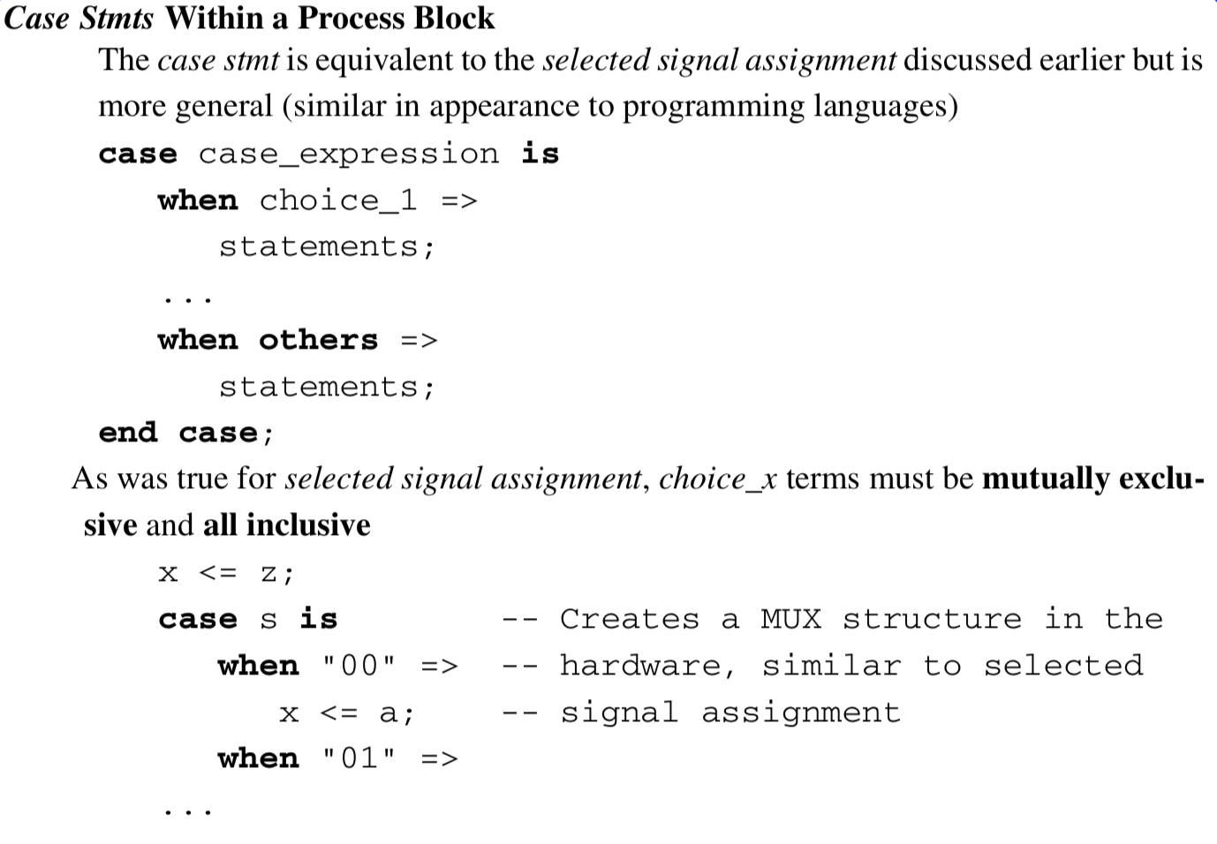
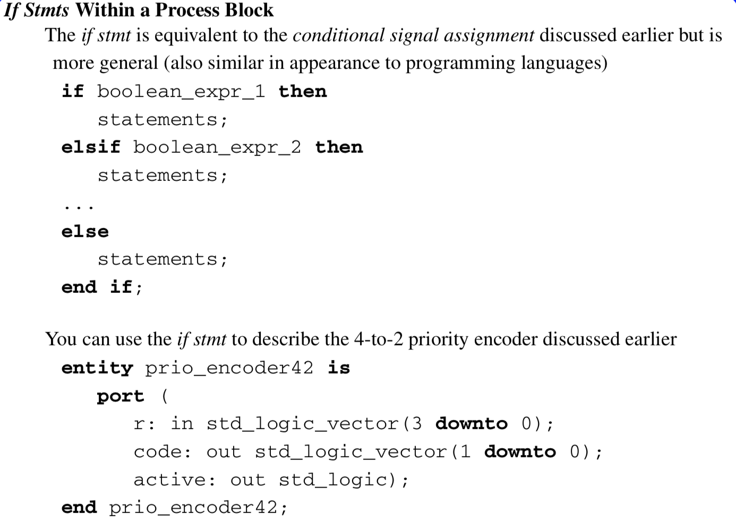
  - Never assign to an output signal both inside and outside the PB -> generates a syntax error



