Verification of Gas Laws

Written by:

Mustafa Ismail, 300076311
and
Phanisri Mudunuri 300073087

TA: Mykhaylo Slobodyanyuk

Date: September 20th, 2018

Introduction:
Gas is a form of matter that has indefinite shape and volume. It is characterized by several variables including temperature(T), volume(V), and moles(n). In theory, an ideal gas takes up no volume and is negligible in space that it does not have any attraction to between particles. Boyle’s law states that when the temperature of an ideal gas remains constant, any change in volume will be inversely proportional to a change in pressure. This is represented by the equation:
V ∝ $\frac{1}{p}$ (1)
Charles’ law states that when the pressure of an ideal gas is fixed, the volume and temperature are proportionate. Gases expand when heated and contract when cooled. The volume of a ideal gas increases linearly when temperature increases and when pressure is fixed.
V ∝ T (2)
In real life, gas are not truly ideal but we are going to assume that all gases behave as ideal gases. Real gases have mass, are non-elastic, and require kinetic energy for attractions between gas particles. In addition, the pressure is higher in an ideal gas compared to a real gas. In general, all ideal gases follow the equation
PV = nRT (3)

Procedure
Verification of Boyle's law procedure
- Wear lab coat, safety goggles, closed toed
- Configure gas pressure monitoring system and LabQuest2 ensuring volume (mL) is set as independent variable and pressure (kPa) as dependant variables
- Move syringe to the initial volume of 15mL and screw it a ½ turn into the sensor.
- Without touching the syringe, record pressure displayed as instructed in the experiment guide. Ensure when inputting volume to the LabQuest2 that you add 0.8mL of volume to compensate for sensor.
- Push plunger to 14mL and wait for pressure to stabilize. Record and ensure 0.8mL is added to recorded volume for sensor compensation.
- Repeat step number five seven more times decreasing volume by 1 mL each time.
- Conclude the trial by setting the syringe back to 15mL and re-recording pressure at the initial volume (+.8mL).
- Eliminate second reading of initial volume in order to maintain negative slope of data.

Verification of Charles Law procedure
As described in the lab manual (Eliot, T.S. (2018). Do I Dare Disturb the Universe. Exp 1. P.7-8)

Data Tables
Table 1: Raw Data Collection for Charles’ Law Lab
Experiment | Trial 1 | Trial 2
Temperature of air in water bath [℃] | 102 | 101
Temperature of ice bath [℃] | 4 | 6
Volume of Water (v_{cw}) [mL] | 27 | 37
Volume of Water (v₁) [ml] | 155 | 153

Table 2: Raw Data Collection for Boyle’s Law Lab
Volume | Pressure (kPa)
15.8 | 101.18
14.8 | 108.63
13.8 | 117.32
12.8 | 125.20
11.8 | 138.15
10.8 | 149.34
9.8 | 166.55
8.8 | 182.05
15.8 (Second Value) | 100.82
*First value obtained for the original volume was kept

Observations
In the case of Charles law, it was observed that when water accumulated into the Erlenmeyer flask when dipped into the ice bath, the temperature of the ice bath started to increase.

As for Boyle’s law, during the experiment it was observed that pressure would increase when volume in the syringe was decreased, inline with Boyle’s law. After the 10 mL mark it became very difficult to push the syringe as the pressure was so great.

Graphs
Relationship between Volume and Pressure of a gas
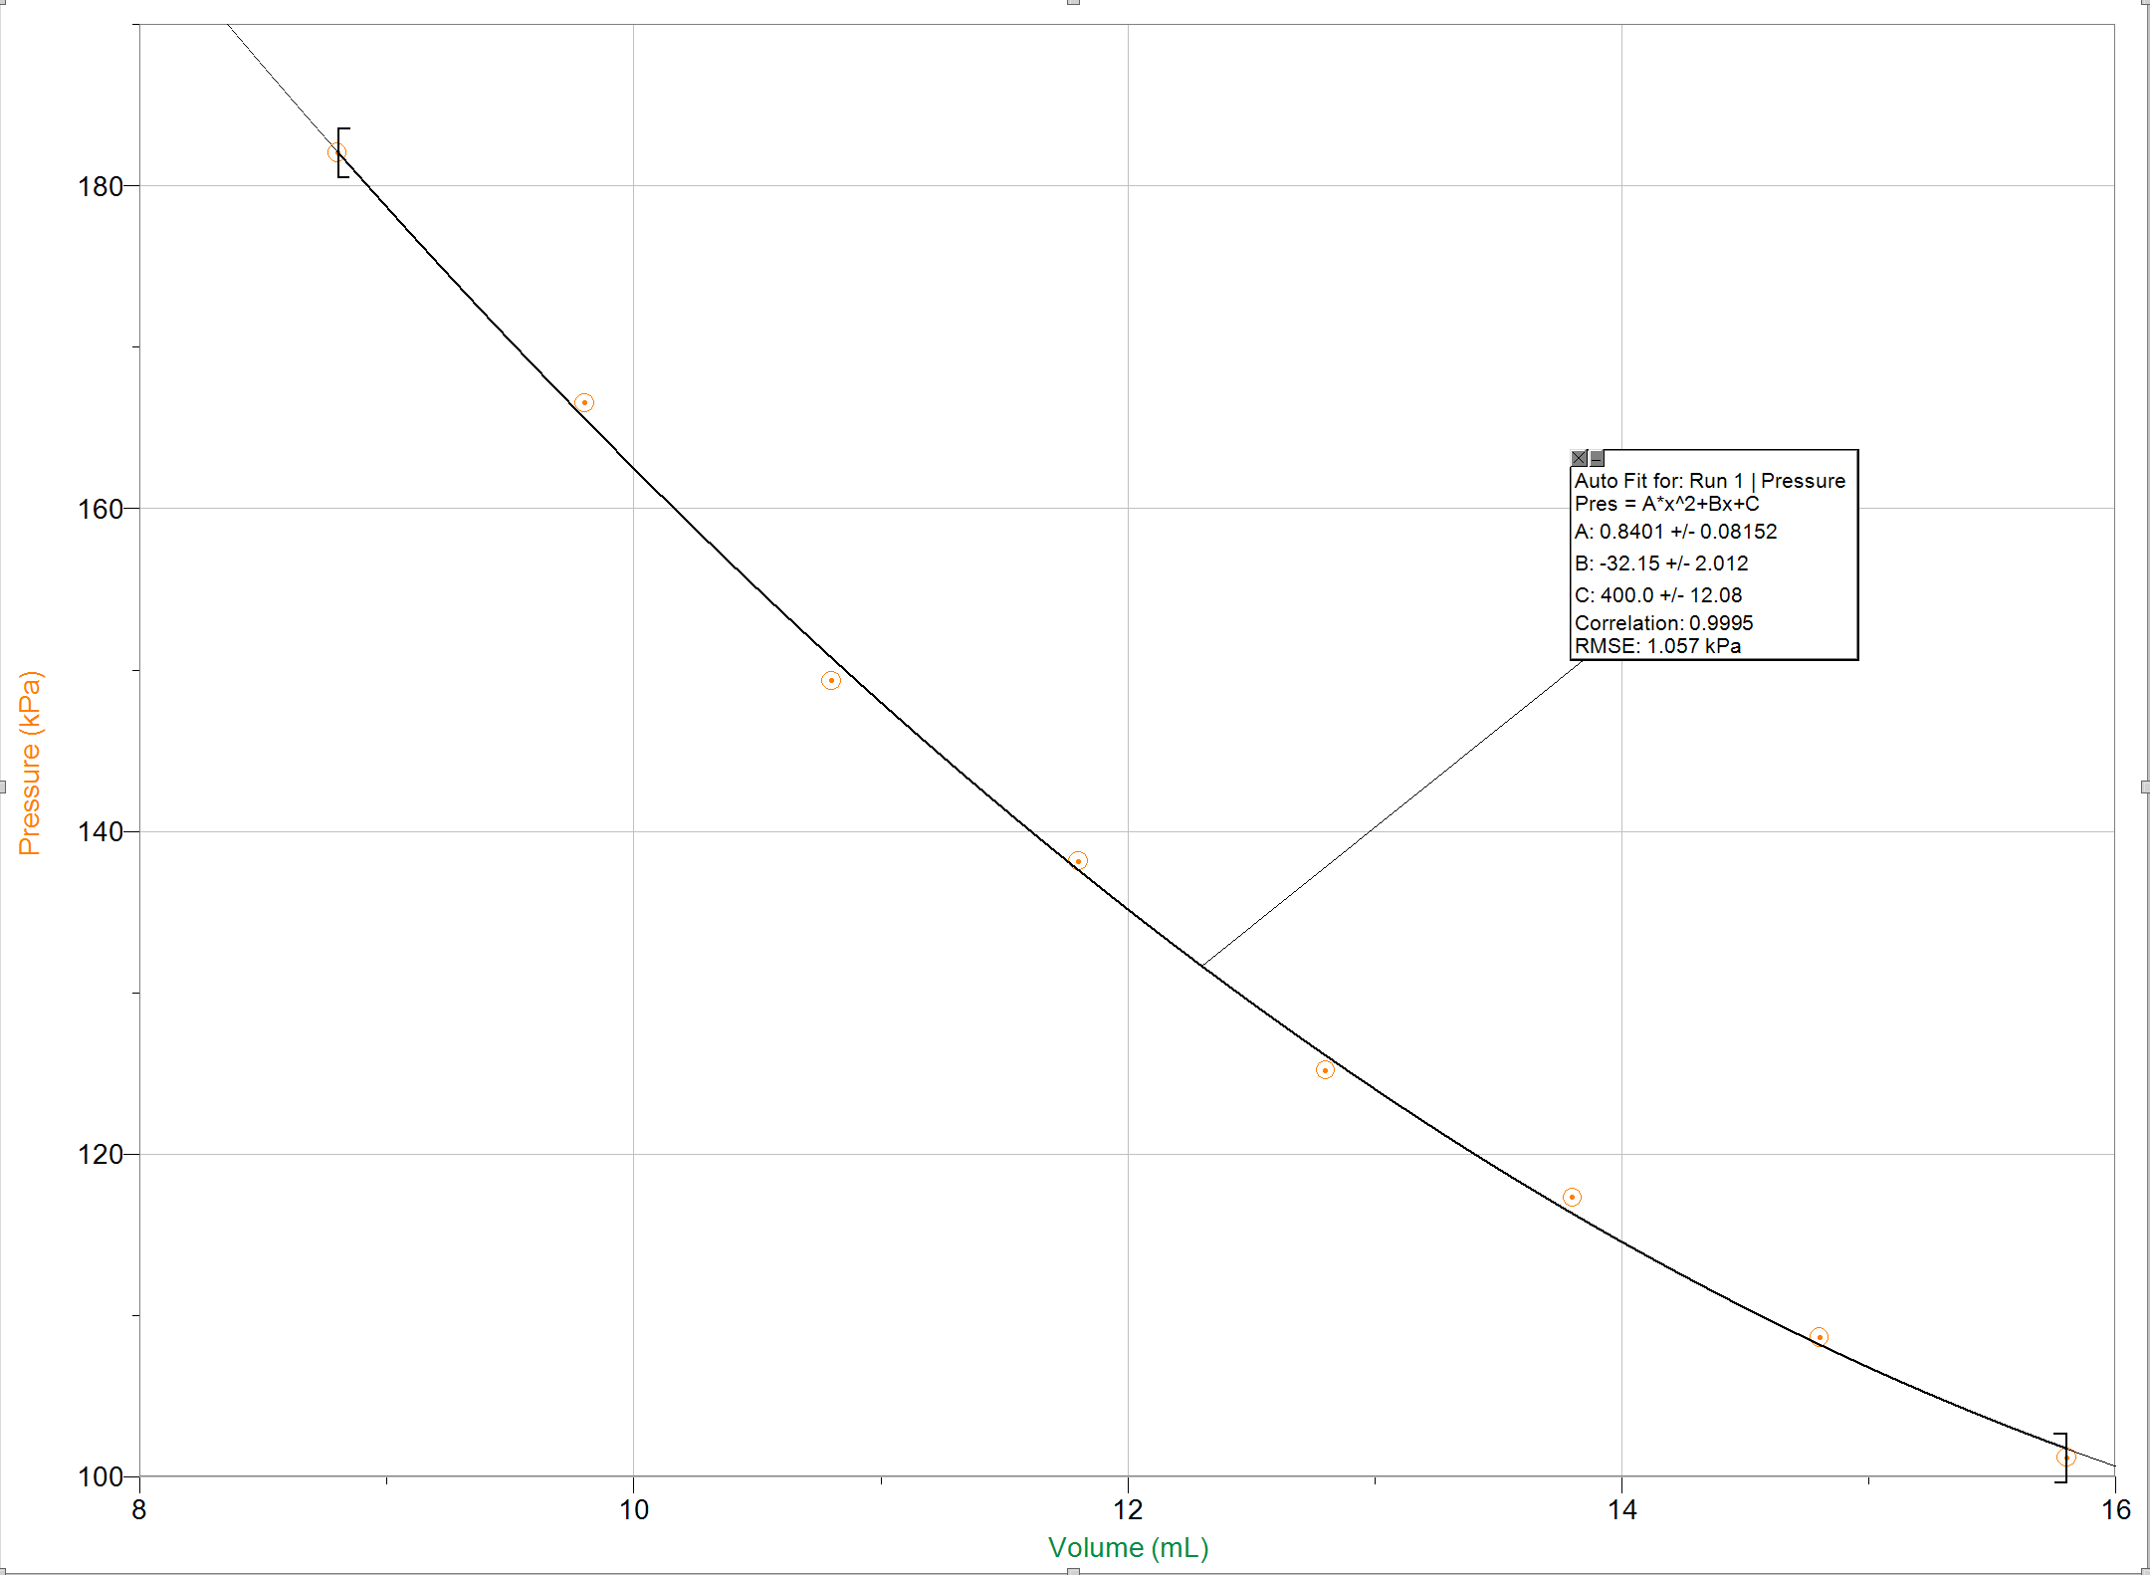

Calculations
Table 3: Calculations for Charles’ Law Experiment
Calculations | Trial 1 | Trial 2
Calculation for Conversion of Temperature from Degrees to Kelvin | T₁ = 102 ℃ + 273  = 375 K | T₁ = 374 K
 | T­₂ = 4 ℃ + 273 | T₂ = 279 K
Calculation for V₂(based on Trial 1) | V₂ = V₁  - V_{cw}  = 155 mL - 27 mL  = 128 mL x $\frac{1 L}{1000 mL}$  = 0.128 L | V₂ = 0.116 L
Calculation of $\frac{V_{1}}{T_{1}}$ | $\frac{V_{1}}{T_{1}}$= 4.13 x ${10}^{-4}$ | $\frac{V_{1}}{T_{1}}$ = 4.09 x ${10}^{-4}$
Calculation of $\frac{V_{2}}{T_{2}}$ | $\frac{V_{2}}{T_{2}}$= 4.62 x ${10}^{-4}$ | $\frac{V_{2}}{T_{2}}$= 4.16 x ${10}^{-4}$
Calculation of $\frac{V_{2}}{T_{2}}$ | Average: $\frac{V_{2}}{T_{2}}$ = 4.39 x ${10}^{-4}$
Verification of Charles’s Law | The values for $\frac{V_{1}}{T_{1}}$ and $\frac{V_{2}}{T_{2}}$ are similarly close but do not equal each other indicating there are sources of error in this experiment.
Percent Error Calculation | % Error = $\frac{\frac{V_{1}}{T_{1}}-\frac{V_{2}}{T_{2}}}{\frac{V_{1}}{T_{1}}}$X 100 %  = $\frac{4.11 x {10}^{-4} - 4.39 x {10}^{-4} }{4.11 x {10}^{-4}}$X 100 %  = -6.81 %  = 6.81 %

Boyle’s Law Calculations/data analysis

1. Boyle's Law constant
$V= k ∙ \frac{1}{p}$
Values from Table 2: V=9.80mL; P=166.55kPa
$9.8mL=k ∙ \frac{1}{166.55 kPa}$
$k=9.80mL ∙ 166.55 kPa$
$k=1632.19mL∙kPa$
To calculate Boyle's law, values were taken from Table 2 and plugged into the Boyle’s law equation. k (constant) was then isolated by multiplying pressure and volume finally supplying the constant.

2. Boyle’s law describes an inverse mathematical relationship between volume and pressure when the temperature is constant. As seen in the experiment, when volume decreases pressure increases. Using the constant (k) found in question one of the calculations we can write the following equation for Boyle’s law:
$V= k ∙ \frac{1}{p}$
$V=1632.19 mL∙kPa ∙\frac{1}{p}$
If the equation holds true, plugging in the following experimental pressure from Table 2 should yield the same pressure ($±.20mL).$
Volume | Pressure (kPa)
10.8 | 149.34
Section of Table 2
$V=1632.19 mL∙kPa ∙\frac{1}{149.34kPa}$
$V=10.93mL$

3. Noting the pressure reading at the initial volume of 15mL twice was essential to identifying experimental error. It was observed that the second reading displayed a pressure 0.36kPa less than the initial reading. Although this is a small difference, it makes clear that the system was not fully closed and there was room for leakage. Had the difference between the initial and final pressure reading of 15 mL been drastically different, it would be evident a leak was present and the results of the experiment were no longer usable.

4. Boyle’s law can only be applied in situations where temperature is constant. Maintaining the temperature of the gasses in the syringe was accomplished by removing all sources of heat and cold in the lab such as ice baths and hot plates. Further, effort was taken to minimize body contact with the syringe so as to avoid heating up the air inside. The syringe was only handled when adjusting the pressure, otherwise it was set on the room temperature table. Finally, the syringe was screwed on tightly to the sensor as to avoid leakage and temperature change resulting of.

Discussion
Charles’ Law
Ideally for the Charles’ law experiment, the percent error should be 0% however, we got a percentage error of 6.81 %, which is considerably a small amount indicating there are a couple of sources of error in this experiment. Even though the percent error was not huge, we were able to verify Charles’ law that when pressure is in a fixed amount, the volume is proportionately constant to temperature. This is evident by the values and calculations as V₁ and T₁ have bigger values than T₂ and V₂. One source of error in this experiment is when we were boiling water or submerging the flask, we did not set a timer, so there were differences because the initial and final temperatures were not constant for both trials and the amount of water accumulated in the Erlenmeyer flask varied. One way we could have reduced the source of error is to use a stopwatch and set a certain amount of time for the water to boil before we transferred it to the ice bath. The stopwatch could also be used to measure the amount of time the Erlenmeyer flask was submerged in the ice bath. This way, the temperatures recorded for both trials and the volume of water accumulated would not have huge deviations and the source of error would be reduced. Another source of error is that the thermometer measures the temperature of both the water and ice baths. It does not measure the temperature of the air inside the flask which means the temperatures recorded does not actually represent the temperature of an ideal gas. We do not know if the flask has reached equilibrium temperature with the water bath even though we waited for a couple of minutes after the water started boiling. Thus this could have affected the results giving us the considerably large percent error. To potentially reduce this source of error, we could have used a digital thermometer connected to LabQuest2, therefore the temperature of the gas inside the flask would have been recorded giving us more accurate data and thus reducing source of error. Even though there was a small percent error, we were able to support that the temperature is proportionally constant to volume under the conditions that pressure was constant under the assumption that the air pressure in the room was the same.

Boyle’s Law
The results of this experiment are inline with the Boyle's law in that the results extrapolated were inverse to each other. As originally hypothesized, when the volume of a gas with a fixed temperature and mass is increased the pressure will decrease. The same applies when volume is decreased, pressure increases. Quantitatively, the recorded data obtained through LabQuest 2 demonstrated that during the experiment I observed that squeezing the syringe and reducing the volume of air resulted in more resistance and higher readings on the pressure sensor. These results therefore prove Boyle's law however, not perfectly. During this experiment there were multiple sources of error, most notably leakage between the sensor and syringe. To test for this specific experimental error, part of the procedure was to retake the pressure at the initial volume. We suspected that there would be some leakage in the connection as it was not airtight and knew this would affect our results. The data collected proved there was some leakage as the second reading had a pressure 0.36kPa lower than the initial. This had miniscule affect on the results however had the difference been larger, the experiment would have failed to demonstrate Boyle’s law. One of the limiting factors of Boyle’s law is maintaining a constant mass, any leakage would void that and no the principle can no longer apply. Another source of error is temperature change. As discussed in the data analysis, precautions were taken to minimize temperature increase however referencing my observations, notably the resistance I felt when squeezing the syringe past 10 mL, I thought about Gay-Lussac’s Law. The law states that pressure exerted on the sides of a container is directly proportional to temperature. Applying this to my observations, it can be speculated that the increased pressure will raise the temperature of the gas inside creating another source of experimental error.

Conclusion
The results obtained in both the Charlee’s law experiment and Boyle’s law experiment demonstrated the theories to be true. In the case of Charles's law, the volume of water absorbed into the flask was proportional to the temperature of the ice bath validating Charles's law. As for Boyle’s law, pressure data obtained from different volumes demonstrated an inversely proportional relationship between volume and pressure.

References
Laugier,A, Garai,J., Derivation of the Ideal Gas Law, 84 (11), p 1832. November 1, 2007
Eliot, T.S. (2018). Do I Dare Disturb the Universe. Exp 1.
Pictures of Raw Data Collection


