PAP1301 – Monday, September 17th

Democracy

- Based on legal-rational legitimacy
- Based on input legitimacy (also output)

What is public policy?

Two types of democracy:

- Direct democracy: Where the people govern themselves.
- Popular assemblies constituted by the people to directly govern themselves.
- Is voting an example of direct democracy?

- Representative democracy
- Citizens are one step removed
- Citizens elect persons to represent them and make decisions on their behalf
- “Public policies are made, on a majority basis, by representative’s subject to effective popular control at periodic elections which are conducted on the principle of political equality and under conditions of political freedom” -Inwood, p.32
- A way of giving the people legitimacy without giving them too much power
- House of commons

Healthy representative democracy (Robert Dahl)

- Freedom to form and join organizations
- Freedom of expression
- Right to vote
- Eligibility for public office
- Right of political leaders to compete for support (compete for votes)
- Alternative sources of information
- Free and fair elections (secret ballot, all citizens have the same rules, no individuals are restricted from voting, all votes are equal,
- Institutions making government policies depend on votes and other expressions of preference (shows that input and output works)

What is democracy?
- Is democracy about making the right decisions? No, its about letting the people decided what is right or wrong or what should or should not be.
- What is a right decision?
Letting a group of people decide for themselves.

If you don’t turn…politics, politics will turn on you.
Institutional political structure in Canada

Parliamentary Actors: Legislative, Executive, Judicial

How does our representative democracy work?

- Parliamentary system of government
- Westminster (inherited British Model)
- Fusion of powers between legislative and executive.
  - Not branches of government (despite contemporary nomenclature)
- Legislature: Bicameral
  - House of Commons (elected representatives MPs)
  - Senate (appointed by the prime minister)
- Executive
  - Crown (governor General)
  - Cabinet and Prime Minister (primus inter pares, first among people)
- Legislature (Parliament)
  - House of commons:
    - Members of parliament voted to represent the people of their riding
    - Serve until the next election (unless early or unexpected departure)
  - Senate:
    - Appointed by the prime minister
    - Serve until the age of 75
  - Crown (Governor General)
    - Largely Ceremonial (periodically important decisions e.g. turnover of minority governments)
  - Cabinet and Prime Minister:
    - Party leader with largest number of seats in the House of Commons asked to for the government (becomes prime minister (first minister))
    - Generally, prime minister forms a cabinet from elected members of the house of commons
- Executive is formed from the House of Commons
- Executive is responsible to the legislative branch: responsible government
- Motion of Confidence: Failing to have a majority of votes leader to the end of the governments term in power (dissolution of the house of commons)
So why is parliamentary government seen to be dominated by the executive

Party discipline and first ministerial prerogatives
- Party members must vote as indicated by the party leader:
  - Party discipline
    - PM has prerogative to nominate Cabinet Members and administrative department head (deputy minister)

PAP1301 – Wednesday, September 19th

Difference between a coalition and minority government.

THE JUDICIARY

- Appointed by the government (executive)
- Interprets constitutional law (relationships between governments)
- Ensures public servants work within their jurisdictions and fulfill their responsibilities.

POLITICAL INSTITUTIONS IN CANADA

- Political parties
  - Aggregate and articulate interests
  - In Canada tradition of brokerage parties (catch all parties)
    - Liberal Party; Conservative Party; Progressive Conservative Party (All very similar)
  - But at the provinces more ideologically fixed parties are present:
    - Le Parti Québécois, Saskatchewan Party. (Stronger ideologically)

- Interest groups (Advocacy groups)
  - Like-minded individuals who want to influence public policies (they express power)
  - Provide information to government
    - What citizens want
    - Policy relevant knowledge

- The media
  - Influences legitimacy, sets the agenda, communicates information to citizens

BUREAUCRACY

What is bureaucracy?

Etymology: The rule of the office

Two meanings:
- An organizational structure
- The professional institutions carrying out the government’s policy decisions.

Ideal-type Weberian bureaucracy
- Hierarchy: Each office has a clearly defined sphere of competence (division of labour) organized in a fixed hierarchy (answers to a superior)
- Continuity: full time work, which constitutes a career. (Working there for the next 25 years)
- Impersonality: behaviour based on predetermined written rules.
- Expertise: personnel are selected on the basis of merit; keep records and have access to this information.

Bureaucracy:
- Interested in the means that government objectives are realized.
- That is, bureaucracy is the institution responsible for the administration of governing.

Politics VS Administration
- Politics:
  - Elected politicians
  - Objectives (what)
  - Normative
- Administration
  - Appointed public servants
  - Means of realizing objectives (how)
  - Empirical

Advantages:
- Efficient
- Accumulation of knowledge
- Accountable: to your superiors, clients, etc.
  - The obligation to have to explain your actions to another person.
- Universal treatment of citizens (impersonal relationships)

PAP1301 – Monday, September 24th

What is bureaucracy?
- Type of organizational structure
- Public/ Civil service

Politics-administration dichotomy – Reading

But…
- Bureaucracy can develop its own identity.
- Bureaucracy can develop its own interests.
  - Budget maximizing
  - Truth to power
  - Neutrality is false

“Prime Minister, I’m not here to tell you fucking want to hear. I am here to tell you what you fucking need to hear.”
-Tony Ayers to Australian PM Malcolm Fraser (1975-1983)

Why does the bureaucracy develop its own interests and identity that is different than the government’s?

- They don’t agree with the governments decisions.
- They believe in what they are doing; it is important. “I’m making society better by doing this.”
- Decisions based on information.
- Career structure is different: based on merit.

*Everything under the Minister of Finance is considered administration.

Temporal differences and meritocratic recruitment:
- Permanency of position leads to different interests and different identity
  - Incentives
    - Professional identity associated

Do bureaucrats speak truth to power?

Tensions: bureaucracy and democracy
- Democracy:
  - Participation
  - The will of the people
  - Empowering individuals (citizens treated as a member of the community)
- Bureaucracy
  - Obedience (hierarchy)
  - Written procedures
  - Dehumanizing (people treated as a number)

The will of the people vs. the written procedure:
“We must remember this fact: that “democracy” as such is opposed to the “rule” of the bureaucracy, in spite and perhaps because of its…

Bureaucracy: Critique
- According to Marx the bureaucracy, and the state itself in capitalist society, supported the capitalist class.
“The bureaucracy has the state, the spiritual essence of society, in its possession, as its private property. In the case of. The individual bureaucrat, the state objective turns into his private objective, into a chasing after higher posts, the making of a career.”
-Karl Marx

Co-operative Commonwealth Federation - Saskatchewan:
- Health Care
- Tommy Douglas

Critiques against bureaucracy
- Trained incapacity (lost sight of objectives)
- Emphasis on rules
- Not innovative
- Dehumanizing (employees and clients)
- Inefficient
- Usurps the rule of the elected

*If the right people don’t have power -Yes, Prime Minister – Video

PAP1301 – Wednesday, September 26th

The benefits of a Weberian bureaucracy

- Improved bureaucracy improves socioeconomic development & lowers corruption
  - Expertise
  - Distinct preferences
  - Employee voice

Normative
- Interested in values
- Ex: Something is “bad” or “good”

Empirical
- Something referred to as positivism or naturalism.
- Presumes a belief that the world is independent of our observations.
- Humans, with the use of observations study nature as it real is and undercover its essence.
- Empirical statements can describe (she is 6 feet tall) and or explain (she is 6 feet tall because she in standing on the latter).

Bureaucratic neutrality
- Officials at work do not express a partisan opinion.
- Officials work loyally regardless of party in power.
- Work of officials is protected from political interference.
- Careers of officials are based on merit and not political considerations.

Formal politicization
- The replacement of merit with political consideration in the appointment nomination and careers of civil servants.

Functional politicization
- Public servants adopt a politically responsive behaviour.
  - Example: Harper man

Administrative Politicization
- Ministerial adviser’s relationships with permanent civil service.
- Partisan advisors “politicize” the advice relationship civil servants have with politicians.

PAP1301 – Monday, October 1st

Video about discussing politics in the workplace
- To improve productivity, keep a positive chemistry.
- Don’t discuss politics, it negates positive chemistry.
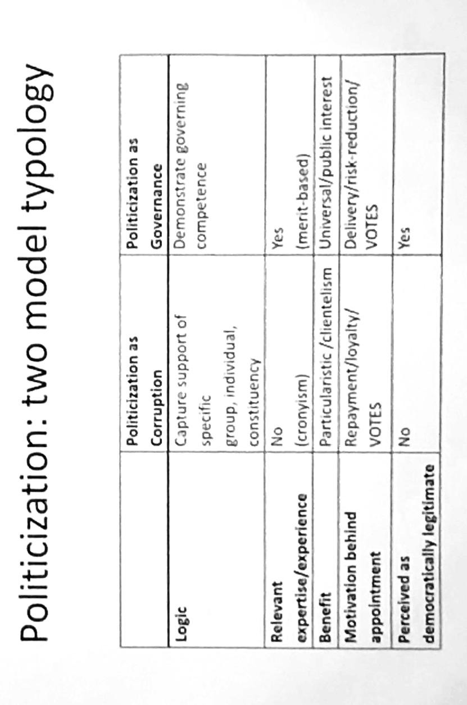

Motivaiton x Governance - Share the same political orientation

Ways to protect against politicization
- Independent hiring commissions
- Restrict the political activities of public servants.
Review
Implies that we can distinguish between Politics and administrative.

Organization theory …
Two sources of support of ministers: Public service, Exempt staff

The public service:
- The bureaucracy; civil service; public service.
- Departments, Government agencies & ASDs, regulatory bodies, crown corporations.
- Role: provide professional non-partisan advice.

Departments
- Ministries
- Statutory (Federal government – Financial Administration Act
- “administrative unit consisting of one or more organizational components under the direct management and control of a minister” (Hodgetts)
- Line departments and central agencies.
  - Direct responsibility for the delivery of goods and services to citizens
  - Spending departments
  - Large staff
  - Large number of sub-units
  - E.G. Agriculture and Argi-food; Veterans Affairs
  - Vertical silos
- Central Agencies
  - Support decision making of cabinet
  - Coordinate line departments
  - Supply information upward to cabinet and downward to line departments
  - E.G. Finance; Treasury Board Secretariat; The Privy Council Office; Prime Minister’s Office

