PP.1 Epithelial Tissue
- A sheet of cells that covers a body surface or lines a body cavity
- Forms boundaries between different environments
Functions
- Absorption
- Protection
- Secretion
- Filtration
- Excretion
- Sensory reception
Two forms occur in the body:
- Covering and lining
  - Forms the outer layer of the skin
  - Lines cavities of digestive and respiratory
  - Covers walls and organs
- Glandular
  - Fashions the glands of the body
Five distinguishing characteristics
- Polarity
- Specialized contacts
- Supported by connective tissue
- Avascular but innervated
- The ability to regenerate
Avascular: contains no blood vessels
Innervated: supplied by nerve fibers
Covering and Lining
All epithelia have a(n):
- Apical surface: upper free surface that’s exposed to blood flow
- Basal surface: lower fixed point
Therefore, exhibits apical-basal polarity

Basement Membrane consist of:
- Basal lamina (adjacent to the basal surface): non cellular, unsupportive sheet of primary glycoproteins (Functions are to filter and support)
  - Two laminae
- Reticular lamina
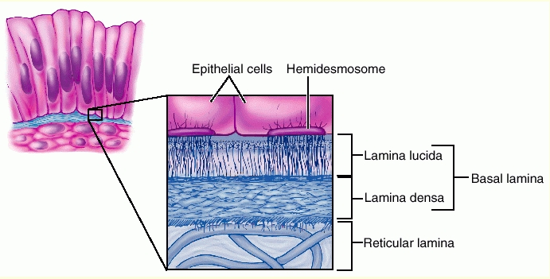

Epithelial cells fit closely together to form continuous sheets (Tight junctions, desmosomes)
Tight junctions- keep proteins in the apical region from diffusing into the basal region, which maintains polarity

Classification of Epithelial Cells
First name indicates number of cell layers’ present
- Simple: consists of one layer
  - Found where absorption, secretion and filtration occurs (thin layer)
- Stratified: consists of two or more layers
  - Found where protection is important such as the skin surface and lining of the mouth (think layering)
Second name describes the shape of the cell
- Squamous cells: flattened and scale like
- Cuboidal cells: boxlike, as tall as they are wide
- Columnar cells: tall and column shaped

- Simple Squamous: thin and permeable for filtration and diffusion
- Simple Cuboidal: secretion and absorption
- Simple Columnar: digestion and secretion
- Pseudostratified Columnar: a single layer of differing heights, secretes mucus in trachea
- Transitional: lines hollow urinary organs which stretch to fill with urine
- Squamous stratified: found in areas subjected to wear and tear
    - Keratinized: outer layer of skin contains a protective protein and dead layers of skin
    - Non-Keratinized: don’t contain protective proteins or dead layers of skin

Glandular
Classified according to two traits:
- Where they release their products
  - Endocrine (internally)
  - Exocrine (externally)
- Number of cells forming the gland
  - Unicellular
  - Multicellular

Endocrine Glands
- Ductless
- Produce hormones

Exocrine Glands
Ex. Sweat, mucus
- Unicellular
  - Mucus and goblet cells
  - No ducts
- Multicellular
  - 2 basic parts- epithelium-derived duct and a secretory unit
  - Classified by:
    - Structure- simple glands (unbranched duct) or compound glands (branched duct)
    - Mode of secretion
      - Merocrine –most common, not altered, secretes products by exocytosis
      - Holocrine –accumulate their products within them until they rupture
      - Apocrine (controversy whether human have this gland type)–accumulate their products but only cell apex pinches off with the product
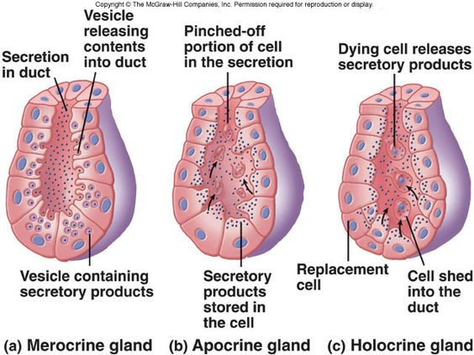
Connective Tissue
Four main classes of CT:
- CT proper (fat and fibrous tissue of ligaments)
- Cartilage
- Bone
- Blood
Functions
- Binding or support
- Protection
- Insulating or storing reserve fuels
- Transportation
Structural Elements of CT
- Ground substance
  - Fills space between the cells
  - Helps cells attach to CT elements
  - Consists of large amounts of fluid
- Fibers
  - Collagen -Strength
  - Elastic -Stretch and recoil (rubber bands)
  - Reticular -Support blood vessels and soft tissues
- Cells
  - Immature “blast” –actively dividing/synthesizing cells during growth and repair
  - Mature “cyte” –not as active, provide a level of maintenance

Types of loose connective tissue
- Areolar
- Supports and binds other tissues
- Holds body fluids
- Stores nutrients
- Ex. Surrounds capillaries
- Adipose
- Similar to areolar in structure and function but ability to store nutrients is much greater
- Ex. In breasts
- Reticular
- Fibers from soft internal skeleton that supports free blood cells
- Ex. Lymph nodes

Types of dense connective tissue
      - Dense regular
- Contain bundles of collagen fibers running parallel to direction of pull
- White, flexible tissues with great resistance to tension
- Strong in one direction
- Ex. Tendons
      - Dense irregular
- Same as regular but are thicker and arrange irregularly
- Ex. Shoulder joint
      - Elastic
- Like dense regular but a very high content of elastic fibers
- Ex. Aorta

Remaining types of connective tissue
- Cartilage
  - Found between CT and bones
  - Avascular
  - Tough but flexible
  - 80% H₂O
  - Varieties of cartilage
    - Hyaline
    - Elastic
    - Fibrocartilage
- Bone
  - Calcium salts gives hardness and strength
  - Supports and protects softer tissues
  - Contains cavities for fat storage and synthesis of blood cells
  - Cells in bones: osteoblasts, osteocytes, osteoclasts
- Blood
  - Classified as CT because it consists of blood cells and is surrounded by a matrix, blood plasma
  - Fibers are only visible during clotting
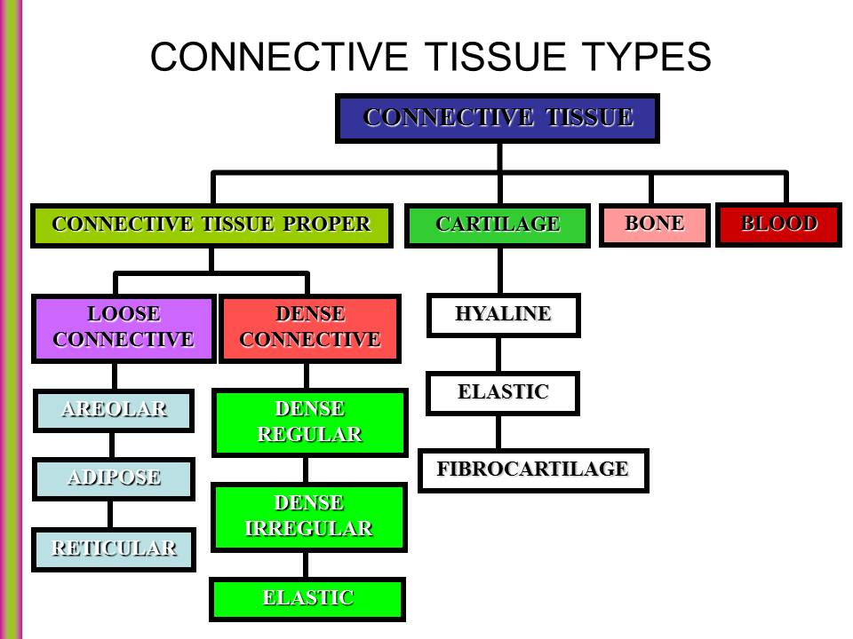

PP.2 Plasma Membrane
Phospholipid bilayer is the basic structure of a membrane containing two phospholipids with a hydrophilic and hydrophobic end
It creates a barrier/wall for the cell
- Peripheral proteins: attached to the integral proteins and helps support the membrane
- Cytoskeleton: anchors to plasma membrane, can also interact with receptors
- Glycocalyx: forms a carbohydrate-rich area at the cells surface “sugar coat”
  - Provides specific markers for recognition between cells (sperm recognizes ovum because of its glycocalyx)
- Cholesterol reduces fluidity which helps stabilize the cell
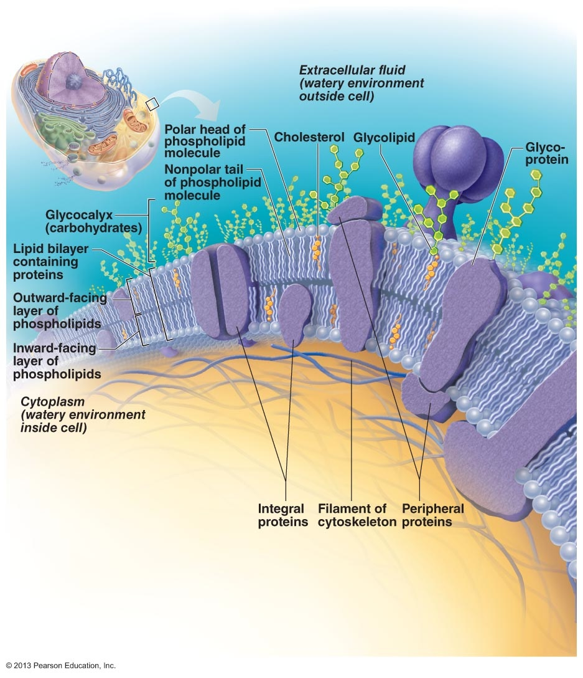
4 Functions:
- Barrier between intracellular and extracellular fluids
- Selectively permeable
- Allows the cell to respond to changes
- Site of cell-to-cell interaction and recognition
Cell Junctions
Tight junctions
- Fusion of adjacent plasma membranes to prevent passage of molecules
- Ex. Helps digestive enzymes stay in the digestive tract and not seep into the bloodstream
Desmosomes “binding body”
- Anchoring junctions
- Prevents separation
- Plaques are how adjacent cells are held together
- Keratin filaments anchor to the plaque
- Found in skin and heart muscle
Gap junctions
- Molecular channels between cells to allow passage of cytoplasmic molecules
- Connexons are cylinders that connect adjacent PM’s
- Electrically-excitable tissues
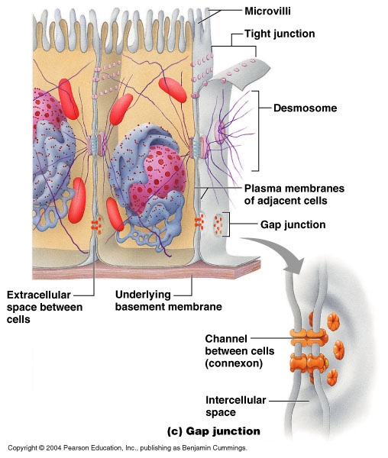
Transport Across the Plasma Membrane
Passive transport
Diffusion: tendency of molecules or ions to scatter evenly throughout the environment
- Simple diffusion
  - Molecule moves down its concentration gradient and are small enough to pass through the PM
  - Ex. Oxygen, fats
- Facilitated diffusion
  - Assisted transport
  - No ATP requires
  - Movement down concentration gradient
- A. Carrier-mediated
  - Larger molecules that cannot pass through the membrane or channels are carried through a transport protein
- B. Channel-mediated
  - Same as carrier-mediated but uses channels
  - Leakage channels are always open
  - Gated channels are controlled
- Filtration
  - Water and solutes forced through membrane or capillary wall by fluid or hydrostatic pressure
  - Ex. Fluid out of capillaries to cells of tissues to form urine
- Osmosis
Active Transport
Active: uses energy
Requires carrier proteins that combine specifically and reversibly with the transported substances
Solute pumps move substances against concentration gradient

Primary
- Uses ATP
- Sodium potassium pump stores energy by creating a steep concentration gradient for Na⁺ entry into the cell
Secondary
- Uses other forms of energy
- Symport: allows 2 transported substances to move in the same direction
Antiport: allows transported substances to cross the membrane in opposite directions
- As Na⁺ diffuses back into the cell through a membrane cotransporter protein, it drives glucose against its concentration gradient.
- Driven be the concentration gradient created in primary active transport

Vesicular Transport
Exocytosis (out)
- Vesicle moves to PM, fuses with PM, ruptures, releasing contents outside the cell
- Ex. hormones
Endocytosis (in)
- Using ATP, large particles can enter the cell from vesicles pinching off and moving into the cytoplasm

Osmosis
- Unassisted diffusion of water from an area of low to one of high solute concentration across a membrane
Osmolarity: total concentration of solute particles in a solution
- when the water concentration decreases because the number of solute particles increase in the solution
Toncity: the ability of a cell to change its shape due to osmosis
- Isotonic: same solute/water concentration –cell retains their shape
- Hypertonic: loses water from osmosis therefore shrinks
- Hypotonic: takes on water from osmosis until the cell bursts

Neurons
Special features
- Extreme longevity
- Amitotic
- High metabolic rate

3 Functional regions
- Receptive: dendrites, receive signal
- Conducting: axon, generates nerve impulses
- Secretory: axon terminals, releases neurotransmitters

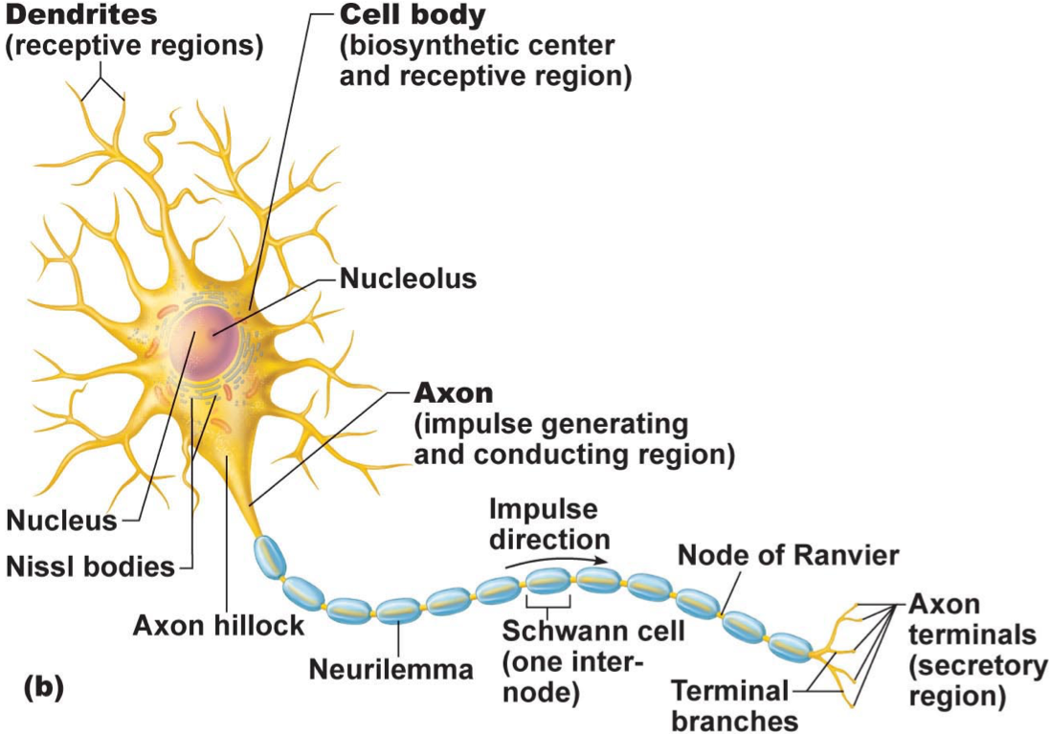

Larger diameter axons and ones with a myelin sheath on them conduct action potentials faster than smaller diameter axons without myelin sheath
Anterograde: moving forward, with the flow
Retrograde: moving backward, against the usual direction of the flow

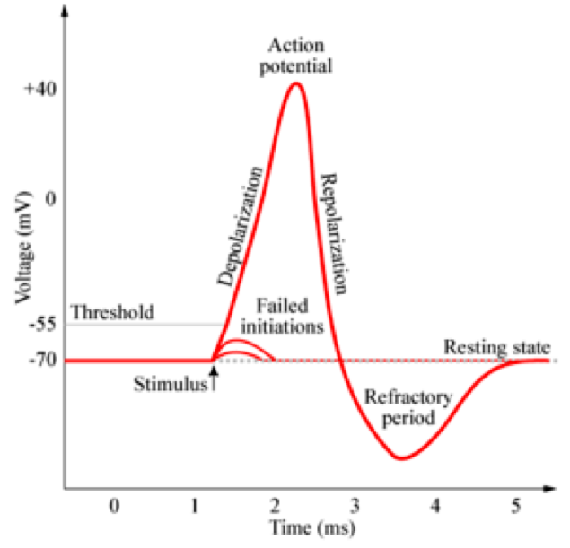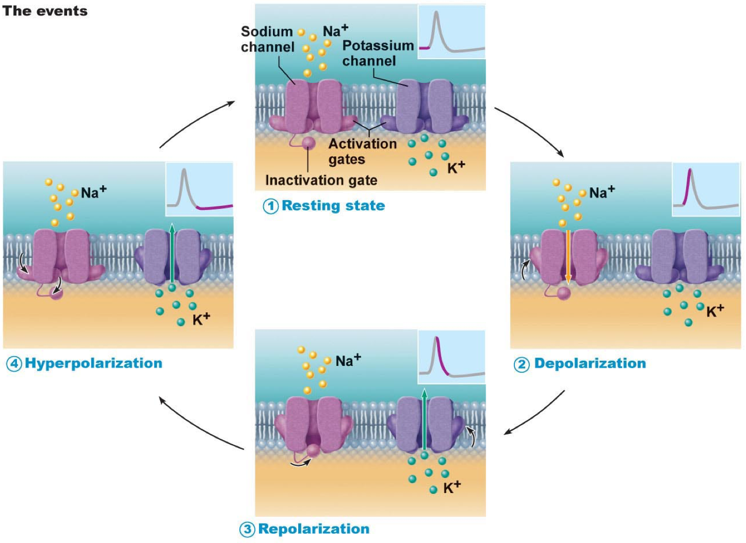

- Resting neuron is more negative on the inside of the cell (K)
- Polarized neuron is when one side of the membrane is positive and other is negative
- Action potential occurs when the resting neuron is depolarized (becomes positive inside the cell)

- Repolarization occurs once the action potential is finished –potassium ions exit the cell to rebalance the charges
- Hyperpolarization is when too much K exits the cell
- Refractory period is where no stimulus can be detecting
- Electrochemical gradient is an unequal distribution of charges across the membrane, then the difference in electric potential generates a force that drives ion diffusion until the charges are balanced on both sides of the membrane
- Graded potentials are changes in membrane potential that vary in size
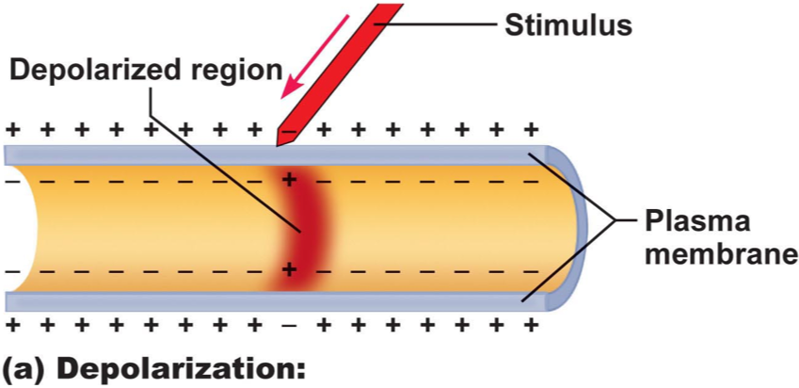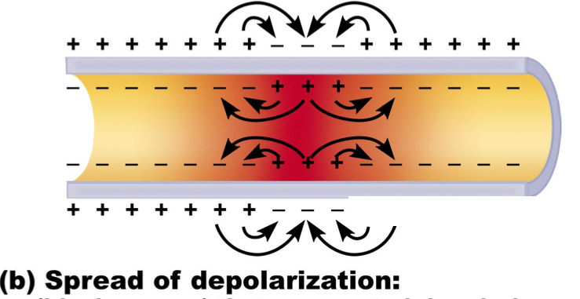
- Schwann cells produce myelin sheath around axons
  - Myelin sheath is an insulator allowing for action potentials to travel faster down the axon

Synapse
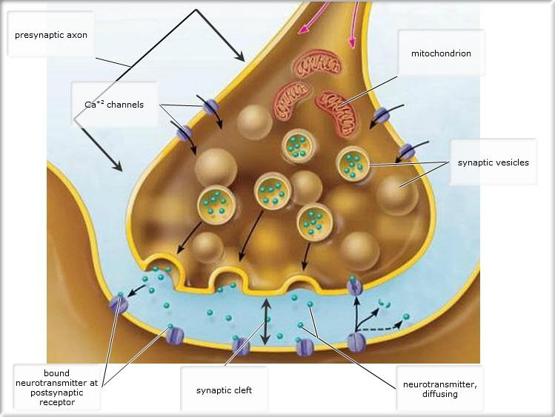
Presynaptic neuron: the neuron conducting impulses toward the synapse
Postsynaptic neuron: when the neuron transmits the electrical signal away from the synapse

Electrical synapse
- Less common
- Consist of gap junctions connecting the cytoplasm to the adjacent neuron allowing for the small molecules to flow directly from one neuron to the next
Chemical synapse
- Most common type of synapse
- Specialized to allow the release and reception of chemical messengers (neurotransmitters)

3 ways chemical synaptic transmission can be terminated
- Degradation
- Reuptake
- Diffusion

- An excitatory postsynaptic potential (EPSP) is a temporary depolarization of postsynaptic membrane potential caused by the flow of positively charged ions into the postsynaptic cell.
- An Inhibitory Postsynaptic Potential (commonly abbreviated as IPSP) is the change in membrane voltage of a postsynaptic neuron which results from synaptic activation of inhibitory neurotransmitter receptors

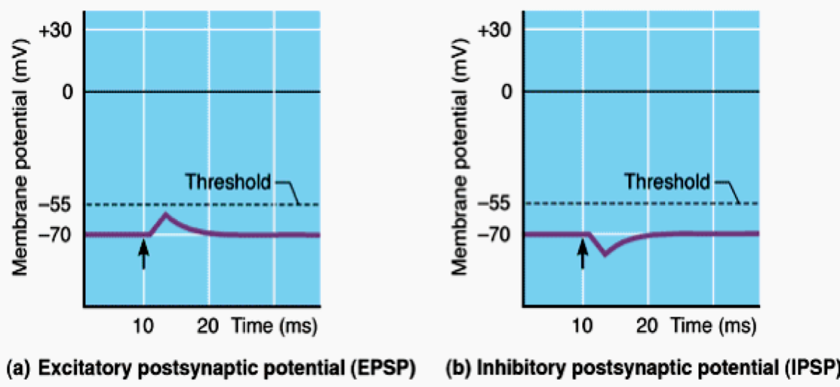

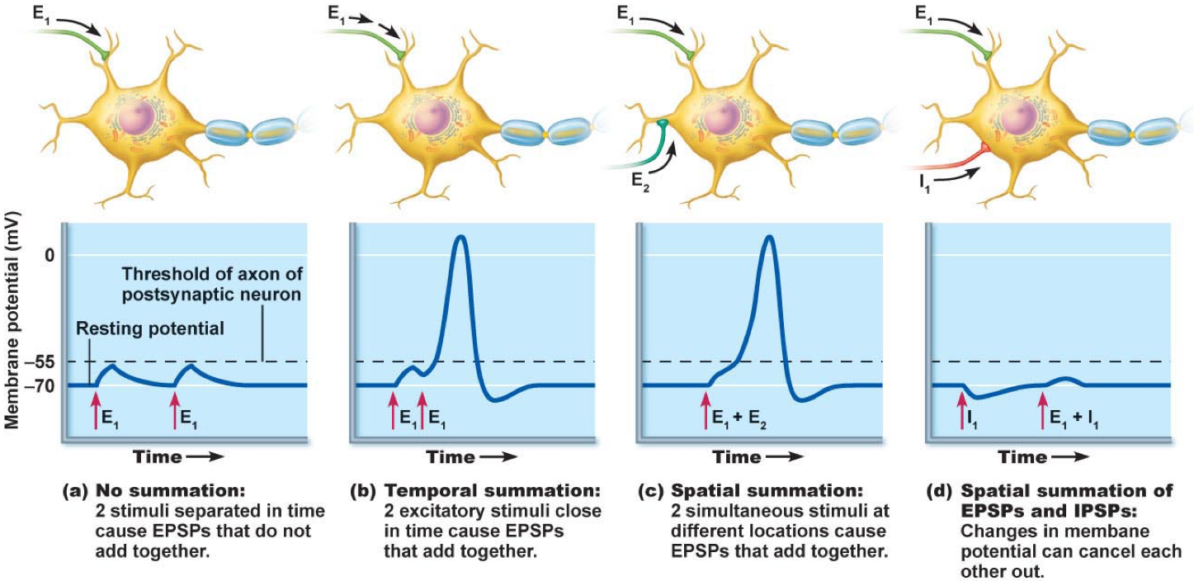
Summation
- Temporal
  - From ESPS
  - Single neuron
- Spatial
  - From multiple neurons

PP.3 Muscle Tissue
3 Types of Muscle Tissue
- Cardiac muscle
  - Occurs only in the heart
  - striated
- Skeletal muscle
  - Elongated (muscle fibers)
  - Voluntary muscles (conscious control)
  - Can contract rapidly, but tires easily
  - striated

- Smooth muscle
  - Elongated (muscle fibers)
  - Found in the wall of organs
  - Forces fluids and other substances through internal body channels

Muscle Functions
- Generate movement: locomotion, manipulation, blood flow
- Maintain posture and body position: constantly working against gravity
- Joint stabilization: ex. Shoulders, knees
- Generation of heat: maintenance of body temperature
Functional Characteristics of Muscle
- Excitability: ability to receive and respond to a stimulus
- Contractility: ability to shorten forcibly when stimulated
- Extensibility: ability to stretch or extended
- Elasticity: ability to resume resting length after being stretched

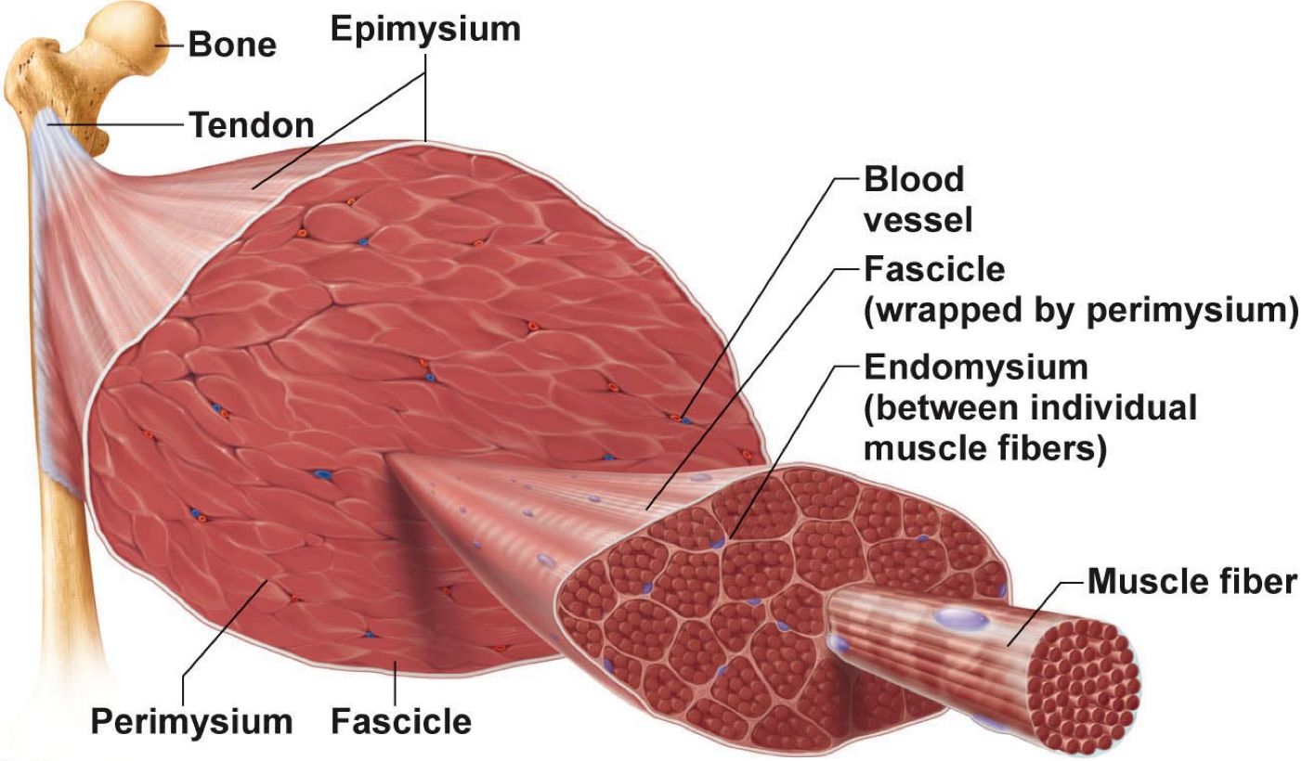

Epismysium: over coat of the whole muscle that consists of dens irregular connective tissue –keeps the muscle from bursting when contracting
Fascicle: bundles of muscle fibers
Perimysium: what wraps the fascicle
Endomysium: a sheath of connective tissue between each muscle fibers consists of areolar connective tissue

A singe muscle fiber contains 100’s of 1000’s myofibrils

Zones and Lines
- Z disc: darker region of the I band
- H zone: lighter region in midsection of A band
- M line: a dark line that vertically bisects the H zone

Sarcomeres
- The region between two successive Z discs
- Smallest contractile unit of a muscle
- Each one aligns end to end > striated
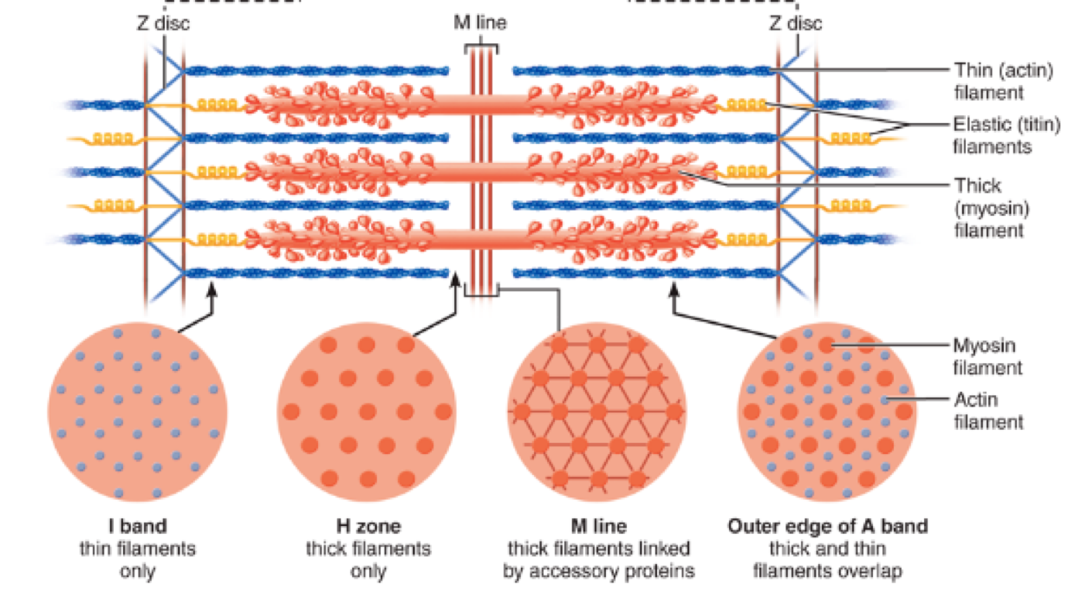 dotted lines

Myofilaments
- The muscle equivalents of the actin or myosin containing microfilaments
- Actin: thin filaments across I bands and partly into A bands
- Myosin: thick filaments entire width of A band

Sarcoplasmic Reticulum
- Shown in blue
- A web of ER around each myofibril
- Regenerates intracellular calcium and stores it to release when the muscle contracts
T tubules
- Shown in gray
- Hollow elongated tube between A and I bands
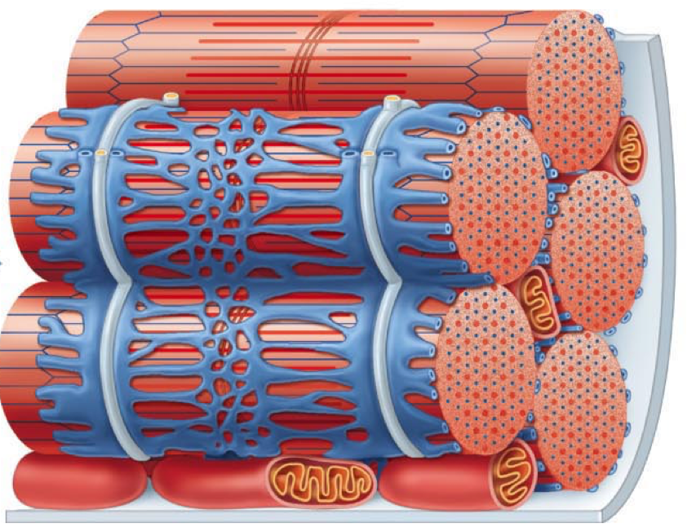

- Sliding filament model of contraction states that during contraction, thin filaments slide past the thick filaments so that actin and myosin overlap to a greater degree. Therefore, neither of the filaments change length during contraction
- But muscle fiber shortens because sarcomere shortens
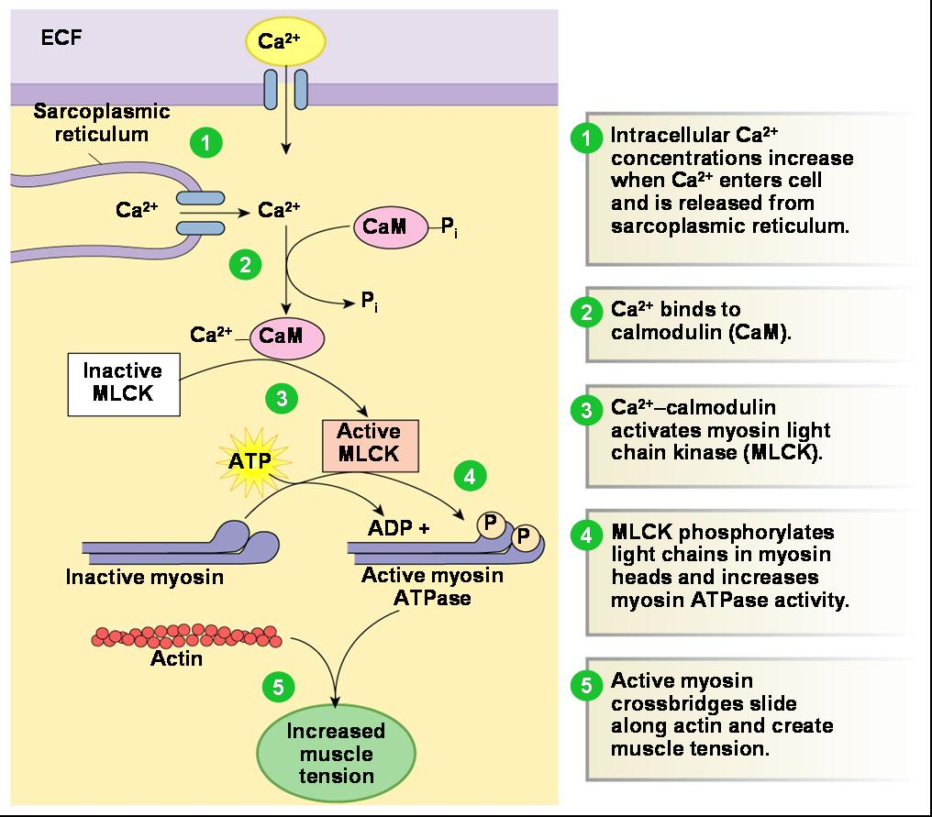

Four sources of energy for muscle contraction
- Stored ATP

- Direct phosphorylation of ADP by creatine phosphate

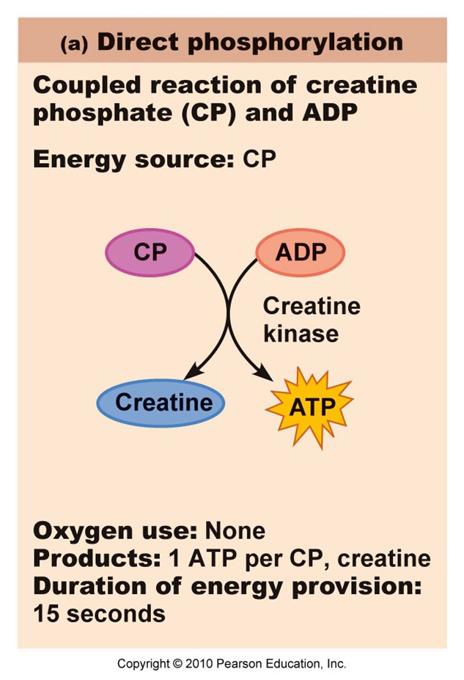
- Aerobic pathway
- Anaerobic pathway

Muscle fatigue
- Inability to contract
- Ionic imbalances contribute to muscle fatigue > lactic acid forms
- Results from not enough ATP
Oxygen Debt
- After exercise the oxygen needs to be replenished
- Lactic acid is converted to pyruvic acid
- Restocks ATP and CP
- Extra amounts of oxygen needed to be taken in to accomplish the above

Muscle Fiber types
- Slow oxidative fibers: thin cells with slow acting myosin ATPase > contracts slowly
- Fast glycolytic fibers: large fibers with fast acting myosin ATPase > will fatigue
- Fast oxidative fibers: fast acting myosin ATPase > fatigue resistant



