ANP 1105: Topic 1

1) Structural Organization of the Human Body

Chapter Objectives
- 1.1) Levels of Organization: Describe the levels of structural organization that make up the human body
- Chapter 1, pages 4-5
- 1.2) Cells: Summarize the major organelles and structures found in body cells
- Chapter 3, pages 83-96
- 1.3) Tissues: Describe the different tissues of the human body
- Chapter 4, pages 116-137

1.1 Levels of Structural Organization
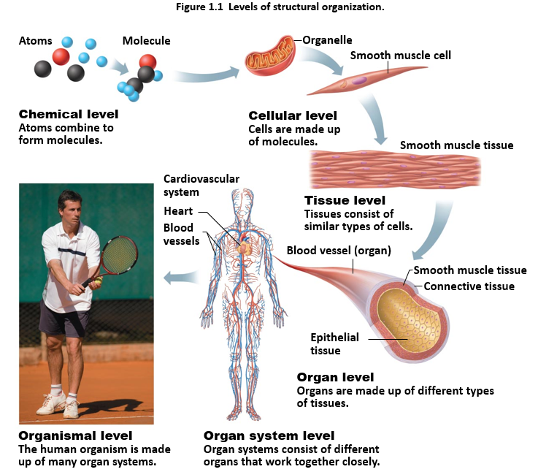
- Chemical
  - Atoms and molecules (chapter 2) and organelles (chapter 3)
  - Atoms (tiny building blocks of matter) combine to form molecules such as water and proteins
  - Molecules combine to form organelles (basic components of the cells)
- Cellular
  - Cells (smallest unit of human life) are made up of molecules (chapter 3)
  - Organelles function together to run a cell.
- Tissue
  - Groups of similar cells that have a common function (chapter 4)
  - Types of tissue: Epithelium, muscle, connective and nervous tissue
    - Epithelium covers the body surface and lines its cavities
    - Muscle provides movement
    - Connective tissue supports and protects body organs
    - Nervous tissue provides a means for rapid internal communication by transmitting electrical impulses
    - ** Goes more into depth further into notes (epithelium and connective—nervous and muscle covered in Topic 2
- Organ
  - A discrete structure composed of a least two or more types of tissue that performs a specific function for the body
- Organ system
  - Different organs that work closely together to accomplish a common purpose.
  - Ex. The heart and blood vessels work together in the cardiovascular system to see that blood circulates and delivers oxygen and nutrients to other areas of the body.
- Organismal
  - All organ systems/a living human being
  - It represents the sum of all structural levels working together to promote life.

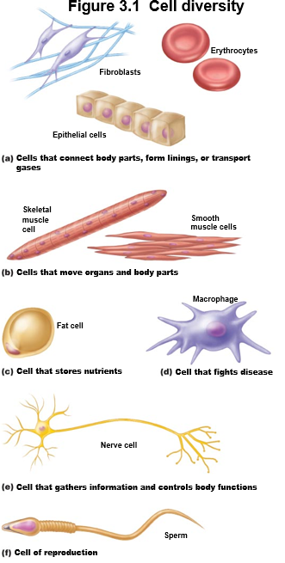
1.2 Cells/ The Cell Theory
Cell: Structural and functional unit of life
Cell Theory: All living organisms are composed of one or more cells. The cell is the basic unit of structure and organization in organisms. Cells arise from pre-existing cells.
- Organismal functions depend on the function of the cells
- Life depends on the continuity of cells
- The biochemical activity of cells depends on their shape/form and specific subcellular structure

Cell Diversity
There are over 200 different types of human cells all differing in size, shape, subcellular components and functions.

The cell is dynamic: This means that the cell integrates a variety of different biochemical and mechanical information while continuously adapting and responding to their local environment. For example, cells undergo mitosis, cellular respiration, energy production, waste production and excretion simultaneously by a variety of different organelles.

Figure 3.2—Generalized structure of cell
All cells have common structures and functions. For example, human cells all have:
- Plasma membrane: Flexible outer boundary of the cell that separates two of the body’s major fluid compartments (intercellular fluid within cell and extracellular fluid outside of cell).
  - Structure: Made up of a double layer of lipids (phospholipid bilayer, cholesterol etc. with proteins embedded within)
  - It also transports substances in and out of the cell.
  - Cellular extension: Microvilli increases surface area for absorption containing bundles of actin filaments (tubular extensions). They are finger-like extensions of the plasma membrane.
- Cytoplasm: Intercellular fluid (gel) in which organelles are suspended
- Nucleus: Contains DNA and controls the cell; transmits genetic info and provides instructions for protein synthesis
  - Structure
    - Nuclear envelope: Double membrane the regulates passage into nucleus
    - Nucleolus: Sphere in centre that holds ribosomal RNA and proteins
    - Chromatin: Consists of DNA and histone proteins and makes the genes
Other organelles:
- Mitochondria
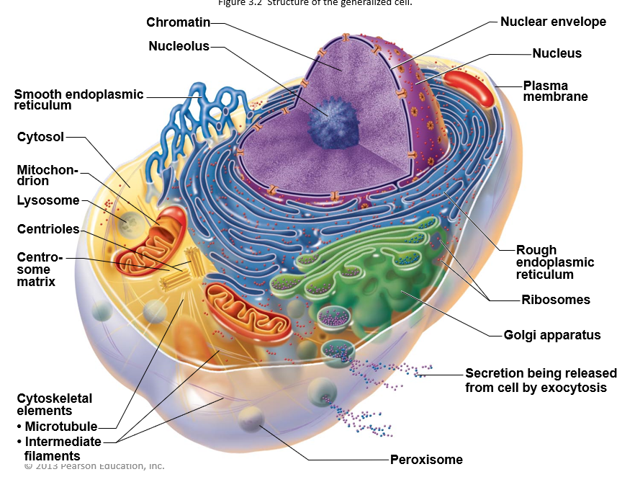
  - Function: ATP synthesis (energy production) and powerhouse of cell
  - Structure: Double membrane (cristae form folds) with a rod like structures inside.
- Ribosomes
  - Function: Translate mRNA into protein (protein synthesis); what make the rough endoplasmic reticulum rough
  - Structure: Particles consisting of ribosomal RNA and protein (two subunits). Can be attached to endoplasmic or free.
- Golgi apparatus
  - Function: Receives vesicles from ribosome (protein) and distributes packages to other areas of the cell for secretion from cell, digestion or incorporation into plasma membrane
  - Structure: Stack of flattened membranes near the nucleus
- Rough endoplasmic reticulum
  - Function: Sends proteins (with sugar attached) bound in vesicles to the Golgi apparatus and other areas. It also synthesizes phospholipids.
  - Structure: Membranous system encloses cavity, coiling through cytoplasm and studded with ribosomes.
- Smooth endoplasmic reticulum:
  - Function: Lipid and cholesterol synthesis/degradation and drug detoxification
  - Structure: Membranous system of sacs and tubules without ribosomes
- Peroxisomes
  - Function: Detoxifies substances; enzyme catalase breaking down hydrogen peroxide.
  - Structure: Sacs of catalase (small balls)
- Lysosome
  - Function: Digests food particles, bacteria or worn out organelles and disposes the waste.
  - Structure: Sacs (little balls) with acid hydrolases
- Cytoskeleton
  - Microtubule (cylinder made up of tubulin proteins)
    - Supports and gives cell shape; helps in movement and form centrioles, cilia and flagella
  - Intermediate filaments (protein fibers)
    - Form structure and resist forces acting on cell
  - Microfilaments (fine/ thin protein actin-think of actin in muscle cells)
    - Help in muscle contraction and forming cell cytoskeleton
- Centrioles
  - Function: Form base of cilia and flagella; also form a microtubule network during mitosis to form spindle and asters
  - Structure: Cylindrical bodies composed of nine triplets of microtubules
- Inclusions
  - Function: Store waste, nutrients and cell products
  - Structure: Varies, e.g. Fat droplets, protein crystals etc.
Other Cellular Extensions
- Cilia (like long hairs—consist of microtubules)
  - Propels substances across cell surfaces
- Flagellum (little tail e.g. Sperm cell)
  - Propels cell

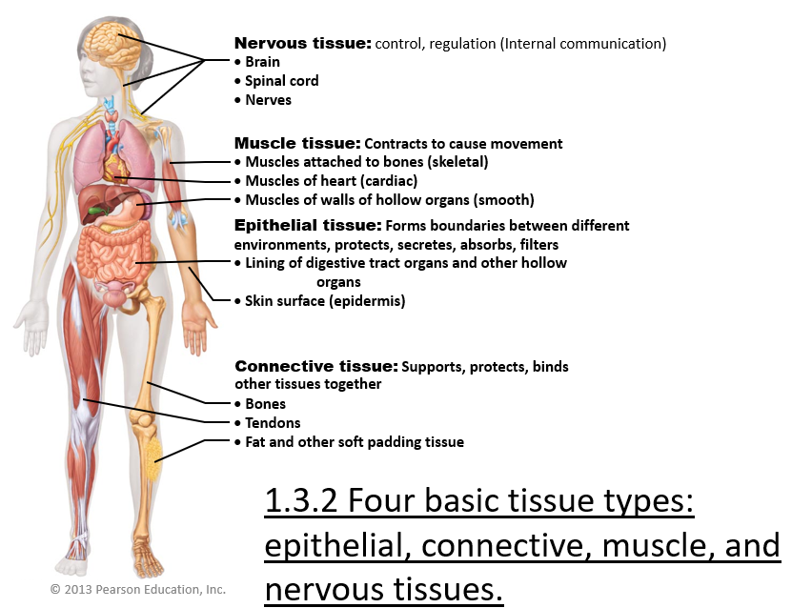
1.3 Describe the different tissues of the human body
Cells are specialized, each performing a specific function to maintain homeostasis.
Histology is the study of tissues which are groups of cells similar in structure that perform common or related functions (1.3.1)

Types of Tissues
- Epithelial (covering)
- Connective (support)
- Nervous (control)
- Muscle (movement)
1.3.3 Define Epithelial Tissue and its Functions
Epithelial tissue is a sheet of cells that covers a body surface or lines a body cavity. It consists of two sections (a) the covering and lining epithelium creates boundaries and (b) the glandular epithelium promotes secretion.
Almost all substances received or given off by the body must pass through an epithelium. For example, the epidermis of the skin lies between the inside and the outside of the body and epithelium lining the urinary bladder separates underlying cells of the bladder wall from urine.
6 Epithelial Functions (SAFE PS)
- Protection (mechanical and chemical injury and bacterial infection)
  - Skin
  - Epithelial cells are connected by tight junctions to provide protection for the cell
- Absorption (nutrients/water)
  - GI tract (where food is digested; this includes intestines and stomach)
- Filtration (toxins)
  - Kidney
- Excretion (toxins)
  - Kidneys
- Secretion
  - Glands such as sweat glands
- Sensory Reception (reacts to physical stimulus in the environment)
  - Taste buds, olfactory membranes
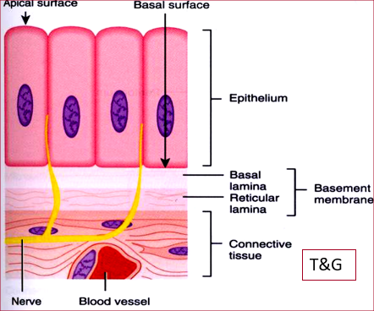
Apical surface: Top surface of epithelia; faces body exterior or cavity of internal organ. It is not attached to surrounding tissue.
Figure 1.3.3, 1.3.4
Basal surface: Faces the interior of the epithelia and is attached to the underlying connective tissue.
Basal lamina: Epithelial cells lie on top of the basal lamina
Reticular lamina: Basal and reticular lamina form the base of the membrane to provide support for the epithelial cells and provides filtration and waste for products and nutrients from the connective tissue containing blood vessels.

1.3.4 Seven Special Characteristics of Epithelial Tissue (BRASS PC)
- Cellularity: Epithelial tissue are composed almost entirely of loose-packed cells with some extracellular material between the narrow spaces left.
- Specialized contacts: Epithelial cells fit close together forming continuous sheets. Adjacent cells are bound together by lateral contacts including tight junctions and desmosomes. This is to create barriers.
  - Tight junctions: Prevent substances from leaking through
  - Desmosomes: Keep cells from pulling apart
- Polarity: Epithelia have apical surface and basal surface (mentioned above) so all epithelia exhibit polarity (cell regions near apical surface are different in structure and function than the regions near basal surface). Therefore, it is said that the epithelia exhibit apical-basal polarity.
  - Microvilli: Apical surface can be smooth but often have microvilli which increase the exposed surface area and allows for more secretion and absorption of substances (such as in intestinal lining). Microvilli are also dense so that cell apices appear fuzzy, forming brush borders.
  - Cilia: Some epithelia (lining of trachea) have motile cilia that propel substances along their surface.
- Basal lamina: It is a thin supporting sheet that lies adjacent to the basal surface. The non-cellular, adhesive sheet consists largely of glycoproteins secreted by epithelial cells. It acts as a selective filter that determines which molecules from the underlying connective tissue will enter the epithelium. It also acts as a scaffolding where epithelial cells can come and repair wounds.
- Supported by connective tissue: Epithelial sheets rest upon and are supported by connective tissue. The reticular lamina (layer of extracellular material containing a fine network of collagen protein fibers in connective tissue). The basal and reticular lamina form the basement membrane which reinforces the epithelial sheet, helping it to resist tearing and stretching and defining the epithelial boundary.
  - Epithelial cancer cells fail to respect that boundary (important feature) so they penetrate to invade tissue below (skin cancer)
- Avascular but innervated: Epithelium is innervated (supplied by nerve fibers), it is avascular (has no blood vessels) so it is supplemented with nutrients from the underlying blood vessels in the connective tissue.
- Regeneration: Epithelium has a high regenerative capacity as it is sometimes exposed to friction and their surface cells rub off. Some are also damaged by hostile external environments (bacteria, acid, smoke). Epithelial cells divide regularly to regenerate and protect our bodies if they receive adequate nutrition.
1.3.5 Indicate the 2 criteria used to classify epithelial cells
The epithelium is given two names. The first refers to number of cell layers present and the second refers to the shape of its cells.
1. Number of Cell Layers
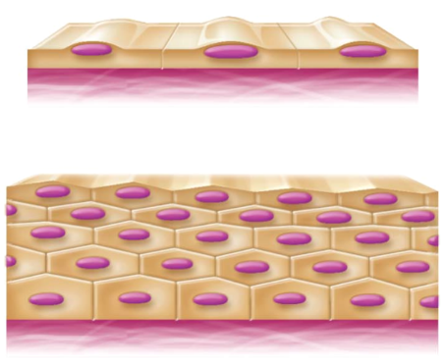
- Simple epithelia: Single layer of cells
  - Found where absorption and filtration occur with thin boundaries
  - All cells have the same shape
- Stratified epithelia: Two or more layers of cells
  - Occur in high-abrasion areas where protection is important such as skin or lining of mouth (more durable than simple)
  - Cells regenerate from below-basal cells divide, cells migrate to surface
  - Epithelia classified by cell shape in apical layer (top) due to variety in shape of cells within layers
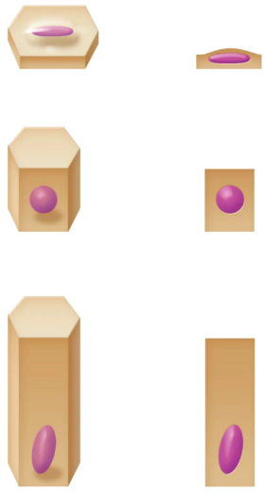
2. Cell Shape
The nucleus always conforms to the shape of the cell.
- Squamous cells
  - Flattened and scale like
  - Nucleus flattened
- Cuboidal cells
  - Boxlike (tall as they are wide)
  - Nucleus round
- Columnar cells
  - Tall, column shaped
  - Nucleus elongated (located close to the cell base)
1.3.6 List the 4 types of simple epithelia (Refer to pages 119 to 123 in textbook)
1) Simple squamous epithelium
- Two types:
  - Endothelium: Located in the heart and blood vessels.
  - Mesothelium: Found in serous membranes
2) Simple cuboidal epithelium
3) Simple columnar epithelium
4) Pseudostratified columnar epithelium

1.3.7 Stratified Squamous Epithelium *Refer to picture in slides/textbook (pg. 122-123)
- Most widespread of stratified epithelia.
- Surface cells are squamous but deeper layers are either cuboidal or columnar
- Farthest cells from basal layer contain more nutrients and are less viable
- Located where there is a lot of wear and tear (stress) such as our skin

1.3.7.1 Transitional Epithelium
- Resembles both stratified squamous and stratified cuboidal
- Located in areas where there is a lot of stretching (e.g. The bladder to allow for stretching when you need to go pee, holds the urine)

1.3.8 Glandular Epithelia
Gland: One or more cells that make and secrete an aqueous fluid called a secretion. It is classified by:
- Site of product release
  - Endocrine: Release product (hormones) directly into blood (they are ductless); inner secreting glands
  - Exocrine: Release products into ducts (mucous, swat, oil/salivary glands, liver, pancreas); outnumber endocrine glands; secrete products outside of body
    - Unicellular exocrine glands secrete their products directly through exocytosis
- Relative number of cells forming the gland
  - Unicellular (endocrine): No ducts because only one cell (ex. Goblet cells in digestive and respiratory tracts, they secrete mucus into inner lumen of intestine)
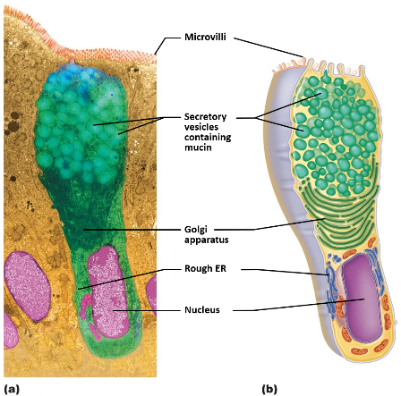
  - Multicellular (exocrine): Epithelium derived duct and secretory cells; surrounded by supportive connective tissue which brings blood vessels and nerves and holds ducts.
Goblet Cell
Goblet Cells
- Unicellular exocrine gland
- Secretes mucous
- They are sprinkled in epithelial linings of the intestinal and respiratory tracts with columnar cells.

Classification of Multicellular Glands (page 125)
By structure and type of secretion
- Structure
  - Simple glands (unbranched duct) or compound glands (branched duct)
- Secretory Unit
  - Tubular (secretory cells form tubes)
  - Alveolar (secretory cells form small flask like sacs)
  - Tubuloalveolar (secretory cells of both types of secretory units)
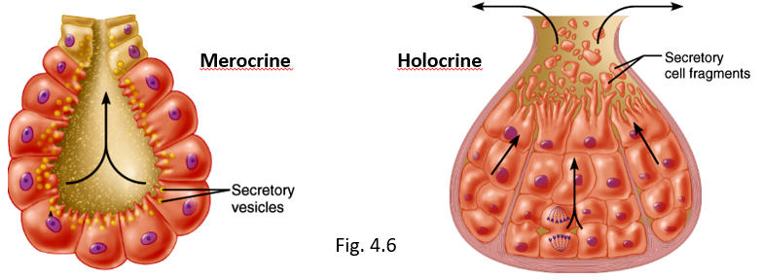
- Type of secretion
  - Merocrine (MERELY secrete)
    - Most common, secretes products by exocytosis as they are produced, and secretory cells are not altered in any way.
    - E.g. Pancreas, salivary glands, sweat glands
  - Holocrine (Sacrifice themselves as a WHOLE to secrete)
    - Accumulate products within then rupture
    - E.g. Only sebaceous glands (secretes oily matter e.g., hair)
  - Apocrine (Pinch of APEX)
    - Accumulates products within then apex pinches off
    - They don’t know if this happens in humans (controversy)
    - E.g. Mammary glands

1.3.9 List the 5 types of CT; list the 4 main functions associated with CTs **CT=connective tissue
5 major types:
- Mesenchyme (in embryonic tissue)
- CT proper
- Cartilage
- Bone
- Blood
Main Functions:
- Binding or support
  - Bone and cartilage provide support
- Protection
  - Bones and cartilage also provide protection of body organs
- Insulation
  - Adipose provides good insulation, protects body organs, stores energy and can act as a form of fat
- Transportation
  - Blood transports nutrients, oxygen and waste (CO₂) into and out of the body.

1.3.10 Describe the structural organization of CT in general
Three Structural Elements of CT:
a) Ground substance: Interstitial fluid and cell adhesion proteins and proteoglycans molecular sieve.
- Fibronectin, laminin-helps attach CT elements
- Proteoglycans-Trap water (compound protein with GAGs)
b) Fibers
- Collagen fibers: High tensile strength
- Elastic fibers: Elastin has coiled structure to allow stretch and recoil
- Reticular fibers: Thin collagenous protein; fine network to support blood vessels, soft tissue
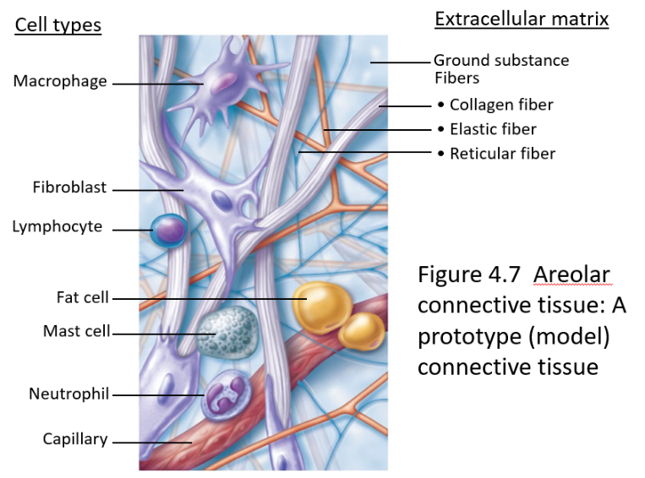
c) Cells: Immature (“blast”) forms vs mature (“cyte”) forms
Figure 3: Good to Know for Midterm
- “Blasts” are actively dividing/synthesizing cells during growth and repair
- “Cytes” primarily provide a level of maintenance
- Others—fat cells, immune cells (WBC, mast cells, macrophages)
  - Mast cells mediate inflammation
NB: CT are living cells surrounded by matric; details vary by tissue type

Connective Tissue Cells
- Fibroblasts: Become fibrocytes in connective tissue proper
- Chondroblasts: Become chondrocytes in cartilage
- Osteoblasts: Become osteocytes in bone

1.3.11 List and describe the 3 kinds of loose CT, its location and function
Refer to pictures from the textbook or pictures from slideshow

1.3.12 List and describe the 3 kinds of dense CT
Do the same as above

1.3.13 List the other remaining types of connective tissue
1. Cartilage: Features between dense CT and bone; tough but flexible
- Avascular (no blood vessels), devoid of nerve fibers
- Ground substance contains lots of the GAGs chondroitin sulfate and hyaluronic acid also chondronectin (adhesive protein)
- Collagen fibers (can have some elastic fibers)
- Up to 80% H₂O
2. Bone: Calcium salts gives hardness and strength for support/protection of softer tissues; cavities for fat storage and synthesis of blood cells
- Osteoblasts: Bone producing cell, mature into osteocytes
- Osteocytes: Mature bone cell, reside in lacunae (spaces in bone matrix)
- Osteoclasts: “Bone breakers”
3. Blood: Fluid within blood vessels. It does not connect things or give support. It is classified as a connective tissue because it develops from mesenchyme and consists of blood cells surrounded by a non-living fluid matrix called blood plasma.
- Transports respiratory gases, nutrients, wastes and other substances
- Has red and white blood cells
- Fiber components are soluble protein molecules that are only visible during clotting

