Chapter 3

Charles Darwin and Evolution
Life:
- Father was a doctor
- Married to his cousin, had 10 children
- Stopped his studies in medicine to take interest in religion
- Developed interest in nature: taxidermy, botany, insects, etc
Voyage on the beagle:
- ship commissioned to do cartography of South America
- Darwin became naturalist of voyage
- 2 books had an impact on Darwin:
  - “Theology, or evidences of the existence and attributes of the deity”: Harmony and design in nature are indicators of the existence and the acts of God
  - Lyell: “Principles of Geology”:
    - Darwin, at the beginning, believed in the great flood and in cuvier’s catastrophism
    - After trip, he was in agreement with Lyell and Hutton’s principle of uniformity
- The very distinct fauna of south america had a profound effect on Darwin:
  - Why do the fauna and flora of Africa, Europe, Australia and South America have relatively few species in common? – i.e. why did god create different species on different continents?
  - Why are the animals and plants of the temperate zones of South America resemble the species living in the tropical zones of South America but not the species in temperate Europe?
    - they have different habitats but they look alike – this did not fit Lamarck’s theory of environmental determinism (recall: theory states that environment is the sole determinant of species features)
  - Why are the mammal fossils of South America absent from the current fauna (e.g. Giant Sloth)? Why do these fossils show resemblance with current species found only in South America (e.g. Three-toed Sloth)? – this did not fit Cuvier’s catastrophism theory
  - Why do species on Galapagos islands resemble species on SA continent?
    - E.g. Galapagos marine iguana, Galapagos sea lions (closely resemble Californian sea lion)
  - Why is there so much shell variability on turtles in galapagos?
  - Why so much morphological variability in one group? (ex. Darwin’s finches – all have the same body, but all different beaks?)
  - Why does each island have their own species?

In 1837, we find in Darwin's notes the first mention that species show resemblance to each other because they share a common ancestor (not a common environment – like Lamarck thought).
- Rejects the fixity (no change) of species and accepts the concept of descent with modifications (evolution).
- Very materialistic view of life that is in contradiction to the religious dogma of the time.
- Rejects Lamarck’s evolutionary mechanism (environmental determinism)
Then, he begins the search for an evolutionary mechanism.

Example: Darwin’s finches
- Darwin finds multiple species of finches with morphological differences on the Galapagos islands
- Hypothesis: finches share a common ancestor (bird from south America) that flew to Galapagos and deviated into multiple species
  - Species have morphological differences based on their beak size, and their diet
- This is a fairly recent event – few fossils of these species

Darwin also wanted to explain gaps in species, i.e. closely related species with different morphological characteristics (ex. Dugong and African elephant)

99% of species that have lived on earth are now extinct (most of the evolutionary branches finish in dead end)
- fossils will fill the gaps in between these species (show the intermediate steps in evolutionary path)

Natural Selection
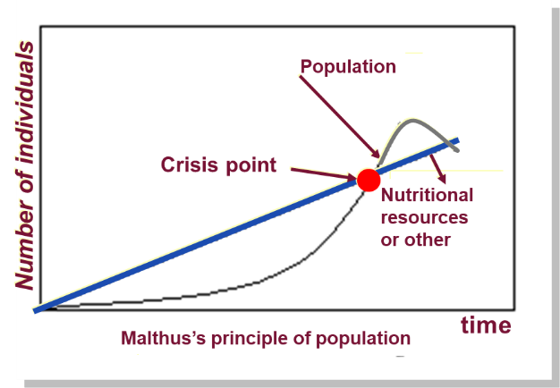
- Darwin did not have a mechanism of evolution that could explain his theories. The only one available at the time was Lamarck’s, which he was not satisfied with
- He was inspired by Malthus’ “An essay on the principle of population”:
  - Every human population tends to increase geometrically (exponential growth), whereas the available resources to feed these populations increase arithmetically
  - Crisis point – the population becomes too large for the resources available
(stable growth)

The human population increase faster than its capacity to feed itself. This leads to chaos (famine, sickness, war, etc.) and eventually to a substantial reduction in population size.
-Once you go through this crisis, there would be winners and losers
- this concept of winners and losers in humans inspired Darwin – thought the same concept could be applied to nature and animals

Darwin’s first observation: all species can produce more offspring than their environment can sustain and many of these offspring fail to survive and reproduce
- puffball: releases spore cloud that will become mushrooms
- maple tree seeds: large bundle of seeds for dispersion
- fish: can produce hundreds of thousands of eggs

In reality: very few of these seeds/eggs will actually reach adult stage and reproduce
-i.e. there are very few winners
- these winners must have some kind of unifying hereditary characteristic that makes them survive

Darwin’s second observation: Members of a population often vary in their inherited traits - there is a lot of genetic variability within species/population
- recall: past evolutionary thinkers rejected variability, saw it as an imperfection – Darwin saw variability as the key to evolution

Two inferences:
- individuals whose inherited traits gives them a higher probability of surviving and reproducing in a given environment tend to leave more offspring than other individuals
- from generation to generation, this unequal capacity of surviving and reproducing (differential reproductive success) results in an accumulation of favorable traits in a population (as unfavorable traits die out)
  - this is natural selection. It enables the emergence of adaptations

Example: Fish coloration
- population of fish, with genetic variability in their coloration
- predators are more likely to attack fish that contrast their environment, because they are more visible
- after several generations, brightly colored fish are more likely to die off and be attacked, while camouflaged fish have a higher probability of surviving
  - the camouflaged fish reproduce more often, producing more fish with the same advantageous coloration (recall: inherited traits!)
  - differential reproductive success brightly colored fish do not reproduce as often/successfully
    - over time, if environmental factors (called selective pressures) stays the same, the camouflaged fish will become more abundant in the population
- if selective pressures change, the trend changes: let’s assume the colour of the water changes because of climate change
- now, the red fish no longer have the favored trait – the blue fish do. Blue fish reproduce more often, producing more offspring with the same favored trait that they have – now blue fish become more abundant.
  - Note: there is no “fixed” goal in natural selection – not a quest to change the species to be perfect. Natural selection causes species to change to adapt to their environment. If the environment changes, the favoured traits will change.

- It is a letter from Alfred Russel Wallace (1823-1913), received in 1853, that forced Darwin to publicly release his ideas.
- Wallace had come to the same conclusions as Darwin concerning the theory of natural selection by observing the fauna of Indonesia.
- Thus, it was 23 years after his voyage on the Beagle that Darwin publicly released his views on the evolution of species.

Darwin publishes the first edition of his book: “On the origin of species”
- Darwin provided many examples of natural selection
- he obeys the 4 clauses of contract of science and knowledge
  - skepticism on facts – he became skeptic of cuvier’s idea of catastrophism after seeing fossils that were similar to each other
  - realism – although is a catholic, does not invoke his beliefs into his work. He does not remain fixed his past beliefs – once he observes what his actually happening in nature, those observations took priority over his beliefs.
  - rationality – his theories come from logical steps of reasoning
  - methodological materialism - doesn’t invoke god/belief/surnatural forces, relies solely on observations of nature

Important notions linked with natural selection:
- Individuals do not evolve, populations evolve (contrary to Lamarck)
  - Individuals cannot evolve, we are simply a carrier of genes given to us at birth
- Only hereditary traits are subject to natural selection (unlike Lamarck and his acquired characteristics)
- For evolution to occur, we need genetic variability.
- Natural selection corresponds to differential reproductive success (capacity to transmit genes to a next population) within a population from generation to generation.
- The mechanism is not random. Specific traits are more likely to be passed on to new generations because of their ability to help species become better adapted to their environment.
- Natural selection does not have a fixed goal – it is not a quest for perfection. It does not lead to the appearance of perfect traits – only helps species adapt to environment, which is changing
  - Environmental factors vary in time (ex. Climate change) and space (geological and geographical changes). Thus, the selective forces are variable.
- Traits in populations will change and can modify the species, or cause new species to arise.

For Darwin this mechanism is valid because:
- It respects the principle of uniformity of lyell and hutton
- The laws of natural selection are visible in nature
- The mechanism can be verified on current populations (e.g. artificial selection) – his hypothesis is verifiable
  - Darwin bred pigeons to prove his idea
- It is a materialistic concept (no need for divine intervention):
Artificial Selection is finalized because the goal is fixed well in advance and precedes the causes. The end result can be obtained in a few generations.
Natural Selection is not finalized. It can take a long time for changes to occur (geological time scale). There is no fixed goal, as it changes depending on how the selective pressures change.

Example: the peppered moth
- Moth species displays genetic variability in the coloration of the moth – black and grey. This genetic variability is already existent.
- During industrial revolution, most birch trees appeared black because of the soot on the trees.
- Grey moths on black trees were more likely to be spotted and eaten by birds
- Black coloration became the advantageous trait and had higher reproductive success – because this trait is inheritable, they passed on trait of black coloration to offspring
  - This differential reproductive success accumulates over time, in these areas % of black moths increased.
  - As a whole, the population evolved to become better adapted to their environment, since more and more of the population could now camouflage to the tree
- This hypothesis was not falsified: in the country-side, trees appeared grey/white
  - Black moths were more visible to predators
  - For the same reasons that the black moths were more abundant in the soot-colored trees, grey moths became more abundant in the country side
- Years later, when society attempted to reduce amount of coal in environment (filters) – selective pressures changed, and grey moths became more abundant everywhere
  - Note: natural selection does not have a fixed goal – it simply allows individuals to become better adapted to their environment – if the environment (selective pressures) change, then the favoured traits will change

Example: climate and the medium ground finch
- During the drought, population of 1200 adults diminished to 80
- Hypothesis: selection favours individuals that have bigger and stronger beaks to break available seeds during the drought
- Study: they tagged birds and their offspring in nests → Enabled them to measure the heritability of the height of the beak
- Results: the remaining surviving birds had the largest beak sizes
- Explanation: the plants that were wiped out by drought had the smallest seeds – plant that survived has larger seeds – birds that could break larger seeds had favourable traits

Example: humans and altitude
- High altitude: danger of altitude sickness
  - Over 2000m, the partial pressure of O₂ is insufficient for normal saturation of hemoglobin for a traveller in high altitudes
    - Shortness of breath, altitude sickness
    - Physiological response (acclimatization): after a few days, the body compensates the low partial pressure of O₂ by increasing the concentration of red blood cells in our blood. (health risks associated with increased blood cells: thrombosis, edema, etc.)
- Tibetan people has advantage: genetic traits favour living at high altitudes
- Abundance of favourable trait in Tibetan people:
  - 22000 years ago, humans moved to Tibet Plateau (3500m elevation) – this population displayed genetic variability in traits – some
  - After generations and generations, % of population with favourable traits becomes increased.
- How this example of altitude disproves Lamarck’s theory of environmental determinism:
  - Adaptation in the Andes: increase in hemoglobin concentration
  - Adaptation in Tibet: deeper breath, larger pulmonary capacity, increased blood flow
    - These adaptations do not appear because they go into high altitudes, these already-existing adaptations become favourable after they go into high altitudes
    - These populations have different genetic basis, which affects how their populations evolve
      - Natural selection is dependent on inherited traits and the environment, not just the environment (like Lamarck thought)

In these three examples (moths, finches, humans) the hereditary traits that give a reproductive advantage (i.e. adaptation) to individuals in a population will be favoured. Thus, from generation to generation, there will be a higher percentage of individuals carrying the adaptation. This is natural selection.
These adaptations can sometimes redefine a species and, in certain circumstances, define a new species.

Proof of Evolution:
Homology
- Descent with modification theory explains the resemblance between certain traits even if the functions are different. (Homologous structures)
- Example: some chordates vary widely in morphological features – such that one might question how they are related
  - However, sometimes you must look at embryos to see homology.
  - Ex. Embryos of fish, chickens and humans have similar features, such as pharyngeal pouches and the post-anal tail
    - In chicks and humans, pharyngeal pouches develop into the throat
    - In fish, the pharyngeal pouches develop into gills
    - Post-anal tail is not in use and regresses in humans
- Homologous characteristics are used to differentiate between phylogenetic groups
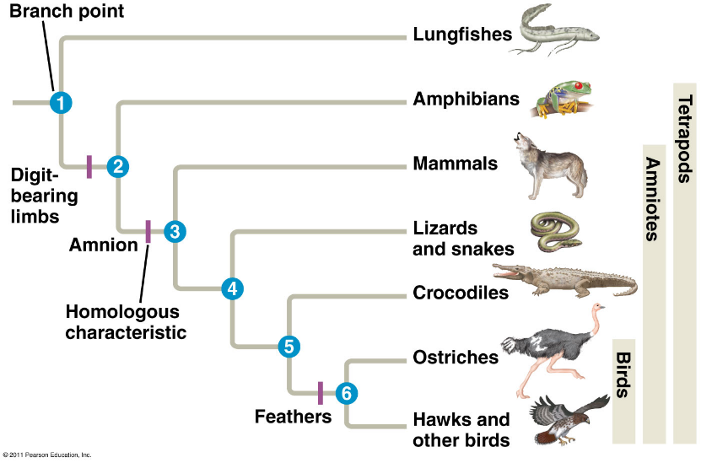

Proof of Evolution: Fossils
EVOLUTION OF THE HORSE:
Linear evolution:
- -over time foot becomes simple and simpler – toe bones disappear (no longer necessary; less bones in distal end = less weight to carry = more speed)
- -over time, teeth become longer (as horses left forest habitat and moved into prairies – they became grazers (feed on grass). Teeth became longer to compensate for increased wear and tear on the teeth due to erosion from dirt and sand
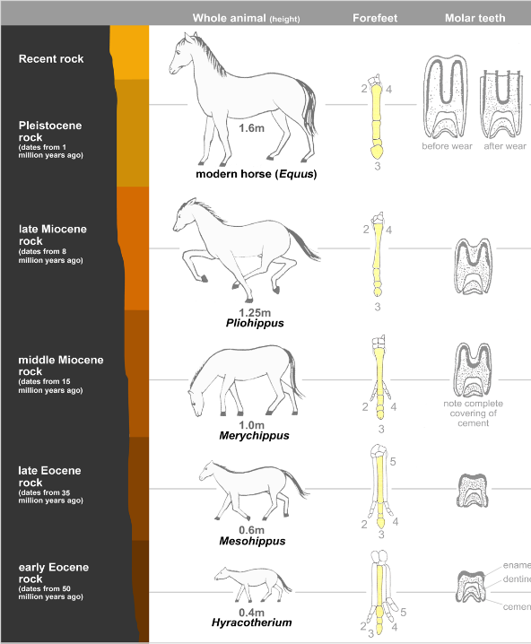
In reality:
- Evolution is not linear! That is an oversimplification of horse evolution. There are multiple hidden species that graphic does not show – those species became extinct
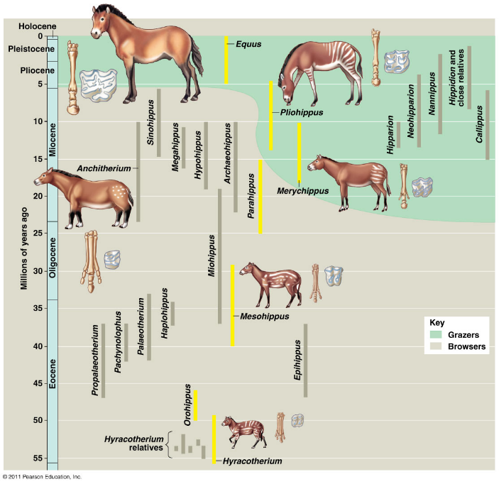

vestigial structure: anatomic structure that has lost almost all of its initial function
Hippopotamuses are related to whales – they have many morphological differences for example. These missing gaps are evident by looking at fossils.

Between the hippo and whale, the pakicetus fills in missing gap. pakicetus is ancestor of whales. From pakicetus to cetaceans (whales) there is regression of the hindleg. Overtime, the hindleg disappeared because of a lack of need in an aquatic environment.
- the only remnant of the hindleg in the whale is the pelvis – which is a useless structure that is hidden in the flesh. However, its presence is evidence of evolution – shows that the whale evolved from an ancestor with limbs.

Examples of vestigial structures:
- Third eyelid, or nicitating membrane is the remnant of functional structure in other vertebrates – a translucent membrane that can slide over the eye for protection, while still allowing the animal to see.
  - In humans, it has become functionless and cannot move – however its presence is an indication of common ancestry with other mammals
- Appendix: a projection of the caecum. The caecum contains microorganisms and bacteria that will help digest vegetation. For this reason, herbivores have large caecum. As humans developed more omnivorous diets, the large size of the caecum became unnecessary – so it folded into a small projection (appendix).
  - This is an indication that humans evolved from an herbivorous species
- Goosebumps cause hair to rise when an individual is cold or scared. Rising of hair creates a layer of air between the skin and the tip of the air, which insulates the body. This adaptation is only useful for species with greater body hair density. Humans evolved to not have fur because of a lack of need.
  - In humans, goosebumps are useless because we have little body hair. However, this indicates that we have evolved from species with a lot of body hair.
- Phrenic nerve: starts at the 4th cervical vertebrae and goes through the thoracic cage, towards the diaphragm and epiglottis
  - Hiccups occur when the phrenic nerve gets pinched or squished between organs because it is so long
  - Why is it so long? The phrenic nerve developed in fish, whose respiratory systems are located near their throat, so their nerve is a lot shorter. As mammals evolved, respiratory system moved down to the chest → phrenic nerve elongated to reach the chest

