- Structural Organization of the Human Body
HELPFUL TEXTBOOK PAGES:
- Pg. 94-96 table 3.4

1.1. Describe the levels of structural organization that make up the human body (pg. 4-5)

1.1.1. Define: atom, molecule, organelle, cell, tissue, organ, organ system, give an example of each and localize each in the hierarchy of anatomical structure.
- Atom: the smallest particle of an element with all the properties of that element (consists of protons, neutrons, and electrons)
- Molecule: the smallest amount of a substance that can exist alone (consists of a combination of atoms)
- Organelle: the basic components of living cells (consists of molecules)
- Cell: the fundamental structure or living things (consists of nucleus and other organelles)
- Tissue: a group of similar cells that have a common function (4 types; epithelium, muscle, connective, and nervous.)
- Organ: structure composed of at least 2 (but usually 4) tissue types
- Organ System: organs that work closely together to accomplish a common purpose

1.2. Cells: describe the major structures found in body cells
- Nucleus: the control centre of the cell; contains genetic code for making proteins
- Cytoplasm: fills the space between the nucleus and the plasma membrane
  - Cytosol: a viscous fluid which other components are suspended (consists of water, proteins, salts, sugars etc.)
  - Organelles: basic components floating around
  - Inclusions: stored nutrients, secretory products, and pigment granules.
- Plasma Membrane: semi-permeable wall enclosing the cell
- Intracellular Fluid: inside membrane
- Extracellular Fluid: outside membrane

1.2.2. List, recognize the structure, and indicate the functions of each of the following organelles: mitochondrion, peroxisomes, endoplasmic reticulum, Golgi apparatus, lysosome
  - Mitochondrion
    - Site of ATP synthesis
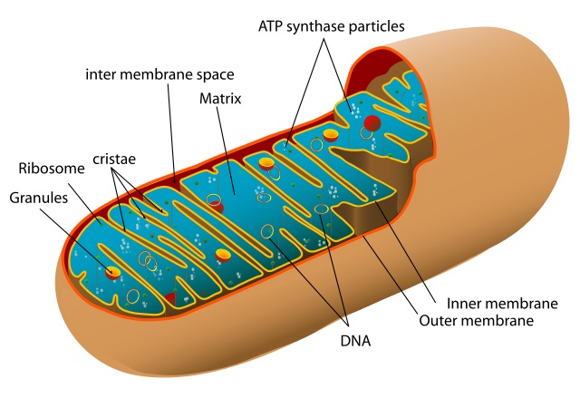

  - Ribosome
    - Site of protein synthesis
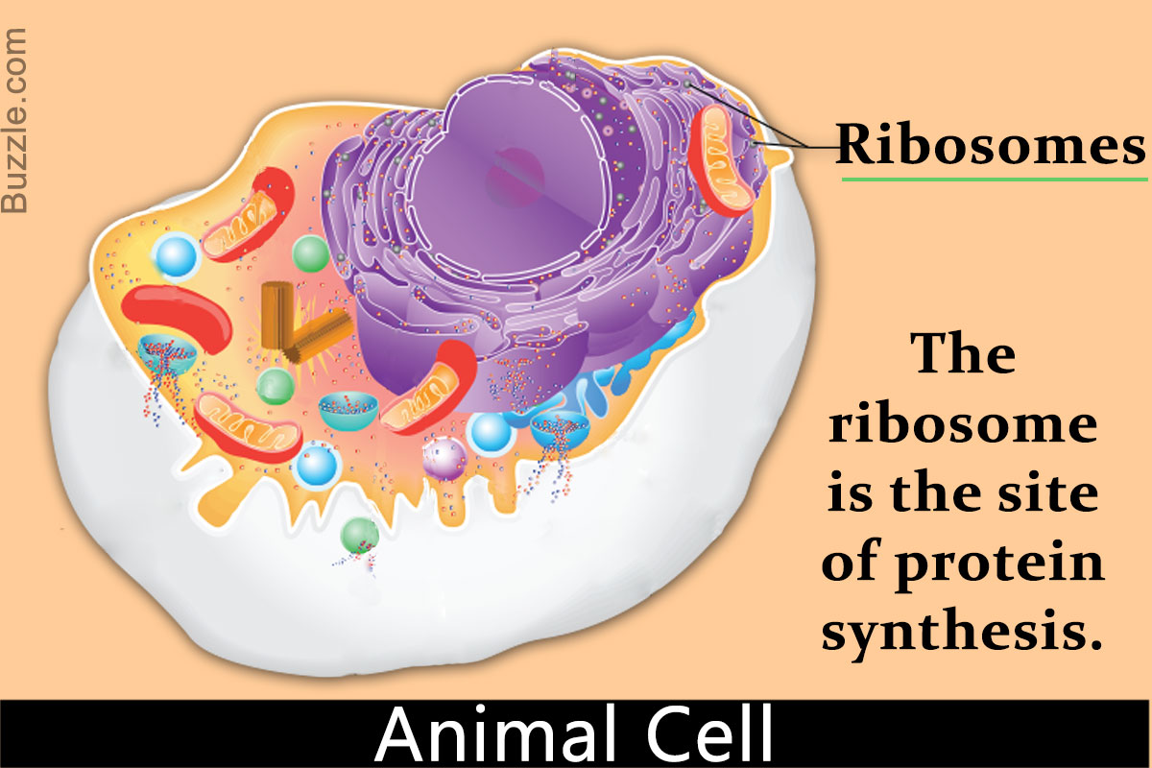
  - Endoplasmic Reticulum

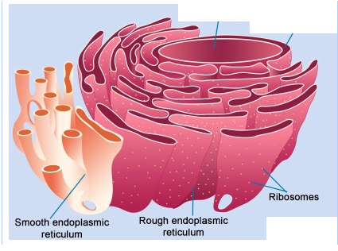
  - Golgi Apparatus
    - Looks after proteins & carbohydrates on proteins
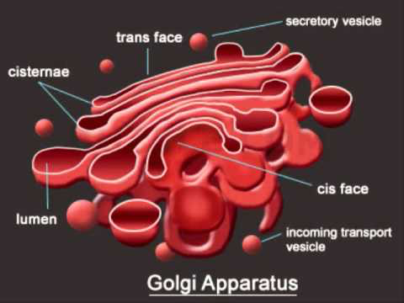
  - Lysosome
    - Site of intracellular digestion
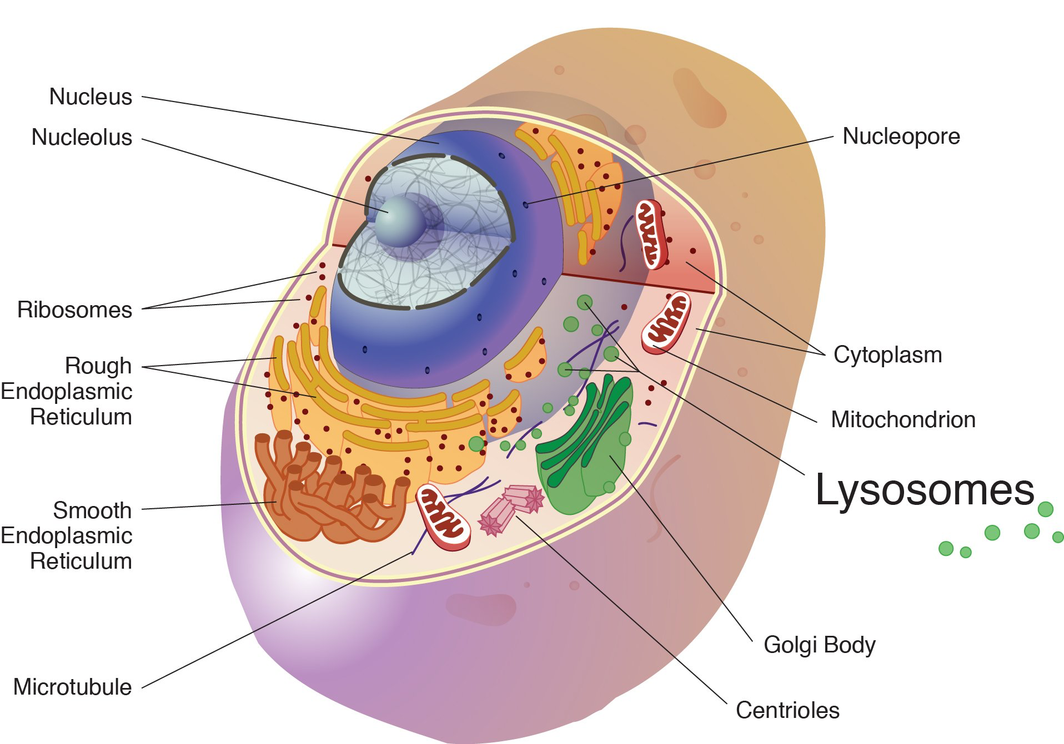
  - Peroxisome
    - Detoxifies substances
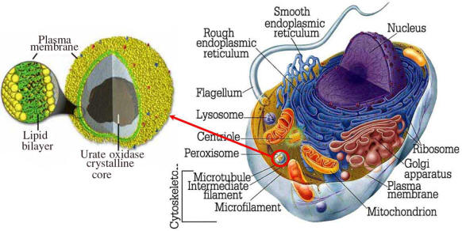
- “Endomembrane System”= group of membranes & organelles that work together

1.2.3. Name and briefly describe the 3 types of cytoskeletal filaments; define centriole and distinguish between a cilium and a flagellum
- “Cytoskeleton”= provides structural support, permits shape change, and allows movement.
  - 3 TYPES OF FILAMENTS: Microfilaments, Intermediate Filaments, Microtubules
- Microfilaments: support shape & allow shape change (made of ACTIN subunits).
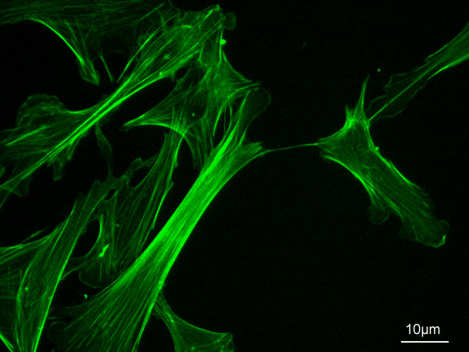
- Intermediate Filaments: sturdiness to cell (made of TETRAMER subunits).
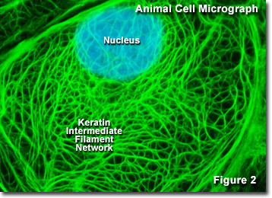
- Microtubules: allow for motility (made of TUBULIN subunits).

1.2.4. Briefly describe the structural organization of the nucleus demonstrating your
understanding of the terms: nuclear envelope, nuclear pore, nucleolus, chromatin
- “Nuclear Envelope”= the surface of the nucleus which the pores traverse
- “Nuclear Pore”= traverse the nuclear envelope to regulate what enters/exits the nucleus
- “Nucleolus”= informal site of ribosome synthesis
- “Chromatin”= packages DNA for protein synthesis (consists of DNA + associated proteins)
- From Nucleus TO Cytoplasm:
  - mRNA (bring protein synthesis instructions)
  - ribosomal subunits (to do work in cytoplasm)
  - tRNA molecules (bring amino acids for protein synthesis)
- From Cytoplasm TO Nucleus:
  - Proteins (for the construction of ribosomes)
  - Other regulatory and structural nuclear proteins

1.3. Tissues: Describe the different tissues of the human body
1.3.1. Define tissue and demonstrate how the organization of cells into tissues contributes to overall homeostasis
- “Tissue: a group of similar cells that have a common function (4 types; epithelium, muscle, connective, and nervous.)
- “Histology”= study of tissues and their cellular organization

- 1.3.2. List the 4 primary types of tissues
- Nervous Tissue: internal communication
  - Brain, spinal cord, nerves
- Muscle Tissue: movement
  - Muscles attached to bones, to hear, or to walls of hollow organs
- Epithelial Tissue: forms boundaries, protects, secretes, absorbs, filters etc.
  - Lining of digestive tract and other hollow organs, skin surface
- Connective Tissue: supports, protects, binds
  - Bones, tendons, fat

1.3.3. Define epithelial tissue and list 6 functions associated with various types of epithelia
- “Epithelial= a sheet of cells that covers a body surface or lines a body cavity
- 2 TYPES:
  - Covering & lining
  - Glandular epithelium
- 6 FUNCTIONS:
  - 1. Protection (skin)
  - 2. Absorption (GI Tract)
  - 3. Filtration (kidney)
  - 4. Excretion (kidney)
  - 5. Secretion (glands)
  - 6. Sensory reception (taste buds)

1.3.4. List and demonstrate your understanding of 5 special structural characteristics of epithelial tissue
- 1. Polarity: apical and basal surfaces
- 2. Special Contacts: tight junctions and desmosomes
- 3. Support by connective tissue: basement membrane is composed of a basal lamina sitting on top of a reticular lamina
- 4. Innervated (supplied by nerve fibres) but avascular (contains no blood cells): nourished through diffusion
- 5. Regeneration: high regenerative capacity because in easily damaged areas
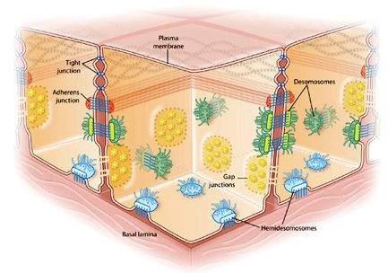

1.3.5. Indicate the two criteria used to classify epithelial cells
- 1. Cell Shape
  - Squamous
  - Cuboidal
  - Columnar

- 2. Layers
  - Simple epithelia
  - Stratified epithelia
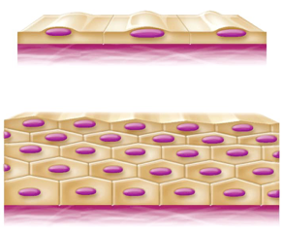

1.3.6. List the 4 types of simple epithelia; indicate the primary functions associated with each and give a sample body location for each type
- 1. Simple Squamous Epithelium: thin and permeable- filtration, diffusion (found in kidneys and lungs)
- 2. Simple Cuboidal Epithelium: secretion and absorption (found in kidney tubules, small glands)
- 3. Simple Columnar Epithelium: digestion and secretion (found in digestive tract)
- 4. Pseudostratified Columnar Epithelium: secretion (appears stratified but isn’t) (found in respiratory tract)

1.3.7. Describe the structure of stratified squamous epithelium and give a sample body location
- Structure of stratified squamous epithelium:
  - (protective role) basal cells are cuboidal and undergo mitosis to keep regenerating from the layer below
  - Therefore, the apical layers are actually dead cells (skin for example)
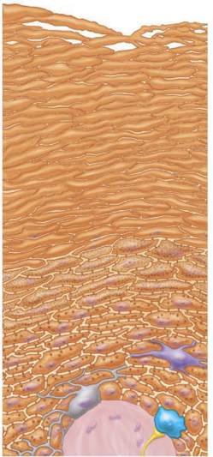
- Structure of transitional epithelium:
  - Mix of columnar and squamous cells
  - Lines the bladder (an organ that has to fill)
  - The basal layers are cuboidal, and the apical layers become increasingly squamous as filling occurs
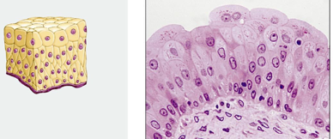
1.3.8. Define gland, endocrine gland, exocrine gland
- “gland”= 1 or more cells that make and secrete a particular product
- “Endocrine gland”= no duct (products are called hormones)
- “Exocrine gland”= has a duct (mucous, sweat, liver etc.)
  - “Unicellular exocrine gland”= no duct because single celled
  - “multicellular”= has a duct because more than one cell
- Secretory methods:
  - Merocrine= exocytosis (most common type) (pancreas, salivary glands, sweat glands)
  - Holocrine= cell rupture
  - apocrine= cell apex pinches off with secretory product

- 1.3.9. List the 5 types of connective tissue; list the 4 main functions associated with
various types of connective tissue
- Mesenchyme (binding or support)
- CT Proper (diffusion)
- Cartilage
- Bone (protection)
- Blood (insulation, transportation)

1.3.10. Describe the structural organization of connective tissue in general; distinguish
between collagen, elastic and reticular fibers; distinguish between “blast” and “cyte”
types of connective tissue cells
- Structural organization of CT:
  - Ground Substance
    - Fluid, cell adhesion proteins and proteoglycans (helps cells attach to CT)
  - Fibers
    - “Collagen fibers”= high tensile strength (purple)
    - “Elastic fibers”= stretch and coil (orange)
    - “Reticular fibers”= fine network to support blood vessels (blue)
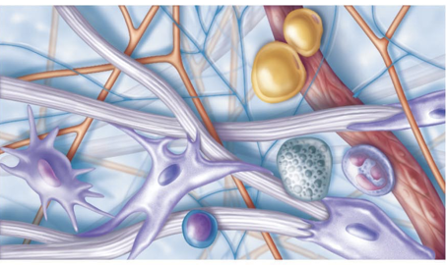
- Cells
  - “blasts”= actively dividing cells (immature cells)
  - “cytes”= provide a level of maintenance (mature cells)
Tissue Type:
- CT Proper: “fibroblast”, “fibrocyte”
- Cartilage: “chondroblast”, “chondrocyte”
- Bone: “osteoblast”, “osteocyte”
- Blood: “hemocytoblast”, “RBCs, WBCs, platelets”

1.3.11. List and briefly describe the three types of loose connective tissue; your description should include key functions associated with each type as well as sample body
Locations
- THREE types of Loose CT: areolar, adipose, reticular
- Areolar: get-like matrix with all 3 fiber types, cells= fibroblasts
- FUNCTION: cushioning or organs, immunity and inflammation; fluid reservoir
- LOCATION: under epithelia of the body
- Adipose: areolar CT modified to store nutrients
- FUNCTION: fuel reservoir, insulation, support and protection
- LOCATION: under skin, around kidneys and eye balls, in bones, in breasts
- Reticular: like areolar CT but with reticular fibers
- FUNCTION: supports free blood cells
- LOCATION: lymphoid organs

1.3.12. List and briefly describe the 3 types of dense connective tissue; your description should include key functions associated with each type as well as sample body
Locations
- THREE types of dense CT: regular, irregular, elastic
- Regular: bundles of parallel collagen fibers
- FUNCTION: attachment with strength
- LOCATION: tendons, ligaments
- Irregular: thicker collagen bundles arranged irregularly
- FUNCTION: withstands tension exerted in many directions
- LOCATION: dermis, digestive tract, joints
- Elastic: parallel elastic fibers
- FUNCTION: coil and reform
- LOCATION: ligaments

1.3.13. List the other remaining types of connective tissue
- Cartilage: tough, but flexible
  - Devoid of nerve fibers
  - Have some elastic fibers
  - Up to 80% H2O
- Bone: gives hardness and strength for support/ protection. Also has cavities for fat storage and synthesis of blood cells
  - “osteoblasts”= immature
  - “osteocytes”= mature
  - “osteoclasts”=
- Blood: classified as CT because it consists of cells surrounded by a nonliving fluid matrix
  - “Fiber” components are soluble protein molecules which are only visible during clotting.

