Intelligence

November 2 2012

Defining intelligence
- Difficult to find consensus
  - “Intelligent” behaviors change with age
  - Most people suggest
  - Verbal ability
  - Practical problem-solving
  - Social competence
Intelligence tests
- Group Tests
  - Allow testing of large groups
  - Require little training to administer
  - Useful for instructional planning
  - identify students who need individual testing
- individual tests
  - Examiners need training & experience
  - Provide insights about accuracy of score
  - Identify highly intelligent children and also those with learning problems
Commonly-used intelligence tests
Individual Tests | - Stanford-Binet  - Weschsler
Aptitude Tests | - SAT  - Specific abilities
Achievement Tests | - Classroom tests  - Academic subjects
Infant Tests | - Bayley Scales  - Achievement against month of age  - Habituation  - Hand manipulation

- Wechsler test most popular for kids
- Stanford- binet kids and adults
Spatial Tasks
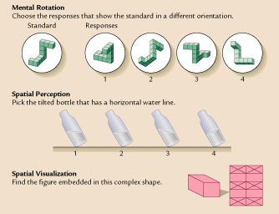
A Normal Distribution
- Child compared to norm of age group
- Most peoples iq fall around 100
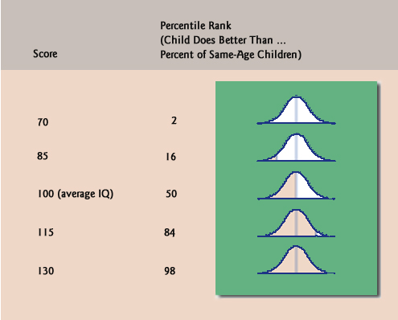
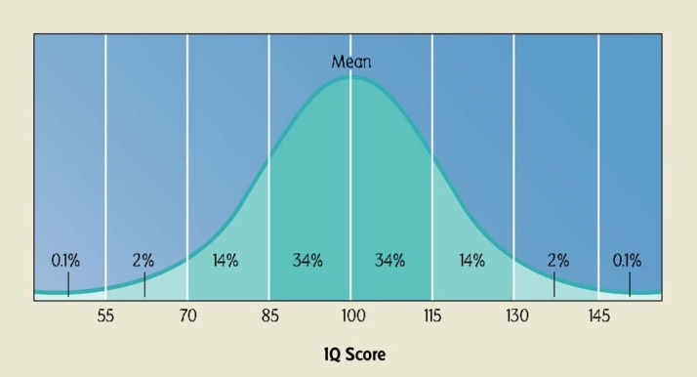

Stability if IQ scored
- If you are labelling a kid it is a huge impact
- The later you test the more predictable of adult scores
- Can test a kid no closer than two years, practice effects
- Kids will do better as they grow older, more abstract thinking
- Correlational stability
  - Compares how children score relative to age mates, from one time to the next
  - Better correlations
    - When older at first testing
    - When tests are close together
- Absolute scores
  - Examines same childs profile of scores over repeated testings
  - Most children fluctuate
  - Some increase or decrease with age
IQ as a Predictor
Academic Achievement | - Correlated with achievement test scores, grades, staying in school
Occupational Attainment | - IQ predicts adult attainment well, but not perfectly  - Personality, practical intelligence also important  - Sometimes more related to street smarts
Psychological Adjustment | - Moderately correlated  - Low IQ related to school failure, aggression, delinquency

IQ similarity among relatives
- Kids who are adopted have higher iqs that their adoptive families, but less than the adoptive family
- Environmental component
- 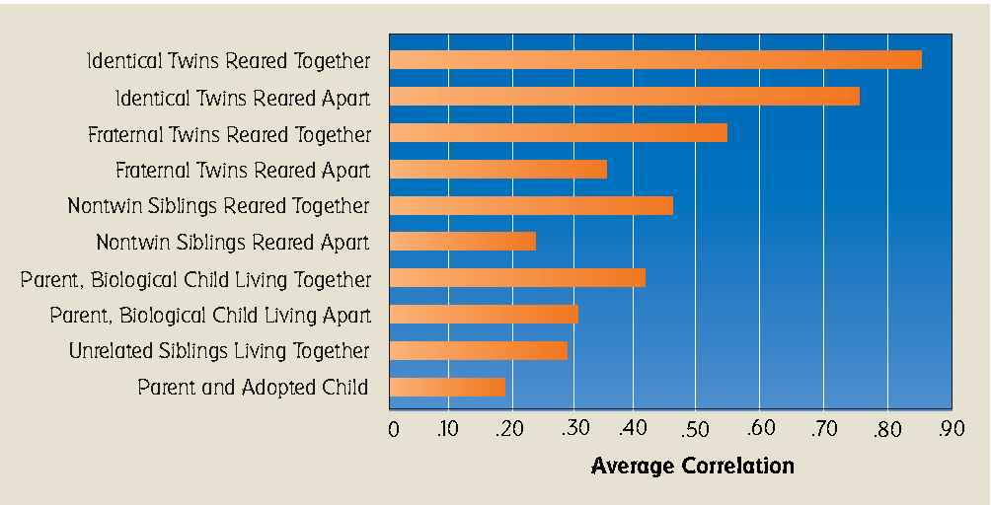
- Adoptions and IQ
- 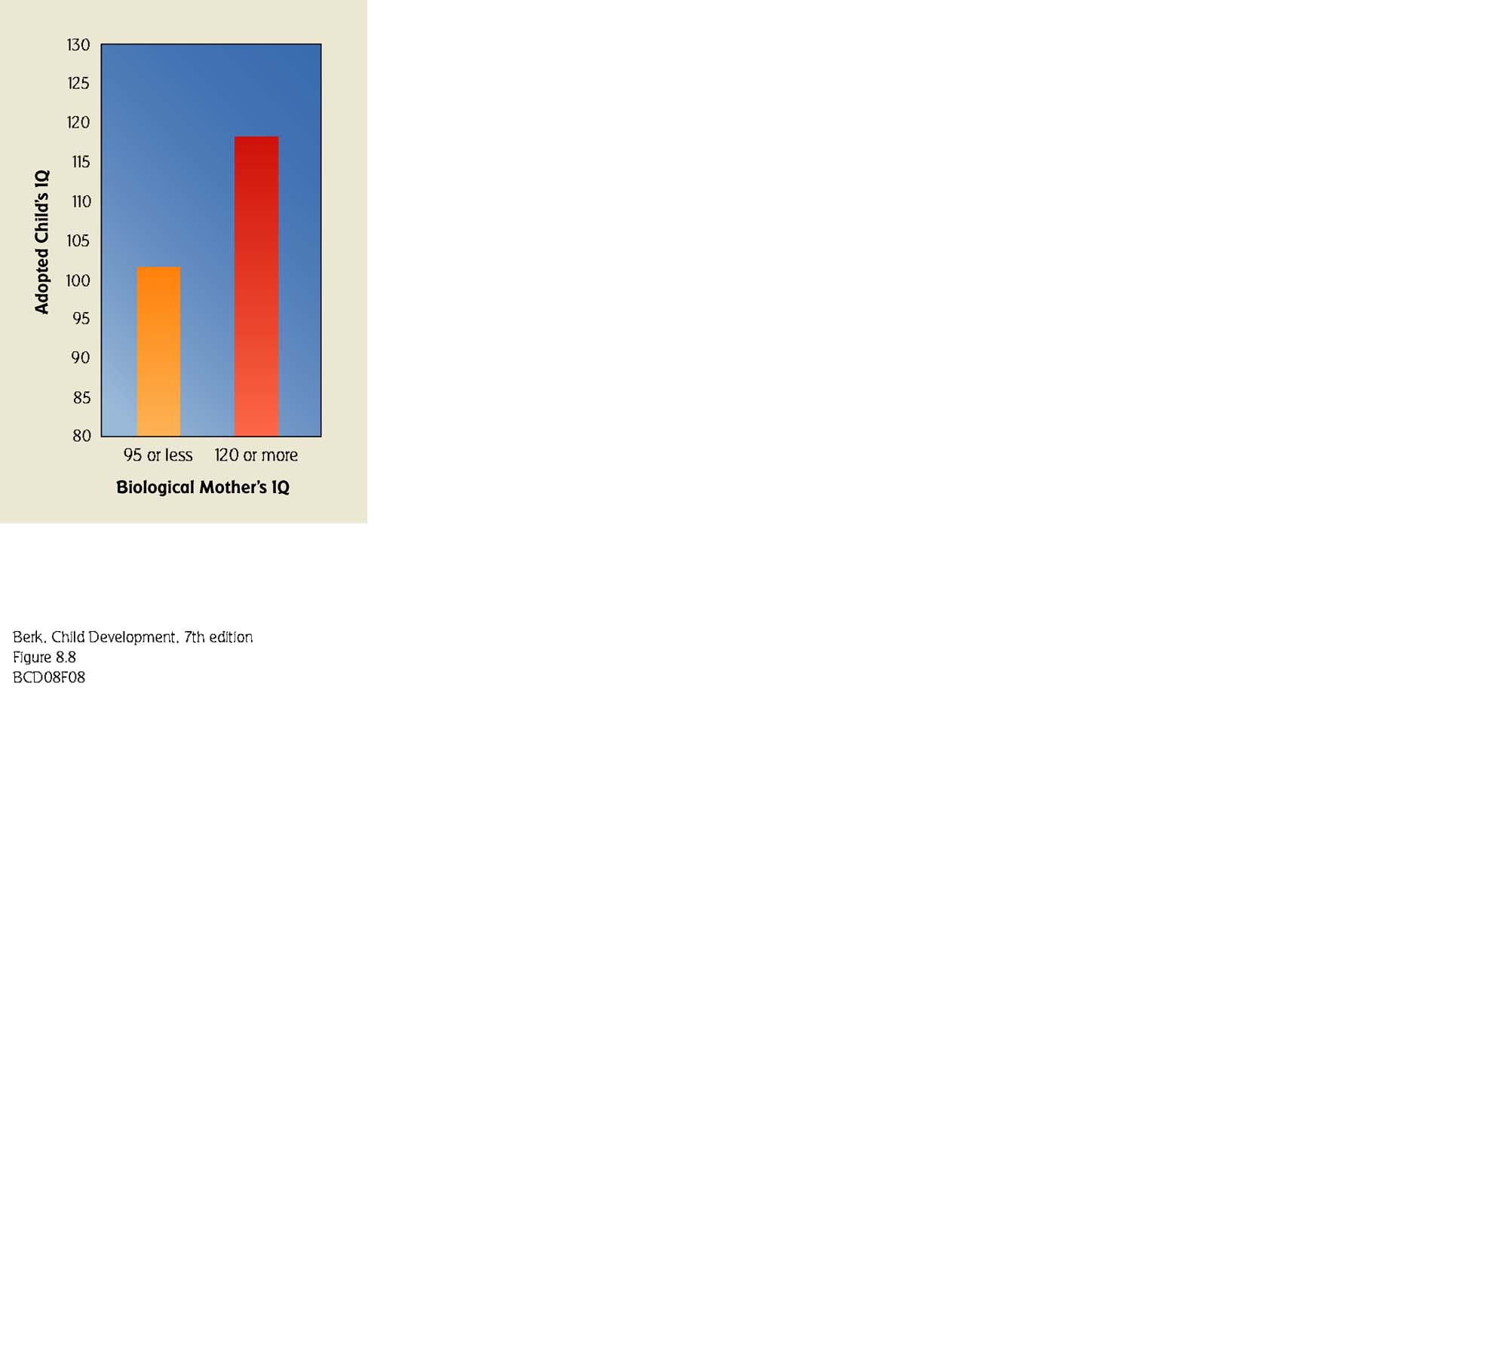
- The Flynn effect
  - Gathered data
  - Generational increase in iq
How to increase IQ
- Mozart effect
  - Original test was done on college students

Preschool Intervention
- Project head start, aboriginal head start
  - 1-2 years preschool
  - Nutrition, health services
  - Parental involvement
- Long-term benefits of excellent intervention
  - Better early school IQ, achievement
  - Less special ed
  - More high school graduation, college enrollment, employment
  - Lower drug use, teen pregnancy, delinquency
  - Preserves aboriginal heritage and culture
- Future: two –generation approach
Outcomes of preschool intervention
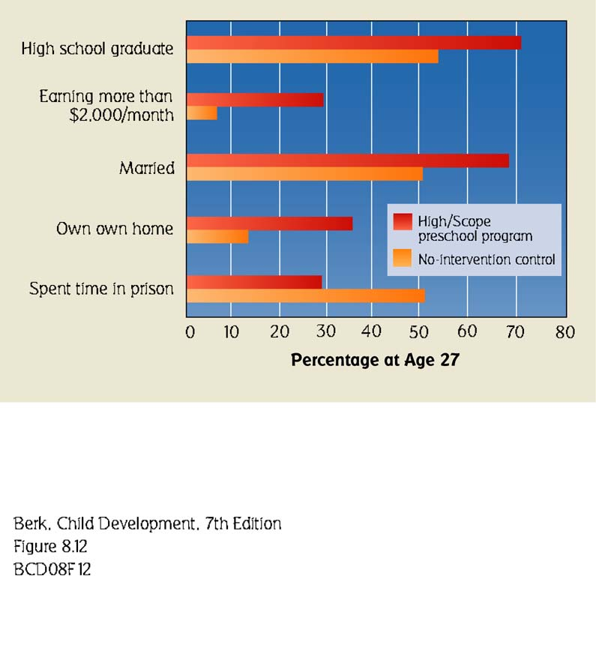

Enrichment programs
- Better beginnings better futures
  - Started in 1991
  - Targets 0-4 4-8 year olds
  - Targets disadvantaged communities
  - In home programs
  - Child / parent socialization/interaction
  - Community programs parenting group
- Targeted programs for disadvantaged populations
- Focus on prevention and early intervention
- Also targets family and community involvement
- http://bbbf.queensu.ca
- Sesame street was originally targeted towards the low income prone people

Giftedness
- Those who display exceptional intellectual strengths
  - Some have IQ scores above 130
  - High-IQ children are particularly quick at academic work
  - IQ tests do not sample the entire range of human mental skills has led to an expanded conception of giftedness (e.g. creativity)
  - http://www.gifteddevelopment.com
- Article
  - Not cool to be smart
  - Pressures too much
  - Childcare and schooling
Schools and childcare
- To teach society’s knowledge, skills, customs, and beliefs
- What do kids need to know in order to be a success in the future?
  - individuality/cooperation
  - status quo/creativity
  - what are we trying to teach
- school are often based on zone, not necessarily good
John Goodlad
- 4 categories of goals:
  - academic (reading, writing, arithmetic)
    - pushing kids before they are cognitively ready
  - vocational (preparation for world of work)
  - social and civic (preparation to participate in a democracy)
  - personal (develop individual talent and self-expression)

