Verification of Gas Laws
CHM 1311

Written by:
(Student Name), (Student #)

TA: (Name)

Date Performed: (Date)

(Date)
Introduction:

A gas is a state of matter which has very weak bonds between its molecules. Due to this, gases have a volume and shape that is defined by the container they occupy, meaning a gas has variable volume and shape. If a gas is cooled, it will contract. Alternatively, if a gas is heated, it will expand. Because of these traits, a gas is defined by the variables pressure, volume, temperature, and the amount of gas (moles). Assuming extremely low temperatures and high pressures are not in effect, a gas can be said to have no attraction between its molecules, resulting in an ideal gas. An ideal gas is defined by the equation:

PV= nRT ; P = pressure, V = Volume, n = amount of gas in moles, R = universal gas constant, T = temperature in Kelvin

The relationship between the changes in volume with respect to temperature is known as Charles’ Law. At a fixed pressure, a gas will expand (increase in volume) with respect to an increase in temperature, just as it will contract (decrease in volume) with a decrease in temperature. This shows that the law can be stated, “When at a constant pressure, the volume of a gas is directly proportional to the temperature in Kelvin.” This is expressed by the equation:

V = m T_{K} ; V = Volume, m = slope, T_{K} = Temperature in Kelvin

The relationship between pressure and volume at a fixed temperature is known as Boyle’s Law. Any amount of gas trapped in a container exerts pressure. By reducing the size of the container, while also keeping the volume of the gas the same, the pressure exerted by the gas increases. The comparison between volume and pressure can be said to be inversely proportional. The equation for this is:
PV = C ; V = volume, P = Pressure, C = a constant

Experiment 1 – Part A: Verification of Charles’ Law
Procedure:

As described in the lab manual, “What in the World ISN’T Chemistry?” Dr. Rashmi Venkateswaran, 2017, Exp. 1 – Verification of Gas Laws.

Observations/Data/Results:

T₁ = 6℃ (Temperature of the ice bath)
T₂ = 91.9℃ (Temperature of the air at boiling water)

V_{cw} = 27 mL (Volume of water that entered the flask)
V₁ = 154 mL (Volume of the Erlenmeyer flask)
V₂ = 127 mL (Volume of air when in ice bath)

No bubbles were observed during the ice bath.
Water entered the flask during the ice bath.

Table 1. Volume to Temperature Data (With Consistent Mass and Pressure)
Volume (mL) | Temperature (℃) | Temperature (K) | V/T (mL/℃) | V/T (mL/K)
154 | 6.0 | 293.15 | 25.7 | 0.53
127 | 91.9 | 365.05 | 1.38 | 0.35

Calculations:

V = mT_{k}

V₁ = 49mL + 50mL + 50mL + 5mL T_{1K} = 6℃ + 273.15
= 154ml = 293.15 K

V₂ = V₁ - V_{cw} T_{2K} = 91.9℃ + 273.15
= 154 mL – 27mL = 365.05 K
= 127 mL

Solve for m:
m = $\frac{V_{1}- V_{2}}{T_{1}-T_{2}}$
= $\frac{154 mL -127 mL}{91.9℃-6.0℃}$
= 0.31 mL/℃

V = (0.31 mL/℃)(T_{K})

Error % = $\left|\frac{\frac{V_{1}}{T_{1K}}- \frac{V_{2}}{T_{2K}}}{\frac{V_{1}}{T_{1K}}}\right|$ x 100%
= $\left|\frac{\frac{154 mL}{365.05 K}- \frac{127 mL}{279.15 K}}{\frac{154 mL}{365.05 K}}\right|$ x 100%

= 7.84%

Discussion:

Charles’ law states that the volume of a gas is directly proportional to the temperature in Kelvin. The experiment conducted is consistent with this result, and thus, verifies Charles’ Law. The numerical proof of this can be seen in Table 1 because the volume of the air in the Erlenmeyer flask when in the boiling water is higher than the volume of the air when exposed to cold water. This confirms the principle of thermo-expansion and thermo-contraction of Charles’ Law.

This principle can be seen physically due to the intake of water in the Erlenmeyer flask when submerged in cold water. By sealing off the hole in the Erlenmeyer flask’s stopper before inverting it in the ice bath, the same volume of air when heated is maintained when in the ice bath. Plugging the hole prevents additional air from filling the flask as the air cools. By doing this, the water from the ice bath is able to enter the flask in order to record a measurement of the volume of the flask that is unoccupied by air. This space occurs because the air contracts in the ice bath as it cools, leaving space in the flask for water to fill. This principle validates Charles’ law by showing that volume of a gas at fixed pressure decreases as the gas is cooled.

Although an ideal gas is directly proportional, the data from this experiment’s data did not result in the relationship between volume and temperature being completely proportional (0.18mL/K difference). This may have been a result of experimental error, as well as the gas being a real gas rather than an ideal gas that has no attraction between its particles.

Some experimental error in the experiment could be not plugging the hole in the stopper fully, allowing air to enter the flask before being placed in the ice bath. This would reduce the volume of water that enters the flask, resulting in the data being skewed to show a smaller contraction of the gas. In addition to that, there are the uncertainties related to measuring the temperature using a liquid thermometer, and the uncertainties involved in measuring the liquids using a graduated cylinder.

Conclusion:

The data collected in this experiment is able to verify the concept of Charles’ Law about the relationship between volume and temperature at a fixed pressure. The percent error for this experiment came out to 7.84%, showing that the data from the experiment is consistent and valid. Although there is a percentage error of 7.84%, the data is still able to verify Charles’ Law to an extent because Charles’ law deals with an ideal gas, while this experiment is using a real gas.

(date)
Experiment 1 – Part B: Verification of Boyle’s Law

Procedure:

- Determine the variables to be used in the procedure as well as their units.
- Determine which part of the plunger of the 20mL syringe will be the reference point to ensure consistency in volume measurements.
- Choose an initial volume of the air in the 20mL syringe to measure against pressure.
- Attach the syringe to the pressure sensor connected to LabQuest2.
NOTE: Do not overtighten the syringe – about ½ turn should lock the syringe without damaging the syringe tip or the sensor.
- Set the initial volume, which was chosen in Step 3, on the syringe. Allow the pressure reading to stabilize and record its value. Use LabQuest2 to save your points for later consultation.
NOTE: Add 0.8mL to the volume applied to the syringe in order to account for the space inside the sensor (0.8mL).
- Repeat Step 5 at six (6) additional points in order to collect enough data to verify Boyle’s Law
- Retest at the original volume to get a second reading. Choose the reading that fits the best and explain why this value was chosen.
- Collect electronic data off LabQuest2 for graphing.

*Use of the LabQuest2 as described in the lab manual, “What in the World ISN’T Chemistry?” Dr. Rashmi Venkateswaran, 2017, Exp. 1 – Verification of Gas Laws.

Data/Results:

Table 2. Pressure Readings Based on Volume Input on Gas Sensor
Independent Variable |  | Dependent Variable
Volume on Syringe (mL) | Total Volume  (+ 0.8 mL) | Pressure (kPA)
4 | 4.8 | 102.72
8 | 8.8 | 102.61
10 | 10.8 | 102.54
12 | 12.8 | 101.64
14 | 14.8 | 102.23
16 | 16.8 | 101.98
20 (trial 1) | 20.8 | 101.74
20 (trial 2) | 20.8 | 102.62
*Trial 2 at 20mL was the original volume chosen to be ignored because it did not follow the pattern of increasing pressure with a decrease in volume.

Table 3. Pressure Readings Based on Volume Input on Gas Sensor from Logger Pro
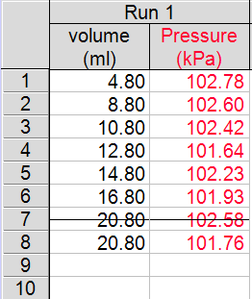
Note: Variations in pressure values from Table 2. is due to small changes when taking a reading as the pressure never fully settled.

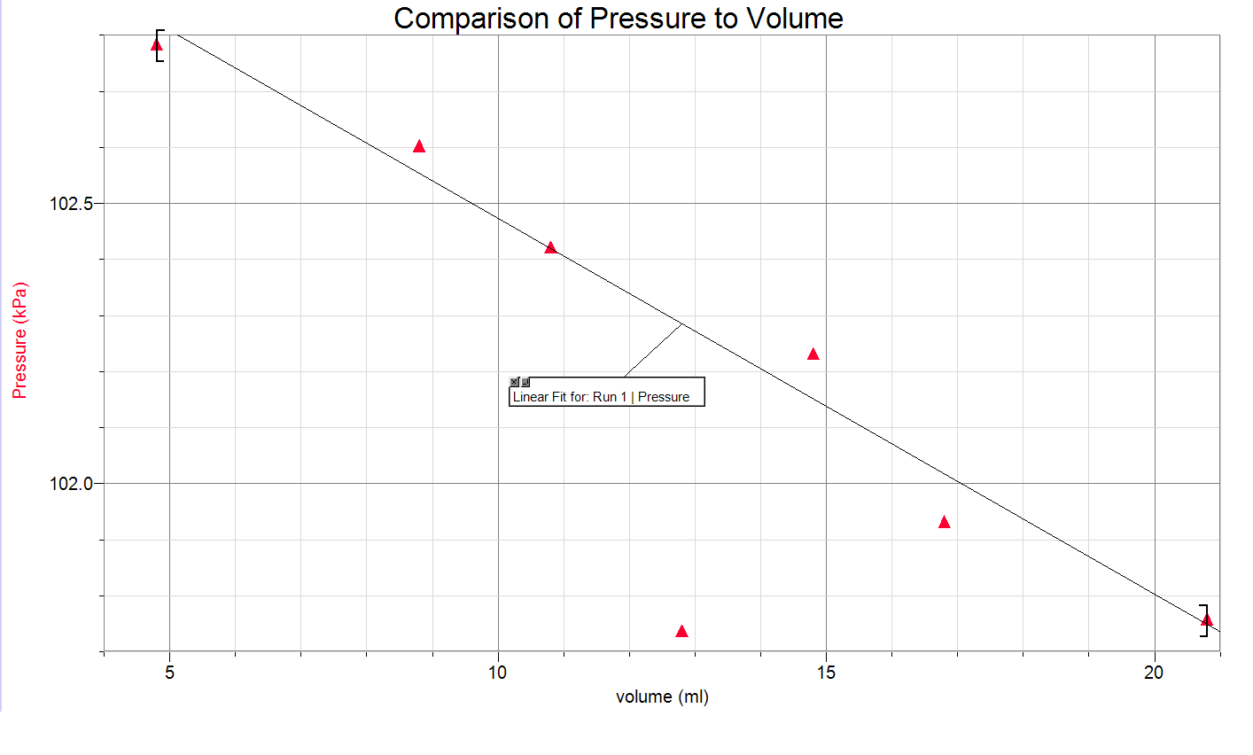
Observations:

As the volume of the syringe was decreased, there was a negative correlation, resulting in an increase in pressure.

When the plunger was moved to a lower volume, there was an increase in the force pushing back against the plunger, to the extent of pushing the plunger off the mark (towards a larger volume). Conversely, when the plunger was moved to a larger volume, the plunger was pulled to try to reach a smaller volume than what was increased to.

Calculations:

PV = C

V = V_{Syringe} + V_{Gas sensor}
= 20mL + 0.8 mL
= 20.8 mL

Determine a constant:
Let P = 102.72 kPa
Let V = 4.8 mL

PV = C
C = (102.72 kPa)*(4.8 mL)
= 493.1 kPa*mL
Let P = 101.74 kPa
Let V = 20.8 mL

PV = C
C = (101.74 kPa)*(20.8 mL)
= 2116.2 kPa*mL

C ≠ C

Discussion:

The constant that was found varied for each of the points tested. This is due to an error in the procedure, as an initial fixed volume of gas was not used. The procedure was incorrectly followed as the syringe was removed from the sensor, causing the experiment to become invalid as Boyle’s law requires an initial fixed volume of gas to be compressed and expanded based off the volume of the container. Instead, different volumes of gas were tested. The experiment needs to be completed again, and the procedure should make note that the syringe should stay connected to the gas pressure sensor in order to accurately validate Boyle’s Law.

The mathematical relationship between Boyle’s law and the constants found show that there was a negative correlation between pressure and volume. Boyle’s law suggests that the relationship should be proportional, not just a correlation. This is due to a wrong step following the procedure, resulting in invalid data being collected.

In accordance with McCall’s article, More on Systematic Error in Boyle’s Law Experiment, the volume that was indicated on the syringe does not take into effect the actual value of the volume of the experiment. The heading space inside the gas sensor is important to add to the volume in order to achieve more accurate results. This was accomplished, as seen in Table 2, by adding 0.8 mL to the volume indicated on the syringe.

The importance of taking multiple readings of the dependant variable for the same value of the independent value is to account for error during the experiment. One such error that could occur is gas escaping the system due to a damaged plunger, syringe, threads, or gas sensor. This loss in air would result in a different reading at the same independent variable as there would be a different volume of gas trapped. Remember, Boyle’s law requires the volume of the gas to be fixed. If any volume of gas was lost during the experiment, the values for the dependant variables would be false.

There are other variables of the gas that need to be considered in this experiment, as they could have caused a skew in the results of the data. Temperature is a variable that needs to be controlled, as shown by Charles’ law. If the temperature of the gas was changed, than the gas would expand or contract (increasing or decreasing volume). Temperature could have varied due to the warmth of a hand on the syringe (or other heat source). Another reason for a change in temperature would be the speed at which the plunger of the syringe was moved. If the gas was compressed to quickly, the temperature of the gas would increase as well. In order to counteract this and ensure the temperature did not increase, the plunger would have to be moved slowly, limiting the speed at which the gas expands and contracts. Both factors were taken into consideration, and the syringe was left for a couple minutes to ensure it had reached the same temperature for all readings. In order to improve this experiment more, a thermal reading of the gas inside would be good to know in order to ensure the gas was at the same temperature the entire experiment.

Another possible error that could have occurred is the accuracy of the independent variable. A reference point was decided upon, in order to maintain accuracy of the plunger, however, small deviations from the actual independent variable could have occurred. This would be a human error, and using a machine with a digital scale for the independent variable could increase the accuracy of results.

Conclusion:

Due to an incorrectly followed step in the procedure, the experiment conducted became invalid at verifying Boyle’s Law. Although this occurred, the experiment still showed a negative correlation between pressure and volume, however, it was not an inversely proportional relationship like Boyle’s Law explains.

References:

McCall, Richard P. (2011, December 27). More on Systematic Error in a Boyle’s Law Experiment. Retrieved from https://aapt-scitation-org.proxy.bib.uottawa.ca/doi/citedby/10.1119/1.3670078

(Marked assessment criteria for procedure)
(Rough work from lab book)


