EXPERIMENT #2
Purifying Chemicals by Distillation

Procedures:
Refer to lab manual pages 26-27
There was a modification to the procedures, and that is the addition of aluminium foil to cover the distillation head and distillation flask in the simple distillation and to the fractioning column and distillation flask in the fractional distillation.

Observations:

Table 1.1: Table showing the qualitative and quantitative observations from the experiment.

Qualitative | Quantitative
The 50:50 mixture of 2-propanol and 1-butanol was colorless | 25 mL of a 50:50 mixture of 2propanol and 1-butanol
The 50:50 mixture of 2-propanol and 1-butanol was odorless | The heater was set to 60%.
The 50:50 mixture of 2-propanol and 1-butanol was a clear solution

Table 1.2: Table showing the amount of distillate and temperature of the simple distillation.

Amount Distilled (mL) | Temperature (C)
0 | 25.6
1 | 84.5
2 | 87.5
3 | 88.4
4 | 89.0
5 | 89.8
6 | 90.5
7 | 91.1
8 | 92.0
9 | 92.8
10 | 94.9
11 | 96.4
12 | 98.1
13 | 99.0

Table 1.2: Table showing the amount of distillate and temperature from the fractional distillation.

Amount Distilled (mL) | Temperature (C)
0 | 27.5
1 | 81.1
2 | 81.7
3 | 82.1
4 | 82.3
5 | 82.8
6 | 83.2
7 | 83.7
8 | 84.5
9 | 86.5
10 | 87.9
11 | 90.9
12 | 96.5
13 | 105.4
14 | 95.1
15 | 106.9
16 | 114.2
17 | 115.6
18 | 115.7
19 | 115.7
20 | 115.7
21 | 115.7
22 | 115.7
23 | 115.6

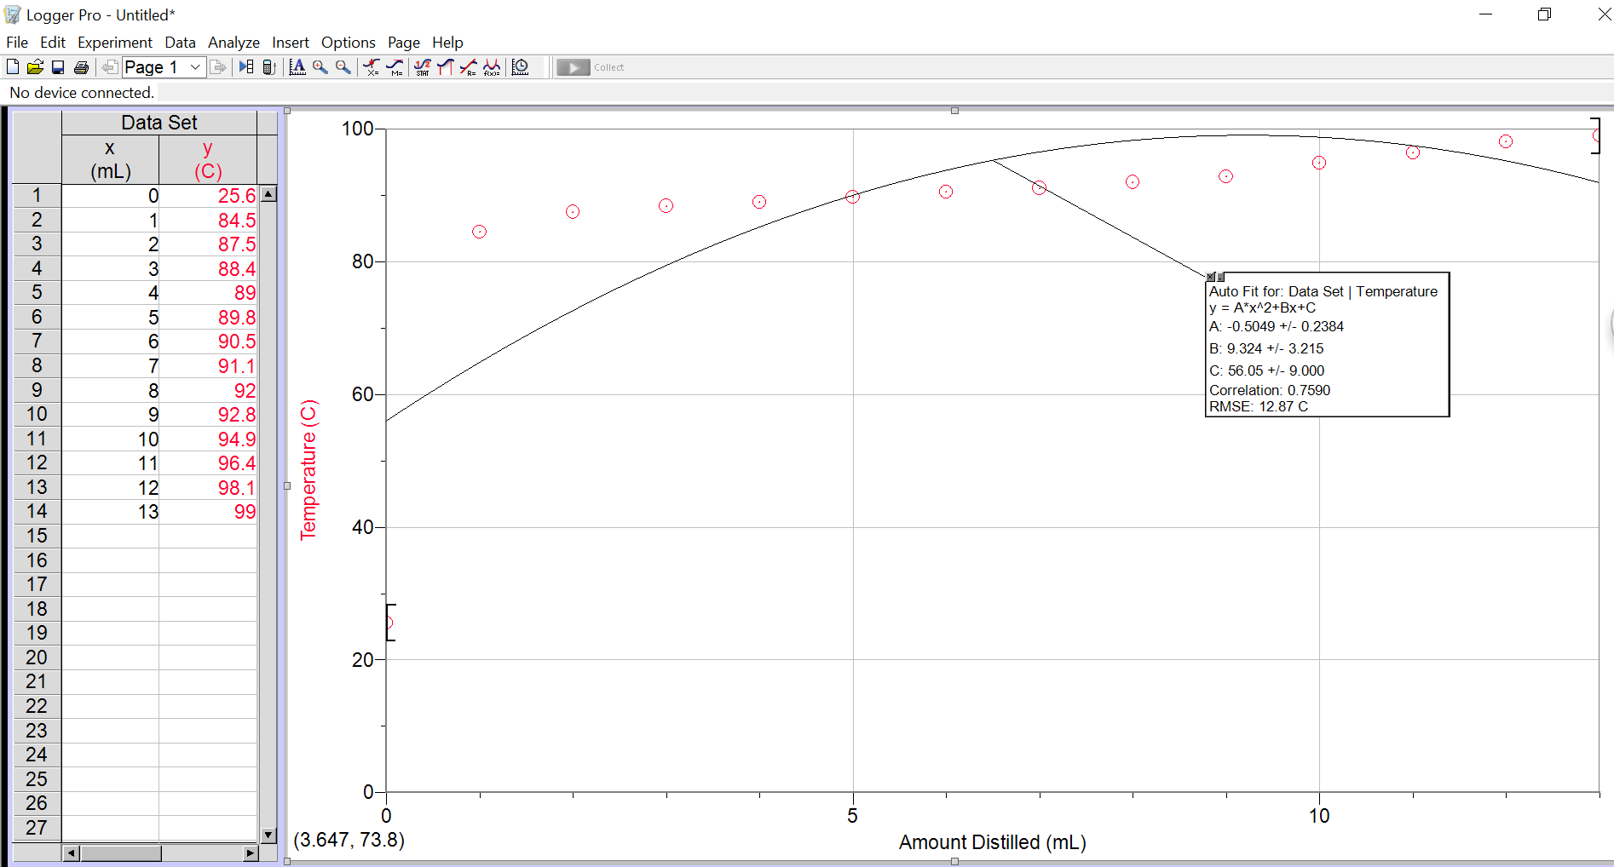

Figure 1.1: Graph Showing the amount of distillate and temperature from the simple distillation.

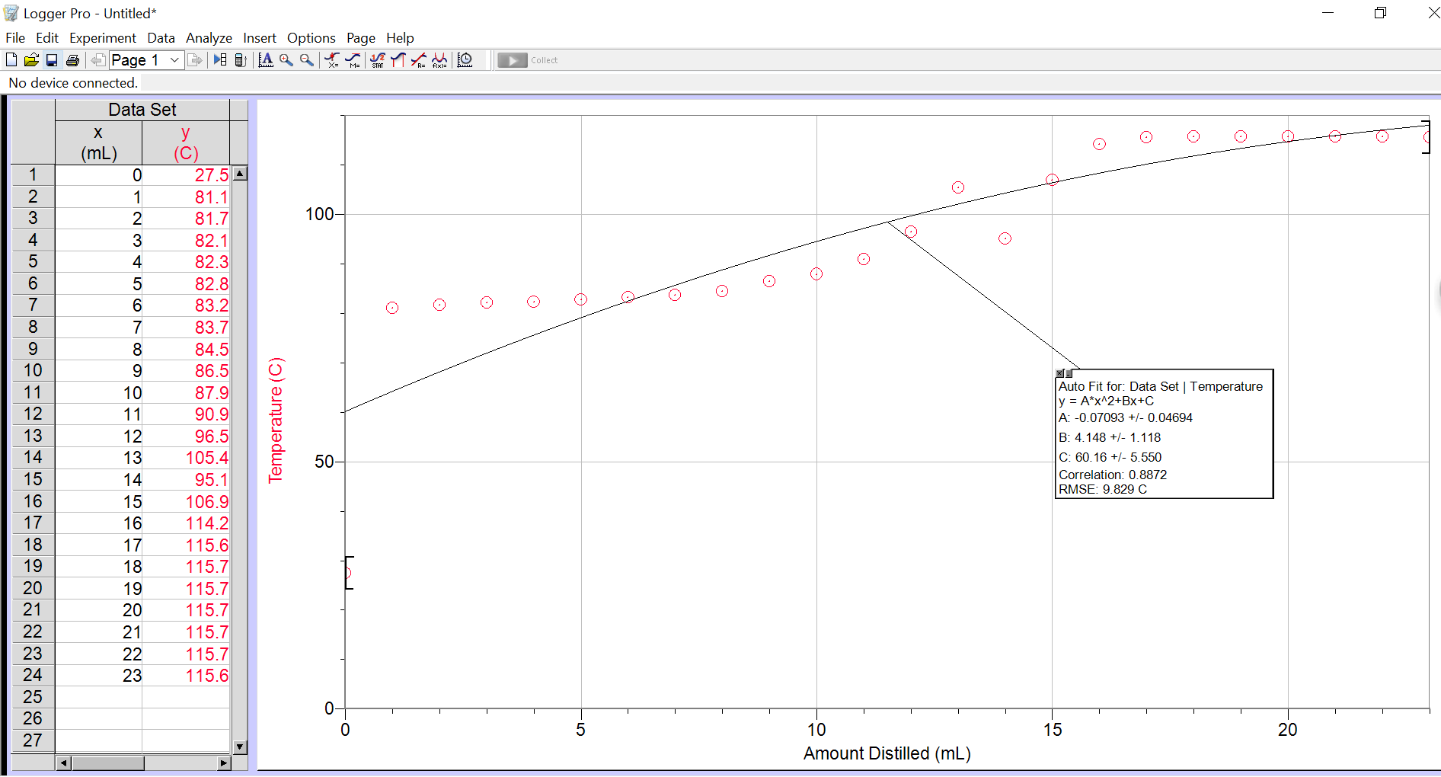

Graph 1.2: Graph showing the amount of distillate and temperature from the fractional distillation.
Discussion:

Distillation is the process of purifying or separating a liquid by heating and cooling. Simple distillation is a relatively fast method of distillation and is best used to separate compounds with a difference of boiling points greater than 100 degrees Celsius. Fractional distillation is a slower method of distillation, but it is more effective compared to simple distillation. It is best suited for the separation of compounds with a difference of boiling points less than 100 degrees Celsius.
In this experiment, both simple and fractional distillation was done using 25 mL of a 50:50 mixture of 2-propanol and 1-butanol. Because of this, we have 12.5 mL of 2-propanol and 12.5 mL of 1- butanol. The boiling points of 2-propanol is 83 degrees Celsius and for 1-butanol is 118 degrees Celsius. 1-propanol has a higher boiling point due to the extra carbon bond it has compared to 2-propanol. The difference between both boiling points is 35 degrees Celsius. For the simple distillation, the 2-propanol was the first to evaporate and condense into the receiving flask because it has a lower boiling point compared to the 1-butanol, which also means that it is more volatile compared to 1-butanol. We distilled approximately 12.5 mL of the liquid, and we know that the we needed to stop at 12.5 because we were using a 50:50 mixture and the liquid distilled was 2-propanol. As you can see in the tables, we only started to collect distillate when the temperature was at 84.5 degrees Celsius, which makes sense because the 2-propanols boiling point is 83 degrees Celsius. In order to increase the speed at which the distillation was occurring, we used aluminium foil to cover the distillation flask and at the distillation head, to produce insulation and reduce the amount of heat that escaped. The curve that we obtained for the simple distillation is similar to the expected curve, which means that a good distillation was done.
For the fractional distillation, a fractional column was added to the simple distillation set-up. Inside the fractional column there is packing, which is inert material that is used to increase the surface area at which the evaporating vapours can condense throughout the distillation. The general rule is that the greater the surface area of the fractioning column, the better the separation. Aluminium foil was also used to cover the fractioning column and the distillation flask. The purpose of doing this is similar as to why we did it in the simple distillation, but we can also say that the aluminium foil was used to provide a smooth temperature gradient, which ensures the efficiency of the distillation. In the experiment we only allowed the distillation to occur until 12.5 mL, but apparently, we were supposed to distillate the 25 mL. We used the data of fellow lab mates in order to compensate for our lack of data. From 14 mL onwards, the data that is shown is of our fellow lab mates. There is an error that occurred in the experiment and that is that we had the thermometer touching the glass, rather than it being in the center without touching anything. When the thermometer touches the glass, it is reading the temperature of the glass rather than the temperature of the evaporating contents, which can potentially affect the results of the experiment. From 8mL onwards to 13mL, you can a gradual spike in temperature, which was due to the fact that we replaced the thermometer and aligned it to the center, without it touching the glass. The curve that is shown in the graph for a fractional distillation somewhat matches the expected curve, but the change in the evaporation of components at 12.5 mL was met with a sudden drop in temperature whereas a drastic rise in temperature was suppose to occur. This is due to the fact that we used our lab mates results, which makes the graph look different than the expected graph. Other than the problem mentioned above the graph shows that a decent separation occurred.

Questions:
- Explain why you must have liquid flowing back through the fractionating column in order to get separation of the components during a fractional distillation.

You must have liquids flowing back through the fractionating column in order to get the separation of components during a fractional distillation because the solution is a mix of two compounds and the compound that has the lower boiling point will be evaporated to the receiving flask whereas the compound with a higher boiling point will return back to the distilling flask in order to have the two components separated.

- Fractionating columns normally work better if they are insulated in order to maintain a smooth temperature gradient in the column. Why is it important to maintain a uniform temperature gradient in a fractionating column?

It is important to maintain a uniform and constant temperature gradient in a fractioning column to prevent the already evaporating liquids that are supposed to enter the receiving flask condensing back into the distillation flask. If there are some points whereby the temperature is lower and causes the evaporating compounds to condense back to the distillation flask, then the results might be affected or the experiment and reaction will not proceed efficiently.

- The boiling point of benzene is 81 °C. What is the vapour pressure of benzene at this temperature?

The vapour pressure of benzene at this temperature is 790.54 mmHg at 81 degrees Celsius.

- What effect does an increase in atmospheric pressure have on the boiling point of a liquid?

Since the boiling point is sensitive to pressure, an increase in atmospheric pressure will increase the boiling point of the liquid. It is usually atmospheric pressure that is involved, thus we need to state the pressure when we state the boiling points.

- Why is it important to have cooling water enter the bottom of the condenser and not the top?

It is important to have cooling water enter the bottom of the condenser and not the top because, if water was to enter through the top, the water will just trickle down one side of the condenser and exit the condenser. This causes for only a small portion of the condenser to be cool enough to condense the evaporating liquids. But if the water was to enter from the bottom of the condenser, then the entire condenser will be filled before water can exit the condenser, which results in better cooling and condensing.

- Compound A has a vapour pressure of 350 mm Hg at 95 °C whereas compound B has a vapour pressure of 150 mm Hg at the same temperature. If A and B are miscible, what is the vapour pressure of a 3:1 mixture of A and B at 95 °C?
Ptotal = PA + PB or Ptotal = (PA°) (NA) + (PB°) (NB)

Ptotal= (350mmHg)*(375/500mmHg)+(150mmHg)*(125mmHg/500mmHg)=300mmHg (Vapor Pressure)

The vapour pressure of a 3:1 mixture of A and B at 95 degrees Celsius is 300 mmHg.

