Experiment 1: Verification of Gas Laws

Written by:

Ahmed Sandhu, 300076862
and
Curtis Lei, 300017071

TA: Kareem Harrison

Laboratory performed on: 09/19/2018
Date: 09/27/2018

Introduction:
Gases have a state of matter such that they hold no fixed volume or shape. Since they do not have a fixed volume or shape, gases can be manipulated by different volumes, temperatures and pressures to determine the relationship between these factors and how they impact gasses. When gases are confined within a certain closed vessel, they occupy the volume of that vessel. If the volume of the vessel increases, the gases will occupy the change in volume despite the identity of the gas. Due to this property of gases, if the realities of gas behaviour (4 points mentioned below) are ignored, the ideal relationship between volume and pressure can be found when moles of gas and temperature are constant (Boyle’s Law). Similarly, when pressure and moles of gas are kept constant and ideal conditions are assumed, the ideal relationship between volume and temperature can be found (Charles’s Law).
An ideal gas is a gas that follows a certain set of rules (LeTran, 2017):
1) Gases are made of molecules in constant, random motion.
2) There are no intermolecular forces between the molecules i.e. the collisions are elastic.
3) The collisions of the gas with the walls of the vessel cause pressure.
4) Volume of the molecules is negligible.
In ideal gas scenarios we assume the entity of the gas does not matter and that all gasses behave the same. The nature of an ideal gas is defined by pressure, volume, moles, the constant “R” and temperature through the ideal gas law equation: PV = nRT [1]
In an environment where both the moles of gas and the temperature of the gas is controlled and remains constant in the initial equation [1], the following equation can be derived: PV = k [2]

This means any changes to volume will alter the pressure and vice versa. Boyle’s Law states that at a constant temperature and amount (mol) of gas, the volume is inversely proportional to the pressure (LeTran, 2017). Gas molecules in a large enclosed vessel exert pressure by causing collisions (assume elastic collision) with the walls of the vessel. If the same number of gas molecules were to occupy a smaller enclosed vessel, there would be more frequent collisions with the walls as there is less distance to travel. This results in a greater pressure than when the gas was in a large vessel (Staroscik, 2017).
The relationship between temperature and volume for ideal gasses is shown by Charles’s Law in which he stated, after experimental evidence, that the volume of a gas and temperature are directly proportional if moles of gas and pressure remain constant. This is given through the equation T=kV. If either temperature or volume increase or decrease in an ideal situation for gasses, the volume and temperature will increase or decrease in proportion with each other. Thus, the given equation for Charles’s Law is the following: V / T = k [3]

Purpose:
The purpose of the experiment is to prove the validity of Boyle’s Law and Charles’s Law, as well as to calculate a Boyle’s Law constant. For Boyle’s law, in theory, either pressure or volume could be chosen to act as the independent variable. However, since a syringe will be used, it will be easy to manipulate the volume that the gas is contained within. Therefore, volume will be the independent variable and pressure will be the dependent variable.

Charles’ Law’s verification portion of the experiment calls for temperature and volume to be measured in order to have the data necessary to verify Charles’ Law. In this experiment, temperature is the independent variable to be manipulated and volume the dependent variable to be measured (assume pressure and amount of gas are constant). This is because in the experiment done, it is easier to manipulate temperature as a hot plate is readily available and since it does not matter which variable is the independent one, temperature is the independent variable.

Procedure:
Boyle’s Law:
- Lab Equipment (gas pressure sensor, syringe, LabQuest 2) was gathered
- Equipment was set up:
  - Gas pressure sensor was connected to the LabQuest 2 device
  - Plunger in syringe was moved to the 10 mL volume line (with the front line of the syringe being the marker for the volume to keep constant)
  - Syringe was connected to the gas pressure sensor (with a half turn of the syringe to ensure security)
- Data was collected:
  - Pressure of initial volume (10 mL) was recorded
  - Plunger in syringe was moved to the chosen volume markings (10, 6, 2, 14, 18, 20, 10, in order of trials), and held in place
  - Pressure was recorded for each volume when the reading became stable
  - Graphing data from LabQuest 2 was recorded after all volume trials
- Syringe was disconnected and LabQuest 2 was reset. Steps 2 and 3 were repeated for a second experimental trial.
- Laboratory bench was cleaned, and equipment returned to its respective place.
Charles’s Law:
Refer to pages 7 to 8 of the CHM1311 Lab Manual for the procedure of the Charles’ Law portion of the experiment as described in the lab manual (Dr. Rashmi Venkateswaran, “‘DO I DARE DISTURB THE UNIVERSE?’ (T.S. Eliot) VERIFICATION OF GAS LAWS”, 2018) with the exception of step 8 in the manual in which a glass thermometer was used instead of a digital thermometer. Two trials were performed.

Data & Observations:
Table 1: Qualitative Observations of Equipment (Boyle’s Law)
 | Observation:
Room Temperature | Room temperature stayed superficially the same throughout the experiment, though no measurement was made
Reading of LabQuest measurement | The reading of the pressure was never truly stable; there was always some amount of fluctuation for all trials, excluding initial trials. (This will be discussed further in the Discussion section.)
Resistance pressure of syringe | At higher pressures, it was difficult to hold the plunger steady, as the great amount of force caused resistance and pushed back.

Table 2: Raw Data of Syringe and Gas Pressure Experiment (Boyle’s Law)
 | Trial 1 |  | Trial 2
Value # | Independent Value (mL) | Dependent Value (kPa) | Independent Value (mL) | Dependent Value (kPa)
1 | 10.8 | 100.95 | 10.8 | 101.10
2 | 6.8 | 163.17 | 6.8 | 162.08
3 | 2.8 | 225.25 | 2.8 | 225.25
4 | 14.8 | 73.29 | 14.8 | 74.86
5 | 18.8 | 57.45 | 18.8 | 59.05
6 | 20.8 | 51.83 | 20.8 | 53.06
7 | 10.8* | 100.73* | 10.8* | 103.20*
*indicates data point taken out
Table 3: Qualitative Observations of Experiment (Charles’s Law)
 | Observation:
Water loss | Liquid was lost when transferring from graduated cylinder into the flask, as liquid would stick on the walls of the initial container.
Erlenmeyer Flask | Flask was mostly dry, but had some remaining liquids inside

Table 4: Raw Data of Temperatures and Volumes (Charles’s Law)
Trial 1 | Trial 2
T1= 30.5ºC  T2= 6.5ºC  V_{cw}= 24mL  V1= 145mL | T1= 30.0ºC  T2= 6.0ºC  V_{cw}= 29mL  V1= 144mL

Fig 1.0: Relationship between Pressure and Volume in a Syringe (linear best fit) (Trial 1)
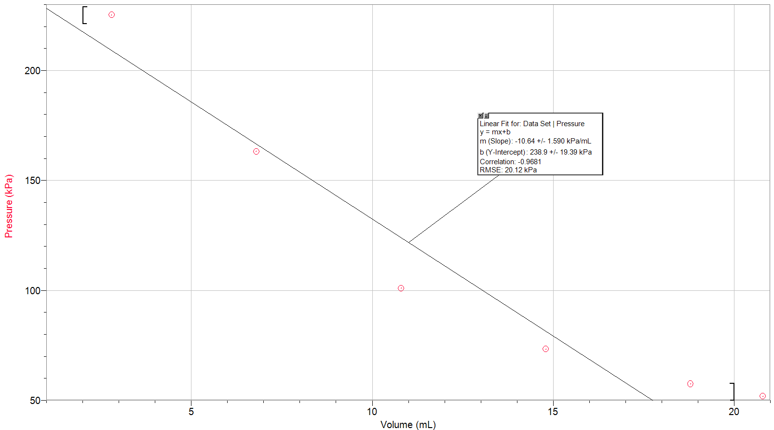
During the lab, the plotted points on the graph were given a linear best fit. However, from the experiment it was understood that the relation between volume and pressure in Boyle’s law is inversely related and so the data from the experiment was plotted again with an inverse best fit and a correlation value closer to 1 was seen, (0.9996 > 0.9681) which proves the inverse relation is correct over linear. The same results were found for trial 2.
Fig 1.1: Relationship between Pressure and Volume in a Syringe (inverse best fit without anomalous result) (Trial 1)
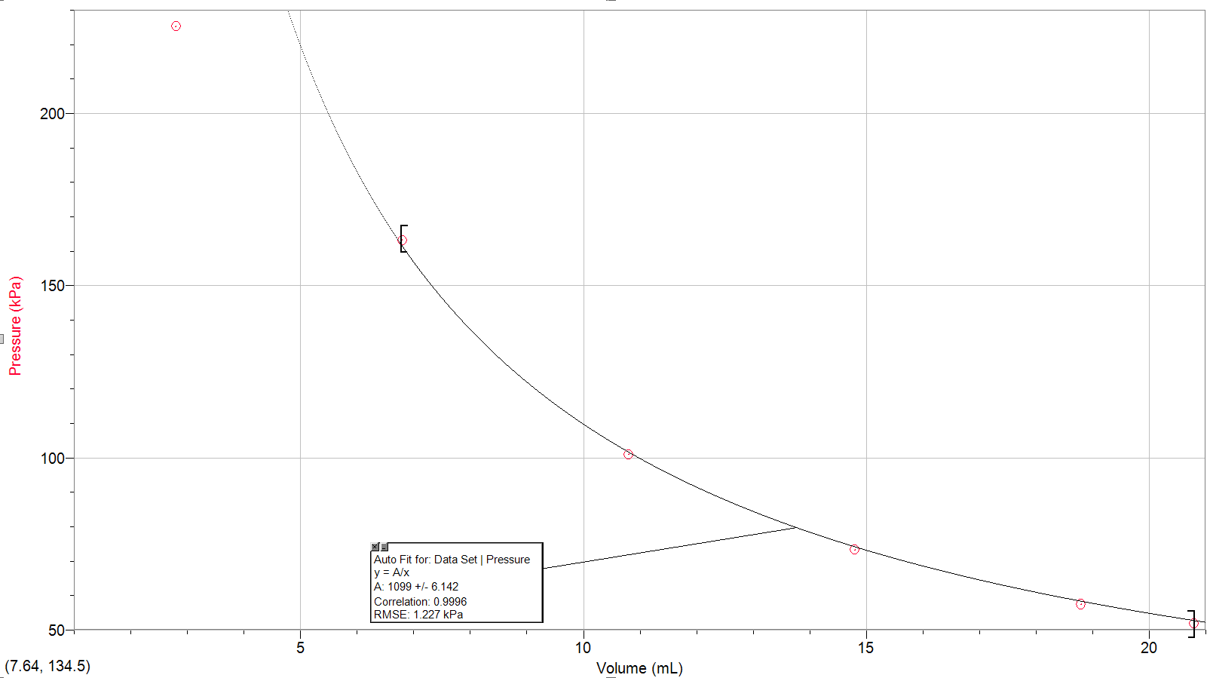
After analyzing the data, the 2.8ml data point seemed to be anomalous, thus two graphs are shown: Figure 1.2 includes and Figure 1.1 excludes the anomalous result inside the best fit. The major difference in the correlation values demonstrates that the data point is anomalous.
Figure 1.2: Relationship between Pressure and Volume in a Syringe (inverse best fit with anomalous result) (Trial 1)
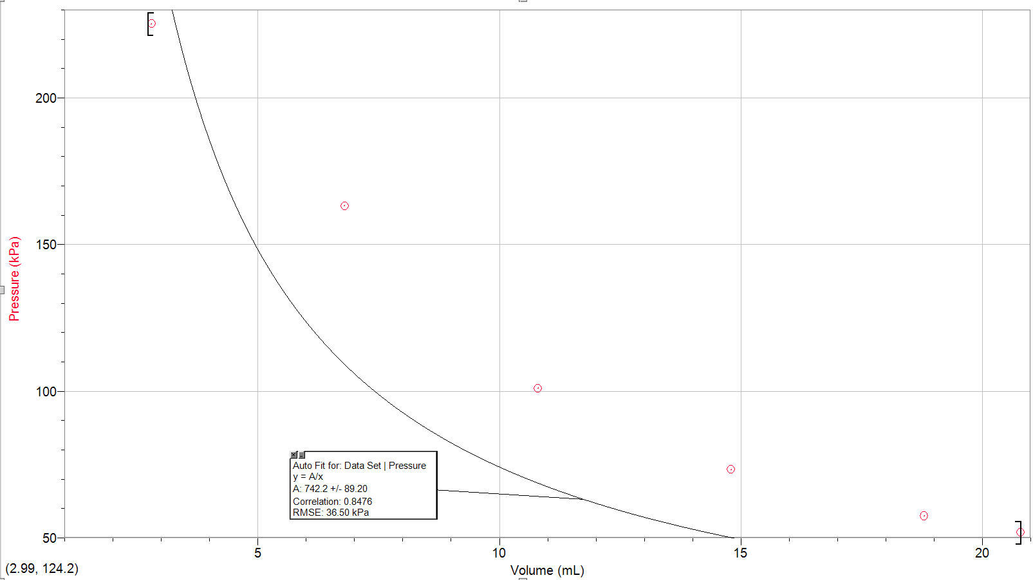
Fig 2.0: Relationship between Pressure and Volume in a Syringe (inverse best fit without anomalous result (Trial 2)
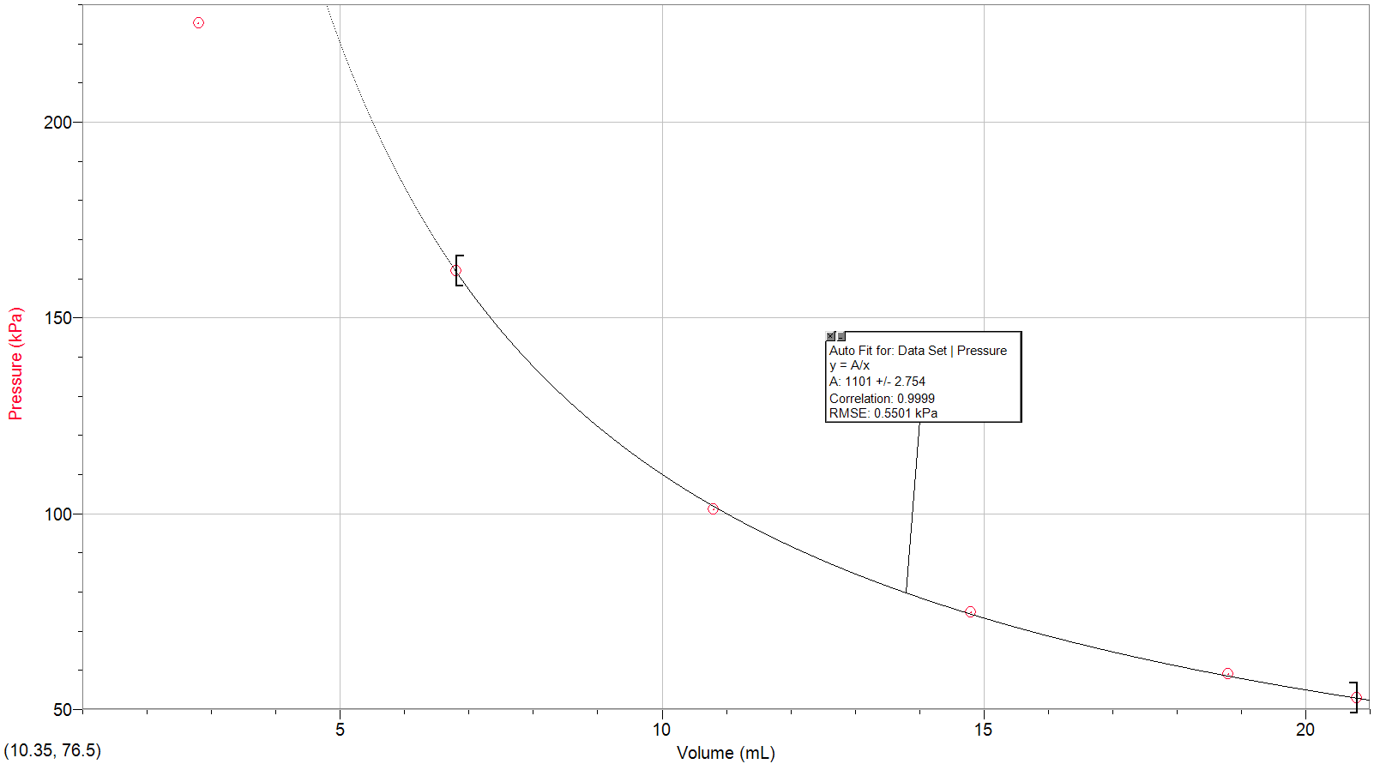
Calculations:
Boyle’s Law:
PV = k
(where P = pressure(kPa), V = volume(L), and k = Boyle’s law gas constant)
Sample Calculations for the Gas Constant from Boyle’s Law:
(0.0108 L) x (100.95 kPa)
= 1.09026 → 1.09*

(0.00680 L) x (163.17 kPa)
= 1.109556 → 1.11*

(0.00280 L) x (225.25 kPa)
= 0.6307 → 0.63*

(0.0148 L) x (73.29 kPa)
= 1.084692 → 1.09*

(0.0188 L) x (57.45 kPa)
= 1.08006 → 1.08*

(0.0208 L) x (51.83 kPa)
= 1.078064 → 1.08*

(The measurement at 2.8 mL seems to be anomalous, therefore it will be excluded in the next calculation. This will be further discussed in the Discussion section.)

* Values are rounded to 3 significant figures based on data

Sample Calculation for Average Value of Gas Constants (Trial 1):
(1.09026+1.109556+1.084692+1.08006+1.078064) / 5
= 1.0885264 → 1.09 kPa*L

Thus, our equation for the first trial is: PV = 1.09 kPa*L
The same calculations were done for the data set in trial 2. the equation for the second trial is: PV = 1.10 kPa*L
∵ PV = k
P₁V₁ = k
P₂V₂ = k
∴ P₁V₁ = P₂V₂
This is the equation for Boyle’s Law.
The gas constant should be equated to an average of 1.09 kPa*L and 1.10 kPa*L.
Avg k for both trials = (1.09 + 1.10) / 2 = 1.095 kPa*L

From this we can mathematically deduce that no matter how we change pressure or volume, if moles and temperature remain constant, we will get the same k value. So, we can calculate, for example, a final pressure using just math if we know the initial pressure and volume and the aid of a pressure sensor would not be needed This is the equation for Boyle’s Law.
The gas constant should be equated to an average of 1.09 kPa*L and 1.10 kPa*L.

Charles’s Law (from trial 2):
Temperature (T) is measured in Kelvin and Volume (V) is measured in mL.
- V1 = 144mL T1= 30 + 273.15 = 303.15K
- V1 - Vcw = V2 = 144mL - 29mL = 115mL
- V1 / T1 = V2 / T2
LS = 144mL/303.15K RS = 115mL/279.15K
= 0.475 mL/K = 0.412 mL/K
(RS does not equal LS due to errors. They are similar which validates the law, but in theory they should be the same under perfect conditions with no errors)

4. Avg V1 / T1 = (V1 / T1 Trial 1 + V1 / T1 Trial 2) / 2
= 0.477 mL/K
Avg V2 / T2 = (V2 / T2 Trial 1 + V2 / T2 Trial 2) / 2
= 0.422 mL/K
5. %error = 100% * [ (Avg V1 / T1) - (Avg V2 / T2) ] / (Avg V1 / T1)
= 11.5%

Discussion:
From the results in the experiment a constant “k” value was calculated for Boyle’s Law, which was very close between both trials, all with a low degree of variance in the data when regarding data points trial by trial. As discussed previously in the introduction, a fixed number of moles and a fixed temperature makes it so that any changes to volume will alter the pressure (with the reverse also being true). Therefore, this experiment was able to validate Boyle’s Law, as the Law is just a special case of the ideal gas law (mentioned previously in the introduction as equation 1).
The two graphs in Figure 1.1 and Figure 2.0 strongly demonstrated an inverse correlation; graphically, a hyperbolic curve. These results are expected, as the two asymptotes in the property of the hyperbola show that volume can never reach zero, and, likewise, pressure cannot reach zero, as a zero pressure would need a result of an infinitely large volume, which cannot be obtained in theory or practice. However, the correlation still stands.

Regarding the data, between the two trials, the gas constant for both individual volumes and averaged volumes were not quite the same. Even in regards to the first and last measurement of the initial volume marking, results were different. For example, in Trials 2’s first measurement of 101.10 kPa, and its last measurement of 103.20 kPa are very different, and account for a significant difference when calculating an experimental average. This is seen again in Trial 1 but to a lesser degree, with the first measurement being 100.95 kPa and the last measurement being 100.73 kPa. In the first case, the higher value was omitted as it less accurately represented Boyle’s Law in terms of data correlation. The lower value omitted in the second case. Calculating afterwards, taking out either the higher or lower initial volumes (10.8 mL in our trials) effects the correlation, thus it is important to see which data point is more accurate, and to omit the other. This shows the importance of taking multiple data points of the dependent variable for the same independent variable value (in this case 10.8mL).
Since the experiment is not done in ideal conditions there are many factors that could affect this change in results for the same value. For example, while holding the syringe, heat could be transferred from our hands or heat could be transferred to our hands from the syringe if the hands are cold. Superficial human skin (especially hands) radiates at about 32-35 degrees Celsius (Farzana, 2001), and thus would cause change in temperature of the gas inside the syringe over time. Another source of error could be the friction caused by the moving parts in the syringe. This very slight change in temperature could cause a change in the pressure results. To eliminate this, an insulated syringe could be used. Another erroneous aspect of this experiment is that gas could escape or leave the syringe as it may not be fully sealed. Even though this is a dynamic equilibria, it is not possible to be sure that the amount of moles of gas is the same in the syringe throughout the experiment. So, under perfect conditions, the two kPa values for the 10.8mL data points should be the same. However, they are not so an error in the experiment can be deduced. For Boyle’s Law the conditions necessary are that temperature and moles of gas should be constant. In the errors mentioned above, either temperature or moles are not remaining constant and so it affects the results to move away from the standard. This is also why multiple trials and an average were conducted and calculated.

During the conduction of the experiment, a test value of 2.8mL was chosen. However, this data point produced an anomalous result which deviated from the standard and so it was excluded from calculations as it would affect the accuracy of the average and overall, the result of the experiment. Reasons for the anomalous result are that its very close to an extreme value (0mL) and so it was not a stable recording as the syringe was not stable at that reading. As noted in the qualitative observations, as the values got closer to 0, it became increasingly difficult to push the syringe plunger, thus causing instability in the reading. To fix this source of error, using a clamp to hold the syringe in place would help avoid instability.
For the Charles’s law portion of the lab, the reasons why the initial volume and temperature ratio did not equate to the final ratio could be due to the fact that water was not completely transferred from the Erlenmeyer flask to the Graduated Cylinder. This source of error was difficult to avoid, as even if all the water was poured correctly, a small amount of liquid would remain in the initial container. There is no avoidance to this source of error, thus the only solution is to account for loss of water when calculating data. If ideal conditions were present for the duration of the experiment, the two ratios would equate. However, they are similar (around 0.42 to 0.47) which validates the results and ensures they correspond with Charles’s Law.

Conclusion:
In conclusion, it was verified that Charles’s Law shows a proportional relationship between temperature and volume by the fact that the experimental data showed similar results when volume as divided by temperature; ~ 0.42 - 0.47. Boyle’s law and the inverse relation between volume and pressure was verified when each volume was multiplied by the corresponding pressure and each set (excluding anomalous entity) gave a similar and consistent value for the constant k; ~1.9 - 1.10. The average k value for all the results was 1.095 L*kPa.

Appendix:
Image 1: Raw Data from Laboratory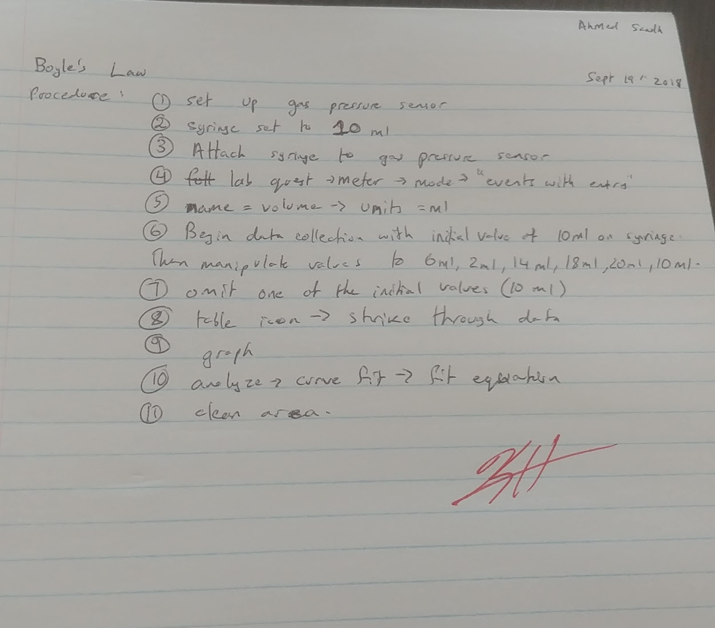

Image 2: Raw Data from Laboratory
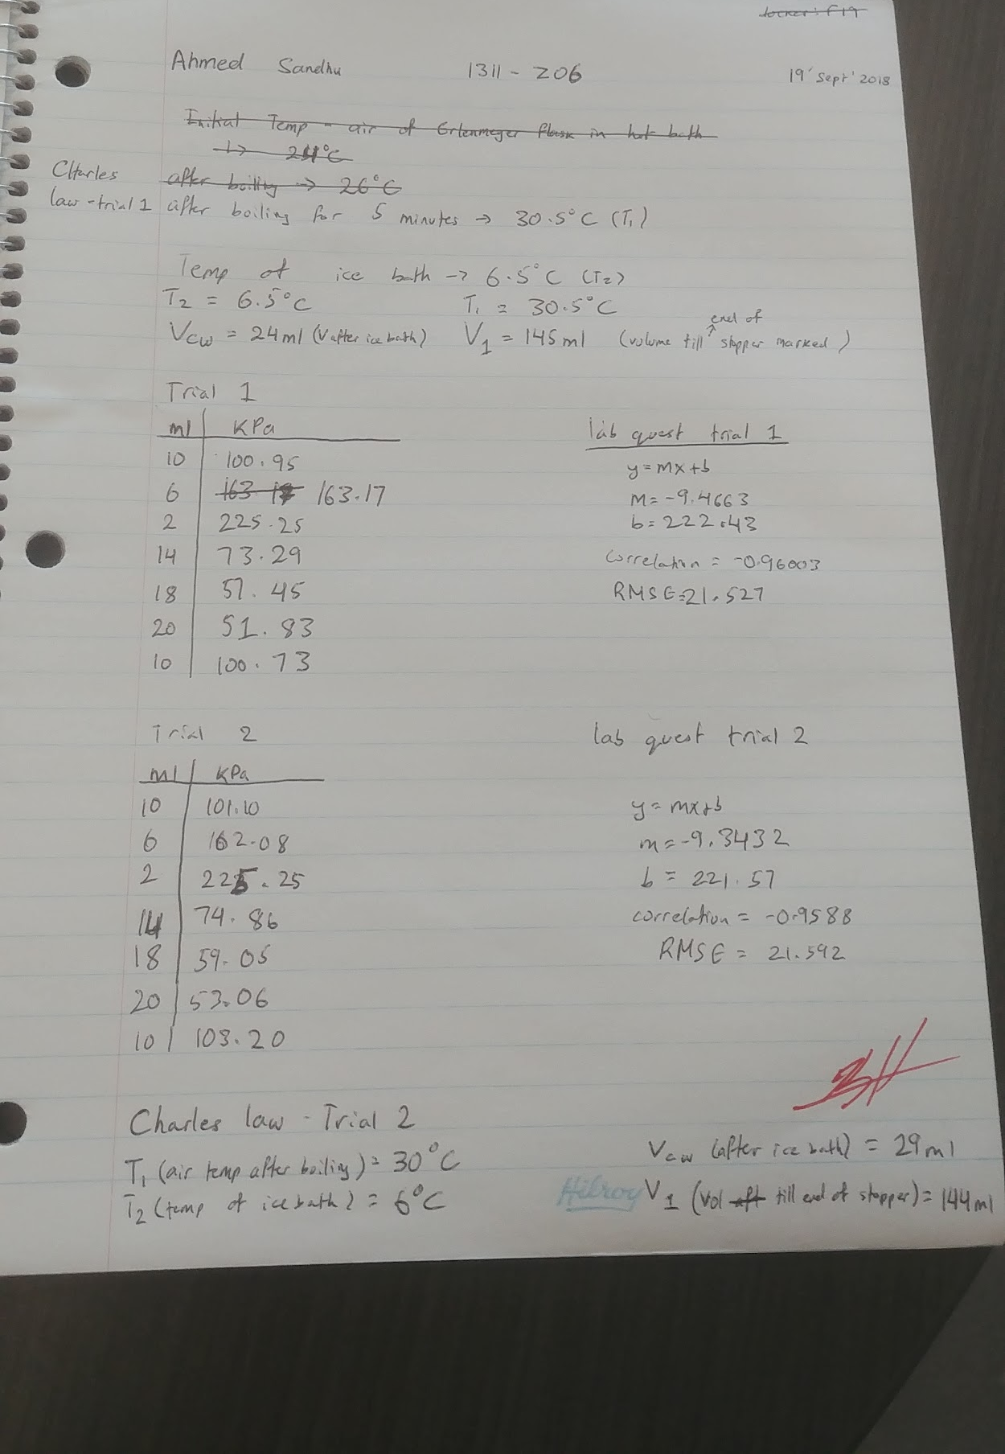

Image 3: Raw Data from Laboratory
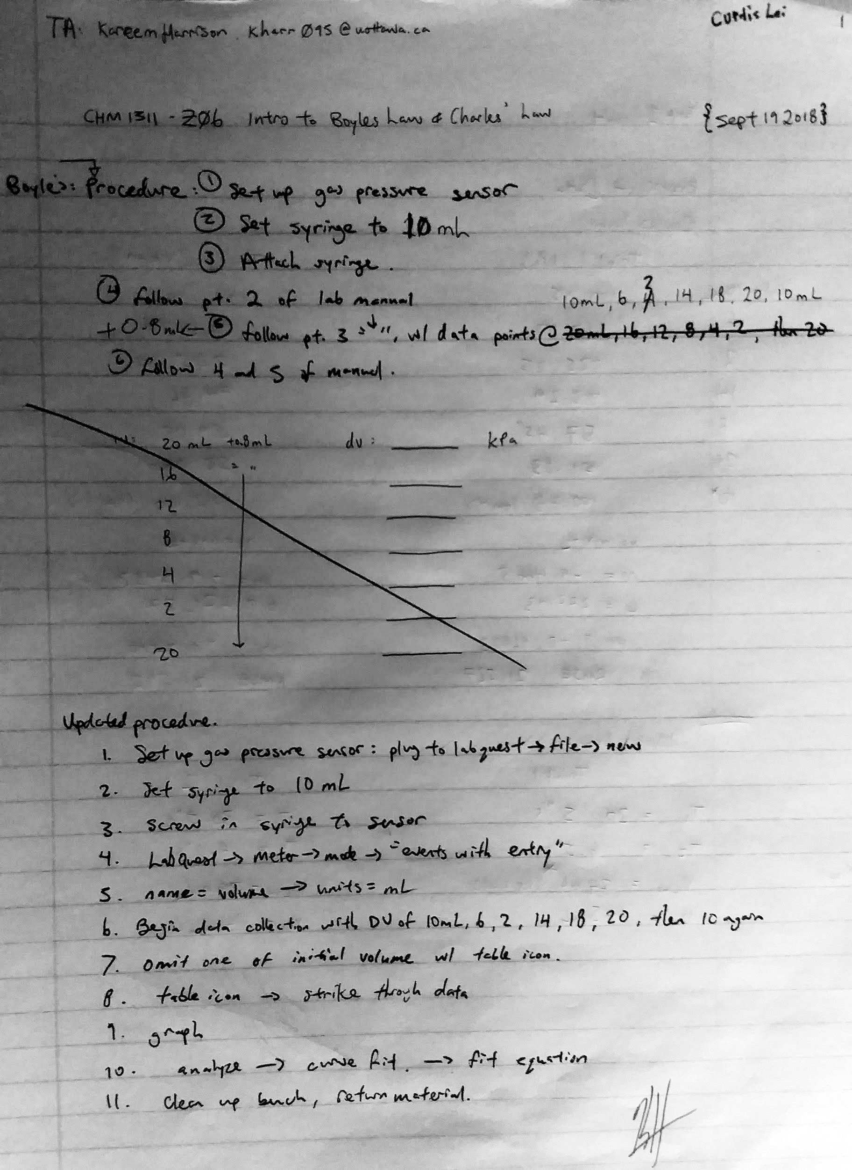

Image 4: Raw Data from Laboratory
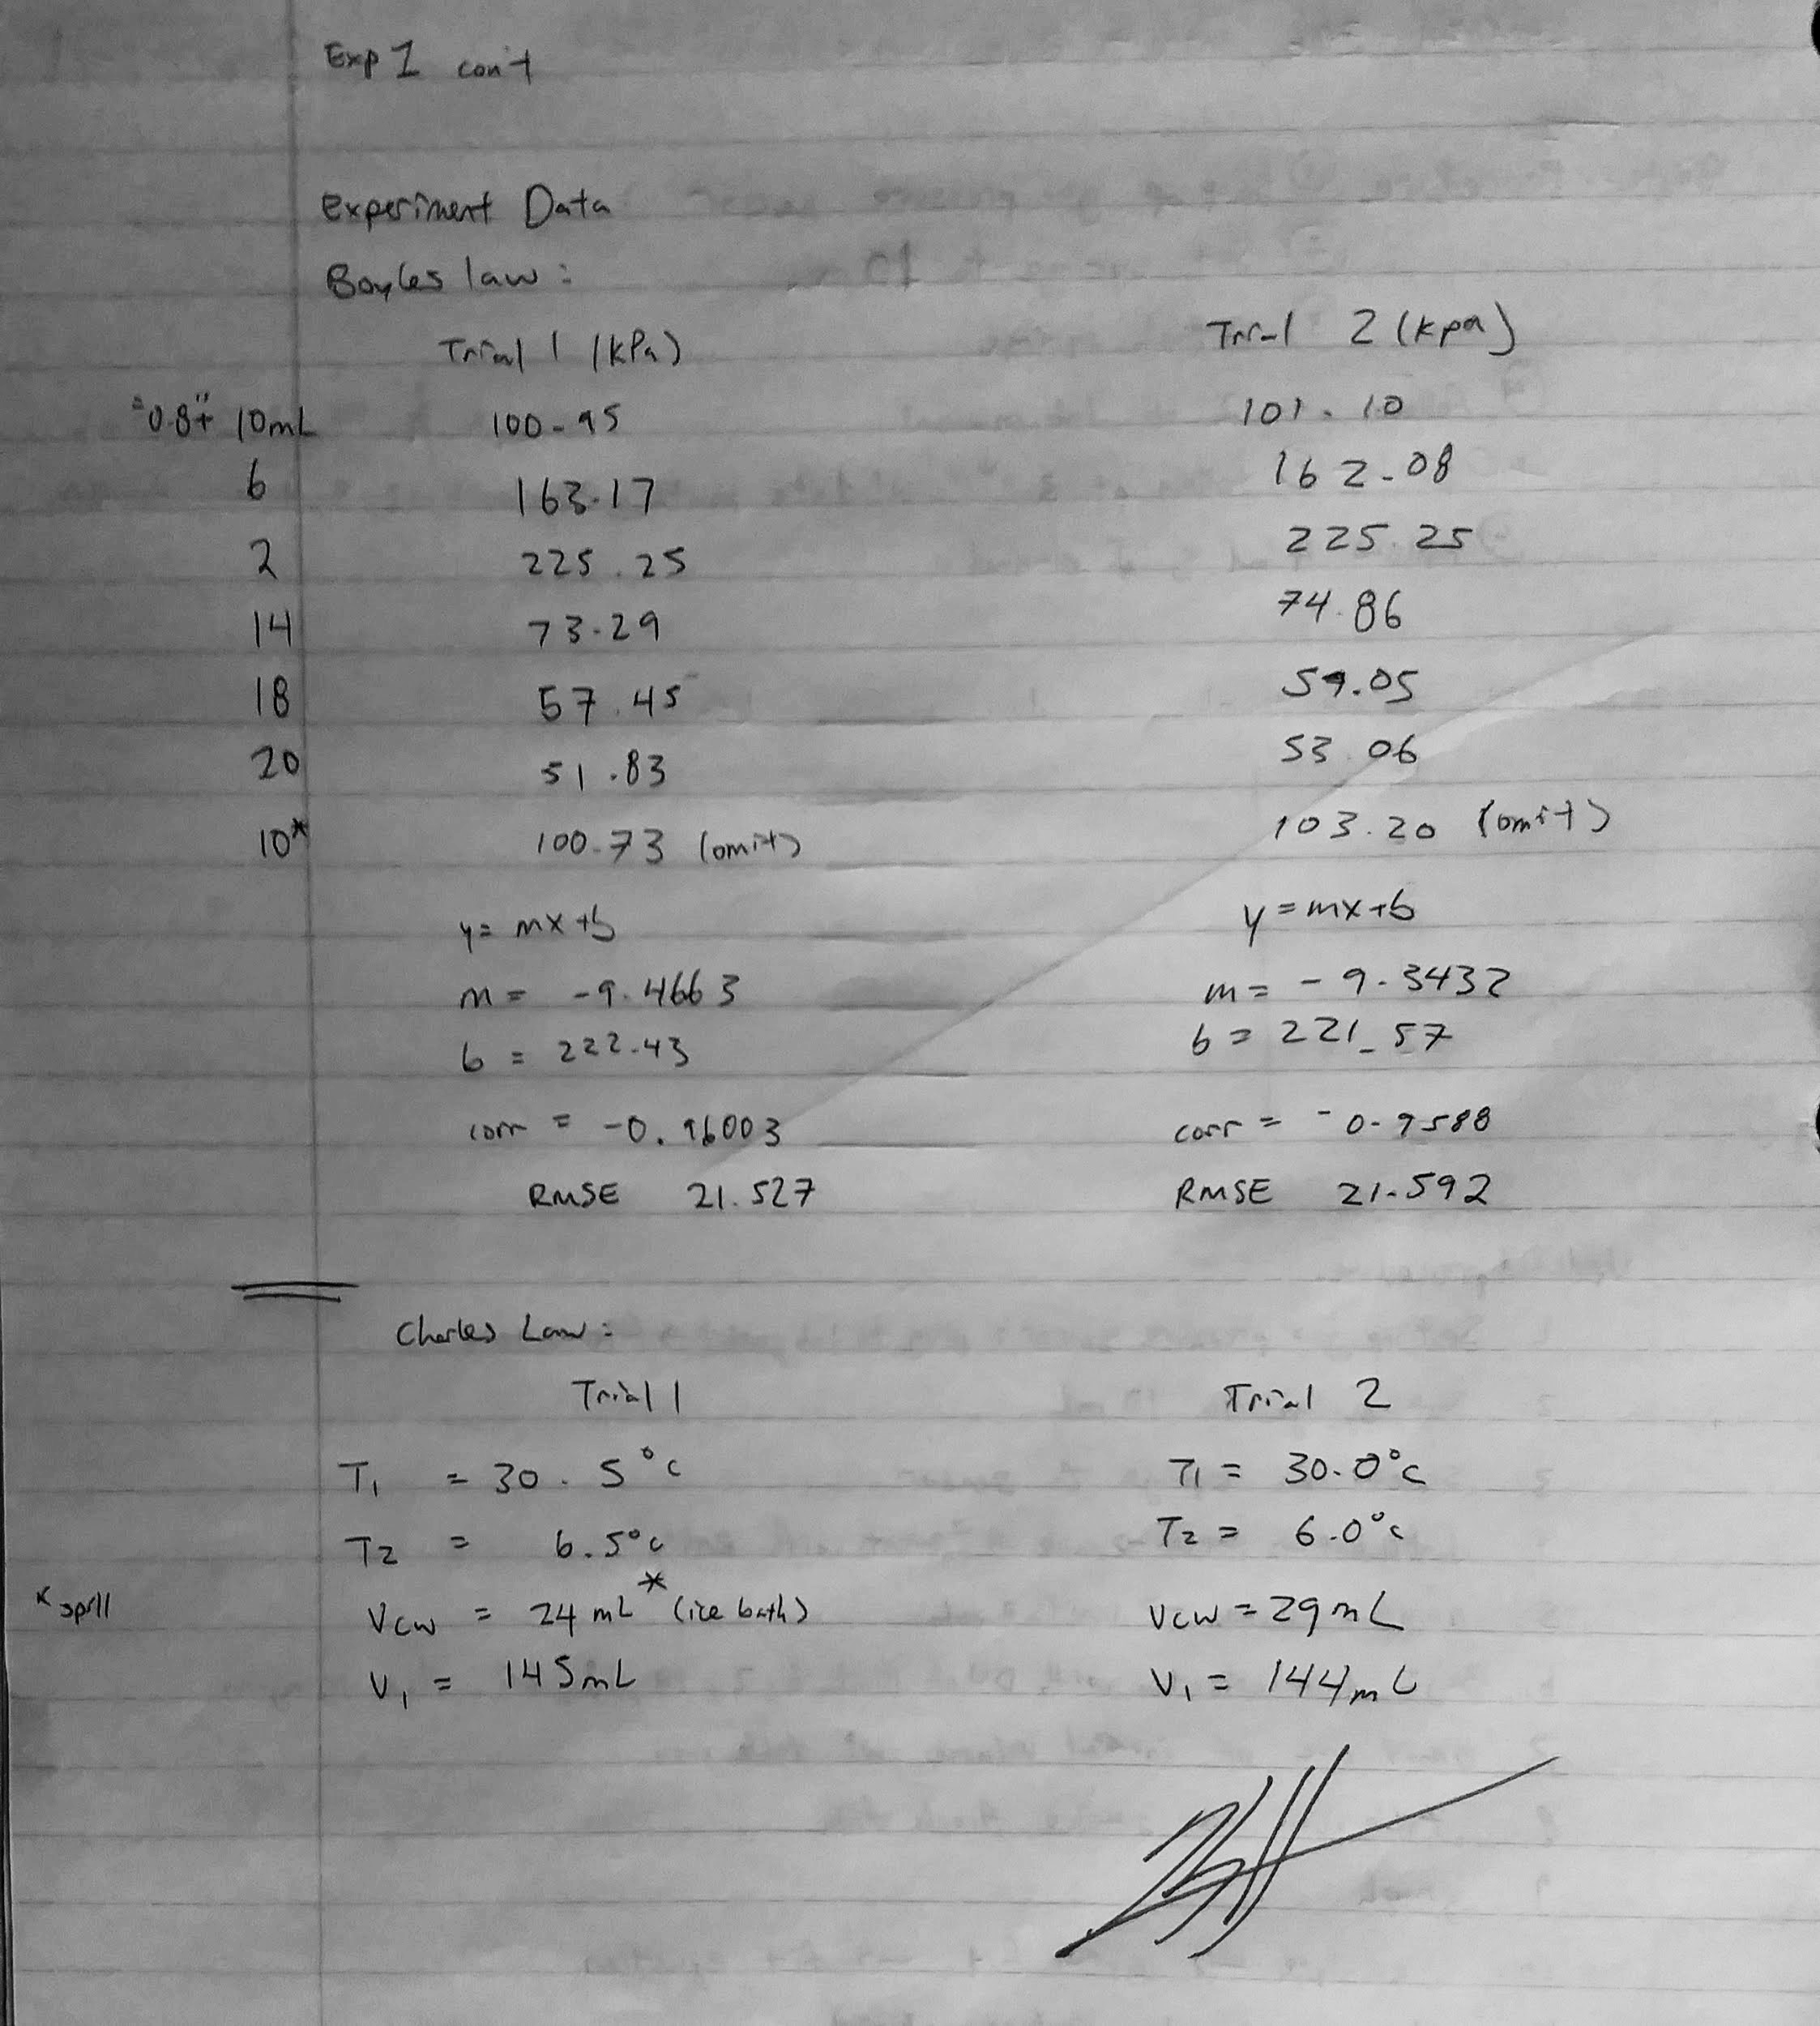

References:

Farzana, Abanty. (2001) Temperature Of A Healthy Human. The Physics Factbook. Retrieved
from https://hypertextbook.com/facts/2001/AbantyFarzana.shtml

LeTran, Duke. (Jan 9, 2017) The Ideal Gas Law. Chemistry LibreTexts. Retrieved from
https://chem.libretexts.org/Core/Physical_and_Theoretical_Chemistry/Physical_Properties_of_Matter/States_of_Matter/Properties_of_Gases/Gas_Laws/The_Ideal_Gas_Law

Staroscik, Andrew. (2017) Boyle’s Law. SciencePrimer. Retrieved from
http://scienceprimer.com/boyles-law

Venkateswaran, Rashmi. (2018) CHM1311 Lab Manual. DO I DARE DISTURB THE
UNIVERSE?’ (T.S. Eliot) VERIFICATION OF GAS LAWS, (p7-8)

