There are 3 parts to this test
- ADD YOUR NAME TO ALL SECTIONS and IF-AT SHEET
- THIS TEST HAS 11 PAGES
PART A = 20 multiple choice questions (1 point each)
- OPTION 1 : USING THE IF-AT SHEET FOR MCQ
  - ADD YOUR NAME AND STUDENT # AT TOP OF IF-AT
  - NOTE – Scratch ALL or NOTHING
    - Partial scratches will count as a WHOLE SCRATCH = ANSWER
    - CONTINUE TO SCRATCH UNTIL YOU HAVE THE RIGHT ANSWER (*)
    - 1 SCRATCH = 1 POINT
    - 2 SCRATCHES = 0.5 POINT
    - 3 SCRATCHES = 0.1 POINT
    - 4 SCRATCHES = 0 POINT
    - ADD YOUR SCORE PER QUESTION AND IF TIME ALLOWS ADD UP THE MARKS (out of 20)
- OPTION 2 : DO NOT USE IF-AT BUT RANK YOUR ANSWERS ON THE TEST
  - 1st, 2nd, 3rd, 4th
    - If you rank the correct answer 1st = 1 point
    - 2nd answer = 0.5 point
    - 3rd answer = 0.1 point
    - 4th answer = 0 point
PARTS B and C = 4 SHORT ANSWER QUESTIONS at 5 points per answer IN THE BOOKLET
Part B – 4 Short Answer questions – YOU DO THREE (3) (15 points total).
Part C – 1 Case Study – YOU DO IT (5 points total).
- Use the space provided to answer these questions.
- If I ask for 5 things and you give 6, only the first 5 are answered.
- Answers in pencil cannot be remarked.
Total Points = 40 points!
SUBMIT THE WHOLE TEST WITH IF-AT SHEET AT END OF TEST
Read carefully:

Cellular phones, unauthorized electronic devices or course notes (unless an open-book exam) are not allowed during this exam. Phones and devices must be turned off and put away in your bag. Do not keep them in your possession, such as in your pockets. If caught with such a device or document, the following may occur: academic fraud allegations will be filed which may result in your obtaining a 0 (zero) for the exam.

By signing below, you acknowledge that you have read and ensured that you are complying with the above statement.

Signature: ________________________________

PART A – MULTIPLE CHOICE (20 QUESTIONS)
- Which ONE of the following statements about cells is TRUE?

    - The term “cell” was coined in the 10th century when describing the individual units that make up a living organism.
    - The discovery of cells using early microscopes argued in favour of the spermist and ovist perspectives on the development of life.
    - The discovery of cells using early microscopes argued in favour of the preformation model for the development of life.
    - Cells that made up an organism were famously categorized into two different types based on their ability to form gametes or cells of the body.

- Recall this image and the way it is drawn here. It relates not just that DNA can act as a ligand in the cytosol to mediate cell signaling but that: ( dna can also induce signalling)
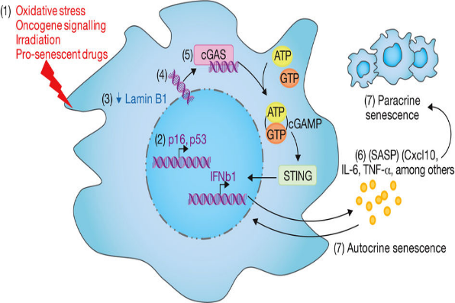
  - The initial senescent cell can maintain the senescent phenotype indefinitely.
  - The aging cell can signal its neighbours to undergo necrosis and die.
  - The aging cell can initiate reciprocal signaling with its neighbours.
  - That the aging cell uses a RTK to sense the DNA for signalling by phosphorylation.

- “I define nothing. Not beauty, not patriotism. I take each thing as it is, without prior rules about what (I) should be.”
― Bob Dylan
If Bob Dylan was a cell, based on what you learned in the course, which statement BEST describes his current state?

  - He is an inducer providing instructive signals to other cells competenet enough to listen.
  - He is a responder waiting for permissive signals to allow him to proceed down a path.
  - He is a mesenchymal cell too liberated to be chained down in epithelial tissue.
  - He can respond to conditional signals that will determine his final outcome.

- An article dealing with early stress and the epigenome stated that “... the decreases in methylation in stressed mice result from the inactivation of a protein known as MeCP2 which is involved in the initial recruitment of proteins that methylate...” Based on your understanding of this figure from your notes, which statement below BEST summarizes the significance of this figure in the context of this article.

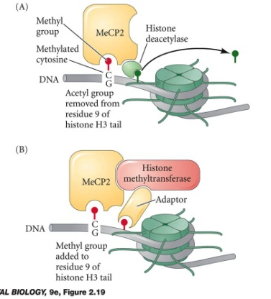
- This slide emphasizes methylation of DNA causes the formation of euchromatin through modification of histones. This euchromatin is more open. If MeCP2 is inactivated, you have heterochromatin.
- This slide emphasizes how DNA methylation can trigger a series of post-translational modifications such as methylation of histones resulting in inhibition of transcription. If MeCP2 is inactivated, this additional mechanism of gene repression is removed.
- This slide emphasizes how DNA methylation requires methyltransferases to bind to areas rich in CpG motifs. If you have no MeCP2, the methyl groups will still be there and you will have no transcription of your gene.
- This slide emphasizes how DNA methylation of CpG motifs in the promoter region prevents transcription of a gene by blocking transcription factors from binding to their target sequence. If you inactivate MeCP2, then transcription factors can bind to the promoter to initiate transcription.

- Which answer BEST describes the following situation?
I was one of many and up until recently we worked as one. But I have received a call from the outside that my neighbours did not hear. It tells me to leave the rest behind and, as I escaped, I became something that they were not.
- The cell was epithelial but has been induced by a morphogenic signal and instructed to change into a mesenchymal cell.
- The cell was a member of an equivalence group that through a stochastic event resulted in one member becoming something different than the others.
- The cell was an epithelial cell but now it has changed into a mesenchymal cell due to its unique cytoplasmic determinants.
- The cells have sent signals to its epithelial neighbours and they have responded by inducing the inducer (now responder) to become a mesenchymal cell.

- Read this brief excerpt from a recent study dealing with fibroblast growth factor (FGF; a paracrine factor) signaling. A female cancer patient, X, is discovered that is highly responsive to the drugs despite having high levels of FGF1. This observation with patient X is counter to the paper’s observation. Which statement below provides the BEST explanation in support of the paper despite this result?

- FGF1 works through the Wnt pathway resulting in the activation of an inhibitor that may not be working in patient X.
- It turns out that patient X has a non-functioning receptor to FGF1 due to a deleterious mutation.
- High levels of FGF stimulates high levels of gene transcription that provides sensitivity to chemotherapy.
- The platinum-based drugs bind to the same receptor as FGF1, outcompeting it and preventing FGF1 signaling.

- In a hypothetical situation, a parent cell divides but the daughter cells have unequal content: one has mRNA A, the other, mRNA B. Which ONE of the following mechanisms would NOT explain this asymmetry?

- Prior to cell division, mRNA A was trapped on one side of the parent cell while mRNA B was trapped on the other side.
- mRNAs A and B are actively transported to opposite ends of the parent cell in an ATP-dependent manner prior to division.
- mRNAs A and B have a poly A tail added after activation of the parent cell (like what happens in oocytes).
- mRNA A is degraded everywhere but at one side where it is protected. By contrast, mRNA B is degraded everywhere but on the other side where it is protected.

- Which ONE of the following would NOT be an example of LEVEL 3 regulation?

    - Acetylation of histone 3 tails in the nucleosome of the cell.
    - Primary transcripts not released into the cytoplasm of the cell.
    - Alternative splicing of primary transcript before forming mRNA.
    - Mutations of the consensus sequences at the junction between introns and exons.

- As indicated in class, not all promoters are the same. There are apparently now 2 categories of promoter, namely high CpG containing (HCP) and low CpG containing (LCP) promoters. Which statement concerning high CpG content promoters is TRUE?

    - These promoters are typically left ON thanks in large part to deacetylation of histones on the DNA.
    - These promoters are typically associated with housekeeping genes (vital genes for cell survival).
    - These promoters are typically turned OFF thanks to methylation of the DNA in the promoter region.
    - These promoters are typically associated with developmental regulatory genes (for driving cellular development).

- Which statement about enhancers, promoters, and silencers is FALSE?

    - If an enhancer element for gene Y has acetylated histones, then an RNA transcript for Y would not be expected.
    - Enhancers, promoters, and silencers are all cis-regulatory elements that are only functional on the same stretch of DNA (e.g. chromosome).
    - Promoters allow genes to be transcribed but enhancers/silencers regulate when and where genes are transcribed.
    - If a silencer element for gene X is methylated, then an RNA transcript for X would be expected.

- Recall the debate between the early geneticists and the early embryologists. One contended that the genes (nature) affected development while the others stated that it was environment (nurture). Which of the following experiments provided evidence for the role of both?

    - W. Roux’s experiment killing one of the two cells of a 2-cell frog embryo with a hot needle.
    - The demonstration that genetically identical twins can develop differently over their lifetimes due to lifestyle differences (e.g. smoking in one sibling).
    - The cloning of Dolly the sheep by taking the diploid DNA from an udder cell and plugging into an enucleated egg. The diploid egg would give rise to Dolly.
    - The gene editing of livestock using the CRISPR/Cas9 targeting system; generating cattle with no horns despite having a genome for horns.

- Recall this image of the regulation of transcription by mediator molecules. The purpose of this image can be BEST described as a:

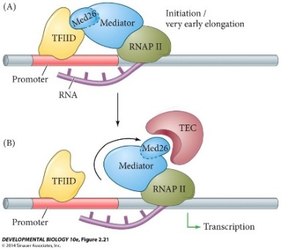
    - Model to explain the poised intermediate state of transcription as regulated by the action of the mediator.
    - Model to explain the assembly of the initiation complex at the promoter region of gene with the help of the mediator in question.
    - Model to explain how mediator molecules shown here are a type of transcription factor that regulate transcription.
    - Model for gene regulation that is typically associated with LCP type promoters of the cell.

- Here is an image of a signalling pathway. Only ONE of the following can be inferred from the image.
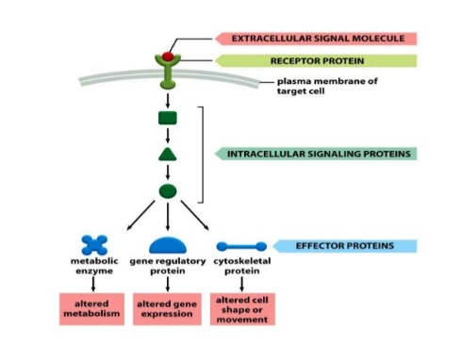
    - This image highlights the modularity of the signalling pathway.
    - This image highlights the redundancy of the signalling pathway.
    - This image highlights activation of effector responses through inhibition of an inhibitor.
    - This image highlights the pleiotropy of the signaling pathway.

- In the video concerning epigenetics, there was talk about the agouti mouse. The fat yellow mouse has its agouti gene turned on while in the lean brown sisters, the gene is turned off. Pregnant brown mice exposed to Bisphenol A (a chemical found in hard plastics) became yellow and so were the offspring once born. This suggests that:

    - Bisphenol A can alter the epigenetic profile; the enhancer of the agouti gene was methylated in both the exposed mother and her pups.
    - Bisphenol A can alter the epigenetic profile; the silencer for the agouti gene was methylated in both the mother and pups.
    - Bisphenol A changed the structure of the DNA; the agouti gene was compacted into heterochromatin in both mother and pups.
    - Bisphenol A can create inheritable effects; the perpetuating methyltransferase was activated by Bisphenol A in both mother and pups in utero.

- Recall this figure dealing with ribosomal heterogeneity. Which statement is TRUE concerning the implications of these findings:

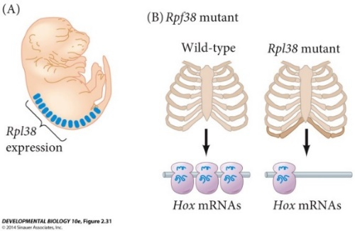
- There are many different types of ribosomes due to combinatorial diversity within the genome.
- In the absence of particular ribosomal proteins, certain mRNA transcripts are not translated, resulting in deformities.
- The ribosomes are modular in nature, diverse, and used equally in all cells to give a normal phenotype. Incomplete splicing results in deformities.
- The ribosomal protein Rpl38 mutants arise due to epigenetic changes that result in defects in development such as the skeleton and Hox mRNA usage.

- As mentioned in class, Wilhelm Roux’s defect experiment (shown above) with the frog embryo would have shown regulative development :
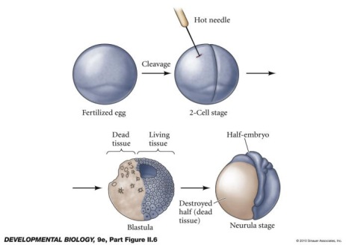
- Had he separated the killed cell from the live cell and cultured the live cell by itself.
- Had he done the defect experiment with a four cell embryo instead of two cell embryo.
- Had he transplanted a cell from another frog species to replace the dead cell from this experiment.
- Had he transferred all the nuclear determinants from the still living cell to its neighbour before killing it.

- Recall this image from the video dealing with RNAi. This image is meant to correspond to :
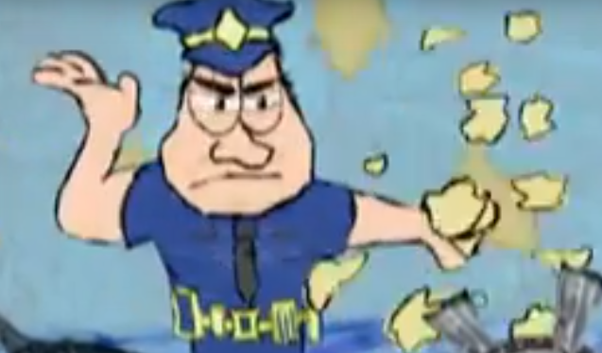
  - RISC destroying its RNA targets.
  - DICER destroying its RNA targets.
  - DROSHA cutting the RNA targets.
  - The proteasome destroying the RNA targets.
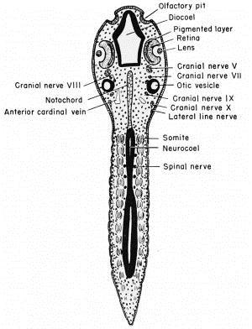
- Using the proper terminology, this is what kind of tissue section of the frog tadpole?

  - Transverse section
  - Horizontal section
  - Mid-sagittal section
  - Anterior to Posterior section

- A good indication whether a protein is a transcription factor would be:

    - It becomes phosphorylated by signalling cascades from the membrane.
    - It contains a domain rich in CpG motifs that can be methylated.
    - It transports mRNA to different ends of the cell by active transport.
    - It contains a domain that binds to a cis-acting DNA element.

- Recall this image dealing with methylation of RNA. Here, FTO is a:
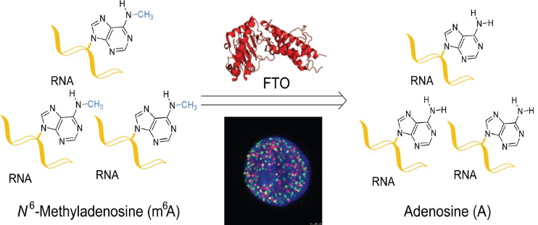
- Phosphatase
- Phosphorylase
- Deacetylase
- Demethylase

PART B: Short Answer questions: ANSWER ONLY 3 OUT OF 4 (5 points each)
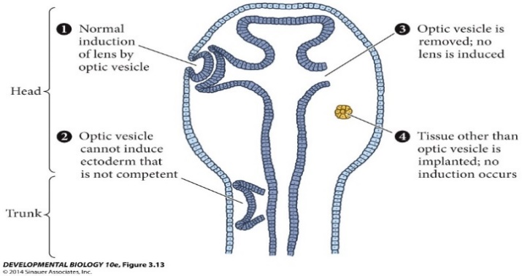
- Summarize each of the 4 scenarios indicated in this figure to the right from Xenopus. For the 5th point, what is the take home message of this figure?
- Provide the 5 major stages of cell movement at the embryonic-level including a written explanation and/or drawing of each to help depict each process in action. (1 point per).
- Recall the classical transplantation experiment demonstrating determination of cells. Tell me (or show me) how it was done.
- A researcher discovers gene x that codes for protein X. The researcher speculates that gene x is vital for fish embryonic development since a gene x knock out (deletion) of a recombinant zygote results in lethality very early on (by day 2 post fertilization the embryo dies). That being said, the researcher also suspects two things – that gene x is necessary for heart development in a day 10 embryo in fish and that works in the same way as Drosophila’s Delta protein since X is homologous (similar in sequence) to Delta. Based on what was taught in class, your task is i) to select the appropriate animal model to study the effects of gene x (give the common species name), ii) to suggest a strategy to knock out gene x to cause lethality, iii) to suggest two strategies that can be used to show gene x’s role in heart development in a day 10 embryo, and iv) an in vitro method to test that protein X works like Delta (hint: how does Delta work?).
PART C: DO THIS CASE STUDY: (5 points)
So take this opportunity to explain a possible mechanism in the skin cell (epidermal cell) i) that outlines how epidermal growth factor receptor (EGFR) and its ligand, EGF (assume like FGF), drives skin cancer and ii) how siRNA is mediating its inhibitory effects on i) within this same cell (treated with the cream). I would suggest that you draw the MAIN STEPS and PLAYERS that, although not explicitly mentioned in this article, were highlighted in my lectures on (paracrine) signalling pathways (i) and RNAi (ii) (to the best of your memory). (siRNA is already single stranded RNA).

