BIO1130 Midterm 1 Notes

Introduction

Morphology: Cheetahs
- An example of evolution: locomotion in cheetahs
- Cheetah will catch their prey approx 50% of the time
  - 110km/h speed
  - Deer around 60-90km/h
- Human VS cheetah
  - Usain bolt 100m in 9.58sec, cheetah ran 100m in 6.1sec.
- Morphology of the cheetah to consider (via video): next slides
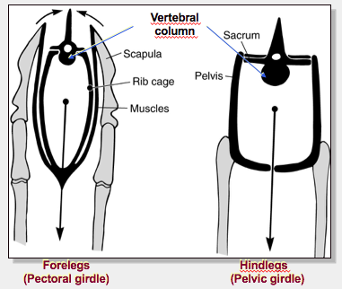
- Hind legs
  - Motor of the cheetah
    - Generates speed, pushes animal forward
  - Thin limbs = don’t have to carry a lot of weight = can go faster
  - Pelvic girdle (pelvis) fused to the vertebral column (propulsion)

- Forelegs
  - Scapula is on the side of the thoracic cage limits capacity for movement
    - VS humans (we have scapula on the back of the thoracic cage) which allows us to have a lot of movement
  - Thoracic cage sits in a string of muscles muscles act as the shock absorber for all the movements when the cheetah runs
  - Pectoral girdle (scapula) not directly attached to the vertebral column (slides on the rib cage)
    - Propulsion, orientation, stride length
  - If the limbs were attached to the vertebral column, the head would bob up and down during running, internal organs may be squished, etc.
    - Limbs not attached to vertebral column allows the head to remain very still and focus on the prey

- Tail
  - Compensates for balance, stops animal from sliding to the side when turning (during running)

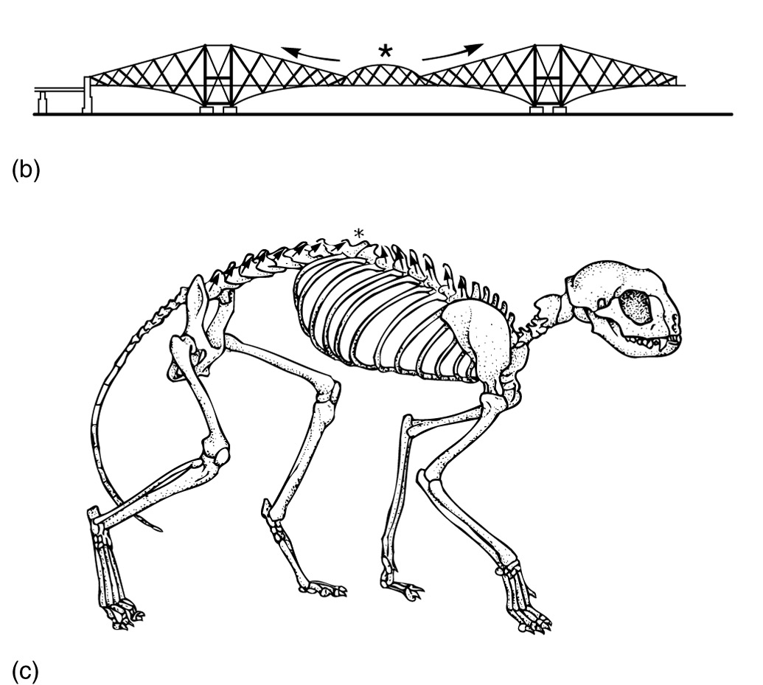
- Skeleton of Cheetah VS Bridge
  - Everything left of the node is responsible for the hind limbs
  - Everything right of the node is responsible for front limbs
  - In a bridge, the node marks the trade-off point in weight and structure distribution between two pillars. We can observe a similar node in the vertebral column between the paired limbs of a quadrupedal mammal. The node is visible as the point of transition in the orientation of the neural spines (bony processes on the top of each vertebra).

Evolution: Cheetah
- Appearance of limbs: 440myr
  - From evolutionary discourse, limbs come from FINS of fish
    - Fins and limbs are HOMOLOGOUS
- Some fish have bones in fins; comparing to limbs, you can recognize femur, tibia
- Oldest fish that had limbs: appeared 440 million years ago
- Pelvic fins
- But fins in fish have different role than limbs in animals

- Pelvic girdle fused to the vertebral column: 385myr
  - Pelvic fins in tetrapod are much more developed than in fish (last slide)
    - Fish are closely related to tetrapod (ex; primitive amphibian)
  - First characteristic of land animals is this fusion
  - Limb provides support to vertebral column

- Rotation of the knee and elbow under the body (erect posture): 220myr
  - Crocodile, amphibians, lizard, etc; their limbs are parallel to the ground, and protrude off the sides of the body
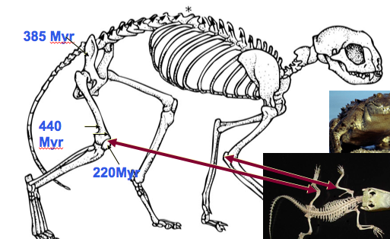
    - aka Sprawled position
    - These animals annot run very fast or for very long
  - Having limbs underneath the body (ex; cheetah and most tetrapods) allows them to move faster and for a longer time
  - Not unique to cheetah

- Walking on fingers (digitigrade): 65myr
  - Most carnivores walk on their fingers
  - Cheetah run on their fingers (whole foot is off the ground)
    - Digitigrade
    - Since is foot is off the ground, it is essentially part of the limb extends length of the limb which allows for longer strides
    - They also have claws (complicated foot structure)
  - Gazelles have magnified this characteristic
    - Walk on their nails
    - Uniguligrade
    - Makes the leg length much longer (longer strides)

- Retractable claws: 25myr
  - All big cats have retractable claws
    - Protects nails from being worn out too quickly
    - Dangerous weapons
    - Oldest species of cats we have now is about 25 mill years old

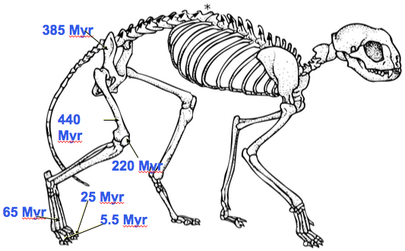
- Cheetah have semi-retractable claws: 5.5myr
  - Only a part of its claw will go back into the foot
  - More blunt
  - Gives more grip when running/turning direction
  - Unique to the cheetah (evolved in cheetah)

- Hindlegs of a cheetah: the result of 440 mill years of evolution

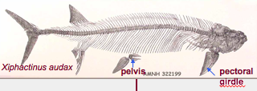
Overview of Adaptions in Cheetahs
- Adaptation of vertebrates in cheetahs
  - Locomotion organs (fins or limbs)
- Adaptations of terrestrial tetrapods in cheetahs
  - Pectoral girdle (scapula) detached from skull
    - Pectoral girdle is fused from the cranium in FISH (fish’s environment never caused it to evolve a neck)
    - As animals moved to the land, they evolved to remove the fusion of the pectoral girdle to the cranium (allowed formation of neck)
  - Pelvic girdle (pelvis) fused to the vertebral column

- Adaptations of mammals in cheetahs
  - Rotation of the knees and elbows under the body (support/speed)
- Adaptations of the carnivore family in cheetahs
  - Walk on fingertips (digitigrade)
- Adaptations of cheetahs COMPARED to other felines
  - Fur pigmentation
  - Long and thin limbs especially in the distal end (stridge length)
  - Lightweight, slender and muscular body (speed)
  - Flexibility of the spine (speed, stride length)
  - Wide nostrils, heart and lungs with high functional capacity

  - Cheetah are fastest animal on land
  - Most features are just slight adjustments of characteristics of other land animals

Thus, what is a Cheetah?
- A cheetah is a mammal characterized by few derived traits (evolutionary innovations) that distinguishes it from other feline species.
  - The species is the result of 3,500 Myr of evolution. Why?
  - More than 99% of its characteristics have evolved in species that are now extinct.
  - Less than 1 % of its features are unique. (exaggeration)
- So the cheetah is more the result of the history of its ancestors than of its own history.
- This applies to all living species, including humans
- All living species are the endpoint of their evolutionary groups* basic concept

- Importance of Genetic Variability: Royal Cheetah
  - Royal cheetah (species, or a mutation) are endangered
    - Because lack of genetic variability
    - They are almost all clones
    - If a disease or environmental pressure kills one, it will likely kill all

- We don’t know why they lack G.V, but hypothesis:
  - Maybe at some point the pop had high G.V.
  - Maybe bottleneck effect occurred (species was decreased to few individuals that survived situation)
  - Surviving pop had little G.V.

- G.V. allows individuals in a pop to have different adaptations that helsp them avoid/fight a disease or pressure
  - Makes population STRONG

- ‘American cheetah’ VS Pronghorn
  - Pronghorn were previously endangered (were hunted by settlers)
    - Run 95km/h, for long lengths
  - American cheetah = extinct for 20,000 years
    - Runs slower than pronghorn, for shorter length
  - How could an herbivore outrun a cheetah?
    - Fossils of a very fast predator that is extinct (American cheetah) found
    - Pronghorns evolved to outrun cheetah, thus they can run very fast

Chapter 1: Scientific Process

Science
- Science = a coherent body of knowledge (related to certain categories of facts, objects, or phenomena), that obeys laws that are verifiable through experimental methods
- Scientific inquiry to acquire new knowledge
- Description based (ex; describing nature)
- Hypothesis based (ex; explaining nature, more ambitious)

The Scientific Method
- Inductive reasoning
  - Linked to descriptive based approach
  - Particular observation generalization
- Deductive reasoning
  - Linked to hypothesis based approach
  - General particular
- All scientific inquiry starts with one or multiple observations
  - Ex; massive fish death in a lagoon in Florida
    - Evidence speculation
    - Lots of dead fish hypothesize why this occurred
      - Lack of oxygen? Tests strengthen hypotheses
- Scientific hypotheses must be verifiable, refutable, reproducible
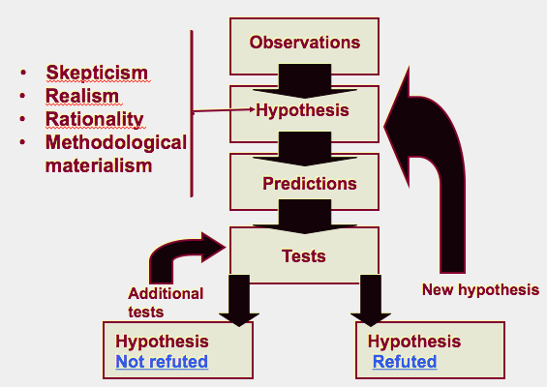
  - Observation: statement about particular thing
  - Hypothesis: statement about nature
  - Prediction: way to test hypothesis (if/then statements)
  - Test of Prediction: make strongest test to reject the prediction; if prediction survives, hypothesis is not falsified
  - Result: hypothesis is falsified, or not
  - We can NEVER prove that something is scientific truth (only get close to truth)
  - Ex; prof hypothesized all oranges are sweet, but found sour orange in Madagascar falsified hypothesis
  - Ex; evolution has never been scientifically falsified, and is a THEORY (can never be fact)

Valid Scientific Process
- Must respect 4 clauses of the ‘contract’
- Breaking a clause invalidates contract
- Scientific ‘Contract’
  - Way of acquiring knowledge (contract between science and knowledge)
- Skepticism: doubt facts and hypotheses, and retest findings
  - Best hypothesis is not necessarily ‘proven’ but is the one that survived most tests. Repeat tests to ensure other variables are controlled, no mistakes, not fraudulent.
- Realism: the world exists independently from my perception of it; avoid pre-conceived ideas
- Rationality: clear reasoning
  - Logic: coherent steps
  - Parsimony: acceptable theories are most economical in assumptions (least assumptions = better hyp)
- Methodological materialism: science must be done with material, or has material origin
- Ex; Crop circle thought to be made by aliens, but using parsimony, a better explanation is that humans made it
- Science vs Non-Science *exam q

Mimicry
- Batesian mimicry: animal that is non-toxic, and imitates colour/pattern of a toxic animal
- Mullerian mimicry: 2 toxic animals that evolved the same colour/pattern
- Viceroy are non-toxic, Monarch is toxic
  - Blue jays refused to eat Viceroy even though they’re non-toxic

Dark vs Light Mouse: Case Study
- More pale mice live in beach, more dark mice live inland
- Hypothesis : In this species, fur colouration patterns has evolved as camouflage in their native environments.
- Prediction: If mice have a colouration that does not match their habitat, then they will be preyed on more heavily than the native, well-matched mice.
- Test:
  - Plasticine mice sprayed-painted in beach or inland colours.
    - Material of mice is controlled factor
  - Spread both colors models (control and experimental) in equal numbers in both habitats.
  - Count signs of attacks.
- Results: more dark mice attacked in beach, more light mice attacked inland
- Conclude: hypothesis is NOT REFUTED
- Best type of research: simple question with minimal variables that can be tested.

Fish in Gatineau Park: Case Study
- In Canada, the value of a lake is linked with the quality of recreational fishing
  - Introduction of species for fishing are frequent to enhance the lake’s value
  - Fish species for fishing are often piscivores (prey on other smaller fish)
  - Gatineau Park has dozens of small lakes where species were introduced for recreational fishing.
- Observation: Small lakes where recreational fishing species have been introduced do not have schools of small fish near shore
- Sample area: 20 small lakes that had piscivores introduced in 20th centuray (experimental group), and 25 untouched lakes (control group)
- Hypothesis: introduction of piscivores fish in small lakes would result in a decline in number of smaller fish species
- Prediction: If lakes contain introduced piscivorous species, then they will have fewer small fish species, than lakes without introduced fish.
  - Controlled factor: size of lakes
- Testing prediction: determine number of fish species in both groups of lakes
- Results: lakes WITHOUT piscvorous fish have 50% more small-sized fish species than lakes WITH piscivourous fish.
- Recommendation: ban introduction of piscivores in Gatineau Park

Chapter 4: Genetics, Neo-Darwinism, Synthesis

Transmission of Traits (Inheritance) Pre-Mendel Perspectives
Preformism
- Preformist theory: until 19th century (Aristotle)
  - Believed in sex cells, but
  - Sex cells contain homunculus (mini individuals with, legs, arms etc.) waiting to be born
  - People initially thought that each sperm was a mini human, which would then be contributed to by the egg, and then start development
    - This was not received well, because that meant there were lots of dead people (millions of sperm per ejaculation, many times = lots of dead people)
  - They then revised the hypothesis: miniature human was in the egg, and the develops after contribution by the sperm (which would catalyze development)
  - Theory collapsed in 19th century as no evidence supported
- Epigenesis: currently accepted theory (Aristotle)
  - Humans begin as a few cells (embryo), NOT as a mini human

Theory of Blending Inheritance
- Universally accepted theory until the end of the 19th century.
- Both parents participate equally in the genetic makeup of offspring.
- The child will show an intermediate trait, between the traits of its parents.
  - Blonde mom + black hair dad brown hair offspring
- But, after some generations, all individuals would become identical / very similar
  - This is not consistent with what we see in real life

Darwin’s Pangenesis
- Theory of gemmules: we all have hereditary particles produced by each part of the body
  - When an organ is used, it grows, and contains more gemmules (or vice versa)
  - Gemmules are transported in the blood from all parts of the body and assembled in gametes
  - Gemmules are particles associated with transmission of heredity
- Francis Galton’s (1822-1911) experiment refuted Darwin’s hypothesis
  - Transfused blood from brown rabbit to white rabbit
  - Theory would suggest the white rabbit’s offspring would have brown patches (since white rabbit is supposed to have some gemmules indicating brown fur)
  - This did not occur theory of gemmules refuted

August Weismann’s Theory
- Weismann said only sex cells are responsible for heredity
  - We are carriers of genetic info from parents (with some uncontrollable changes)
  - Rest of us is only a structure that disappears with death of the individual
- Living beings are divided into two parts, with distinct outcomes:
  - Germline (gametes): continuity of heredity
  - Soma (the remainder of the body)
- The germline and the environment can influence the phenotype (soma)
  - BUT soma and the environment have no effect on the genotype (germline)
  - natural selection is the only mechanism that can eventually modify germline of a population
- Ex; a chicken is the method by which an egg makes another egg

Video: Monkfish (lantern fish)
- Has big teeth, has bioluminescent light at tip of first ray of dorsal fin
  - Light attracts other fish, and then lantern fish eats it
  - All lantern fish are females no one could find any males
- Females have parasites near their genitalia.
  - Scientists realized that these ‘parasites’ are the male fish
  - Male’s only objective in life is to find a female and attach to it
- Once males attach, they lose everything (eyes, internal organs, lost, blood vessels fuse with female)
  - All there is left is the sperm sac
- The male is thus modified to its primary function (for fertilization)
  - Clearly shows that the soma is independent from the germline
  - Soma is just the container for the germline

Chapter 2: Theories and Thinkers

Transformism in Antiquity
Anaximander
- First philosopher to write his thoughts
- Transformism view
- “Animals are born from the sea, by solar heat on water...as they aged, they migrated onto mainland. When the bark burst, they survived briefly in their new lifestyle.”
- Humans originated from fishes that tried to invade mainland
- Water is the central element of this universe
  - Life came from wàter

Empedocles
- All structures of the world (matter) are made of four elements:
  - Earth, water, air, fire
  - These elements are simple, eternal and unalterable
- Two major forces interact constantly on these elements:
  - Love (attraction or harmony)
  - Hate (repulsion or discord)
- These elements, and the forces between them are what created living beings, humans
  - Interactions of forces are important
- Transformism; materialistic

Democritus
- The most “scientific” of Greek philosophers
- Thought everything we see can be divisible
- Two realities:
  - Atoms
  - Emptiness: space where atoms can be attached together
- Matter: group of atoms in movement
  - An atom cannot be created of destroyed (atomic theory).
- Atoms have an intrinsic property (a force) that causes them to agglutinate and creates shapes
- Humans and animals are born from dirt
  - Created by chance (spontaneous generation due to the force of atoms)
- Transformism: matter can be converted from living, to non-living, and vice-versa

Conclusion
- Acts of creation are not due to God, but rather due to the innovative power of matter
  - Power of matter has driven life
- The origin of all things is not teleological (NOT for an ultimate goal or purpose), but is the result of chance or of an irrational need

Classical Thinkers
- Classical tradition: more abstract questions and to the contemplation of the soul
  - They thought materialistic approach of past philosophers is flawed
  - Had great impact on science
- The important questions are not materialistic, but linked to a search for beauty, kindness, justice and sanity
  - Not interested in nature of life or nature of humans
- Arguments about logical, ethical and political questions are more interesting than the search for truth
- Answers are not found in nature, but within the self
- Debates important to get opinions
  - Socrates renowned as great debator

Socrates, Plato
- Essentialism: defining the essense of things/life
- Theory of Ideal Forms (Essentialism)
  - The Ideal World is permanent and perfect, and have innate idea of it
    - We are born with basic concepts of things “what a chair is”
  - What we see in nature is an imperfect and changing realm (a poor imitation of an Ideal World)
  - Goal of life = find the essence of things
- The variation of forms is not important; only the quest to define the Ideal Form is important
- This philosophy will have a lasting impact on our perception of nature.
- Gods are the creative forces
- Plato’s student was Aristotle…

Aristotle
- Does not believe in innate ideal world
  - No need to assume hypothetical existence of innate world of forms
  - We can find the essence of things by observing nature
- The species are static
  - SO, morphological variability is an illusion and imperfection (not important)
    - VS when Darwin comes along, he believes variability is very important
- Vitalist: all organisms have cumulative souls (levels), all organisms created by God; created hierarchy
  - Vegetal (plants): bottom level
  - Animate (animals): middle level, have animate and vegetal soul
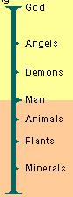
  - Rational (humanity): top level, have all 3 souls
- Created the scala naturae
  - Great chain of being (visions of life organised in scale)
  - Species are depicted in a static and unchangeable hierarchy
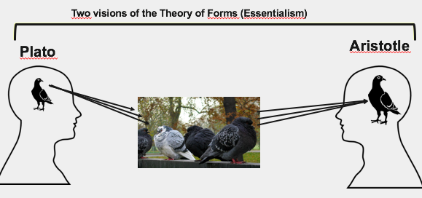

Impact of Christianism
- Decline of the Roman empire Christianity becomes main ideology in western world
  - The dark age for tranformism (evolutionary thought)
    - No one was interested in transformism
- God becomes the measure of all things
- The concept of scala naturae becomes purely metaphysical, proclaiming the perfection of the Creator
  - Great chain of being was glorified
  - Viewed as very static approach of species
  - Showed creation of the world

From Fixity of Species Transformism
- Renaissance in Europe (14th to 17th century):
  - Return to experimentation and observation of nature
    - Great expeditions + discoveries
  - Power of religion is progressively challenged
- French Revolution (end of the 18th century)
  - Challenge of ordered system (monarchy)
  - French society believed in progress, changing things, rejecting past
- More open-mindedness towards science
- Scala naturae still important
  - Trying to find how God created the world; noble research

Linnaeus
- Influential Swedish scientist, father of modern taxonomy (Systema Naturae, 1758)
  - Binomial nomenclature – system of words to define order of nature
  - Hierarchical classification – organized ladder of categories
  - His concepts still used today to define species
- Believed he was discovering each piece of the puzzle: the Plan of Creation of God
- Linnaeus’s work remains an important contribution and his perfect application of the essentialism of Aristotle
  - He was looking for the essence of things via observation of unique attributes of species
- Was viewed very highly (noble) because it was an extension of the fact that scientists wanted to show how God created living things
- Difference from Darwin: Darwin will also account for variability of species

Buffon
- Before Darwin’s time
- Objective: describe nature
- He wrote:
  - “Every family, from animals to plants, has a common origin, all animals derive from one animal, which through time produced all animal species in existence today”
  - His theory established the age of Earth to be around 75 000 years
  - He suggested the initial temperature of the Earth was very high
    - Since then climate has mellowed
- The faculty of Theology of the Sorbonne censored many of Buffon’s theories because of it conflicted with religious views
- Thus, he decided to abandon his evolutionary ideas and to focus on observing nature
  - Was very high up in society, and would have lost everything if he had continued his studies/beliefs
  - Decided to describe nature, without discussing how nature came to be (evolution)

Lamarck
- First evolutionist
  - Believed species modify their morphology through time
- Uses the environment as a factor of change (environmental determinism)
  - Environment is main factor of the evolution of morphology
- 2 principles (affects individuals):
  - Principle of usage and non-usage
    - If you use an organ hard/long enough, it will get larger/stronger
    - If you DON’T, it will get smaller/weaker
  - Principle of inheritance of acquired characteristics
    - Changes caused by environment are passed down generations via genes
    - Ex; Giraffes reach their necks up to reach higher trees, which stretched their neck slightly, and this stretched neck gene was passed onto their offspring
    - This thought can be applied to tennis players: thick, strong arm muscles that were acquired through their life, can be passed to children
    - But, it is FALSE: any morphological change acquired in the lifetime of an individual, it will not be passed down to offspring
- Gradual mechanism
  - Adaptive and involves an innate ability (internal force) of organisms to become more complex
- Spontaneous generation explains the presence of simple organisms
  - Simple organisms then become more complex via spontaneous generation
- Theory not well received by his peers, since it contradicted religious theories
- Problem with Lamarck’s theory: acquired traits cannot be inherited!

Cuvier
- French scientist interested in mammal fossils
- Fossils remnants of past life
- Established the fundamentals concepts of paleontology
  - Older stratum = older fossils
  - Older the stratum = more dissimilar its fossils were to current species
  - From one layer to the next species appear and disappear.
- Theory of correlation of parts (organs)
  - Using a part of the fossil, you could ‘create’ the organism
  - ex; looking at a piece of jaw of a carnivore
    - Round socket jaw joint, joint is level to row of teeth, for cutting meat
  - ex; VS a herbivore jaw
    - Jaw joint is mobile bony plate; joint is higher than row of teeth, allows all teeth to press on each other and break up vegetation
  - ex; dinosaurs
    - Jaw joints were much lower than the level of teeth (all teeth touch together)
  - For humans, our jaw joints are higher than our row of teeth; suggests that our ancestors were herbivores
  - At one point of our ancestral history, we began eating meat
- Creationist: belief God created all
  - Tried to connect God creating living species, with God creating fossils (difficult to understand)
  - His answer: It is highly probable that the planet went through major extinction that wiped out many species; these wiped out species were replaced by new species (new creations of God). Maybe God perfected his creation every time he made one (older fossils are simpler) and he made more complex creations, until he made Man.
    - Great flood --> one supposed massive extinction that occurred
- Cuvier believed in the fixity of species and catastrophism
  - Controversial idea (God destroyed everything he created?)

- Cuvier strikes the final blow to the unifying concept of the great chain of beings, proclaiming God as the Creator of 4 major types of animals
  - Radiata, Mollusca, Articulata, Vertebrata
- Darwin accepted his concept before he embarked on the Beagle

Hutton and Lyell
- Geologists Lyell is the first to establish geology as a scientific discipline
- Geological changes result from a slow, gradual and continuous processes
  - They were challenging the idea that the planet was only 6000 years old
  - Because these geological processes would have taken much longer than 6000 years to occur
- Principle of uniformity (uniformitarianism): The laws of nature are not affected by the passage of time
  - What we see now is relevant in explaining the past (uniformity)
  - Darwin accepted this theory after returning from Beagle
- “the present is the key to the past”
- Vision of the world: “with respect to human observation, this world has neither a beginning nor an end”
- Lyell was friends with Darwin
  - At first he didn’t agree with Darwin’s theory, but in the end defended it

- Hoodoo (tent rock)
  - Cone like structure up to 200m tall
  - Specific pattern of erosion anything under rock is protected

Chapter 3: Charles Darwin and Evolution

Charles Darwin Education
- Father was a doctor, Mother was from the Wedgwood family (porcelain).
- He married to his cousin Emma Wedgwood, had 10 children
- He abandons his studies in medicine and takes a more serious interest in religion (CambridgeU).
  - Prerequisite to become a pastor: Bachelor of Arts
- Became interested in nature: taxidermy, insects collecting, botany, etc.

Voyage on the Beagle
- In 1831, he leaves on the Beagle
  - Ship commissioned by the British gov. to cartograph South America’s coast
- Darwin was invited on board as a companion of the captain
  - The scientist on board resigned quickly, so they asked Darwin if he would do it
  - So then Darwin was the naturalist on the Beagle
- He travels the world and spends most of his time on land to sample the fauna and flora and to study the South-American geology
  - Chile - major earthquake occurred when he was there (the area he was mapping had changed, and he had to redo it)
    - Darwin realized that there were animals living at lower ground were now on cliffs, underwater animals were now above water, etc.
  - Andes – 3000 metres up, he found fossil bed (mollusks, sea creatures)
    - Maybe accumulated earth quakes over millions of years could explain why sea creatures were so high up on the mountain
    - These observations made him doubt the planet was only 6,000 yrs old
  - Saw many continents, and was able to make many observations
    - South Africa, Austrailia, South America

- The voyage was planned for 2 years, lasted 5 years
- During the voyage, two books greatly influenced Darwin
  - William Paley: “Theology, or evidences of the existence and attributes of the deity”.
    - Paley is the father of the Theology of Nature. This theology advocated that harmony and design of nature as indicators of the existence and the act of God (today = intelligent design).
    - World and creations are so complex that it is only explainable through the existence of God
  - Charles Lyell: “Principles of Geology”.
    - This had a great impact on Darwin
    - He started expedition thinking like a good protestant, believing in the Great Flood and in Cuvier’s catastrophism
    - When he returned 5 years later, he agreed with Lyell and Hutton’s principle of uniformity
    - Darwin began voyage he believing the earth was 6000 years old, but when he returned his belief changed (world was much older than they initially thought)

- When he came back, he was a very popular person (not due to theory of evol., but because the book he wrote about his travels on the Beagle)

- Very unique fauna on the Galápagos Islands surprised Darwin
  - Why do fauna and flora of South America, Africa, Europe, and Australia have few species in common, even in same environments? Why are mammal fossils of SA absent from current fauna (giant sloth)
  - Galápagos Marine iguana (Amblyrhynchus cristatus)
    - Only iguanas to live in a marine environment
    - Marine iguanas are nowhere else in the world
- Why does it show resemblance with species on the American continent?
  - Galápagos Sea lions (narrowly related to the Californian sea lion)

- Giant Glapagos Tortoise (15 sub species on island)
  - Why so much shell variability in Tortoises in the Galápagos?

- Finches on the Island
  - Why so much morphological variability in one group?
  - Why does each island, in most cases, have their own species?
  - Darwin brought specimens of birds back to London (he himself didn’t know much about birds)
    - British museum said the birds are unique (Galapagos island is the only place you can find them)
  - Different beak shapes, but everything else was similar between the birds
    - Beak shapes indicated type of food they ate (what was available on the island)
    - The Finches are similar because they share a common ancestor

Evolution and Natural Selection
- In 1837, Darwin's notes first mention that species resemble themselves because they share a common ancestor (not a common environment).
  - Rejects fixity of species
  - Accepts the concept of descent with modifications (evolution)
  - Contradicts the religious dogma of the time
  - Rejects Lamarck’s evolutionary mechanism (environmental determinism)
    - Did not find his theory to be true via observations / studies
- Previous belief was that all species are created by God, and do not change over time (creationism)
- New belief: species can modify themselves through time, for different reasons
  - ex; food acquisition for Galapagos bird species
- This suggested that earth is much older than 6000 years
  - Evolutionary mechanism would have taken much longer than 6000 yrs
- Thus, he begins the search for an evolutionary mechanism.
- First phylogenetic tree (tree of life)

- Rock hyrax (like ground hog), African elephant, and Duogong (sea cow)
  - These 3 animals are closely related
    - Darwin was aware that these all looked very different
    - But he said to determine pattern of life, we must consider past species (not only current species)
      - USING FOSSILS
  - 99% of species that have lived on Earth are extinct
    - Most of the evolutionary branches finish in a dead-end
    - You can’t take DNA from fossils
  - Darwin found that these animals had similar DNA, even though they had very different morphology
  - Thus, fossils fill up gaps
- Another ex; whales are closely related to hippopotamus
  - Big gap between animals, but gaps are filled by fossils
  - This explained why each continent has its own fauna share a common ancestors proper to that continent

- In 1838, Darwin read “An essay on the principle of population” by the economist Thomas R. Malthus, who wrote:
  - Every human population has a tendency to increase geometrically (exponentially), whereas the available resources to feed these populations increase arithmetically
  - Human pop increases faster than its capacity to feed itself leads to crisis reduction of pop size
  - Crisis point: not enough resources for number of humans
    - There will be winners, and losers
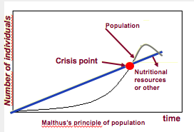
  - Malthus predicted that human pop would crash at crisis point
    - Said we have to limit pop size
    - He had lots of controversial suggestions (don’t let poor reproduce, etc.)
- There would be winners and losers at crisis point (people who get resources VS those who don’t
- This reading became one of the main sources that brought him to formulate his famous theory on natural selection

Darwin’s first observation:
- All species can produce more offspring than their environment can sustain and many of these offspring fail to survive and reproduce
  - Puffball: each spore has ability to become mushroom
  - Ocean sunfish produce between 200mil-300 mill eggs
    - Obviously, only a few end up surviving
    - Made him think there must be winners and losers in animals too

Darwin’s second observation:
- Members of a population often vary in their inherited traits
- He knew there was similarity between parents and kids (traits passed on)
- Lemarck said anything can be transmitted through genetics (acquired or transmitted from parents)
- Darwin’s question about winner and losers (what makes an individual a ‘winner’ that can obtain necessary resources and ultimately survive) lead to idea of natural selection

- Natural selection (2 inferences)
  - Hereditary/inherited traits are transmitted from generation to generation, and some of these traits provide an advantage to individuals, which provides them with better chances of survival and reproductive success.
  - From generation to generation, this unequal capacity of survival and reproducing (differential reproductive success) results in an accumulation of favourable traits in a population
    - Natural selection enables the emergence of adaptations
    - No other evolutionary process results in adaptation
  - ex; different colour fish in a pond; being blue (an adaptation) gives increased protection from environment/predators
  - This leaves more blue fish alive vs other colours; in the next generation, more blue fish will create offspring, and their offspring will receive their adaptation (blue colour), and will be more likely to survive
- Different environments, and different times favour different heritable traits (adaptations) via selective pressure
  - May change depending on location, depending on season, etc.

- It is a letter from Alfred Russel Wallace received in 1858, that forced Darwin to publicly release his ideas
  - Wallace had come to the same conclusions as Darwin concerning the theory of natural selection by observing the fauna of Indonesia
  - Darwin did not publish his findings of natural selection earlier because it went against the common religious beliefs
- It was 23 yrs after his voyage on the Beagle when Darwin publicly released his views on the evolution of species
- On the same day, in 1858, Darwin and Wallace presented a resume of their ideas on natural selection to the Linnean Society of London.
- In 1859, Darwin publishes the first edition of his book “On the Origin of Species”
  - Instant bestseller
  - Lots of controversy
- The 6th and last edition of his book (1872) contains a chapter dedicated to the most important arguments against his theory. Most of these coming from his creationist colleagues.

- Important notions linked with natural selection:
  - Individuals do not evolve, populations evolve.
  - Only hereditary traits are subject to natural selection.
  - For evolution to occur, we need genetic variability.
  - Natural selection corresponds to differential reproductive success within a population from generation to generation
  - With time, natural selection enables individuals to become better adapted to their environment
  - Environmental factors vary in time and space. Thus, the selective forces are variable.
  - Traits in populations will change and can modify the species.

- In Lemarck’s said acquired traits can be passed down. Darwin said this is not possible. Individuals DO NOT evolve. Populations evolve over time.
  - Natural selection is measured at the population level
  - Individuals are carriers of genetic materials; these genes do not alter or ‘evolve’ during the individual’s life time.
- Genetic variability: one of the greatest discoveries of Darwin.
  - The material on which natural selection is born.
  - Genetic variability allows for individuals in a population to adapt, in the event that the environment changes (new predators, temps, etc.)
- Evolving: acquiring an adaptation of some sort
- Selective pressures are different in different environments/times/locations results in different adaptations in species

- For Darwin this mechanism is valid because:
  - It respects the principle of uniformity of Lyell and Hutton.
  - The results of natural selection are visible in nature
  - The mechanism can be verified on current populations (e.g. artificial selection)
  - It is a material concept (no need for divine intervention)
    - The mechanism is not random. Natural selection enables individuals that are better adapted to their environment to become more abundant than those who are not (differential reproductive success).
    - Not a quest for perfection (evolution is not a directed process). It does not lead to the appearance of “perfect” traits. Organisms only adapt to their environment.

Artificial vs natural selection
- Artificial selection:
  - Is finalized (has clear objective)
  - The goal, fixed well in advance, precedes the causes
  - The end result can be obtained in a few generations
  - Ex; cabbage, Brussel sprouts, kale, broccoli all come from wild mustard
- Natural selection:
  - Not finalized (no objective)
  - It can take a long time for changes to occur (geological time scale)
  - No objective, other than to be well adapted to the environment
  - Direction of selection can change depending on the environmental pressure

Evolution and Natural Selection: Peppered Moth
- Comes in various colours
- Are nocturnal; rest on trees during day
- In areas that relied on coal for energy production, the environment was dark (due to coal and smoke pollution)
  - In darker environments, there seemed to be more dark moths present (compared to pale moths)
  - The paler moths were more visible against dark environment; the birds would see and eat more pale moths
  - Dark moths had a trait of being dark that protected them better from predators
  - Abundance of dark moths (being dark was favoured by natural selection adaptation)
- In areas that had cleaner environments, there were more pale moths than dark moths
  - Dark moths stood out more and were more visible to predators
  - Abundance of pale moths (being pale was favoured by natural selection adaptation)
- When energy production stopped releasing as much smoke and coal, environment wasn’t as dark, and then there was an abundance of pale moths (they blended in better and had protection against predators)

Evolution and Natural Selection: Climate and Medium Ground Finch
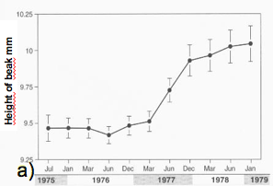
- Drought in 1977
  - Population from 1200 adults to 80.
  - Only the plants that produced seeds survived
- Natural selection favoured finches that had bigger and stronger beaks to break available seeds during the drought

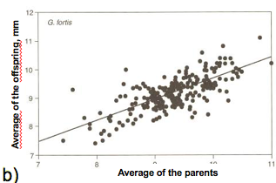
- A) Changes in the height of the Medium groundfinch’s beak (Geospiza fortis) on Daphne Major Island during the 1977 drought
  - Average beak size spikes after drought
  - Clear tendency of individuals with large beaks being favoured in environment
  - Higher beak = better reproductive success
- B) Correlation between the avg beak heights in parents and offspring for G. fortis on Daphne Major Island
  - The slope of the relation is 0,74
  - Size of beak is inherited trait (74% from parents)
  - Infer that the environment has a small effect on trait (26%)

Evolution and Natural Selection: Humans and Altitude
- Mountain life: Adaptation to altitude
- High altitude – lower partial pressure of oxygen (lower oxygen concentration)
- Body starts to react to change in altitude at about 1500 m above sea level – you start having increasing respiratory distress
- 2000m above sea level
  - Partial pressure of O2 is insufficient for a normal saturation of hemoglobin
  - Shortness of breath, sickness
- Prof climbed Himalaya – comes from pop that always lived 500m below sea level
  - Felt nauseous at first
  - After 3 days felt fine – body had become acclimatized to the environment by producing more RBCs (body trying to survive in high altitude)
  - After leaving area, about 3 months later he no longer had higher RBC count since he was no longer in that environment
- Guide: comes from pop that lived 3500m above sea level for thousands of years
  - Had an adaptation to this altitude
  - Had no problem with the altitude; very energetic
- Physiological response (acclimatization): After a few days at high altitude, the body compensates the low partial pressure by increasing the concentration of red blood cells in our blood
  - Serious health risks: thrombosis, pulmonary edema, etc.).
- Ability to live in high altitude does not depend on fitness, age, health factors, etc
  - You either have the adaptation (to high altitudes) or you don’t

- Ability to live in higher altitudes Adaptation
  - People that lived at low level slowly moved to mountain
  - Some people had random mutations that provided them an advantage
    - Favoured by adaptation
    - More of these people survived vs people that didn’t have mutation
  - Proportion of population that has adaptation becomes higher at higher altitudes, as time goes on
  - Proportion of people with adaptations on main land stays same
  - Proportion of people with adaptation continues to increase at high altitude
  - This adaptation is clearly a heritable trait
  - Time period that it takes for the adaptation trait to have a high proportion in the population can be quick (ground finches) or take longer (humans); also depends on what the trait is
  - Moving to the higher altitude did NOT cause them to suddenly develop the favourable mutation. The mutation was already present in certain individuals before they even moved to the higher altitude environment.
  - Natural selection does not CREATE adaptations, they FAVOUR them.

- Many regions in high altitude were independently colonized by humans
  - Qinghai Tibet Plateau VS Andes
  - On the Qinghai–Tibet Plateau, human adaptation to high altitude differs from the Andes
  - Adaptations:
    - Andes: increased hemoglobin concentration (red blood cells).
  - Qinghai–Tibet Plateau: increased blood flow.

Overview of Examples of Natural Selection
- In the three cases of natural selection (moths, finches and humans), the hereditary traits that give a reproductive advantage (ie. adaptation) to individuals in a population will be favoured
  - From generation to generation, there will be a higher percentage of individuals carrying the adaptation
    - This is natural selection
    - *Individuals in population already had the adaptation (favoured trait), but the population with the adaptation was naturally selected
  - Darwin’s descent with modification (evolution)
- These adaptations can sometimes define a species and, in certain circumstance, define a new species

Proof of Evolution: Homology
- Descent with modification theory (theory of evolution) explains the resemblance between certain traits even if the functions are different
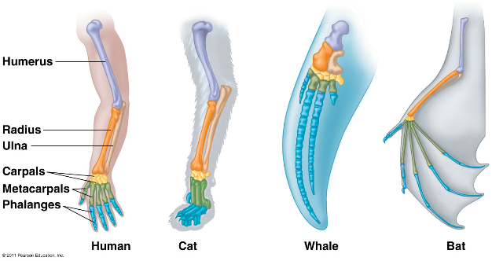
  - Homologous structures

- Forearms of species
  - Forearms of different species have different functions; but they all have the same/similar structure (same bones)
  - Homologous structures indicate a common ancestor
  - Bones have evolved /modified for different structures

- Chick embryo vs human embryo
  - Post-anal tail
    - Adult humans don’t have a tail; but in the embryo of humans, a post-anal tail is present
    - Our bodies have the program to produce a tail, but it has been shut down overtime due to evolution
      - Also vestigial structure
    - The tail reserves itself in its during pregnancy, and ends up becoming what we know as a coccyx
    - Chickens have a tail
  - Pharyngeal pouches
    - Found in the embryo of all vertebrates
    - But are only present in one animal’s adult form: the fish
      - The pouches become gills (resp organs)
    - Humans developed different method of respiration, so this pouch is absorbed during development
  - Both are indications of evolution
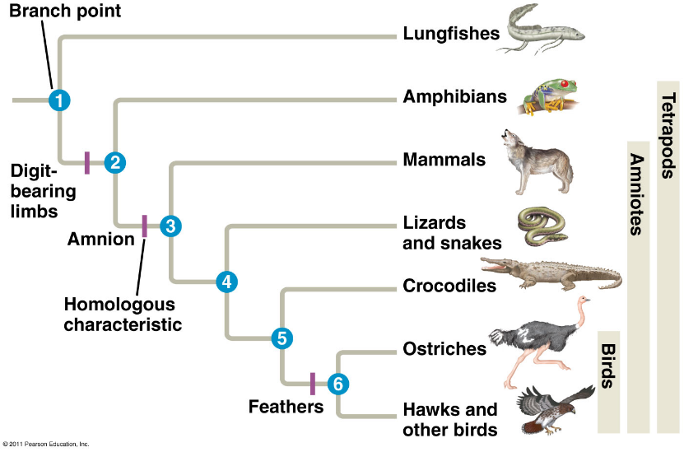
- Tree approach to life: phylogenetic tree
  - Birds share feathers
  - Amniotes share amnion
  - Tetrapods share digit-bearing limbs
    - Suggest all these species share common ancestors

Proof of Evolution: Fossils
- Evolution of the horse:
  - Classic interpretation
    - Linear path of growth, new structures, etc.
      - Small large
      - Complex feet simple
      - Small teeth large teeth
    - This type of image showing evolution is WRONG; evolution is not simply linear like this, and does not occur by progressive elimination
  - More realistic interpretation (phylogenetic tree)
    - Trees provide a better interpretation of evolution
    - 5 different species of horses alive at the same time (seen in fossils)
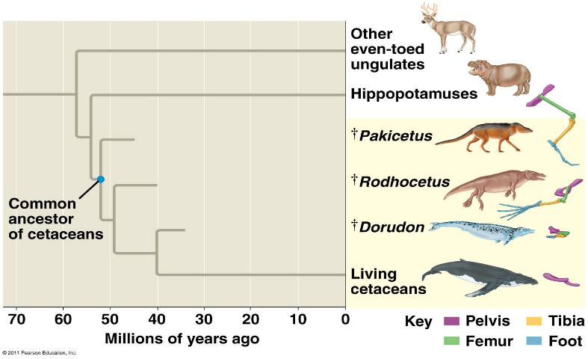
- Pakicetus
  - As tree branches, mammals that are more and more adapted to live in water
    - Dougong: suddenly smaller hindlegs
    - Whales: no hind legs; do have a pelvis
  - Based on this we would say that the closest relative to whales in current fauna is the hippopotamus

Proof of Evolution: Vestigial Structures
- Vestigial structure: anatomic structure that has lost almost all of its initial function

- Dwarf subspecies of a blue whale
  - Has reduced vestigial posterior limb, the pelvis reduced to a floating pelvic bone under the spine
  - 2 small bones at the back of the animal: is the pelvic girdle (a vestigial structure)
  - If these species were created independently, they would not have limbs because there is no use for them to have limbs
  - These limbs (vestigial structures) indicate they have common ancestors
    - Indicate evolution

- Nictitating membrane or third eyelid in humans
  - Translucent membrane and goes from corner of the eye and can cover the entire eye
    - Fish, chicken, birds still have this structure (to protect eyes from environment)
    - Humans don’t need this anymore, but we still have it (has no function to humans), thus is a vestigial structure

- Appendix
  - Appendix is a shrivelled portion of the cecum, that must have had some use before
  - There are some mammals (horses, rabbits, etc.) that have a large cecum (function as a storage area for plants) to digest plant cells
  - Humans don’t have function for appendix, since we also don’t have enzymes to digest plant cells
  - We can survive without our appendix, thus it is a vestigial structure

- Goose bumps and hair
  - Animals with thick fur use their fur for thermoregulation; their hair reacts to temperature, or emotion
    - When their hair stands up in cold, to create a layer of warm air around body
  - For humans, the hair reacts to cold, to emotions as well; but has no function because it is not dense enough to keep us warm, thus is a vestigial structure

- The hiccups
  - A heritage from fishes and amphibians
  - Hiccups are contractions of the diaphragm, occur when phrenic nerve is pinched
  - Diaphragm is innervated by Phrenic Nerve
    - Comes out of 4th vertebrae, passes by neck, throat, lungs, heart
    - Why doesn’t it just come out of a lumbar vertebra (it is much closer to the main organ it innervates, the diaphragm)
  - In FISH, the phrenic nerve is used for respiration, which is why it makes sense for the nerve to exit through the 4th C vertebrae
  - In humans, we have developed a newer respiratory system, which pushed all of our organs (including diaphragm) down
    - Thus the phrenic nerve got longer
  - Epiglottis
    - Kind of a stretch

  - Thus the hiccups, and the epiglottis show evidence for evolution and common ancestors

- Discovery of a fossil in the wrong place in the geological archives would be sufficient to refute our concept of evolution

Format
75min
20 m/c question (50%)
Association, short answers, long answers (50%)

