Assignment 1

1i) The table reveals the various economic and financial data of Canada.
ii) The five level one headings are real sector, fiscal sector, financial sector, external sector and population.
iii) P variable represents price and Q variable represents quantity. Price is measured in terms of currency and quantity in different ways for example units and kilograms. The labour markets represent the Q variable (number of people) such as employment and unemployment rates. On the other hand, wages and earnings are P variables.
iv) The fiscal sector consists of government net lending, operations, revenues and debt.
b) I) The table contents reveal Gross domestic product based on expenditure from 2012 to 2016.
ii) The six level one headings are final consumption expenditure, gross fixed capital formation, investment in inventories, exports of goods and services, less: imports of goods and services and statistical discrepancy.
iii) 1,613,915+472,419-487-630,353-679,538-1,156=2,035,506 which is the same number.
c) I) The table contents reveal Gross domestic product based on income from 2012 to 2016.
ii) The six level one headings are compensation of employees, gross operating surplus, gross mixed income, taxes less subsidies on production, tax less subsidies on products and imports, and statistical discrepancy.
iii) The income based GDP and expenditure based GDP are the same for each year respectively because every transaction has a buyer and a seller, so the total expenditure in the economy must equal the total income of the economy.
iv) Labours share of national income: Share for corporate profits:
2 a) monthly cpi is (126.6/84) *100=150.7
b) I) ((115.4/113.9)-1)*100=1.317
ii) (127.4/84.7-1) *100=50.4
iii) (127.1/101.3)-1) *100=25.7
c) The lowest inflation rate was 0.12percent in the year 1994 and the highest inflation rate was in the year 1981 with 12.50percent. based on the graph that was shown, the rate of inflation is decreasing over the years and the trend shows that this graph was highly variable until 1994, where the inflation rate fell and didn’t reach its peak.
d) I) (AVERAGE (first cell: last cell)) = 2percent.
ii) (cpiyear2017/cpiyear1990) **(1/25)-1*100= 2.
e) I) CPI= CPI year 1990 * (1+0.05) **27= 270.
ii) CPI= CPI year 1990* (1-0.01) **27= 62
f) I) 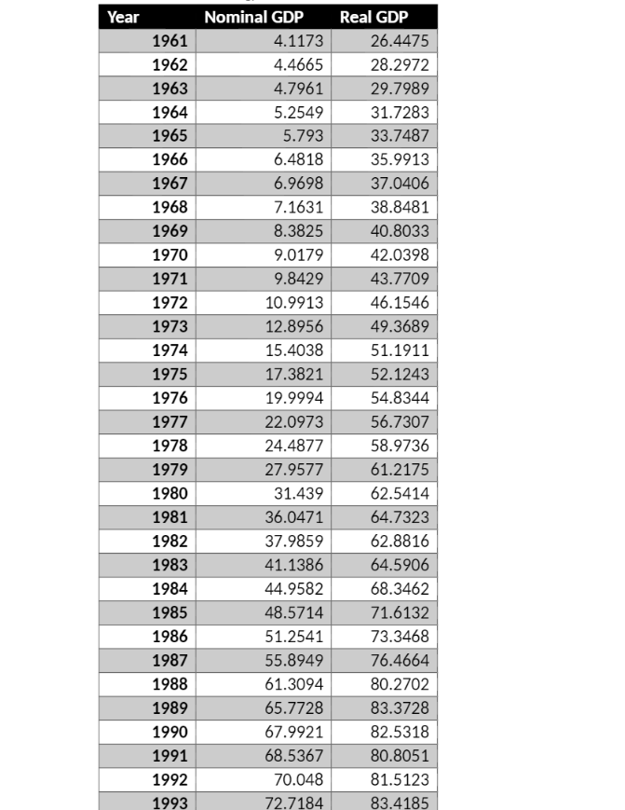
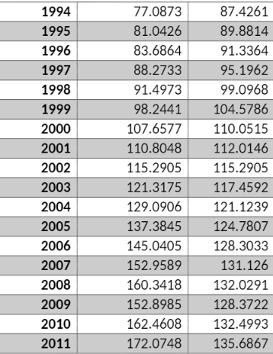

ii) 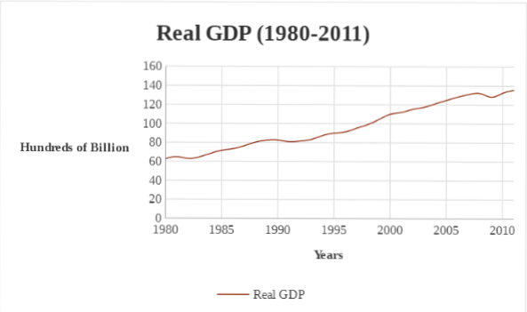
A business cycle is a series of cycles of economic expansion and contraction and is the fluctuations in economic activity. The business cycle includes the following stages: expansions, peak, contraction and trough. From this graph, we can identify the expansion period to be in the years 1980 and around 2008, where the GDP hit its highest and begins to contract for a year. The graph then continues at steady pace.
iii) 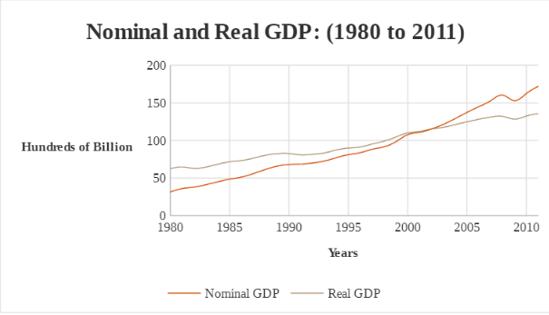
iv) Nominal and real GDP are at a constant rate until they reach 2008. They both have negative values as there is a recession and both intersect at 2000 because it is the base year. Nominal GDP is total economic output of a country and it grows at a faster pace in 2003. This is due to total outputs being measured at current price levels and currency values without factoring in inflation. Therefore, it causes the value nominal GDP to go higher than previous years.
g) I)
Year | Nominal GDP | Real GDP | GDP Deflator
1961 | 4.1173 | 26.4475 | 15.57%
1962 | 4.4665 | 28.2972 | 15.78%
1963 | 4.7961 | 29.7989 | 16.09%
1964 | 5.2549 | 31.7283 | 16.56%
1965 | 5.793 | 33.7487 | 17.17%
1966 | 6.4818 | 35.9913 | 18.01%
1967 | 6.9698 | 37.0406 | 18.82%
1968 | 7.1631 | 38.8481 | 18.44%
1969 | 8.3825 | 40.8033 | 20.54%
1970 | 9.0179 | 42.0398 | 21.45%
1971 | 9.8429 | 43.7709 | 22.49%
1972 | 10.9913 | 46.1546 | 23.81%
1973 | 12.8956 | 49.3689 | 26.12%
1974 | 15.4038 | 51.1911 | 30.09%
1975 | 17.3821 | 52.1243 | 33.35%
1976 | 19.9994 | 54.8344 | 36.47%
1977 | 22.0973 | 56.7307 | 38.95%
1978 | 24.4877 | 58.9736 | 41.52%
1979 | 27.9577 | 61.2175 | 45.67%
1980 | 31.439 | 62.5414 | 50.27%
1981 | 36.0471 | 64.7323 | 55.69%
1982 | 37.9859 | 62.8816 | 60.41%
1983 | 41.1386 | 64.5906 | 63.69%
1984 | 44.9582 | 68.3462 | 65.78%
1985 | 48.5714 | 71.6132 | 67.82%
1986 | 51.2541 | 73.3468 | 69.88%
1987 | 55.8949 | 76.4664 | 73.10%
1988 | 61.3094 | 80.2702 | 76.38%
1989 | 65.7728 | 83.3728 | 78.89%
1990 | 67.9921 | 82.5318 | 82.38%
1991 | 68.5367 | 80.8051 | 84.82%
1992 | 70.048 | 81.5123 | 85.94%
1993 | 72.7184 | 83.4185 | 87.17%
1994 | 77.0873 | 87.4261 | 88.17%
1995 | 81.0426 | 89.8814 | 90.17%
1996 | 83.6864 | 91.3364 | 91.62%
1997 | 88.2733 | 95.1962 | 92.73%
1998 | 91.4973 | 99.0968 | 92.33%
1999 | 98.2441 | 104.5786 | 93.94%
2000 | 107.6577 | 110.0515 | 97.82%
2001 | 110.8048 | 112.0146 | 98.92%
2002 | 115.2905 | 115.2905 | 100.00%
2003 | 121.3175 | 117.4592 | 103.28%
2004 | 129.0906 | 121.1239 | 106.58%
2005 | 137.3845 | 124.7807 | 110.10%
2006 | 145.0405 | 128.3033 | 113.05%
2007 | 152.9589 | 131.126 | 116.65%
2008 | 160.3418 | 132.0291 | 121.44%
2009 | 152.8985 | 128.3722 | 119.11%
2010 | 162.4608 | 132.4993 | 122.61%
2011 | 172.0748 | 135.6867 | 126.82%

ii)
Year | % change in Nominal GDP | % change in Real GDP | % change in Deflator
1981 | 5.37851866 | 2.859005473 | 8.47996685
1982 | 8.299658558 | 2.717806163 | 5.434162394
1983 | 9.28471071 | 5.814468359 | 3.279553736
1984 | 8.036798626 | 4.780075557 | 3.18151099
1985 | 5.523209131 | 2.420782761 | 3.029098477
1986 | 9.054495153 | 4.253218954 | 4.605398516
1987 | 9.686930292 | 4.974472448 | 4.489146489
1988 | 7.280123439 | 2.619402966 | 4.541753643
1989 | 3.374191155 | 0.913024882 | 3.17503766
1990 | 0.800975407 | 2.092163263 | 2.954961285
1991 | 2.205095956 | 0.875192284 | 1.31836544
1992 | 3.812243033 | 2.333854277 | 1.440024668
1993 | 6.007970472 | 4.804210097 | 1.148580171
1994 | 5.130935965 | 2.808429062 | 2.259062729
1995 | 3.262234923 | 1.618799885 | 1.617254916
1996 | 5.481057854 | 4.225916502 | 1.204250722
1997 | 3.652293502 | 4.097432461 | 0.427617615
1998 | 7.373769499 | 5.531762882 | 1.745545233
1999 | 9.581847663 | 5.233288646 | 4.13230364
2000 | 2.923246549 | 1.878380122 | 1.1194761
2001 | 4.048290327 | 2.924529481 | 1.091829957
2002 | 5.227664031 | 1.88107433 | 3.284800169
2003 | 6.407237208 | 3.119976979 | 3.187801554
2004 | 6.424867796 | 3.019057345 | 3.306000112
2005 | 5.572681052 | 2.823023729 | 2.674156024
2006 | 5.459440639 | 2.200021356 | 3.189254992
2007 | 4.826721426 | 0.688726873 | 4.109690014
2008 | 4.642145716 | -2.76978618 | 1.925715388
2009 | 6.254018189 | 3.214948408 | 2.944408564
2010 | 5.917735232 | 2.405597614 | 3.429634414

iii)
1980 | 50.269
1981 | 55.686 | 3.503 | 14.657 | 10.777 | 14.28
1982 | 60.409 | -2.859 | 5.379 | 8.48 | 5.621
1983 | 63.691 | 2.718 | 8.23 | 5.434 | 8.152
1984 | 65.78 | 5.814 | 9.285 | 3.28 | 9.094
1985 | 67.825 | 4.78 | 8.037 | 3.108 | 7.888
1986 | 69.879 | 2.421 | 5.523 | 3.03 | 5.45
1987 | 73.097 | 4.253 | 9.054 | 4.605 | 8.859
1988 | 76.379 | 4.974 | 9.687 | 4.489 | 9.464
1989 | 79.848 | 2.619 | 7.28 | 4.542 | 7.161
1990 | 82.383 | 0.193 | 3.374 | 3.175 | 3.368
1991 | 84.812 | -2.092 | 0.801 | 2.955 | 0.863
1992 | 85.935 | 0.875 | 2.205 | 1.318 | 2.194
1993 | 87.173 | 2.339 | 3.812 | 1.44 | 3.779
1994 | 88.174 | 4.804 | 6.008 | 1.149 | 5.953
1995 | 90.166 | 2.808 | 5.131 | 2.259 | 5.067
1996 | 91.624 | 1.619 | 3.262 | 1.617 | 3.237
1997 | 92.728 | 4.226 | 5.481 | 1.204 | 5.43
1998 | 92.331 | 4.097 | 3.652 | -0.428 | 3.67
1999 | 93.942 | 5.532 | 7.374 | 1.745 | 7.28
2000 | 97.825 | 5.233 | 9.582 | 4.132 | 9.366
2001 | 98.92 | 1.784 | 2.923 | 1.119 | 2.903
2002 | 100 | 2.925 | 4.049 | 1.092 | 4.016
2003 | 103.285 | 1.881 | 5.228 | 3.284 | 5.166
2004 | 106.577 | 3.12 | 6.408 | 3.188 | 6.308
2005 | 110.101 | 3.02 | 6.425 | 3.306 | 6.325
2006 | 113.045 | 2.823 | 5.573 | 2.674 | 5.497
2007 | 116.65 | 2.2 | 5.46 | 3.189 | 5.389
2008 | 121.444 | 0.689 | 4.827 | 4.11 | 4.798
2009 | 119.106 | -2.77 | -4.642 | -1.926 | -4.695
2010 | 122.613 | 3.215 | 6.254 | 2.944 | 6.159
2011 | 126.818 | 2.406 | 5.918 | 3.43 | 5.835

