Chapter 1 – Thinking Critically with Psychological Science
What is Psychology?
The scientific study of “how” we think, feel and behave.
Counseling / Therapy is only a small part of Psychology.
Scope: Psychology is relevant to every aspect of human life.
The Need for Psychological Science (A to C)
- Why
A1. The Limits of Intuition
Intuition has its value however more often than not, it is seriously misleading. Can’t
A2. The Limits of Common Sense
Common sense doesn’t generate new knowledge; it is the result of having learned, experienced something which then develops into “common sense”.
Hindsight Bias – I-Knew-It-All-Along-Phenomenon
When we know all the facts about something; we believe we could have easily predicted the outcome. When we don’t know all the facts, it isn’t easy to predict outcomes.
A3. Overconfidence
We tend to overestimate our knowledge and how good our skills/performances are. We tend to be more confident than accurate.
A4. Illusory Correlation
When we see relationship between variables but there are no actual relationships.
Such as the “#13” and “black cats”. It affects how we think, feel and behave; we only pay attention and remember events that support our beliefs and ignore all those that doesn’t.
A5. Perceiving Order in Random Events
We are very uncomfortable with uncertainty and randomness, we look for pattern and explanation to make the world more orderly.
- Scientific Attitude
  - Curiosity is essential to fuel our hunger for learning.
  - Open-Mindedness: New ideas and perspective can be very different from our own although we must remain skeptic and not simply accept things at face value. Always evaluate the evidence.
  - Awareness of our own biases and tries to limit their effect of us.
  - Humility
    - Our ego can get in the way; we must remember it isn’t about us but about the truth.
    - We are not the only smart brain.
    - No matter how smart we are, we can and will make mistakes.

- The Scientific Method
Here are the standard ways of doing research:
Observation: It can go from casual to systematic observation.
Theory: It helps summarize, organize and integrate observations. They are only considered tentative observations, not facts nor truths yet.
Take your Idea and Test it for consistency.

Hypothesis Testing: Tentative statement about the relationship between variables.

Operational Definition of Variables
Absolute, precise and clear statement on how we will measure our variables.

Replication: We must repeat our studies and if our results are similar then we can be more confident.

Generate and Refine: New theory and hypothesis based on results or go back to original hypothesis for adjustment.
Type of Research Studies
- Descriptive Research
A1. Purpose: It is simply to observe and describe. We mustn’t interfere, manipulate or control the experiments.
A2. A Case Study studies either a single person or a small group of people. Usually the sample is taken from unusual people or group. An in-depth study collects every single piece of evidence that is relevant.
Advantage
- Most in-depth research possible
- Helps us keep record of rare cases which otherwise may be lost
- It may give us a glimpse about human nature
Disadvantage
- Small sample (1 person or small group)
- Cannot generalize
- Researcher Bias
- Must have objective way to collect data through video/picture/audio
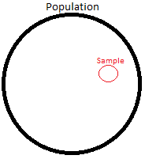
A3. Survey
It can be either descriptive or operational; you can also question a very large number of people. Done properly it can become a Representative Sample of the population you are interested in; as such it will closely reflect characteristics of the population.
You can get an adequate representative sample through random sampling.
1. Every single person in the population must have a chance to participate.
2. The people must be chosen by random chance.
Advantage
- Cheap, Easy and Wide Reach; especially through electronic means.
- Sometimes it can be the only way to know the information we want to ask.
Disadvantage
- Participants can lie, no way to enforce or fully incentivize honest answers.
- Wording of questions could affect the collected data.

A4. Naturalistic Observation
Leave the lab and dive into the real world but we mustn’t interfere or manipulation the world.
Advantage
- It can’t get any more real than that.
- Real life, behavior, far away from superficial environment.
- You may observe behavior/events you otherwise wouldn’t be able to see in a lab.
Disadvantage
- Researcher Bias.
- Even though you don’t interfere, your presence may affect the people around you.
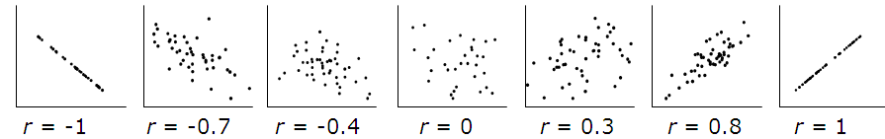
- Correlational Research
B1. Purpose: Observe / Describe / Predict
The research mustn’t interfere, manipulate or control the data; the goal is to define if there is a systematic relationship between variables.
B2. Do they Covary?
If one changes, does the other one change too?
B3. In which direction? Positive Correlation = Same Direction ↑↑ or ↓↓
Same or opposite direction? Negative Correlation = Different Direction ↑↓ or ↓↑
B4. To what extent?
How strong is the relationship between the variables?
Correlation Coefficient = r and it can range from -1 which is considered a “perfect negative correlation” to +1 which is considered a “perfect position correlation”. A correlation of “0” means that there is no correlation at all, therefore a correlation closer to 0 is weaker than a correlation closer to either -1/+1.
Perfect Correlation: Every single time 1 variable changes, the other changes too.
Advantage
Excellent 1st step when it is too expensive to do a full experiment.
If the correlation is strong, then do experiment.
Great when there is no other option available.
Observe and describe as information of 1 variable allows to make predictions about the other.
Disadvantage
Can NOT infer causality.
- Experimental Research
Only research that can explain causality; cause/effect relationship.
C1. Why?
  - In experiments, the researcher will manipulate individual variables.
  - He will control all other individual variables that would otherwise affect the results.
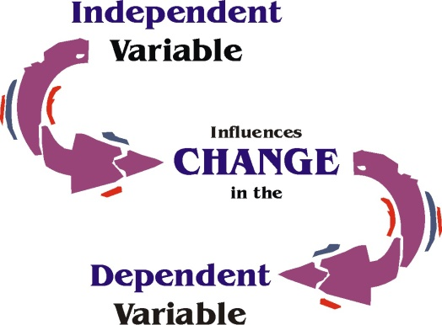
Researcher observes / describes / interferes / controls.
Independent Variable = IV
Dependent Variable = DV
IV is the variable that is causing a change in other DV.
DV is the variable that research will measure.
IV Influence Change DV
C2. Manipulation of the Independent Variables
Research manipulate the DV he is interested in by creating 2 levels of IV.
Group 1: Experimental group, which is exposed to IV.
Group 2: Control group, which is NOT exposed to IV.
Compare the results from both group to see if the manipulation has caused a change in the DV or not.
C3. Control all other IV
IV that researcher is NOT studying.
We must control for ALL other known and unknown IV that could affect results.
Why? Otherwise he won’t know what cause the change.
Confounding Variable is a variable that influences both the dependent variable and independent variable causing a spurious association.
Controlling Known IV: Based on research/experience, he might know what could affect the DV.
Controlling Unknown IV: Random Assignment: Chance and only chance will determine which subject will be in either the control or experimental group. Every single subject in study has equal chance to be in either group.
Control for Placebo Effect: An inert substances however if someone believe it will work then it may end up making them feel better.
Group 1 Group 2
Prozac Result Placebo
If 30% decrease Not positive Also 30% decrease
If 75% decrease Positive Only 30% decrease
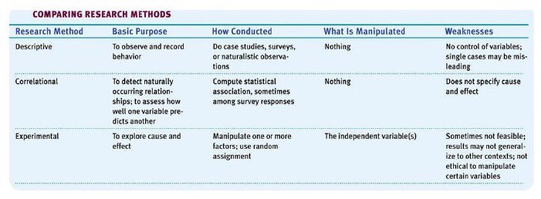
Blind Procedure: Your subjects have to be blind, mustn’t let them know the purpose of the study.
Double-Blind Procedure: Keep both subject and researchers blind to the study.

Statistical Reasoning
Fundamental and essential for scientific research.
Mathematical tool which summarize and organize the data to help make conclusions.
2 types: Descriptive Statistics and Inference Statistics
- Descriptive Statistics (A1 to A3)
A1. Purpose: The gold is to organize, summarize and describe data in a clear and precise way.
Percentages: Summarize data nicely.
Different between saying: 50 students had A+ in class (based on how many students?) compared
to 31% of students had A+ in class which demonstrate the ratio more clearly.
A2. Measures of Control Tendencies
Descriptive statistics meant to give a better idea about a typical distribution of scores.
  - The Mode: The most frequently occurring score in a distribution.
Ex: 1 – 37 – 19 – 74 – 22 – 1 – 1 Number “1” showed up 3 times which makes it the mode. We must be cautious as it doesn’t mean that it is the most typical score of a distribution.
Ex: 72-81-79-70-86-12-12 Number “12” is the mode although it isn’t anywhere near a typical score on the distribution.
  - The Median: The middle score in a distribution ranked from lowest to highest.
Ex: 3 9 1 4 5 1 3 4 5 9
It is also known as the 50th percentile because half of the distribution is above and below. We must be cautious with the Median as it takes into consideration only a single score.
The following two examples can show us why…
Ex: 5 8 40 78 93 vs 34 36 40 42 43
The 1st median doesn’t really capture the whole distribution while the 2nd one does.
  - The Mean: It is the mathematical average of the whole distribution of scores.
Every single score in a distribution of scores is considered and is calculated by adding all the scores and dividing the result by the number of scores in the distribution.
It is the most reliable of the 3 options although we must be aware of possible outliers that might artificially pull the results from the extremes.
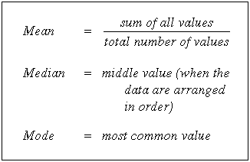

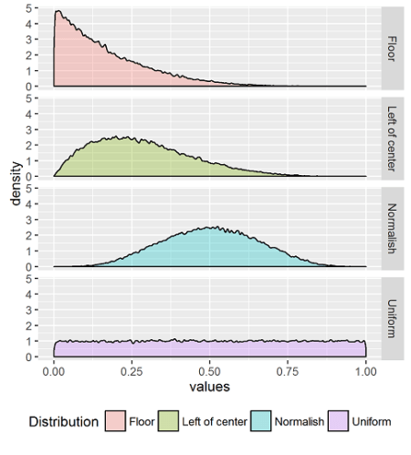
A3. Measure the Variability
It gives us an idea about the typical difference between scores in a distribution of scores.
- The Range: It is the difference between the highest and lowest scores.
Ex: H – L = 100 – 20 = 80 score range
We must be cautious with this measurement as it only relies on 2 scores of the distribution and give a distorted idea about variability.
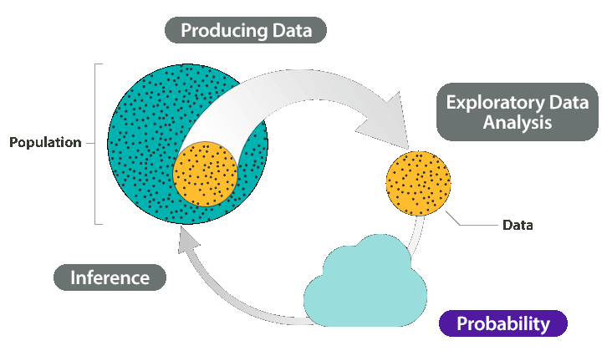
- Standard Deviation
SD are better measurements because it takes into consideration every single score and how it varies from the mean.
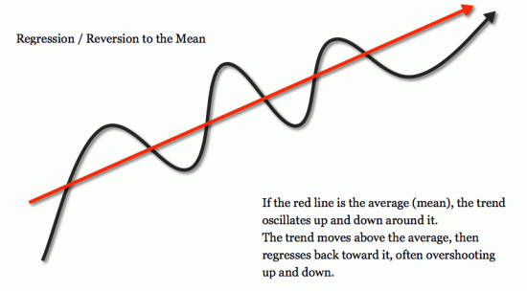
- Inference Statistics
It allows answering if my results are statistically significance or chance.
Results are to be statistically significance when
probability of chance is very small.
The probability is considered as “P” value
between “0>1” such as P=0.6=60% and P=0.07=7%.
How small should a P-value be to be considered small?
When P ≤ 0.05 therefore less than 5% probability of chance, then we can conclude that the results are significant. Anything higher and the results will be considered as chance.
Regression Towards the Mean
Regression to the mean is a statistical phenomenon stating that data
that is extremely higher or lower than the mean will likely be closer
to the mean if it is measured a second time. This means that if you
take two independent sets of measurements from every person in
your sample, you would find that the people who had scores that
were well above or below the mean during the first measurement
would have scores that are closer to the mean in the second measurement.
Psychology’s Research Ethics
Studying Animals:
Studying Humans:
Informed Consent: Giving potential participants enough information about a study to enable them to choose whether they wish to participate.
Debriefing: The post experimental explanation of a study, including its prupose and any deception, to its participants.


