MIS ADM2372 N

Day 1 Section 1.1
- Information Systems Impact on Business Operations
  - Business undertake enterprise-wide IT initiatives
    - Lower cost
    - Improve Productivity
    - Generate Growth
  - IT provides
    - Communication and data and information analysis
  - Organizations typically operate by functional areas or “silos”
  - Departments must function interdependently to share common information
- Information Systems Basics
  - Information Systems
    - Computer tools that used to work with information and support the info and info-processing needs of an organization
    - Include: Hardware, software, trained personnel, policies and procedures and security measures
  - IS is an enabler of business success and innovation (help you achieve what you want by aiding your business judgement)
- Information Technology
  - The acquisition, processing storage, and distribution of voice, graphics, text, and numbers and other information by a combination of computers and telecommunications networks.
- Information System Basics
  - Management information Systems (MIS)
    - The function that plans for, develops, implements, and maintains IS hardware, software, and applications that people use to support the goals of an organization.
    - MIS is a business function, similar to accounting, finance, operations, and human resources

- Data, Information, BI and Knowledge
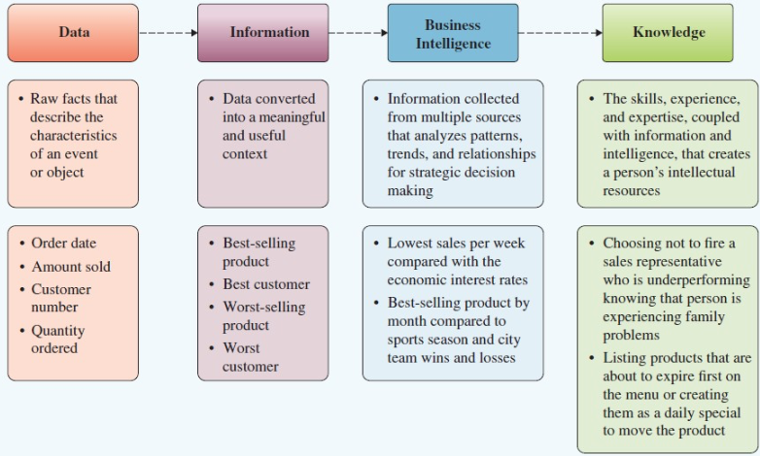
  - Data
    - Raw facts that describe the characteristics of an event or object (the basics)
  - Information
    - Data converted into meaningful and useful context (the use of the data)
  - Business Intelligence and knowledge
    - Information collected from multiple sources that analyzes patterns, trends, and relationships for strategic decision making
    - The skills, experience, and expertise, coupled with information and intelligence, that creates a person’s intellectual resources.
- Relationship among people, processes, info technology and information
  - People use processes to work with info systems to produce information
- Information Cultures
  - Information-functional culture
  - Information- inquiring culture
  - Information-sharing culture
  - Information-discovery culture
- Information System Roles and Responsibilities
  - Chief Information Officer (CIO)
    - Oversees all use of IT and ensures the strategic alignment of IT with business goals and objectives
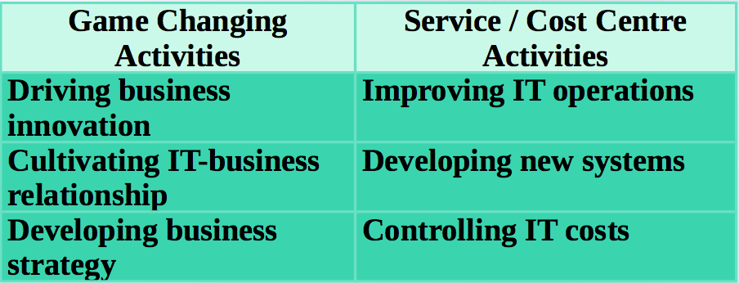
  - Chief Knowledge Officer (CKO)
    - Responsible for collecting, maintaining, and distributing the organizations knowledge
  - Chief Privacy Officer (CPO)
    - Responsible for ensuring the ethical and legal use of information
  - Chief Security Officer (CSO)
    - Responsible for ensuring the safety of IT resources including data, hardware, software and people
  - Chief Technology Officer (CTO)
    - Responsible for ensuring the throughput, speed, accuracy, availability and reliability of IT
- Skill Gap in Canada
  - Report from information and communication technology council
    - Over 100,000 jobs in MIS/ICT 11-16

Section 1.2 Business Strategy
- Competitive Advantage
  - Key to survival and growth
    - Competitive advantage
      - A product that an organization’s customers place a greater value on than similar offerings from a competitor
    - First-mover advantage
      - Occurs when an organization can significantly impact its market share by being first to market with a competitive advantage
    - Always temporary as it is quickly copied
- Identifying Competitive Advantage
  - Environmental Scanning
    - The acquisition and analysis of events and trends in the environment external to an organization
  - Three common tools used in developing competitive advantage
    - Porters Five Forces Model
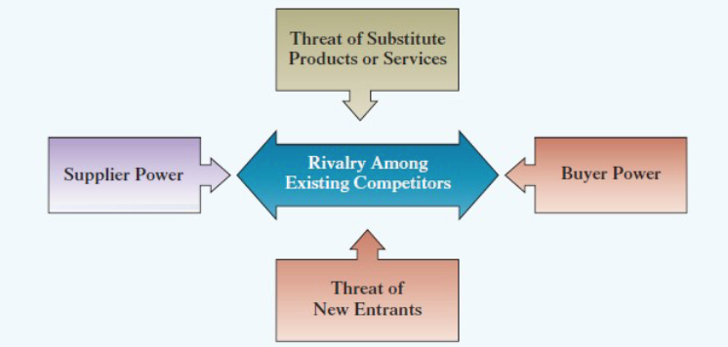
    - Porters Three Generic Strategies
    - Value Chains
- Buyer Power
  - The ability of buyers to affect the price of an item
  - Generated for the buyer when it accounts for the largest percentage of a business profit
  - Switching Cost
    - The amount of benefits (monetary or non-monetary) a consumer must give up to go to another buyer
  - Loyalty Program
    - Rewards customers based on the amount of business they do with a particular organization
    - Increase the switching costs for buyers
- Supplier Power
  - The ability of suppliers to set prices and terms
  - Suppliers
    - Organizations want supplier power to be low and buyer power to be high here
  - Organization
    - Organizations want supplier power to be high and buyer power to be low here
  - Customers
- Substitute Product or Service
  - Substitutes products or services
    - Alternatives to a product or service
  - Loyalty programs increase Switching Costs and reduce this threat
- New Entrants
  - The ease of which new competitors can enter a market
  - Entry Barrier
    - A feature of a product that customers have come to expect that entering competitors must offer the same for survival
- Rivalry Amoung Competitors
  - The amount of direct conflict between businesses in a specific industry
  - Product Differentiation
    - Unique differences in the features of products that influence demand
- Three Generic Strategies
  - Using a single generic strategy makes efficient use of resources
  - First selection is broad or narrow focus
  - Within broad focus choose
    - Cost leadership
    - Differentiation
  - Narrow focus is a single generic strategy
    - You can look at either high cost or small costs
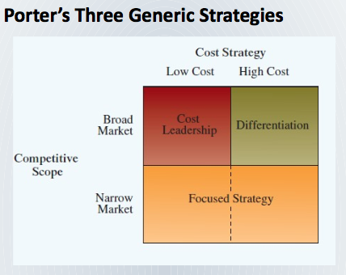
- Value Creation
  - Business Process
    - A standard set of activities that accomplish a specific task or objective
  - Value Chain
    - A series of business processes, each adding value to the final product or service
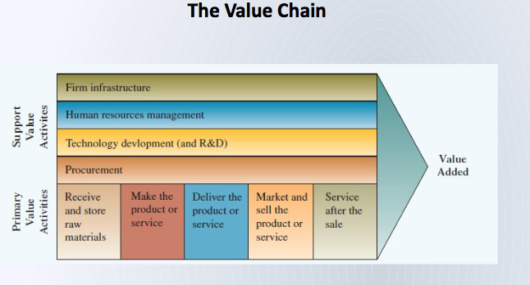
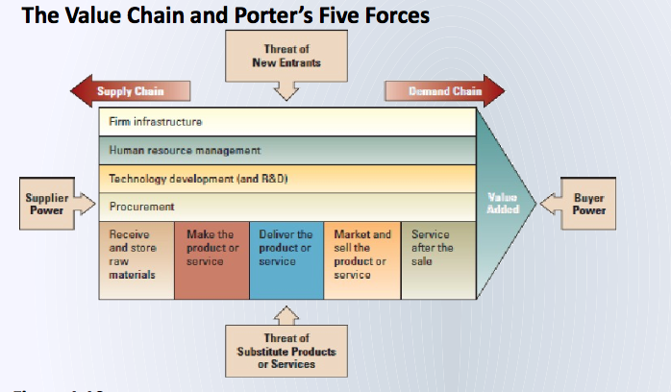
- Business-Driven Information Systems
  - Porters Five Forces Model
    - An external analysis of industry forces impacting on the organization
    - IS collects, process an reports environmental scan information
    - IS provides the technology to support strategies to limit the threat of the forces
  - Three Generic Strategies
    - The strategic decision a company can make in about its business focus
    - IS can run simulations and models of possible alternatives updated in real time
  - The Value Chain
    - An internal analysis that helps a business optimize the value from its functions
    - IS integrates the functions by enabling critical data/information sharing
  - Business Driven Information Systems
    - Information systems developed to support a business’s competitive strategy
    - Business strategy drives information systems design and choices

Decisions and Processes: Value – Driven Business
Section 2.1 Decision Making and Information Systems
- Making Business Decisions
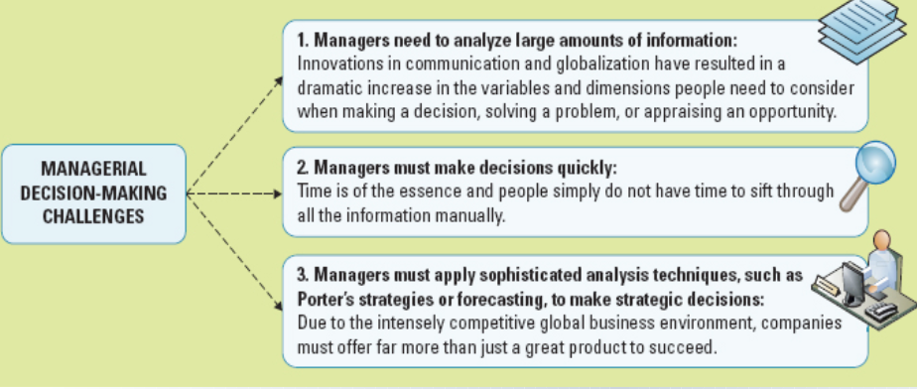
  - Decision making and problem solving occur at each level in an organization
    - Strategic -> Managerial -> Operational
- Operational Decision Making
    - Employees develop, control, and maintain core business activities required to run the day to day operations
  - Structured Decisions
    - Situations where established processes offer potential solutions
- Managerial Decision Making
    - Employees evaluate company operations to identify, adapt to, and leverage change
  - Semi Structured Decisions
    - Occur in situations in which a few establish processes help to evaluate potential solutions, but not enough to lead to a definite recommended decision
- Strategic Decision Making
    - Managers develop overall strategies, goals, and objectives
  - Unstructured decisions
    - Occurs in situations in which no procedures or rules exist to guide decision makers toward the correct choice
- Measures Success
  - Project
    - Temporary activity a company undertakes to a create a new product, service or result
  - Metrics
    - Measurements that evaluate results to determine whether a project is meeting its goals
    - Common types
      - KPIs – Key Performance Indicators
      - Efficiency and Effectiveness
    - Effciency Metrics Effectiveness Metrics
      - Throughout Usability
      - Transaction speed Customer Satisfaction
      - System Availability Conversion Rates
      - Information Accuracy Financial Goal Achievement
      - Response Time
- Critical Success Factors
  - The crucial steps companies make to perform to achieve their goals and objectives and implement strategies
    - Create high quality products
    - Retain competitive Advantage
    - Reduce Product Costs
    - Increase customer satisfaction
    - Hire and retain the best professionals
- Key Performance Indicators (KPIs)
  - The quantifiable metrics a company uses to evaluate progress toward critical success factors
    - Turnover rats of employees
    - Number of product returns
    - Number of new customers
    - Average customer spending
- Benchmarking
  - Benchmark
    - Baseline values the system seeks to attain
  - Benchmarking
    - A process of continuously measuring system results, comparing those results, comparing those results to benchmark values, and identifying steps and procedures to improve system performance
- Benchmarking Efficiency and Effectivness
  - Managerial Decision Making Challenges
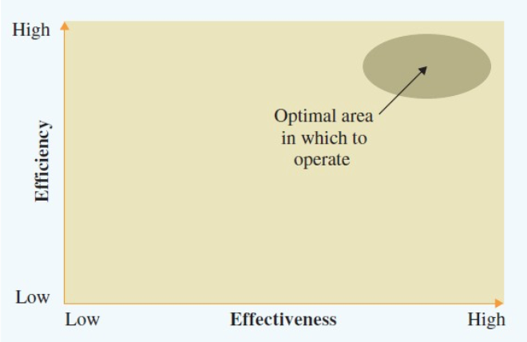
- Types of Information
  - Transactional Data
    - Encompasses all the new raw facts within a single business process or unit of work
    - Supports daily operational tasks
    - Examples: Order size, manager’s salary, product price, stock price, shipping date
  - Analytical Information
    - Summarized transactional data
    - Used to support decision analysis
    - Examples: Market trends, forecasts, sales by region, environmental scans
- Types of Information Processing
  - Online Transactions Processing (OLTP)
    - Captures, stores, updates and process data according to defined rules
  - Online Analytical Processing (OLAP)
    - Summarization or aggregation of raw data from transaction systems
    - Data transformed into information for the managerial and strategic organizational levels
  - Granularity
    - Level of detail from raw data (granular or fine) to summarized data (coarse)
- Business Intelligence
  - Broad term describing the information supporting analytical and strategic decision making
  - Consolidation
    - Aggregation of information into groups of interrelated information
  - Drill-Down
    - Breaking out of details into successive levels or grater granularity
  - Slice and Dice
    - Grouping data in different ways to offer differing perspectives
  - Information levels throughout an organization
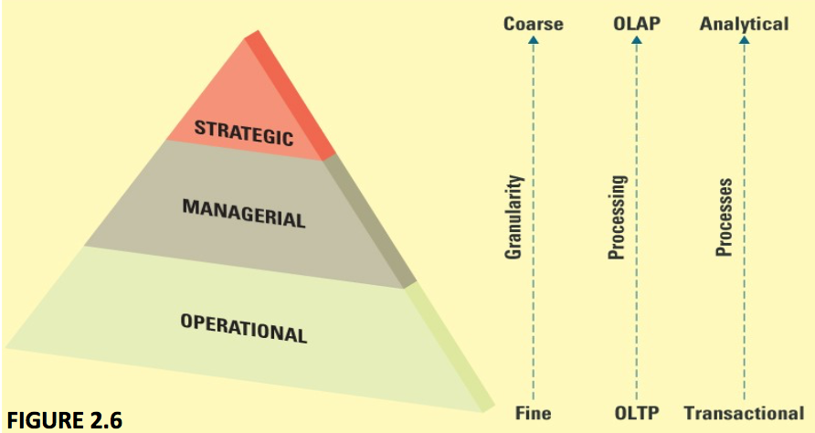
- Three Major Classes of IS
  - Transactional Processing Systems
    - Handles data for the operation level
    - Performs OLAP for transactional data
      - Examples: payroll and order entry
  - Decision Support Systems
    - Models data and information to support managerial decisions
    - Performs OLAP
  - Executive Information Systems
    - Highly aggregated data for strategic decisions
    - Usually presented in graphical format
- Quantitative DSS Models
  - Sensitivity Analysis
    - Changing one factor in an analysis and observing the change in result
  - What if Analysis
    - Changing a basic assumption in the analysis and observing the impact on the result
    - Often used for contingency plans
  - Goal-Seeking Analysis
    - Determining the optimal configuration of resources necessary to achieve a stated goal
- Interaction Between TPS and DSS
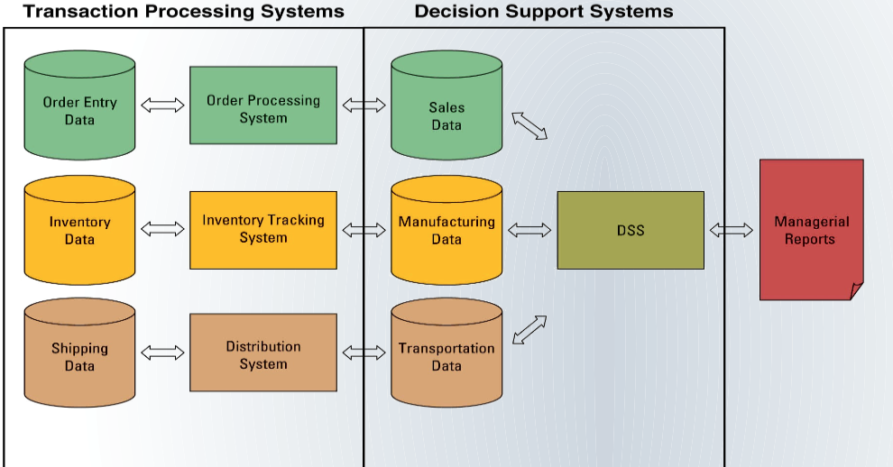
- Executive Information Systems
  - Specialized DSS for senior managers and executives
  - Uses external as well as internal data
  - Essential results at a glance
  - Visualization tools display key results
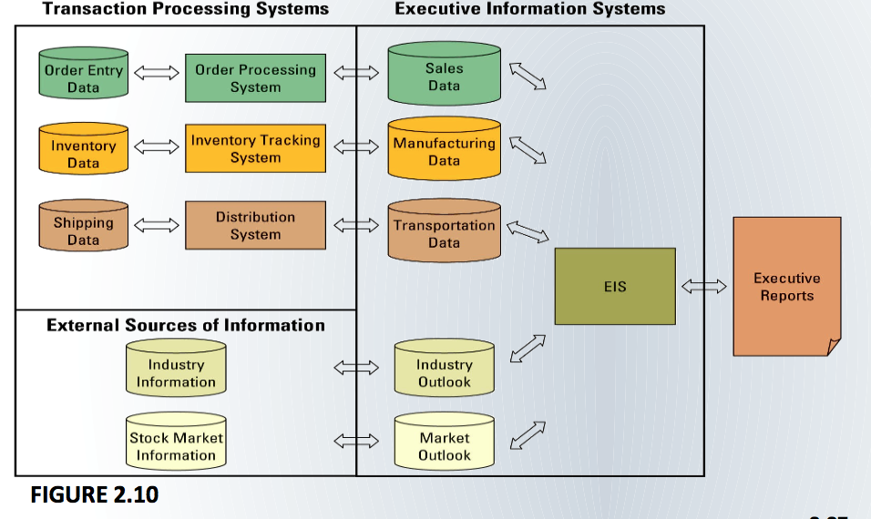
- Digital Dashboards
  - Integrates information from multiple components and presents it in a unified display
- Artificial Intelligence (AI)
    - Simulates human intelligence such as the ability to reason and learn
  - Intelligent System
    - Various commercial applications of artificial intelligence
- Types of Artificial Intelligence
  - Expert Systems (Playing Chess)
  - Neutral Networks (credit card companies checking for fraud)
  - Genetic Algorithms (investment companies in trading decisions
  - Intelligent Agents (environmental scanning and competitive intelligences
  - Virtual Reality (working virtually around the globe)
- AI- Expert Systems
  - Software applications that imitate human reasoning in a specific subject area
  - 3 components of expert systems
    - Knowledge Base
      - Database containing objective information and subjective experiences
      - Contributions from leading experts
    - Set of Rules
      - Similar to a search engine, compiles knowledge to a specific situation
    - User Interface
      - Allows non-technical individuals to more easily ask questions of the systems
- AI – Neural Networks
  - Attempts to emulate the way the human brain works in
    - Learning and adjusting to new circumstances on its own
    - Functioning without complete information
    - Coping with large amounts of information and many variables
    - Analyzing non-linear patterns
  - Users:
    - Decisions that involve patterns or image recognition
    - Problems where “rules” or logical pathways are unknown
  - Fuzzy logic
    - A mathematical method of handling imprecise or subjective information
- AI – Genetic Algorithm
  - A system that evaluates thousands of options choosing the most likely to succeed
  - Optimization
    - Finds the combination of inputs product the best output
    - Works faster with more possibilities than any human
  - Uses
    - Which set of projects should a company invest in?
    - Network configuration selects the lowest cost among millions of possible connections
- AI – Intelligence Agents and Multi-agent Systems
  - Specialized applications that complete online tasks that require decision-making
  - Based on a programmed “set of rules” that can adapt to changing situations
  - Shopping Bot
    - Application that searches the net for products, negotiates price and executes transactions for businesses
  - Multi-agent systems
    - Intelligence Agents that work independently and interact with each other
  - Agent-based Modeling
    - Use of multi-agent systems to simulate and predict behaviour of human organizations
- AI – Virtual Reality
  - Computer-generated environment that simulates a real world or imagery world experience
  - Uses
    - Flight simulation for pilot training
    - Surgery conducted from a remote site. Visual images guide the surgeon who manipulates equipment many miles away
    - Remote use of equipment to dispose of hazardous waste.
    - Entertainment

Business Processes
Section 2.2
- Understanding the Importance of Business Processes
  - Business Process
    - Standardized set of activities that accomplish a specific task
    - Transform a set of inputs into a set of outputs (goods and services)
  - Types of business Processes
    - Customer check-out process, order delivery processes, invoicing process, payroll process
  - Importance
    - Determine bottlenecks, eliminate duplication, identify and benchmark smooth running processes
- Sample Business Process
  - Accounting and finance
  - Environmental management
  - Human Resources
  - Management information systems
- Order –to-Delivery Process
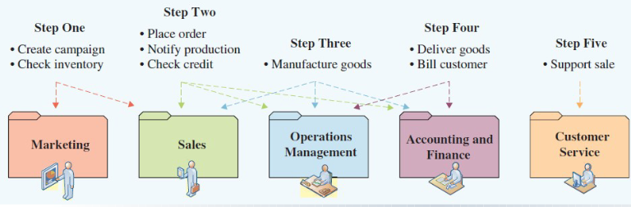
- Customer and Business Facing Processes
  - Customer Facing Processes
    - Results in a product that is received by an organizations external customer
  - Business Facing Processes
    - Are invisible to the external customer but are essential to the effective management of the business
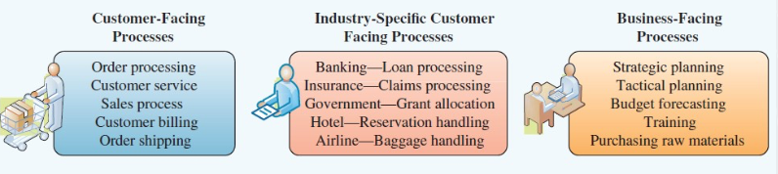
- Business Process Modeling (Mapping)
  - The activity of creating a detailed flow chart or process map of a work process showing its inputs, tasks, and activities in a structured sequence
  - Business process model
    - A graphic description of a process, showing the sequence of process tasks, which is developed for a specific
  - As-Is process model
    - Current state of the operation without improvements or changes
  - To-Be process model
    - Shows the results of proposed changes to As-Is model
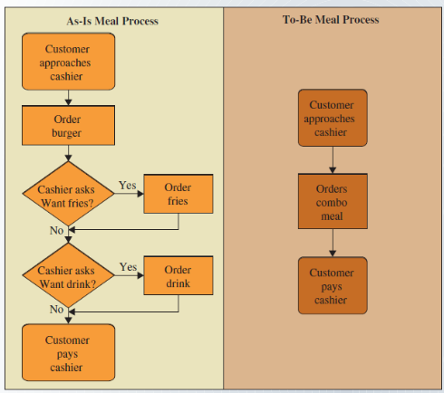
- As-Is Process Modeling for Order Fulfillment
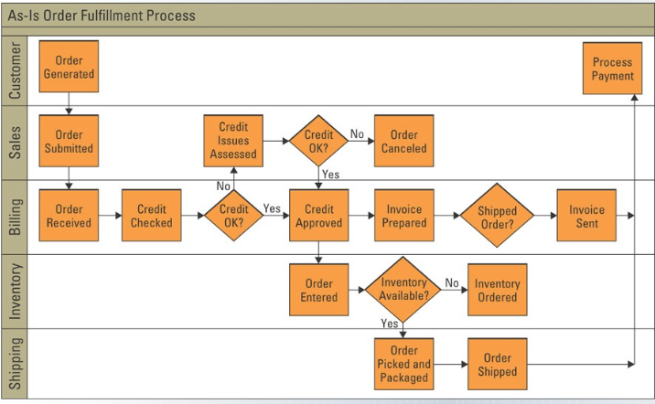
- Business Process Improvement
  - Attempts to understand and measure current processes and make performance improvements accordingly
  - Three conditions for initiating a business process change
    - A pronounced shift in the market the process was designed to serve
    - The company is markedly below industry benchmarks on the performance of its core processes
    - To regain competitiveness, the company must leap-frog the competition on key dimensions
  - Workflow
    - Task, activities, and responsibilities required to execute each step in a business process
  - Critical Ingredients in Process Improvement
    - Understanding workflow, customer expectations and the competitive environment
  - Steps in Business Process Improvement
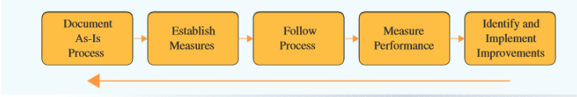
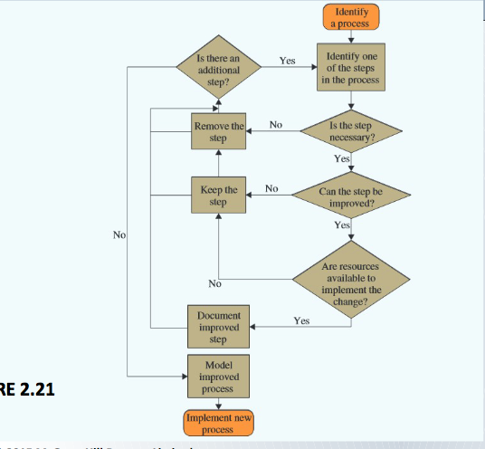
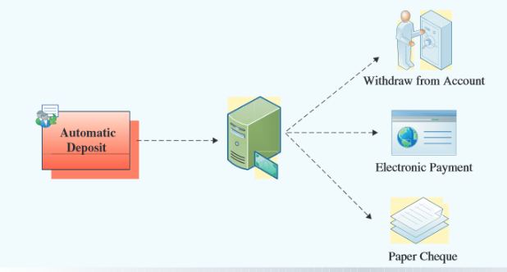
- Online Order Fulfillment Process Model
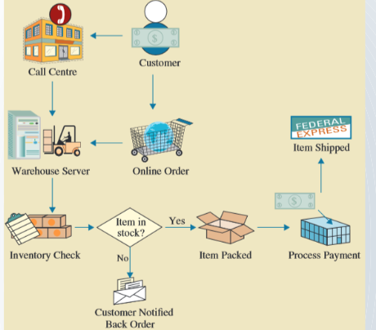
- eBay Customer-Facing Business Process Models
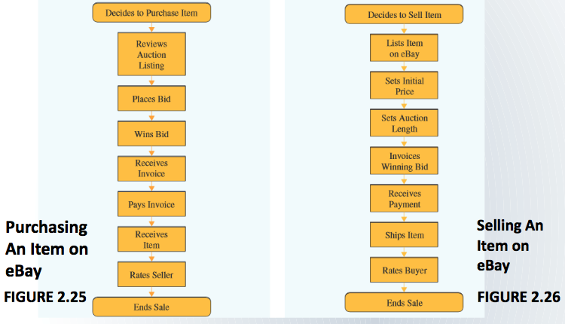
- Business Process Engineering (BPR)
  - Is the analysis and re-design of workflow within and between enterprises?
  - Is not built off of the old process. Is Always revolutionary not evolutionary
  - A vision is created and an entirely innovated process is implemented
  - Business Process Re-engineering Model
    - Set Project Scope -> Study Competition-> Create New Processes -> Implement Solution
- Business Process Re-engineering
  - Results in better, faster and cheaper AND re-defining best practices in the industry
  - Focus must be on core business activities
    - Does it impact highly on customer satisfaction?
    - Is it consistent with the strategic direction?
    - Is it crucial for productivity improvement?
    - Does it fall below best in class?
- Creating Customer Value
  - The key driver for business process engineering
- Increasing Change Increases Benefits
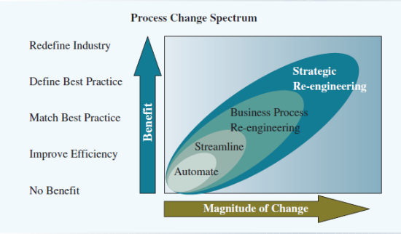
- Business Process Management
  - Integrates all of an organization’s business processes to make individual processes more efficient
  - Focus on People and Systems
    - Focuses on evaluating and improving processes that include both person to person workflow and system to system communications
    - Works across functional areas so IT and functional managers must understand each other and work together
  - Requirements
    - Flexibility with cultural and organization change
    - Willingness to share power and information
- Key Reasons for BPM
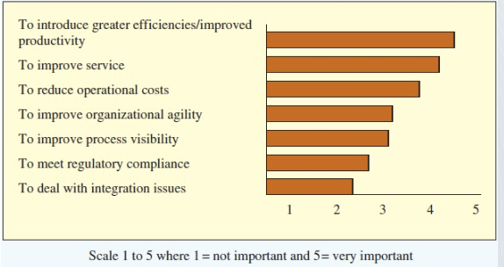

Data, Information, and Knowledge
3.1
- Organizational Data and Information
  - For specific business issues, employees must be able to obtain and analyze all relevant data
    - Data comes in different levels, formats and detail
    - Granularity refers to the level of detail
      - Course granularity: summarized data
      - Fin Granularity: often raw data
    - Surprising and valuable results from compiling, sorting and analyzing data of multiple types
- Classification of Data and Information
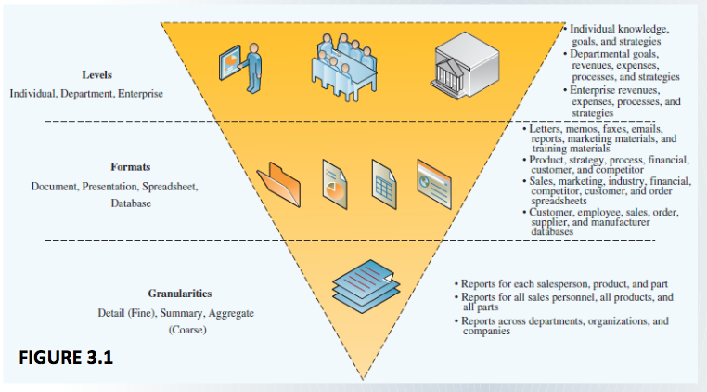
- Transaction Data Versus Analytical Information
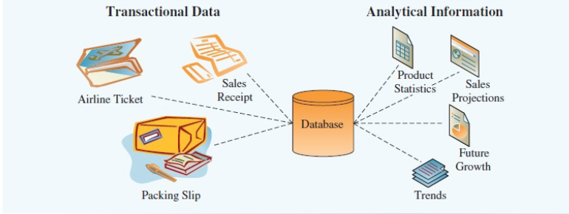
- Value of Timely Data and Information
  - Timeliness of data depends on the decision that requires it
    - Real time data and Real time information are immediate and up to date. Permit:
      - Smaller inventions
      - More efficient operations
      - Faster diagnosis and solutions to problem
      - Faster cycle times for cash, sales, and delivers and payment
- Data and Info Quality
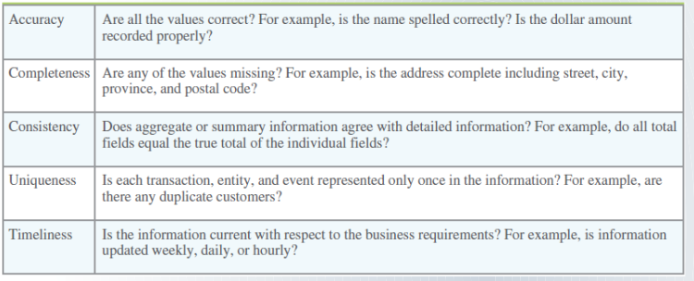
- Data Governance
  - Refers to the overall management of the availability, usability, integrity, and security or organizational data
    - Businesses are required to have policies specifying accountabilities for data quality, security, privacy and as to who can access what data and information
    - Must comply with government laws and regulations, and accounting and other professional policies and by-laws
- Knowledge
  - Actionable information that requires:
    - Understanding of the information
    - Ability to make inferences between “tidbits” of information
    - Be able to apply the information the appropriate context

