EXPERIMENT: NO. 1
TITLE: VERIFICATION OF BOYLE’S LAW
NAME: JAMES CHRISTOPHER
STUDENT NUMBER: 500038486
TA’S NAME: TOM BURNS
DATE COMPLETED: 28/09/2017
DATE SUBMITTED: 28/09/2017

INTRODUCTION:
Gases are complex structures that contain lots of energetic tiny gas particles that can interact as well as collide with each other. In this world, the ideal gas concept is used to shape and define the real gases’ behaviour. It is proven that there are no true ideal gases but there are gases that almost behave like them with pressures and temperatures close to normal atmospheric pressure and room temperature, which are called the real gases. Ideal gases follow some certain rules which includes the gas molecules not having a volume between themselves, gas molecules not having any kinetic energy loss during their collisions (elastic collisions), gas molecules not having repulsive and attractive forces between them and so on. All these concepts cannot be found in any gas because they are too perfect to be realistic, which is why there is no presence of gases that are 100% ideal.
The ideal gas law/ equation is one that relates the variables: temperature in kelvins(K)or degree Celsius °C, Pressure P in Pa or atm, Volume V in cm³ or m³ and the amount of gas. This equation is given by:
PV=nRT (1)
In this equation, it is said that four other gas laws are combined to form this one equation which include Boyle’s law, Charles’ law and Gay Lussac’s law and Avogradro’s law. Since the experiment is based on Boyle’s law, it would be the one that would be further explained. In Boyle’s law, the temperature and amount of gas(n) is constant and the pressure is inversely proportional to the volume of a fixed mass of gas which means that if the pressure of a gas increases, the volume decreases. The law is given by:
PV = c or P ∝ 1/V (2)
In this experiment, I am going to be verifying this law.

Web: https://www.khanacademy.org/science/physics/thermodynamics/temp-kinetic-theory-ideal-gas-law/a/what-is-the-ideal-gas-law, Mr Khan, www.khanacademy.org

PROCEDURE
- I connected the gas pressure sensor to LabQuest 2.
- I turned on LabQuest 2 and chose ‘New’ from file menu.
- I moved the tip of my plunger to my chosen volume.
- Then I attached the plastic syringe to the valve of the gas pressure sensor (Half a turn was enough for me to secure the attachment)
- ‘Mode’ on the Meter screen was then tapped and was changed to events with entry.
- The name of my variable was then entered along with the unit then I selected OK.
- The data collection was then started by holding the plunger at my initial volume mark.
- After the pressure reading stabilized, I tapped keep and recorded my volume with the addition of 0.8ml and then selected OK to proceed.
- The plunger was moved again to my next volume of air and held in place. After the pressure reading stabilized, I tapped keep and entered my volume plus 0.8ml and selected OK to proceed.
- This was repeated 6 times for different volumes and 3 runs were also done
- For my final volume measurement, I ensured that it was done by moving my plunger back to its original volume mark and then stopping the data collection right after taking the reading.
- After each run, I examined the plotted points and made a decision on which of the original volume points were better to use and therefore removing the other one
- I did this by first tapping the table icon at the end top of screen and choosing the desired original volume point to be removed, which was followed by opening the table menu and selecting ‘strike through data’ which indicated the removal of the point.
- After that, I tapped on the graph icon to return to the graph screen.
- I started analyzing my graph by tapping analyze and choosing curve fit from the analyze menu.
- A function was then chosen to perform on my data from the menu below ‘Fit equation’
- Then OK was selected to return to my graph screen which showed my function plotted against my data.

TABLES
RUN 1
Volume (ml) | Pressure (KPa)
3.8 | 101.96
6.8 | 44.14
9.8 | 27.76
12.8 | 20.51
15.8 | 16.72
18.8 | 14.04

RUN 2
Volume (ml) | Pressure (KPa)
3.8 | 102.19
6.8 | 44.14
9.8 | 27.76
12.8 | 20.67
15.8 | 16.72
18.8 | 13.86

RUN 3
Volume (ml) | Pressure (KPa)
3.8 | 101.87
6.8 | 42.12
9.8 | 26.74
12.8 | 19.90
15.8 | 15.94
18.8 | 13.47

OBSERVATIONS
- The plunger was harder to pull out than to push in for my experiment.
- The pressure was always fluctuating between two similar values and it was hard for it to stabilize/remain on one value e.g. it always fluctuated between 16.72 and 16.73 and hardly remained on one of them.

GRAPHS
RUN 1
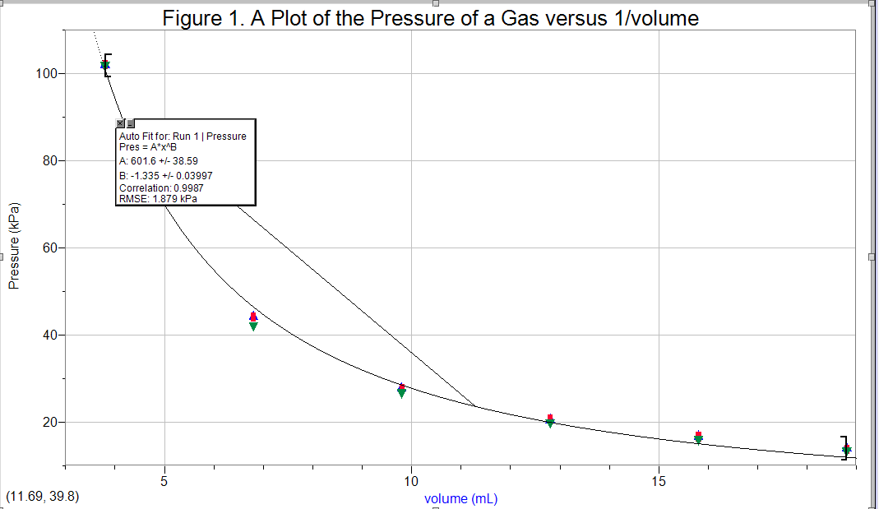
RUN 2
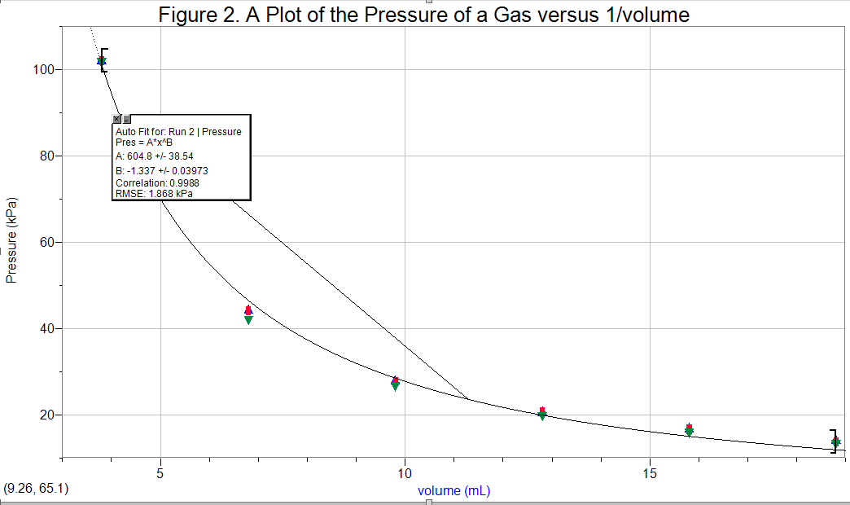
RUN 3
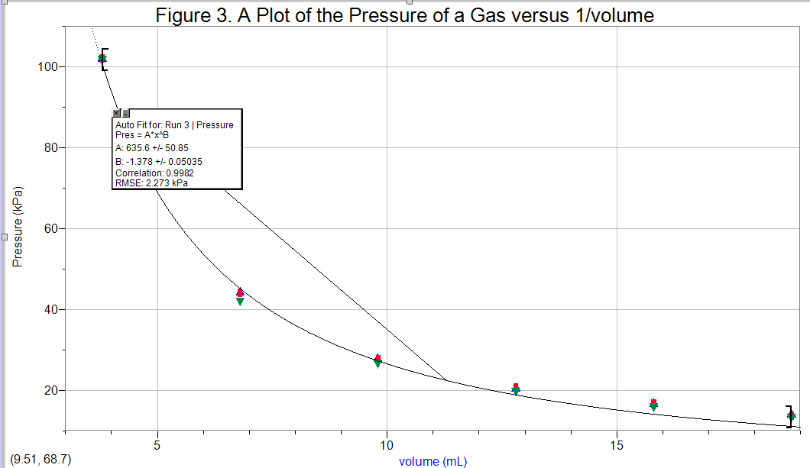

CALCULATIONS
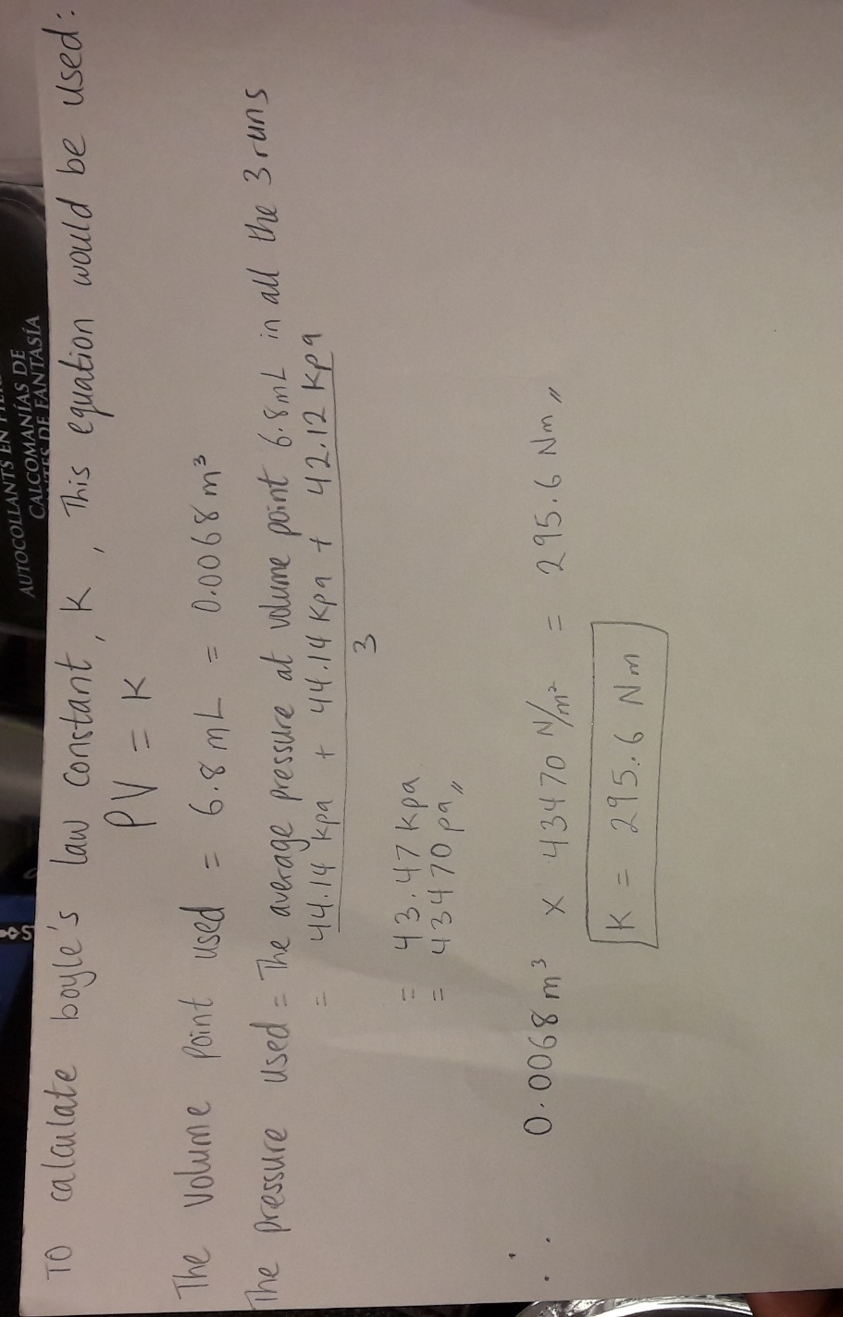

DISCUSSION
Before my experiment I expected a situation in which the pressure decreased as the volume in the syringe increased to verify Boyle’s law. My results both in the data and the graphs supported my prediction because as the values for the volume got larger the pressure values got smaller. This simply shows that pressure is inversely proportional to the volume of a fixed mass of gas at constant temperature and amount of gas(n). The law has been verified. Data analysis answers: (1) For my calculations, I used the volume point of 6.8 ml and the average pressure at this point for the 3 runs which was 43.47 KPa to get the constant, k, by multiplying both values. (2) the mathematical relationship of P and V in Boyle’s law is that the pressure is inversely proportional to the volume of a fixed mass of gas at constant temperature, given by P ∝ 1/V and can also be written as PV=k(constant). Using the constant I calculated in my calculations, an equation for Boyle’s law could be written as PV=295.6Nm (3) The importance of taking multiple readings of the dependent variable for the same value of the independent variable is to make your experimental data more reliable and accurate. This decreases the error or uncertainty on the data taken. (4) the other gas variables are the temperature and the amount of gas/number of moles. I took these variables into consideration and made sure they were constant throughout the experiment. I did these by making sure the experiment was done at room temperature and without allowing any form of heat to be exchanged with my surroundings by closing all doors and windows. Also, I ensured there was no leakage in the syringe and my syringe was firmly attached to the gas pressure sensor. These precautions made my results to be consistent because to verify Boyle’s law, the temperature and amount of gas(n) must remain constant.
CONCLUSION
In my experiment, I can say my results remained consistent because as the volume increased , pressure always decreased e.g at the volume point 3.8, the average pressure was 102 KPa and the volume point 6.8, the average pressure was 43.47 Kpa.



