EXPERIMENT : NO 2
TITLE: THERMOCHEMISTRY
NAME: JAMES CHRISTOPHER
STUDENT NO: 500038486
TA NAME: TOM BURNS
DATE COMPLETED: 11/10/2017
DATE SUBMITTED: 11/10/2017

INTRODUCTION:
The enthalpy of solution is a change that occurs when an ionic substance has one mole of it dissolved in water which would form an infinite dilution. This may be negative(exothermic) or positive(endothermic). At constant temperature, it is usually expressed as KJ/mol. 2 major factors are depended on by the enthalpy of solution which includes the hydration enthalpy and the lattice enthalpy. Hydration enthalpy is a change that occurs when aqueous ions are formed from the dissolution of a mole of gaseous ions in water. This is always negative(exothermic). Also, the lattice enthalpy is the heat energy required to form gaseous ions from the vaporisation of a mole of salt. This is always positive(endothermic). Using these two major factors, one can calculate the enthalpy of solution by adding both of them. The enthalpy of solution can also be calculated by using this equation:
ΔH(sol) =q(sol)/n(salt) (1)
This equation was used in my experiment to test the amount of salt (which was ammonium chloride) that was needed to change the temperature of a sports drink by -5°C in less than 5 minutes when desired by a user. Ammonium chloride was chosen because it was much safer than ammonium nitrate (the other option) due to it being much less toxic than ammonium nitrate. The experimental design that was used in this experiment was chosen because it clearly shows what amount of ammonium chloride would be needed to cool down a drink in a quick time by less than -5°C. it also clearly shows the process of how heat would be exchanged in an isolated system. The experimental goal would be achieved by testing a wide range of masses of ammonium chloride over a period of time (which is 5 minutes) and finding the mass that would give the desired results which is achieving a -5°C change in temperature of a whole solution within or in 5 minutes.
Web: http://www.chemguide.co.uk/physical/energetics/solution.html , Jim Clark, http://www.chemguide.co.uk

PROCEDURE:
- The mass of the can was weighed then labQuest 2 was set up.
- 100cm3 of water was poured into the can by using a graduated cylinder
- 100cm3 of water was also poured outside of the can (in the calorimeter).
- Pressure inside the can was measured as initial temperature using the thermometer connected to LabQuest 2.
- 9g of ammonium chloride was then added to the water on the outside of the can to begin the reaction.
- It was then stirred for about 30 seconds.
- Then the final temperature of the water inside the can was recorded after 5 mins 30 s.
- This was repeated with 11g,13g,15g,17g of ammonium chloride until the desired results where gotten. They were recorded as separate trials.
- I cleaned up after the experiment.

DATA TABLES
Trial | Mass  (g) | Initial Temp.  (°C) | Final Temp.  (°C) | Change in temp.  (°C)
1 | 9 | 24.2 | 21.3 | 3.1
2 | 11 | 23.6 | 20.3 | 3.3
3 | 13 | 23.2 | 19.4 | 3.8
4 | 15 | 23.5 | 18.5 | 5.0
5 | 17 | 23.3 | 19.0 | 4.3

OBSERVATIONS
-The salt was white and shiny
-The first can we used for the 11g experiment was leaking so it had to be replaced with another one before we started the experiment.

GRAPHS
9g RUN
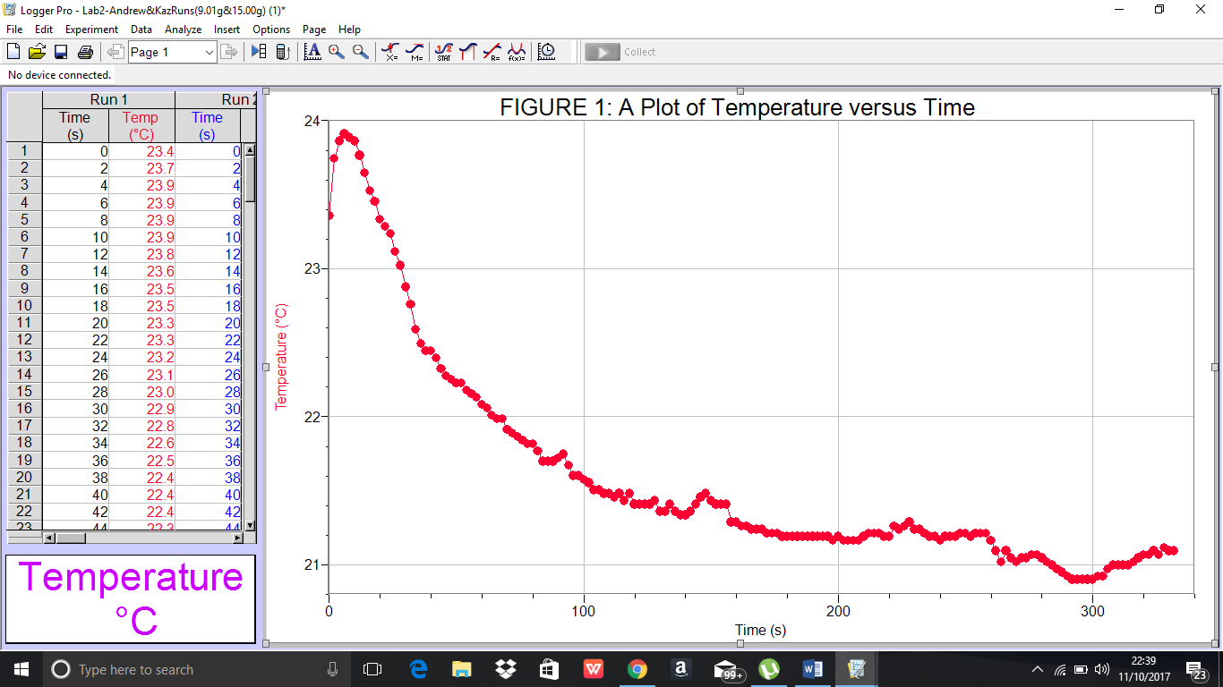
11g RUN
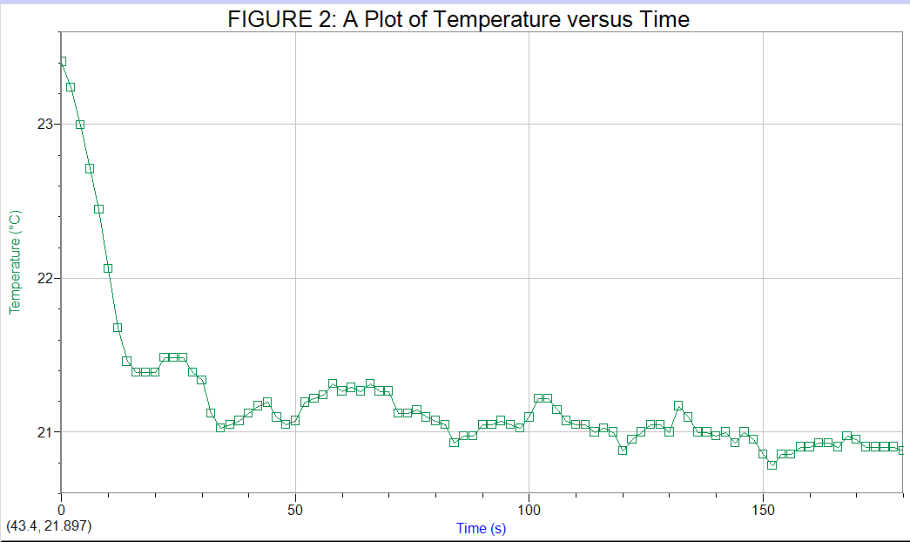
13g RUN
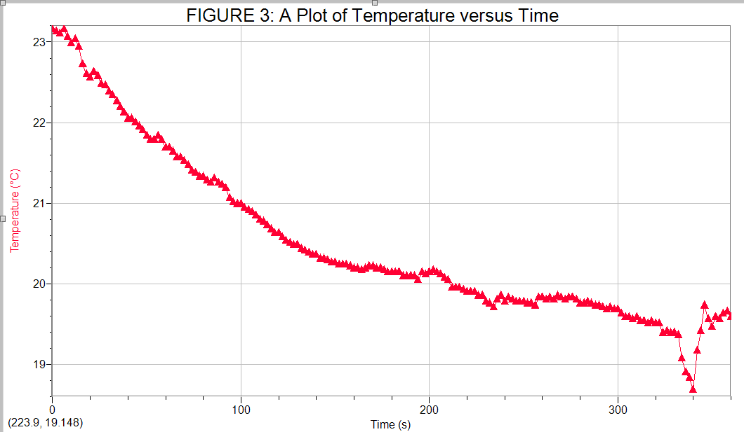
15g RUN
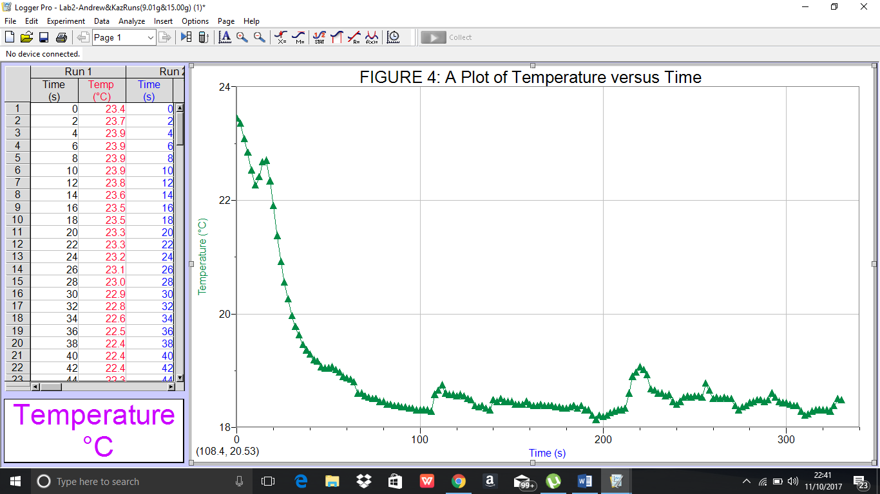

17g RUN
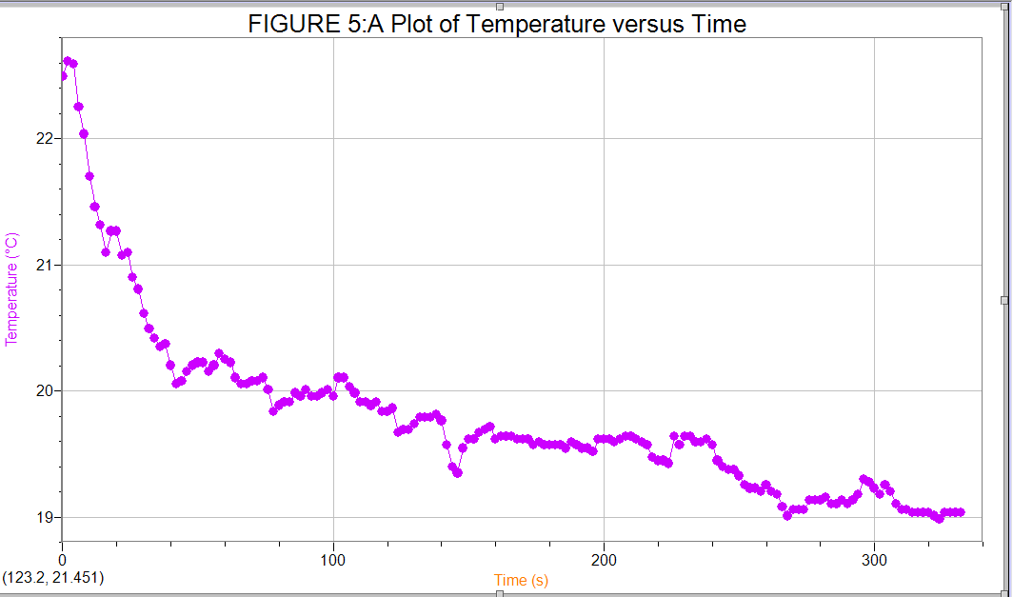

CALCULATIONS
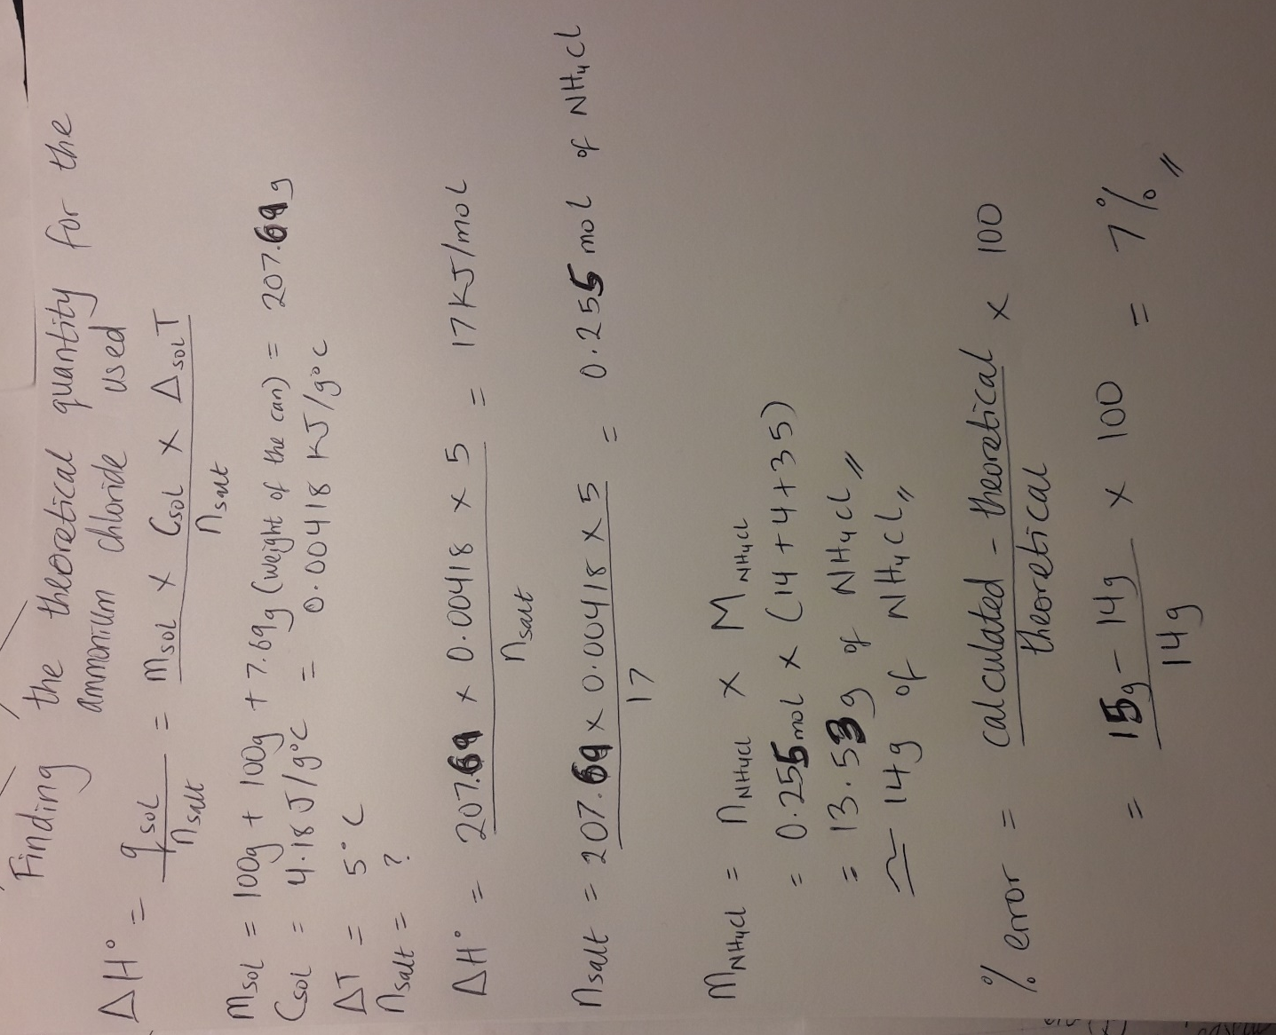

DISCUSSION:
In my experiment, as I added higher masses of ammonium chloride starting from 9g, the temperature change was getting close to -5°C within 5 minutes until I used 15 g of ammonium chloride which got me my desired results. The design worked because with 15g of ammonium chloride, I was able to achieve -5°C within 5 minutes which was the experimental goal I planned to achieve before the beginning of the experiment. Considering the cooling effect of ammonium chloride, this result is reasonable because 15g seems close to the theoretical amount of 14g of salt needed to quickly change the temperature of a solution of over 200g by -5°C. Some errors could have prevented the result from being better which include not stirring the solution enough after the salt was added which could have affected the temperature in some way, and also not properly covering the calorimeter during a run which could have also affected the temperature. Any of these errors could have affected my final temperature value for the 17g run which did not follow the trend of increasing temperature change. Also, another huge error was done by me and my partner as we set the duration of the 11g run on LabQuest 2 to 180s instead of 330s and had to use the timers on our phones to complete the run and get the final temperature. This can be noted in the graph containing the 11g run.

CONCLUSION:
The experiment showed that 15g was about enough to change the temperature of a solution of mass 208g by -5°C within the period of 5 minutes. Comparing this experimental mass to the theoretical mass, there was a 7% error that was found.



