FINAL EXAM SURVIVAL GUIDE – ORGANIZATION BEHAVIOUR

CHAPTER 8 – TRUST, JUSTICE, AND ETHICS

8.1 – What is trust, ad how does it relate to justice and ethics?

Reputation: the prominence of one’s brand in the eyes of the public and the expectation of one’s quality of goods and services.

Trustor: a person trusting someone else.

Trustee: a person being trusted.

Trust: the willingness of a trustor to be vulnerable to a trustee based on positive expectations of that trustee’s actions and intentions.

Justice: the perceived fairness of an authority’s decision making.

Ethics: the degree to which an authority’s behaviours agree with generally accepted moral norms.

8.2 – In what three sources can trust be rooted?

THREE TYPES OF TRUST: Canadian dollars are trusting (CAD):

Cognition-based trust: trust rooted in a rational assessment of an authority’s trustworthiness.

“After rational decision, I feel you are trustworthy.”

Affect-based trust: trust dependent on feelings toward the authority that go beyond any rational assessment of trustworthiness.

“I have an emotional connection for you, or I like you enough that I feel I trust you.”

Dispositional-based trust: trust rooted in one’s own personality.

“I have no data on you, but I feel that I could trust you.”

Trust propensity: the general feeling that an individual’s words, promises, and statements can be relied upon.

8.3 – What dimensions can be used to describe the trustworthiness of an authority?

If we have no data on a trustee, our disposition will decide our propensity to trust.

If authority’s record of being trustable is spotty, we use three types of gauge trustworthiness based on three dimensions:

Ability: the skills, competencies, and areas of expertise that enable an authority to be successful in a specific area.

Ex. Jim has a master’s degree in computer programming, so I would trust him to fix my computer.

Benevolence (well-meaning & kindly): the belief that the trustee wants to do good for the trustor, apart from any profit-centered motives. The trustee genuinely wants to help.

Ex. Mentor to protégé relationships. Mentors genuinely want the best for their protégé, regardless of financial incentive.

Integrity: the trustee adheres to values and principles that the trustor deems acceptable.

Ex. When your manager does what he says he is going to.

Trustworthiness: characteristics of a person that inspire trust – including ability, benevolence, and integrity.

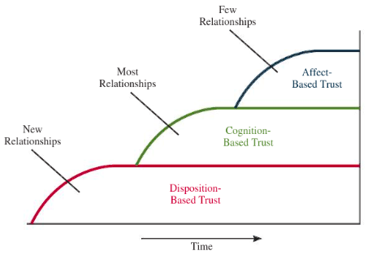

8.4 - What dimensions can be used to describe the fairness of an authority’s decision making?

Procedural justice: the perceived fairness of the decision-making process.

Ex. Giving employees the chance to express their opinions and views over the course of decision making.

Interpersonal justice: employees perceive that their authorities treat them with respect and propriety.

Respect rule: authorities treat employees with a dignified and sincere manner.

Propriety rule: authorities refrain from making offensive remarks.

Ex. My boss respects by abilities and allows me to work in an autonomous work environment. He treats me with kindness never makes offensive remarks towards me.

Abusive supervision [Interpersonally unjust]: Hostile verbal and nonverbal behaviours (excluding physical contact) by a supervisor.

Abusive supervision leads to lower productivity and higher reported levels of employee absenteeism, strains, burnout, and anxiety.

Informational justice: perceived fairness of communication; authorities will justify truthful decision-making procedures to their employees.

Ex. Communicating well with employees to keep them in the loop and out of the dark.

Distributive justice: perceived fairness of decision-making outcomes.

Ex. In most business situation, the proper norm is equity: more outcomes are allocated for those with higher inputs.

8.5 - What is the four-component model to ethical decision making?

Four-component model: ethical behaviour result from a multistage sequence of moral awareness, moral judgement, moral intent, and ethical behaviour.

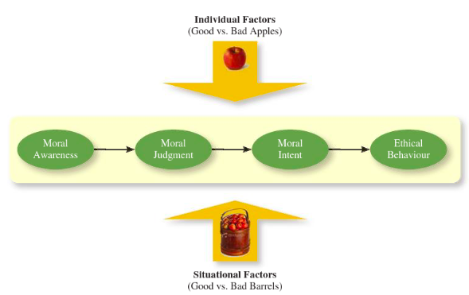

Moral Awareness: Recognition by an authority that a moral issue exists in a situation.

Ex. You see your competitors Diane’s clothing style is selling really hot. Would it be wrong for you to copy her style and put it on your clothing racks? This happens all the time in fashion, but you are still using Diane’s intellectual property. You identify a moral issue. Way to go! Fuckin’ fairy…

Moral intensity: the degree to which an issue has ethical urgency.

Ex. An act that might kill a person is more morally intense than an act that would make someone ill.

Moral attentiveness: people experience more ethical dilemmas during a day because they see the world as black and white in terms of ethics.

Moral judgement: the process people use to determine if an act is ethical or unethical.

Kohlberg’s theory of moral development: as people age and mature, they move through various stages of moral development – each one more mature than the other.

Moral principles: prescriptive guides to making moral judgements.

Moral Intent: an authority’s degree of commitment to the moral course of action.

Moral identity: the degree to which a person determines oneself to be a moral person.

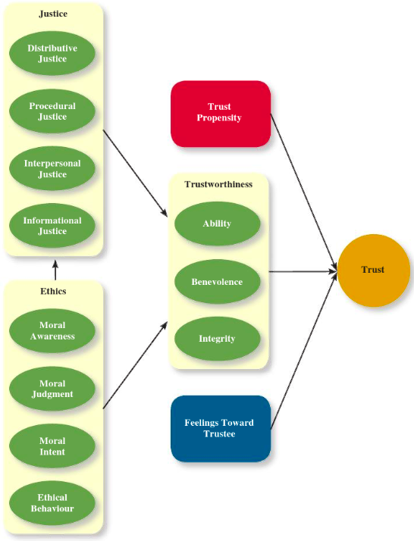

8.6 –How does trust affect job performance and organizational commitment?

Ability to focus: the degree to which an employee can devote their attention to work.

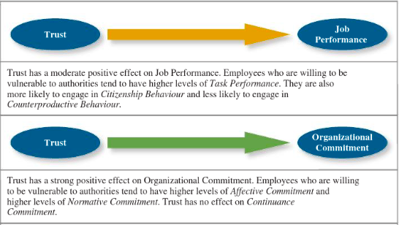

Economic exchange: Work relationships that are like a contractual agreement where employees do work in exchange for money.

Social exchange: Work relationship characterized by mutually investment; an employee that is willing to go the “extra mile” because they trust that their extra work will go noticed and be rewarded.

8.7 – What step can an organization take to become more trustworthy?

They can show a higher level of corporate social responsibility.

Corporate social responsibility: a business shows the perspective that they care about ethical, economical, legal, social citizenship expectations of society.

Chapter 9 – Learning & decision making – NEED TO KNOWS

What do employees learn?

- Practical skills
- Cultural awareness
- Interpersonal skills
- Extra-personal skills

Learning: A relatively permanent change in an employee’s knowledge or skill that results from experience

decision making: The process of generating and choosing from a set of alternatives to solve a problem

explicit knowledge Knowledge that is easily communicated and available to everyone
- If you can articulate the information into a manual someone could learn from, it’s likely explicit knowledge.

tacit knowledge Knowledge that employees can only learn through experience
- Knowledge that is learned through experience.
- Examples: Learning a language, leadership, how to sell something.

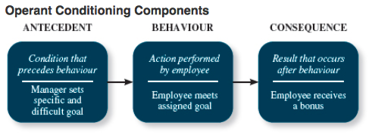

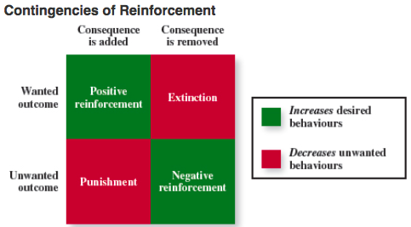
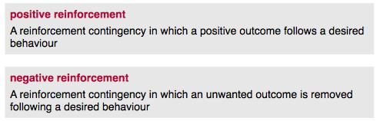
**NOTE**
Punishment -> Positive punishment
Extinction -> Negative punishment
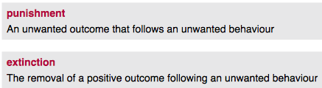

social learning theory Theory that argues that people in organizations learn by observing others

programmed decisions: Decisions that are somewhat automatic because the decision maker’s knowledge allows him or her to recognize the situation and the course of action to be taken

intuition An emotional judgment based on quick, unconscious gut feelings
- Intuitive decision making is perhaps never more important than during a crisis.

A crisis situation is a change—whether sudden or evolving—that results in an urgent problem that must be addressed immediately.

nonprogrammed decision One made by employees when a problem is new, complex, or not recognized

As employees move up the ladder, more and more decisions become nonprogrammed and require the rational decision-making model: A step-by-step approach to making decisions that is designed to maximize utcomes by examining all available alternatives
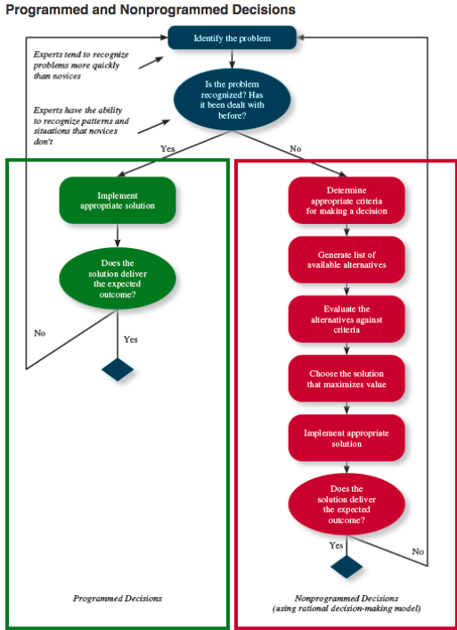

When are people most likely to falter in terms of the rational decision-making model and why?

Decision making problems:
Limited Information

bounded rationality people simplify information to make it understandable to the point that they miss important details when perceiving the problem, and generating alternative solutions.

This leads them to satisfice:

satisficing What a decision maker is doing who chooses the first acceptable alternative considered

Faulty Perceptions

selective perception The tendency for people to see their environment only as it affects them and as it is consistent with their expectations

projection bias The faulty perception by decision makers that others think, feel, and act as they do
- “I would never do that—that’s unethical” equates to “They would never do that—that’s unethical.”

Stereotype Assumptions made about others based on their social group membership

Heuristics Simple and efficient rules of thumb that allow one to make decisions more easily

Faulty Attributions

fundamental attribution error The tendency for people to judge others’ behaviours as being due to internal factors such as ability, motivation, or attitudes

self-serving bias When one attributes one’s own failures to external factors and success to internal factors

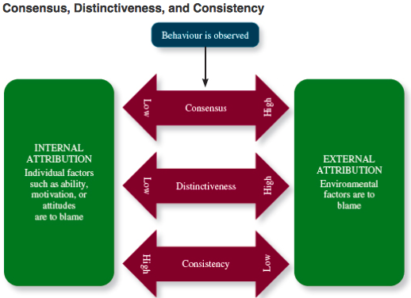
consensus Used by decision makers to attribute cause; whether other individuals behave the same way under similar circumstances

distinctiveness Used by decision makers to attribute cause; whether the person being judged acts in a similar fashion under different circumstances

consistency Used by decision makers to attribute cause; whether this individual has behaved this way before under similar circumstances

Escalation of Commitment

escalation of commitment A common decision-making error, in which the decision maker continues to follow a failing course of action
- “throwing good money after bad”

CHAPTER 12 - POWER

12.1 – What is power?
Power: The ability to influence the behavior of others and resist unwanted influence in return.

Ex. A manager shows their subordinate how to put together the seat on the factory line better, and the subordinate listens.

12.2 – What are the different types of power people have? And when can they those types most effectively?

ORGANIZATIONAL POWER:

Legitimate power: power based on authority or position.

Ex. They have the name tag on the door that implies they have power over you.

Reward Power: when someone has control of resources or rewards another person wants.

Ex. Some managers have control over pay raises.

Coercive power: When a person has control over punishment in an organization.

Ex. When you believe someone has the ability to punish you and is willing to use that power.

PERSONAL POWER:

Expert Power: power based on knowledge or expertise.

Ex. Think of a factory where there is only one person who knows how to work the fork lift. That guy has expert power because he will be able to influence other people who want to use the forklift.

Referent power: when the leader is attractive and charismatic.

Ex. Think of a boss you really liked; do you recall feeling influenced to do things they asked simply because you liked them?

THE CONTINGENCIES OF POWER:

The amount of power one has over another is contingent upon various situations.

Substitutability: the degree to which people have alternative resources.
Leaders that control resources no one else has have greater power.

Discretion: the degree to which managers have the right to make decisions on their own.
If managers are forced to followed organizational policies and rules, their power is limited.

Centrality: power depends on how important your job is and how many people rely on you in order for them to do their own job.
Leaders who perform critical task and communicate with other regularly have more power to influence others.

Visibility: how aware others are of the power a leader has and what resources they can provide.

USING INFLUENCE:

Influence: The use of your own behavior to influence behavioral or attitudinal changes in others.

12.3 - What behaviors do people use when trying to influence others? And which of these behaviors is most effective?

10 MOST USED INFLUENCE TACTICS
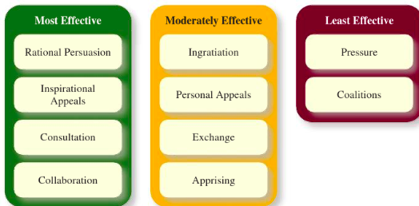

Most effective:

Rational persuasion: using logical evidence and facts to show the target a request is a worthwhile one.

Inspirational appeal: leader must have insight on what values are important to the target. The leader then uses those important values to create an emotional or attitudinal reaction.

Consultation: the target is able to participate deciding in how the leader’s request is carried out.

Collaboration: the leader offers to help the target complete the request.

Moderately effective:

Ingratiation: the requestor compliments or flatters the target in order for the target to like them so they will listen.

Personal appeals: the requestor asks for something based on friendship or loyalty.

Exchange tactic: the requestor offers a reward in exchange for performing a request.
Apprising: the requestor clearly explains why the request will benefit the target personally.

Least effective:

Pressure: the requestor attempts to use coercive power through threat or demands.

Coalitions: the requestor lists other people to help influence the target.

RESPONSES TO INFLUENCE TACTICS (pages 418-424)
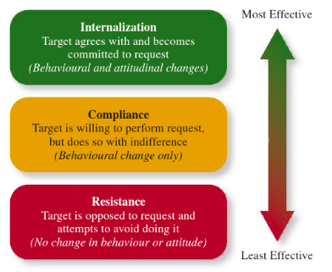
Internalization: the target agrees to perform the request and embraces your vision.
- Legitimate
- Expert Power
- Referent Power

Compliance: the target agrees to do what the requestor asks, but does it with ambivalence [mixed emotions].
- In early stages, coercive power.
- Reward power.
- Legitimate power.

Resistance: The target refuses to perform the request and puts forth an effort to avoid doing it.
- Coercive power.
- Reward

CHAPTER 13 – LEADERSHIP
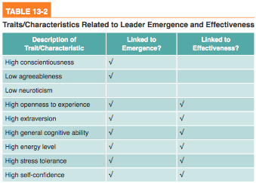
WHAT DOES IT MEAN TO LEAD?

- We are using our power and influence…
  - To direct the activities of our followers.
  - To encourage goal achievement

EARLY LEADERDSHIP THEORIES

Great person theory
- Leaders are born and made.

leader effectiveness The degree to which the leader’s actions result in the achievement of the unit’s goals

leader effectiveness The degree to which the leader’s actions result in the achievement of the unit’s goals

What do leaders actually do?

initiating structure A pattern of behavior in which the leader defines and structures the roles of employees in pursuit of goal attainment
- Directive
- Task oriented

consideration A pattern of behaviour in which the leader creates job relationships characterized by mutual trust, respect for employee ideas, and consideration of employee feelings
- Supportive
- Relations-oriented

life cycle theory of leadership A theory stating that the optimal combination of initiating structure and consideration depends on the readiness of the employees in the work unit.

LEADERERSHIP DECISION-MAKING STYLES (FIG. 13-2)

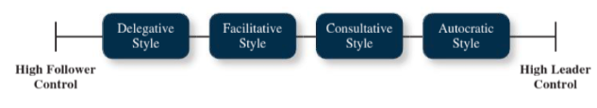
“Can I make these decisions on my own or should I be involving my followers in my decisions?”

Autocratic Dictator model. Leaders makes decisions and don’t give a fuuuuck whatchu thank.

Consultative style You listen to advice and consult your subordinates on their ideas but you have the power and control of final outcome.

Facilitative You include yourself in a meeting with your employees as a fellow employee not a manager. You speaking last, you let your group make the decision.

Delegation employees have meeting, leader lets employees make decision on their own.

High leader control is more appropriate when
- Decisions less significant
- Employee committees less important
- Expertise: leader > employees
- Employees don’t work well as a tam
- Own objectives

High follower control more appropriate when
- Decisions are more significant
- Employees commitment is important – they need to buy in, it critical
- Expertise: leader<employees
- Employees work well as a team
- Shared objectives

TRANSACTIONAL & TRANSFORMATIONAL LEADERSHIP
(The “full range” model of leadership)

transactional leadership A pattern of behaviour in which the leader rewards or disciplines the follower on the basis of performance

Transactional leadership behaviours:

Contingent reward
- Most effective transactional behaviour
- contingent rewardA more active and effective type of transactional leadership, in which the leader attains follower agreement on what needs to be done using rewards in exchange for adequate performance

Management by Exception (active)
- Sometimes necessary
- active management-by-exception A type of transactional leadership in which the leader arranges to monitor mistakes and errors actively, and takes corrective action when required
- Ex. Driving instructor presses break before you run red light. GOOD LEADERHSHIP.

Management by exception (passive)
- passive management-by-exception A type of transactional leadership in which the leader waits around for mistakes and errors, then takes corrective action as necessary
- Ex. Driving instructor lets you run the light and get in an accident because it is a “teachable moment”. BAD LEADERSHIP STYLE.

transformational leadership A pattern of behaviour in which the leader inspires followers to commit to a shared vision that provides meaning to their work while also serving as a role model who helps followers develop their own potential and view problems from new perspectives

Transformational leadership behaviours

- Idealized influence Leader behaves in admirable ways.
- Inspirational motivation do you have a vision you share with your followers Is your message going to be well understood by your followers?
- Intellectual stimulation do you challenge your employees to feel the status quo is not good enough? do you present novel ideas?
- Individualized consideration when your leader speaks, do you feel it is individually directed at you? Is the leader speaking to you?

Leader–member exchange theory, which describes how leader–member relationships develop over time on a dyadic basis, can explain why those differences exist.

role taking The phase in a leader–follower relationship when a leader provides an employee with job expectations and the follower tries to meet those expectations

role making The phase in a leader–follower relationship when a follower voices his or her own expectations for the relationship, resulting in a free-flowing exchange of opportunities and resources for activities and effort

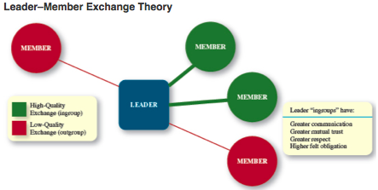

TED TALK – JOHN ANTONAKIS

CHARISMA IS SYMBOLIC MOTIONS

Charisma can be taught

Charisma can increase motivation and production the same amount as bonuses for FREE.

1 Frame to give the vision – use metaphor, stories, and other tequniues ( think of starfish story of girl throwing starfish into the ocean).
2 provide substance for the presentaiton
3 passionate by giving voice, gestures.

Metaphors - sImplifify, aid in recal, and make it stick!

Leader-member exchange (LMX)

Quality of exchange

Role taking versus role making

High quality LMX relationship:
- The leader is grooming you and making sure you are exposed to key individuals and pushing your intellect.
- High trust high respect
- High sense of obligation from one person to another.
- Repeated exchange of “ethical favors” – you look out for me I’ll look out for you.

Chapter 11 – Teams

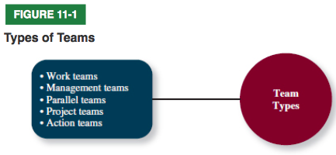
work teams Relatively permanent teams in which members work together to produce goods and/or provide services

management teams Relatively permanent team that participates in managerial-level tasks that affect the entire organization

parallel teams Teams composed of members from various jobs within the organization that meet to provide recommendations about important issues

project teams Teams formed to take on one-time tasks, most of which tend to be complex and require input from members from different functional areas

action teams Teams of limited duration that performs complex tasks in contexts that tend to be highly visible and challenging
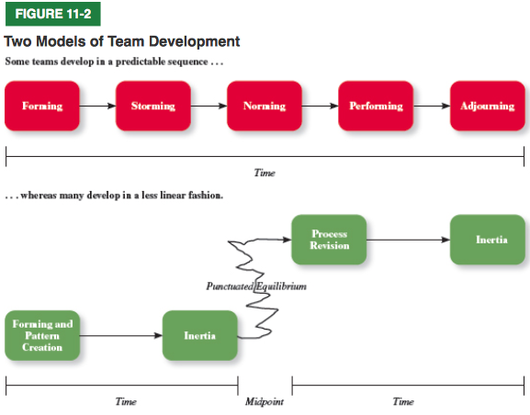

Forming: members try to establish what is expected of them and what their boundaries are.

Storming: initial unwillingness to accommodate other’s ideas creates conflict.

Norming: members realize they need to work together and begin to cooperate with one another.

Performing: members are comfortable working within their roles and the team makes progress toward its goals.

Adjourning: members separate from the team as mission is accomplished.

punctuated equilibrium A sequence of team development during which not much gets done until the halfway point of a project, after which teams make necessary changes to complete the project on time

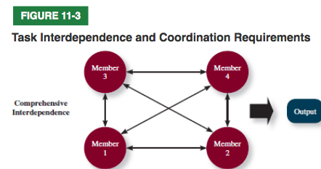

- Highest level of coordination among members.
- Very specific whom each member interacts with & what their role is.
- Members of diverse backgrounds.

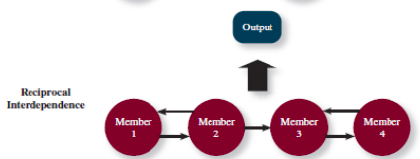

- Members are specialized to perform specific tasks.
- Members interact with a subset of other members to complete work.

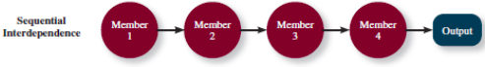
- Different tasks are done in prescribed order.
- Members specialize in tasks.
- Members communicate with members whose task is linked before and after theirs.

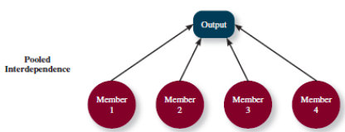
- Lowest degree of coordination.
- Members complete their work independently and pool it together to complete final project.

goal interdependence The degree to which team members have a shared goal and align their individual goals with that vision

outcome interdependence The degree to which team members share equally in the feedback and rewards that result from the team achieving its goals

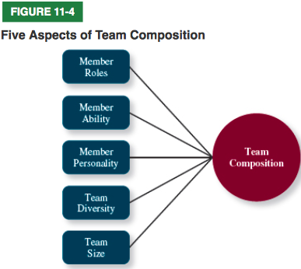
team composition The mix of the various characteristics that describe the individuals who work in the team

similarity-attraction approach A theory explaining that team diversity can be counterproductive because people tend to avoid interacting with others who are unlike them

surface-level diversity Diversity of observable attributes such as race, gender, ethnicity, and age

deep-level diversity Diversity of attributes that are inferred through observation or experience, such as one’s values or personality

Disjunctive task: Tasks in which the performance of an entire group or team depends on the performance of its best member(s).
Conjunctive task: Job or work-situation in which a group's achievement is restricted by the performance of its less resourceful members.
Additive Task. * When all group members perform the same job and group performance is a sum of individual performance.

process gain Achievement of team outcomes greater than those one would expect on the basis of the capabilities of the individual members

process loss Achievement of team outcomes less than those one would expect on the basis of the capabilities of the individual members

taskwork processes The activities of team members that relate directly to the accomplishment of team tasks
- Creative behavior & Decision making & Boundary spanning
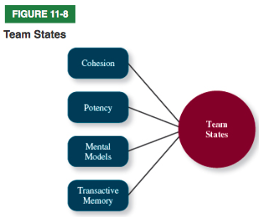
team states Specific types of feelings and thoughts that coalesce in the minds of team members as a consequence of their experience working together

cohesion A team state that occurs when members of the team develop strong emotional bonds to other members of the team and to the team itself

groupthink Behaviours that support conformity and team harmony at the expense of other team priorities

potency A team state reflecting the degree of confidence among team members that the team can be effective across situations and tasks

mental modelsThe degree to which team members have a shared understanding of important aspects of the team and its task
COMMUNICATION & ORGANIZATIONAL STRUCTURE CH. 10 & 14
Communication The process by which information and meaning is transferred from a sender to a receiver

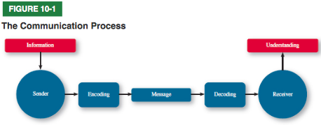

Barrier to communication:
- Communicator competence – how one can encode and interpret a message.
- Noise – distracting stimuli that interfere with the message.
- Information richness - amount and depth of information transmitted in a message.
- Gender differences – how men and women differ in the way they understand messages.
- Privacy

Verbal communication: messages are sent and received using written and non-written spoken language.

Non-verbal communication: a form of communication without written or spoken language.

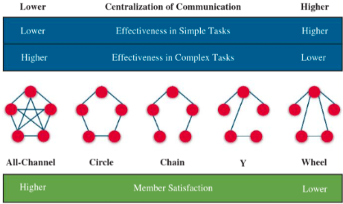
Communication network structure

When work is simple: use centralized communication structure.

When work is complex: use decentralized communication structure.

organizational structure Formally dictates how jobs and tasks are divided and coordinated between individuals and groups within the company

chain of command Specifies who reports to whom; signifies formal authority relationships

span of control Represents how many employees each manager in the organization has responsibility for

centralization Aspect of structure that dictates where decisions are formally made in organizations

formalization The degree to which rules and procedures are used to standardize behaviours and decisions in an organization.

functional structure An organizational form in which employees are grouped by the functions they perform for the organization

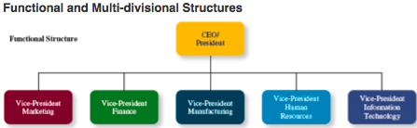

client structure An organizational form in which employees are organized around serving customers

Organizational culture & change – CH 15

organizational culture The shared social knowledge within an organization regarding the rules, norms, and values that shape the attitudes and behaviours of its employees

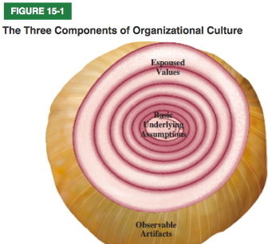
observable artifacts Aspects of an organization’s culture that employees and outsiders can easily see or talk about
- Symbols
- Structures
- Stories
- Ceremonies
- Language
- Rituals

espoused values The beliefs, philosophies, and norms that a company explicitly states

basic underlying assumptions The engrained beliefs and philosophies of employees

FUNCTIONS OF CULTURE: Provides standards for when employees should say or do.

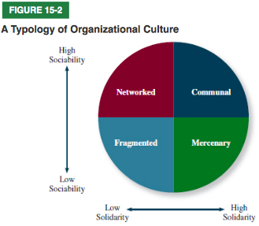
fragmented culture An organizational culture type in which employees are distant and disconnected

mercenary culture An organizational culture type in which employees think alike but are not friendly to one another

networked culture An organizational culture type in which employees are friendly to one another, but everyone thinks differently and does his or her own thing

communal culture An organizational culture type in which employees are friendly to one another and all think

culture strength The degree to which employees agree about how things should happen within the organization and behave accordingly

STRONG CULTURES - ADVANTAGES
- Coordination
- Conflict resolution
- Financial success
STRONG CULTURES – LIABILITIES
- Change – makes adapting to environment more difficult.
- Diversity – limits diversity by attracting the same kind of employees.
- Mergers and acquisitions – makes merging with other organizations more difficult.

ASA framework
Attraction – employees will be attracted to culture that matches their personality.

Selection – Organizations will select employees that match.

Attrition – Employees will leave or be forced out by attrition.

Socialization: when we have people that are onboarding, we teach them the norms, knowledge, attitudes and behaviours of the organizational member.

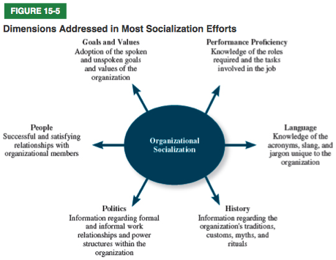

Unfreezing - Unfreezing occurs when the organization comes to some realization that the status quo is unacceptable.
- Ex. Increase in customer complaints.

Changing initiative – Plan and implement change.

Refreezing – the newly developed attitudes and behaviours will “harden up” like a BBC.

MENTORING
Career-related mentoring:
- Creating exposure and visibility
- Coaching and feedback
- Mental developmental assignments

Psychosocial mentoring:
- Acts as a role model.
- Provide support and encouragement in times of doubt.
- Counselling your protégé

REALISTICS OF JOB PREVEIEWS: A realistic job picture provided to applicants of the pros and cons of a job.

Sources of unrealistic expectations:
- Media
- Occupational stereotypes
  - Think of the spike in Law and Forensic science enrollments due to people having the illusion of the show CSI.
- Recruiters

