GNG 1106
Fundamentals of Engineering Computation

Lab 1 – Fall 2017
Report

Jessica Alicandro 300031862

Lab 1: Introduction Programming in C

- Creating a C Program: Hello World

Hello World C Program:

#include <stdio.h>

/*
File GNG Lab 1
Name: Jessica Alicandro
Student #: 300031862
Description: Hello World
Lab1_PartA
*/

void main ()
{
printf ("Hello World!\n");
}

Hello World C Program Output:

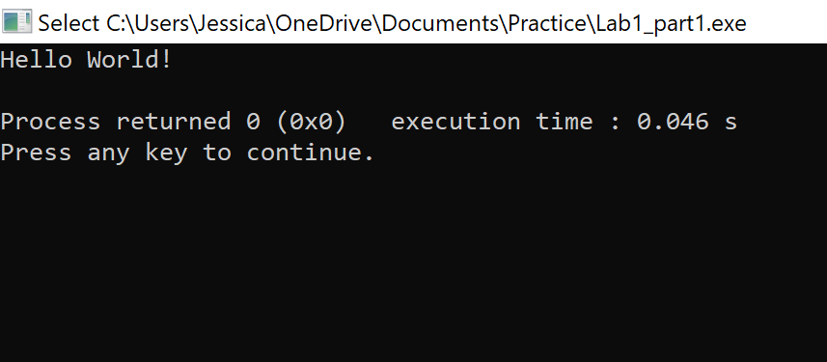
- Exercise: Temperature Conversion

Temperature Conversion Program:

#include <stdio.h>

//Temerature Conversion form Kelvin to Farenheit

float convertKtoF(float degreeK);

void main(void)
{
float degreeK; //variable declarations
float degreeF; //variable declarations

printf ("Please enter a number in degrees Kelvin:\n");
scanf ("%f", &degreeK);

degreeF=convertKtoF (degreeK);
printf ("Kelvin: %f Farenheit: %f", degreeK, degreeF);

}

float convertKtoF (float degreeK)
{
float degreeC;
float degreeF;
degreeC=degreeK-273.2;
degreeF=(degreeC*9/5)+32;
return degreeF;

}

Temperature Conversion Program Output:

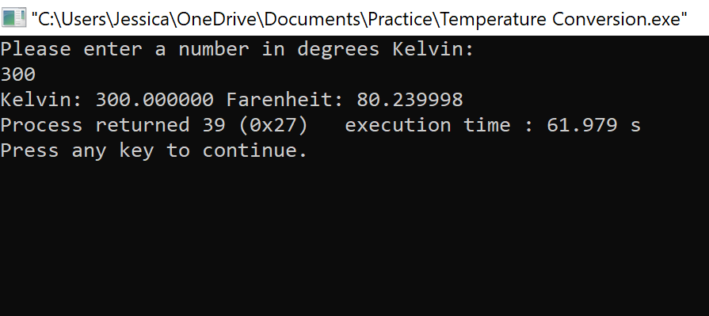

#include <stdio.h>

float convertKtoF(float degreeK);

void main(void)
{
float degreeK;
float degreeF;

printf ("Please enter a number in degrees Kelvin:\n");
scanf ("%f", &degreeK);

degreeF=convertKtoF (degreeK);
printf ("Kelvin: %f Fahrenheit: %f", degreeK, degreeF);

}

float convertKtoF (float degreeK)
{
float degreeC;
float degreeF;
degreeC=degreeK-273.2;
degreeF=(degreeC*9/5)+32;
return degreeF;

}

Kelvin 300
Fahrenheit 80.24
Celsius 26.8
Working Memory
Code Memory

Kelvin 300
Fahrenheit 80.24
CPU

