Lab 1:

SEPARATION AND PURIFICATION OF CAFFEINE

By:
Camila Almonacid
8753583

CHM 2123
Section C

Demonstrator:
Yousef Risha

September 20, 2018

Department of Science

University of Ottawa
Introduction:

The purpose of this experiment was to isolate and purify caffeine through extraction, using a cold finger as a sublimation technique, recrystallization, and thin layer chromatography.

Tannins, catechin, theaflavin, and theanine are all polyphenols found in tea leaves. Caffeine is a stimulant alkaloid drug for the central nervous system, and it is also found in tea leaves. Through this experiment the goal is to isolate the caffeine found in steeped tea. Black tea has a caffeine content of approximately 30-75 mg/250 mL. When tea is boiled not only caffeine, but other tannins also become dissolved and thus to obtain pure caffeine, the solution of steeped tea must be extracted. Three rounds of extraction were completed to isolate the caffeine product (organic layer) from steeped tea. The extraction was done using an organic solvent (dichloromethane) and a base (sodium carbonate). This allows the organic components caffeine and dichloromethane to create an organic layer and the catechin (found in the steeped tea) and the sodium carbonate to create an aqueous layer. The two layers then separate from one another which allows for the extraction of the organic layer containing the caffeine. Once the extraction was complete the gravity filtration and a recrystallization technique were carried out in order to purify the extracted caffeine.
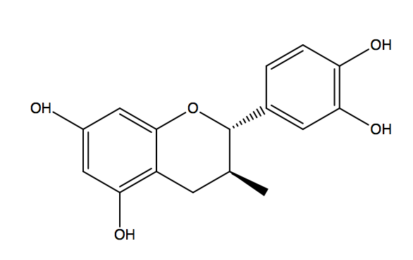
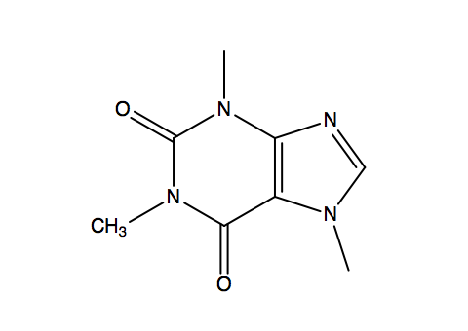

Catechin
Caffeine

Figure 1: The structure of caffeine and catechin

Mechanism:
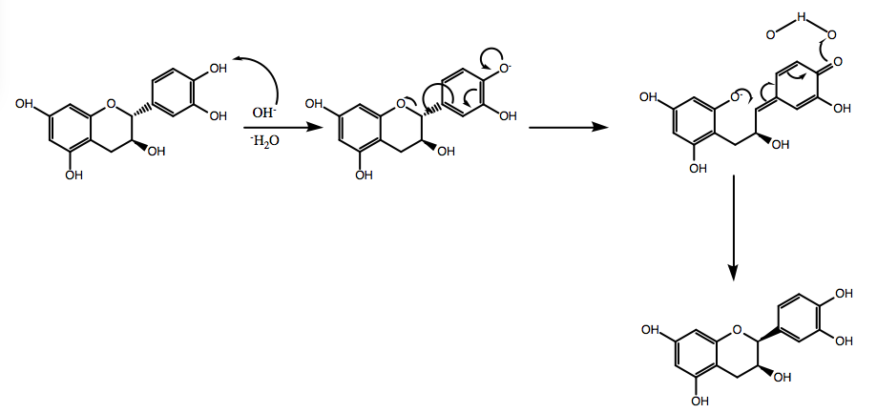

Figure 2: Catechin and NaCO₃ Reaction
Table of Reagents:

Table 1: Reagents
Compound | Mol. Mass  (g/mol) | Quantity | Density  (g/mL) | Mmol
Water | 18.02 | 60.0 mL | 0.993 | 3.31
Dichloromethane | 84.93 | 45.0 mL | 1.33 | 0.70
Caffeine | 194.19 |  | -
Sodium Sulfate | 142.04 | 3.86 g | - | 0.03
Sodium Carbonate | 105.99 | 2.0 g | - | 0.02

Experimental Procedures:

For the experimental procedure followed please refer to the CHM 2123 Lab Manual - Experiment 1 section. No modifications were made.

Results:

Table 2: Results of the Experiment
Compound | Mol. Mass  (g/mol) | Quantity  (g) | Yield (%) | Melting Point  (°C)
Tea Bags | - | 4.79 | - | -
Crude Caffeine Product | 194.19 | 0.01 | - | -
Sublimed Caffeine | 194.10 | 0.06 | 1.32 | 232-235

Observations:

Table 3: Observations of the Key Steps of the Experiment
Key Step | Observation
5) Addition of NaCO₃ | Solution became dark and the NaCO₃ dissolved
6) Addition of CH₂Cl₂ | Clear separation of organic and aqueous layers
11) Addition of NaSO₄ | 3.86g of NaSO₄ were added and created clumps at the bottom of the beaker containing the solution, after a while the clumps turned into white fluffs and the solution overall turned light-brown.

Calculations:

- Percent Yield_{Caffeine}:
$$Percent Yield \left(\%\right)= \frac{{Quantity Obtained}_{Caffeine}}{{Theoretical Quantity}_{Tea Leaves}}×100$$

$$Percent Yield \left(\%\right)= \frac{0.06g}{\left(4.79g\right)-(2×0.120g)}×100$$

$$Percent Yield \left(\%\right)= 1.32$$

TLC Plates:
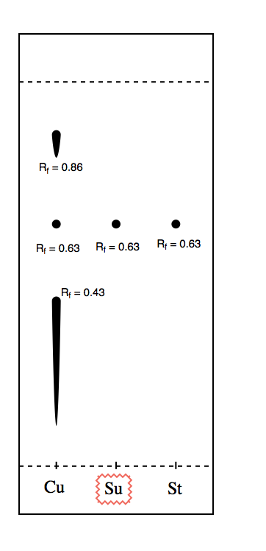
TLC #1

Solvent System: 99:1 acetone: acetic acid
Sample: Crude Product (Cu)
Spot | 1 | 2 | 3
D(cm) | 3.8 | 2.8 | 1.9
Rf: | 0.86 | 0.63 | 0.43

Sample: Recrystallized Caffeine (Su)
Spot | 1
D(cm) | 2.8
Rf: | 0.64

Sample: Caffeine Sample (St)
Spot | 1
D(cm) | 2.8
Rf: | 0.64

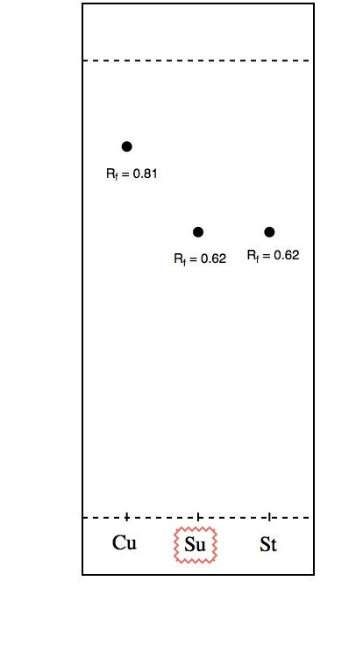
TLC #2

Solvent System: 80:20 acetone: acetic acid
Sample: Crude Product (Cu)
Spot | 1
D(cm) | 3.9
Rf: | 0.87

Sample: Recrystallized Caffeine (Su)
Spot | 1
D(cm) | 3.0
Rf: | 0.67

Sample: Caffeine Sample (St)
Spot | 1
D(cm) | 3.0
Rf: | 0.67

Flow Diagram:
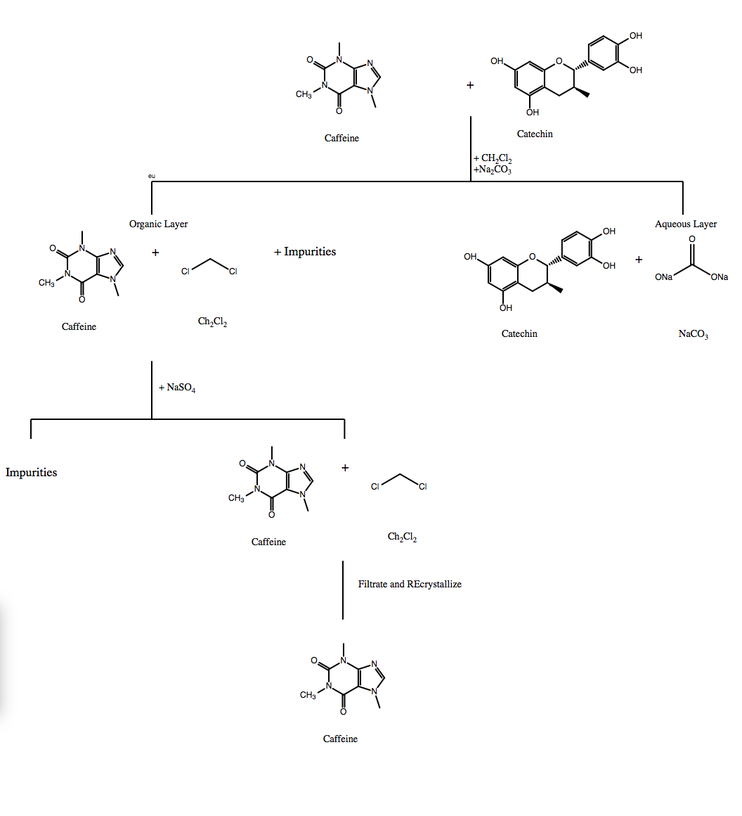

Discussion:

As stated in the introduction, the objective of this experiment was to extract the caffeine component from tea leaves, the extraction is described in the introduction as well. The TLCs were used as well as an apparatus in order to determine the melting point of the product. The addition of the NaCO₃ and dichloromethane to the steeped tea allowed for the separation of the organic and aqueous phases, which then allowed for the extraction of the organic phase containing the caffeine. The addition of NaSO₄ removed any amounts of water that may have transferred over with the organic phase that was extracted and it was also filtered to remove any other impurities.

The first TLC plate (99:1 acetone: acetic acid solvent) showed five spot, out of which three had the same Rf value. Which means that for the most part the extraction of the caffeine was successful, however the other two smears on the lane were the crude sample was spotted could determine some sort of error in that sample. A possible source of error could be that the sample had remaining impurities when the TLCs were performed. On the second TLC, two of the spots had the same Rf except the one on the lane of the crude product. This could once again be due to an error due to possible impurities in the crude product that was obtained.

The melting point of the sublimed product was measured using a melting point apparatus. In this case if the closer melting point range of the sample was to the theoretical melting point range, then that would mean the purer the sample. In our results we obtained a melting point range of 232-235°C which is exactly the theoretical range.

In conclusion, the extraction and purification of caffeine in our experiment gave a low yield but was successful. The low yield could be due to loss in transference from one step to the next.

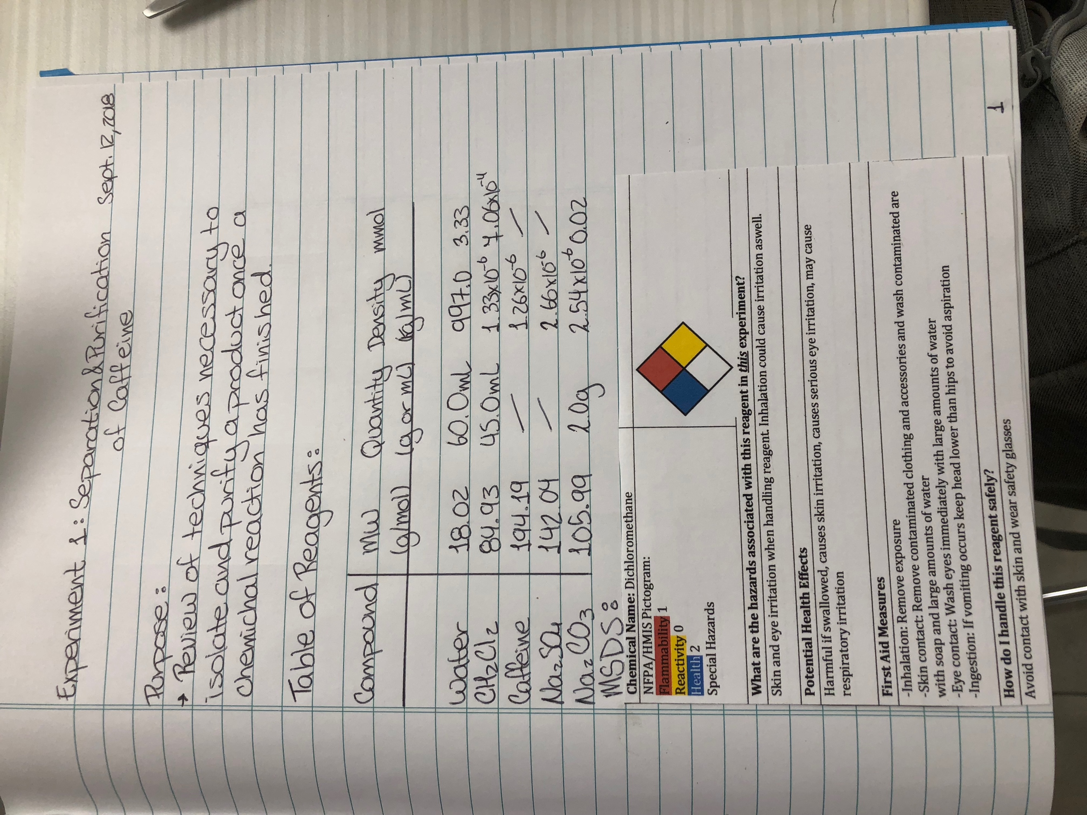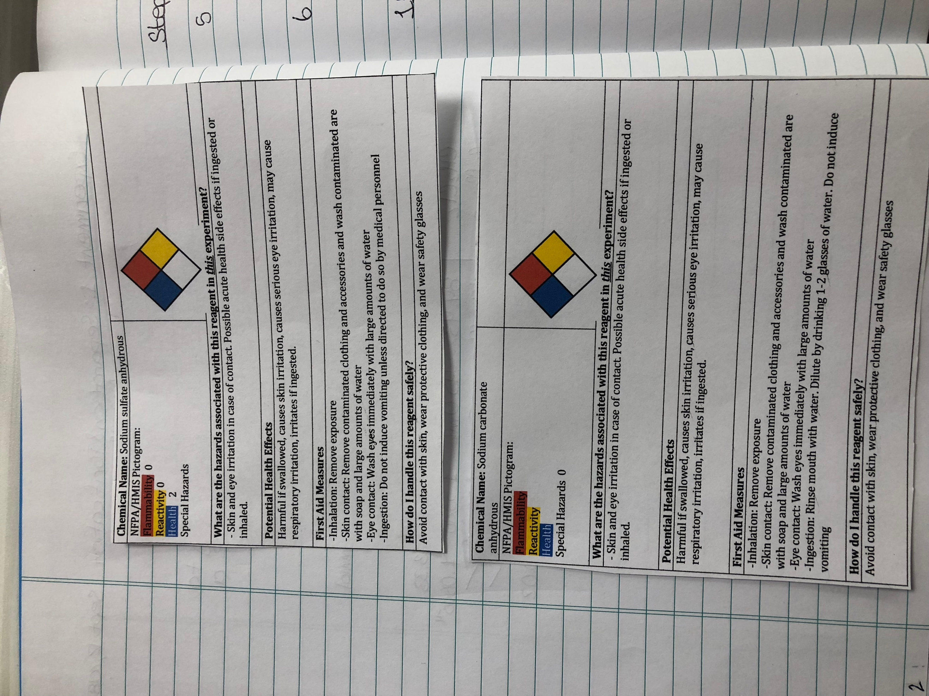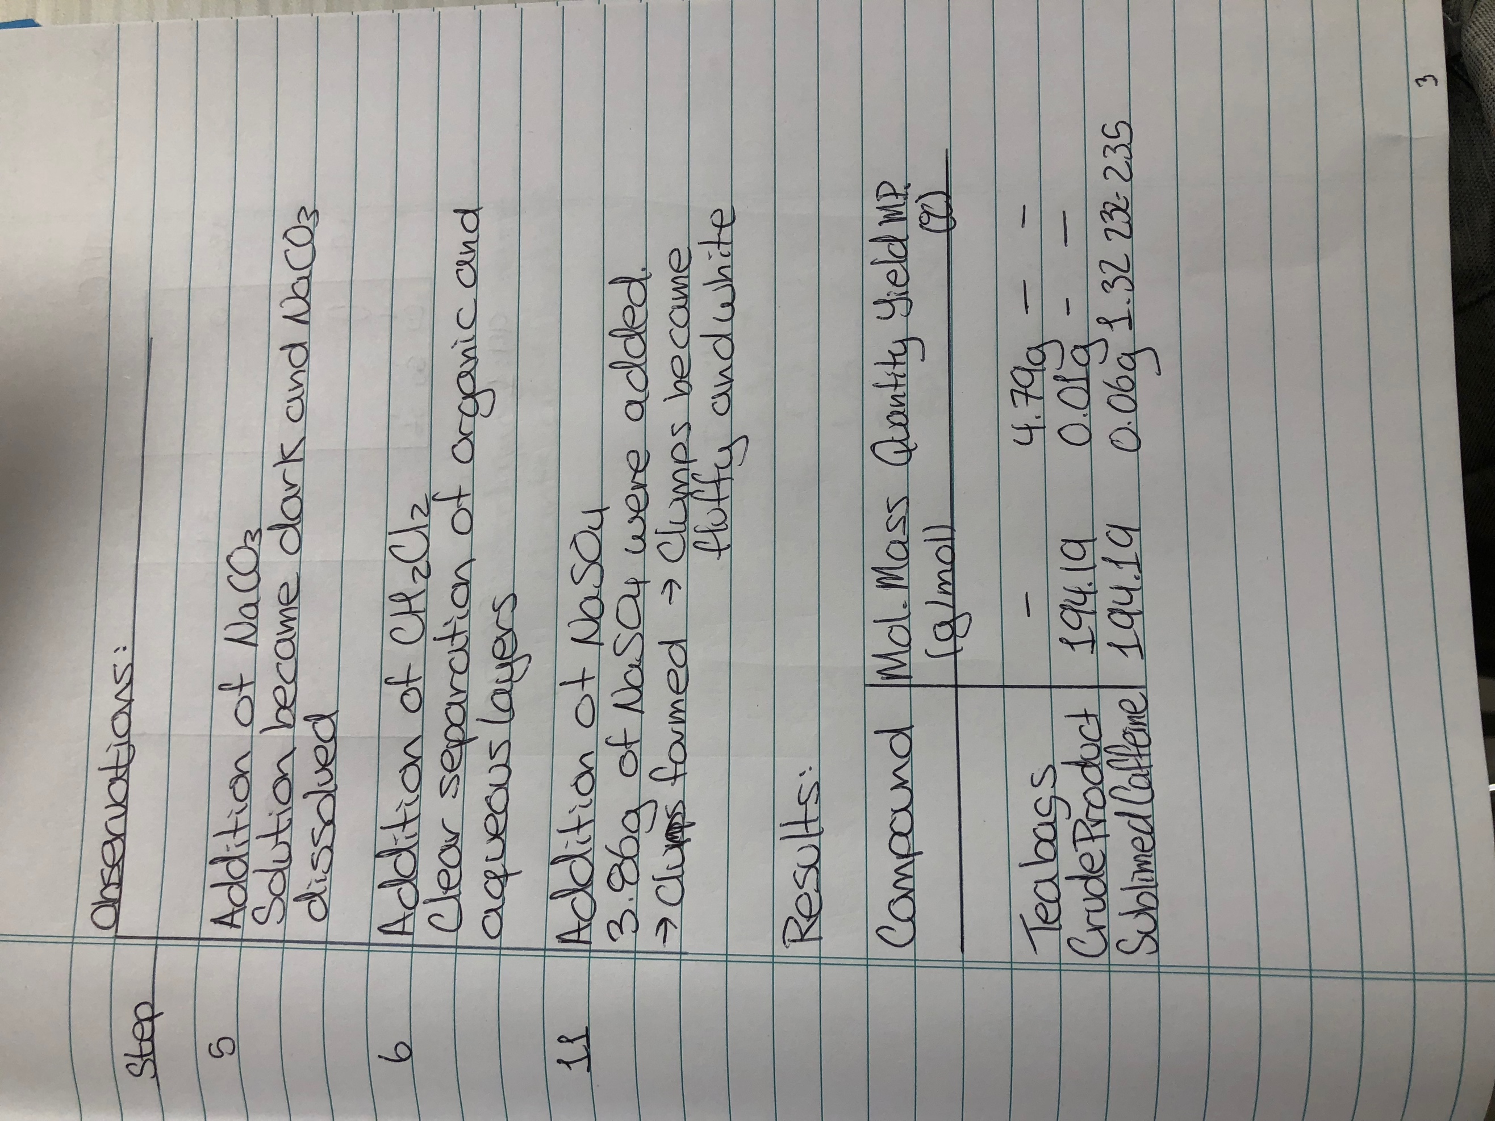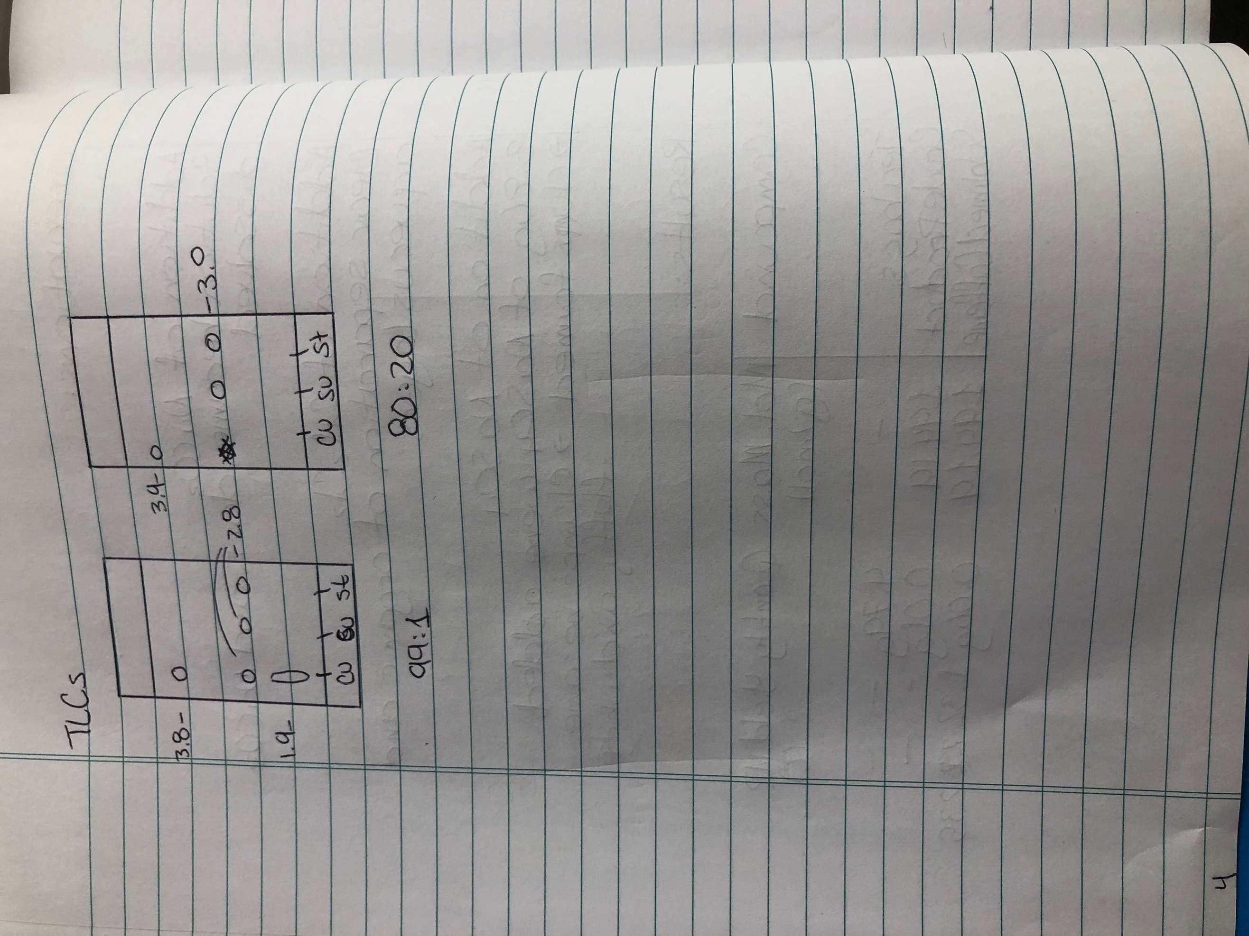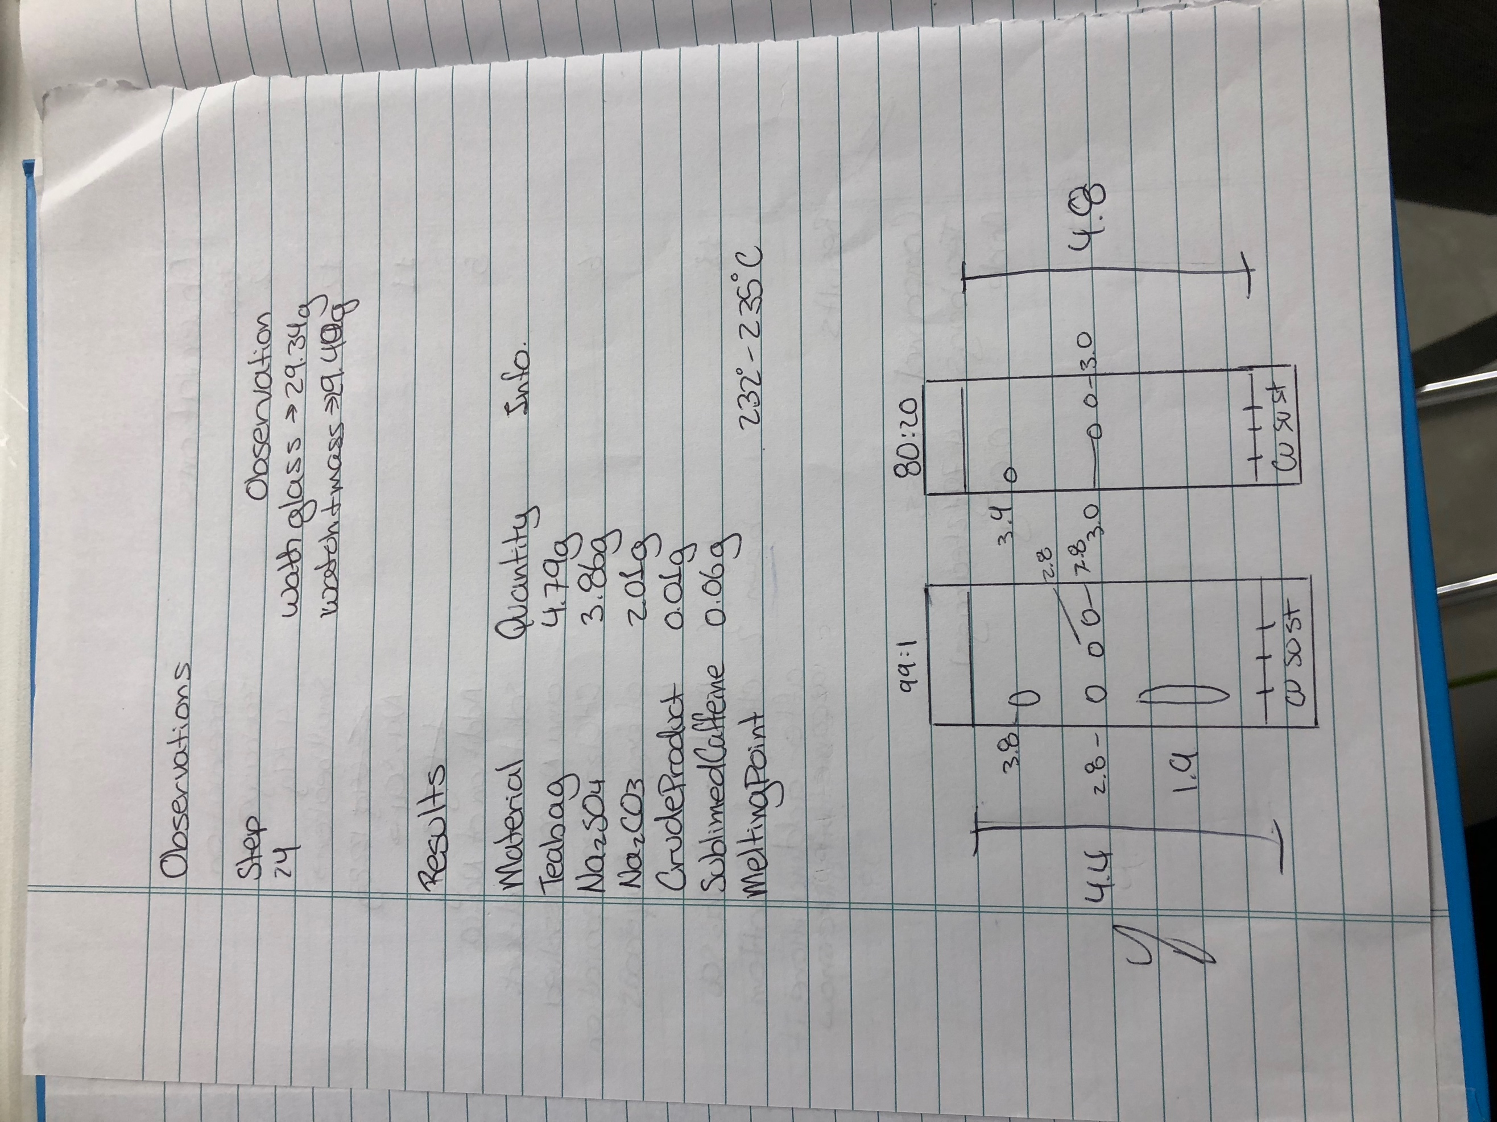
Original Data sheet with signature

