Verification of Ideal Gas Laws
Written by:

Dimitrina Bayarova (300062025)
and
Kessia Umwari Mugabo (300040896)

TA: Scott Southern

September 21, 2018
For CHM1311B - Group Z
University of Ottawa

Introduction
An ideal gas is defined as having average kinetic energy and negligible molecular size. This means that they do not attract each other, but collide because they are in constant motion. A gas behaves like an ideal gas under low pressure and high temperatures. As pressure increases and temperature decreases, gases behave less like ideal gases. In reality, variation in a system’s temperature and pressure cause imperfect results. When conducting this experiment, the data had numerical variability from the expected results. The expected results is that the verification will yield results that follow Charles's and Boyle’s law such that all variables will change in proportion to each other. The data was analysed by finding percentage error and average value. Equations used were: $V_{2}=V_{1}-V_{cw}$, P V = k, and mean of the data $μ=(\sum{}x_{i})÷N$where$μ$is the mean,$\sum{}x_{i}$is the sum of all data values in a set and $N$is the amount of data points.
Charles’ Law indicates how gases can be affected by temperature. “Gases contract when they are cold and expand when they are heated.²” Therefore, gases increase in volume with an increase of temperature.
When the volume of a gas trapped in a container is changed, the pressure acting on the container will also change if temperature is held constant. Therefore, making a change in pressure influences the change in volume, and vice versa.

Method

Procedure:
Experiment 1, (verification of Charles law): As described in the lab manual.²
Experiment 2, (verification of Boyle’s law):
- Ensure that your syringe is clean and free from any dust or debris
- Turn labQuest on.
- Connect the Gas pressure sensor to the labQuest 2.
- Pull the handle of the syringe so that the reading is 20ml.
- Screw the syringe onto the pressure gauge, be sure not to tighten too much.
- Record Initial pressure and volume.
- Push syringe incrementally 6-8 times, making sure to record pressure values at each increment.
- Record data in lab manual and download data on USB.
- Re-do the steps 1-8 in the procedure one more time.
- Unscrew syringe, turn off labQuest, and clean up workstation.

Assessments and Measures
When working in a lab, recording results legibly is crucial. During the experiment, there were obstacles reading the hand-recorded data. Data was not recorded simultaneously, the tasks were delegated between two people. One was recording pressure for the verification of Boyle’s law and the other was recording temperature for the verification of Charle’s law. As such, there is a copying error in my data for experiment 1, trial 2, volume 1.

Data
During any experiment there are potential obstacles to obtaining accurate data. Such was the case during experiment 2. The pressure sensor gauge fluctuates continuously. Once it was time to save a reading, the data was not displayed long enough to record it accurately. As such the data recorded by hand and the data recorded by the pressure sensor are slightly different.

Experiment 1
Trial | 1 | 2
Temperature of boiling water (℃) | $T_{1 boiling water}=98.0$ | $T_{1 boiling water}=98.5$
Temperature of ice bath after reaching thermal equilibrium with hot flask (℃) | $T_{2 equilibrium}=10.0$ | $T_{2 equilibrium}=6.00$
Volume_{cw} (ml) | $V_{cw}=29.9$ | $V_{cw}=$33.9
Volume₁ (ml) | $V_{1}=151$ | $V_{1}=159$

Experiment 2
Volume (ml) | Trial 1: Pressure (kpa) | Trial 2: Pressure (kpa)
20.8 | 102.45 | 101.84
18.8 | 113.60 | 113.69
16.8 | 126.41 | 127.18
14.8 | 144.94 | 144.88
12.8 | 167.48 | 169.47
10.8 | 197.28 | 196.85
8.8 | 226.58 | 226.57
6.8 | 226.58 | 226.57
20.8 | - | 103.11

Observations
Experiment 1
When working with ice water in trial one, the ice quickly melted, reaching thermal equilibrium with the flask.
When we put the flask into the water, it created a vacuum that started absorbing the water into the flask.
In trial two more ice was used. It took longer for the flask to reach thermal equilibrium with the ice bath. When the hot flask was put into the bath, the water temperature did not go up. Instead it decreased from 10℃ to 6℃ as the ice was cooling the water.
Experiment 2
As the plunger of the syringe moved to decrease volume, the pressure increased as shown on the sensor. It was difficult to record data through LabQuest 2 due to sudden movements. The syringe was hard to push as the volume decreased because the pressure increased.

Data Analysis And Calculations
Experiment 1:
Trial 1 Final Volume:  $V_{1}=151ml$, $V_{cw}=29.9ml$  $V_{2}=V_{1}-V_{cw}$  $V_{2}=151-29.9=121ml$ | Trial 2 Final Volume:  $V_{1}=159ml$, $V_{cw}=33.9ml$  $V_{2}=V_{1}-V_{cw}$  $V_{2}=159-33.9=125ml$
Average Value Trial 1:  $V_{1}=151ml$, $V_{1}=33.9ml$  $μ=(151+159)÷2=155ml$ | Average Value Trial 2:  $V_{2}=121ml$, $V_{2}=4.00ml$  $μ=(121+125)÷2=123.0ml$

Experiment 2 : Verification of Boyle's law

1.The Boyle’s law constant in experiment one is
Pressure * volume = constant
Using the logger pro, we calculated the Boyle’s law constant in Trial 1 to be K= 2153
Using logger Pro, we calculated the Boyle’s law constant in Trial 2 to be K=2116
We determined the constant for both trials by taking the slope of each point in both graph 1 and graph 2.
Average K= ( 2153-2116)/2 = 2134.5

2. The mathematical relationship illustrated by Boyle’s law is that as the volume of a gas increases, the pressure will decrease. This holds true for the opposite. When the volume of a gas decreases, the pressure will increase. For example, in Trial 2 the pressure exerted by 20.8ml of air was 101.84 kPa.
k=PV
P=2116/V or V= 2116/P
The calculated results for V and P differ from the original values because of obstacles in data collection.

3. Taking multiple readings of a single variable is very important because it improves accuracy. For instance, the pressure at 20.8ml was recorded twice to get a more accurate reading of standard atmospheric pressure. Unfortunately we did not take our first and last measurement at the same mark in trial 1. If we make multiple trials at the same mark at the beginning and the end, we will have more accurate results because there will be more data. This also verifies whether the conditions within a system remain constant. The initial and final pressures were almost identical, as shown in Trial 2. This proves that there was a source of error or inconsistency influencing the readings on the pressure sensor.

4. There are certain conditions that Boyle’s Law needs to be satisfied to be applicable to any other ideal gas. Temperature and number of moles must be constant. There is also R, which is the universal gas constant, R is always constant no matter the conditions.
From the ideal gas law: $PV=nRT$
The number of moles and the temperature stay constant in order to execute Boyle’s law. Which is becomes $PV=K$ where K is the constant. If the temperature or the moles of the gas were changed, this would result to a change of the value of K. These variables must be taken into consideration. The moles and temperature were constant during the experiment because the syringe was not removed from the gas pressure sensor. This means that no gas escaped, therefore the number of moles was constant. However, the warmth of our hands exerted some heat when holding the syringe which would have resulted in a slight change in the pressure. Increasing the temperature of a gas causes a higher frequency in the number of collisions between molecules of gas, therefore heat increases the pressure the gas exerts on its container.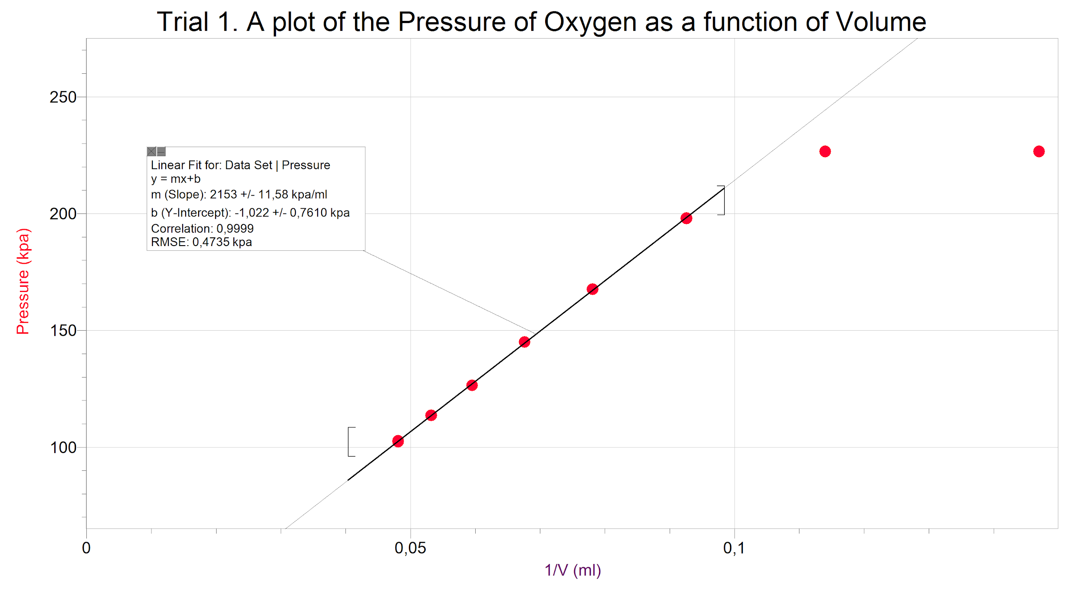
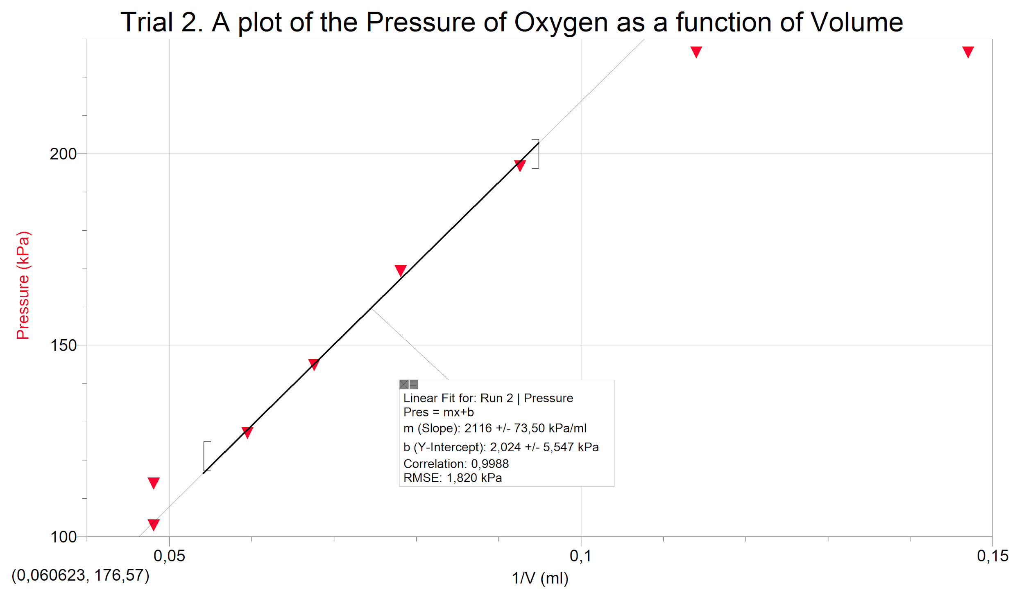

Discussions
Experiment 1
According to Charles’s law, Gases contract when they cool down and expand when heated. As described in the introduction we were able to see how the temperature affected the gases volume. In the observations we stated how the flask was able to absorb water inside the flask. This happened because the gases were contracting due to the temperature decrease, creating space and a vacuum for water to enter.
The results in Trail 1 and Trail 2 we close together as we expected. The difference was that the initial temperature in trail 2 affected the volume as well as the colder temperature in trail 2 contracted the gases more, making the volume of absorbed water (V_{cw}) to be greater.
Experiment 2
As predicted in the introduction, the pressure and volume exerted on a gas are inversely proportional. When creating the graph, it was evident that as the volume was decreasing in the syringe, the pressure was increasing as well. Therefore making the graph to displays it in a form of a straight line. As shown in the graphs, the straight line does not pass through all points, this because the graph should be a curve due to the imperfections the gases and slight unknown inconsistency in temperature.
The value of K that was calculated was similar in the different trials, but there was a slight difference between the calculations. This affected the results in the calculation we had, when using K to write an equation of Boyle’s law. The results came out either having greater values or lower value than the original values of pressure and volume.
Conclusion
In Experiment 1, (verification of Charles law) the results were as expected. The change in temperature affected the volume. When the gas was being heated, its volume increased to to an average of 155 ml (average of both trials). When the gases temperature dropped, its volume also decreased to an average of 123ml.
In Experiment 2, (verification of Boyle’s law) we observed that the relationship between pressure and volume behaved according to Boyle’s law. That is, as the volume was decreased incrementally by 2ml, (as demonstrated in “Results Experiment 2”), the pressure increased. We kept the syringe in the sensor the whole time, therefore there was no outside air affecting the data recorded. We calculated an average constant of K to be 2134.5.

References
(2018). Verification of gas laws. Chemistry Lab manual, Experiment 1. Pages 2, 3, 10.
Helmenstine, Anne Marie, Ph.D. "Ideal Gas Definition." ThoughtCo, Jun. 22, 2018, thoughtco.com/definition-of-ideal-gas-604532.
“Common Statistical Formulas.” Statistics Solutions, www.statisticssolutions.com/common-statistical-formulas/.
Tzyh-lee Chang, Pi-ling Chang and Herbert C. Cheung, Journal of National Taipei Teachers College, Vol. ⅩⅣ (Sep. 2001). Page
chem.libretexts.org/Textbook_Maps/Physical_and_Theoretical_Chemistry_Textbook, Jan 9, 2017
Laugier, Alexander; Garai, Jozef. "Derivation of
the Ideal Gas Law." Journal of Chemical Education. 2007, Vol. 84, Iss. 11, pgs. 1832 -1833.
Luder, W. F. "Ideal Gas Definition." Journal of Chemistry Education. 1968, 45(5), p351 DOI:10.1021/ed045p351.1
Petrucci, Ralph H., William S. Harwood, F. G. Herring, and Jeffry D. Madura. General Chemistry: Principles and Modern Applications. 9th ed. Upper Saddle River: Pearson Education, Inc., 2007.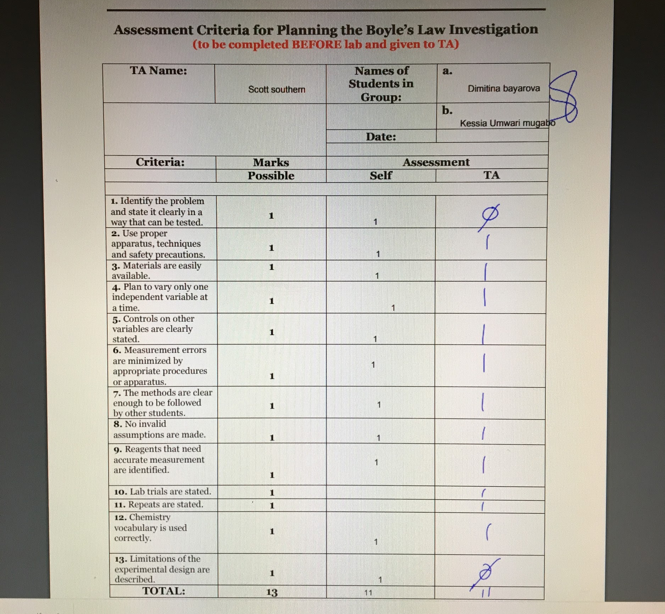
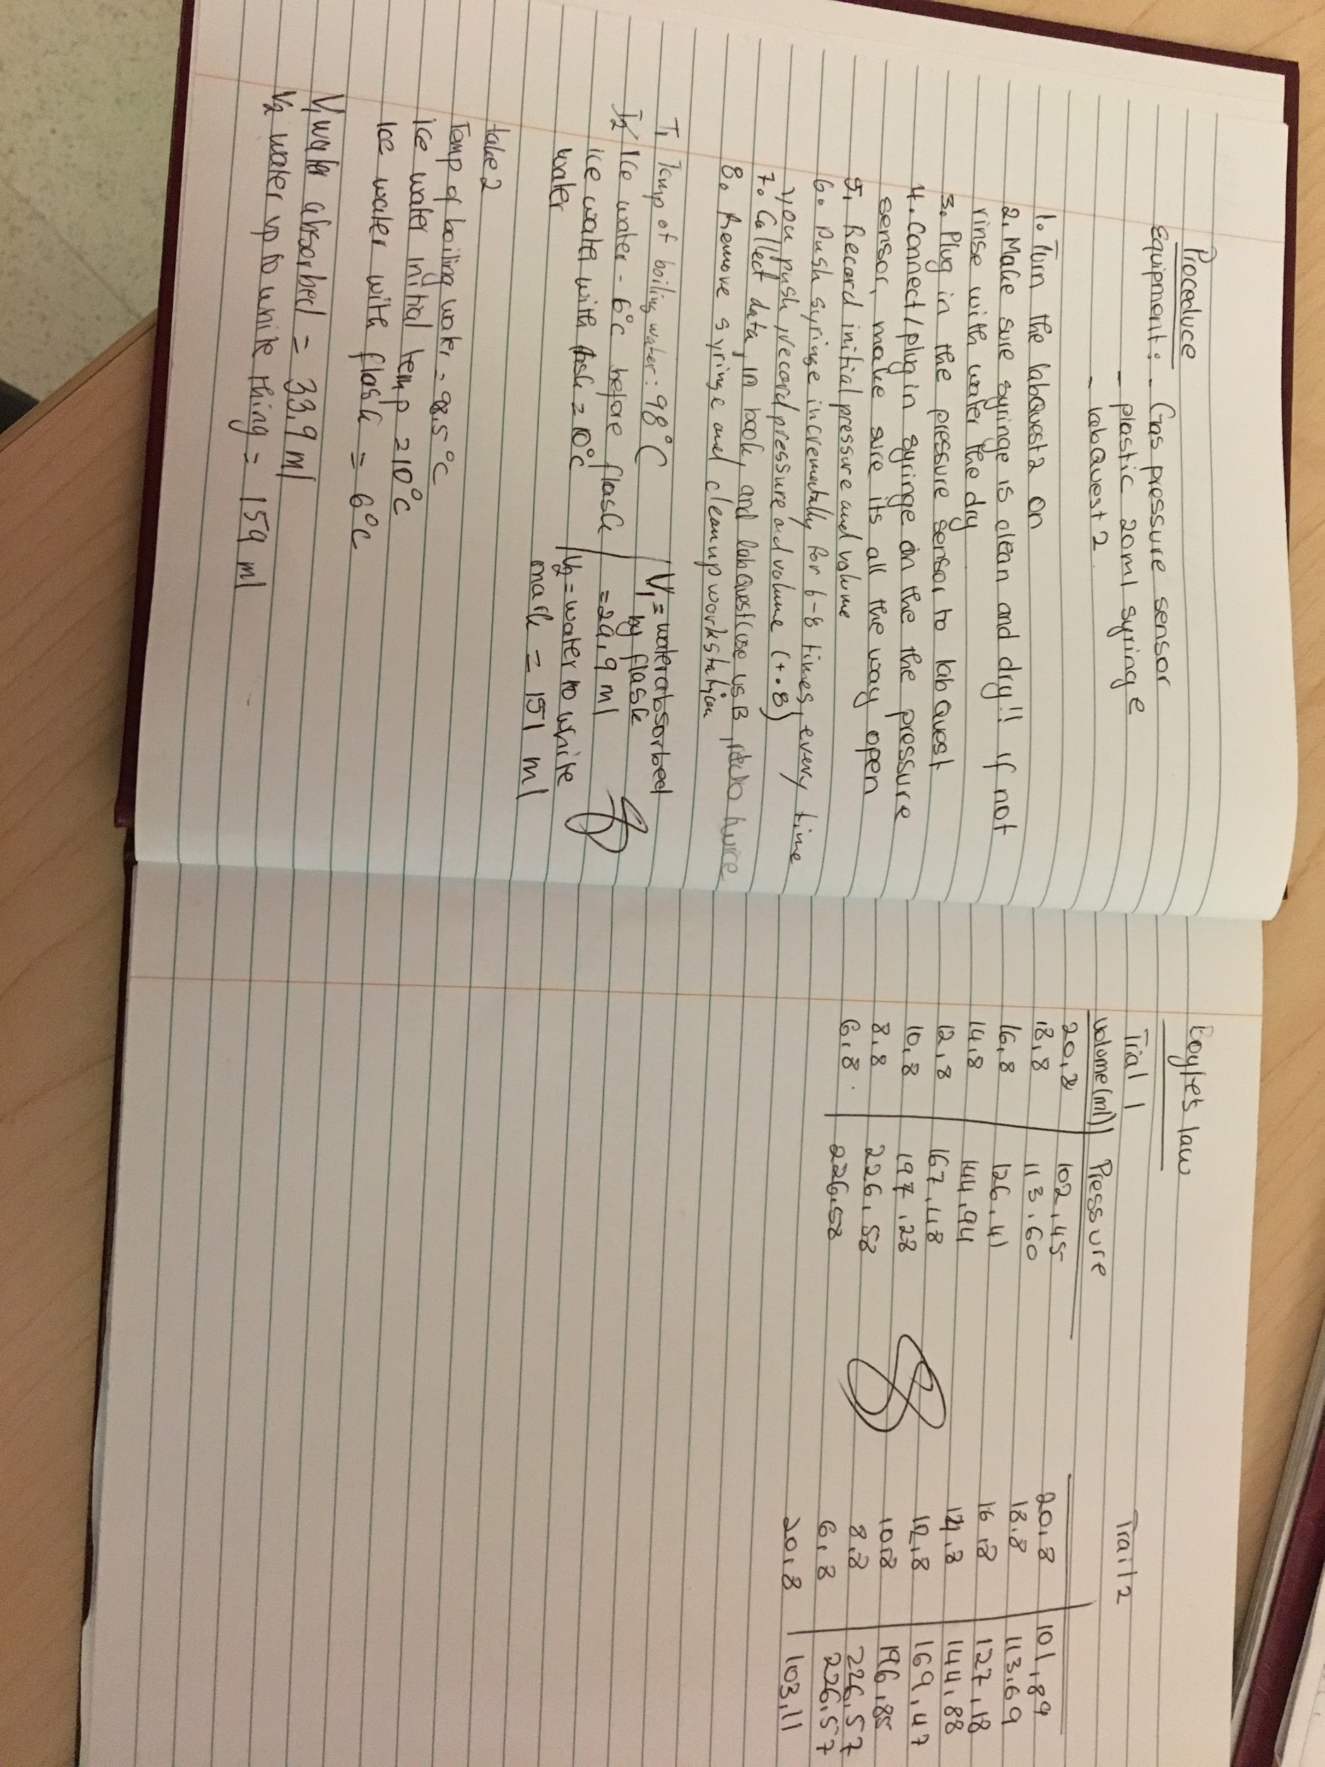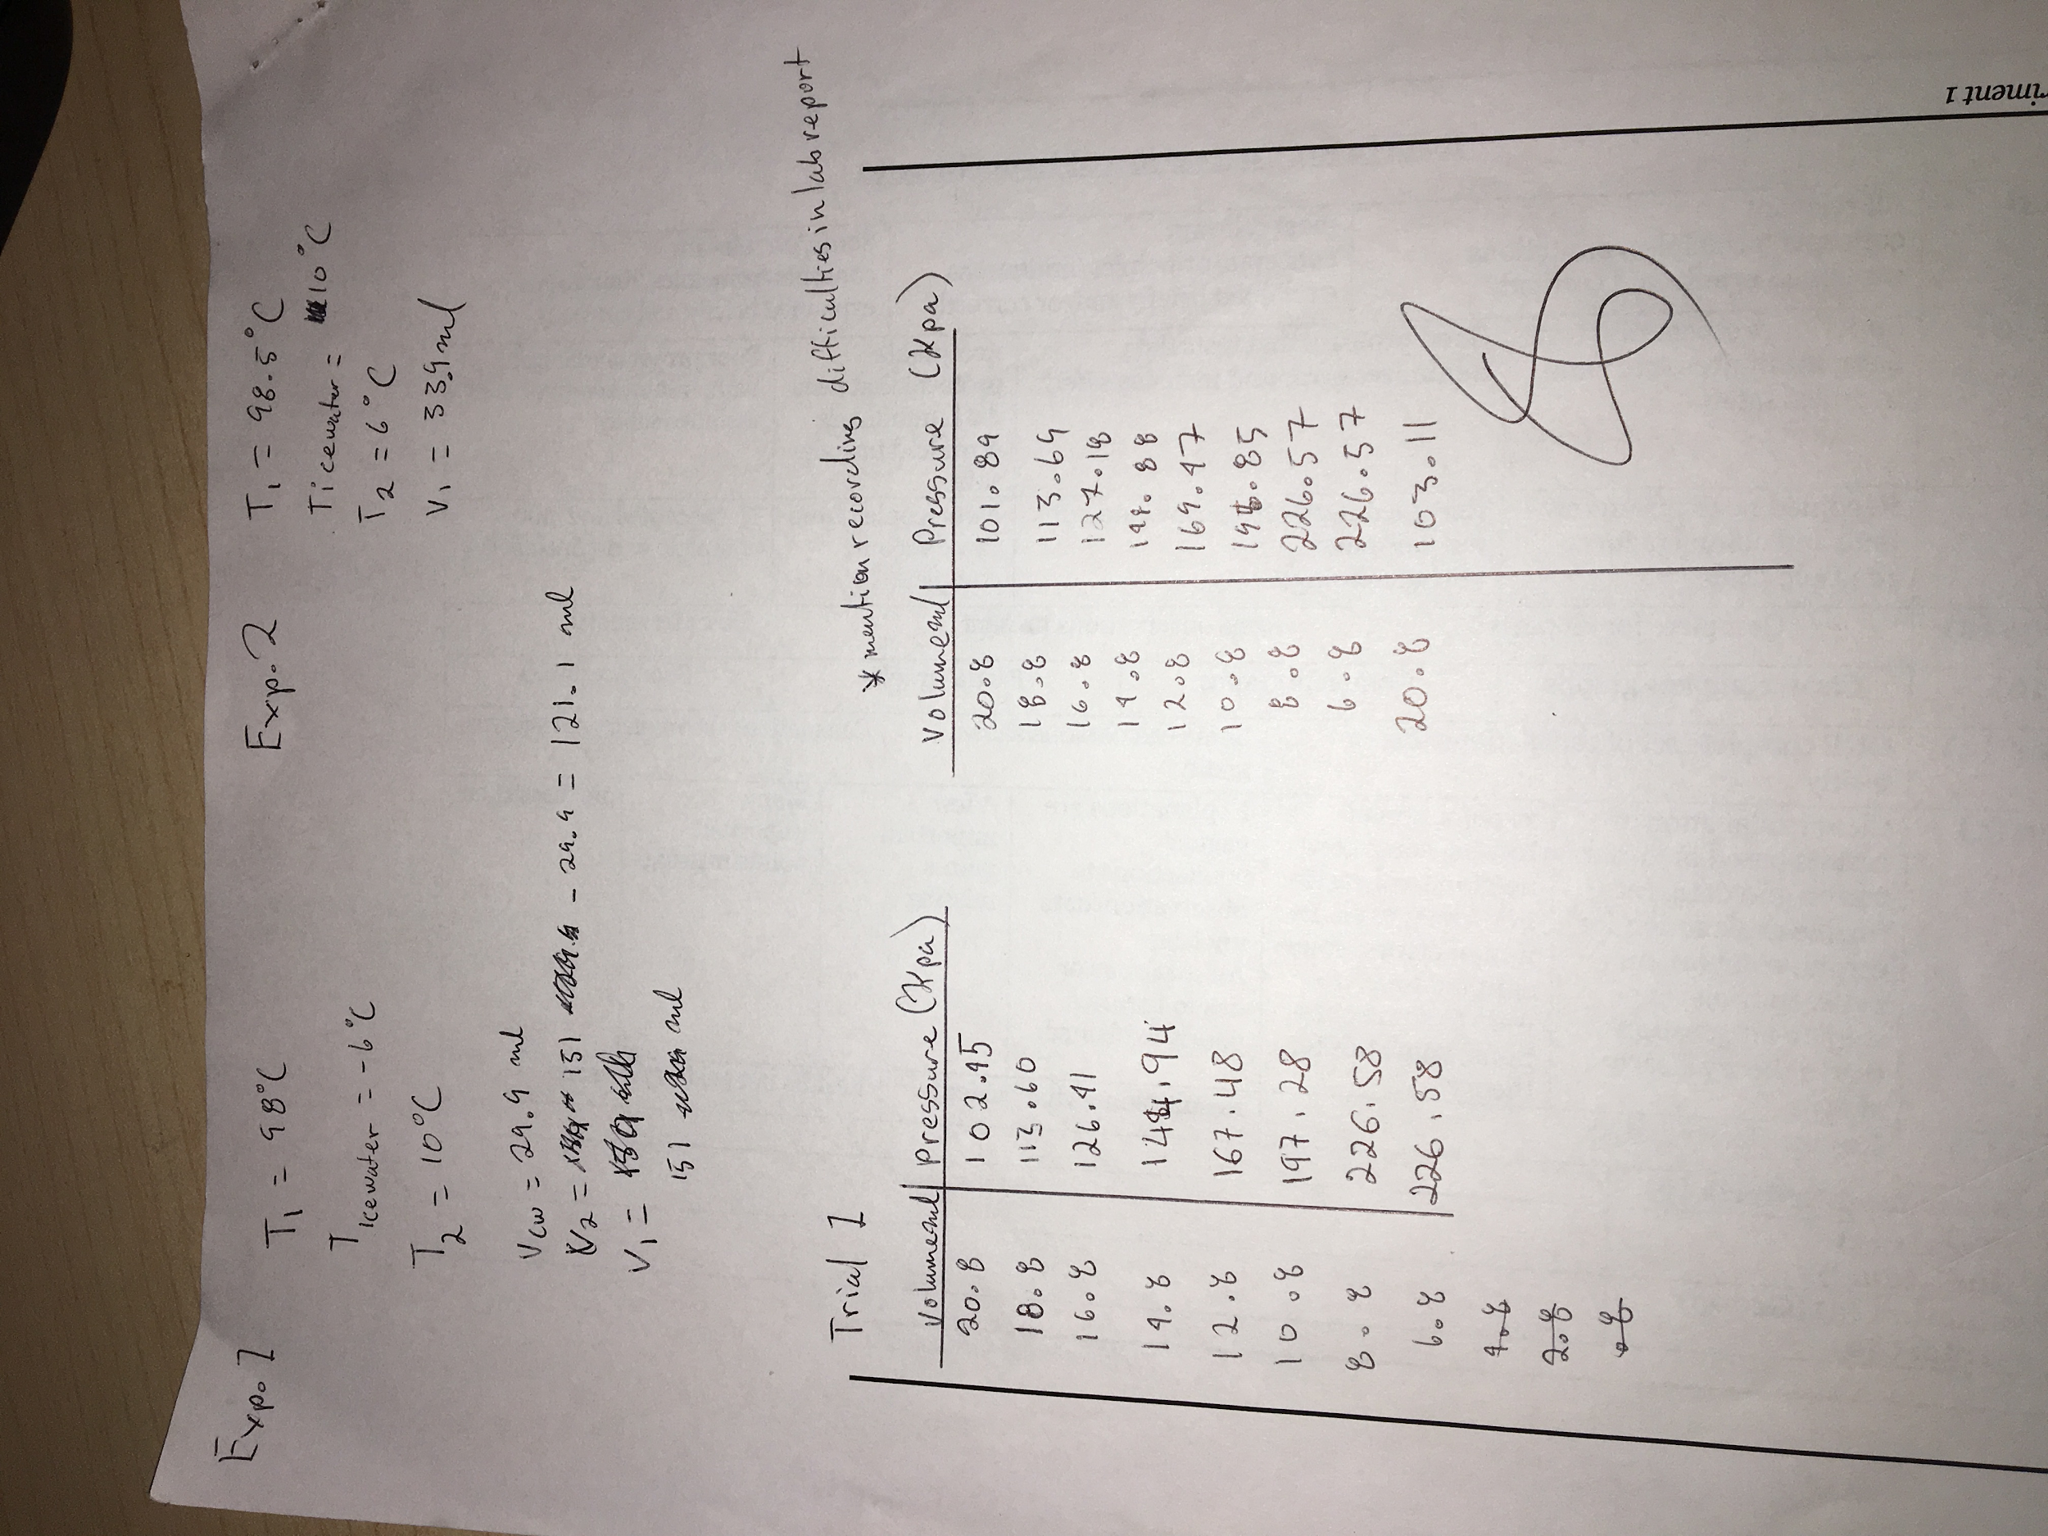

Helmenstine, Anne Marie, Ph.D. "Ideal Gas Definition."
Verification of gas laws. Chemistry Lab manual, Experiment 1
“Common Statistical Formulas.” Statistics Solutions

