Concordia University

The Brinell Hardness Test
ENGR 244-XL-X

Student: Group Member:
Helder Melo – 27055137 Adamo Corlone

February 1st 2018

Abstract:

The hardness test is defined as a measure of a materials resistance to localized plastic deformation. There is no absolute scale for hardness. Other commonly used tests are:
- Brinell Hardness Test
- Rockwell Hardness Test
- Knoop Hardness Test
- Vickers Hardness Test
- Scratch Test

In the following experiment, the Brinell hardness test was used to examine the resistance of metals to permanent deformation under specific conditions.
The Brinell method applies a predetermined test load (Kg) to a carbide ball of fixed diameter (D) which is held for a predetermined time period and then removed. The resulting impression is measured with a specially designed Brinell microscope or across at least two diameters – usually at right angles to each other and these results are averaged (d). These results were tabulated in a data chart to better understand the properties of each specimen. The discussion and conclusion were made in comparison with the theory presented in the course followed by brief recommendations in response to errors encountered during the experiment.

Objective:
The goals of the Brinell hardness test experiment were to:
- Examine the deformation of different metal specimens when compressed by an indenter (steel ball) under different applied loads.

- Use the results of the impression to determine the properties of the specimen.

Introduction:

Theoretical Basis:
Hardness is a measure of a materials resistance to indentation, abrasion or permanent deformation. The hardness of a surface of the material is a direct result of inter-atomic forces acting on the surface of the material. We must note that hardness is not a fundamental property of a material, however, but rather a combined effect of compressive, elastic and plastic properties relative to the mode of penetration, shape of penetrator, etc. Hardness seems to bear a fairly constant relationship to the tensile strength of a given material and thus it can be used as a practical non-destructive test for an approximate idea of the value of that property and the state of the metal near the surface.
Hardness can be expressed in terms of macro-hardness and micro-hardness. Macro-hardness materials relate to its resistance to larger volume movements in plastic deformation, whereas micro-hardness is the hardness of the materials in microscopically small volumes.
The Brinell hardness test method is used to determine Brinell hardness number (HB) in accordance with the ASTM specifications (ASTM E10). The Brinell hardness test is a simple and nondestructive method commonly used to test materials that have a structure that is too coarse or that have a surface that is too rough to be tested using another hardening methods. Rockwell hardness test or Knoop and Vickers hardness test are examples of different tests to measure hardness of a material.
The Brinell hardness test requires a hard, spherical indenter; typically a steel ball with a diameter of 10mm; to be forced into the surface of the metal to be tested. Although harder materials require greater loads, the standard applied loads should range between 500 and 3000 kg for a specific time period. The load time period is required to ensure that plastic flow of the metal has ceased.
Therefore, in this experiment report, we use a steel ball, following the standard procedure for performance of Brinell hardness test to determine some mechanical properties of two metal specimens i.e. steel and aluminum.

Procedure:
- Place the test sample on the top of the test table as demonstrated in Figure 1, and raised it with the elevating screw and compressor pump until the test sample slightly touches the indenter.
- Activate the peak reading mode on the electronic digital load read-out device by pushing the LB/KG key. If three green lights appear on the right side of the display then the device is in PEAK mode.
- Before applying load, confirm the readings on the device is zero.
- Allow the load (P) to be applied to the specimen for 15 seconds.
- P = 10,000 N for steel
- P = 5000 N for aluminum
- Hold the hand level to remove the specimen from the test table, mark two straight perpendicular lines at the center of the impression to use as reference and begin to measure the impression diameter in millimeters using a microscope.
- Record all readings on original data sheet.
- Repeat steps 1 through 6 at least two more times with the same load to achieve an average.
Precautions to consider when following the procedure:
- The distance of the center of the indentation from the edge of the specimen or edge of another indentation shall be at least two and one half times the diameter of the indentation.
- Assign each indentation with a number for simplicity.
- If the diameters differ by more than 0.1mm, discard the readings and make a new indentation.
The Apparatus and Microscope used to Measure the Diameter:
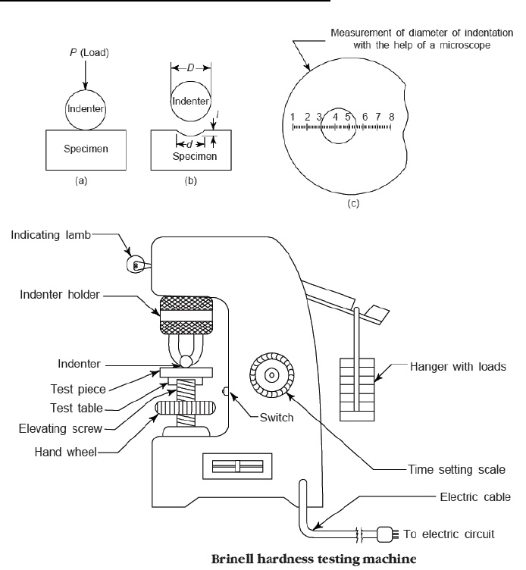
Figure 1

Results:
Experimental data from the experiment has been recorded and calculated in a tabulated format. These results can be seen from the original data sheet.
Formulas:
- $Brinell Hardness, HB = \frac{P }{A }$ $(\frac{kg}{{mm}^{2}})$
- $Area of Indentation, A=πDt ($mm²)
- Depth of Indentation, $t=\frac{D-\sqrt{D^{2}-d^{2}}}{2 } (mm)$
- Average Diamete, $d=\frac{dx+dy}{2} \left(mm\right)$
- $1 Kg=\frac{N}{9.81}$
- Average Brinell Hardness, $HB= \frac{HB1+HB2+HB3 }{3 }$ $(\frac{kg}{{mm}^{2}})$
Where:
P = applied load
dx = measured diameter of indentation on x-axis
dy = measured diameter of indentation on y- axis
N = Newton
Kg = kilogram
D = Diameter of indenter (Steel Ball, mm)

Sample Calculation for trial 1 of Steel:
Step 1:
Convert Newton to Kilograms, $\frac{P }{A }=$ $\frac{10,272N}{9.81}=1047.10 kg$
Step 2:
Calculate depth of indentation, t = $\frac{D-\sqrt{D^{2}-d^{2}}}{2 }$ = $\frac{10mm-\sqrt{{(10mm)}^{2}-({2.7mm)}^{2}}}{2 }$= 0.1857 mm
Step 3:
Compute Area of indentation, A = πDt = π(10mm)(0.1857mm) = 5.83 ${mm}^{2}$
Step 4:
Determine Brinell hardness, HB = $\frac{P }{A }$ = $\frac{1047.10 kg }{5.83 {mm}^{2}}$

Discussion:
- Comment on the practical applicability of the hardness test in engineering and list some examples.
In accordance to structural, aerospace, automotive, quality control, failure analysis and many other forms of manufacturing and industry. The hardness test provides valuable insight to the durability, strength, flexibility, and resistance to localized plastic deformation of a variety of component types from raw materials to prepared specimens, and finished good.
- Describe other hardness tests for metals that are currently used in engineering.
Rockwell hardness test is the only one that allows direct reading of the hardness value without need of optical reading, thus it is the most rapid and the only test that can be fully automated. Although this is a suitable benefit, the Rockwell test is restricted to light loads.
Vickers hardness test is a rather slow and expensive test which can be used with any and all materials and test specimens, from soft to hard, as the procedure covers the entire hardness range.
Knoop hardness test is particularly suitable for testing small, longish components and very thin layers as well as brittle materials (glass and ceramics) for which no other method is appropriate. Precise evaluation can only be achieved if the surface quality of the specimen is decent because the indent is measure optically.
- Discuss the effects of the following experimental errors on the Brinell hardness number.

- Indentations were made to close to the edge of the specimen
If impressions were too close to the edge of the specimen this would have caused unsymmetrical indentations, in turn would make it difficult to mark and quantify perpendicular diameters.

- Indentations were made too close to each other
If the impressions were made too close to one another, inaccurate data would be attained due to the fact that the surrounding deformed metal is weaker.
- Discuss the sources of error in this experiment.
The main limitation of this method is due to the optical reading of the indentation that may cause measurement errors due to the operator. Furthermore, an accurate surface preparation and calibrated apparatus is needed to obtain reliable results. Minor errors such as overpassing the time limit or surpassing the applied loads drastically can also amount to sources of error. For these reasons, the Brinell method cannot be considered a quick test and it is not suitable for testing of high volumes.

Conclusion
From the experiment carried out, the hardness number for steel and aluminum were calculated successfully. After the experiment, steel proved out to be the strongest, while aluminum to be the softest.

References:
Dr. Ahmed Soliman, Mechanics of Materials, Stress Strain: "Plastic Behaviour.” Concordia University, Montreal. January, 15, 2018.
Hardnesstesters.com. (2018). Brinell Hardness Testing. [online] Available at: http://www.hardnesstesters.com/test-types/brinell-hardness-testing [Accessed 21 Jan. 2018].
Emcotest.com. (2018). Theory of hardness testing. [online] Available at: https://www.emcotest.com/en/the-world-of-hardness-testing/hardness-know-how/theory-of-hardness-testing/brinell-50/advantages-and-disadvantages-of-the-brinell-method-247/ [Accessed 21 Jan. 2018].

