Mark 301

SITUATION ANALYSIS

THE MARKETING PLANNING CYCLE
1. Research / Analysis of current situation 2. Understand Markets and Customers 3.Identify Opportunities and challenges 4. Develop overall objectives 5. Develop specific strategies and marketing programs 6. Implementation 7. Track + Control + Adjust

5 C’s
- Customers : Customer analysis involves two primary activities: understanding the consumer needs driving consumption and understanding the decision making process consumers undergo to fulfill their needs.
- Context: The external context plays a major role in setting the stage for business opportunities. Marketing managers need to understand how factors in the world around them impact their business model. Analyzing the context involves analyzing the six external environments that impact business. (Demographic, Economic, Socio Cultural, Political/Legal, Technological, Natural)
- Company: Analysis of the company begins with an understanding of the firm's business model. What fundamentally does the company do and how does it make money? What is the engine that makes the business run? Then, an analysis of the firm's competitive strategy is needed. Firms generally compete by either 1. Having the lowest costs and thus being able to offer consumers the lowest price (Southwest Airlines), or
2. Offering unique, and superior performance on attributes or benefits that are valuable to a large part of the market (the superior shave offered by Gillette)
3.By focusing on a small segment/niche of the market and knowing it so well that the firm can customize its products to meet the needs of its consumers in a superior way.
- Collaborators/complementers: Collaborators are the companies and/or people who help the firm in marketing the product to customers. Common collaborators include suppliers who provide the materials to make the products, distributors and retailers who sell the products to consumers, key influencers like doctors, the media, or bloggers who spread the word about the products. Complementers are the companies and/or people who also benefit when the firm sells its product. Common complementers include other companies who sell products which are complementary to the ones the firm sells
- Competitors: Competitive analysis involves identifying and analyzing companies who compete with the firm by delivering a similar product to consumers or an alternate solution to consumers’ needs. The analysis focuses on analyzing the business models, competitive strategies, competitive advantages, and marketing strategies of each firm in comparison to your firm.
These all allow managers to understand themselves, their customers, and the external players and forces that affect their business.

USING PORTER’S 5 FORCES TO UNDERSTANDING INDUSTRY COMPETITIVENESS

The Five forces that determine the intrinsic long run attractiveness of an industry
- Industry Competitors
- Potential Entrants
- Availability of substitutes
- Buyer power
- Supplier power

Analysis of these 5 markets allows marketers to better understand the market they are competing in
These all create profitability potential for the industry & firms in it (situation), therefore have implications on Marketing strategy

SWOT ANALYSIS
S
- FOCUS ON THOSE THAT ARE CUSTOMER-RELEVANT & A DISTINCTIVE COMPETENCE COMPARED TO COMPETITION
W
- CORE COMPETENCIES/CAPABILITIES THAT ARE INFERIOR TO COMPETITION (DEFICIENCIES)
O
- ‘STATES OF THE WORLD’ WHICH DO NOT INCLUDE MARKETING STRATEGIES TO TAKE CARE OF THEM
T
- FACTORS THAT CAN IMPEDE BUSINESS DEVELOPMENT
- NOT HYPOTHETICAL

Using the 5’c, Porter’s 5 forces, and SWOT to make a decision
- Market Segmentation and Target Market Decisions: The customer section of the 5 C's analysis provides essential input into different customer segments. The competitive section of the 5 C's analysis shows who various competitors are targeting, so that the marketing manager can choose a unique and profitable target market.
- Branding Decisions: The company section of the 5 C's analysis provides essential input on the brand equity that the firm currently has. The competitive section of the 5 C's analysis provides input on the brand equity that competitors have so that the firm can assess its brand's strengths and weaknesses vs. others.
- Positioning Decisions: The company section of the 5 C's analysis identifies the competencies that the firm possesses which allow it to claim a unique and differentiated position in the marketplace. The competitive section of the 5 C's analysis shows how competitors are positioned which can help identify points of parity and points of difference. The customer section of the 5 C's analysis provides insight into what customers value so that various positioning statements can be evaluated.
- Product Decisions: The company section of the 5 C's analysis identifies the product related competencies the firm possesses and the competitive section identifies the product features and benefits offered by other firms in the industry. The customer section of the 5 C's analysis provides insight into which product features customers value so that product feature additions can be evaluated.
- Pricing Decisions: Porter's Five Forces analysis is crucial to making pricing decisions. Before a price can be assigned to a product, managers need to understand the underlying profitability of the industry and the competitive dynamics that affect it. Analyzing the company's supplier power, buyer power, competitive rivalry, the availability of substitutes, and the threat of new entrants helps determine how much power the company has to raise prices.
- Distribution Decisions: The buyer power section of the Porter's Five Forces analysis sheds essential light on the company's relationships with its buyers, which in many cases include not only the end user of the product, but intermediaries, such as retailers, who deliver and sell the product to the end user. Companies that have power over their retailer buyers will be able to gain more shelf space and better promotional deals than those that have little power. The complementer section of the 5 C's analysis informs strategic planning for distribution, as it often includes analysis of distribution partners.
- Promotion Decisions: The customer section of the 5 C's analysis provides important insight into the customer's decision making process, which can indicate at what point the company can communicate with the customer. The customer's media habits can indicate where, when, and how to communicate.
CREATING CUSTOMER EXPERIENCE
- Customer Experience: internal subjective response customers have to any direct or indirect contact with the company (i.e. at every “touch point”)
- Total experience derived from consumption process – from search, purchase, consumption, to after-sale
- “Customer corridor”
Creating “customer experience” is a strategic undertaking that can result in strong competitive advantage.
- Understand customer journey and expectations
- Design “experience motif” – consistent with brand image and strategy (e.g. hospital: create feeling of psychological comfort)
Systematic integration of a well-conceived, consistent series of “clues” that collectively meet or (preferably) exceed customer expectations and evoke an emotional reaction
What determines whether the customer has a positive or negative experience?
- Expectations!!! based on
  - Past (personal) experiences
  - WOM OR observation of others
  - Company promises
The more expectations a company meets, the more positive the consumer experience satisfaction
  - Product efficiency – i.e. extent to which product satisfies need or solves problem
  - Knowledgeable, polite, responsive sales reps
  - Price
  - Marketing promotion and communications
  - Appropriate retail atmosphere
  - Professional webpage easy to navigate
  - Reaction of others (after purchase)
  - Etc.
- Meeting customer expectations is not enough…
- Customer satisfaction is not enough…
- Companies need to strive to exceed expectations and deliver “emotional delight”

How to exceed customer expectations
i.e. how to “delight” customers?
  - Deliver exceptional customer experience
  - Deliver “emotion”
  - Make them feel special – personalized experience
  - Deliver something unexpected (i.e. surprise them!)
  - Deliver something “cool”
Co-Creation Experiences
- ‘Traditional’ firm-centric view of value creation: value lies in the products and services created by firm and delivered to customers
- Market-orientation view of value creation: firm creates offerings consumers value based on market research
- Today’s co-creation view of value creation: value is created jointly by customers and firm – co-creation of experience
  - Meaningful interactions with companies that allow consumers to feel involved in the production and consumption process
Why is Co-Creation important / beneficial?
  - Allows the creation of unique experiences that are tailored to ever consumers specific needs, preferences, expectations
  - Results in better, more innovative,
more valued experiences
  - Results in more satisfied, invested,
engaged, committed consumers
How to achieve efficient co-creation?
  - Dialog: interactivity, engagement
  - Access: information, resources
  - Transparency: understanding
  - Risk-benefits: disclosure, share in responsibility
  - Another important element: Technology (as interface)

STOP TRYING TO DELIGHT YOUR CUSTOMERS
- Focus should not be on achieving delight but rather preventing dissatisfaction
- Especially in today’s business world where customer service is generally pretty bad (one of first things that gets brushed aside when reducing costs)
- Negative experience have stronger
impact on consumer outcomes than
positive experience
Is negative customer experience always a bad thing? No because some customers are worth firing
BRANDING
1) The Brand Report Card
What are the major takeaways/lessons in this article about BRAND and BRANDING?
- Brands are intangible assets, which provide value to the firm and its customers IDENTIFIES THE COMPANY IDENTITY
- “Products are made in the factory, brands are made in the mind”
- Brands have an INFORMATIONAL role , lower the amount of mental effort customer must do because they can buy a product based on the reputation or their past history with that brand.
- BUILDING BRAND refers to the process of establishing and maintaining brand knowledge in the minds of customers
- TANGIBLE brands: products actual performance
- INTAGIBLE: stress the extrinsic value of the product, more imaginary abstract
- Brand management is actually meaning-management
- BRAND PERSONALITY: making the brand human (anthropomorphized) give it a personality
  - Sincere
  - Exciting
  - Competent
  - Sophisticated
  - Rugged
- 1. Uncover your TM current identity
- 2. Customers buy products to capture meaning within the
- 3.Load brand with identity meaning
- 4.Be careful when changing meaning
Note: Brand Equity: Micro level : defferential responses consumer have to products when they are branded
Macro level: brand equity measured as the incremental; profits that accrue from the sale the branded products vs the level of profits that would have accrued from the same products unbranded (eg. Put the name Chanel on it)

Differentiation (e.g. Nike is differentiated from others just because it’s “Nike”) → competitive advantage
Recognition & Trust: grab attention, familiarity = trust = buy
Attachment: emotional bond
Payoffs:
- Loyal consumers (difficult for competitors to steal them away)
- Brand advocates :‘walking billboards’
- Brand equity (added value endowed to goods and services)
  - Derived from how consumers feel,think and act with respect to the brand
  - Result in large margins, market share and profitability
Other advantages of strong brands:
- Improved perceptions of product performance
- Smoother introductions of new products
- Increases marketing communications efficiencies

2) If Brands Are Built over Years, Why Are They Managed over Quarters?
What is the single most important marketing message/learning to be derived from this article?

List and briefly elaborate upon the major factors accounting for the myopia that seems to pervade the managing of brands.
- Marketing myopia: a company views marketing strictly from the standpoint of selling a specific product rather than from the standpoint of fulfilling customer needs.
- Long-term metrics can redress short-term myopia

- Discuss the various facets/dimensions of the solution to this brand management deficiency proposed in this article.

Describe the essence and significance of each of the following terms:
- QUANTITY PREMIUM: Higher baseline sales mean that consumers are buying more of a product at full price. The baseline measure reflects only the volume sold when a product is not discounted, the lift-over-baseline measure represents the difference between discounted and nondiscounted sales.
- PRICE PREMIUM: Brands with loyal customers face less pressure to reduce their prices and therefore enjoy a price premium. Together, quantity and price premiums reflect a brand’s long-term health. If both increase, demand and margins will be higher—along with brand equity and profits. If consumers pay less of a premium for the brand and baseline demand is decreasing, then the brand is headed in the wrong direction—and the firm has a problem.

3) How Millenials Are Changing the Way Companies Build Brands

Why are ‘Millenials’ viewed as a key segment in our North American economy?
Millenials are the largest group of customers to the U.S
Identify and briefly elaborate upon the characteristics/priorities of ‘Millenials’ that marketing planners must appeal to and leverage.
- Millenials love technology
- Rely on social media
- Health, adventure, living authentically
- Hashtags

4) Consumers Aren’t Fooled When CSR (Corporate Social Responsibility) is Packaged as Purpose

How is this article related to the ‘Millenials’ article? (see previous)
- Describe the essence and importance of “Purpose”?
Purpose is not corporate social responsibility. purpose is so deeply ingrained in their culture and business practices that their behaviors both build business and help others while occurring naturally and authentically.
- What is the test for the properly articulating core purpose?
If you can answer these three questions with the same fundamental thought, you've essentially articulated your core purpose.
- What is your organization best in the world at? (What is your expertise?)
- What drives your economic engine? (How do you make money?)
- What are you passionate about? (What gets your employees up in the morning, beyond making a paycheck?)

- What are the 2 essential steps for carrying out one’s core purpose?
Step 1: Create a clear purpose statement. This is harder than it sounds. Take the time to make it as short as possible. Avoid "and" and subordinate clauses. It should be one simple, declarative sentence.
Step 2 : Don't just say, act. Purpose is not a presentation slide. It should ultimately be ingrained in your culture and practiced daily -- in the initiatives you get behind, who you hire and fire and what partners you work with. The more it's practiced, the more authentic and effective it will become.

5) “Open Up with OREO”
Consumer insights are an important cornerstone of marketing planning today. What particular consumer insights is OREO attempting to leverage in the “Open UP with OREO” campaign?
- How is this campaign consistent with the essence of the “OREO” brand?
- Based on this article alone, why do you think “OREO” is such a successful brand?

Marketing in a Digital World
Digital marketing is the promotion of products or brands via one or more forms of electronic media
Companies must consider managing
- Paid Media: Paid media occurs when a company invests to pay for visitors, reach or conversions through third-party search, display ad networks, or affiliate marketing.
- Owned Media: Media or channels created and controlled by the brand. Online, this includes a company’s own websites, blogs, mobile apps, or its social presence on Facebook, LinkedIn, or Twitter.
- Earned Media: Media spread when customers, the press, and the public share a company’s content or discuss a company’s brand via word of mouth. It is stimulated by viral and social media marketing.
A Framework of Digital Marketing

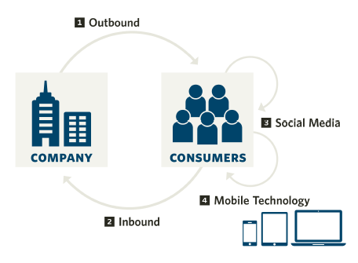
Native Advertising
It is a form of online advertising in which brands create sponsored content that blends into the main story or editorial content of an article. It creates compelling content to engage consumers who are increasingly ignoring both offline and online ads.
Display Ads
Display ad Graphical advertising on the Internet that appears next to content on web pages, instant messaging (IM) applications, e-mail, and so forth. These ads come in standardized ad sizes and can include text, logos, pictures, or more recently, rich media (videos). Also known as banner ad.
INBOUND MARKETING
- Inbound marketing positions the company as a target consumers search for.
- The focus of inbound marketing is to ensure that, in keyword searches by search engines, organic links for a firm rank higher than competing links.-
- Two forces drive the increasing importance of inbound marketing:
1. The diminished influence of advertising
2. Rise of consumer search.
Steps of Inbound Marketing
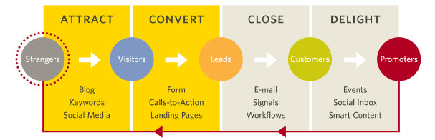
Outbound Marketing
- In outbound marketing, the first element in our digital marketing framework, a firm initiates a conversation and sends a message to target consumers.
- In digital channels, outbound marketing takes the form of search ads and display ads
How has Marketing Changed ?
- Marketers are losing control, while consumers are gaining control over brand and product information propagation
- The web has changed the marketer’s role from a broadcaster pushing out messages, to an aggregator who brings together content, enables collaboration, and builds and participates in communities – i.e. communication directed at consumers vs. with consumers
How have Consumers changed ?
- 90% of consumers trust recommendations from other consumers, versus 56% trust brand communication claims
- Change in how consumers make decisions – i.e. decision making process ... How?
Branding in the digital Age 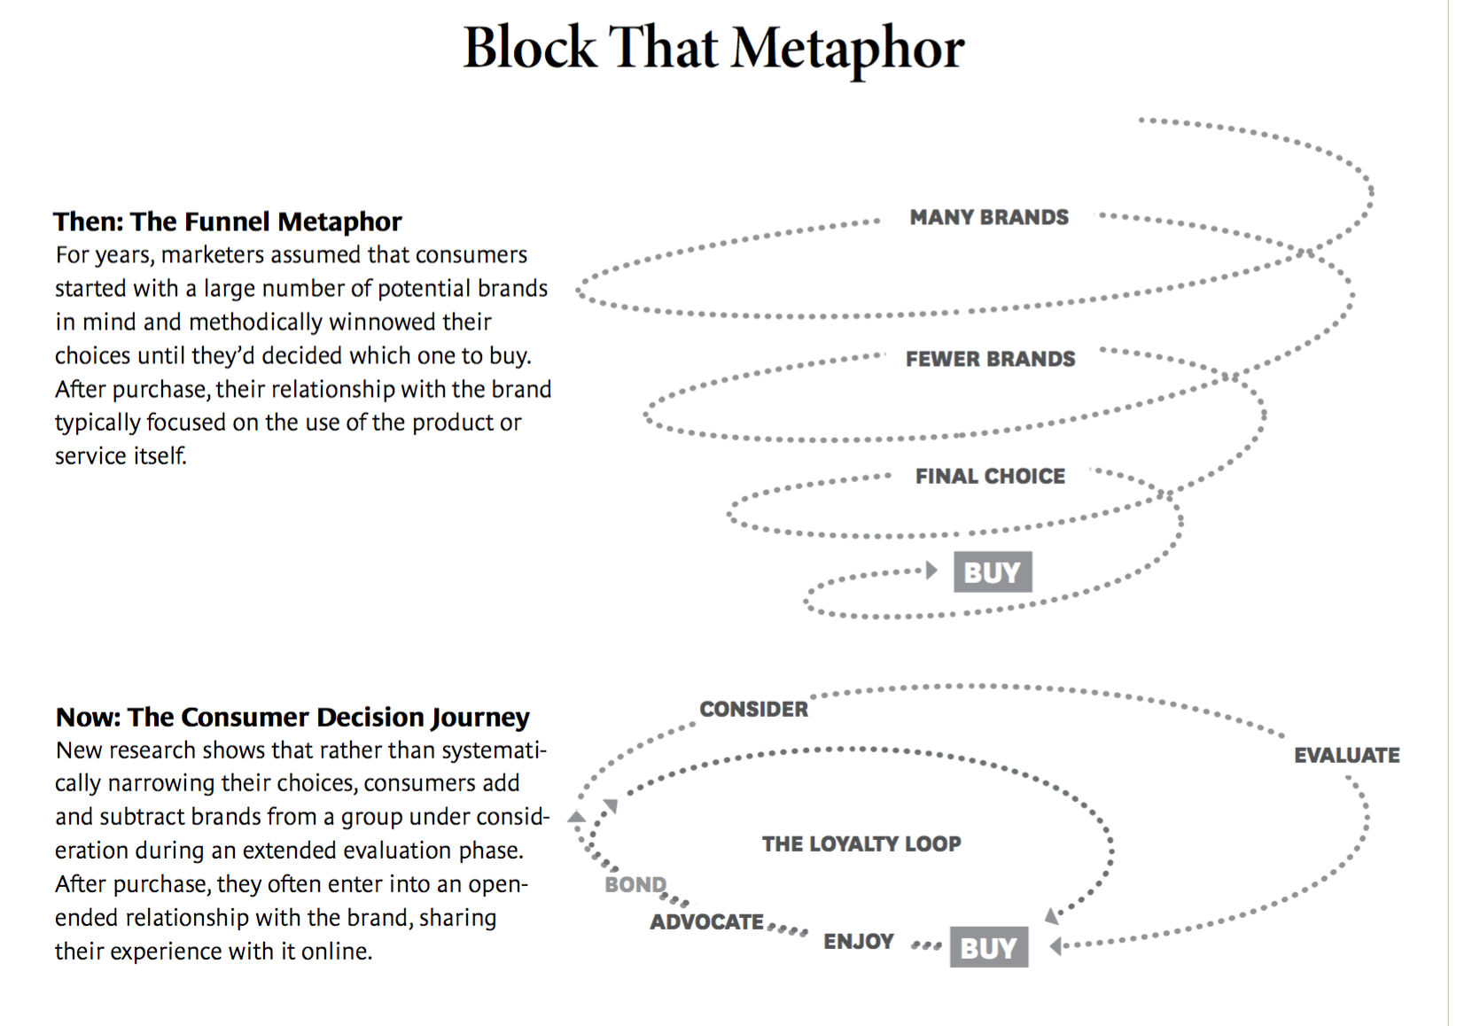
How to minimize negative reviews?
- Provide excellent consumer experience… every time!
- Apologize and compensate for unfortunate rare mistakes
How to handle negative reviews online?
● If a statement made is untrue, you have the right to ask for the comment to be removed, but you need to provide evidence
● If the statement is true, apologize! Take accountability for your mistakes, don’t blame others (or junior employee), be genuine
- Publicly acknowledging the issue ASAP
- Demonstrate strong consumer empathy
- Refund the consumer or provide immediate compensation (do not give discount on future services)
- Do not overtly promote your brand in your response
* Use negative reviews to improve your business
How to increase likelihood that customers will spread positive word of mouth?
... CHECK NOTES
RETAILING
- Explain the role of retailers in the distribution channel and describe the major types of retailers.
- Describe the major retailer marketing decisions.
- Discuss the major trends and developments in retailing.
- Explain the major types of wholesalers and their marketing decisions.
Retailing includes all the activities in selling products or services directly to final consumers for their personal, non-business use.
Retailers are businesses whose sales come primarily from retailing.
Types of Retailers – Amount of Service
- Self-service retailers serve customers who are willing to perform their own “locate-compare-select” process to save money.
- Limited service retailers provide more sales assistance because they carry more shopping goods about which customers need information.
- Full service retailers have salespeople assist customers in every aspect of the shopping process.
Product Line
- Specialty stores (narrow product line with deep assortment
- Department stores (Wide variety of product line)
- Supermarkets (High volume carrying grocery and household products)
- Convenience stores (Limited line of high-turnover goods)
- Superstores (non food goods)
- Category Killers (Deep in category with sales staff)
- Service Retailers (Product lines are services)
Type of Retailers Relative Prices
- Discount stores sell standard merchandise at lower prices by accepting lower margins and selling higher volume.
- Independent off-price retailers either are owned and run by entrepreneurs or are divisions of larger retail corporations.
- Off-price retailers buy at less-than-regular wholesale prices and charge customers less than retail.
- Factory outlets are producer-operated stores.
- Warehouse clubs are large warehouse-like facilities with few frills and offer ultra-low prices.
Types of Retailers Organizational Approach
- Corporate chains are two or more outlets that are commonly owned and controlled.
  - Size allows them to buy in large quantities at lower prices and gain promotional economies.
- Voluntary chains are wholesale-sponsored groups of independent retailers that engage in group buying and common merchandising.
- A retailer cooperative is a group of independent retailers that band together to set up a joint-owned, central wholesale operation and conduct joint merchandising and promotion efforts.
- Franchise organizations are based on some unique product or service; on a method of doing business; or on the trade name, good will, or patent that the franchisor has developed.
- Merchandising conglomerates are corporations that combine several retailing forms under central ownership.
Retailer Marketing Decisions Product Assortment and Services
- Product assortment should differentiate the retailer while matching target shoppers’ expectations. Offers merchandise that no other competitor carries:
  - Private or national brands
  - Merchandising events
  - Highly targeted product assortment
- Services mix should also serve to differentiate the retailer from the competition with customer support.
- Store atmosphere is the physical layout that makes moving around the store hard or easy.
Retailing Trends and Developments
- Slowed U.S. economy
- New retail forms, shortening retail life cycles, and retail convergence
- Rise of mega-retailers
- Growth of non-store retailing
- Retail technology becoming important
- Green retailing: yields both top and bottom line benefits.
  - Top line: Sustainable practices lift a retailer’s top line by attracting consumers looking to support environmentally friendly sellers and producers.
  - Bottom line: Such practices can also reduce costs, such as Amazon.com’s reduced-packaging efforts.
- Global expansion of major retailers
  - While Canada has a number of retailers that rank among the largest retail companies in the world, only Alimentation Couche-Tard has significant international operations whereas more and more U.S.-based retailers are moving into Canada, viewing it as a more profitable, low-risk marketplace.
  - European retailers and U.S. retailers are expanding both domestically and internationally, and European retailers rival those in the U.S. when it comes to global dominance
- Growing importance of retail technology provides better forecasts, inventory control, electronic ordering, transfer of information, scanning, online transaction processing, improved merchandise handling systems, and the ability to connect with customers.
WHOLESALING
- Selling and promoting involves the wholesaler’s sales force helping the manufacturer reach many smaller customers at lower cost.
- Buying assortment building involves the selection of items and building of assortments needed by customers, saving the customers work.
- Bulk breaking involves the wholesaler buying in larger quantity and breaking into smaller lots for its customers.
- Warehousing involves the wholesaler holding inventory, reducing its customers’ inventory cost and risk.
- Transportation involves the wholesaler providing quick delivery due to its proximity to the buyer.
- Financing involves the wholesaler providing credit and financing suppliers by ordering earlier and paying on time.
- Risk bearing involves the wholesaler absorbing risk by taking title and bearing the cost of theft, damage, spoilage, and obsolescence.
- Market information involves the wholesaler providing information to suppliers and customers about competitors, new products, and price developments.
- Management services and advice involves wholesalers helping retailers train their sales clerks, improve store layouts, and set up accounting and inventory control systems.
*TYPES OF WHOLESALERS
- Merchant wholesalers is the largest group of wholesalers. They include:
- Full-service wholesalers who provide a full set of services
- Limited service wholesalers who provide few services and specialized functions
- Brokers are wholesalers who do not take title to goods and whose function is to bring buyers and sellers together and assist in negotiation.
- Agents are wholesalers who represent buyers or sellers on a relatively permanent basis, perform only a few functions, and do not take title to goods.
ONLINE VS. OFFLINE RETAILING
What do consumers want in multichannel retail env.?
Trend: consumers often try product in store, than go
home and buy it online for cheaper…
What to do?
Offer better basic experience
hyper-convience
“fun” experience
Interactive technology
relevant / personalized experience
Solution for today’s retailers?
- Omni-channel retailing: seamlessly enhance consumer experience through all available shopping channels, i.e. mobile internet devices, computers, brick-and-mortar, catalog and so on.
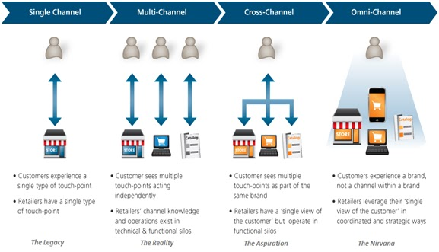

B2B MARKETING

- How does the buying process in business markets differ from that in consumer marketing. List the major ways, and discuss the significance of each for B2B marketers.
- Market Structure and Demand
  - Fewer but larger buyers (Every customer becomes extremely important)
  - More geographically concentrated (not always true)
  - Derived demand (i.e. from consumer demand)
  - More inelastic demand
  - Sharper fluctuations in demand
  - Order size is much higher
  - The ability to quantify VALUE can yield a significant advantage (Value- based pricing)
  - There is no such thing as an “average customer”
  - Supplementary services, programs, and systems are profitable sources of differentiation that can significantly change the way customers value market offerings.
  - “Value-based pricing” is the best pricing strategy to adopt for B2B markets
- Nature of the Buying Unit
  - More buyers
  - More professional purchasing effort
- Types of Decisions and Decision Process
  - More complex buying decisions
  - More formalized buying process
  - Relationship is more important and KEY(Can make it very personalized)
- Other Characteristics
  - More direct buying
  - Reciprocity
  - More leasing
IN SHORT
- Fewer, larger buyers
- Close supplier-customer relationships
- Professional purchasing
- Many buying influences
- Multiple sales calls
- Derived demand
- Inelastic demand
- Fluctuating demand
- Geographically concentrated buyers
- Direct purchasing

Two major types of customer relationships:
- Transactional : strictly just purchase the product no relationship
- Collaborative : Build relationship with consumer

Stages in the Buying Process for B2B

Problem Recognition General-Need Description Product Specification Supplier Search Proposal Solicitation Supplier Selection Order-Routine Specification Performance review

- Identify and briefly elaborate upon the three major types of buying situations in B2B marketing.
- Straight Rebuy: Business buying situation in which the buyer ROUTINELY reorders something WITHOUT any modifications
- Modified Rebuy: Business buying situation in which the buyer want to MODIFY product specifications, prices, or suppliers
- New Task Buy: Business buying situation in which the buyer purchases the product or service for the first time

- Identify and briefly elaborate upon the many ways in which the evolution of digital has impacted B2B marketing?
Uses for Social Media include: Product Development, Marketing, Online Presence, Expert Advice, Customer Support, Corporate

- Briefly explain each of the following concepts and discuss the relevance of each for B2B marketers:
a) e-procurement: is the B2B purchase and sale of supplies, work, and services through the Internet as well as other information and networking systems, such as electronic data interchange and enterprise resource planning
- Method of e-procurement
- Websites organized using vertical hubs
- Websites organized using functional hubs
- Direct extranet links to major suppliers
- Buying alliances
- Company buying sites
b) Systems selling: Buying a packaged solution to a problem under a single seller, thus avoiding all the separate decisions involved in a complex buying situation
c) buying center: All the individuals and units that play a role in the purchase decision-making process d) product value analysis

Principles of Pricing

Company’s profitability relies on how well pricing decisions are made.

Pricing’s role in the marketing mix is to tap to the value created and generate revenues
- To fund the firms current activities
- To fund research that will lead to future value creation
- To generate profit

Basic formula to calculate profits
Profits = (Unit Price – Cost of Goods Sold) x Unit Sales Volume

The Value Pricing Approach
- Driven by small handful of factors
- Objective Value A measure of benefits that the product delivers to the consumers relative to other products
- Perceived Value Is the value the consumer understands the product to deliver. (objective and perceived value can be influenced by the price of substitutes)
** Perceived value of consumer = maximum price consumer is willing to pay

Perceived Value-Pricing Thermometer 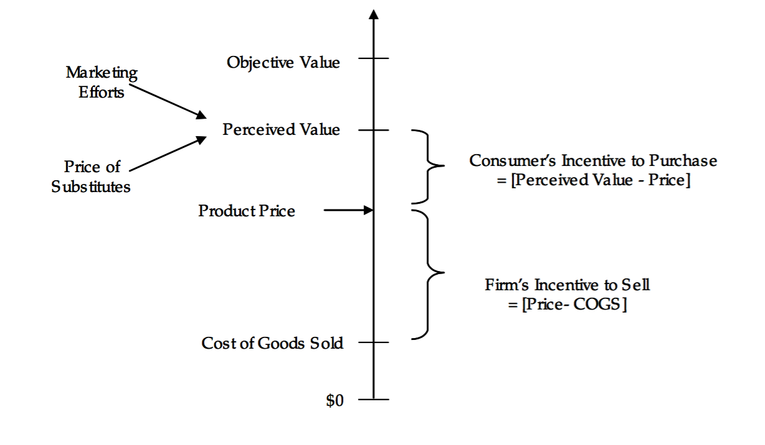
- Cost of goods sold the firm requires an incentive to sell the product. Must charge a price that covers production

By pricing above COGS and below perceived value the firm has an incentive to sell (price – COGS) and the consumer has an incentive to purchase the product (perceived value – price)
- Low price should only be undertaken by cost leaders
  - Cost leaders = companies that have not focussed on designing cutting edge products, nor on marketing & advertising, but rather on improving efficiency of operation and reducing costs.
  - If you are not a cost leader, and you decrease your prices relative to your competition, you may gain market share, but you are squeezing your margins.
- COST < IDEAL PRICE
Assessing a Product’s Value to Customers
Firm’s usually had out surveys to potential customers

- Determining Objective Value through Cost Structure Studies
- Assess the True Economic Value of a product to a consumer by understanding the competitive alternatives, the price and performance of those alternatives, and the buyer’s costs

TEV= Cost of the next best alternative + Value of Performance Differential

- Determining Perceived Value
- Most common way is through a survey
- Problems : Induce an unrealistically high level of price consciousness in consumers, consumers are not actually required to pay anything, results often too optimistic

Assessing Price Sensitivity
Major Factors that affect price sensitivity

- The Magnitude of Price
Price sensitivity tends to be higher in big-ticket items versus less expensive items
- The absolute value of the product increases
- The aggregate (total) cost of ongoing usage increases
- The cost of that product increases as a percentage of the total cost

- Who Pay’s?
- To the extent that the user is responsible for the cost the greator is their price sensitivity

- Competitive Factors
Price sensitivity is higher to the extent that
- The customer does not perceive significant differences in alternative products
- It is easy to compare products and their prices
- It is for the decision maker to switch products

Price Customization
Factors that cause value variation across potential customers:
- Taste
- Importance of performance
- Ability to pay
- Intensity of use
- Category of knowledge
Firms should charge a higher price to consumers that value the product more
Ways to customize price per consumer:
- Through the product line: high end products with many features versus a more basic model for lower value customers
- By controlling availability: e.g. send different catalogues to different consumers
- Through demographics: discounts to children and seniors
- Through transaction characteristics: e.g. buy a plane ticket today for six months versus buying a plane ticket today for tomorrow

Integrating Price with Other Marketing-Mix Elements
A key to effective pricing is to have a firms pricing strategy in sync with the other elements of the marketing mix

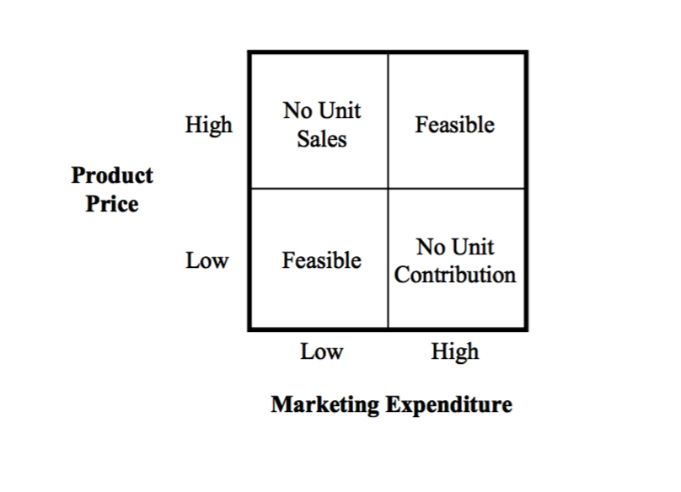
Cost-Plus Pricing

PRICE = UNIT COST + MARGIN

- Reactive Approach: when sales are low or need to recuperate $ during intro stage, set high prices in order to maximize profit
Higher price decrease sales volume increase unit cost (variable + fixed costs / unit)
= reason for many business failures, because increasing price to increase profit margin in times of low sales, often leads to selling less : unit cost increase : and the profits tank.
= death spiral of cost based pricing !

Product Cost Price Value Customers WRONG

VALUE BASED PRICING

Customer Value Price Cost Product

- Deep understanding of how products and service create value for customers
- understand consumer needs
- know your products’ features, translate them into customer benefits
- assess how well product features / benefits meet consumer needs
→ VALUE
- Communicate VALUE to customers then set price and ensure that it covers costs

