MANA 362 – Human Resource Management – Class

Final killer exam, generally:
- 20-30 multiple choice (30-40%)
- 8-9 short answer (60-70%) (short-answers and case studies, show you understand with proper terminology)

What is human resource management?
- HRM is an integrated set of processes, practices, programs, and systems in an organization that focuses on the effective deployment and development of its employees
  - A lot of organizations see HR as a waste of time, not adding value to it
    - Processes and procedures of how to function was not properly implemented before
  - Obligation to management while ensuring that employees are well cared for
HRM activities
- Organizational, work and job design
- HR planning
- Recruitment and selection
- Training and development
- Performance management
- Rewards and recognition
- Health and safety
- Employee and labour relations
Why does HRM matter?
- As people are central to organizations, HRM issues impact organizational success (bottom line)
- HRM issues have an impact on individual well-being, and society
Just cause: Automatically get expelled or fired, harassment or abuse
-------------------------------------------------------------------------------------------------------------------------------
8 January 2018 – Class 1
Chapter 1: Why HRM Matters

Partnership of line managers and HR professionals (equal partner with all other seniors)
- Line manager’s role: Manage/lead employees so that they contribute effectively
  - Determines work and job design
  - Makes hiring decision
  - Coaches and develops employees
  - Supervises day-to-day activities
  - Evaluates performance (sometimes try to push evaluation to HR but they don’t know day-to-day basis)
  - …
  - Generally consults HR professional with regards to HR issues
- HR professional’s role: Equip line managers with the best people practices
  - Aligns HR strategy with business strategy
  - Delivers service (recruiting, based off of criteria created by line manager)
  - Develops and implements HR policies
  - Is an employee advocate
  - …
  - Generally assists line manager in his role with regards to HR issues
- Both lead to the success of the organization
Current business issues (challenges and opportunities)
- Global economy
- Evolution of firms and sectors
- Technology and quality
- Sustainability
- Developing human capital and talent management
- Demographic and employee concerns
Global economy (1)
- Globalization (reduction of barriers to international trade) has facilitated the movement of people, goods, and capital; means that:
  - Companies now have business opportunities in global markets (Canadian economy is primarily built on exports)
  - But they must also compete globally
- Work globally and compete globally
- Implications for business:
  - Increased competition
  - More partnerships
- Implications for HRM:
  - Multiple legal contexts, cultures, business practices – must be taken into account
  - More international workers – increases complexity of HR activities
Exercise
- Senior VP HR in pharmaceutical industry based in Canada to open plant in South America, main HR issues to consider before making move
  - Environmental concerns
  - How it would impact the people located around the plant
  - Shouldn’t be taking advantage of the people there, be legal and equivalent to Canada perhaps
  - HR being on same page as in Canada
  - Cultural differences (holidays, how are different people treated)
- Must underlie culture of country of origin to country being moved into (Canada’s culture transitioned and implemented into Canadian company in Mexico)
Evolution of firms and sectors (2)
- Recent economic downturn has impacted certain sectors more than others (manufacturing, mining)
- Survival rates for new entrants are low
- In the past years, most firms have experienced low growth
- Where is population pool coming from
- Implications for business:
  - Many companies in “survival mode” as the economy is still fragile, and the stock market very volatile
- Implications for HRM:
  - As labour costs are a large expenditure, pressure to cut costs often leads to:
    - Downsizing (planned elimination of jobs)
      - Potential hidden costs:
        - Severance and rehiring costs
        - Pension and benefit payoffs
        - Potential lawsuits from aggrieved workers
        - Loss of institutional memory
        - Loss of trust in management
        - Lack of staffers when the economy rebounds
        - Survivors who are risk-averse, paranoid, disappointed
      - Alternatives of downsizing:
        - Reduce hours
        - Job sharing
        - Lower wages for all, possibly with shared ownership
        - Alternative placement
        - Transfers
        - Attrition
    - Outsourcing (contracting outside vs. doing internally)
Technology and quality (3)
- Technology has enabled companies to dramatically improve processes and quality, and reduce costs
- Technology has also changed customer requirements
- The way to do business has changed fundamentally for many organizations… some thrive, others don’t!
- Must have some sort of flexibility, counterproductive to keep people with no work
- Implications for business:
  - Has changed the way to meet customer expectations
  - Some companies need to rethink their strategy
- Implications for HRM:
  - High demand for knowledge workers, low demand for low-skilled workers
  - More virtual workers (teleworking)
    - Not everyone is made for telecommuting
  - Training is often required
  - Widespread use of human resource management systems (HRMS)
Sustainability (4)
- Natural resources are declining, climate is changing
- People are more concerned with protecting the environment
- Implications for business:
  - New threats (ex: reduced demands for some products)
  - New opportunities (ex: green businesses)
- Implications for HRM
  - New skills required (ex: environmental skills)
Human capital and talent management (5)
- Organizations’ success increasingly depends on their ability to manage human capital (i.e. the set of knowledge, skills, and capabilities of individuals that have economic value to an organization)
- Organization’s core competencies (those that differentiate the company from its competitors) are part of organization’s human capital
  - Core competency because the more the people are useful, the better the productivity and success of the organization
  - More people feel cared for, more willing to do stuff for the organization
- Implication for business:
  - Organizations must build their human capital, and identify and develop their core competencies
- Implications for HRM:
  - HRM activities are required to retain and develop human capital, and reinforce core competencies
  - Talent management (effectively leveraging competencies) has thus become the focus of HR activities
Demographic and employee concerns (6)
- Changes in the composition of the workforce:
  - Diverse backgrounds
  - Diverse generations, aging population
  - Skills/labour shortage
  - Gender distribution (more women)
  - More educated workers
  - More part-time and temporary workers
- Is having a diverse population a challenge, or an opportunity?
- Changes in expectations and concerns of employees, driven by cultural changes:
  - Employees have more rights, are more aware of their rights
  - Employees (and society) more concerned with ethics
  - Employees are concerned with privacy
  - Employees have different attitudes towards work
  - Employees expect some work/life balance
- Generations at work
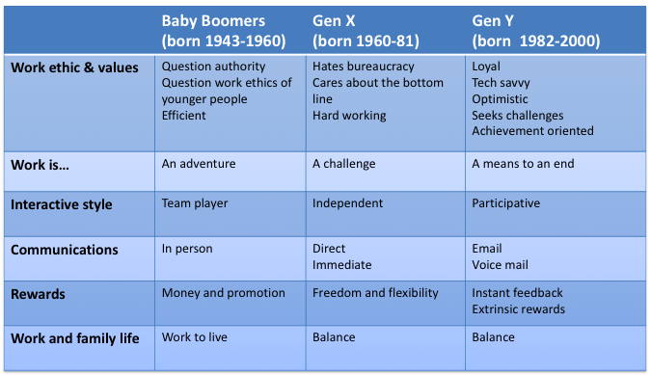

- Implications for business:
  - Organizations who are successful in taking advantage of this diverse, changing workforce will gain a competitive advantage
- Implications for HRM:
  - Need to accommodate workers from diverse backgrounds: Immigrants, older workers, women (for legal & business reasons)
  - Need to meet diverse employee needs and expectations
    - Jobs say can’t find people, people say can’t find jobs
Business strategy and strategic HRM
- Corporate strategy
  - Focuses on the overall scope and direction of an organization
  - Answers the questions:
    - What do we do?
    - Where are we going?
- Business strategy
  - Focuses on value creation through the development of a sustainable competitive advantage
  - Answers the question:
    - How will we compete?
- HR strategy
  - Focuses on developing and implementing people processes and systems that contribute to maintaining and developing the competitive advantage
  - Strategic HRM involves identifying key HR processes and linking them to the business strategy
-------------------------------------------------------------------------------------------------------------------------------
15 January 2018 – Class 2
Chapter 2: Operating Within the Legal Framework

Why employment laws?
- Form of protection
- Reflection of values of current society
- Standard that dictates what can and cannot be done in business
- Must be followed; ignorance is not acceptable
  - Obligation to be aware of new laws put in place
- Perception is as valid as intent
- Multicultural workforce
Distribution of powers in Canadian federation (Constitutional Act, 1867)
- Federal jurisdiction: Matters of national interest
  - Banks and money
  - Defence
  - Criminal law
  - Mail
  - Transportation: ships, rail, air
- Provincial jurisdiction: Matters of regional interest
  - Health
  - Education
  - Municipal institutions
  - Civil law
  - Private or local matters
- Shared between both:
  - Agriculture
  - Immigration
2 sets of employment legislation in Canada
- Federal legislation
  - Applies to worker in:
    - Federal government
    - Organizations under federal jurisdiction (banks, ships, air, rail transport)
  - About 10% of workers
- Provincial legislation
  - Applies to workers in organizations under provincial jurisdiction
  - Most employees
Main Federal employment laws (MUST KNOW LAWS)
- Canadian Charter of Rights and Freedoms
  - Covers human rights (applies to all government entities)
- Canadian Human Rights Act (supersedes the other law)
  - Covers human rights and pay equity
- Employment Equity Act
  - Covers employment equity
- Canada Labour Code
  - Covers employment standards, labour relations, health and safety
- PIPEDA (becoming more stringent, tell what information is used for etc.)
  - Covers handling of personal information
Main provincial (Quebec) employment laws
- Quebec Charter of Rights and Freedoms
  - Covers human rights
- Labour Code
  - Covers labour relations
- Act respecting Labour Standards
  - Covers employment standards
- Act respecting Occupational Health and Safety
  - Covers health and safety
- Pay Equity Act
  - Covers pay equity
- Act respecting Equal Access to Employment in Public Bodies
  - Covers employment equity (public sector only)
- Act respecting the Protection of Personal Information
  - Covers handling of personal information
Human rights
- What are human rights?
  - Race, ethnic, or national origin
  - Religion
  - Gender
  - Age
  - Disability
  - Sexual orientation
- Federal level: Canadian Charter of Rights and Freedoms, Canadian Human rights Act
- Provincial level: Quebec Charter of Rights and Freedoms
- Also prohibits harassment
- Paramount over other employment laws
Harassment
- What is harassment?
  - Sexual harassment
  - Psychological harassment
  - Perception harassment
- Harassment: Unwanted physical or verbal conduct that offends or humiliates an individual
  - Objective criteria: “reasonable person”
  - Organizations should have a good anti-harassment policy
5 criteria for psychological harassment (not tested on)
  - Vexatious (annoying) behaviours
  - Repetitive in nature
  - Verbal comments, gestures that are hostile and unwelcomed
  - Affect the person’s dignity or integrity
  - Harmful work environment
Harassment
- Includes:
  - Threats, intimidation, or verbal abuse
  - Unwelcome jokes about appearances
  - Displaying sexist, racist or offensive pictures
  - Sexually suggestive remarks or comments
  - Inappropriate physical conduct, touching, patting, punching
  - Excluding members
  - Bullying
- What would be a good anti-harassment policy?
Enforcement of legislation
- Canadian Human Rights Commission Disputes Resolution Process:
  - Inquiry
  - Early resolution and preventive mediation
  - Filing a complaint
  - Mediation
  - Preliminary assessment
  - Investigation
  - Conciliation
  - Tribunal
Discrimination
- Discrimination: Adverse differential treatment to members of a particular group
  - Systemic when it results from the application of organization policies and practices
    - Ex: Hire men 18-25 = direct discrimination; want to hire only Italians so only post ads in Italian places etc. = systemic discrimination
- Reverse discrimination: Preference given to members of a minority group resulting in members from the dominant groups being discriminated against
  - Ex: Employ 15% more women in management in 2016; increase visible minorities to 25% of workforce
    - Want to undo an injustice that was done in the past
    - This is fine, as long as people are equally qualified
    - As soon as the man is partially more qualified, then it is reverse discrimination
Allowed to discriminate (REMEMBER THIS SLIDE)
- Bona fide occupational qualifications: Discrimination is permitted if employer can establish its necessity for business operations
  - Firefighter must be able to carry 50kg of weight through a fire
- Reasonable accommodations: Employer has an obligation to adjust policies and practices to prevent discrimination (limit: “undue hardship”)
  - Ramp for wheelchair, or allowed to work from home, but on 5th floor with no elevator would require too much stress monetary so it’s not a reasonable accommodation
Employment standards
- Main goal: Specify minimum obligations of employers towards employees
  - Hours of work
  - Minimum wages
  - Overtime pay
  - Vacation pay
  - Holidays
- Exist at federal level (Canada Labour Code) and provincial levels (Act respecting Labour Standards in Quebec)
- Apply to all employers (unionized or not)
- For instance, the Act respecting Labour Standards in Quebec covers:

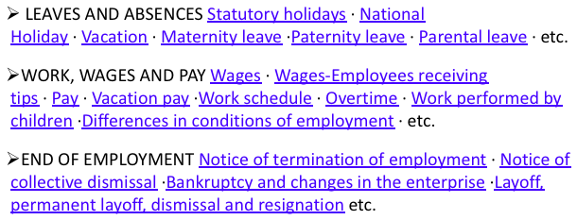

Labour relations
- Goals:
  - Govern the process by which a union acquires bargaining right
  - Govern collective bargaining procedures
- Exist at federal level (Canada Labour Code) and provincial levels (Labour Code in Quebec)
- FYI: Unionization rate about 30% in Canada, 40% in Quebec
Health and safety
- Goals:
  - Describe the standards for workplace health and safety
  - Outline the role and involvement of employers and employees in health and safety
  - Provides compensation for workers injured on the job
- Exist at federal level (Canada Labour Code) and provincial levels (Act respecting Occupational Health and Safety in Quebec)
- Health and safety is a responsibility of the employer
Employment and pay equity
- A woman gets 30-35% less than a man for same work in Quebec
- Goal: Eliminate barriers preventing certain Canadians to access
  - Employment opportunities
  - Fair pay
- Exist at the federal level (Canadian Human Rights Act, Employment Equity Act), and, in Quebec, at the provincial level (Pay Equity Act, Act respecting Equal Access to Employment in Public Bodies)
- Employment equity:
  - Goal: Achieve equity in all aspects of employment for 4 specific groups
    - Women
    - First nations people
    - Visible minorities
    - People with disabilities
  - Laws: Employment Equity Act (federal) and Act respecting Equal Access to Employment in Public Bodies (Quebec)
  - Applies to: Federally-regulated organizations, and companies that do business with the government of > 100 employees (federal legislation) and provincial organizations of the public sector (provincial legislation)
  - Means of action:
    - Removing barriers to equitable employment opportunities (plan with timelines)
    - Implementing reasonable accommodations and special measures
- Pay equity:
  - Goal: Narrow wage gap between men and women
  - Laws: Canadian Human Rights Act (federal) and Pay Equity Act (Quebec)
  - Applies to: All federally-regulated organizations (federal legislation) and provincially-regulated organizations of > 10 employees (provincial legislation)
  - Principles:
    - Equal pay for equal work
    - Equal pay for work of equal value
Diversity
- Workplace diversity: Differences among employees (potential or actual)
  - While employment equity is mandatory, diversity management is voluntary
  - Benefits of really helping to see the different points of view
Benefits of diversity
- General benefits:
  - Access to larger pool of candidates when hiring, more creative decisions and problem solving, more innovation
  - Better understanding and meeting the needs of customers, more positive organizational image
  - More positive employee attitudes, better retention due to fair environment, etc.
- Which lead to these overall benefits:
  - Savings in litigation
  - Higher company performance and competitiveness
  - Higher stock prices, etc.
Challenges of diversity
- Similarity-attraction phenomenon: Tendency to be more attracted to individuals who are similar to us
  - We assume that there is the surface level diversity (gender, ethnicity, age, sexual orientations, etc.) that is related to the deep level diversity (values, beliefs, attitudes)
- Ethnocentrism: Belief that one’s own culture is superior to other cultures
- Stereotypes: Generalizations about a group of people; can be based on:
  - Ethnic/cultural background
  - Gender
  - Age
  - Sexual orientation
  - Etc.
- Stereotypes can:
  - Impact the behaviour of those who stereotype
  - Impact the behaviour of members of targeted group because they know the stereotype exists (stereotype threat)
Managing diversity
- Beneficially diverse organization:
  - Build a culture that embraces diversity
  - Make leaders accountable for diversity
  - Establish diversity training programs
  - Review HR practices (communication, selection & recruitment, development, etc.)
  - Be systematic: Asses needs, set goals, monitor progress
Practice questions
- Federal employment laws:
  - Apply to federally regulated companies and agencies only
  - Prohibit companies from using fair HRM practices
  - Are responsible for determining who can get health benefits
  - Apply to all employers and employees in Canada
  - Concern human rights exclusively
- Which of the following is not a prohibited ground of discrimination?
  - Religion
  - Handicap or disability
  - Lack of qualifications
  - Race or colour
  - Sexual orientation
- A justifiable reason for discrimination based on business reasons of safety or effectiveness is called:
  - Legitimate discrimination
  - Disparate treatment
  - A bona fide occupation qualification
  - Reverse discrimination
  - Discrimination is never justified on the part of an employer
-------------------------------------------------------------------------------------------------------------------------------
22 January 2018 – Class 3
Chapter 3: Defining and Designing the Work (Chapter 4)

Job analysis vs. job design
- Job analysis: Defining the work (what job is now, “picture”, objective)
- Job design: Designing the work (what job should be, “ideal”, subjective)
- Ideally you would start with job design, design who takes care of what, and now let me go and outline the ideal minute tasks a person will do in each category
Line manager’s role
- While HR is usually responsible for conducting the job analysis…
- … the line manager plays an important role in determining:
  - What work will be performed, and in what order (job design)
  - The skills and abilities needed to successfully perform work (part of the job analysis process)
- Line manager should take care of job design, but also part of job analysis
- HR is usually responsible for conducting job analysis, and then observing if people are properly doing their jobs
- If HR was more responsible for job design, then they might be creating unspecified jobs or not finding the actual right people, ex: if hired underqualified or overqualified
  - Frustration of others of underqualified person
  - People leave because they’re overqualified and bored
  - Tylenol killing babies issue 20 years ago, HR was responsible for training and development and hiring and so they were really screwed basically, task training should not be done by HR, if line manager told them to do it, so push back
Clarifying work-related notions (not used interchangeably)
- Job: Group of related activities and duties (corporate chef)
- Position: Specific duties performed by 1 person (# of chefs to do job)
- Work: Tasks or activities that need to be complemented (what will this chef do day-to-day)
- Role: Part an employee plays in an organization– refers to behaviours (who does chef report to and how does chef add to strategic overall vision of firm)
Job analysis: Overview
- Job analysis is conducted
- Job description is written
- Job description is used in HRM processes
Job analysis
- Job analysis is the process of systematically obtaining information about jobs:
  - Duties and tasks
  - Knowledge, skills and abilities (KSAs) needed to do the work successfully
  - Effort needed, working conditions, etc.
- Result: A job description
- Goal: Improve organizational performance
Job analysis (continued)
- Sources of information
  - Employees
  - Supervisor
  - Other subject matter experts (subordinates, clients)
- Methods of obtaining information
  - Interview is best option
  - Questionnaires would be anonymous and open-ended questions
  - Observation is good if can observe all tasks at hand and which are most crucial
  - Diaries not really that important, done by the person themselves where what they are doing is not necessarily what they should be doing
  - Organizational reports are not treated for 1 particular individual
- A useful approach to analyse the information
  - Task analysis
1. Job analysis: Task analysis approach
- Collect task statements (1)
  - Gather information about tasks and duties
  - Transcribe into task statements, each describing 1 specific aspect of the job
    - Task statements star with an action verb, and specify what, with what, for what
  - Compile a list of all statements (master list – all tasks that they do, 120 tasks)
    - Rephrase is different ones mean the same
- Identify important statements (2)
  - Ask interviewees to rate (1-5) each statement in master list on importance to job and frequently (separately)
  - Investigate important disagreements between raters
  - Calculate average rating for each statement (/5)
  - Decide on a cut-off, anything below this number is not that important (ex: >2.5)
  - Eliminate non-important statements (usually end with 20-25)
- Establish dimensions (3)
  - Group statements into logical categories (dimensions, ex: administrative duties)
    - Usually 3-5 dimensions are enough
    - Each statement should only be in 1 dimension
- Determine KSAs (4)
  - Determine needed knowledge, skills, and abilities needed for the job (i.e. job specifications)
    - Every K, S, or A should be linked to 1 or more task statements
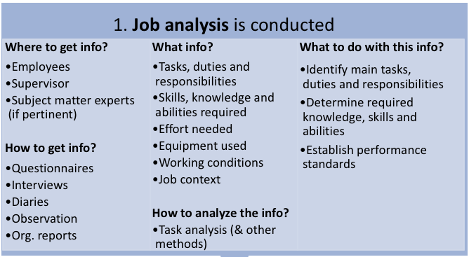

Job analysis: Challenge of information accuracy
- Potential problem: Lack of accuracy
- May occur because of:
  - Employees inflating the job (naming flipping burgers as something else)
  - Information not collected from a representative sample of employees
  - Used observation and length of job cycle exceeded observation period
  - Used observation and some tasks are “not observable” in the job
  - Ongoing changes in the job
- Job analyst must try to minimize these issues
2. Job description
- Job description: Result of the job analysis; short written document that contains:
  - Date
  - O*NET or NOC code
  - Job title
  - Summary of job
  - Job tasks, duties and responsibilities (characteristics of the job)
  - Job specifications; required KSAs (characteristics of the person)
  - Standards of performance
Job description: Do’s and don’ts
- Common problems:
  - Poorly written, vague terms
  - Not updated
  - Contain specs not related to job (danger: discrimination)
  - Omits important tasks/duties
  - Limits scope of activities
  - No standards of performance
- What to do:
  - Use concise, direct, simply worded statements
  - Update regularly
  - Match actual job requirements (bona fide occ. requirements)
  - Include actual duties
  - Not too restrictive
  - Include standards of performance
3. Job description is used in HRM processes
- Recruitment: Required qualifications serve as basis for attracting qualified applicants
- Selection: Job specifications help choose most qualified applicant
- Training and development: Discrepancies highlight training needs and help develop training programs
- Performance appraisal: Performance standards provide criteria for evaluating jobholders
- Compensation: Description helps determine the job’s relative worth, a basis for determining pay
- Job analysis is thus a crucial process in HRM (cornerstone)
Job analysis in a changing environment
- “Traditional” job analysis assumes a static environment
- However, in dynamic environments, jobs can change quickly; leads to:
  - New approaches
    - Future-orientation: Trying to predict future needs
    - Competency-based: Focusing on characteristics or behaviours of successful performers
    - Living job description: Updated as the job changes by line manager and jobholder
Job design
- Job design: Process of defining and organizing tasks, roles, and other processes
- The supervisor/line manager plays a very important part in this process
- Goal: Improve organizational performance
  - However, well-designed jobs can also serve to achieve employee goals
Job design: The basis (what to consider)
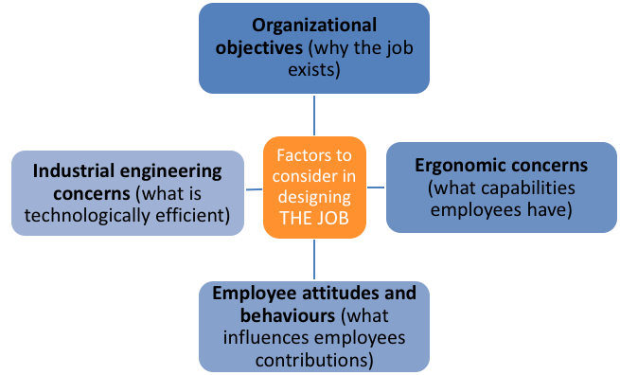

Job design: The strategies (how to do it)
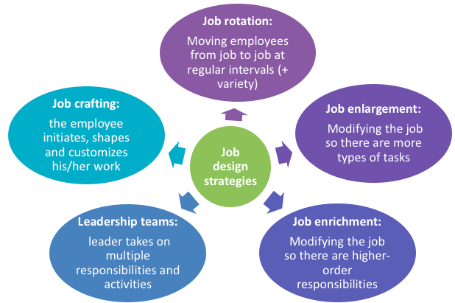

Job design: The job characteristics model, i.e. how
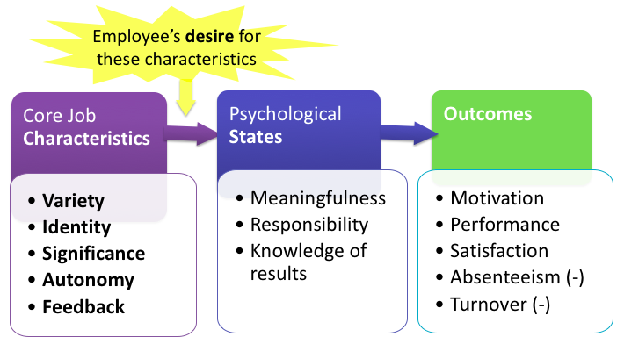

Exercise

- 2
- 3
- 2
- 1
- 4
- 3
- 3
- 2
- 1
- 1

- Variety: Variety of different activities demanding different skills and talents 1.5
- Identity: Completion of a whole and identifiable piece of work 3 (science)
- Significance: Impact on the lives or work of other people, inside or outside the organization 2.5 (teaching)
- Autonomy: Freedom, independence, and discretion in scheduling the work and determining how to carry it out 2 (business)
- Feedback: The work activities give direct and clear information about the effectiveness of your performance 2 (business)
Group job design
- Specific goals:
  - Increase collaboration
  - Increase synergy
- Techniques presented:
  - Empowerment (+ engagement)
  - Teams
- Necessary conditions:
  - Leadership expectations clearly (re)defined
  - Organization design and structure adapted
Group job design: Empowerment
- Empowering employees means granting them power to initiate change
  - Encourages them to take charge of what they do
  - Make employees have ability to make the changes
  - Environment where their ideas are not frowned upon
- Conditions:
  - Participation: Encourages employees to take control of work tasks
  - Innovation: Receptive to new ideas and change
  - Information: Gives employees access to information
  - Accountability: Makes employees accountable for their behaviour
Group job design: Engagement
- Engagement is the state of an employee who is both committed and dedicated to his organization
  - Helping person feel like they’re part of the organization, constantly updating the employees with the good and bad news
- Conditions:
  - Communication: Consistent and non-ambiguous
  - Hopeful future: Proposes attractive opportunities and work in the future
  - Development: Invests in developing employees
  - Performance: Commitment to performance, support for employees to achieve goals
Group job design: Teams
- Teams are groups of employees who work together towards a common goal, have complementary skills, are interdependent in their work, and have discretion over tasks
- Conditions:
  - Goals: Shared, members are committed to them
  - Decision-making: By consensus
  - Communication: Open and honest
  - Leadership: Shared
  - Climate: Cooperation, collaboration, trust and support
  - Diversity: Valued
  - Conflict: Recognized and solved
Practice questions
- The process of obtaining information about jobs by determining their duties, tasks, or activities is called:
  - Job description
  - Job design
  - Job analysis
  - Job empowerment
  - Job enrichment
- All of the following statements about job analysis are true, except:
  - Job analysis is useful for developing performance evaluation tools
  - Job analysis helps making pay rate decisions
  - Job analysis is helpful in ensuring a firm’s compliance with human rights legislation
  - Job analysis is more important in large firms than small ones
- Which of the following is not a dimension of Hackman and Oldham’s Job Characteristic Model?
  - Variety
  - Intensity
  - Autonomy
  - Feedback
  - Significance
-------------------------------------------------------------------------------------------------------------------------------
29 January 2018 – Class 4
Chapter 4: HR Planning, Recruitment, and Selection (Chapter 5)

HR planning
- HR planning: Process of anticipating current and future needs to ensure that people are being used effectively to accomplish the organization’s goals
  - Means having the right people with the right skills in the right jobs at the right time
- Implies forecasting the demand and supply for particular types of employees
HR planning vs. Strategic planning
- Strategic planning: Making decisions about long-term business objectives
- HR planning: Anticipating and making provisions to have the people required to meet these objectives
- HR planning must be part of the strategic plan at the beginning, or else they wouldn’t have much time to staff when a big project were to come
- Cannot lower someone’s salary, so demotion is rare, either fire, or transfer to completely different department where new job description fits the salary
HR planning approaches (REMEMBER THIS SLIDE)
- Quantitative:
  - Trend analysis: Previous year’s data (org. index) to make projections about requirements
  - Markov analysis: Pattern of employee movement (% and # who remain, are promoted, demoted, transferred, or leave)
  - Staffing tables: Graphic representations of jobs with # of employees (and possibly future needs)
- Qualitative:
  - Management forecast: Opinions based on managers’ knowledge to determine future requirements
  - Skills inventory: Information on current employees (education, experience, skills, etc.)
- Provide usable information about employee:
  - Demand: Trend analysis, management forecast, possibly staffing tables
  - Supply: Staffing tables, Markov analysis, skills inventory
- Trend analysis example:
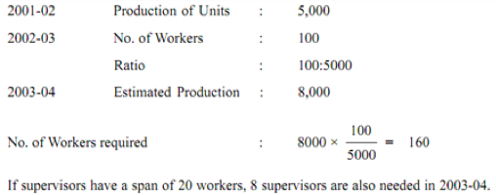

HR planning steps
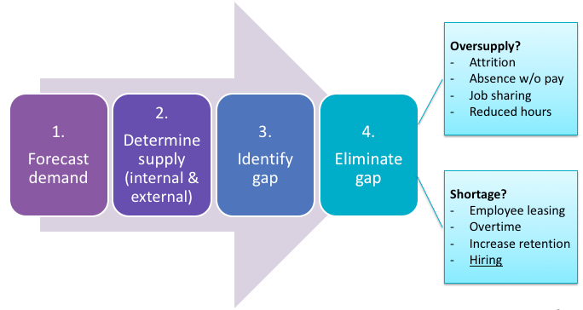

Recruitment
- Recruitment: Process of locating and encouraging potential applicants to apply for jobs
- Can be done from within and/or outside the organization
Recruitment process
- Based on HR planning, identify current or future openings (1)
- Get job description with job specifications (KSAs) (2)
- Determines recruitment method(s) (within and/or outside, specific methods) (3)
  - Important: Know why you choose to recruit internally/externally, and why a particular method (or combination)
- Conduct chosen recruitment activities to create a pool of potentially qualified applicants (4)
Recruiting within the organization
- Pros
  - Rewards employees for past good performance
  - Employees already know the organization
  - Serves as a motivator for all (perspective of being promoted)
- Cons
  - Employees may not have required training and experience
  - Risk of inbreeding of ideas and attitudes
  - May result in discrimination
- Internal recruitment methods:
  - HR management systems: Database of employee records to identify potential candidates
  - Succession planning: Identify, develop, and track employees and plan for future promotions; use this list to fill vacancies
  - Internal job posting: Company board, intranet, newsletter, etc.
- Currently, succession planning is a huge problem in society
  - Incorporates planning for the roles that are always required to be filled
  - Employees don’t stay long, especially Millennials
    - People don’t feel as though they’re getting promoted
    - Always negotiate a good salary before accepting the offer
  - HR has created an issue where they can’t help the people leaving with a raise
    - People take the less paying jobs because they don’t negotiate because they need the les spaying jobs (immigrants for example)
    - Demand and supply (February, September hiring season)
  - People are retiring
    - People not being trained to take over the jobs because of bad persona of Millennials so they’re keeping them until 70 years, and people don’t want to train others who may take their own jobs
Recruiting outside the organization
- Pros
  - New employee brings unique skills needed now
  - Increases variety of experiences and perspectives within organization
  - May increase innovation and creativity
- Cons
  - Lack of first-hand information about past performance
  - New employee not familiar with organization and possibly industry
  - Organizational constraints may prevent from accessing large applicant pool (high cost)
- External recruitment methods:
  - Advertisements: Websites, newspapers, TV, billboards, professional journals, etc.
  - Internet: Company website and recruiting sites
  - Employment agencies and head hunters: Specialized company matches applicants with specific organizational needs
  - Educational institutions: Recruiting directly at institutions
  - Open houses and job fairs: Events within or outside the organization
  - Employee referrals: Referrals and recommendations by current employees, sometimes for a fee
  - Unsolicited applications: Bringing in potential candidates who send their CVs
  - Professional organizations: Listings of members or placement services
  - Unions: Union lists (especially for blue collar jobs)
- Labour market:
  - Geographical area from which the organization recruits
  - Varies depending on the type of job, requirements, salary, supply of labour
Selection (REMEMBER THIS SLIDE)
- Selection: Process of choosing individuals with relevant qualifications and who will best perform on the job; implies:
  - Assessing applicants’ qualification
  - Choosing the one most suitable
- Challenge: Getting information that is:
  - Reliable (procedure gives comparable results over time)
  - Valid (procedure really measures what it says it measures, i.e. ability to do the work)
The selection process (which may vary)
- Completion of application form or submission of resume
- Initial screening/interview by HR person
- Employment test
- Interview with supervisor or team
- Reference check
- Hiring decision
  - Based on the information, choosing the applicant who can and who will do that job best
Selection (continued)
- Factors affecting the hiring decision:
  - Job requirements: KSAs to perform the job
  - Organization culture: How the employee’s role and responsibilities fit in the larger context
  - Organizational constraints: Policies, finances, recruitment source, business conditions
- Sources of information
  - Application forms and resumes
  - Interviews
  - Tests
  - Reference checks
Selection: Sources of information
- Application forms and resumes
  - Application forms
    - Quick and systematic
    - Provide information about minimum requirements
    - Provide a basis for interview questions
    - Provide sources for reference checks
    - Should ask for very specific information
  - Resumes
    - In addition to basic information, provides information about applicant’s creativity, personality, interests
- Interviews
  - Characteristics
    - Used extensively
    - Leaves room for personal judgement (subjective)
  - Methods (can be combined)
    - One on one
    - Panel/group
    - Phone
    - Internet-based
  - Types of questions
    - Structured, ex: behavioural description (what they did in the past), situational (hypothetical scenario)
    - Unstructured
  - Guidelines
    - Plan the course of the interview
    - Establish a rapport with the candidate
    - Be an active listener
    - Pay attention to nonverbal cues
    - Provide information honestly
    - Use questions effectively (no “leading”)
    - Separate facts from inferences
    - Recognize biases and stereotypes
    - Control the course of the interview
    - Standardize the questions
- Tests
  - Characteristics
    - Objective
    - Standardized
  - Types of tests
    - Cognitive ability
    - Personality and interests
    - Emotional intelligence
    - Physical ability
    - Job sample
    - Substance abuse
  - Note
    - Tests can measure potential or actual characteristics or KSAs
    - What you test should be related to the job!
- Reference checks
  - Characteristics
    - Provide a subjective “picture” of the applicant
    - Not highly predictive of good performance
    - Questions should be well-structured
In-class exercise that was a past short exam question (8-9 of these kind of questions in final)
- You must hire a manager for a fast food restaurant. For this position you are hiring from outside, and have received several resumes. You have the following information about the position: (15 min) Write down your answers and submit
  - The person will be managing around 30 employees.
  - Operations are highly standardized; employees have specific job descriptions.
  - Turnover is high and retention will be a priority.
  - Most employees are young with little work experience; few view the restaurant business as a full time career.
  - The atmosphere in the restaurant has a fast pace.
  - In this company, managers are often promoted from within and this position is an exception. The incoming manager may not receive a warm welcome from employees who were passed over for a promotion…
  - Employees are unionized. Therefore, the manager will have limited opportunities for distributing pay raises or bonuses.
- Which method(s) of selection would you use?
  - Would want to do emotional intelligence normally, but not here…
    - Wouldn’t use personality test because they are unionized
  - Will interview
- If using tests, which ones, and why?
  - Might give a manager a trial test that they are “technically” unaware of
- If using interviews, what questions would you ask applicants?
  - Ask behavioural questions to how they’ve reacted to a situation in the past
  - Ask situational questions, give example
    - Middle of rush, an employee quits, what are you going to do
    - If a customer does this and this, how would you handle this
Practice questions
- Elements in an effective HR planning process must include all of the following except:
  - Balancing supply and demand considerations
  - Performing supply analyses
  - Making forecasts
  - Analyzing statistics
  - Choosing the planning approach(es)
- Recruiting from within may:
  - Increase recruiting costs
  - Increase an organization’s technology
  - Inhibit creativity
  - Reduce employee motivation
  - Result in higher salaries
- Answering the question, “Does this selection method or instrument measure what it is supposed to measure?” is an assessment of:
  - Validity of the instrument
  - Aptitude and achievement
  - Reliability of the instrument
  - Personality and behaviours
  - Worth of the instrument
-------------------------------------------------------------------------------------------------------------------------------
5 February 2018 – Class 5
Chapter 5: Orientation, Training and Development (Chapter 6)

Introduction
- 3 aspects that are separate:
  - Orientation
    - Familiarizing new employees with the organization, their jobs, their work unit and embedding organizational values, beliefs, and accepted behaviours
  - Training
    - Ensuring the acquisition of skills, behaviours and abilities to perform current work
  - Development
    - Ensuring the acquisition of skills, behaviours and abilities to perform future work, or solve a problem
- These processes allow employees and the organization to learn thus increasing its human capital (competencies)
- Goal of orientation, training, and development: Foster individual and organizational learning in order to contribute to the attainment or the organization’s goals
  - Investment vs. Cost
- Learning = Ongoing change in behavior and thinking
- How to back-up $100,000 investment on training etc.
  - Can show past examples if it has worked previously
  - Can show money lost by not implementing it, cost of errors
  - Pulse of where employees are now, after receiving training, but not right away, and see if employee has incorporated what they learned and is it giving the results wanted, show up unannounced, test period to see how the large investment would be beneficial
- Quebec’s “training tax” (Loi sur les compétences):
  - Organizations with a payroll > $1 million must spend 1% of payroll on training, or pay 1% tax
  - Unique in North America
  - Positive results? Not clear
    - No added value to training
    - Or receiving same training
    - Health and safety is worth revisiting
    - Code of conduct is necessary to be seen every year (ethics)
    - Law made because companies were saying they don’t have money to train employees
    - Time loss and efficiency of the employee already trained repeating same training
    - Doing proper training shows that they’re investing in their people which could lead to more outside benefits (rare to pay tax)
    - Companies can’t misuse the money, it’s very specific criteria
    - Find out where the need is to get the training
Systematic training and development: The process
- Assess needs
- Design the program
- Implement the program
- Evaluate the program
Assessing needs (1)
- Determine if there are training/development needs (competencies employees need vs. competencies they have = gap?)
- 3 levels (types) of analysis to consider:
  - Organizational level: What is happening with the organizational environment & strategy? (helps determine whether training is required, and content)
    - Merger/acquisition?
    - Change in technology? etc.
  - Task level: What does the task require? (helps determine content)
    - Specific KSAs required?
  - Employee level: Who should be offered training? (helps determine participants)
    - Employees with performance issues due to lack of ability?
    - Employees being groomed for different responsibilities? etc.
- Organizational level is more pressing as it’d be like “town hall meetings” to make sure everyone’s on the same page rather than create rumours
- Type of training would be completely different depending on which level is required
Designing the program (2)
- Create a program and choose a method (or combination) which meets training/development needs previously identifies
- 4 issues to consider for an appropriate training program:
  - Instructional objectives
  - Trainee readiness/motivation
  - Characteristics of trainers
  - Principles of learning
    - Goal setting
    - Individual differences
    - Active practice and repetition
    - Whole vs. part learning
    - Massed vs. distributed learning
    - Feedback and reinforcement
    - Meaningful presentation
    - Modelling
Implementing the program (3)
- Schedule and conduct training based on chosen method(s)
- Sample methods to choose from:
  - On-the-job training
    - Hands on experience, provided by manager or trainer
    - Requires:
      - Good planning and structure
      - A trained manager/trainer
      - Clear job performance criteria
  - Apprenticeship training
    - For skilled trades, on- and off-the-job instruction and experience (theoretical and practical)
  - Cooperation training/internship
    - Combination of practical on-the-job experience and formal education
  - Classroom instruction
    - Instruction offered by one instructor to many trainees through a combination of methods (lecture, demonstrations, films, etc.) in a classroom
  - Self-directed learning
    - Learners work at their own pace, typically through books, manuals, computers
  - Audio-visual
    - Use of audio-visual media (webinars, video conferences, etc.)
    - Useful for skills and procedures in production jobs (visual component) or when participants are geographically distant
  - Simulation
    - Use of realistic equipment and operation
    - Useful when it is impractical or unwise to use real equipment for training
  - E-learning
    - Use of electronic media (web, computer-based)
    - Flexible, popular
- Methods often used for management development
  - On-the-job experiences
    - Provide hands on experience
    - Various methods (coaching, mentoring, job rotation, special project, etc.)
    - Requires careful planning and structure
  - Seminars & conferences
    - Involve group of people with similar needs/interests
    - Useful for communicating ideas, policies, procedures, discussing issues
  - Case studies
    - Use documented examples to learn how to analyze and synthesize facts, be aware of important variables, and improve decision making skills
    - Emphasize both process and solution
  - Management games
    - Use hypothetical situations to improve communication, decision-making skills, etc.
  - Role playing
    - Learners assume roles and behaviours of others
    - Helps improve interaction abilities
    - Requires learners to be very comfortable with each other
Evaluating the program (4)
- Measure outcomes, compare with objectives and criteria
- 4 methods:
  - Gather trainee reactions
    - Ask participants whether they liked the training, most useful content and techniques (simple, but satisfaction not a guarantee of success)
  - Assess extent of learning
    - Test knowledge and skills after training, compare with before
  - Assess behaviour change
    - Assess whether transfer has occurred: Participants apply in their jobs what they have learner in training
  - Measure results (ROI)
    - Calculate ratio cost (salary of trainer, materials, etc.) vs. benefits (+ quality, productivity, - rejects/wasted material, etc.) shows value of the training
Orientation
- Orientation is the formal process of:
  - Familiarizing new employees with the organization, their jobs, and their work units
  - Embedding organizational values, beliefs and accepted behaviours
- Orientation is a type of training
- Why? (benefits)
  - + productivity
  - + employee morale
  - + learning
  - – turnover
  - – recruitment/training costs
  - – new employee anxiety
- How? (process)
  - Continuous: For all, reorientation as organization changes
  - Cooperative: Involves HR, supervisor, employees
  - Planned: Predetermine goals, topics, methods
  - Systematic: Follow-up and evaluation
Special topics: Examples of content
- Basic skills (1)
  - Skills that are essential occupational qualifications for most jobs
  - Examples:
    - Reading and writing
    - Computer skills
    - Speaking and listening
    - Problem solving
    - Managing oneself (honesty, ethics, etc.)
    - Customer service
    - Safety, etc.
- Team work (2)
  - Skills required to facilitate interaction and performance
  - Examples:
    - Task related:
      - Project planning
      - Time management
      - Problem solving
      - Goal setting
    - Team related:
      - Communication
      - Establishing team norms
      - Conflict management
      - Valuing diversity
- Diversity (3)
  - Skills required to benefit from organizational diversity
  - Types of diversity training:
    - Awareness: Helping employees and managers realize the benefits of diversity
    - Skills building: Providing employees and managers with capabilities for working with diverse people
Career development
- Career development programs: Dynamic processes which seek to help employees plan their careers and meet career goals, as well as meeting organizational goals
- Important: Link individual needs (personal and professional) and organizational needs (strategic and operational)
- Favourable conditions for effective career development program:
  - Set and known goals (organization and employee)
  - Support from top management
  - HR practices that facilitate employee development (job rotation, transfers, promotions)
- Specialized career development:
  - Setting up mentoring relationships
    - A senior employee coaches, advises and encourages a more junior one
  - Including diverse employees
    - Offering career development programs that include special groups (women, dual-career couples, youth)
  - Emphasizing work/life balance
    - Encouraging employees to invest in other areas of their life
Practice questions
- Common drawback to on-the-job training include all of the following except:
  - Lack of structure
  - Lower motivation of trainees
  - Absence of well-defined job performance criteria
  - Poor training skills of trainer/supervisors
  - No evaluation of training quality
- A needs assessment that focuses on the environment and strategy of the company to see where training emphasis should be placed involves a(n):
  - Organization-level analysis
  - Individual-level analysis
  - Task-level analysis
  - Job analysis
  - Requirements analysis
- Which method of training helps managers learn how to analyze and synthesize facts and generally improve their decision making skills?
  - Role playing
  - Self-directed learning
  - Case studies
  - Job rotation
  - Seminars and conferences
-------------------------------------------------------------------------------------------------------------------------------
26 February 2018 – Class 7
Chapter 6: Managing Performance (Chapter 7)

Performance management systems: Introduction
- Performance management system: Set of integrated management practices that:
  - Maximize employee potential
  - Help increase employee satisfaction
- Should be done in every organization
- Why do some refuse to do it or why do they not do it systematically?
  - Time consuming
    - Set parameters for specific schedule and show the results of other companies that have implemented it
  - Consistent work/performance
    - By doing it you’ll learn how the employee is actually doing not just how it seems
  - No resources
    - Incorporate into budgeting
    - Create the program
  - Failed program/hiding failure
    - Reconstruct the program because it will improve everything and make the company more reliable
  - Don’t want to address problems
    - Mandatory meetings to see what is good on and what needs work on, instead of letting problems get worse
  - Don’t want to pay more for better work
    - Avoid demoralization of employee
  - Laziness
    - Incentives (monetary, recognition, activities)
- Sign performance evaluation but put disclaimer that you don’t agree with all of the aspects and weren’t given feedback along the way
- Performance evaluations should be at least 2 per year
Performance management systems: Purposes
- Compensation: Basis for salary increases, bonuses
  - Most frequent use
- Administrative: Basis and paper trail for other HR practices (promotion, transfers, planning, layoffs)
- Overall performance: Helps assessing organization performance, strengths and weaknesses; influences future behaviour
- Development: Provides feedback on strengths and weaknesses; helps identify training & development needs
Performance management systems: Examples of pitfalls
- Managers not realizing the benefits of effective performance management, not trained, leaving it to HR
- Metrics unknown to employees (don’t know what they’ll be evaluated on) or questionable (not reliable, not valid, not fair)
- No plans for helping employees develop or for addressing poor performance
- System not aligned with strategy, not linked to other HR processes, not consistent throughout the organization, etc.
- Importance of:
  - Managers trained and accountable
  - Employees perceive the system as fair
  - Support from top management
Steps of an effective performance management system (REMEMBER THIS SLIDE)
- Clarify the work to be done
  - Set and communicate clear expectations
- Set goals, establish plan
  - Linked to corporate strategy
  - With employee participation
- Provide regular and frequent coaching
  - Continuous
  - Helpful and supportive
- Conduct a formal performance review
  - Employee should bring a self-evaluation
  - Focus on goal accomplishments
  - Discuss areas for improvement
- Recognize and reward performance
  - Financial and non-financial rewards
- Create an action plan to improve performance
  - (If needed)
Complying with the law
- 3 general criteria:
  - Fairness: No biases caused by factors unrelated to performance
  - Reliability: Measures performance consistently among employees and over time
  - Validity: Metrics are job-related and accurate (measure what they aim to measure)
- Concrete guidelines:
  - Performance standards:
    - Exist and are job-related
    - Employees get a written copy before review
  - Managers who appraise performance:
    - Are trained on managing performance
    - Are able to observe performance
  - Reviews:
    - Are discussed openly with employees
    - Are documented
    - May be appealed by employees
Sources of performance information
- Combined: 360-degree review (must be company-wide)
  - Customers (internal, external)
    - Useful for attainment of customer service goals (should be linked to them)
  - Team (equal rank + work closely)
    - Useful when difficult to separate individual vs. team performance
  - Peers (equal rank)
    - Likely accurate and valid for some behaviours
    - Should be confidential, with clear criteria
    - Not useful if competitive environment
  - Subordinates
    - Useful for performance at supervising employees
    - Should be confidential, with clear criteria
  - Employee (self)
    - Increases employee involvement
    - Useful for employee development
  - Supervisor
    - Most common
    - Often in best position
- 360-degree review pros:
  - Comprehensive, broad perspective
  - Helpful for developmental purposes
  - Qualitative information sometimes not otherwise available
  - Encourages accountability, empowers employees
  - Consistent with flat organizational structures, etc.
- 360-degree review cons:
  - Administratively complex, time-consuming
  - My be difficult in certain organization cultures
  - Requires training (for everyone)
  - Opinions may be conflicting, information may be overwhelming
  - Potential confidentiality issues, etc.
  - C-suite hate this the most because they don’t want the subordinates to think that they have a voice that is stronger than theirs
Methods of reviewing performance: Overview
- Trait methods: Focus on traits (characteristics)
  - Measure to what extent the employee possesses certain characteristics
  - Pros: Cheap, easy to implement
  - Cons: Highly subjective, vague, easily biased, high potential for rating errors
  - Approach: Graphic rating scale (manager rates employee on several characteristics)
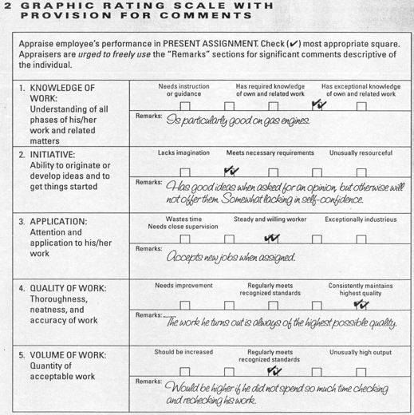

- Behavioural methods: Focus on behaviours (actions)
  - Describe to what extent the employee performs specific actions which should be exhibited on the job
  - Pros: More objective, more likely to be perceived as fair by employees – useful to provide feedback and allocate rewards/promotions
  - Cons: More complex to implement (can be time-consuming, costly), some potential for rating errors
  - 3 different approaches:
    - Behavioural checklist: Supervisor checks statements that characterize the employee’s behaviour
      - More of a link to actual behaviour than person
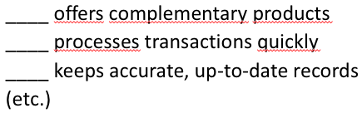

    - Behaviourally anchored rating scales (BARS): Assessing employee on scales representing important dimensions of performance for the job
      - Scales are based on critical incidents (events that denote superior/inferior performance)
      - Behaviour that I want but break down to different kind of levels of what I’m seeking employee to do
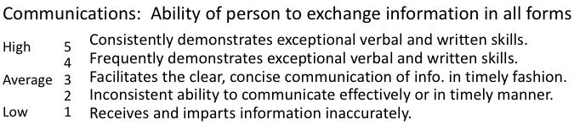

    - Behaviour observation scale (BOS): Similar to BARS, but supervisor observes frequency of behaviour
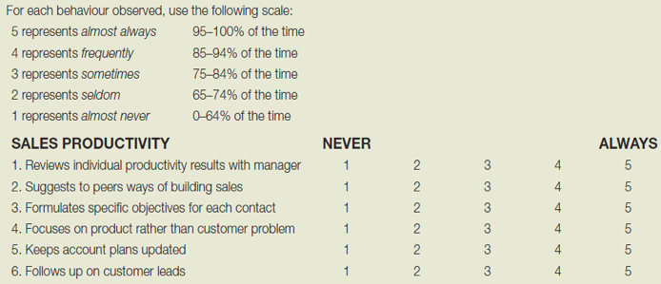

- Results methods: Focus on results (achievements)
  - Assess the results achieved by the employee on the job
    - Specific targets I need you to hit, did you hit those targets (sales uses this the most)
  - Pros: Even more objective and likely to be perceived as fair, link individual and organizational performance – useful to provide feedback and allocate rewards/promotions
  - Cons: Complex to implements and use (time-consuming), may encourage short-term perspective, requires adequate criteria (may use contaminated or deficient criteria)
  - Approaches:
    - Productivity measures: Employee is evaluated based on measure of productivity
      - Ex: sales, # of units without defects
    - Management by objectives (MBO): Employee is evaluated based on attainment of goals established jointly with the supervisor
    - Involves several steps; it’s a process:
      - Use corporate strategy to set company-wide goals (1)
      - Set department-level goals (aligned with #1) (2)
      - Employee and manager agree on individual-level goals (aligned with #1 & #2) (3)
      - Interim review: Periodically meet to monitor progress and provide feedback; modify objectives if needed (4)
      - Review employee performance – identify reasons for success/failure (5)
      - Review organization performance (6)
    - Balanced scorecard (BSC): Framework that helps managers translate strategic goals into operational objectives for the department/team, and for individuals
      - Career progression
      - Results assessed in 4 categories:
        - Financial
        - Customer
        - Processes
        - Learning
- Factors to consider in choosing methods:
  - Performance appraisal methods that fit the organization and job
    - Purpose of the system
    - Organization’s culture
    - Organization’s strategy
Performance review interview
- Guidelines:
  - Ask for a self-assessment before
  - Invite participation from employee
  - Express appreciation (positive feedback)
  - Minimize criticism (constructive, focused on most problematic areas)
  - Focus on behaviours, not the person
  - Focus on solving problems (vs. finding the culprit)
  - Be supportive
  - Establish goals for the future (with the employee)
  - Follow up (periodically)
  - Set up the meeting properly (private, convenient time)
Improving performance
- Identify sources of ineffective performance
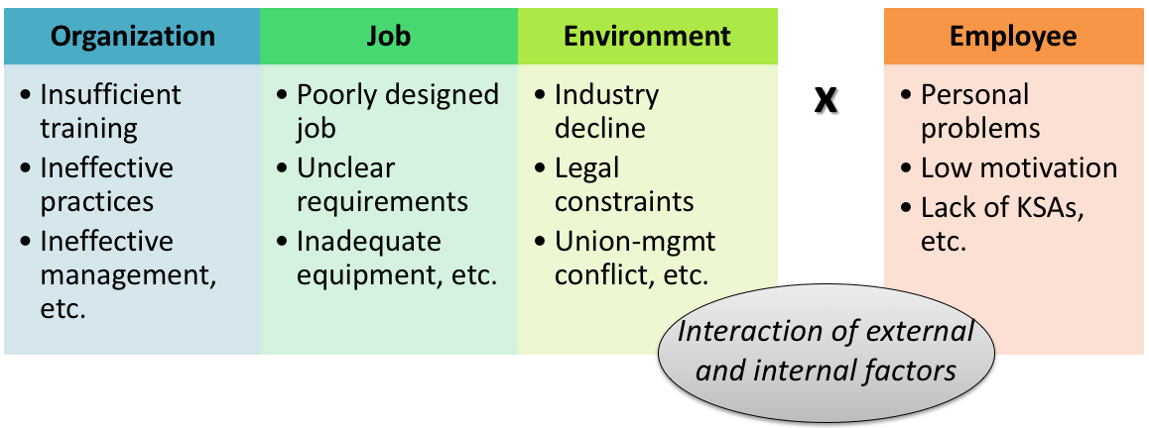

- Manage ineffective performance
  - Intervene to target the source of ineffective performance:
    - Offer training
    - Transfer employee
    - Modify working conditions
    - Re-design job, etc.
Practice questions
- Arman has been hired as a HR professional at a cosmetics manufacturing firm. The firm currently uses an appraisal method that lists traits such as “proactive”, “organized” and performance values ranging from “needs improvement” to “outstanding”. Which appraisal method is that firm using?
  - Behavioural checklist
  - Behaviour observation scale
  - Trait assessment scale
  - Graphic rating scale
  - Behaviourally anchored scale
- Performance management should meet the following guidelines except:
  - Performance standards should be job-related
  - Employees should be given a written copy of their job standards before the appraisal
  - Users should be trained to use the performance management system correctly
  - Peers and/or members of the employee’s team should be involved in the process
  - The focus should be on behaviours rather than on the employee’s traits
-------------------------------------------------------------------------------------------------------------------------------
5 March 2018 – Class 8
Chapter 7: Rewarding and Recognizing Employees (Chapter 8)

Compensation: Introduction
- Compensation includes all forms of rewards (financial or not, direct or not) that employees receive for their work
- Pay is one aspect of compensation… but it is an important motivator
- Types of compensation (rewards):
  - Financial:
    - Direct: Wages, salary, incentives, bonuses, commission
    - Indirect: Benefits supplied by the employer (dental plan, life insurance, etc.)
  - Non-financial:
    - Perks that have no monetary value: Recognition programs, interesting work, flexible hours, etc.
- Stay away from hoping to make more money when telling employees
  - Try not to keep job security
Compensation as part of company strategy
- Why? Strategic advantages of well-designed compensation (which lead to higher organization performance):
  - Motivates employees
  - Contributes to the attainment of organization goals
  - Reinforces the organization’s culture, etc.
- Importance of thinking in terms of “total rewards” (financial direct, financial indirect, non-financial compensation)
  - Pay, benefits, work-life balance, recognition, development and career opportunities
- Specific goals of compensation (what well-designed compensation can do):
  - Reward past performance
  - Remain competitive in the labour market
  - Maintain salary equity among employees
  - Blend employees’ performance with organizational goals
  - Control compensation budget
  - Attract, motivate, retain employees
  - Influence employee behaviours and attitudes
- How? Organizations should:
  - Offer equitable compensation (internally, externally): Corresponds to value of the work, and respects ratios of social comparison process see equity theory
  - Pay for performance: Tie direct financial rewards to employee, team or organizational performance see incentive plans
  - Choose the appropriate basis: Hourly work, piece work, or salary (amount per pay period)
Equity theory
- Individuals are motivated by a sense of fairness in rewards distribution, which results from:
  - A social comparison with others, i.e., the referent(s), based on perceptions of:
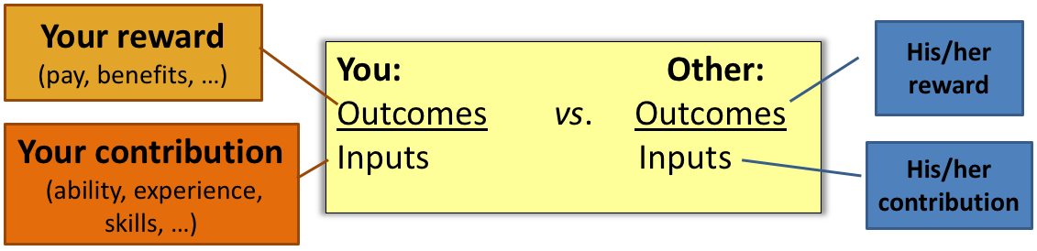

  - The perceived value of work, and whether pay is perceived to be equal to it
Determining compensation
- Internal factors:
  - Compensation strategy/policies: Organization’s objectives to lead, lag, or match competitors
  - Worth of the job: Internal relationships among jobs (see job evaluation)
  - Employee’s relative worth: Individual employee performance
  - Ability to pay: Organization’s resources and profits
- Job evaluation system: Systematic process of determining the relative worth of jobs within an organization
  - Based on:
    - Skill
    - Effort
    - Responsibility
    - Working conditions
  - Job evaluation systems:
    - Job ranking system: Job arrayed on basis of relative worth, compensation determined by rank
    - Job classification system: Jobs classified and grouped based on certain factors, jobs of same group get same compensation (descriptive)
      - Groups people doing same job
    - Point system (refers to “based on”): Attribute points to jobs on basis of “compensable factors”, compensation based on sum of points (quantitative)
      - Specific to you and the position
    - Factor comparison (refers to “based on”): Also uses compensable factors, but compensation based on comparison with those of key jobs within organization (quantitative)
      - Uses point but what does it mean to the company
- External factors:
  - Economy: Current economic conditions
  - Labour market conditions: Supply and demand of potential employees
  - Area wage rates: Rates of other area employers for comparable jobs
  - Cost of living: CPI: Consumer price index
    - Real wages only increase if increase is > to CPI
    - Must know real wages and is if it’s greater than cost of living
  - Collective bargaining: Negotiated agreements
    - Unions want real wages to increase, i.e. > than CPI rise
  - Legal requirements: Legislation on pay equity and basic employment conditions
Compensation structure
- Tools (can be combined):
  - Wage and salary surveys: Survey of wages paid by employers in the organization’s labour market (area from which the organization obtains workers)
  - Wage curves: Relationship between the relative worth of jobs and their wage rates (in the organization, area, etc.)
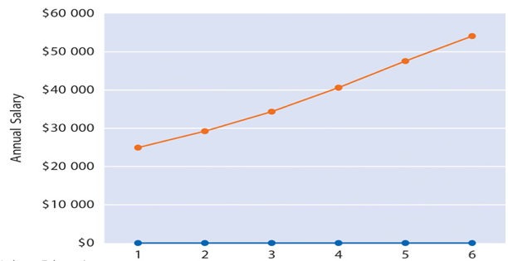

  - Pay grades: Groups of jobs within a particular class that are paid the same rate or rate range (see below)
    - If job evaluation was conducted using the classification system, jobs are already grouped; otherwise, pay grades must be established
  - Rate ranges: Range of rates for each pay grade
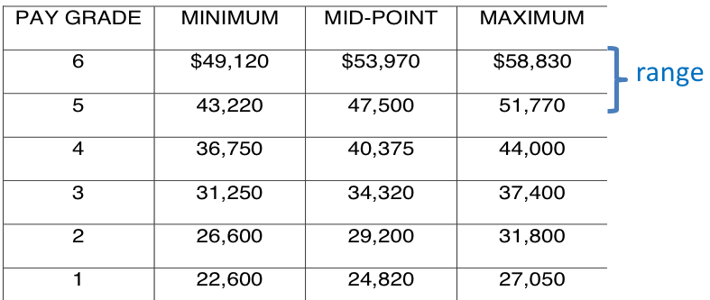

  - Other ways (not job based): Competency-based (or knowledge-based, skill-based, etc.) pay – based on employees’ capabilities, or how many jobs they can perform
    - Broad-banding: Collapsing many traditional salary grades into a few wide salary bands
Incentive plans
- Incentive plans (variable pay): Tie employee compensation with the attainment of organizational objectives (individual, team or organizational level performance)
- Examples:
  - Individual bonuses
  - Team or group-based incentives
  - Merit raises
  - Gainsharing
  - Profit sharing
  - Employee stock ownership plans
Employee benefits
- Benefits: Indirect form of financial compensation to improve employees’ quality of life (work and personal)
  - Can be voluntary or mandatory
- Benefits programs should be linked to specific objectives:
  - Improve employee satisfaction
  - Meet employee health and security requirements
  - Attract and motivate employees
  - Retain top performers
  - Maintain a favourable competitive position
- Cost concerns of benefits programs:
  - Typically 35% - 45% of payroll
  - Largely a fixed cost… which is increasing
- Mandatory benefits: (MUST KNOW)
  - Canada & Quebec pension plan
  - Employment insurance (EI)
  - Provincial hospital and medical services
  - Leaves without pay (compassionate leaves – attend to someone with cancer, or children, etc.)
  - Other benefits related to employment standards (holidays)
- Voluntary benefits:
  - Health and welfare benefits
    - Dental and/or health coverage, life insurance
  - Retirement and pension plans
    - Defined benefit or defined contribution plans
      - Defined benefit not there anymore really
  - Pay for time not worked
    - Vacations with pay, paid holidays, sick leave
  - Employee wellness programs
    - Seek to enhance employee health and wellbeing
  - Employee assistance programs
    - Diagnosis, limited counselling and referral for various difficulties (financial, emotional, substance abuse)
  - Educational assistance programs
    - Seek to help employees keep up to date with advances in their fields
  - Childcare and eldercare
    - Helps employee with child and elderly relative arrangements
Exercise in-class
- Should only look at performance when giving bonuses
Practice questions
- The term pay-for-performance can encompass all of the following except:
  - Merit pay
  - Base salary
  - Cash bonuses (?)
  - Gainsharing plans
  - Profit sharing plans
- An employer wishing to raise the real wages of employees would have to:
  - Grant across the board wage increases
  - Re-evaluate jobs in order to upgrade their worth
  - Pay employees on a pay for performance standard
  - Grant wage increases larger than the cost of living (?)
  - Increase wages more than competitors
- A quantitative job evaluation procedure that determines a job’s relative value on the basis of quantitative assessments of specific job elements is known as:
  - Point system
  - Job ranking
  - Job grade system
  - Factor comparison method (?)
  - Wage and salary surveys
-------------------------------------------------------------------------------------------------------------------------------
12 March 2018 – Class 9 (Substitute)
Chapter 8: Creating a Safe and Healthy Work Environment (Chapter 3: Creating a Culture of Well-Being)

Well-being, health and safety: Introduction
- Workplace well-being, health, and safety refers to organizations’ role in promoting and protecting employees’ physical and psychological health at work
- Each year:
  - Over 900 workplace related deaths
  - Over 1 million work-related injuries – over 300,000 serious enough that the worker misses a day of work
  - Over 12 billion dollars paid out to injured workers and their families
- Workplace health/wellbeing issues are important and costly for organizations AND society
The law
- Applicable legislation
  - Federal: Canada Labour Code
  - Provincial: Act respecting Occupational Health and Safety (Quebec)
- Employees and employers (including supervisors) have a legal obligation to maintain a safe and healthy workplace
- There are minimum requirements, but organizations can do more!
The law: Types of health incidents
- Occupational injury (this is when damage was done)
  - Cut, fracture, sprain, or amputation resulting from a workplace accident or from an exposure involving an accident in the work environment
- Occupational illness (more over time)
  - Abnormal condition or disorder caused by exposure to environmental factors associated with employment
- (Industrial disease) (related to occupational illness)
  - Disease resulting from exposure relating to a particular process, trade, or occupation in industry
  - People working with asbestos
The law: Duties and responsibilities
- Employers’ duties
  - General:
    - Provide hazard-free workplace
    - Comply with regulation
    - Take every reasonable precaution to ensure employee health & safety
      - Sometimes justification for discriminating (bona fide occupational requirement)
      - Reasonable expectation or reasonable accommodation which is what most organizations would generally do to deal with it
  - … includes these specific duties:
    - Inform employees about health & safety requirements
    - Investigate accidents and keep records
    - Compile annual summary of work injuries and illnesses
    - Report accidents that cause injuries and diseases
    - Ensure supervisors are familiar with the work and hazards
    - Provide health and safety training
- Workers’ duties
  - Comply with acts and regulations
  - Report hazardous conditions or defective equipment
  - Follow health & safety rules and regulations
- Workers’ rights
  - Request and receive information about health & safety
  - Refuse unsafe work (with exceptions)
    - If the nature of the job has some dangers associated with it, can’t refuse (like policeman, but construction workers with employer not implementing all safety measures could refuse)
- Supervisors’ duties
  - Advise employees of potential hazard
  - Ensure workers wear safety equipment, devices, or clothing
  - Provide written instructions about health and safety
  - Take every reasonable precaution to guarantee health and safety of workers
- Joint health and safety committee’s duties
  - Advise employer
  - Create a non-adversarial climate
  - Investigate accidents
  - Train others in health and safety obligations
The law: Penalties
- Penalties (fines) vary across provinces and territories
- Criminal charges may be brought against employers, co-workers, supervisors, executives when a worker is injured or killed on the job
The law: Workers compensation
- Workers may receive
  - Cash payouts (for permanent disability)
    - If temporary then temporarily covered
  - Wage loss payments (if worker can no longer earn as much)
  - Medical aid
  - Vocational rehabilitation
- Goal: Return the employee to original job
- All of this works with mental health too like for burnout, but employers aren’t sure how to approach employee to see if better, or how frequently to contact etc.
  - Employees might have to hide their recuperation for fear of insurance companies wishing them to no longer need money for not working
Creating a safe work environment: The safety program
- Purposes of a safety program:
  - Promoting safety awareness
    - Most important role
    - Most effective when:
      - Managers are good role models
        - (People learn from social learning theory or operative learning theory)
      - Employees willingly obey and champion safety rules
        - Different levels of motivation, but also qualities of motivation (controlled, autonomous, intrinsic, external, internal, etc.)
    - Supervisor is key, but employees should be actively involved
    - Topics: First aid, accident investigation, accident prevention techniques, hazardous materials, emergency procedures
  - Enforcing safety rules
    - Communicate specific expectations and standards to workers
    - Specify penalties and apply them consistently
  - Investigating accidents and keeping records
    - Supervisor and a member of the safety committee should investigate every accident
    - Keep records, including incidence rates:
      - # of injuries & illnesses x 200 000
Total hours worker during the period
Health & safety issues
- Physical health
  - Workplace hazardous materials: WHMIS: Information system about these materials; based on labels, data sheet, training
  - Indoor air quality: Inadequate ventilation, pollution
  - Technology: Video display terminals (watching screen for many hours)
  - Cumulative trauma disorders: Musculoskeletal disorders (use ergonomics to improve)
  - Communicable diseases: SARS, AIDS (covered in public health, not occupational health legislation), ex: flight crew being exposed to it
- Workplace security
  - Workplace violence: Physical assaults, threats, harassment, verbal abuse, etc.
    - Proactive security measures are related to workplace design, administrative practices and work practices
    - May include forming a crisis management team
    - Warning signs:
      - Crying, sulking or temper tantrums
      - Excessive absenteeism
      - Disregard for health and safety of others
      - Disrespect for authority
      - Increased mistakes or errors
      - Refusal to acknowledge performance problems
      - Overreacting to criticism
- Psychological health
  - Workplace stress: Any adjustive demand caused by physical, mental, or emotional factors that requires coping behaviour
    - Goal-setting theory: Ambitious (realistic) goals that are detailed to achieve, but may not achieve goals
      - Leads to higher performance every time
    - Stressors: Role ambiguity (vague expectations), deadlines, incompatible expectations from different people or incompatible tasks with expectations
  - Causes of workplace stress (examples):
    - High workloads (role overhead)
    - Unclear expectations (role ambiguity)
    - Incompatible demands (role conflict)
    - Poor work-life balance
    - Lack of resources, autonomy, communication, recognition
    - Organizational changes
    - Excessive job pressures
    - Precarious employment, concerns about income
    - Conflict with others, etc.
  - Not all stress is bad!
    - Damageable when it reaches a certain point (which varies depending on context, person)
Can’t ever really go wrong by mentioning that training is a solution to any HR issue
Creating a healthy work environment
- Building better health involves developing and maintaining a culture of health for employees
- A multidimensional approach works best: Addressing physical, psychological, social health
- Specifically, organizations must reduce sources of:
  - Physical health issues
  - Psychological health issues
  - Workplace violence
- Tools:
  - Health services
    - Related to size of organization
    - From basic first-aid to complete diagnostic, treatment, etc.
  - Alternative approaches
    - Less invasive approaches such as relaxation, chiropractic, therapeutic massage, diets, etc.
  - Wellness programs
    - Programs that emphasize exercise, nutrition, weight control, avoiding substances harmful to health
  - Disability management
    - Integrated approach to deal with short- and long-term absences
      - Integrated implies that there are different departments that need to communicate
    - Aims to create a work environment that employees want to come back to
  - Employee assistance programs
    - Provide short-term counselling and referrals to appropriate professional
    - Deal with psychological/mental health problems such as:
      - Personal crises
      - Emotional problems
      - Substance abuse
      - Job-related stress
Practice questions
- Which of the following is not an employee responsibility or right related to safety?
  - Employees must exercise discretion in the use of protective equipment
  - Employees must follow safety and health rules and regulations
  - Employees are required to comply with all applicable safety standards
  - Employees must report hazardous conditions
  - Unless it’s part of their job description, employees can refuse unsafe work
- Company-sponsored nutrition, weight control, and smoking cessation programs are often organized under larger plans known as:
  - Wellness programs
  - Employee assistance programs
  - Alternative approaches programs
  - Health service programs
  - Disability management
-------------------------------------------------------------------------------------------------------------------------------
19 March 2018 – Class 10
Chapter 9: Management Rights, Employee Rights, and Discipline

Rights and discipline: Introduction
- Management has the right to make decisions about how business is run
  - Implies the right to hire, discipline, and terminate employees
  - However, these rights must be exercised a certain way, i.e. there are also responsibilities
- Can boss force employee to stay and work overtime on a project?
  - Can’t physically force the person
  - Can strongly urge corporate employee, salaried employee
  - Management’s right to manage to force the employee
  - Employee rights to privacy, to have safe and good workplace, not that management can’t manage
  - If employee has plans previously, may be able to get out of it
  - Sometimes if manager harasses to do overtime simply to put employee in lower position, then employee could say they’re taking advantage of their rights
Employee rights
- Employee rights refer to the expectation of fair treatment from employers
  - Granted by:
    - Governments (legislation)
    - Employers (contract)
    - Courts (e.g., due process)
  - Employers must exercise reasonable care… Otherwise they can be held negligent by outside parties or employees
    - Reasonable care: Know you have drug issue and I put you in a situation where you work with pharmaceuticals and you steal it or someone gets sick, then I’m being negligent
    - All of the KSAs are all the steps taken to ensure that it is best person for job so that people don’t get hurt
- Don’t have to tell employees that they have cameras legally, but out of respect for employee, managers tend to tell employees
- Employee rights in-class discussion
  - Must have policy on clothing
  - Clear policy on alcohol, how much consumed, who’s paying, if company is paying then company is responsible for the rape
  - Alcohol is never an excuse because whatever is said must be followed through
- Types of employee rights
  - Employment protection rights: Deal with the main aspects of the employment relationship (termination, progression)
  - Job expectancy rights: Deal with specific issues on (and sometimes off) the job
Employment protection rights
- Statutory rights
  - Derive from legislation
  - Ex: Human rights, basic employment conditions, health and safety
- If you are a consultant/contractor and you have a verbal agreement, is that binding? Can that be held up in a court of law?
  - Technically should be in writing, but a verbal contract is binding so they can be held accountable if they offered job
  - Especially if detailed about the job about what they’ll do, more weight given
- Contractual rights
  - Derive from contracts (written or verbal, may be implied)
  - E.g.: Type of work, length of work, compensation
  - To lessen vulnerability to verbal contracts:
    - Make supervisors aware that words can be binding
    - Train supervisors not to imply contractual rights
    - Include statement regarding termination with proper notice or for just cause in employment offers
    - Explain nature of employment relationship in writing
    - Keep proof that employees have read documents
- No longer need the position, would I be able to get rid of you? Not guaranteed continuous employment under any circumstance
  - Could rename the job but it’s basically the same thing
  - Only have the right because employees don’t think they have the right to challenge it, but can prove it by same job description and job would be yours
- Due process
  - Employee’s right to a fair process (procedural justice) in decisions related to the employment relationship (dismissal)
  - Derived from the courts
  - May include the following:
    - Right to know job expectations and consequences of not fulfilling them
    - Right to consistent and predictable action for rule violation
    - Right to fair discipline based on facts
    - Right to appeal disciplinary action
    - Right to progressive discipline
  - NB: Employee rights are not a guarantee of permanent or continuous employment
Job expectancy rights
- Employee searches and electronic monitoring
  - Employers have the right to search and monitor employees, but must be reasonable in doing so (probable cause)
  - Employees have no reasonable expectation of privacy in places where rules that provide for inspections exist
- Electronic privacy
  - Employees’ right to privacy does not extend to email and voicemail messages
  - Employers have the right to monitor materials created, received, or sent on company-owned material
- Employers should:
  - Establish a clear, written policy
  - Communicate the policy to employees
  - Apply policy in a reasonable, consistent manner
  - Clarify consequences of not abiding by the policy
  - Confront employee suspected of misconduct to give him a chance to explain, modify behaviour before undertaking actions
  - (Procedural justice)
- Substance abuse and drug testing
  - Employers must provide a safe, i.e. drug-free environment
  - No legislation on drug-testing, but some organizations have drug-testing policies (situation unclear…)
- Access to employee files
  - Applicable legislation: Personal Information Protection and Electronic Document Act (PIPEDA, federal), Act respecting the protection of personal information (provincial)
  - Employees are entitled to examine their file
    - Medical aspect is personal, yes hire or no restrictions, no right to know specifics to a job, and should ask for a copy of the results
  - Information cannot be disclosed or used without the employee’s prior knowledge and consent (general principle)
- Employee conduct outside the workplace
  - Monitoring of employees outside the workplace is a complex issue
  - Generally, employee conduct outside the workplace is not subject to employer disciplinary action
  - For the employer to be justified in disciplining an employee for his conduct outside the workplace, a clear relationship must be established between the misconduct and its negative effect on the organization or on other employees
Discipline
- In HR, discipline generally refers to actions to correct undesirable conduct and getting employees to conform to certain standards…
- But the main goal is that employees receive fair, constructive treatment to improve their behaviour
  - Employer right to discipline employees is limited
  - Use of discipline must be justified, and governed by effective and consistently applied policies and procedures (procedural justice)
  - Supervisor is primarily responsible for applying disciplinary measures
- Overview of the process: (REMEMBER THIS SLIDE)
  - Set organization rules/policies (1)
    - Set clear expectations of performance and behaviour
      - Set reasonable rules
      - Distribute information to all employees
      - Provide written copy
      - Explain the reasons for rules
      - Review rules periodically
  - Define discipline (2)
    - Must be punished effectively or else policies aren’t being implemented
    - Clarify what discipline means in your organization
      - Dictionary meanings:
        - Treatment that punishes
        - Orderly behaviour in an organizational setting
        - Training that moulds and strengthens desirable conduct or corrects undesirable conduct and develops self-control
  - Apparent violation of rules occurs
  - Conduct an investigation (3)
    - Must document every conversation or event, record
    - Be objective, avoid assumptions, suppositions and biases
    - Document the events immediately, accurately and comprehensively
  - Interview the employee (4)
    - Push the person to get all of the information
    - I waived my right to explain if they refuse the opportunity to explain
    - Conduct an investigative interview with the employee
      - Focus on how the employee’s behaviour violated the rules
      - Give the employee an opportunity to explain
  - Take disciplinary action (5)
    - Goal: Improve employee’s future behaviour
    - Common approach: Progressive discipline (REMEMBER THIS) (applying corrective measures by increasing degrees); typically:
      - Verbal warning (1)
      - Written warning (2)
      - Suspension without pay (3)
      - Termination (4)
      - Exceptions (skipping steps) must be justified
        - Get fired without the first three can’t get rid, or just cause (pornography, drugs, stealing)
    - Alternative approach: Positive discipline (early correction of misconduct, employee taking responsibility for fixing the problem)
    - Compile a disciplinary record to be kept in employee’s file
    - Train managers on what/how to document
  - Respect due process (6)
    - Due process refers to the fairness of the procedure (procedural justice):
      - Communicated clearly
      - Applied consistently
      - Non-biased/objective
      - Opportunity for the employee to be heard
      - Opportunity to appeal, etc.
  - Assess Just Cause for dismissal (7)
    - Just cause means the employee violated the company’s rules or did not perform as expected, and if appropriate, has been offered an opportunity to resolve the problem
      - If there is, the employee can be dismissed
      - If there isn’t and the employee is dismissed, it may be considered “wrongful dismissal”
    - Ex: Poor performance, incompetence, interpersonal conflict (but not downsizing, lack of organizational resources, lack of fit)
    - NB: Changing an employee’s working conditions such that compensation, status or prestige is reduced is a “constructive dismissal”, and must be justified as well
  - Discharge if appropriate (8)
    - Discharge only if appropriate, after a thorough review of facts
    - Employers should:
      - Show personal consideration for the employee
      - Provide career transition assistance
Appealing disciplinary actions
- Alternative dispute resolution (ADR): Different types of employee complaint or dispute resolution procedures
  - Used in non-unionized organizations
    - In unionized organizations, collective agreements specify grievance procedures
  - ADR just saying you want an appeal because you don’t agree with it
- Alternative dispute resolution methods: (REMEMBER THIS SLIDE)
  - Mediation
    - Use of 3rd party to facilitate the resolution of the dispute
    - Mediator suggests solutions
  - Hearing officer
    - Full-time employee who assumes a neutral role when deciding cases between management and an employee
    - Actually works for the company (internal mediator)
  - Open-door policy
    - Identifies various levels of management above the immediate supervisor for employee contact
    - Less effective, can go talk to any department
  - Arbitration
    - Alternative method of solving disputes
    - Arbitrator’s decision is final and binding
  - Ombdusperson (most companies should have at least this)
    - Designated individual from whom employees may seek counsel
    - He has no other role within the organization
    - They are away from biases because they don’t report directly to management
  - Step-review
    - System for reviewing complaints and disputes by successively higher levels of management
    - Less effective, just go up hierarchy chain
  - IF these methods fail Seek legal resolution (Commission des Relations du Travail OR Canada Industrial Relations Board)
  - Company decides which resolution to use
Organizational ethics in employee relations
- Ethics are sets of standards of conduct and moral judgments that help determine right vs. wrong behaviour
  - They provide cultural (societal and organizational) guidelines
- Code of ethics are written acts of standards of conducts
  - They provide a basis for organizational members to evaluate their plans and actions
  - Strongly urged to be created if not in place already for a company
Practice questions
- In law, failure to provide reasonable care where such failure results in injury to others is known as:
  - Negligence (?)
  - Employee right
  - Just cause
  - Lack of clear expectations
  - Wrongful dismissal
- The right of an employee to expect that he will not be subjected to discrimination in the workplace is a(n):
  - Statutory right (?)
  - Matter of due process
  - Moral rights
  - Contractual right
  - Job expectancy right
-------------------------------------------------------------------------------------------------------------------------------
26 March 2018 – Class 11
Chapter 10: Labour Relations and Collective Bargaining

Labour relations: Introduction
- Labour relations: Interactions between managements and unions in organizations
  - Union: An officially recognized association of employees in the same company or industry
  - Purpose: Present a united front and a collective voice in dealing with management
- Collective front that gets together and they have issues that they want to get pull from management
- Performance appraisals with unions is really only seniority, so not your actual merit or effort you put in
Labour relations legislation (REMEMBER)
- Reminder: The applicable legislation depends on the jurisdiction in which the organization operates
  - Matters of “national interest” (baking, transportation): Canada Labour Code (Canada Industrial Relations Board)
  - Matters of “regional interest” (most employees): In Quebec, Labour Code (Commission des relations de travail)
- Common features of federal and provincial legislation:
  - Employees’ right to unionize
  - Employers’ obligation to recognize certified unions
  - Identification of unfair labour practices
  - Union rights (ex: strike) and employer rights (ex: lockout)
- Government decides if you can unionize or not and what the certification will look like
  - When you can and cannot strike (very particular time)
  - Only when in middle of renegotiation agreement
- Why would people unionize?
  - Can’t go around collective agreement when government steps in
    - People feel trapped
  - Sometimes employees don’t have a choice but you have to pay the union fees or else you can’t get the job
  - Not happy with pay or benefits so employees demand union
  - Employers abuse power
Why and how employees unionize (REMEMBER sequence of how it’s done is super important)
- Causes:
  - Desire to improve pay, benefits and working conditions (most important)
  - Dissatisfaction with managerial practices/supervisors
    - Usually one really strong character that would pull through and have to have many reasons
    - Once 50% does want a union, manager can’t really do much
    - People don’t really want unions though because it does limit future advantages
  - Social and status concerns
    - Note: Once a union exists, employees may join because it is a condition for employment (in collective agreement), i.e. union shop
- Sequence of events:
  - Employees want collective representation (1)
  - Organizing process (several steps, see next slides) (2)
  - Collective bargaining Leads to collective agreement (3)
  - Collective agreement is administered (4)
- Framework: Labour relations legislation
The organizing process (REMEMBER)
- Employees-union contact (1)
  - Employees an union officials get in touch and discuss the possibility of unionization
  - Employees identify the advantages of joining a union
  - Union officials gather information in order to win employee support
  - Union officials talk to management as well as employees
- Initial organizational meeting (2)
  - Organizer sets up a meeting to attract supporters, using information gathered in step 1, explains the advantages of joining a union
  - Need to have a specific person who will head this and be the link between the employees and the union
    - Outspoken
    - Thick-skin
    - Emotionally stable
    - Negotiable
    - Person everyone trusts (people go to this person with questions)
    - Someone who can bring people together and get them to push the boundaries (convince the employees)
    - Well-spoken (change the way they speak depending who they’re speaking to)
    - Knows what he’s talking about (credible)
    - Has done a wealth of different duties within the job to really understand the different facets of the jobs
- Formation of in-house organizing (3)
  - Committee of employees willing to lead the campaign is formed
  - Role: Interest other employees to support an join the union
  - Committee gets employees to sign membership cards
    - Signed statement authorizing union to act as a representative for collective bargaining
    - Membership card must be signed (very important)
- Application to appropriate labour relations board (4)
  - If there is support, organizers present evidence to board (membership cards from employees in the bargaining unit)
    - Bargaining unit: Group of employees sharing common employment interests and conditions, to be covered by the agreement
- Certification by labour relations board (5)
  - Application is reviewed:
    - If sufficient support (more than 50%): Automatic certification
    - Otherwise, there will be a vote
    - There may also be a vote if there are signs of irregularities
  - Need 51% to get automatic certification, or it goes to vote which is a lengthier vote
- Election of bargaining committee and negotiations (6)
  - Bargaining committee is elected, in charge of negotiating a collective agreement
- Why does management not want unions?
  - Loss of control
  - Management aspect of day-to-day things changes with a union
  - What can and can’t an employer do?
    - Not allowed to threaten employees (not legal but they do indirectly)
    - Can’t change working conditions specifically when in middle of making the negotiations; can’t take advantage of the fact that they’re trying to do the negotiations by giving more work
  - What can and can’t employees do to encourage union?
Tactics: Employers
- OK/expected
  - Bargain in good faith
  - Make the case that employees have a right not to join a union or deal directly with the employer
  - Emphasize current advantages
- Unfair!
  - Interfere with the organizing or certification process
  - Dismiss, discipline, threaten employees for exercising their rights to form a union
  - Promise better conditions if employees vote against the union or join a particular union
  - Unilaterally change wages or working conditions during certification process or collective bargaining
  - Once a union is certified: Fail to bargain. hire strike-breakers
  - Once a collective agreement is signed: Treat employees differently than what the agreement says
  - Any other action not in accordance with the law
  - Can’t threaten, can’t bully
  - Unfair treatment
    - “What is your biggest concern?”
    - “Oh we feel like we’re paid less than competitor”
    - “Ok have plan in action, can’t promise anything, but bribe with % each year until it happens, and you still have promotions”
    - They tell union nah
    - Then management says due to budgetary constraints cannot follow-through
  - Can’t hire someone if others are picketing
    - Should not do because you’re taking away all bargaining power
    - Should you cross picket line or not?
      - Manager or non-unionized employee?
        - Purposely came to JMSB because they weren’t involved in supporting the red square so all other departments came to JMSB
      - Employees should not cross because it’s dangerous, not good for working relations, so if there is work to do, you do it at home
      - All communications of getting together amicably has passed, so now it’s a volatile situation, so employees are seen as the enemy
Tactics: Unions
- OK/expected
  - Present the advantages of joining a union
  - Provide fair representation for all employees in the bargaining unit
  - What they can offer you yes
- Unfair!
  - Interfere with the operation of the organization
  - Intimidate or coerce employees to become or remain members of the union
  - Pressure the employer to dismiss, discipline or discriminate against non-union employees
  - Not represent fairly all members of the bargaining unit
  - Go on strike before the expiration of the collective agreement
  - Any other action not in accordance with the law
  - Can’t put pressure to force them to go on strike or picket, or become volatile if it’s not necessary
Tactics
- Unfair labour practices are specific employer or union illegal practices that operate to deny employees their rights and benefits under labour law
  - The labour relations board
    - Examines charges of unfair labour practices
    - Determines whether unfair labour practices have occurred
    - Enforces applicable labour laws
- If there are issues there is the labour relations board who appoints a lawyer to take care of the issues
Jonquière Walmart unionization battle
- Was actually one of the most profitable locations in Quebec
- Employees brought Walmart to court and Walmart won
  - Table full of legal presentation
  - 2 people from Jonquière who stood for it
- Brought to supreme court and won against Walmart
  - Not allowed to change working conditions
  - So Walmart is still paying and compensating for them, and this little town did win
How unions operate
- Types and structure
  - Unions are often grouped under an umbrella organization (national, international)
  - National and international unions provide support to local unions
  - Unions have elected leaders
  - Distinction between types (craft, industrial unions) is less relevant today
- Officers of local union:
  - Union (shop) steward: None paid union official – employee who represents the interests of members in relations with management
    - Union steward: Not paid for by union?
  - Business agent: Paid union official who negotiate and administers the collective agreement
- A work in progress, used to have to be a part of an overarching field
  - But now if desire to unionize, have a right
- Normally done through an overarching umbrella (for this class)
The collective bargaining process
- Prepare for negotiations (1)
  - Each party describes what they want to talk about
  - Gather data:
    - Grievances
    - Disciplinary actions
    - Layoffs
    - Collective agreements in other firms
    - Economic conditions
    - Organization’s financial positions, etc.
  - Form bargaining teams
    - Then form bargaining teams (4-6 individuals from union and from management and usually a senior HR person included)
  - Which fields can’t completely strikeout
    - Police, firefighters, ambulance, very limited in what they can do, they can’t not work
    - Cops were getting cut on their pension, but because they did cargo pants mockery instead, thought they’d get public support for it, but instead people were annoyed by them
  - Am I prepared to go on strike and am I allowed to?
- Develop strategies (2)
  - Identify objectives (yours, and likely objectives of other side)
  - Identify nature of union-management, union-members relationships
  - Prepare contingency plan in case of strike
  - Ideally, interest-based approach
- Conduct negotiations (3)
  - Bargaining teams meet
  - Teams develop and analyze proposals
  - Attempt to resolve each issue
  - Should be done in good faith
  - Union powers: Strike, picket, encourage boycott
  - Employer powers: Keep operating (with managers), lockout
  - Use mediation and arbitration in case of deadlock
- Formalize collective agreement (4)
  - Conclusion of negotiations: Written, binding contract for union and employer
  - Provisions (REMEMBER)
    - Wages and benefits
    - Overtime
    - Health and safety
    - Discipline
    - Job security
    - Grievance procedures, etc.
The collective agreement
- Typical provisions:
  - Management rights:
    - Residual rights: Management’s authority is supreme in all matters except those it has expressly conceded in the collective agreement or where its authority is restricted by law
VS.
    - Defined rights: management has rights that are expressly defined
    - Manager has right to go through and punish them as see fit (management right to manage is still there)
  - Union security:
    - Closed shop: Employees must join union before being hired
    - Union shop: Employees must join
      - Union shop have 30 days but will have to join
    - Agency shop: Allows voluntary membership but employees must pay union dues
    - Open shop: Does not require employees to join or pay dues
      - Open shop have a union but don’t have to op in but not so relevant anymore
Grievance procedures
- Grievance: Complaint by employee (or employer) that some aspect of collective agreement has been violated
- Grievance procedures provides for the union with a formal process to represent the interests of employees (members and non-members) in processing a complaint
- Grievances me bae resolved through:
  - Discussion and compromise, or
  - Grievance resolution (arbitration): With the help of a neutral third party (binding)
    - When a mediator comes in and it’s binding and final decisions
Practice questions
- Six steps lead to unionization; at which step would labour organizers seek information about the employer’s finances, supervisory styles, and management practices?
  - Employee/union contact
  - Initial organizational meeting
  - Formation of in-house organizing committee
  - Application to relation board
  - Election of bargaining committee and negotiations
- Once a bargaining unit becomes certified, the employer is required to:
  - Sign a collective agreement
  - Deduct union dues from everyone’s pay
  - Notify employees of the bargaining relationship
  - Notify the labour relations board
  - Begin negotiations toward a collective agreement

8-10 min presentation 5min question period
- Everyone has to talk
- 8 minutes focused on phase 2 could literally just show it
- Very easy not substantial focus more on phase 2 than project
- Put it up here’s our product this is how they’re going to use it who will use it
- Do not want me to stop you

Phase 2 if 15 pages it’s fine
Appendix only job description

Final april 21
- 30 mc (40%) abcde
  - No trick questions
  - What it is and what you answer
  - some are scenario
- 8 short answer questions (60%) start off with this
  - Understand terminology the concepts, this is what happened here so therefore this should happen
  - Define 4 aspects of this
- Have a grader
  - Don’t assume she knows what I’m talking about
- Can use point form

