equilibria

Partnership Between: Nagaad Warsame, LindEn Beauchamp, Tuo-Yu yang, Janaya petteplace

Student ID Warsame: 300010460
Student ID BEAUCHAMP: 300034972
Student ID YANG: 6562506
Student ID petteplace: 300022816
Date: October 19, 2017
Teachers Assistant: Alex Daniels
Senior instructor: Dr. Rashmi venkateswaran

Introduction
purpose
To determine qualitative assessments of pH on a scale to measure acidity, and to describe the effect of different reactants and external stimuli on a reaction equilibrium.
lab concept
In this experiment, the goals are to as be described in the lab Equilibria (Venkateswaran):
- Observe shifts in equilibria
- Observe multiple equilibria using the silver ion
- Prepare a buffer system
- Observe the effects of acids and bases on a buffer system that stimulates a metabolic reaction

chemical reactions
The following reactions have been performed in stages one, two and three of the experiments respectively:
- $Cu{SO}_{4} → Cu{\left(H_{2}O\right)}_{n}\left(SO_{4}\right) [1]$
- $Cu(H_{2}O)_{n}\left(SO_{4}\right) ↔Cu(NH_{3})_{n}\left(SO_{4}\right) [2]$
- $NH_{3} →\left( NH_{4}\right)+ Cl^{- } [3]$
Hypothesis
Part 1 of the Experiment: According to Chatelier’s Principle, if more reactants are added, reaction will shift to the right-hand side of the equation (therefore its will favour the products side) and vice-versa.
Part 2 of the Experiment: Silver ions help maintain equilibria because they are amphoteric (can act as both acids and bases in a solution).
Part 3 of the Experiment: Buffer solutions in the body are usually weak acids/ bases.

Background Information

Equilibrium
Most commonly, chemical reactions are written with one arrow going from reactants to products in a straight line:
$$NaOH_{(aq)}+HCl_{(aq)} → NaCl_{\left(aq\right)}+{H_{2}O}_{\left(l\right)} [4]$$
However, the term equilibria refer to reactions that do not go straight from reactants to products but often describe reactions that go into a stage where the rate of reactants to from products is equaled by the rate of products going into reactants (Venkateswaran).
$$Cu(H_{2}O)_{n}\left(SO_{4}\right) ↔Cu(NH_{3})_{n}\left(SO_{4}\right) [2]^{*}$$

The reactions do not stop but they signify that any additional product/reactant is not finalized, but will most likely continue to revert to opposite stages of the reaction. Some reactions favor products and some favor the reactants, all of which depend on equilibrium constant.

Equilibrium Constant
An equilibrium constant, $K_{c}$, is the ratio of products to the concentrations of reactants at equilibrium. The concentration of each species’ coefficient in the balanced chemical equation (LibreTexts).
$$aA+bB ↔cC+dD+heat [5]$$

$$∴the equilibirum constant is as follows:K=\frac{[C]^{c}[D]^{d}}{{[A]}^{a}{[B]}^{b}} [6]$$

From this reaction, we can see that the reaction is product favored, the equilibrium constant thus is a large number. Similarly, a small equilibrium constant indicates a reaction-favored reaction.

Le Chatelier’s Principle
Le Chatelier’s Principle always states that a reaction will always move in the direction that minimizes the effect of any change imposed on a system at equilibrium (Venkateswaran). As seen in the exothermic chemical reaction equation $[5]$, if more heat is added to the reaction it will shift to the left where heat I lowered/ dissipated in order to maintain equilibrium. As well as, if pressure increases in an equilibrium system, the reaction will shift to the side favoring reactants/products with less moles.
Example (Increasing Pressure):
$$A_{(g)}+ {2B}_{(g)} ↔C_{(g)}+ D_{(g)}$$
In this equilibrium chemical reaction, the reaction will shift to the right (products) which ultimately produce less moles, taking up less space in the container.

Weak Acids and Bases
When an equilibrium reaction favors one side, the species that dissociate completely are denoted as strong acids and bases. Whereas, weak acids and bases do not dissipate completely when placed in water. As described in the Equilibria Lab by (Venkateswaran):
$$CH_{3}COOH_{3\left(aq\right)}(acid)+ H_{2}O_{\left(l\right)}(base) ↔ H_{3}O_{\left(l\right)}(conj.acid)+{CH}_{3}{OO_{\left(aq\right)}(conj.base)}^{-}$$

pH and Indicators
pH is the main method used to determine the pH of a solution. Indicators are complete organic compounds. An indicator is usually a weak acid that dissociates into different extents in a solution depending on the acidity of the solution (Jircitona). Important indicator if the solutions acidity/ basic solution is the shade of its coloration which can then be samples against pH indicator timeline indicating what every colour represents as seen in the following figure below.
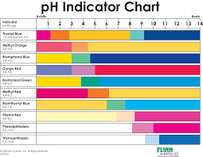

Figure 1: Indicates the pH Indicator Chart

procedure
As described in the lab manual (Violent Fires Soon Burn Out Themselves, Small Show’rs Last Long, But Sudden, Dr. Rashmi Venkateswaran, 2000, Exp.1,all pages).

observations

Data Tables

Table 1: Observations of part 1 of experiment - equilibrium shift
Step | Action | Observation
1 | Adding approximately 1 ml (20 drops) of 0.1 mol/L CuSO₄ | Solution is clear, in light blue colour
2 | Adding concentrated NH₃ until observe a change; change observed after 2 drops (appx. 0.1 ml) | Colour turned to dark blue, solution remained clear
3 a) | Adding 1 mol/L HCl until observe a change. First change observed after 8 drops (appx. 0.4 ml) | Colour started to fade
3 b) | Continually adding 1mol/L HCl. Second change observed after 14 drops (appx. 0.7 ml) | Colour turned to light teal, and solution became translucent
3 c) | Continually adding 1mol/L HCl. Third change observed after 20 drops (appx. 1 ml) | Solution returned to the original light blue colour in Step 1, and became clear again
4 a) | Repeating step 2-3. First, adding concentrated NH₃; change observed after 2 drops (appx. 0.1 ml) | Colour turned to dark blue, very similar to the observation after step 2, and solution remained clear
4 b) | Adding 1 mol/L HCl. Change observed after 8 drops (appx. 0.4 ml) | Colour started to fade, solution remained clear

Observations: Table 2: Observations of part 2 of experiment - multiple equilibria
Step | Addition | Qualitative Observations
5. | 0.5mL Na₂CO₃ in its concentration of 0.1M | Clear and colourless
6. | 0.5mL AgNO₃ with concentration of 0.01M | Changes colour to become sandy brown similar to brown paper towel and cloudy, colouring has a gradient with denser colouring at the bottom of the test tube and a lighter at the top of the mixture
7. | HNO₃ in concertation of 6M, 4 drops, roughly equivalent to 0.08mL | From cloudy with a sandy brown colour to clear and colourless
8. | 2 drops of HCl in concentration of 0.1M, roughly 0.04mL | Changed to have a cloudy white colouring
9. | 2 drops of NH₃ concentrated, roughly 0.04mL | Changed from cloudy and white to clear and colourless
10.a) | 2 drops of HNO₃ in concentration of 6M, roughly 0.04mL | Changed to have a cloudy white colouring, similar to the reaction the first time this compound is added to the mixture, only with the addition of small bubbles forming
b) | 2 drops of NH₃ concentrated, roughly 0.04mL | Changed from cloudy and white to clear and colourless., similar to the reaction the first time this compound is added to the mixture
11. | 2 drops of KI in concentration of 0.1M, roughly 0.04mL | Clear and colourless mixture becoming cloudy with a pale yellow colour, precipitate can be seen forming and falling to the bottom of the test tube
12. | 2 drops of Na₂S in concentration of 0.1M, roughly 0.04mL | Precipitate of a medium gray to light gray forming in various sizes with the liquid of the solution turning a light gray to brown colour

Table 3: Observations of Part 3 - Buffers
Step | Action | Quantitative Observations | Qualitative Observations
14 | Insertion of pH probe into beaker with distilled water | pH of 4.82 | Solution is clear, colourless and odourless
15 | Addition of 2.52 g of NaHCO₃ to solution | pH of 5.01 | No visible change from previous step
16 | Addition of 30 mL of 0.1 mol/L HCl (aq) to solution | pH of 1.78 | Reaction completed in under 30 seconds  Solution is colourless and transparent  No observable colour change  No visible change from previous step
17 | Addition of 10 mL of 0.85% lactic acid to solution | pH of 1.80 | No visible changes from previous step
18 | Increasing the stirring rate of solution | pH of 1.79 | No visible changes from previous step
19 | Addition of 0.50 g of NaHCO₃ to solution | pH of 6.14 | Bubbles of gas observed on sides of beaker and within the vortex of solution  NaHCO₃ completely dissolved in solution  Solution is colourless and transparent  No observable colour change
20 | Addition of 0.60 g of NaCHO₃ to solution | pH of 6.75 | More bubbles observed on sides of beaker and in vortex of solution  NaHCO₃ completely dissolved in solution  Solution is colourless and transparent  No observable colour change
21 | Addition of a large pellet of CO₂ to solution | pH of 6.66 | Bubbles of CO₂ are coming off the dry ice in the solution, which rise to the surface and burst.  Bursting of CO₂ is a white gas that appears like a white dense smoke  A layer of CO₂ about 1.5 cm in height remains above the surface, but slowly dissipates.  Pellet completely dissolves  Solution is colourless and transparent
22 | Addition of 0.40 of NH₄Cl to solution | pH of 6.70 | Solution is colourless and transparent  No observable colour change  NH₄Cl completely dissolves

Discussion
Experiment 1:
In part 1, at the first point, the solution of 0.1 mol/L CuSO₄ is in light blue colour. This colour is caused by copper ions. When CuSO₄ solid, no colour, dissolved by water, an aqueous solution is produced; this complex has a specific structure to block the wave length of yellow light, therefore gives blue colour to the solution (LibreText,2017).
$$CuSO_{4}\underset{→}{nH_{2}O}Cu{\left(H_{2}O\right)}_{n}SO_{4}$$
After excessive NH₃ has been added to the solution, only 2 drops are needed and make it be excessive because the NH₃ added is concentrated, and the CuSO₄ solution used is 0.1 mol/L, the colour turned dark blue. The only product can explain this observation is Cu(NH₃)_{n}SO₄.
$${\left[Cu{\left(H_{2}O\right)}_{4}\right]}^{2+}\left(aq\right)+4NH_{3}\left(aq\right)↔{\left[Cu{\left({NH}_{3}\right)}_{4}\right]}^{2+}\left(aq\right)+4H_{2}O(l)$$
Copper ions are still responsible for the new colour of solution, but this time copper ions formed another species of complex ion [Cu(NH₃)₄]²⁺, which gave the solution a dark blue colour.
After 1 mol/L HCl is presented in the solution, the dark blue colour started to fade away; with the HCl gradually became excessive in solution, the colour returned to the original light blue colour at the beginning. This is because NH₃ reacts with HCl and generates NH₄CL
$${NH}_{3}+HCl\underset{→}{H_{2}O}{(NH_{4})}^{+}{Cl}^{-}$$
Since HCl is a strong acid and NH₃ is a weak base, HCl will compete with Cu(NH₃)_{n}SO₄ for NH₄⁺, left copper ions became dissociative and no longer in the form of a complexation product Cu(NH₃)_{n}SO₄, and no longer bound with NH₄⁺, and more NH₄Cl will presented in the solution. The molecule of NH₄CL, NH₄⁺ and Cl⁻ are all have no colour, and dissociative copper ions have no colour as well. All these attributes and facts lead the solution’s colour lighter.
In step 4, the same changes are observed when the previous chemicals are reintroduced, the amounts used of reactants to cause the observation result are the same. This observation is expected, according to the definitions of chemical equilibrium and Le Chatelier’s Principle, when more HCl is added in the solution, more copper ions will become dissociative and the equation will move towards left, and the solution colour turns lighter; when more NH₃ is presented, copper ions will bound back with NH₄⁺ because the high concentration, which make the solution colour turns to darker blue (the colour of [Cu(NH₃)₄]²⁺.
Experiment 2:
In experiment 2, the multiple agents were seen reacting and moving to equilibrium with the addition of new agents. The original compounds, AgNO₃ and Na₂CO₃ both appeared to be clear and colourless aqueous solutions.
The initial change when AgNO₃ is added to Na₂CO₃ is due to the Ag cations bonding with the CO₃ anions to form a precipitate. When first mixed a gradient in colour density was noticed, this was due to the precipitate settling to the bottom of the test tube. The filament was too fine to be seen and was not given appropriate settling time for the presence of the precipitate to be noticed. This mixing of these two reactants at these quantities to find equilibrium in their reaction.
$$2AgNO_{3}\left(aq\right)+ {Na}_{2}CO_{3}\left(aq\right)↔ Ag_{2}CO_{3}\left(s\right)+ 2NaNO_{3}\left(aq\right) [1]$$
In the presence of HNO₃, Ag₂CO₃ is broken apart and the Ag cation becomes attracted to the NO₃ anion to reform AgNO₃. This reaction can be explained through Le Chatelier’s Principle, the addition of HNO₃ changed the direction of the reaction to reduce the amount of change. This reaction is only reversible with the presence of a new compound as the CO₂ gas created from the reaction was released into the environment.
$$Ag_{3}CO_{3}\left(s\right)+2HNO_{3}\left(aq\right)→2AgNO_{3}\left(aq\right)+H_{2}O\left(l\right)+CO_{2}\left(g\right) [2]$$
When HCl is added to the solution, AgNO₃ will break apart and the Ag cation will bond with the Cl anion to form AgCl. This new compound is present in the form of a fine white precipitate creating the cloudy white colouring observed, the precipitate was not given enough time to settle to the bottom of the test tube to be recognized as a solid/
$$Ag{NO}_{3}\left(aq\right)+HCl\left(aq\right)↔AgCl\left(s\right)+HNO_{3}\left(aq\right) [3]$$
NH₃ is added to the solution it reacts with AgCl to break apart the compound and create Ag(NH₃)₂, bonding the Ag cation with the NH₃ anion. This reaction breaks apart a solid to form an aqueous solution thereby changing the observed colouring from cloudy and white to clear and colourless.
$$AgCl(s)+2NH_{3}(aq)↔Ag(NH_{3})_{2}(aq)+Cl^{-}\left(aq\right) [4]$$
The same observations were made when repeating steps 7 and 9, save that Ag(NH₃)₂ reverted to AgNO₃ with the addition of HNO₃, and then was converted back to Ag(NH₃)₂ when sufficient amounts of NH₃ were added to break the bonds of AgNO₃.
With KI added to the solution, Ag(NH₃)₂ will break apart and the Ag cation will pair with the I anion to form AgI, this compound is what creates the yellow colour observed. The cloudiness observed was most likely due to some of the NO₃ anions still present in the solution bonding with the now separate Ag cations before they had a chance to bond with this I anions.
$Ag(NH_{3})_{2}(aq)+KI(aq)↔AgI(aq)+2NH_{3}(aq)+K+\left(aq\right) [5]$ (Ideal reaction)
When Na₂S is added, the AgI compound will break apart, as will the Na₂S compound forming an Ag₂S solid precipitate that was observed to have a gray colour. Smaller particles of precipitate in the solution are what made the solution appear cloudy with a gray colouring.
$2AgI\left(aq\right)+Na_{2}S\left(aq\right)↔Ag_{2}S\left(s\right)+2NaI\left(aq\right) [6]$
Experiment 3:
In experiment 3 multiple weak acids and bases were used to create buffers and change equilibrium that simulated the buffer solutions within the blood system. The experiment started with distilled water that appeared clear, colourless and odorless.
By inserting the pH probe into the distilled water, its pH was measured to be 4.82. The measured pH was not expected, as the pH distilled water is neutral at around 7.0. This change is mostly likely caused by the residual amounts of buffer solution that remained on the pH probe even once is was doused in distilled water.
The addition of 2.52 g of NaHCO₃ to water caused the pH of the solution to increase to 5.01. A reaction that caused this change is the addition of sodium bicarbonate, which acts as weak base.
$$H_{2}O\left(l\right)+ NaH\left(CO_{3}\right)\left(s\right)↔ NaOH\left(aq\right)+ H_{2}\left(CO_{3}\right)\left(aq\right) [7]$$
This results in the sodium bicarbonate dissolving into sodium hydroxide and carbonic acid. These alkaline ions are responsible for the raised pH of the solution as the ion formation raises the amount of bicarbonate in the system and buffers excess hydrogen ion concentration; thus, raising the $pH$. As sodium bicarbonate is a weak base, this a reactant-favoured reaction and therefore, little product forms.
The addition of 30 mL of 0.1 mol/L HCl (aq) to the solution was done to simulate the effect of acidosis on the human body.
$$NaOH\left(aq\right)+ H_{2}\left(CO_{3}\right)\left(aq\right)+ HCl\left(aq\right)→ CO_{2}\left(g\right)+ H_{3}O^{+}\left(l\right)+ NaCl\left(aq\right) [8]$$
The addition of the acid to the solution of hydrogen carbonate ion created carbon dioxide gas, water, and sodium chloride. It was observed that the reaction took place quickly and the solution had no visible changes from the addition. The pH decreased to 1.79; this value when compared to the pH of distilled water, 7.0, and blood, 7.4, it is far lower on the pH scale, this means is has a greater concentration of hydrogen ions and would not be sustainable in the human body. $HCl$ is strong acid with a$K_{a}$greater than 1, therefore the reaction is product-favoured and would completely dissociate in the solution (CLAS). Species that are present in the solution is water and sodium chloride, with more water present than sodium chloride; while carbon dioxide is a by-product released as a gas.
The addition of 10 mL of 0.85% lactic acid to the solution stimulates the formation of a large amount of lactic acid
$$H_{2}O\left(l\right)+ CH_{3}CH\left(OH\right)CO_{2}H\left(l\right)↔ H_{3}O^{+}\left(aq\right)+ CH_{3}CH\left(OH\right)C{O_{2}}^{-}\left(aq\right) [9]$$
The pH of the solution is 1.80, 0.01 higher than the initial. The observation of this reaction that occurred was very little visible change, there was no change in the clarity or colour in the solution. Lactic acid dissociates in water resulting in lactate and hydronium ions. Lactic acid is a weak acid with a $K_{a}$value of $1.38 x 10-4$ and thus is partially ionized in water, as well due to the nature of weak acids and equilibrium, this reaction is reactant favored (CLAS).
By increasing the stirring rate of beaker, the pH of the solution decreased slightly from $1.80$ to $1.79$, there were no observable visible changes in the solution. This step is stimulating the body's attempt to compensate for low blood pH by increasing the rate of respiration, causing expelling of more carbon dioxide (Venkateswaran). However, the observations do not match the given information, this was not expected. Perhaps, due to the high amount of H₃O⁺ already present in the solution, the stirring had little effect on the $pH$.
The first addition of 0.50 g of NaHCO₃ to solution stimulated the effect of raising critically low blood pH by adding sodium bicarbonate
$$H_{3}O+\left(l\right)+ NaH\left(CO_{3}\right)\left(s\right)→ Na+\left(aq\right)+ H_{2}\left(CO_{3}\right)\left(aq\right)+ H_{2}O\left(l\right) [10]$$
The pH of the solution greatly increased to 6.14. The presence of the base and its ions greatly increase the pH, as well the conversion from a hydronium ion to water adds to this increase. It was observed that the dissolving of sodium bicarbonate released a great amount of gas in the form of bubbles. These bubbles stuck to the sides of the glass beaker and some became trapped in the vortex created by the magnetic stirrer. Sodium bicarbonate is weak base and thus the reaction is reaction favoured.
The second addition of 0.50 g, measured 0.6 g, of NaHCO₃ to solution stimulated the effect of elevated $pH$:
$$H_{2}O\left(l\right)+ NaH\left(CO_{3}\right)\left(s\right)↔ Na+\left(aq\right)+ H_{2}\left(CO_{3}\right)\left(aq\right)+ OH^{-}\left(aq\right) [11]$$
The pH of the solution was 6.75. More gas bubbles were observed trapped in the vortex and along the sides of the beaker. The body at this point should be experiencing alkalosis. However, this condition is seen in a pH range of 7.45-7.8; the observed pH of the solution never crossed this range. Sodium bicarbonate is a weak base and therefore this is a reactant favored reaction. The increase in pH was not as great as the first addition of sodium bicarbonate, this is due to the presence of sodium bicarbonate in the solution. Creating a buffer which explains the slight pH increase from the addition of an already present base.
The addition of a pellet of CO₂ to the solution simulates the effect of the body slowing respiration to decrease an elevated $pH$.
$$H_{2}O\left(l\right)+ CO_{2}\left(s\right)→ CO_{2}\left(g\right)+ H_{2}O\left(l\right) [12]$$
The solution has a pH 6.66, this is a decrease from the initial pH of 6.75. It was observed that once placed in the solution, the dry ice started to sublimate as seen in bubbles of carbon dioxide gas, which would rise to the surface and burst in the form of a white dense smoke. A layer of carbon dioxide about 1.5 cm in height formed above the surface and started to dissipate once there was little dry ice remaining; it completely disappeared once the dry ice was completely sublimated. This reaction is product favored and cannot be reversed as the presence of water causes solid carbon dioxide to immediately sublimate.
Addition of 0.40 of NH₄Cl to the solution stimulates that in the event of elevated pH, an acid is injected to retain homeostasis
$$H_{2}O\left(l\right)+ NH_{4}Cl\left(s\right)→ NH_{4}^{+}+\left(aq\right)+ Cl^{-}\left(aq\right)+ H_{2}O\left(l\right)↔ NH_{3}\left(aq\right)+ Cl^{-} \left(aq\right)+ H_{3}\left(aq\right) [13]$$
The pH of the solution is 6.70, a slight increase from the initial pH of 6.66. The ammonium chloride completely dissolved in water and there were no visible changes observed. Ammonium acts as a weak acid as it dissociates into ammonia and a hydronium ion. However, the $K_{a}$ is small, due to the nature of a weak acid, and little ammonia and hydronium are created.

Conclusion
Part 1 of the Experiment: A reaction will always shift towards to the side that minimizes the effect of changes imposed on a system at equilibrium, Le Chatelier’s Principle is justified.
Part 2 of the Experiment: Silver ions are amphoteric, capable of behaving both as acids and bases in a solution, can help maintain chemical equilibrium.
Part 3 of the Experiment: Weak acids and weak bases can be combined and consist buffer system in body and help body maintain a relatively stable pH value.

Questions to be Answered at the End of the Report

- Ammonium ion is used instead of the strong acid source of $H{Cl}_{(aq)}$ because it only partly ionizes in the chemical reaction (approximately less than 50%).
$$N{H^{+}}_{4}+ H_{2}O ↔ {NH^{+}}_{3}+ H_{3}O^{+}$$
In the above reaction, the weak acid of $N{H^{+}}_{4}$ did not ionize completely, thus, providing the ability to buffer the solutions compared to $HCl$.
- Chemical compounds like $NH_{4}{NO}_{3}$ and $NH_{4}I$ are more likely to negatively impact the body. $NH_{4}Cl$ is a good compound to be inserted for lower blood pH since it is a neutral salt with a low reactivity and toxicity. Ions such as ${Cl}^{-}, {Na}^{+}, K^{+}$ are all found in high amounts in then body. Therefore, the addition of dissociated common ions will not damage our body harmfully but adequately adjust our blood $pH.$

Equilibrium arguments demonstrates:
- In the reactions of adding acidic substances, the solutions changed in colour
- The color gradually (with more input of the metal) began to convert to a clear/colourless solution
The following reaction depicts the observations observed in steps 16 and 17.
$$M^{+}L+ H^{+} ↔HL^{+}+M^{+}H_{2}O$$
The qualitative observations of the above reaction depict M as the metal, L as the ligand and $M^{+}H_{2}O$ as the clear colourless solution we see at the end of the reaction.

The equilibrium reaction is the following reaction:
$$HbH^{+}+ O_{2} ↔HbO_{2 }+ H^{+}$$
At normal human bodily functions of $pH≈7.35$, lack of acidity allows $Hb$ to bind with $O_{2}$ and thus in the product side $H^{+}$ is dissociated. Conditions like acidosis, a pH significantly lower than that of blood pH, causes the equilibrium shift to the left, reactant side, according to Le Chatelier’s Principle. According to this basic principle, hydronium ions bind to the hemoglobin molecule and oxygen is completely dissociated. As a result, $Hb$ can no longer bind to $O_{2}$, affecting the patient’s ability to transport oxygen and maintaining normal bodily functions. 𝐻𝑏
4.
When 𝐻Cl was added to the blood sample, it broke apart the $HbO_{2}$ compound and 𝐻𝑏 bonded with Cl. Without the hemoglobin to bond to, the oxygen becomes a gas and dissipates from the solution changing the compound from oxyhemoglobin to deoxyhemoglobin, thus removing the rich red colour of blood and changing to black. The reaction equilibrium is changed to favour the reactants.
5.
The pH of the soda should lower to become more basic the longer it is exposed to the environment. Carbonic acid, $H_{2}CO_{3}$, is in higher concentration in a freshly opened can of soda than in an older opened can. The reason for this is that in a closed can under pressure the $H_{2}CO_{3}$remains in a liquid state. When the can is opened and the pressure is released the $H_{2}CO_{3}$is converted to gas and escapes the can, stirring the can will increase the rate of release and more acid will escape, thereby removing the acid and lowering the pH to become more basic.
6.
$H_{2}CO_{3}$ is regularly released from the body by the flow of blood carrying the carbonic acid, created by muscles, to the lungs to be breathed out for more oxygen to be brought in. When chickens pant, more $H_{2}CO_{3}$ is released from the body and would create a deficiency of $H_{2}CO_{3}$. This would have the effect of alkalosis on the chickens and the low levels of carbonate would cause less calcium carbonate to be produced and therefore weaker shells for their eggs.

References
Chemistry , Libretexts. “Calculating an Equilibrium Concentration.” Chemistry LibreTexts, Libretexts, 21 July 2016, chem.libretexts.org/Core/Physical_and_Theoretical_Chemistry/Equilibria/Chemical_Equilibria/Calculating_an_Equilibrium_Concentration.
CLAS. “Table of Acids with Ka and pKa Values”. UCSB. http://clas.sa.ucsb.edu/staff/Resource%20folder/Chem109ABC/Acid,%20Base%20Strength/Table%20of%20Acids%20w%20Kas%20and%20pKas.pdf
Jircitano, Alan J. “Acid -Base Indicators .” ACID BASE INDICATORS, Chemistry, 2001, chemistry.bd.psu.edu/jircitano/abindic.html.
“Origin of Color in Complex Ions” (2017), retrieved from https://chem.libretexts.org/Core/Inorganic_Chemistry/Coordination_Chemistry/Complex_Ion_Chemistry/Origin_of_Color_in_Complex_Ions
“Violent Fires Soon Burn Out Themselve, Small Show’rs Last Long, But Sudden Storms are Short - Equilibria” Dr. Rashmi Venkateswaran, 2000, Exp.1.

Raw data
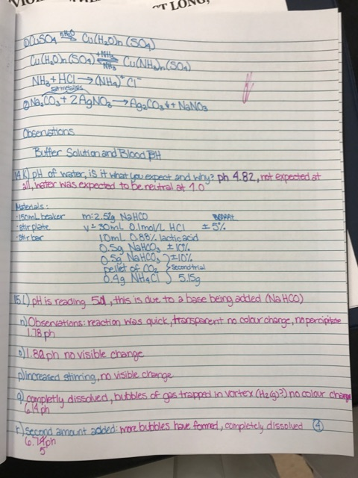
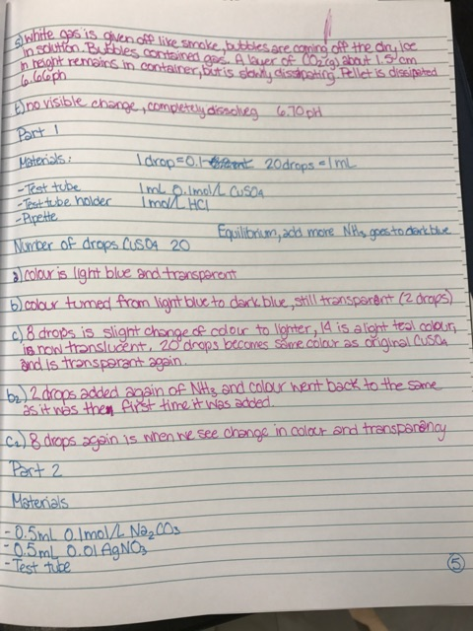
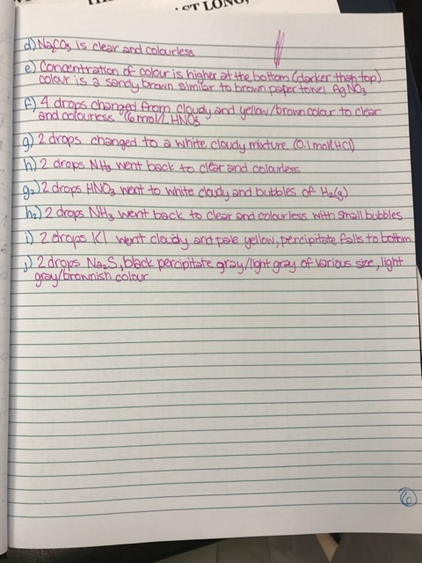

YOUR NAME (PRINT): Janaya Petteplace ___SIGNATURE: _ J.P.______

CONFIDENTIAL PEER EVALUATION FORM FOR EXPERIMENT __4__
Each team member must submit one assessment. Teams may consist of 2-18 members.
You may edit this form.
Do not share or discuss the contents or possible contents of this assessment with others.

In assessing the work of your fellow team members, consider the following aspects:
- Quality of work Ability to get along with others
- Contribution to the work as a whole • Improvements when asked to correct

Team member name | Comments | Grade
Nagaad Warsame | Work has done with high quality, ensured organisation and time management of the lab, works great with others, aided in proofreading of work and ensuring its fluidity, wrote the introduction of report and questions 1-3 | A
Linden Beauchamp | Work was done with high quality, kept notes of observations clear and concise, worked great with the team, aided in proof reading work and ensuring its fluidity, wrote part 2 of report and questions 4-6 | A
Tuo-yu Yang | Work was done with high quality, kept pace and fluidity of experiment, works great with others, had some mistakes in work and immediately corrected them, wrote part 1 of report and the conclusion. | A
A – Excellent (5) B: Great (4) C: Good (3) D: Fair(2) F: Poor (1)
Note: Do not evaluate yourself on this form

