Chapter 40: Basic Principle of Animal Form and Function
- why do species vary so enormously in makeup, complexity, organization, and appearance? The answer is adaptation: Natural selection favors those variations in a population that increase relative fitness.
- Physiology: biological function of a living organism.
- Fast swimmers in sea: such animals share a streamlined body contour: a shape that is fusiform, meaning tapered on both ends. The similar shape found in these speedy vertebrates is an example of convergent evolution.
- How to estimate max running speed of body plans: the fraction of body mass in leg muscles and the effective force such muscles generate.
- Exchange with the environment: The rates of exchange for nutrients, waste products, and gases are proportional to membrane surface area, whereas the amount of material that must be exchanged to sustain life is proportional to cell volume.
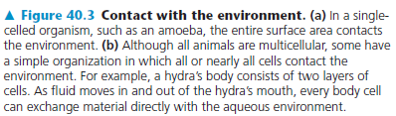
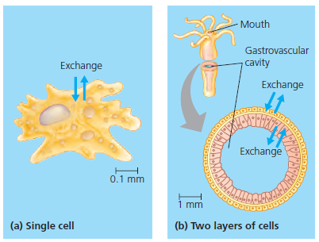
- Maximize exchange with the environment: have a flat body=> maximize the surface of the body with the environment.

- Internal body fluids link exchange surfaces to body cells. The spaces between cells are filled with fluid, in many animals called interstitial fluid.
- Complex body plans also include a circulatory fluid, such as blood. Exchange between the interstitial fluid and the circulatory fluid enables cells throughout the body to obtain nutrients and get rid of wastes.
- Having a more complex body plan is more advantageous because: skeleton, sensory organs, breakdown of food due to internal digestive system, specialized filtration that adjust the composition of the internal fluid (maintain homeostasis).
- Cells are organized into tissues, groups of cells with a similar appearance and a common function. Different types of tissues are further organized into functional units called organs. (simple organisms lack organs.) Groups of organs that work together provide an additional level of organization and coordination and make up an organ system.
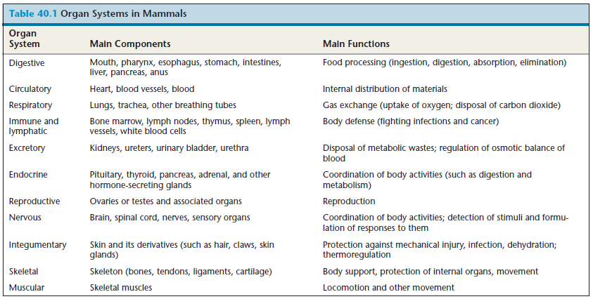
- There are four main types of animal tissues: epithelial, connective, muscle, and nervous

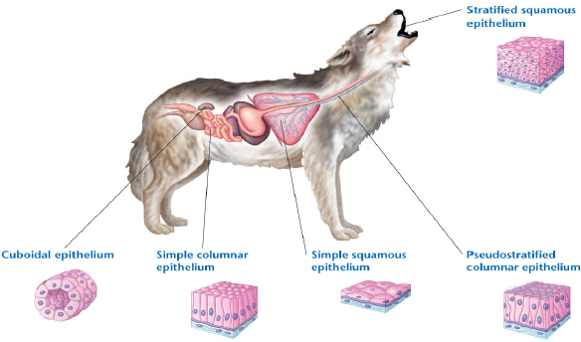
- Epithelial: It covers the outside of the body and line organs and cavitied within the body. They are closely packed and often with tight junction. They function as a barrier against mechanical injury, pathogen and fluid loss. It also forms active interface with the environment.
- Cuboidal: dice-shaped cells specialized for secretion, makes up the epithelium of kidney tubules and many glands, including the thyroid gland and salivary gland
- Simple Columnar epithelium: Large brick-cells of simple columnar epithelia are often found where secretion or active absorption is important. Ex: s simple columnar epithelium lines the intestines, secreting digestive juice and absorbing nutrient.
- Simple squamous epithelium: Single layer of plate-like cells that form a simple squamous epithelium functions in the exchange of material by diffusion. This cell is thin and leaky, with lines blood vessels and the air sac of the lungs- where the diffusion of nutrients and gases is critical.
- Pseudostratified columnar epithelium: consists of single layer of cells varying in height. In many vertebrates, this cell forms a mucous membrane that lines portions of the respiratory tract. The beating cilia sweep the film of mucus along the surface.
- Stratified squamous epithelium: This cell is multilayered and regenerates rapidly. New cells formed by division near the basal lamina push outward, replacing cells that are sloughed off. This epithelium is common in places like anus, outer skin and the lining of the mouth and vagina.

- Connective Tissues: Consists of a sparse population of cells, scattered through an extracellular matrix that holds many tissues and organs together and in place. Within the matrix are numerous cells called fibroblasts, which secrete fiber proteins, and macrophages, which engulf foreign particles and any cell debris by phagocytosis. Connective tissue fibers are of three kinds: Collagenous fibers provide strength and flexibility reticular fibers join connective tissue to adjacent tissues, and elastic fibers make tissues elastic.
- Loose connective tissues (1): It is the most widespread connective tissue in the vertebrate body, which binds epithelia to underlying tissues and holds organs in place. Loose connective tissue gets its name from the loose weave of its fibers, which include all three types. It is found in the skin and throughout the body.
- Fibrous connective tissue (2): It is dense with collagenous fibers. It is found in tendon- attaches muscle to bones- and ligaments- connects bones at joints.
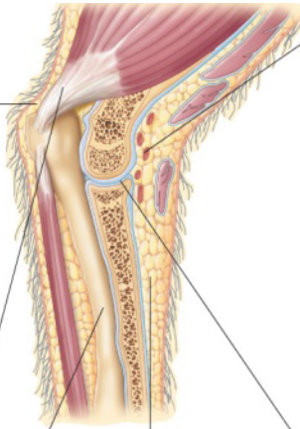
- Bone (3): A mineralized connective tissue that is the skeleton of most vertebrates. Bone-forming cells called osteoblasts deposit a matrix of collagen. Calcium, magnesium, and phosphate ions combine into a hard mineral within the matrix. The microscopic structure of hard mammalian bone consists of repeating units called osteons. Each osteon has concentric layers of the mineralized matrix, which are deposited around a central canal containing blood vessels and nerves.
- Adipose tissue (4): stores fat for insulation and fuel as fat molecule throughout its matrix. Adipose tissue pads and insulates the body. Each adipose cell contains a large fat droplet that swells when fat is stored and shrinks when the body uses that fat as fuel.
- Blood (5): has a liquid extracellular matrix called plasma, which consists of water, salts, and dissolved proteins. Suspended in plasma are erythrocytes (red blood cells), leukocytes (white blood cells), and cell fragments called platelets. Red cells carry oxygen, white cells function in defense, and platelets aid in blood clotting.
- Cartilage (6): Contains collagenous fibers embedded in a rubbery protein complex called chondroitin sulfate. Cells called chondrocytes secrete the collagen and chondroitin sulfate, which together make cartilage a strong yet flexible support material.
- Muscle Tissue: Responsible for almost all body movements. It consists of filaments containing the protein actin and myosin, which enable the muscle to contract. There are three type of muscle tissue in vertebrate body:
- Skeletal muscle: Attached to bones by tendons and is responsible for volunteer movement. It consists of bundle of long cells (muscle fibers). During development, skeletal muscle fibers form by the fusion of many cells, resulting in multiple nuclei in each muscle cell or fiber. The arrangement of contractile units, or sarcomeres, along the fibers gives the cells a striped (striated) appearance.
- Smooth muscle: lacks striations and is found in the walls of the digestive tract and internal organs. The cells are spindle- shaped. They are responsible for involuntary body activities such as contraction of the arteries.
- Cardiac Muscle: Forms the contractile wall of the heart. Just like skeletal, it is striated and has similar contractile properties. It has fibers that interconnect via intercalated disks, which relay signals from cell to cell and help synchronize heart function.
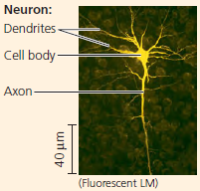
- Nervous Tissue: functions in the receipt, processing, and transmission of information. They contain neurons/ nerve cells, which transmit nerve impulses, as well as support cells called glial cells/glia. A concentration of nervous tissue forms a brain, an information-processing center.
- Neurons: Basic unit of nervous system. They receive nerve impulses from other neurons via its cell body and multiple extensions called dendrites. They transmit impulses to neurons, muscles and other cells vial extensions called axons- which often bundle up together.
- Glia: They help nourish, insulate and replenish neurons. In some cases, they modulate neuron function.

- In the endocrine system, signaling molecules released into the bloodstream by endocrine cells reach all locations in the body. In the nervous system, neurons transmit signals, called nerve impulses, between specific locations in the body. In each system, the type of pathway used is the same regardless of whether the signal reaches across the length of the body or ends up just a few cell diameters away.
- The signaling molecules broadcast throughout the body by the endocrine system are called hormones. They are relatively slow acting (few seconds) but they are long lasting since they stay in the bloodstream for seconds, minutes or hours.
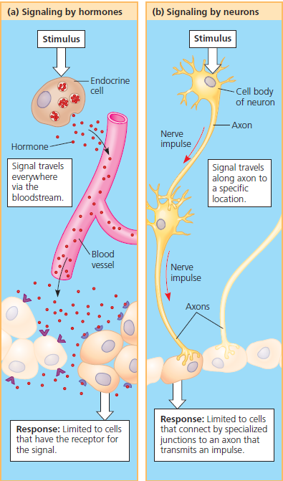
- In nervous system. Each nerve impulse travels to specific target cells along dedicated communication lines consisting mainly of axons.
- Four types of cells can receive nerve impulses: other neurons, muscle cells, endocrine cells, and exocrine cells. The nervous system conveys information by the pathway the signal takes.
- Communication in neuron system is done by signaling. The transmission of information is done very fast- nerve impulses can take fraction of a second to reach the target and last a fraction of a second.
- The two major communication systems of the body differ in signal type, transmission, speed, and duration, they are adapted to different functions.

- Regulating and Conforming:
- Regulator: An animal is said to be regulator for an environment if it uses its internal mechanisms to control internal change in the face of an external situation.
- Conformer: An animal is said to be conformer when it allows its internal organ to change in accordance with external changes in the variable. (Ex: Largemouth bass)
- An animal may regulate internal conditions while allowing others to conform to the environment (Ex: Largemouth can change its temp according to its environment but will keep its concentration the same)

- Homeostasis:
- Homeostasis means “steady state”, referring to the maintenance of the internal balance. It is a dynamic equilibrium. Even when the external environment changes significantly, animals must maintain a constant internal environment. Homeostasis moderates but does not eliminate changes in the internal environment.
- An animal achieves homeostasis by maintaining a variable near a particular value or set point. Fluctuations in the variable above or below the set point serve as the stimulus detected by a receptor, or sensor. Upon receiving a signal from the sensor, a control center generates output that triggers a response, a physiological activity that helps return the variable to the set point.
- Negative feedback: a control mechanism that reduces or “damp” the stimulus. Ex: sweating to bring back your body temperature to its set point.
- Normal range: having an upper and lower limit, rather than a single set point
- Positive feedback: a control mechanism that amplifies rather than reduces the stimulus. It helps drive pressure to completion. Ex: child birth and more pressure
- Some regulated changes are associated with a specific stage (hormone balance in puberty), whereas some are cyclic (women’s menstrual cycle)
- Some cyclic alterations in metabolism reflect a circadian rhythm, a set of physiological changes that occur highly every 24 hours and is intrinsic to the body. A biological clock, however, is coordinated with the cycle of light and darkness in the environment.
- Change in the normal change of homeostasis: through acclimatization, a gradual process by which an animal adjust to change in its external environment.
- Note: acclimatization, a temporary change during an animal’s lifetime, should not be confused with adaptation, a process of change in a population brought about by natural selection acting over many generations.

- Thermoregulation:
- Thermoregulation: the process by which animal maintain an internal temperature within a tolerable range- critical to survival. It depends on animal’s ability to control the exchange of heat with its environment.
- Each animal species has an optimal temperature range. Thermoregulation helps maintain body temperature within that optimal range, enabling cells to function effectively even as the external temperature fluctuates.
- Endothermic: organisms that are warmed by heat generated by metabolism.
- Ectodermic: organisms that gain their heat from external sources. Because their heat source is largely environmental, ectotherms generally need to consume much less food than endotherms of equivalent size.
- Animals can have either a variable or a constant body temperature. An animal whose body temperature varies with its environment is called a poikilotherm. In contrast, a homeotherm has a relatively constant body temperature.
- Note: There is no fixed relationship between the source of heat and the stability of body temperature.
- Note: Ectoderms do not necessarily mean cold-blooded.
- Any organism, like any object, exchanges heat by four physical processes: radiation, evaporation, convection, and conduction. Heat is always transferred from an object of higher temperature to one of lower temperature.
Radiation: the emission of electromagnetic waves by all objects warmer than absolute zero.
Evaporation: the removal of heat from the surface of a liquid that is losing some of its molecules as gas. (has a cooling effect)
Convection: transfer of heat by the movement of air or liquid past a surface, as when a breeze contributes to heat loss.
Conduction: direct transfer of thermal motion between molecules of objects in contact with each other.
- The essence of thermoregulation is maintaining rates of heat gain that equal rates of het loss.
- Integumentary system: when the outer covering of the body consists of skin, hair and nails (or claws or hooves).
- Insulation: it reduces the flow of heat between an animal and its environment. Sources of insulation includes hair, feather and layers of fat.
- The problem of thermoregulation is made worse by the fact that the transfer of heat to water occurs 50 to 100 times more rapidly than heat transfer to air. Just under their skin, marine mammals have a very thick layer of insulating fat called blubber.
- In response to changes in the temperature of their surroundings, many animals alter the amount of blood (and hence heat) flowing between their body core and their skin.
- Vasodilation: a widening of superficial blood vessels (those near the body surface). Consequently, the blood flow in the skin increases. In endomers, this usually warms the skin and increases the transfer of body heat to the environment by radiation, conduction and convection.
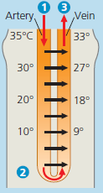
- Vasoconstriction: reduce the blood flow and heat transfer by decreasing the diameter of superficial vessels. (avoid overheating in deserts)

- Arteries carrying warm blood to the animal’s Bottlenose dolphin extremities are in close contact with veins conveying cool blood in the opposite direction, back toward the trunk of the body. This arrangement facilitates heat transfer from arteries to veins along the entire length of the blood vessels.
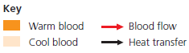
- Near the end of the leg or flipper, where arterial blood has been cooled to far below the animal’s core temperature, the artery can still transfer heat to the even colder blood in an adjacent vein. The blood in the veins continues to absorb heat as it passes warmer and warmer blood traveling in the opposite direction in the arteries.
- As the blood in the veins approaches the center of the body, it is almost as warm as the body core, minimizing the heat loss that results from supplying blood to body parts immersed in cold water.

- Countercurrent exchange: The transfer of heat (or solutes) between fluids that are flowing in the opposite direction. As warm blood moves from the body core in the arteries, it transfers heat to the colder blood returning from the extremities in the veins. Because blood flows through the arteries and veins in opposite directions, heat is transferred along the entire length of the exchanger, maximizing the rate of heat exchange.
- Some insects can experience overheating. In some cases, the countercurrent can be the “shut down”, allowing muscle-produced heat to be the lost from the thorax to the abdomen and then to the environment.
- Evaporation is a way to keep the body cool down. Some animals have adaptations that can greatly augment the cooling effect of evaporation. Panting is important in birds and many mammals.
- Both endoderm and ectoderm control body temperature through behavioral responses to change in the environment. Ectoderm engage in simple activity. Some go through hibernation or migration to a more suitable climate.
- Thermogenesis: the ability to vary heat production of body to match changing rate of heat loss.
- Non-shivering thermogenesis: The process, where in some animals, certain hormones can use mitochondria to increase metabolic activity and produce heat instead of ATP.
- Some mammals have brown fat in their neck and between their shoulders that is specialized for rapid heat production.
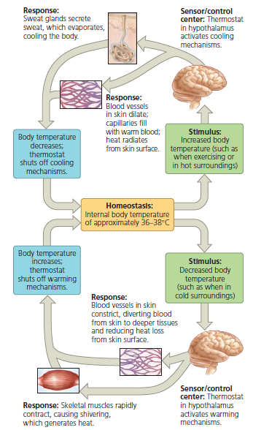
- Acclimatization in Thermoregulation:
- Acclimatization to seasonal temperature changes included adjusting insulation- growing a thicket coat of fur in the winter and shedding in the summer. These changes allow endotherms to keep a steady temperature around the year.
- This also included cellular activities: production of variant enzymes that have the same function but different optimal temperature.

- Physical thermostat and fever:
- The sensor for thermoregulation are concentrated in a brain region called hypothalamus. A group of nerve cells in the hypothalamus function as a thermostat, responding to body temperature outside a normal range.

- Energy requirements are related to animal size, activity, and environment:
- Bioenergetics: the overall flow and transfer of energy in an animal, its bioenergetics, determines nutritional needs and is related to the animal’s size, activity and environment
- autotrophs such as plants use light energy to build energy-rich organic molecules and use then to fuel.
- Heterotrophs such as animals get their energy from food, which contains organic molecules synthesized by other organisms.
- Metabolic rate: the amount of energy an animal uses in a unit of time. The sum of all the energy used in biochemical reactions over a given time interval. Energy is measured in joules ( J) or in calories (cal) and kilocalories (kcal).
- metabolic rate can be measured by monitoring an animal’s rate of heat loss

- Minimum Metabolic Rate and Thermoregulation
- The minimum metabolic rate of a nongrowing endotherm that is at rest, has an empty stomach, and is not experiencing stress is called the basal metabolic rate (BMR). BMR is measured under a “comfortable” temperature range—a range that requires no generation or shedding of heat above the minimum. This is done at a specific temperature.
- The metabolic rate of a fasting, nonstressed ectotherm at rest at a particular temperature is called its standard metabolic rate (SMR).
- Key factor of metabolic rate are influenced by: age, sex, size, activity temperature and nutrition.
- For even more varied organisms ranging in size from bacteria to blue whales, metabolic rate remains roughly proportional to body mass to the three-quarter power ($m^{3/4}$)
- As body size increases, energy costs per gram of tissue decrease, but an ever-larger fraction of body tissue is required for exchange, support, and locomotion.
- Torpor: a physiological state of decreased activity and metabolism, is an adaptation that enables animals to save energy while avoiding difficult and dangerous conditions.
- Hibernation is long-term torpor that is an adaptation to winter cold and food scarcity. When a mammal enters hibernation, its body temperature declines as its body’s thermostat is turned down.
- Like hibernation, the slow metabolism and inactivity of estivation, or summer torpor, enables animals to survive long periods of high temperatures and scarce water supplies.

Chapter 41: Animal Nutrition

Animal nutrition: food being taken in, taken apart and taken up
Herbivore: they rely on plants or algae
Carnivore: they mostly eat animals
Omnivores: they don’t eat everything, but they regularly consume animals as well as plants.
Note: microorganisms are an unavoidable “supplement” in every animal’s diet.

41.1: An animal’s diet must supply chemical energy, organic molecules, and essential nutrients

- Essential Nutrients:
- The materials that an animal’s cells require but cannot synthesize are called essential nutrients.
- Essential Amino Acids:
- Animals require 20 amino acids to make proteins. The majority of animal species have the enzymes to synthesize about half of these amino acids, as long as their diet includes sulfur and organic nitrogen. The remaining amino acids must be obtained from food in prefabricated form and are therefore called essential amino acids.
- Most adults, including humans, require 8 amino acids in their diet (infants need 9, including histidine)
- The proteins in animal products such as meat, eggs, and cheese are complete,” which means that they provide all the essential amino acids in their proper proportions. In contrast, most plant proteins are incomplete,” being deficient in one or more essential amino acids.
- Essential Fatty Acids:
- The type of fatty acids animals cannot make are called fatty acids. They usually contain one or more double bonds and are thus unsaturated.
- Two kinds of polyunsaturated fatty acids are essential nutrients (ie the body cannot synthesize them and therefore must come from diet). They are:
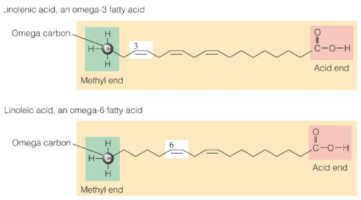
- Vitamins:
- Vitamins are organic molecules that have diverse functions and are required in the diet in very small amounts.
- For humans 13 vitamins have been identified. Depending on the vitamin, the required amount ranges from about 0.01 to 100 mg per day.
- Vitamins are classified as water-soluble or fat-soluble. The water-soluble vitamins include the B vitamins, which are compounds that generally function as coenzymes, and vitamin C, which is required for the production of connective tissue. Among the fat-soluble vitamins are vitamin A, which is incorporated into visual pigments of the eye, and vitamin K, which functions in blood clotting. Another is vitamin D, which aids in calcium absorption and bone formation.
- Overdose of water soluble vitamins will get excreted from body. However, the fat soluble vitamins are deposited in body fat and may result in the accumulation of toxic level of these compounds
- Minerals:
- Dietary minerals are inorganic nutrients, such as iron and sulfur, that are usually required in small amounts—from less than 1 mg to about 2,500 mg per day.
- Ingesting large amounts of some minerals can upset homeostatic balance and impair health. For example, excess salt (sodium chloride) intake can contribute to high blood pressure.

41.2: The main stages of food processing are ingestion, digestion, absorption, and elimination

- Food processing can be divided into four distinct stages: ingestion, digestion, absorption, and elimination.
- Ingestion: The first stage, ingestion, is the act of eating or feeding.
- Digestion: In digestion, the second stage of food processing, food is broken down into molecules small enough for the body to absorb. Mechanical digestion, such as chewing, typically precedes chemical digestion. Although fruit flies and humans have very different diets, both convert proteins in their food to the same 20 amino acids from which they assemble all of the proteins specific for their species. Chemical digestion by enzymes breaks bonds with the addition of water. This splitting process is called enzymatic hydrolysis.
- Absorption: In the third stage, absorption, the animal’s cells take up (absorb) small molecules such as amino acids and simple sugars.
- Elimination: It completes the process as undigested material passes out of the digestive system.

- Digestive compartments:
- Intracellular digestion:
- Food vacuoles—cellular organelles in which hydrolytic enzymes break down food—are the simplest digestive compartments. The hydrolysis of food inside vacuoles, called intracellular digestion, begins after a cell engulfs solid food by phagocytosis or liquid food by pinocytosis.
- Newly formed food vacuoles fuse with lysosomes, organelles containing hydrolytic enzymes. This fusion of organelles brings food in contact with the enzymes, allowing digestion to occur safely within a compartment enclosed by a protective membrane.

- Extracellular Digestion:
- Having one or more extracellular compartments for digestion enables an animal to devour much larger pieces of food than can be ingested by phagocytosis.
- Many animals with relatively simple body plans have a digestive compartment with a single opening. This pouch, called a gastrovascular cavity, functions in digestion as well as in the distribution of nutrients throughout the body (hence the vascular part of the term).
- After a hydra has digested its meal, undigested materials that remain in the gastrovascular cavity, such as exoskeletons of small crustaceans, are eliminated through the same opening by which food entered.
- Most animals have a digestive tube extending between two openings, a mouth and an anus. Such a tube is called a complete digestive tract or, more commonly, an alimentary canal. Because food moves along the alimentary canal in a single direction, the tube can be organized into specialized compartments that carry out digestion and nutrient absorption in a stepwise fashion.

41.3: Organs specialized for food processing form the mammalian digestive system

- The accessory glands of the mammalian digestive system are three pairs of salivary glands, the pancreas, the liver, and the gallbladder.
- Food is pushed along the alimentary canal by peristalsis, alternating waves of contraction and relaxation in the smooth muscles lining the canal. At some of the junctions between specialized compartments, the muscular layer forms ringlike valves called sphincters. Acting like drawstrings to close off the alimentary canal, sphincters regulate the passage of material between compartments.
- The Oral Cavity, Pharynx, and Esophagus:
- Ingestion and the initial steps of digestion occur in the mouth, or oral cavity. Mechanical digestion begins as teeth of various shapes cut, mash, and grind food, making the food easier to swallow and increasing its surface area.
- The presence of food stimulates a nervous reflex that causes the salivary glands to deliver saliva through ducts to the oral cavity. Saliva may also be released before food enters the mouth, triggered by a learned association between eating and the time of day, a cooking odor, or another stimulus.
- Saliva initiates chemical digestion while also protecting the oral cavity. The enzyme amylase, found in saliva, hydrolyzes starch (a glucose polymer from plants) and glycogen (a glucose polymer from animals) into smaller polysaccharides and the disaccharide maltose. Much of the protective effect of saliva is provided by mucus, which is a viscous mixture of water, salts, cells, and slippery glycoproteins (carbohydrateprotein complexes) called mucins. Mucus in saliva protects the lining of the mouth from abrasion and lubricates food for easier swallowing. Additional components of saliva include buffers, which help prevent tooth decay by neutralizing acid, and antimicrobial agents, which protect against bacteria that enter the mouth with food.
- After food is deemed acceptable and chewing commences, tongue movements manipulate the food, helping shape it into a ball called a bolus. During swallowing, the tongue provides further help, pushing the bolus to the back of the oral cavity and into the pharynx.
- The pharynx, or throat region, opens to two passageways: the esophagus and the trachea (windpipe). The esophagus connects to the stomach, whereas the trachea leads to the lungs. Swallowing must therefore be carefully choreographed to keep food from entering and blocking the airway. When you swallow, a flap of cartilage called the epiglottis covers the glottis—the vocal cords and the opening between them. Guided by the movements of the larynx, the upper part of the respiratory tract, this swallowing reflex directs each bolus into the entrance of the esophagus.
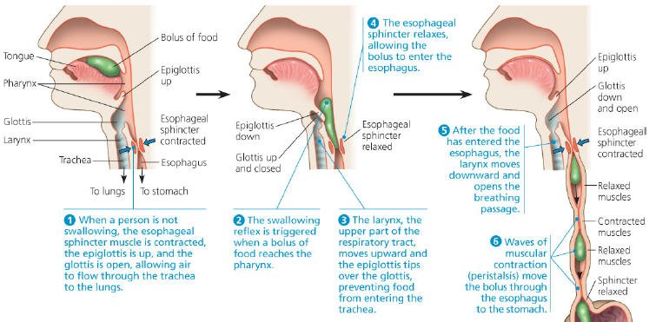
- The esophagus contains both striated and smooth muscle. The striated muscle is situated at the top of the esophagus and is active during swallowing. Throughout the rest of the esophagus, smooth muscle functions in peristalsis. The rhythmic cycles of contraction move each bolus to the stomach.
- Digestion in the stomach
- The stomach, which is located just below the diaphragm, stores food and begins digestion of proteins. With accordionlike folds and a very elastic wall, this organ can stretch to accommodate about 2 L of food and fluid. The stomach secretes a digestive fluid called gastric juice and mixes this secretion with the food through a churning action. This mixture of ingested food and digestive juice is called chyme.
- The low pH in stomach denatures (unfolds) proteins in food, increasing exposure of their peptide bonds. The exposed bonds are attacked by the second component of gastric juice—a protease, or protein-digesting enzyme, called pepsin. Unlike most enzymes, pepsin works best in a strongly acidic environment.
- The components of gastric juice are produced by cells in the gastric glands of the stomach. Parietal cells secrete hydrogen and chloride ions, which form HCl. Using an ATP-driven pump, the parietal cells expel hydrogen ions into the lumen. There, the hydrogen ions combine with chloride ions that diffuse into the lumen through specific membrane channels of the parietal cells. Meanwhile, chief cells release pepsin into the lumen in an inactive form called pepsinogen. HCl converts pepsinogen to active pepsin by clipping off a small portion of the molecule and exposing its active site. Through these processes, both HCl and pepsin form in the lumen of the stomach, not within the cells of the gastric glands.
- Warren reported that infection by the acid-tolerant bacterium Helicobacter pylori causes ulcers. They also demonstrated that an antibiotic treatment could cure most gastric ulcers. For these findings, they were awarded the Nobel Prize in 2005.
- Occasionally, a person experiences acid reflux, a backflow of chyme from the stomach into the lower end of the esophagus. The resulting irritation of the esophagus is commonly called “heartburn.”
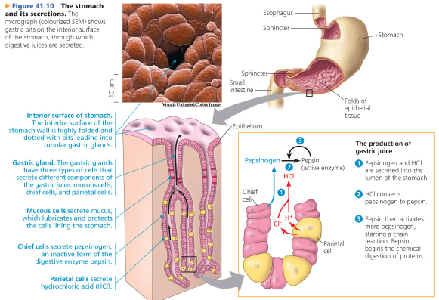

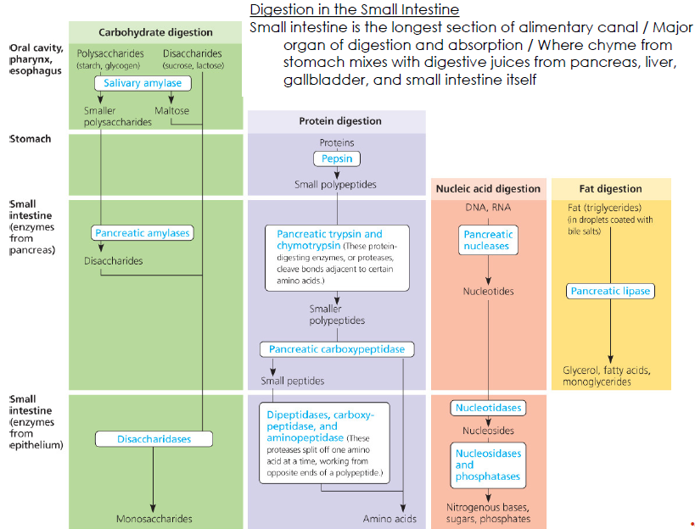

- Digestion in the Small Intestine:
- Most enzymatic hydrolysis of the macromolecules from food occurs in the small intestine. The first 25 cm (10 inches) or so of the small intestine forms the duodenum. It is here that chyme from the stomach mixes with digestive juices from the pancreas, liver, and gallbladder, as well as from gland cells of the intestinal wall itself.
- The pancreas aids chemical digestion by producing an alkaline solution rich in bicarbonate as well as several enzymes. The bicarbonate neutralizes the acidity of chyme and acts as a buffer.
- Digestion of fats and other lipids begins in the small intestine and relies on the production of bile, a mixture of substances that is made in the liver. Bile contains bile salts, which act as emulsifiers (detergents) that aid in digestion and absorption of lipids. Bile is stored and concentrated in the gallbladder. The vital function of bile production is the destruction of red blood cells that are no longer functional.

- Absorption in the Small Intestine:
- Most digestion is completed in the duodenum. The remaining regions of the small intestine, called the jejunum and ileum, function mainly in the absorption of nutrients and water.
- Large folds in the lining encircle the intestine and are studded with finger-like projections called villi. In turn, each epithelial cell of a villus has on its apical surface many microscopic projections, or microvilli, that are exposed to the intestinal lumen.
- Enormous microvillar surface creates a brush border that greatly increases rate of nutrient absorption. Transport across epithelial cells can be passive or active depending on nutrient. Active transport allows much more absorption of nutrients than would be possible with passive diffusion alone.
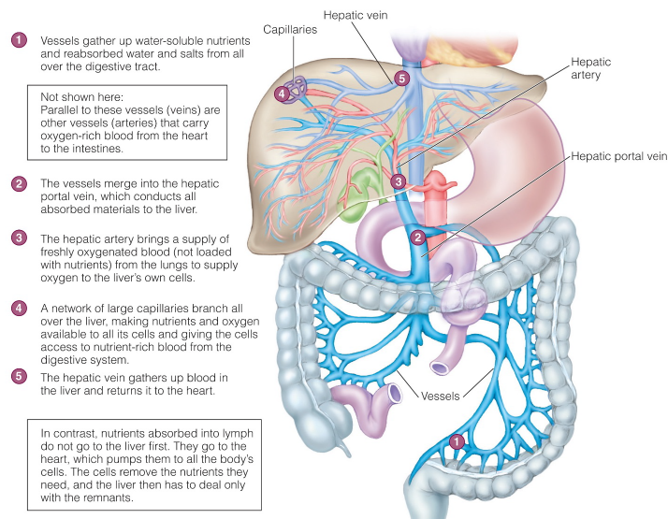
The capillaries and veins that carry nutrient-rich blood away from the villi all converge into the hepatic portal vein, a blood vessel that lead directly to the liver.
Functions:
- It allows the liver to regulate the distribution of nutrients to the rest of the body. It also interconverts many organic molecules.
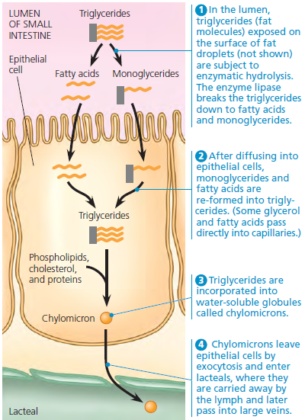
- The arrangement allows the liver to remove toxic substances.

Epithelial cells absorb fatty acids and monoglycerides and recombine them into triglycerides. hydrolysis of fats by lipase in the small intestine generates fatty acids and monoglycerides (glycerol joined to a single fatty acid). These products are absorbed by epithelial cells and recombined into triglycerides. They are then coated with phospholipids, cholesterol, and proteins, forming water-soluble globules called chylomicrons.
- Absorption in the Large Intestine:
- The alimentary canal ends with the large intestine, which includes the colon, cecum, and rectum. The small intestine connects to the large intestine at a T-shaped junction. One arm of the T is the 1.5-m-long colon, which leads to the rectum and anus. The other arm is a pouch called the cecum. The cecum is important for fermenting ingested material.
- The appendix, a finger-like extension of the human cecum, has a minor and dispensable role in immunity.
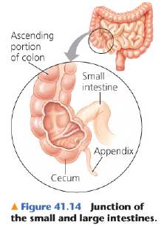
- A major function of the colon is to recover water that has entered the alimentary canal as the solvent of digestive juices. About 7 L of fluid is secreted into the lumen of the alimentary canal each day, and about 90% of that is reabsorbed in the small intestine and colon. There is no mechanism for active transport of water. Instead, water is reabsorbed by osmosis when Na+ and other ions are pumped out of the lumen of the colon.
- The feces, the wastes of the digestive system, become increasingly solid as they are moved along the colon by peristalsis.
- The terminal portion of the large intestine is the rectum, where feces are stored until they can be eliminated.
- Between the rectum and the anus are two sphincters, the inner one being involuntary and the outer one being voluntary.

41.4: Evolutionary adaptations of vertebrate digestive systems correlate with diet

- Dental adaptation:
- Large, expandable stomachs are common in carnivorous vertebrates, which may go for a long time between meals and must eat as much as they can when they do catch prey. The length of the vertebrate digestive system is correlated with diet.
- Dentition, an animal’s assortment of teeth, an example of structural variation reflecting diet Success of mammals due in part to their dentition, specialized for different diets.
- The location of mutualistic microbes in alimentary canals varies, depending on the type of herbivore. For invertebrates and vertebrates alike, mutualistic symbiosis has evolved as a general strategy for expanding the sources of nutrition available to animals.
- Coprophagy: feeding on some of their feces and then passing the food through the alimentary canal a second time.
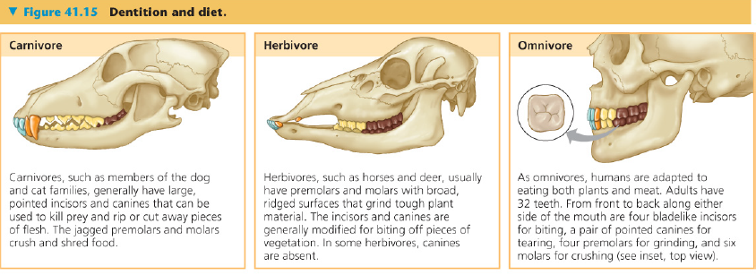
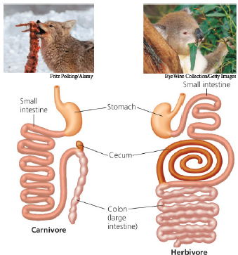

The alimentary canal of an herbivore (koala) and a carnivore (coyote). The koala’s alimentary canal is specialized for digesting leaves. Extensive chewing chops the leaves into tiny pieces, increasing exposure to digestive juices. In a long cecum and the upper portion of the colon, symbiotic bacteria convert the shredded leaves to a more nutritious diet.

41.5: Feedback circuits regulate digestion, energy storage, and appetite
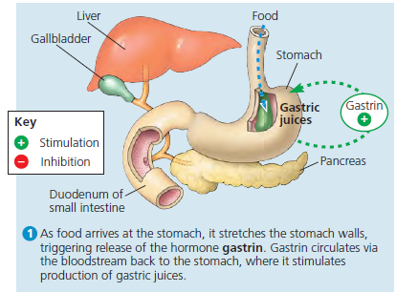
- Regulation of Digestion:
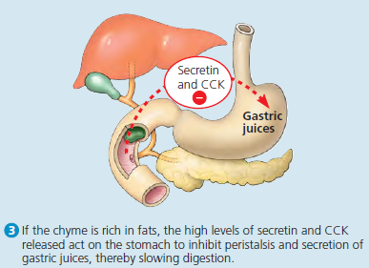
- A branch of the nervous system called the enteric division, which is dedicated to the digestive organs, regulates these events as well as peristalsis in the small and large intestines. The endocrine system also plays a critical role in controlling digestion. A series of hormones released by the stomach and duodenum help ensure that digestive secretions are present only when needed. Like all hormones, they are transported through the bloodstream. This is true even for the hormone gastrin, whose target (the stomach) is the same organ that secretes it.
- Fats are especially rich in energy; oxidizing a gram of fat liberates about twice the energy liberated from a gram of carbohydrate or protein. For this reason, adipose tissue provides the most space-efficient way for the body to store large amounts of energy. Most healthy people have enough stored fat to sustain them through several weeks without food.
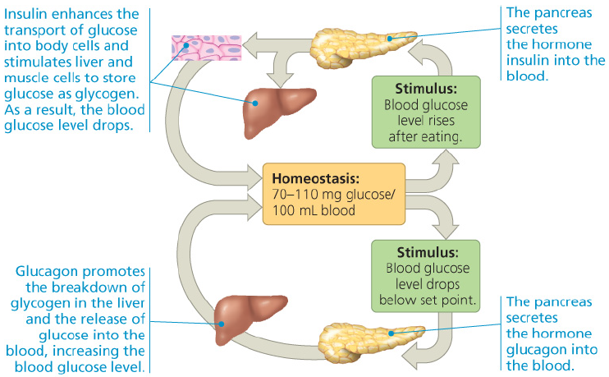
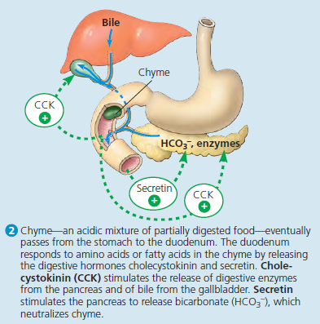
- The pancreatic hormones insulin and glucagon maintain glucose homeostasis by tightly regulating the synthesis and breakdown of glycogen. Endocrine system also regulates digestion through release and transport of hormones.

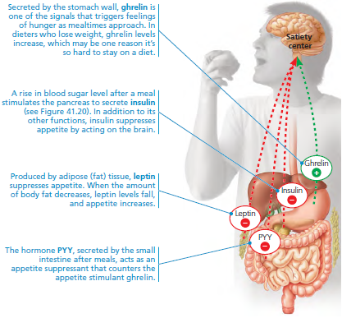
- Several homeostatic mechanisms that help regulate body weight. Operating as feedback circuits, these mechanisms control the storage and metabolism of fat. Several hormones regulate long-term and short-term appetite by affecting a “satiety center” in the brain.
- Cloning of the ob gene led to the demonstration that it codes for the hormone now known as leptin. The db gene encodes the leptin receptor. Leptin and the leptin receptor are key components of the circuitry that regulates appetite over the long term. Because leptin is a product of adipose cells, levels rise when the amount of body fat increases, cuing the brain to suppress appetite.

Chapter 42: Circulation and Gas Exchange
42.1: Circulatory systems link exchange surfaces with cells
throughout the body

- But diffusion is very slow for distances of more than a few millimeters. That’s because the time it takes for a substance to diffuse from one place to another is proportional to the square of the distance.
- Gastrovascular Cavities:
- In animals with a gastrovascular cavity, fluid bathes both the inner and outer tissue layers, facilitating exchange of gases and cellular waste. Only the cells lining the cavity have direct access to nutrients released by digestion.
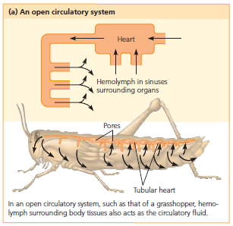
- A flat body optimizes diffusional exchange by increasing surface area and minimizing diffusion distances. For animals with many cell layers, diffusion distances are too great for adequate exchange of nutrients and wastes by a gastrovascular cavity. In these organisms, a circulatory system minimizes the distances that substances must diffuse to enter or leave a cell.
- Circulatory system:
- A circulatory system has three basic components: a circulatory fluid, a set of interconnecting vessels, and a muscular pump, the heart.
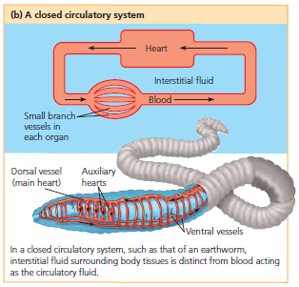
- As the blood streams throughout the body tissues in tiny blood vessels, O2 in the blood diffuses only a short distance before entering the fluid that directly bathes the cells.
- Circulatory systems are either open or closed, vary with regard to the number of circuits in the body, and rely on pumps that differ in structure and organization.
- Open circulatory system:
- The circulatory fluid bathes the organs directly.
- In these animals, the circulatory fluid, called hemolymph, is also the interstitial fluid that bathes body cells. Contraction of one or more hearts pumps the hemolymph through the circulatory vessels into interconnected sinuses, spaces surrounding the organs.
- Closed circulatory system:
- A circulatory fluid called blood is confined to vessels and is distinct from the interstitial fluid. Chemical exchange occurs between the blood and the interstitial fluid, as well as between the interstitial fluid and body cells.
- The lower hydrostatic pressures associated with open circulatory systems make them less costly than closed systems in terms of energy expenditure.
- The benefits of closed circulatory systems include relatively high blood pressures, which enable the effective delivery of O2 and nutrients to the cells of larger and more active animals.
- The closed circulatory system of humans and other vertebrates is often called the cardiovascular system.
- Arteries, veins, and capillaries are the three main types of blood vessels.
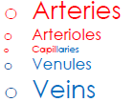
- Arteries: Arteries carry blood away from the heart to organs throughout the body. Within organs, arteries branch into arterioles, small vessels that convey blood to the capillaries.
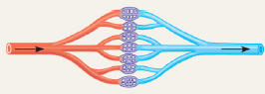
- Capillaries: Capillaries are microscopic vessels with very thin, porous walls. Networks of these vessels, called capillary beds, infiltrate every tissue, passing within a few cell diameters of every cell in the body. Across the thin walls of capillaries, chemicals, including dissolved gases, are exchanged by diffusion between the blood and the interstitial fluid around the tissue cells.
- Veins: At their “downstream” end, capillaries converge into venules, and venules converge into veins, the vessels that carry blood back to the heart.
Note: Arteries and veins distinguished by direction of blood flow, not by O2 content.
Arteries carry blood from the heart toward capillaries, and veins return blood to the heart from capillaries.
The hearts of all vertebrates contain two or more muscular chambers. The chambers that receive blood entering the heart are called atria (singular, atrium). The chambers responsible for pumping blood out of the heart are called ventricles.
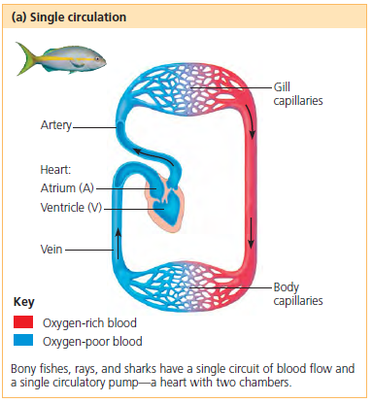
- Single Circulation:
- The blood passes through the heart once in each complete circuit, an arrangement called single circulation.
- In single circulation, blood that leaves the heart passes through two capillary beds before returning to the heart.
- Benefits of single circulation:
- Blood pressure drops as blood floods the gill capillaries
- Heart forced to rely upon deoxygenated blood for its metabolic needs.

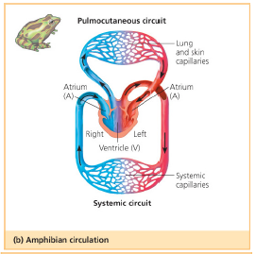
- Double Circulation:
- The circulatory systems of amphibians, reptiles, and mammals have two circuits, an arrangement called double circulation. The pumps for the two circuits are combined into a single organ, the heart. Having both pumps within a single heart simplifies coordination of the pumping cycles.
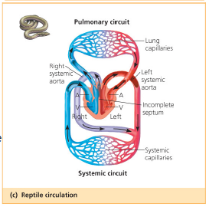
- One pump, the right side of the heart, delivers oxygen-poor blood to the capillary beds of the gas exchange tissues, where there is a net movement of O2 into the blood and of CO2 out of the blood. This part of the circulation is called a pulmonary circuit if the capillary beds involved are all in the lungs, as in reptiles and mammals. It is called a pulmocutaneous circuit if it includes capillaries in both the lungs and the skin, as in many amphibians.
- Three-chambered heart: two atria and one ventricle. A ridge separates the O2 poor and O2 rich blood inside the ventricle. Ventricle pumps blood into forked artery that splits ventricle’s output into pulmocutaneous circuit and systemic circuit. When underwater, blood flow to lungs nearly shut off

- Reptiles have double circulation, with a pulmonary circuit (lungs) and a systemic circuit.
- O2-poor blood flows through pulmonary circuit.
- O2-rich blood returns into the left atrium and empties into the single ventricle. An incomplete septum partially separates the single ventricle into two chambers

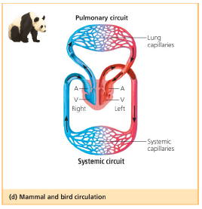

- In mammals, pulmonary and systemic blood completely separated. Mammals and birds have four-chambered heart with two atria and two ventricles. Left side of heart pumps and receives only oxygen-rich blood, while right side receives and pumps only oxygen-poor blood. Mammals and birds endotherms and require more O2 than ectotherms

42.2: Coordinated cycles of heart contraction drive double
circulation in mammals

Mammalian Circulation:
- Contraction of the right ventricle pumps blood to the lungs via
- the pulmonary arteries. As the blood flows through
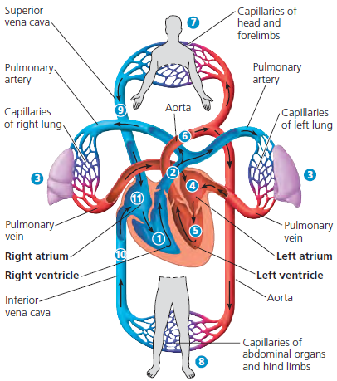
- capillary beds in the left and right lungs, it loads O2 and unloads CO2. Oxygen rich blood returns from the lungs via the pulmonary veins to
- the left atrium of the heart. Next, the oxygen-rich blood flows into
- the heart’s left ventricle, which pumps the oxygenrich blood out to body tissues through the systemic circuit. Blood leaves the left ventricle via
- the aorta, which conveys blood to arteries leading throughout the body. The first branches leading from the aorta are the coronary arteries (not shown), which supply blood to the heart muscle itself. Then branches lead to
- capillary beds in the head and arms (forelimbs). The aorta then descends into the abdomen, supplying oxygen-rich blood to arteries leading to
- capillary beds in the abdominal organs and legs (hind limbs). Within the capillaries, there is a net diffusion of O2 from the blood to the tissues and of CO2 (produced by cellular respiration) into the blood. Capillaries rejoin, forming venules, which convey blood to veins. Oxygen-poor blood from the head, neck, and forelimbs is channeled into a large vein,
- the superior vena cava. Another large vein
- the inferior vena cava, drains blood from the trunk and hind limbs. The two venae cavae empty their blood into
- the right atrium, from which the oxygen-poor blood flows into the right ventricle

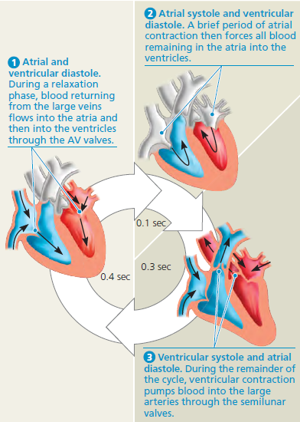
- Mammalian Heart:
- The heart contracts and relaxes in a rhythmic cycle. When it contracts, it pumps blood; when it relaxes, its chambers fill with blood. One complete sequence of pumping and filling is referred to as the cardiac cycle.
- Contraction, or pumping, phase is called systole
- Relaxation, or filling, phase is called diastole
- Heart rate (pulse) = # of beats per minute
- Stroke volume- = amount of blood pumped per contraction
- Cardiac output = volume of blood pumped into systemic circulation per minute
- Depends on both heart rate and stroke volume
- Four valves prevent backflow of blood in heart
- Atrioventricular (AV) valves separate each atrium and ventricle
- Semilunar valves control blood flow to aorta and pulmonary artery. They are located at the two exits of the heart: where the aorta leaves the left ventricle and where the pulmonary artery leaves the right ventricle.
- If blood squirts backward through a defective valve, it may produce an abnormal sound called a heart murmur. Some people are born with heart murmurs; in others, the valves may be damaged by infection.

- Maintaining the Heart’s Rhythmic Beat
- A group of autorhythmic cells located in the wall of the right atrium, near where the superior vena cava enters the heart. This cluster of cells is called the sinoatrial (SA) node, or pacemaker, and it sets the rate and timing at which all cardiac muscle cells contract.
- Impulses generate currents that are conducted to the skin via body fluids. In an electrocardiogram (ECG or, often, EKG, from the German spelling), these currents are recorded by electrodes placed on the skin. The resulting graph of current against time has a characteristic shape that represents the stages in the cardiac cycle.
- Impulses from the SA node travel to the atrioventricular (AV) node. At the AV node, impulses delayed and then travel to Purkinje fibers (specialized muscle fibers) that make ventricles contract.

42.3: Patterns of blood pressure and flow reflect the structure
and arrangement of blood vessels

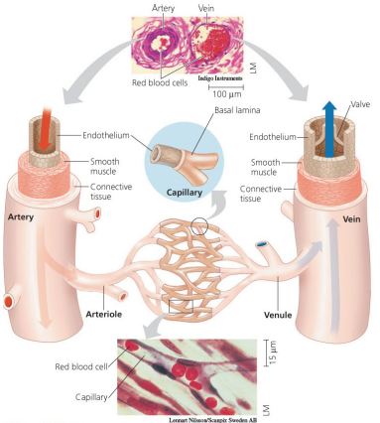
- Blood Vessel Structure and Function
- Blood vessels contain a central lumen (cavity) lined with an endothelium, a single layer of flattened epithelial cells.
- Capillaries are the smallest blood vessels, having a diameter only slightly greater than that of a red blood cell. Capillaries also have very thin walls, which consist of just the endothelium and its basal lamina. This structural organization facilitates the exchange of substances between the blood in capillaries and the interstitial fluid.
- Both arteries and veins have two layers of tissue surrounding the endothelium: an outer layer of connective tissue containing elastic fibers, which allow the vessel to stretch and recoil, and a middle layer containing smooth muscle and more elastic fibers.
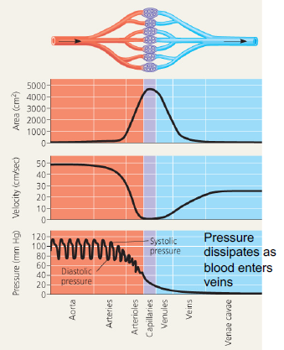
- Arteries are thicker walled than veins to accommodate high pressure of blood pumped from heart. Because veins convey blood back to the heart at a lower pressure, they do not require thick walls. For a given blood vessel diameter, a vein has a wall only about a third as thick as that of an artery.

- Blood Flow Velocity
- Physical laws governing movement of fluids through pipes affect blood flow and blood pressure
- Velocity of blood flow slowest in capillary beds, as a result of high resistance and large total cross-sectional area
- Blood flow in capillaries necessarily slow for exchange of materials
- Systolic pressure is pressure in arteries during ventricular systole; it is the highest pressure in arteries
- The spike in pressure is in part due to the resistance of the arterioles and capillaries to blood flow.
- Diastolic pressure is pressure in arteries during diastole; Arteries fill faster that they can empty. Thus, even at diastole, substantial pressure is maintained in the arteries.
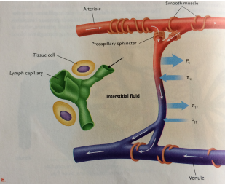

- Regulation of Blood Pressure:
- Blood pressure determined by cardiac output and peripheral resistance due to constriction of arterioles
- Vasoconstriction is contraction of smooth muscle in arterioles; it increases blood pressure
- Vasodilation is relaxation of smooth muscles in arterioles; it causes blood pressure to fall

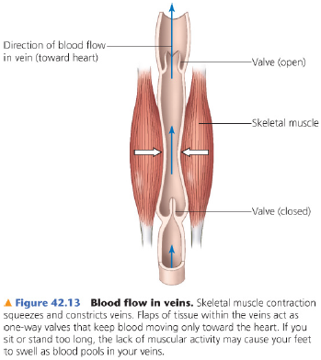

- Blood flow in veins:
- Blood moved through veins by smooth muscle contraction, skeletal muscle contraction, and expansion of vena cava with inhalation
- One-way valves in veins prevent backflow of blood

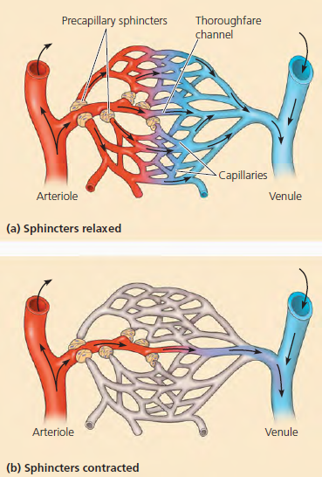
- Capillary Function
- At any given time, only about 5–10% of the body’s capillaries have blood flowing through them. However, each tissue has many capillaries, so every part of the body is supplied with blood at all times.
- How is blood flow in capillary bed altered?
- contraction of the smooth muscle in the wall of an arteriole, which reduces the vessel’s diameter and decreases blood flow to the adjoining capillary beds. When the smooth muscle relaxes, the arterioles dilate, allowing blood to enter the capillaries.
- The action of precapillary sphincters, rings of smooth muscle located at the entrance to capillary beds. The signals that regulate blood flow include nerve impulses, hormones traveling throughout the bloodstream, and chemicals produced locally.

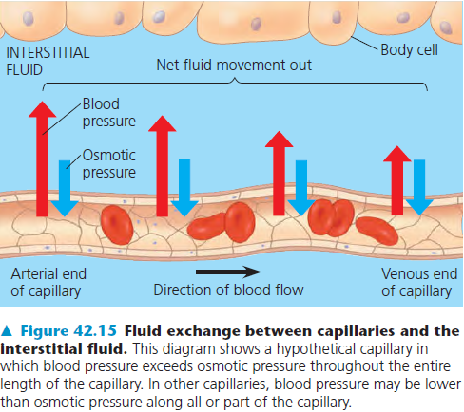

- The critical exchange of substances between the blood and interstitial fluid takes place across the thin endothelial walls of the capillaries.
- Many blood proteins (and all blood cells) are too large to pass readily through the endothelium, and they remain in the capillaries. These dissolved proteins are responsible for much of the blood’s osmotic pressure. The difference in osmotic pressure between the blood and the interstitial fluid opposes fluid movement out of the capillaries.

- Fluid Return by the Lymphatic System:
- The lost fluid and proteins return to the blood via the lymphatic system, which includes a network of tiny vessels intermingled among capillaries of the cardiovascular system.
- After entering the lymphatic system by diffusion, the fluid lost by capillaries is called lymph; its composition is about the same as that of interstitial fluid. The lymphatic system drains into large veins of the circulatory system at the base of the neck.
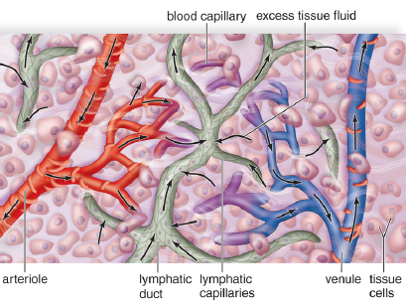

- Lymph vessels, like veins, have valves that prevent the backflow of fluid. Rhythmic contractions of the vessel walls help draw fluid into the small lymphatic vessels.
- Edema is swelling caused by disruptions in the flow of lymph.

42.4: Blood components function in exchange, transport and
Defense

42.5: Gas exchange occurs across specialized respiratory surfaces

42.6: Breathing ventilates the lungs

42.7: Adaptations for gas exchange include pigments that bind and transport gases

