Extraction Experiment

By: Matthew Price
Student #: 300022846

CHM 1321 Section B02
Teaching Assistant: Terry McCallum
Date Conducted: February 13th, 2018
Partner: Laura Giles

University of Ottawa
Due Date: February 27th, 2018

Procedure
Refer to pages 28-33 on a document titled “Laboratory Manual for Introductory Organic Chemistry, 2018” on Brightspace. However, modifications were implemented:
7. Obtain 0.65g of unknown sample #2
17. Prepare only one TLC place with biphenyl in the sample lane, benzophenone in the co spot lane and the organic phase in the reference lane

Observation
Part A
- Ether was a transparent, colourless, liquid that had a strong scent comparable to that of a sharpie and had “swirl” like distortions in it
- Water was a colourless, transparent, liquid
- Once ether and water were mixed in a test tube, layers formed in the test tube water on the bottom (aqueous phase) and ether on the top (organic phase).
- 0.006M Methylene blue was an opaque, deep/inky blue, liquid with no scent
  - Once added to the to the test tube, the dye was only in the aqueous phase (bottom layer)
- 0.006M Methyl Red was an opaque, red, liquid with no scent
  - Once added to the test tube with the water and ether mixture, the dye was only present in the organic phase (top layer)
- Once both test tubes were mixed, one containing methyl red and the ether & water mixture and the other containing methylene blue and the ether & water; the dyes stayed in their respective phases and did not mix
- 1-butanol was a clear, colourless, liquid with a strong scent
- Crystal violet was an opaque, dark purple/violet, liquid
  - Once added to the test tube it became a lighter purple colour.
- NaCl was a white, opaque, crystalline, solid
  - Once added to the test tube containing crystal violent and 1-butanol, it instantly began to become clear at the bottom of the test tube. Upon shaking the test tube, it became gradually clearer leaving a little dye at the top and a few spots on the sides of the test tube
Part B
- Unknown Sample #2 was an opaque, white, crystalline solid
- Dichloromethane is a transparent, colourless, liquid with a strong odour
- 2M NaOH was a clear, colourless, liquid with a strong odour
- HCl was a clear, colourless, liquid with a strong odour
- EtOAc : Hexanes was a clear, colourless, liquid with a strong odour
- NaOH was added to the aqueous phase since it is a base, it allows benzoic acid to become ionic by deprotonating it and allowing it to be in the aqueous phase
- HCL was added to the extracted aqueous phase as a proton donor to benzoic acid which caused it to precipitate
  - The mass of precipitate that formed this way was 0.23g
  - The measurement may have been flawed/inaccurate due to experimental error which would also impact the calculated percent yield of 39.66%

TLC Plate
Figure 1: TLC Plate with Biphenyl, benzophenone and organic phase
Org
Benzo
Bi
Solvent System: 2:8 mixture of EtOAc : Hexanes
Organic phase R_{f} Value = 0.83
Biphenyl R_{f} = 0.83
Benzophenone R_{f} = 0.74

- This TLC plate shows that the unknown sample #2 does not contain benzophenone, but biphenyl and benzoic acid. This was determined by the organic phase spot and the biphenyl spot having the same R_{f} value.
- Biphenyl has a higher R_{f} than benzophenone because of the carbonyl group on the benzophenone which makes it not very soluble in the hydrophobic solvent.

Flow Chart
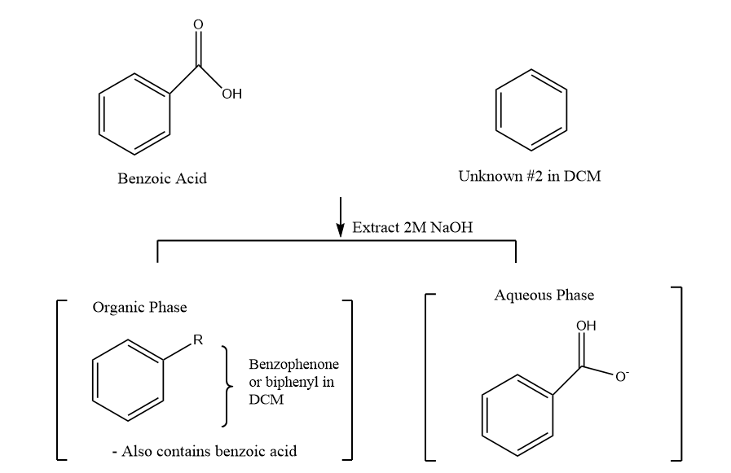
+
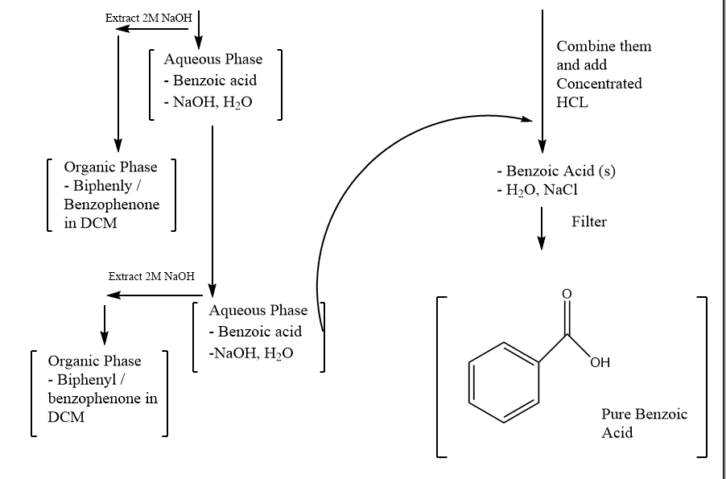
Figure 2: Table of results
Unknown sample # | Initial mass  (g) | Mass obtained  (g) | Composition  (%)
#2 | 0.58 | 0.23 | 39.66

Calculations:
Composition % = (Experimental Yield/Theoretical Yield) * 100%
= (0.23/0.58) * 100% = 39.66%
R_{f} Value = distance travelled by the compound/distance travelled by the solvent
=3.8 cm / 4.6 cm
=0.826 =0.83
Therefore, the Rf value for Biphenyl and the Organic spot is 0.83

Discussion
- Extraction consists of the separation of components of a mixture by their individual ability to dissolve into a certain solvent

Part A
- The lab displayed the separation of compounds based on their ability/affinity to dissolve in aqueous or organic phases
  - To determine this, dyes were introduced which highlighted the different layers
- Methylene blue is a charged species with one chloride cation and one sulfur anion
  - These charges made it a polar compound making it attracted to the aqueous phase
    - Thus, the blue dye was only present in the aqueous layer
- Methyl red is an organic non-polar substance making it favourable to dissolve in non-polar solvents
  - Since it is an organic uncharged substance, it is not soluble in the aqueous phase
    - Thus, the red dye was only present in the organic layer
- Upon mixture of methylene blue and methyl red
  - They remained separated in their respective solvents of water and ether
- In the part of the lab regarding the salting out effect, NaCl was placed into one of the test tubes prepared earlier containing crystal violet, 1-butanol and water.
  - Once in the test tube the dye disappeared or was displaced from the bottom of the test tube making it clear at the bottom
    - This occurred because NaCl is a polar compound and has a high affinity for water
      - Thus, interacting with it and forcing the crystal violet out of the aqueous phase and into the organic phase
Part B
- The TLC plate revealed that the unknown compound consisted of biphenyl and benzoic acid
  - This was determined due to the correspondence between the unknown sample spot, displayed as Org., and the Biphenyl (Bi.) spot
    - Both spots had a matching R_{f} value of 0.83 which confirmed this
  - Benzophenone was omitted from being a component of the unknown sample due to its spot having a different R_{f} value of 0.74
- The reactive separation of benzoic acid and biphenyl mixture was accomplished by utilizing the properties of acids and bases
  - The results matched the expected results because acid-base extractions are dependent on the reaction of an acid or base, which is distinct between compounds
  - Since this reaction produces salts that are soluble in water, the separation between an organic acid and an uncharged substance takes place
    - In the lab this was done by NaOH being added to the mixture and reacting with benzoic acid
      - Benzoic acid donated a proton, which produced water and sodium benzoate which is the conjugate base
        - The conjugate base displays ionic properties and is slightly positive on the sodium cation and partially negative on the oxygen anion.
          - The slightly negative oxygen atoms are attracted to sodium cations in water while the negatively charged hydrogen molecules interact with the oxygen anions causing the conjugate base to dissociate in the aqueous layer
- The extraction is complete since the conjugate base of benzoic acid only exists in the aqueous layer while the organic compound stays in the dichloromethane solvent.
  - Due to dichloromethane having a greater density than water, the organic phase formed at the bottom of the separatory funnel
- To convert the conjugate base salt back, HCl, a strong acid, was introduced to the aqueous flask.
  - This addition allowed the salt to regain the proton it donated earlier
    - This resulted in the salt converting back to an acid
      - This process produced an inorganic salt

Questions
- The reason it would be difficult to perform an extraction using ethanol and water is because they are able to mix together since they are both polar substances that are miscible. As a result, compounds added to the solution can separate but will occupy the same area as ethanol and water making it difficult to have a successful extraction.
- It would decrease the amount of methylene blue in the aqueous layer since the salt would dissolve in the water and displace the methylene blue from the aqueous layer via the salting out effect
- KD = (W1/V1) / (W2/V2)
= (2 g/100 mL) / (2 g / 100mL)
= 0.1
Let A represent the mass of compound Y in aqueous phase (water)
Let B represent the mass of compound Y in organic phase (ether)
A + B = 1.8g
A = 1.8g – B
  - = (B/100mL) / (1.8g – B/100mL)
B = 0.08g
A =1.8g – 0.08g
= 1.72 g
- Extraction 1, using 50mL of ether:
Let A represent the mass of compound Y in aqueous phase (water)
Let B represent the mass of compound Y in organic phase (ether)
A + B = 1.8g
A = 1.8g – B
  - = (B/100mL) / (1.8g – B/50mL)
B = 0.3g
A =1.8g – 0.3g
= 1.50 g
Extraction 2, also using 50 mL of ether:
A + B = 0.3g
A = 0.3g– B
  - = (B/100mL) / (0.3g – B/50mL)
B = 0.05g
A =0.3g – 0.05g
= 0.25 g
Total extracted amount of compound Y:
Total mass of Y removed = 1.50g + 0.25g
= 1.75g
- Add a little more water and if it mixes it is the aqueous phase and it if doesn’t it is organic phase
- The mixture of benzyl amine and naphthalene can be separated by adding a strong acid like HCL to the solution. The acid would react with the base, benzyl amine and produce its conjugate acid in the form of the salt, allowing it to dissolve in water. The two phases, organic and aqueous, will be divided via the separatory funnel and the organic phase will be returned into the funnel to undergo further extraction of benzyl amine from the organic phase. After numerous extractions, the organic phase is transferred to a beaker as now only the organic compound. Once the aqueous phases have been extracted into a transferred to a single flask, NaOH can be added to this solution containing the salt. The beaker can be immersed into a ice bath after, enough NaOH is added to convert the benzyl amine salt back into a base.

Raw Data


