Distillation Experiment

By: Matthew Price
Student #: 300022846

CHM 1321 Section B02
Teaching Assistant: Terry McCallum
Date Conducted: January 30th, 2018
Partner: Laura Giles

University of Ottawa
Due Date: February 6th, 2018
Procedure
Refer to pages 20-27 on a document titled “Laboratory Manual for Introductory Organic Chemistry, 2018” on Brightspace. However, modifications were implemented:
- Aluminum foil was wrapped around only the flask during the simple distillation, but during the fractional distillation the aluminum foil was wrapped around both the flask and the fractional column.
Observation
Simple Distillation
- 50:50 solution of 2-proponal and 1-butanol was a transparent, colourless, liquid that possessed a strong odour
- Took roughly about 8 minutes before distillation commenced
- The temperature drastically increased right before the distillation started
- Each drop of the solution in the cylinder created a little swirl that caused a small distortion in the cylinder which quickly faded
  - This indicated mixing of the substances
- Once the maximum temperature was achieved the temperature began to decrease
- As the temperature began to drop so did the rate at which the amount of solution was coming out of the condenser
Fractional Distillation
- Less solution was used in this distillation
- Solution used was a transparent, colourless, liquid
- Temperature increased much slower than it did in part 1
- Once the maximum temperature was achieved, it began to decrease
Measurements
Table 1: Volume of solution distilled vs Temperature during the simple distillation
Amount (mL) | Temperature (Cº)
1 | 84.6
2 | 85.3
3 | 86.2
4 | 87.7
5 | 88.5
6 | 89.6
7 | 90.3
8 | 92.4
9 | 93.7
10 | 96.8
11 | 99.4
12 | 102.9
13 | 105.3
14 | 109.1
15 | 113.5
16 | 115.0
17 | 115.6
18 | 113.5
19 | 79.3

Table 2: Volume of solution distilled vs Temperature during the fractional distillation
Distillated Volume (mL) | Temperature (Cº)
1 | 76.3
2 | 79.7
3 | 80.4
4 | 81.2
5 | 81.3
6 | 81.7
7 | 81.4
8 | 82.2
9 | 82.5
10 | 83.7
11 | 91.6
12 | 107.4
13 | 108.6
14 | 109.4
15 | 106.1
16 | 103.7
17 | 94.5

Graph
Figure 1: Visual Representation of Simple Distillation Data
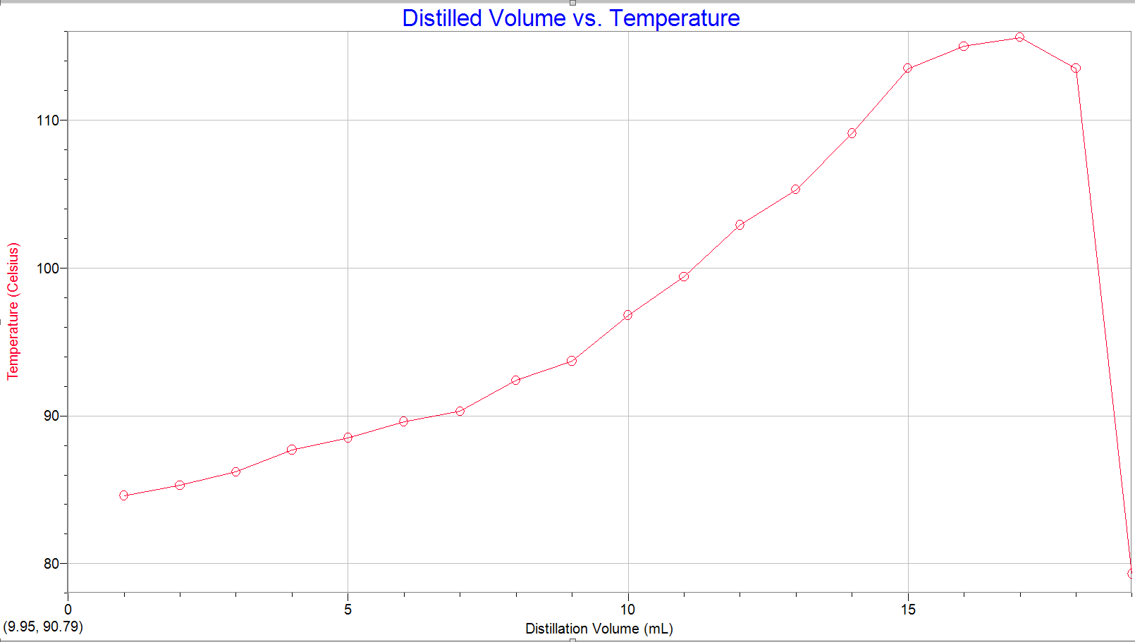

Figure 2: Visual Representation of Fractional Distillation Data
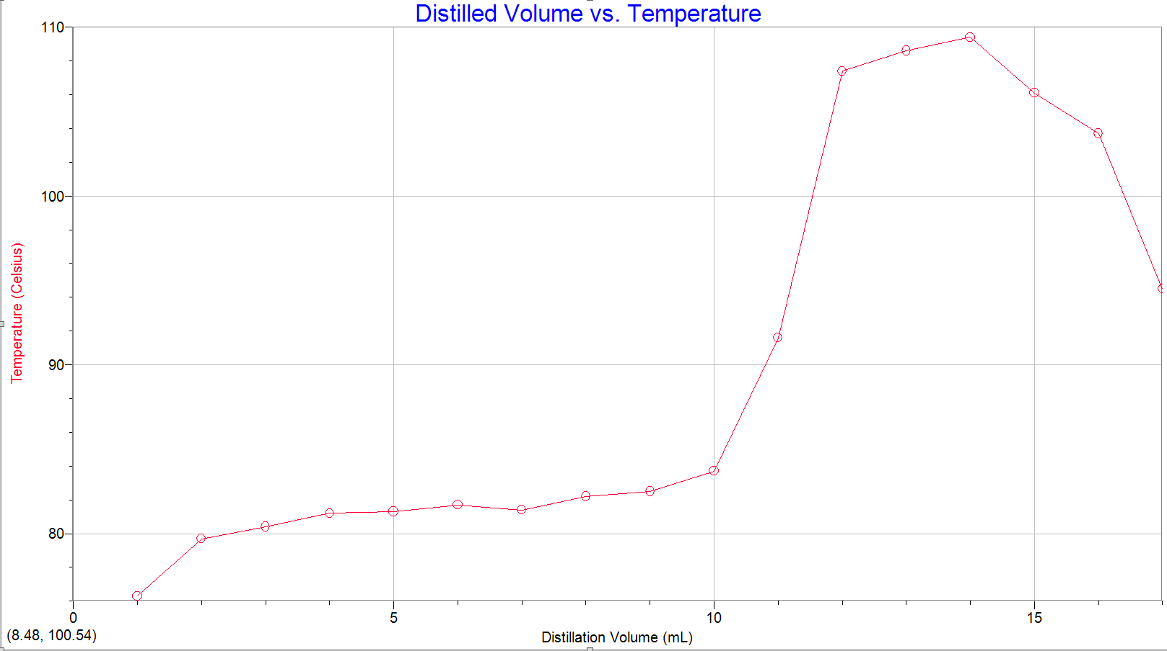

Discussion
Part 1
- Simple distillation was employed to sperate the 50:50 mixture of 2-propanol and 1-butanol
- Every time 1mL of distillate was collected in the graduated cylinder the temperature of the vapour was recorded
  - These points were used to plot the graph demonstrated in figure 1
    - These points form a relatively smooth gradual curve, which is due to the gradual temperature increase of the vapour
- The gradual temperature increase of the vapour was expected due to the distillation technique used
- Simple distillations are more effective when separating compounds with boiling point difference of 100 ºC
  - The boiling point of 2-propanol is roughly 83ºC and the boiling point of 1-butanol is about 118ºC resulting in a difference of only 35ºC.
    - Resulting in this type of distillation not being the ideal choice for this mixture
- Due to the boiling point temperature difference between the two compounds being relatively small and simple distillation only experiencing the condensation-vaporization cycle once results in this method not being an effective separation for this mixture
  - this can be seen in the smooth curve of the graph in figure one,
    - if the distillation method was effective then, a temperature profile showing the respective distinct boiling points of each components
Part 2
- Fractional distillation was used to separate the 50:50 mixture of 2-propanol and 1- butanol
- Just like part 1, for every mL of distillate collected in the graduated cylinder the temperature of the vapour was recorded
- When observing the curve of this graph in figure 2, it is evident2-propanol was collected in the receiving flask
  - What supports this finding is the plotted points are a steady line between 85-80 ºC
  - After roughly 10mL of distillate was collected the temperature of the vapour drastically increased
- Small drops in temperature occurred during the fractured distillation, however this was due to the more volatile component being completely removed
- The outcome of the distillation was depicted by the graph in figure 2 as expected
  - Forming two distinct plateaus that represent the boiling points of the components of the mixture
    - This occurred because the temperature difference between the two points is less than 100 ºC, meaning that fractional distillation is more suitable for those conditions
    - This method allows only the vapour of the more volatile component to be completely removed before allowing the less volatile component to be collected
  - When an effective separation occurs, two plateaus are visible on the temperature profiles
    - This is because all of the more volatile component is collected before the less volatile component can begin to be collected
- Therefore, since the graph in figure 2 demonstrates these plateaus at the boiling points of 2-propanol and 1-butanol
  - It is evident that the separation was successful since the data for the distillation portray the expected results
Error
- During the fractional distillation, the fractional column was wrapped in aluminum foil to provide insulation
  - However if the foil wasn’t wrapped tightly enough around the column it might have been possible that some joints were not sealed adequately resulting in a temperature fluctuations.
    - If this occurred then some of the vapour of the more volatile compound could have escaped through any poorly insulated area of the apparatus which would result in the temperature decrease
Questions
- It is very important for the liquid to flow back through the fractioning column during the distillation to sperate the components of a mixture. The reason it is so crucial to this method is because fractional distillation is used to separate a mixture where the boiling points of each compound are relatively close to each other. Furthermore, it is evident that some form of mechanism needs to be in place during the distillation that allows for effective separation for compounds with similar boiling points, this is the purpose of the fractional column used during this process. The column is filled with a material called “packing” which provides a surface for the vapour to condense on as it rises through the column and thus flow back through the column. Additionally, the heat from the vapour allows some of the condensation to re-vaporize allowing the vapour to become enriched in the compound that is more volatile in the mixture. As this takes place, the remaining condensation that is not vaporized drips back down into the distilling flask. Since the vapour rising is enriched in the more volatile compound the remaining condensation that has dripped back down into the distilling flask becomes more enriched in the less volatile compound. The fractional distillation is a series of condensation and vaporizations, the steps discussed earlier occur several times as a result each cycle of this process enriches the vapour in the more volatile compound and returns the condensation enriched in the less volatile compound back into the distillation flask. Due to this cycle, it is evident that liquid must flow back through the fractionating column so that this cycle may occur to ensure effective separation of component.
- It is crucial that a uniform temperature gradient is maintained in a fractionating column because temperature is a factor that affects the precision of the separation. Furthermore, if the fractionating column is not insulated it is possible for temperature differences at certain points on the column to appear. If a temperature increase was experienced in certain areas of the column, the new temperature of the vapour could re-vaporize both components of the mixture. This would result in the vapour travelling to the receiving flask would not only be enriched in the more volatile compound. If a temperature decrease was experience in certain areas of the column, the new temperature could prevent the more volatile compound from being re-vaporized from the packing causing the condensate that flows bac into the distillation flask to contain both compounds. Both these scenarios would result in an inaccurate separation of the mixture.
- The vapour pressure of benzene at 81 ºC is approx. 760 Torr (http://www.chegg.com/homework-help/questions-and-answers/boiling-point-benzene-81-degrees-celcius-vapor-pressure-benzene-tempereature-q4950144)
- Atmospheric pressure and boiling point of a liquid are proportional to each other, so if one increases so does the other. This is because, if the atmospheric pressure is increased the boiling point will also to increase since more energy is required to elevate vapour pressure to equal the newly increased atmospheric pressure and vice versa would occur if the atmospheric pressure were to decrease.
- The condenser’s purpose on the apparatus is to cool the vapour after it leaves the distillation system via distillation head or fractionating column. Condensation of vapour is done by passing water through the jacket of the condenser, entering from the bottom and exiting from the top. The cooling water enters from the bottom of the condenser to maintain the temperature of the water, if the water entered from the top its temperature would increase as it makes its way to the bottom of the condenser since the top is where the vapour enters. If this were to occur, then the water would not be an effective method to condense the vapour since it would no longer be at a cold temperature. This could affect the distillation by preventing some of the vapour from condensing into the receiving flask. However, if the water enters the bottom, it does not immediately come in contact with vapour which allows it to maintain its low temperature until it exits at the top.

Compound A: Compound B:
T = 95°C T = 95°C
P_{A} ° = 350mmHg P_{B} ° = 150mmHg
N_{A} = 3:1 mixture of A and B N_{B} = 0.25
=0.75
P Total = P A + P B
= (P_{A} °)(N_{A} ) + (P_{B}°)(N_{B} )
= (350)(0.75) + (150)(0.25)
= 262.5 + 37.5
=300.0

Therefore, at a temperature of 95°C, the vapour pressure of a 3:1 mixture of A and B is
300.0mmHg

RAW DATA


