Experiment 4:
Acid-Base Titrations

By Matthew Price
Student #: 300022846

Demonstrator: Collette Yijue Xu
CHM 1311 Section: B10

Due: Friday, November 17th, 2017, 6:00 PM

Department of Chemistry
University of Ottawa

Introduction
Acids and bases are two important substances in chemistry due to their unique reaction to cancel each other out which is known as neutralization. Substances that have a pH of 6.9 or lower are considered acidic or an acid, these substances also are sour in taste. On the other hand, substances with a pH of 7.1 or greater are considered basic or a base, these substances are also bitter in taste and have a slippery feeling. Both substances stated above (acids and bases) are corrosive when they are extremely basic or acidic.
To understand the chemical reactions and interactions between acids and bases, one must accept the both the Arrhenius and Bronsted-Lowry definitions. Firstly, Arrhenius definition according to Britannica dictionary,
“acids are substances that dissociate in water to yield electrically charged atoms or molecules, called ions, one of which is a hydrogen ion (H+), and that bases ionize in water to yield hydroxide ions (OH−). It is now known that the hydrogen ion cannot exist alone in water solution,” (2017).
Lastly, the Bronsted-Lowry definition states that the acid is the acid is the proton donor and the base is the proton acceptor. (SparkNotes,2017)
Acids and bases can be categorized by strength and concentration. Strong acids and bases have to ability to completely dissociate once placed in water, meaning the amount of the acid or base species will be very low in the solution. Oppositely, weak acids or bases are unable to completely dissociate in water, resulting in considerable amounts of the acid or base species remaining in the solution. Furthermore, the concentration of an acid or base varies based on the volume of water added to the base or acid, meaning the lower the volume of water added the higher the concentration of the acid or base or vice versa. The concentration of a solution can be determined by using the following equation:
$$C\left(\frac{mol}{L}\right)= \frac{ volume of the solute (L)}{total volume of solution (L)}$$
As stated earlier, when acid and bases react with each other it is known as a neutralization and this reaction results in the formation of salt and water. The determine the amount of acid required to neutralize a base, one must refer to the stoichiometry of the reaction. The system will reach a point known as the equilibrium point, which is where the reaction is at a point at which the amount of acid added is exactly enough to titrate the amount of base present. Usually, acids and bases are colourless, making it difficult to determine this equivalent point. Due to this issue, an indicator will be added to the system to make the endpoint observable, this is done through the colour of the indicator changing once a certain pH is achieved.
To complete this experiment, four components had to be achieved. First, the preparation of NaOH solution, this is achieved by diluting a given solution of NaOH. Afterwards, the second step will determine the exact concentration of the prepared NaOH solution by standardizing it against the acid, HCl, which concentration is 0.1000 mol/L. Third, the standardized base solution to titrate an unknown acid solution using a volumetric titration. Finally, we will titrate a juice sample and determine the percent by mass of acid in the juice. The Purpose of this lab is to find the concentration of an unknown acid and the mass percent of acid in an unknown juice.
Procedure
Please refer to the lab manual titled, “’OH HOW BITTER A THING IT IS…’ ACID-BASE TITRATIONS”, on Brightspace.

Data
Part 1: Formation of a NaOH Solution
Initial Volume of NaOH Solution (Concentrated) | 5 mL
Volume of Water Added (Step 3) | 250mL
Concentration of Concentrated NaOH Solution | 6 mol/L
Volume of Stock Solution After Dilution | 8.0 mL

Part 2: Standardization of Stock Solution NaOH
Data | Trial 1 | Trial 2
Concentration of HCL solution | 0.1000 mol/L | 0.1000 mol/L
Volume of HCL solution | 10 mL | 10 ml
Calculated Concentration of Stock solution of NaOH with Exact Volume | 0.1202 mol/L | 0.1147 mol/L
Average Calculated Concentration of Stock Solution of NaOH | 0.1176 mol/L
Volume of Visual Endpoint Stock Solution of NaOH | 8.15 mL | 8.56 mL

Part 3: Determination of the Concentration of an Unknown Acid
Data | Trial 1 | Trial 2
Sample number of Unknown Acid | Solution #2
Volume of Unknown Acid Solution | 10.15 mL | 10.21 mL
Average Concentration of Stock Solution of NaOH | 0.1176 mol/L
Calculated concentration of Unknown Acid Solution with Exact Volume | 0.02550 mol/L | 0.02700 mol/L
Average Calculated Concentration of Unknown Acid Solution with Exact Volume | 0.02624 mol/L
Volume of Stock solution of NaOH with Visual Endpoint | 4.65 mL | 4.50 mL

Part 4: Determination of the Mass Percentage of Acid in a Juice
Data | Trial 1 | Trial 2
Sample Juice Number | Sample #5
Density of Juice | 1.0004 g/mL
Volume of Juice | 10.21 mL | 10.16 mL
Average Concentration of Stock Solution of NaOH | 0.1176 mol/L
Calculated Concentration of Acid in Juice with Exact Volume | 0.02945 mol/L | 0.02739 mol/L
Average Calculated Concentration of Acid in Juice with Exact Volume | 0.02842 mol/L
Volume of Stock Solution of NaOH with Visual point | 7.4 mL | 7.1 mL

Observations
- All substances were clear and colourless liquids
- Colour Observation
  - Part 2: At equilibrium solution turned a light pink colour
  - Part 3: At equilibrium, the solution turned a light pink colour
  - Part 4: At equilibrium for trial 1 solution turned a light pink, but for trial 2 turned a pale pink colour
  - After more NaOH solution was added to the system, the colour became a dark pink or magenta colour

Calculations
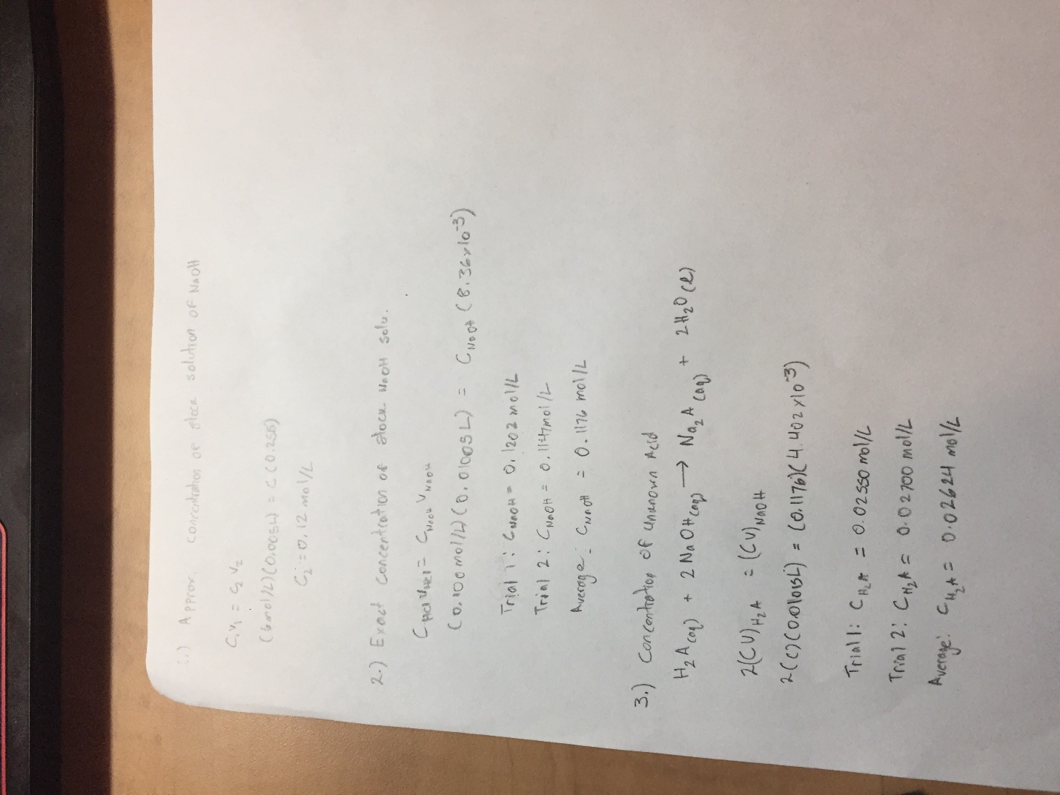
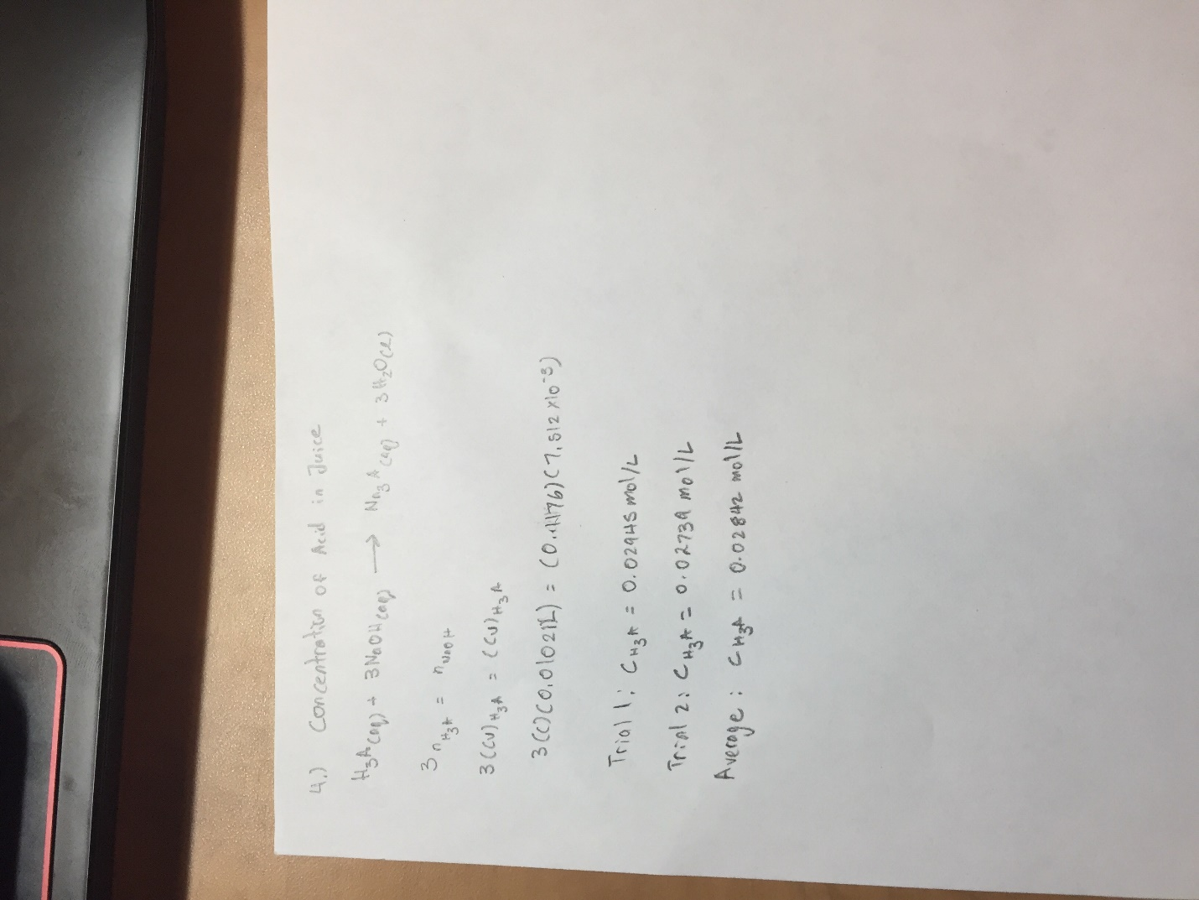

5.) Mass Percent of Juice
MM_{H3C6H5O7} = 8(1.01 amu) + 6(12.01 amu) + 7(16.00 amu)
= 192.12 g/mol
Mass Percentage = (C_{H3C6H5O7} * MM_{H3C6H5O7}) / (Density of Juice x 1000ml/L) x 100%
= (0.02842mol/L*192.12g/mol)/(1.0004g/ml * 1000ml/L) x 100%
= 0.5458%
Graphs
Part 2: Trial 1
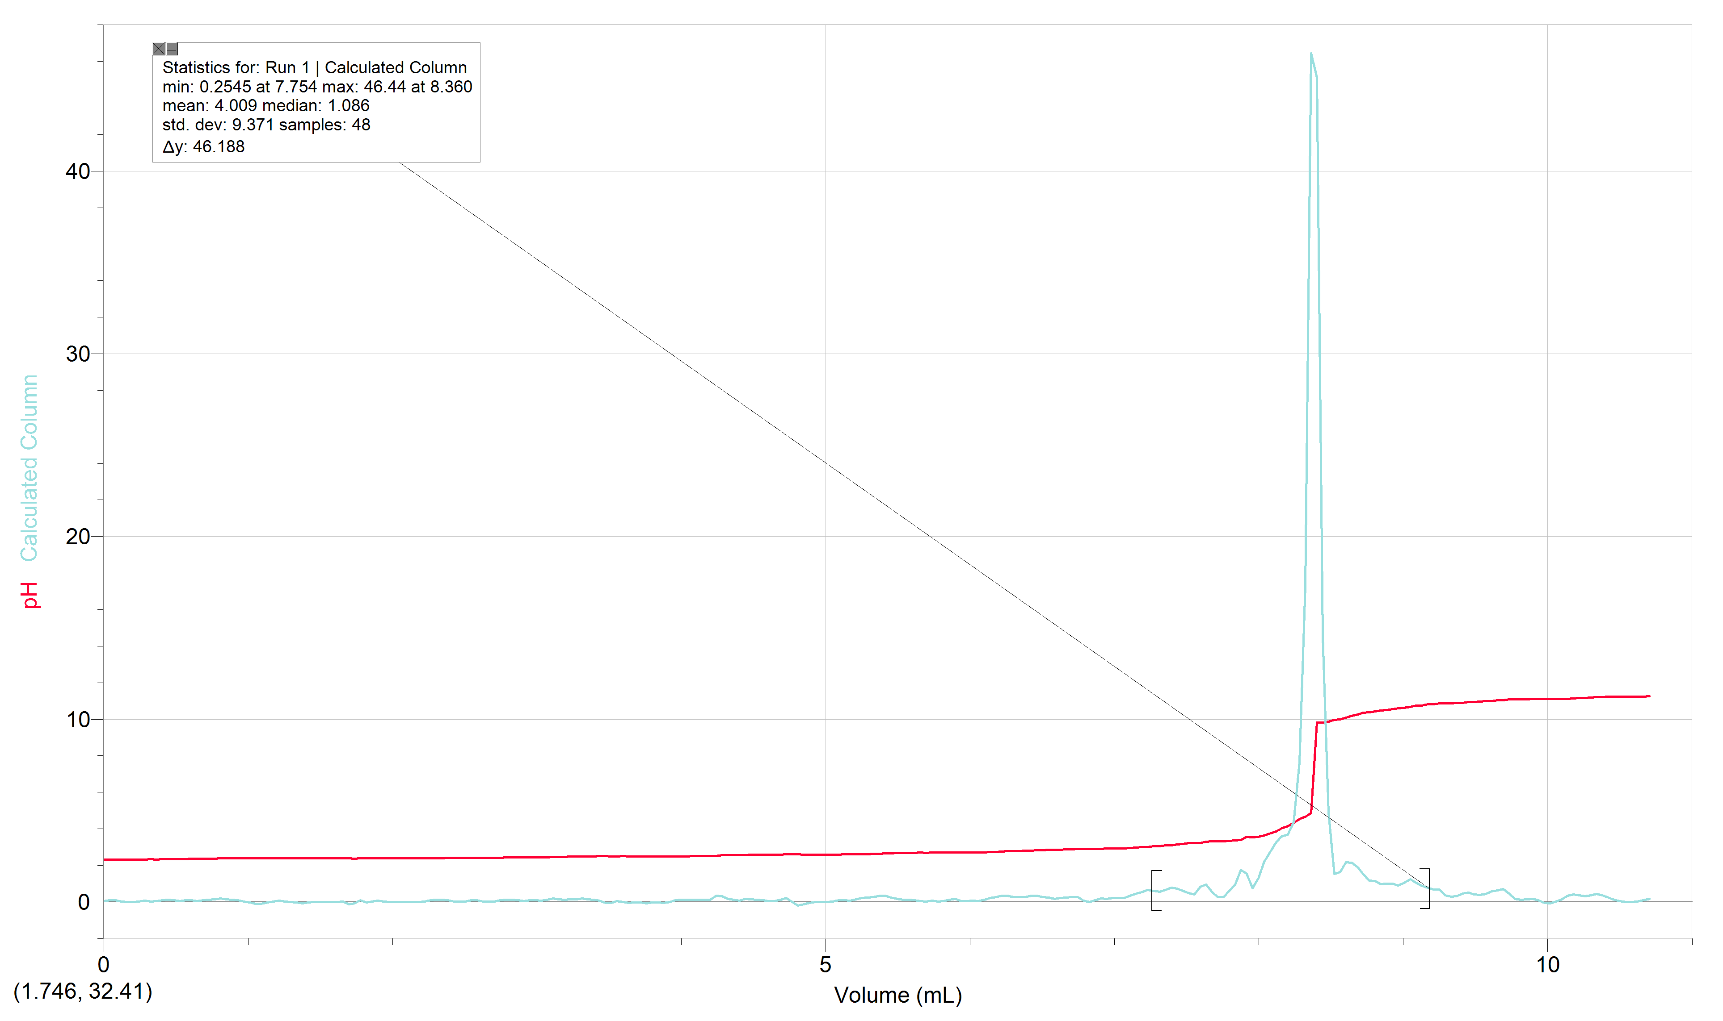

Trial 2
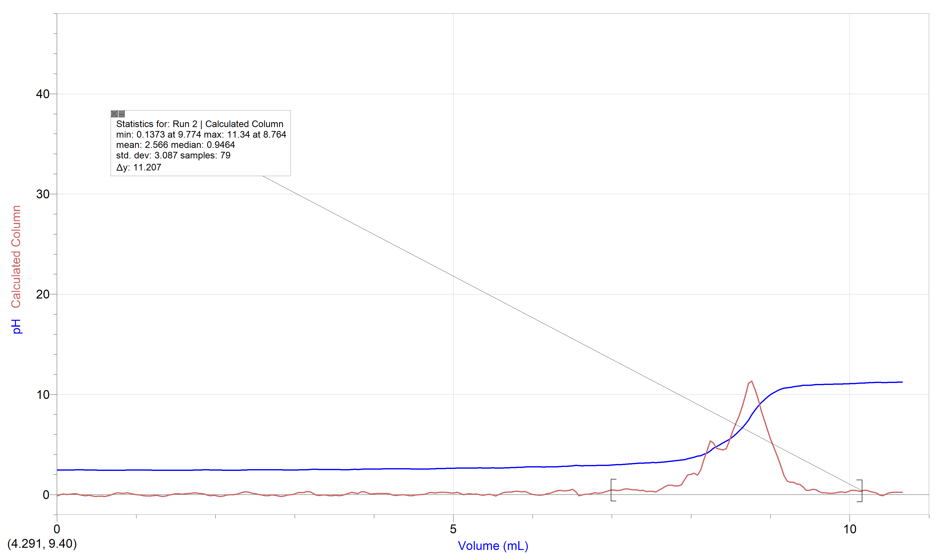

Part 3: Trial 1
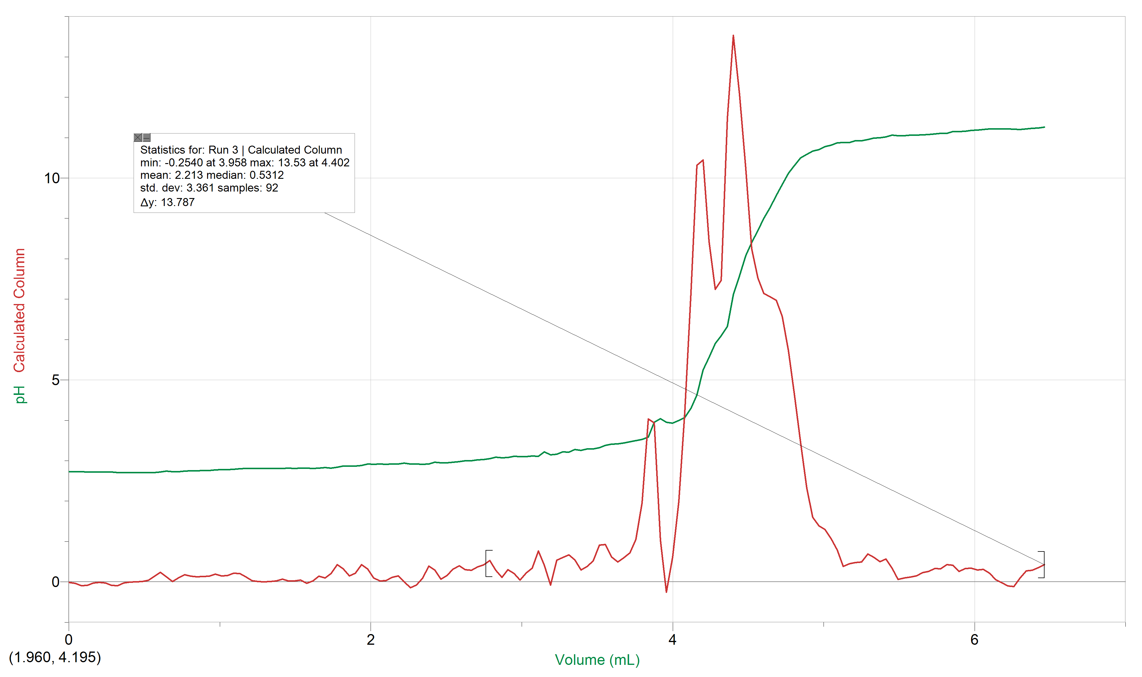

Trial 2
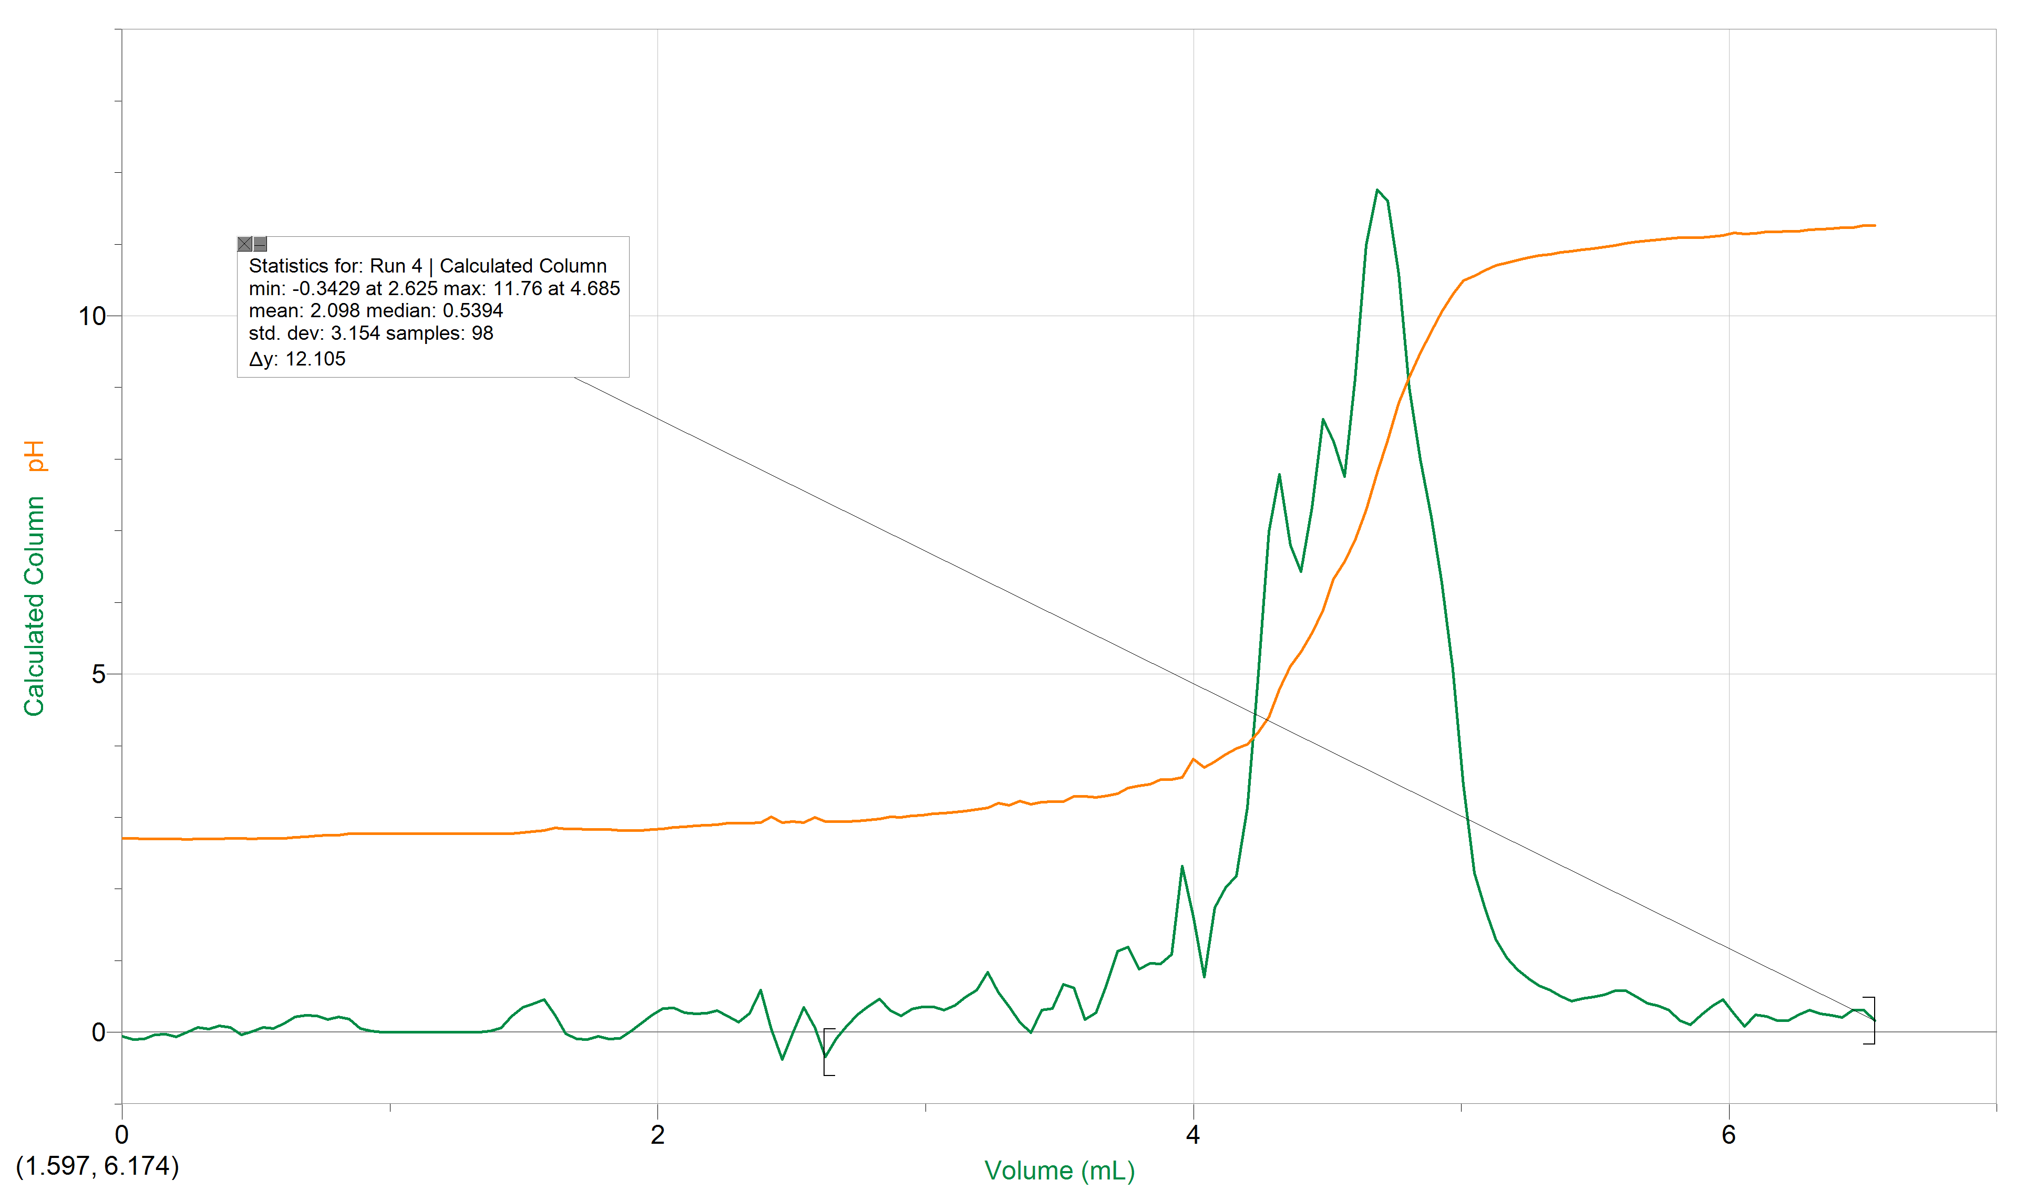

Part 4: Trial 1
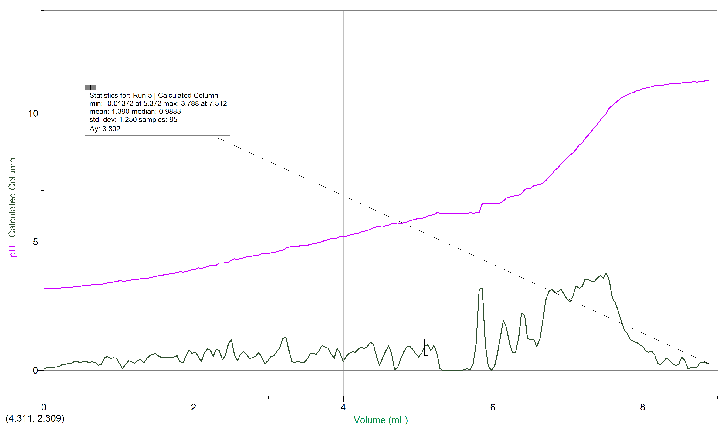

Trial 2
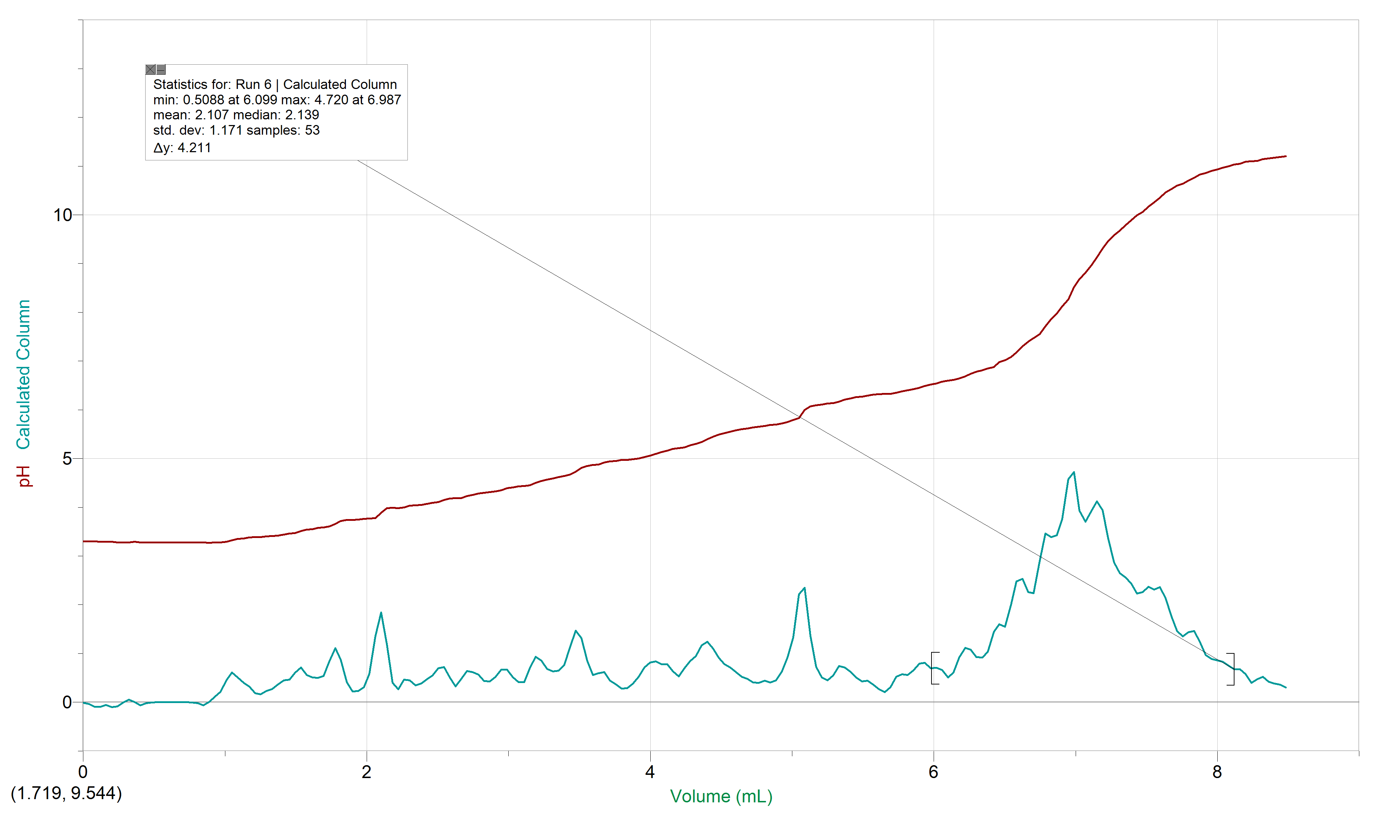

Discussions
There were several sources of error in this experiment, which may or may not have affected the outcome of this experiment. Firstly, as the pipette was turned off and on the valve that controlled the rate of the pipette shifted slightly slowing the drop rate, this was incorrectly corrected by adjusting it mid-experiment which is shown by graph 5. Additionally, two results were obtained for part 4 resulting in two different colours for each trial of the same juice sample, this may have occurred due to improper cleaning of tools and glassware. Both of these would affect the equivalence point by having drops miss counted and contaminants present in the reaction.
During all three cases, when the equivalence point was reached in the solution, it turned a shade of pink and as more NaOH was added the solution rapidly became darker and darker giving it a magenta reddish colour. Additionally, the colour change in the solution purpose is to indicate when the moles of the acid is equal to that of the base, which allowed the calculations C1V1=C2V2 to be applied. Furthermore, for each trial, the difference between the exact equivalence point, which was determined through the use of logger pro and its first derivative, and the observed point was very small averaging about + or – 0.1 mL.
Certain values such as the concentration of the NaOH and the volume of concentrated NaOH were noted during this experiment. What makes these numbers important is their use in the equation which aids in finding the mass percentage of the juice sample. Taking note of the concentration of NaOH was used to calculate the concentration of NaOH in the solution as the volume changed. The concentration and volume used in the titration were used to determine the mole of NaOH used to reach equivalence, making it possible to determine the moles which is a necessary value to determine the concentration of the unknown acid.
Using the following equation:
Mass % of Acid in Juice $\frac{(C of acid\frac{mol}{L})(Molar Mass of Acid\frac{g}{mol})}{(Density of Juice\frac{g}{ml})(1000)}$ x 100%
It was determined that the mass percent of the acid in the juice was 0.55%. The factor of 100 was added to convert the units of the juice from g/ml to g/L.
The titration of the juice sample, three equivalence points are present. At each point, the species present vary. An example of this would be at 0 mL of base: H₃C₆H₅O₇ ↔ H₃C₆H₅O_{7.} These species are expected to present since nothing has changed in the juice solution.
At midway to the first equivalence point: the species that are present are H₃C₆H₅O₇, H₂C₆H₅O₇⁻, H₂O, H₃O^{+.} These are expected to be seen as it is midway through the first equivalence point. The citric acid can is present as well as it has it not fully reached the equivalence point, water is also present at this time as it is reacting with the citric acid to create H₂C₆H₅O₇⁻ and H₃O⁺.
At the first equivalence point: H₃O⁺ + H₂C₆H₅O₇⁻ ↔ H₃C₆H₅O₇ + H₂O. These species are expected to be present as the first proton (H⁺) from citric acid is donated to water to form both H₃O⁺ and H₂C₆H₅O₇⁻.
At midway to the second equivalence point: H₃O⁺, H₂C₆H₅O₇⁻, HC₆H₅O₇²⁻ and H₂O. These species are present because it is the midway through the second equivalence point. The H₂C₆H₅O₇⁻ is present as it has not fully reach equivalence point when reacting with water. When H₂C₆H₅O₇⁻ and water react, they produce HC₆H₅O₇²⁻ and H₃O⁺.
At the second equivalence point: H₂C₆H₅O₇⁻ + H₂O ↔ HC₆H₅O₇²⁻ + H₃O⁺. These species are expected to be seen as the second proton from H₂C₆H₅O₇⁻ is donated to water to form HC₆H₅O₇²⁻ and H₃O⁺.
At midway to the third equivalence point: H₂O, HC₆H₅O₇²⁻, H₃O⁺, C₆H₅O₇³⁻. These are expected to be present in the solution as its midway through the third equivalence point. HC₆H₅O₇²⁻ can be observed as it is not fully at the equivalence point when reacting with water. When HC₆H₅O₇²⁻ reacts with water it produces H₃O⁺ and C₆H₅O₇³⁻ present in the system.
At the third equivalence point: H₂O + HC₆H₅O₇²⁻ ↔ H₃O⁺+ C₆H₅O₇³⁻. These species are present at because the third proton from HC₆H₅O₇²⁻ was donated to water to form H₃O⁺and C₆H₅O₇³⁻.

Conclusion
The concentration of Unknown acid 2 was 0.02624 mol/L and the mass percent of acid in juice sample 5 was 0.5458%

References
The Editors of Encyclopædia Britannica. (2016, June 12). Arrhenius theory. Retrieved November 17, 2017, from https://www.britannica.com/science/Arrhenius-theory
Introduction to Acids and Bases. (n.d.). Retrieved November 17, 2017, from http://www.sparknotes.com/chemistry/acidsbases/intro/summary.html

Raw Data


