Stereochemical Analysis of the Reduction of Benzyl

By: Matthew Price
Student #: 300022846

CHM 1321 Section B02
Teaching Assistant: Terry McCallum
Date Conducted: March 6th, 2018
Partner: Laura Giles

University of Ottawa
Due Date: March 13, 2018

Introduction
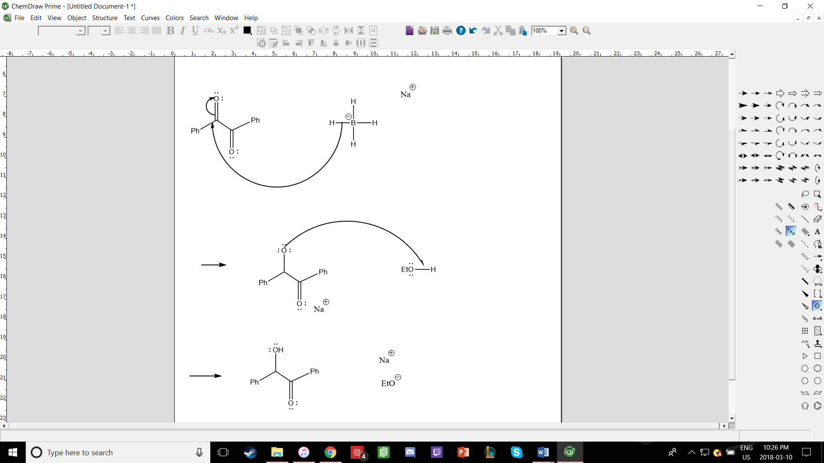
Procedure
Refer to pages 34-42 on a document titled “Laboratory Manual for Introductory Organic Chemistry, 2018” on Brightspace. However, changes were made to the procedure as follows
- Add 10mL of water into the Erlenmeyer flask before placing it into the hot water bath until the solution becomes a clear liquid again, place the flask into the ice bath, and wait for crystals to form
- After the acids are added to the round bottom flask and form a homogenous solution, take one TLC plate with one lane as Syn-acetonide, one lane Anti-acetonide, and the last lane with the solution from the reaction to determine what stereotisomer(s) are present in the product
Observations
Part A
- Benzil
  - Freezer Yellow, Crystalline, Solid, Powder, Opaque, 0.1g
- Ethanol
  - Transparent, Colourless, Liquid with a strong odour, 10mL
- After Ethanol was added to the flask the benzil remained undissolved
- Sodium Borohydride
  - White, fine, opaque powder
- Once sodium borohydride was added to the system it began to dissolve slowly
- After the flask was removed from the ice bath for approximately 8 minutes the homogenous solution began to mix
  - Solution went from a yellow liquid to a white frothy substance when mixed without the ice bath
- 1:9 EtOAc
  - Transparent, Colourless, Liquid, Strong odour that resembled nail polish remover
- Dichloromethane + Benzyl
  - Homogenous yellow clear solution
Part B
- Diol
  - White, brittle, translucent, reflective, crystalline solid, 0.6g
- Once acid was mixed with diol it remained clear
- Once p-toluenesulfric was added to the solution it began to transition to yellow, bright red then finally a wine-red colour
- Syn-acetonide
  - Transparent, colourless, liquid
- Anti-acetonide
  - clear, colourless, liquid
- 2-methylpropane
  - Clear, colourless, liquid, 1.0mL
- P-toluenesulfuric
  - White, crystalline, opaque solid, 0.05g

TLC Plate
Figure 1: TLC Plate with Benzil dissolved in Dichloromethane and the reaction mixture

S
Co
Be
Solvent System: 1:9 EtOAc
Sample Spot R_{f} value = 0.31
Benzil + Dichloromethane R_{f} Value = 0.56
Co-Spot 1 R_{f} Value = 0.56
Co-Spot 2 R_{f} Value = 0.31
1

2

Figure 2: TLC Plate with synacetonide, antiacetonide and the reaction mixture

Solvent System: 1:9 EtOAc
Sample spot 1 R_{f} value = 0.86
Sample spot 2 R_{f} value = 0.62
Sample spot 3 R_{f} value = 0.38
Anti Spot R_{f} value = 0.62
Syn Spot R_{f} value = 0.38

2
1
3

S
S
Anti
Syn

Table of Reagents
Table 1: Table of Reagents for reaction 1
Reagent | Amount | Molecular Weight (g/mol) | # of mols | Density (g/cm³)
Benzil | 1.01g | 210.23 | 0.0048 | 1.23
NaBH₄ | 0.32g | 37.83 | 0.0084589 | 1.07
EtOH (solvent) | 10 mL | - | - | -

Table 2: Table of Result for reaction 1
Product | Amount (g) | Molecular Weight (g/mol) | # of mol | % Yield
Benzoin | 1.23 | 212.24 | 0.005795 | 123.07

Table 3: Table of Reagents for reaction 2
Reagent | Amount | Molecular Weight (g/mol) | # of mols | Density (g/mol)
2-methoxypropene | 1mL | 72.1 | 0.0139 | 0.753
p-toluenesulfonic acid | 0.05g | 172.2 | 0.00029 | 1.24

Calculations
Rf Values
R_{f} Value = distance travelled by the compound/distance travelled by the solvent
=2.5 cm / 4.5 cm
=0.5555 =0.56
Percent Yield
Intial mass of Benzil = 1.01g
Molar mass of Benzil = 210.23 g/mol

Mol of benzil
= Mass/MM
= 1.01/210.23
= 4.80* 10^-3 mols
% Yield of Unknown compound
= (experimental mass/theoretical mass) * 100%
= 0.005842/0.00480 * 100%
= 121.71%
Discussion
- Oxidation-reduction reactions are important reactions in organic chemistry that are often simplified to the process of gaining or losing
  - Oxidation occurs when the amount/number of hydrogen atoms on a molecule decreases, while
Part A
- The purpose of the lab was to reduce ketone into an alcohol
  - Using sodium borohydride as a reducing agent
    - Benzil was reduced into benzoin, expressed in the introduction through the reaction mechanism
      - This produced two different configurations based upon the approach of the hydrogen bonding to the oxygen.
      - The second carbonyl was reduced producing 2 meso-compounds and 2 enantiomers.
- To conclude part one of the experiment, a TLC was run to determine if the reaction had been completed.
  - The reaction was completed since the sample spot had a lower Rf value of 0.31 than the unreacted reference Benzil & Dichloromethane which had an Rf value of 0.56
    - This shows that the ketone was converted into an alcohol
    - The sample has a lower Rf value because alcohols are favoured to stick to the silica gel giving them higher priority than ketones.
Part B
- The purpose of part b was to determine which stereoisomer of hydrobenzion was present in the crystal product by locking the bonds of the isomers in place
  - However, the TLC plates (figure 2.) ran are not very conclusive and do not give us a definitive identity
- To distinguish the two isomers, they were converted into a derivative
- The sample lane appeared to share Rf values with both the syn and anti configurations which is not possible.
  - The OH group formed at the first reduction site will prevent the reduction on the same side meaning that the anti configuration should have been favoured and thus the meso-compound was the major product.
- The purpose of adding the 2-methoxypropene and p-toluenesulfonic acid was to convert the diol product to acetonide which was better for separation on a TLC and would aid in determining the final product
- Therefore, due to the TLC being very inconclusive the result of this experiment was also inconclusive
Experimental Error
- The percent yield of 121.71% means that more product was produced than expected, this yield is more than likely due to errors that occurred in the lab. One error could have been measurement errors as many tools were missing from the cabinet thus making precise measurements more difficult. Furthermore, another error that could have possibly taken place during the lab would be, the crystals were not fully extracted from the funnel and stir bar due to them being attached to hard to navigate corners.
Question
1.)
Solubility of A = 1 g/100 mL at 20°C
Mass of A=3.5g
Solubility of B = 16 g/100 mL at 100°C
Mass of B=10g

Min solvent required to dissolve sample at 100°C:
Compound A
16g/100ml = 3.5g/xml
x =21.875ml
Compound B
16g/100ml = 10g/x ml therefore a minimal 62.5 ml of solvent is necessary.
x=62.5ml

Cooling to 20°C:
1g/100ml=xg/62.5ml
x=0.625g
Therefore, the composition of mother liquor is 0.625 g A and 0.625 g B.

Amount of crystal produced(mass)
Compound A:
3.5g-0.625g
=2.875g
Compound B:
10g-0.625g
=9.375g
Total crystal mass=12.25g

Composition of the crystals
Compound A
=2.875g/12.25g X100%
=23.46%
Compound B
=10g/12.25g X100%
=81.63%

%yeild
=12.25g/13.5g X100%
=90.74%
1.)
Solubility of A = 1 g/100 mL at 20°C
Mass of A=3.5g
Solubility of B = 16 g/100 mL at 100°C
Mass of B=10g

Min solvent required to dissolve sample at 100°C:
Compound A
16g/100ml = 3.5g/xml
x =21.875ml
Compound B
16g/100ml = 10g/x ml therefore a minimal 62.5 ml of solvent is necessary.
x=62.5ml

Cooling to 20°C:
1g/100ml=xg/62.5ml
x=0.625g
Therefore, the composition of mother liquor is 0.625 g A and 0.625 g B.

Amount of crystal produced(mass)
Compound A:
3.5g-0.625g
=2.875g
Compound B:
10g-0.625g
=9.375g
Total crystal mass=12.25g

Composition of the crystals
Compound A
=2.875g/12.25g X100%
=23.46%
Compound B
=10g/12.25g X100%
=81.63%

%yeild
=12.25g/13.5g X100%
=90.74%
- Solubitlity of A = 1.00g/ 100mL at 20ºC & Mass of A = 3.5g
Solubility of B = 16.00g/100mL at 100ºC & Mass of B = 10g

Minimal Solvent required to dissolve sample at 100ºC:

Compound B
16.00g/100mL = 10g/ X mL
X= 62.5Ml
Therefore, 62.5 ml of solvent is required.

Compound A
16g/100mL = 3.5g/ X mL
X = 21.875mL

Cooling to 20ºC:
1.00g/100ml = X g/62.5ml
X = 0.625g
Therefore, the composition of mother liquor is 0.625g A and 0.625g B

Amount of Crystal Produced:
Compound B:
10g – 0.625g
= 9.375g
Compound A:
3.5g - 0.625g
= 2.875g

Total crystal mass =12.25g

Composition of the crystals:

Compound A
Compound B
10g/12.25g * 100%
81.63%
= 2.875g / 12.25 * 100%
= 23.46%

% Yield
= 12.25g / 13.5g * 100%
= 90.74%

- 2.875g A – 1g A in solution = 1.875g solid A
9.385g B – 1g B in solution = 8.385g solid B

total solid formed = 1.875g + 8.375g = 10.25g

% composition A = 1.875g x100%
10.25g
= 18.29% A

% composition B = 100 – 18.29 = 81.71% B

% yield = 10.25g
2.875g + 9.375g
% yield = 83.7%

Composition of the crystals
Compound B
9.00g/11.5g * 100%
=78.26%

Compound A
2.5g/11.5g * 100%
= 21.74%

%Yield
11.5g/13.5g * 100%
= 85.18%
- The recovery was poor since the product was too soluble in methanol. To improve the results, the student should use a solvent in which the substance that is being purified has a high solubility at high temperatures and low solubility at lower temperatures. Furthermore, the student only conducted the process at room temperature while the boiling point of methanol is 65ºC. Lastly, they could improve results by boiling methanol to remove impurities and then crystalizing the product it by cooling.

  - 1-butonal is not obtained since the sodium borohydride is unable to reduce the carboxylic acid. This is because the carbonyl carbon on the carboxylic acid is more electrophilic with the carbonyl carbon on it in an aldehyde or ketone.
  - The product of the reaction is hydrogen gas which is released from the decomposition of the reducing agent

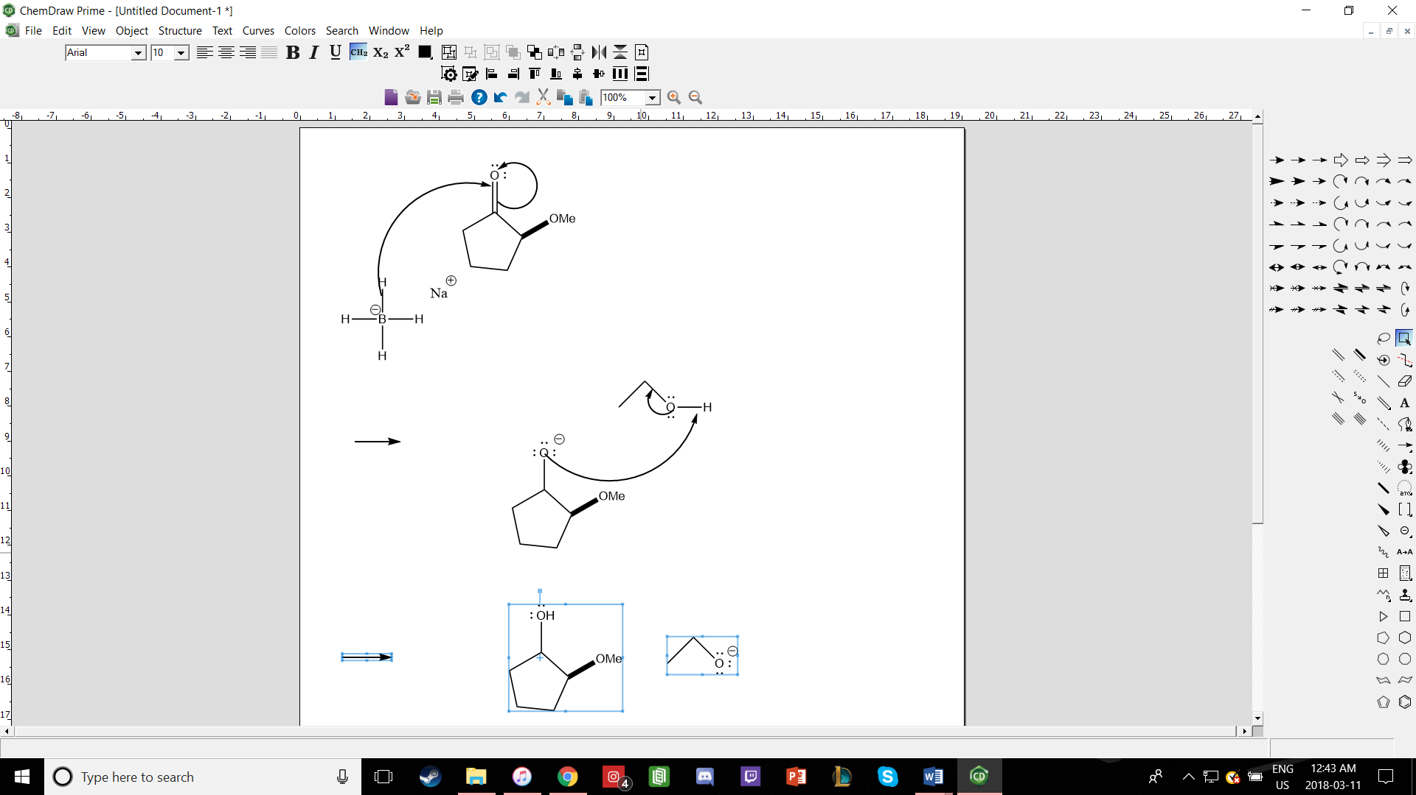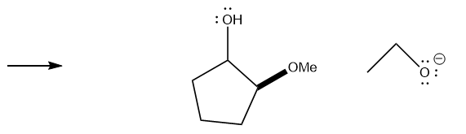

Raw Data


