Equilibrium Experiment

By: Matthew Price
Student #: 300022846

CHM1311 Section B10
Teaching Assistant: Colette Xu

University of Ottawa
Due Date: Nov, 3rd 2017

Introduction
An Equilibrium reaction is a unique type of chemical reaction, where the concentrations of the reactants and products are constant. However, this being said does not mean the concentrations of both reactants and products share the same value, rather they are no longer changing. What makes equilibrium reactions unique is that after the reaction has taken place, only are a portion of reactant’s concentration is used meaning there are still reactants present alongside the product. To illustrate that a reaction has reach equilibrium the notation of a double-ended arrow is used as such:
X + Y $⇆$ XY
Another interesting trait about equilibrium reactions is their ability to adapt to changes in the system to re-establish equilibrium. As stated by Le Chatelier’s Principle the equilibrium reaction will shift to favor either the reactants or products to counteract the effects of the change and restore equilibrium.
According to Khan Academy, “The pH scale is a scale which is used to determine the acidity or basicity of a solution ranging from 0-14, 0 being the most acidic and 14 being the most basic. The value of the pH depends on the concentration of $H^{+}$ ions present in the solution”. Normally human blood Ph ranges from 7.35 – 7.45 and by living this pH can easily fluctuate and to prevent drastic changes of and regulate the pH of blood, a buffer system will come into effect. To maintain this pH one of three buffers will act, in this case the main focus of this experiment surrounds the bicarbonate/carbonic acid buffer system which reaction is as shown:
2 H₂O _{(l)} + CO_{2 (g)} $⇆$ H₂CO₃ _{(aq)} + H₂O _{(l)} $⇆$ HCO₃ ⁻ _{(aq)} + H₃O⁺ _{(aq)}.
If the blood becomes too acidic through the increase of H+ ions, the reverse reaction would be favoured to consume the increased concentration of hydronium ions to produce carbonic acid. Additionally, if the body becomes too basic and is lacking H+ ions, the opposite will be true, and the reaction will favour the forward reaction to produce more hydronium ions. Buffer systems usually contain an acid-base pair, with either a strong acid and weak conjugate base or vice versa, in the case of the carbonic acid/bicarbonate buffer system, the carbonic acid is the acid and the conjugate base is the bicarbonate ion. Furthermore, the stronger the acid or base the faster the rate of ionization in water and the opposite is true for weak acids and bases and the addition of a weak acid or base to its strong counterpart, it will reverse or counteract the pH changes and correct the concentration of hydrogen ions in the solution to allow the body to maintain its ideal pH.
The concepts discussed above will be applied and explored throughout this lab. Various equilibriums will be established and used to observe Le Chatelier’s Principle and how it shifts based on pressures to maintain equilibrium. The buffer system equilibrium will serve as a simulation of the body’s bicarbonate/carbonic acid buffer and will demonstrate how certain pressures affect the blood pH and what the buffer does to correct this alteration.

Observation
Part 1. Equilibrium shift
- The characteristics of the CuSO₄ once placed in a test tuber were light blue colour, transparent, liquid form and no scent. The ion responsible for this colouration is the [Cu(H₂O)₄]²⁺ ion, this ion is a result of the copper sulfate being dissolved in water, the H₂O react with the copper ions, Cu²⁺, and the reaction gives off this pale/light blue colour.
- Once NH₃ was added to the test tube of CuSO_{4,} the solution became a dark blue translucent liquid after a precipitate had formed and subsided. The reason precipitate formed is due to the hydroxide ions introduced to the copper sulfate solution, once introduced the hydroxide ions interacted with the copper ions, creating copper hydroxide which is the precipitate55 that formed. Furthermore, the colour changed that occurred was due to the Copper sulfate being disassociating and forming a complex ion [Cu(H2O)₄]²⁺ and once ammonia is added to the solution this ion reacted to the ammonia forming Cu(NH₃)₄²⁺ which gave off the dark blue colour. The equilibrium reaction that established by this interaction is:
[Cu(H2O)₄] ²⁺ _{(aq)} + 4 NH₃ _{(aq)} ⇌ [Cu(NH₃)₄] ²⁺ _{(aq)} + 4 H₂O _{(l)}
- The addition of 1 drop of HCl to the solution resulted in a precipitate forming while restoring its light blue colour. However, after another drop HCl alongside a little agitation, the precipitate subsided turning the liquid transparent once again while obtaining a very pale/light blue colour. The reason that this occurred. This colour was the original colour of the copper sulfate solution, the reason this colour changed occurred was once the HCl was introduced to the system, the ion it introduced (Cl⁻) reacted and created bonds with the ammonia ion, allowing the copper ions to bond once again with H₂O and allowing the solution to return to its original colour.
- In step 4 the changes are the same, which was expected because the system is an equilibrium meaning that adding either HCl or NH₃ would only shift the equilibrium back and forth. Furthermore, if this step was done continuously there is a chance that the reaction reaches a point where it would stop experiencing these changes because of the loss of concentration of copper II ions. This effect could be beneficial and tested in another experiment to determine if this system ever reaches this point.
Part 2. Multiple Equilibria
- The characteristic of Na₂CO₃ once added to the test tube it was a clear, colourless liquid, and gave off no odour. Other substances that shared these characteristics were AgNO₃ and HNO₃.
- Once AgNO₃ was added the test tube the solution became a tan opaque colour with a white precipitate floating around. Since the Ag⁺ from AgNO₃ reacted with the CO²⁻ from Na₂CO₃ due to the increase in the concentration of nitrate, it formed an insoluble salt which is a tan whitish colour, while the sodium ions bonds with the nitrate ions and remains soluble. This interaction can be illustrated by the following equilibrium statement:
2AgNO₃ _{(aq)} + Na₂CO₃ _{(aq)} ⇌ Ag₂CO_{3 (s)} + 2 NaNO_{3 (aq)}
The ions responsible for the colour change are Ag⁺ and CO⁻² which form the precipitate which alters the colour and appearance of the solution.
- Once one drop of HNO₃ was added to the solution, it becomes clear. The HNO₃ dissociates in the solution, releasing H+ ions and NO₃⁻⁻, the nitrate ion becomes a spectator ion not playing a role in the equilibrium, leaving an excess amount of hydrogen ions. The equilibrium then shifts to consume these ions, which would then consume carbonate ions eliminating the previous precipitate that formed. This reaction can be illustrated by the following equation:
$2H^{+}\left(aq\right)+ {CO}_{3}^{2-}\left(aq\right)↔H_{2}{CO}_{3}\left(aq\right)↔ H_{2}O \left(l\right)+{CO}_{2}(g$)
- After the addition of HCl, the clear solution becomes a cloudy white liquid meaning a precipitate was formed through the addition of this solution. The introduction of hydrogen ions through the addition of HCl resulted in them bonding with carbonate ions since the concentration of H⁺ has increased in the solution which made the equilibrium [2 H⁺ (aq) + CO₃ ²⁻ (aq) ⇌ H₂CO₃ (aq)] shift to the right to consume the increased concentration of reactant. Furthermore, HCl also introduces Cl⁻ ions, these ions act on the existing concentration of silver ions (Ag⁺) establishing an equilibrium which creates an insoluble salt product, AgCI, which forms the white precipitate seen in the test tube which can be demonstrated by equilibrium: Ag⁺ _{(aq)} + Cl⁻ _{(aq)} ⇌ AgCl _{(s)}
- The addition of ammonia resulted in heat being released, a white gas formed, and the solution became a clear liquid.
- The addition of HNO₃ yields the same results in step 7, however, the addition of NH₃ does not yield the same results as it did in step 9. This interaction is because the reactant H₂CO₃ that is essential for the equilibrium required to repeat the effects of step 7, is being used in a 1-way reaction to produce the CO₂ gas which can’t be reversed by simply adding NH₃ back into the system.
- The addition of KI, potassium iodide, resulted in the solution into a milky/cloudy white solution. The introduction of the KI solution results in the potassium and iodine ions being introduced to the system. The iodine then reacts with the Ag⁺, silver ions to create an equilibrium, Ag⁺ _{(aq)} + I⁻ _{(aq)} ⇌ AgI _{(s)}, with the product AgI which is solid, which gives the cloudy/milky white appearance to the fluid.
- The addition of Na₂S, turns the solution into a grey and transparent, along with a black precipitate. This solution introduces a new ion, S⁺², into the system, which then reacts with the silver ions, Ag⁺, establishing a new equilibrium which yields Ag₂S: 2Ag⁺ _{(aq)} + S²⁻ _{(aq)} ⇌ Ag₂S _{(s)}. this ⁺equilibrium yields a solid which would explain the black precipitate giving the clear substance a greyish colour.
PART 3: Buffers
- The initial pH of the water was 7.35, this was the expected pH of water since it is neutral. By the water having a neutral pH, it proves that the water is mostly pure meaning there aren’t any other ions that needed to be taken into consideration during this reaction.
- The pH observed after stirring is 7.07. The reason the pH increased was due to the stirring the water while stirring it created a vortex which allowed CO₂ from the atmosphere, to dissolve into the water lowering the pH, making the substance more acidic. This step was to mimic the carbon dioxide introduced into the bloodstream as a by-product of cellular respiration.
- NaHCO₃ physical characteristics were it had a white colour, crystalline, opaque. Once it was added to the solution the pH raised to 8.05 making the solution more basic. The reason this occurred was once the salt was added it dissociates into its ions Na⁺ and HCO₃⁻, this results in the overall concentration of H⁺ ions to decrease in the solution and the opposite to be true for the concentration of OH⁻ ions which would increase the pH of the system.
- 30 mL of HCl was then added to the solution which lowered the pH of the system from 8.05 to 7.15 and had no other observable effects on the system. The addition of the acid created a buffer system in the beaker, which is responsible for reversing the basic pH of the system back to a neutral pH. What makes this possible is due to the chemical property of hydrochloric acid is a strong acid which allows it to disassociate very quickly into it H⁺ ions which go to the overall H⁺ concentration allowing it to form hydronium ions. The increase of the concentration of hydronium ions then lowers the overall pH of the system back to a more neutral 7.15, which is more basic than the initial pH of the water. The reason this pH is lower than the initial pH is that of the buffer system created by the addition of hydrochloric acid. This step resembles the blood buffer system because of the addition of H+ ions being introduced to the system to neutralize the basic pH, which would be the forward reaction of the blood buffer system; 2 H₂O _{(l)} + CO_{2 (g)} H₂CO₃ _{(aq)} + H₂O _{(l)} HCO₃ ⁻ _{(aq)} + H₃O⁺ _{(aq)}. Furthermore, by adding hydrochloric acid to the system, Chlorine ions were introduced as well, which more than likely bonded with the sodium ions present creating sodium chloride remaining soluble in the system.
- After the lactic acid was introduced into the system the Ph lowered even more to 7.03, which is because of the H+ ions it produced once it dissociated. This step was to simulate when the body is blood is made basic from exercising which increases the intake of oxygen, the muscles will produce lactic acid to lower the overall pH of the blood back to a neutral ph. Once again, this interaction resembles the forward reaction of the blood buffer system.
- Upon stirring the solution, a vortex was formed, and many bubbles were seen in the beaker and around the probe. The pH of the solution raised slightly from 7.03 to 7.06. The increase of the pH was expected as this step imitated the reverse reaction of the blood buffer to neutralize acidic blood, the addition of CO₂ would result in the loss of H+ ions resulting in the more basic solution.
- When NaHCO₃ was added to the system the pH raised to 7.23. The dissociation of this salt introduced bicarbonate ions which is responsible for the increased pH of the system, which result in the reverse reaction to become favoured lowering the concentration of hydronium; 2 H₂O _{(l)} + CO_{2 (g)} H₂CO₃ _{(aq)} + H₂O _{(l)} HCO₃ ⁻ _{(aq)} + H₃O
- The once the salt was added again the pH of the solution raised once again from 7.23 to 7.37. as stated previously this is due to the increase of the bicarbonate ion which shifts the equilibrium favouring the reverse reaction. This step was to simulate a patient who is experiencing a metabolic disease known as metabolic acidosis, this is caused by the lack of CO₂ being present or introduced to the body allowing the bicarbonate ion to accumulate since the equilibrium would be unable to shift.
- When the dry ice or carbon dioxide pellet was added to the beaker the pH lowered to 7.20. While it was in the beaker it gave off a white gas that as it shrunk in the water, the gas being expelled from the beaker was a sublimation of carbon dioxide gas.
- When ammonium chloride was added to the system the pH was lowered to 7.19. This interaction can be explained by the following reactions:
$${NH}_{4}Cl \left(s\right)→{NH}_{4}^{+}\left(aq\right)+ {Cl}^{-}\left(aq\right)$$
$${NH}_{4}^{+}\left(aq\right)+ H_{2}O \left(l\right)→ {NH}_{3}\left(aq\right)+H_{3}O^{+}\left(aq\right)$$
The ammonium chloride ionizes introducing ammonium ions and chloride ions, ammonium ions then react with the surrounding water molecules to create hydronium thus increasing its overall concentration resulting in the system making the pH more acidic.

Conclusion
The reason this experiment was conducted was to qualitatively observe and record equilibrium reactions and to grasp the concept of equilibrium manipulations to produce desired results. Each reaction was manipulated by the introduction of new solutions and outside reactants that altered that produce ions already present in the system, once introduced the concentration/volume would change resulting in the equilibrium to shift to favour either the forward or reverse reaction. In part 1 and 2 of this experiment, Le Chatelier’s Principle could be applied as it was demonstrated that the addition of solutions that ionized into reactants can cause the reaction to shift, which would result in a physical or chemical characteristic change. The last part of the experiment was to simulate the human blood buffer system and how certain actions can affect the Ph of the blood and how the body counteracts upon those forces. This was done by creating a synthetic buffer system that would have similar stresses placed upon it metabolic acidosis or the formation of lactic acid and recording the Ph change that occurred due to that stress. This lab enabled those who participated to understand the importance of equilibriums and draw connects to how these reactions may affect organism outside of the lab, being apart of their basic everyday life.
Discussion
- A) The ammonium ion was used as an acid source instead of HCl because since HCl is a strong acid it would ionize completely in the solution. If it had completely dissociated, the H+ ions would react with the water molecules and form excess hydronium resulting in the pH decreasing more drastically.
b) the reason ammonium chloride was added to the solution was so that once it ionizes the Cl⁻ ions released would not affect the overall Ph of the system as they do not have any acidic or basic properties, allowing ammonium chloride to dissociate without HCl forming because of it.

- Every time an acid was introduced to the system the Ph of the system would become lower. The reason that this happened was once the acid is introduced to the system it dissociates into H+ ions and whatever another ion it was bound to. The hydrogen ions would then form hydronium which makes the system more acidic, however, in this experiment, the acids were only added after a base was added to return the system back to a neutral state. The reason for this is because acids and bases counteract each other, so when a weak acid/base is added to a strong acid/base it will return the system back to a neutral pH.
- Acidosis, as discussed earlier, is a condition where the body contains too much acid resulting in its pH is lower than 7.35 which is desired function pH levels. This would affect the patient’s ability to transport oxygen by blood because “decreases in blood pH result in a lower affinity of hemoglobin for oxygen” (Pathway medicine).
- The solution on the left keeps the hemoglobin’s oxygen affinity the same, which is proven by its bright red oxidized colour, however, the solution on the right has rendered the hemoglobin to equilibrium to favour the reverse reaction since the affinity for oxygen has decreased due to the acidic environment. This dark black colour is blood that lacks oxygen and as the oxygenation of the blood decreases so does its bright red pigmentation.
- Soda contains high levels of phosphoric acid which is used for flavouring and carbon dioxide gas which is used for the fizz. Furthermore, carbon dioxide has a tendency to leave its container, which is why it tries to escape from the can continuously making the can firm. By stirring the soda, it is giving the carbon dioxide bubbles area to disperse into the atmosphere making the soda flat, while simultaneously dissolving the carbon dioxide back into the soda. Therefore, the pH should remain relatively the same due to it being reintroduced to the system, which is similar to what occurred in step 14 of this lab.
- Panting in chickens is a way that their body regulates its temperature. It does this by expelling hot water vapor from its throat outward as it pants, however this water contains carbon dioxide. This loss of carbon dioxide affects their reproductive rate and inhibits a number of eggs a chicken can produce. Moreover, excessive loss of carbon dioxide will cause the bicarbonate buffer system to shift equilibrium and decrease the production of bicarbonate. The carbonate in a chicken’s blood is used to combine with calcium therefore, a deficiency in carbonate would affect the overall strength of the chicken’s eggs making the shells weaker.

Raw Data
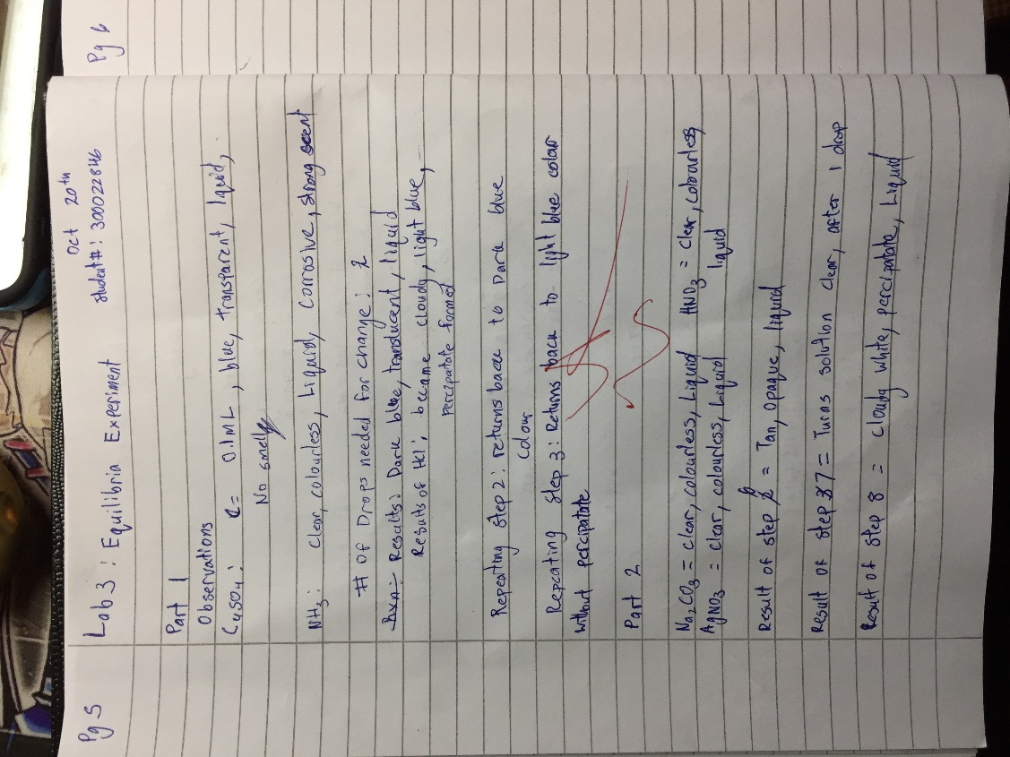
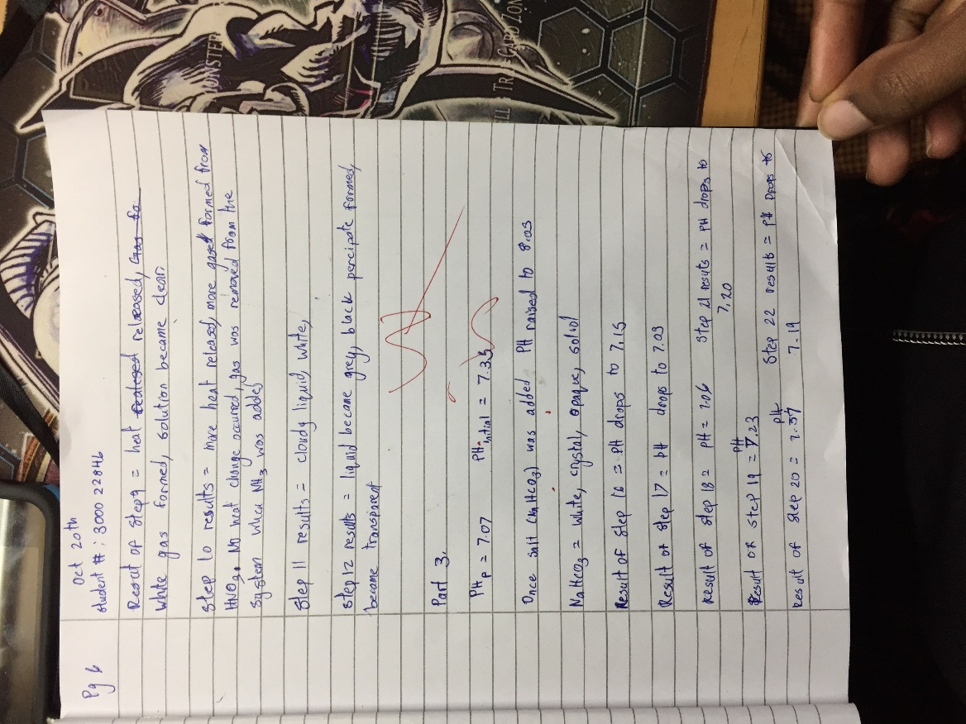

Citations
- Allen, S., & Boskey, E. (2017, June 06). Acidosis. Retrieved October 31, 2017, from https://www.healthline.com/health/acidosis#overview1
- Helmenstine, P. A. (2017, February 7). Here's the Reason Why Dry Ice Makes Fog. Retrieved October 31, 2017, from https://www.thoughtco.com/why-dry-ice-makes-fog-606404
- The role of the bicarbonate buffer system in regulating blood pH. (n.d.). Retrieved October 31, 2017, from https://www.khanacademy.org/test-prep/mcat/physical-sciences-practice/physical-sciences-practice-tut/e/the-role-of-the-bicarbonate-buffer-system-in-regulating-blood-ph
- Bohr Effect. (n.d.). Retrieved October 31, 2017, from http://www.pathwaymedicine.org/bohr-effect
- Medical Definition of Blood pH. (2016, May 13). Retrieved October 31, 2017, from https://www.medicinenet.com/script/main/art.asp?articlekey=10001
- Why does the pH of soft drinks get lower as they go flat? (2016, July). Retrieved October 31, 2017, from https://chemistry.stackexchange.com/questions/55421/why-does-the-ph-of-soft-drinks-get-lower-as-they-go-flat
- Alleviating Heat Stress In Chickens. (n.d.). Retrieved October 31, 2017, from https://www.southernstates.com/articles/poultry-care-heat-stress.aspx
- Hendrickson, K. (2017, October 03). Carbonic Acid in Beverages. Retrieved October 31, 2017, from https://www.livestrong.com/article/547245-carbonic-acid-in-beverages/



