Regioselective Nitration of Acetanilide

By: Matthew Price
Student #: 300022846

CHM 1321 Section B02
Teaching Assistant: Terry McCallum
Date Conducted: April 2nd, 2018
Partner: Laura Giles

University of Ottawa
Due Date: April 10th, 2018

Introduction
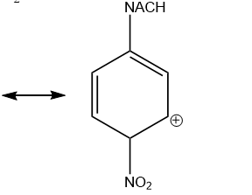
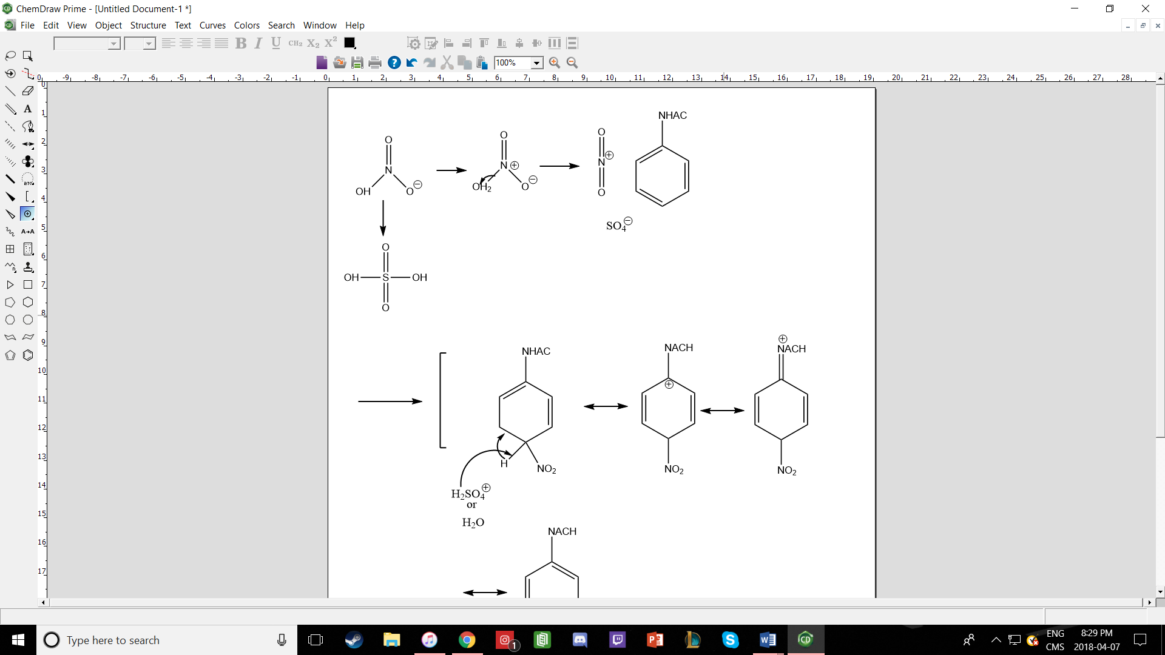

Procedure
Refer to pages 48-55 on a document titled “Laboratory Manual for Introductory Organic Chemistry, 2018” on Brightspace

Observations
- Acetanilide
  - Tan colour, flakes, solid, opaque
- H₂SO₄
  - Clear, colourless, liquid
- Concentrated HNO₃
  - Transparent, colourless, liquid
- Mixing H₂SO₄ + Acetanilide
  - Solution became brown and remained transparent
  - Acetanilide dissolved slowly over time
- Mixing H₂SO₄ + HNO₃
  - Upon mixture the solution became hot
  - A gas formed when transferred from graduated cylinder to the flask
  - Solution remained a clear, colourless substance
- When the two mixtures were mixed
  - The solution became a dark brown colour
- Dark Brown reaction Mixture
  - Once placed in an ice bath
    - Solution became yellow
    - After suction filtration
      - The substance collected on the filter paper was a yellow, paste, slimy product
      - the liquid collected in the flask was a light-yellow colour

Table of Reagents
Table 1: Table of Reagents
Reagent | Amount (g or mL) | Molecular Weight (g/mol) | # of mols | Density (g/mL)
Acetanilide | 1.0g | 135.17 | 0.007398 | -
H₂SO₄ | 6.2mL | 98.08 | 0.1163 | 1.84
HNO₃ | 0.9mL | 63.01 | 0.02157 | 1.51

TLC Plates
Figure 1: TLC Plate with Acetanilide and Reaction Solution
2
1
1
2
3
A
Solvent System: 1:9 EtOAc
Acetanilide R_{f} Value: 0.32
Co-Spot #1 R_{f} Value: 0.76
Co-Spot #2 R_{f} Value: 0.32
Co-Spot #3 R_{f} Value: 0.08
Sample Spot #1 R_{f} Value: 0.76
Sample Spot #2 R_{f} Value: 0.08

S
Co

Figure 2: TLC Plate with Meta and Reaction Solution
Solvent System: 1:9 EtOAc
Meta R_{f} Value: 0.29
Co-Spot #1 R_{f} Value: 0.71
Co-Spot #2 R_{f} Value: 0.29
Co-Spot #3 R_{f} Value: 0.09
Sample Spot #1 R_{f} Value: 0.71
Sample Spot #2 R_{f} Value: 0.29
Sample Spot #3 R_{f} Value:0.09

S
Co

1
1

2
2

3
3
M

Figure 3: TLC Plate with Para and Reaction Solution
3
Solvent System: 1:9 EtOAc
Para R_{f} Value: 0.31
Co-Spot #1 R_{f} Value: 0.72
Co-Spot #2 R_{f} Value: 0.31
Co-Spot #3 R_{f} Value: 0.09
Sample Spot #1 R_{f} Value: 0.72
Sample Spot #2 R_{f} Value: 0.31
Sample Spot #3 R_{f} Value:0.09

S
Co

1
1

2
2

3
P

Figure 4: TLC Plate with 2,4,-Dinitro and Reaction Solution
Solvent System: 1:9 EtOAc
2,4,-Dinitro R_{f} Value: 0.51
Co-Spot #1 R_{f} Value: 0.70
Co-Spot #2 R_{f} Value: 0.32
Co-Spot #3 R_{f} Value: 0.33
Sample Spot #1 R_{f} Value: 0.70
Sample Spot #2 R_{f} Value: 0.33

S
Co
2
3
1
1
2
D

Figure 5: TLC Plate with Ortho and Reaction Solution
Solvent System: 1:9 EtOAc
Ortho R_{f} Value: 0.63
Co-Spot #1 R_{f} Value: 0.73
Co-Spot #2 R_{f} Value: 0.63
Co-Spot #3 R_{f} Value: 0.37
Sample Spot #1 R_{f} Value: 0.73
Sample Spot #2 R_{f} Value: 0.37

S
Co
2
3
D
1
1
2

Calculations
# of Mols
# of mols of HNO₃ = amount(mL) x density /molecular weight(g/mol)
= (0.9mL x 1.51g/mL )/ 63.01g/mol
# of mols = 0.0216mol
Therefore, the number of moles of HNO₃ in 0.9mL is 0.0216 mol
Rf Values
Data used from Figure 5 TLC Plate
Distance travelled by compound = 2.2cm
Distance travelled by the solvent= 3.0cm
R_{f} Value = distance travelled by the compound/distance travelled by the solvent
=2.2 cm / 3 cm
=0.733333 =0.73
Percent Yield
% yield of unknown substance
Amount obtained = 2.73g
Theoretical amount = 1.33g
Calculations to obtain theoretical amount:
Moles of acetanilide = g acetanilide / molecular weight
Moles of acetanilide = 1.0g / 135.17g/mol
Moles of acetanilide = 0.007398mol

Mass of nitroacetanilide = mol acetanilide x molecular weight nitroacetanilide
Mass of nitroacetanilide = 0.007398mol x 180.16g/mol
Mass of nitroacetanilide = 1.33g

% yield = obtained/theoretical x100%
%yield = 2.73g/1.33g x100%
%yield = 205.26%

Therefore, the percent yield of the compound is 205.26%
Ratio of Compounds in Pure Product
The desired products are 1,2,-dinitro and para but since our final products were para and meta we couldn’t use the calibration curve to find the percentage of the isomer the product contained.
Image J
Figure 7: screenshot of dot intensity graph produced by ImageJ
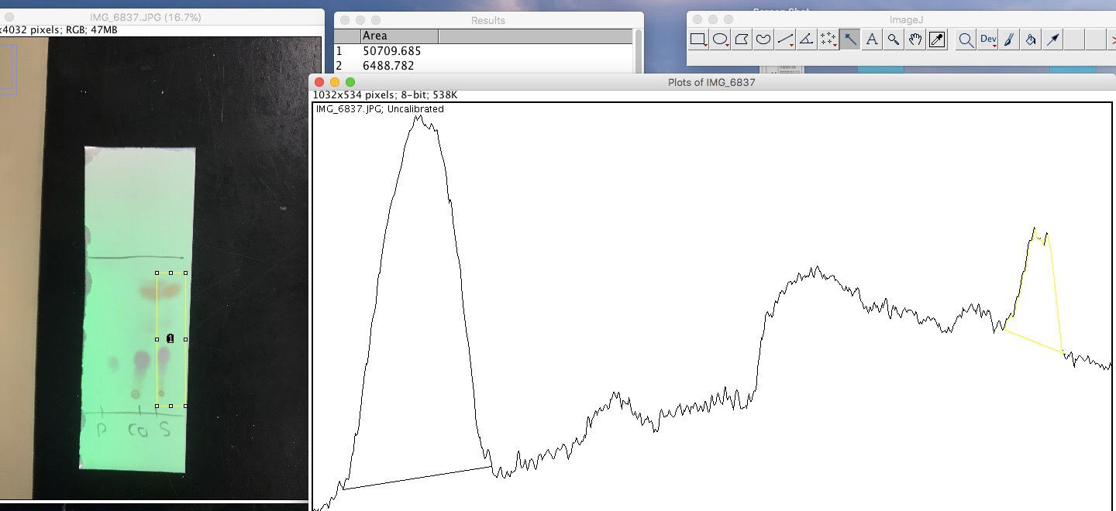

Questions
- there is a difference in polarity between the ortho and para isomers of nitroacetanilide due to the addition of the nitro group to the acetanilide compound creates a dipole. In para substitution, the NHAc and NO₂ substituents occupy the 1 and 4 positions and are thus located opposite to each other. This creates a dipole that spreads across the whole molecule, and as a result causes the molecule to be very polar. Since the silica gel on a TLC plate is also polar, the para isomer is able to interact with the gel. These interactions cause the spot of the para isomer to stick to the plate, which gives it a small Rf value. In ortho substitution, the substituents occupy the 1 and 2 positions, so this time they are not located on opposite sides of the molecule. A dipole is still created; however, it does not spread across the entire molecule. As a result, the ortho isomer is less polar than the para isomer and doesn’t interact with the silica gel to the same extent.
- The para-isomer has a high solubility due to it being a polar molecule, thus it can be dissolved in the polar ethanol. The solubility of the ortho-isomer is lower than the para-isomer since it is less polar resulting it in it being less soluble in the polar ethanol
- Certain bonding positions are more favourable due to resonance and sterics. In this case, the resonance structures do not contribute the preference in position since both para and ortho isomers can form 4 resonance structures, which means that the charge is stabilized to the same extent in both isomers. Therefore, the most favourable position can be determined based on sterics. In ortho substitution, substituents occupy the 1 and 2 positions. Since they are not located as far apart as possible, steric clash can occur between the nitronium ion and the acetyl group, which increases the activation energy of the reaction and therefore the reaction rate. In para substitution, substituents occupy the 1 and 4 positions, and are located opposite of each other. This decreases steric clash between the nitronium ion and the acetyl group as the nitronium approaches the ring. As a result, the activation energy for the reaction is lower since there is less bumping between the two groups, so the reaction can occur faster. Therefore, para isomers are preferred over ortho isomers in EAS since the lack of steric interaction allows the reaction to occur the fastest.
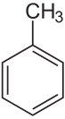

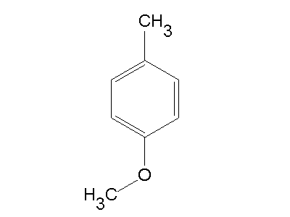
  - preferred position of nitration is para and ortho (more para than ortho since para is more stable) CH₃ an ortho-para directing group

  - preferred position of nitration is meta to the methoxy group there are already para substituted substituents so the nitration has to occur meta to one substituent (methoxy donates most electron density to ring)
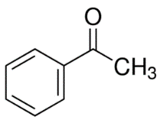
  - preferred position of nitration is meta -OCH₃ a moderately activating group that directs into a meta directing group

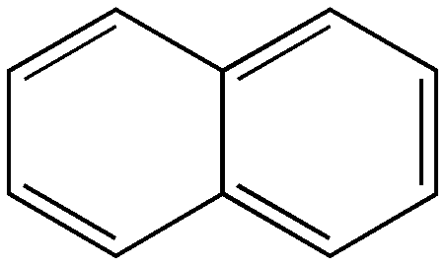
  - nitration occurs at carbon 1 position to yield 1-bitronapthalene does not affect resonance structures

- In the first reaction, the product only has one bromine substituent. This is because when the pi bond of the benzene attacks the bromine, only one Br will attach to the ring which breaks the Br-Br bond. This step breaks aromaticity which causes the compound to become very unstable. As a result, the bond between H and the ring is broken to reform another double bond, and the H and Br⁻ join. Therefore, the product only has one Br substituent so that it can regain its aromaticity. In the second reaction, the product has two bromine substituents. The first step is the same as what occurs in reaction one; however, this compound becomes stable once it loses its double bond. Therefore, the ring does not need to regain aromaticity which is why it forms bonds with both Br atoms. Reactions shown below:
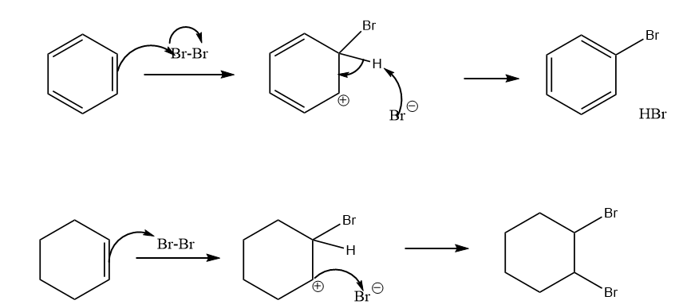

Reagent | Amount | Molecular weight (g/mol) | # of moles
Benzene | 780g | 78 | 10
HNO₃ | 750mL |  | 16
H₂SO₄ | 750mL |  | 18
Nitrobenzene | 1000g | 123 | 8.1
unknown | 250g

Blue = reactants
Red = products

Therefore, between benzene, HNO₃ and H₂SO₄ (reactants), benzene is the limiting reagent

  - % yield = actual amount/theoretical amount x100%
% yield = 8.1mol/10mol x 100%
% yield = 81%

  - dinitrobenzene
  - The role of H₂SO₄ is to protonate HNO₃. As a result of this protonation, a strong electrophile is formed that can carry out the nitration.
  - Moles C₆H₄N₂O₄ = 250g / 168.11g/mol
Moles C₆H₄N₂O₄ = 1.49mol

%yield = actual amount/theoretical amount x100%
%yield = 1.49mol/10mol x100%
%yield = 15%
- The nitration of furan leads preferentially to 1-nitrofuran rather than 2-nitrofuran because 1-nitrofuran can form more resonance structures, and is therefore a more stable compound since the charge is spread over more atoms. The resonance structures of 1-nitrofuran and 2-nitrofuran are shown below:

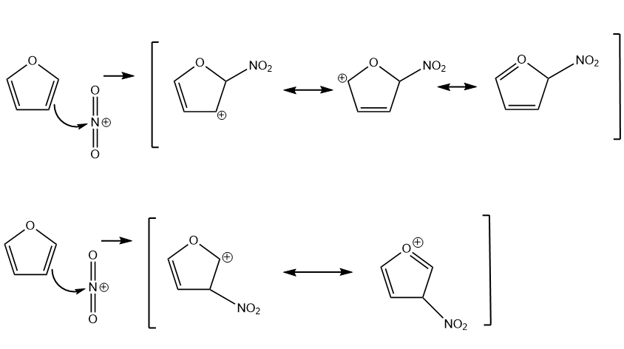

Raw Data



