Lab 4: Basic Computer Organization
CEG 2136B - Computer Architecture I
Fall 2017
School of Engineering

Group 4
TA: ?
James Duffy 8576365
Jingqian Liu 7825240
Experiment Date: 11/30/2017
Submission Date: 12/4/2017

Theory

Introduction:
This lab is about designing a control unit, and simulating and testing a simple 16-bit computer. Programs will be used on the simple computer from simple opcodes in machine language to test on the Altera DE2-115 board and simulate using Quartus II.
Objectives:
- Develop logic equations for a basic computer and implement them using Logic Gates into lab3controller.
- Create a memory content file and test the basic computer using different memory contents.
- Generate a program using machine language and convert it into the memory content file format.
- Run three different simulations based on the different memory contents

Design

Presentation of Design Methodology

Hardware

1. 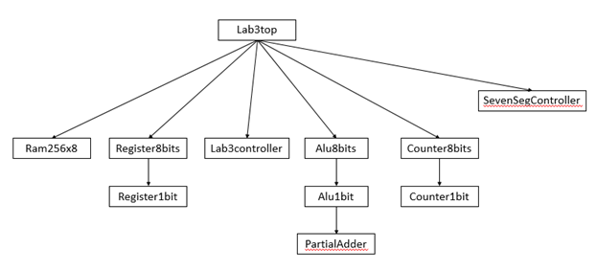
2. Only one register will place an output on the data bus at a time, because the selection of the select bit will choose which operation to perform.
3. The register reset signals are synchronous so that they may be all controlled and come from the same input and output.
4. If load and reset are simultaneously sent to a register, the register is cleared and becomes 0, because both AND gates in register1bit are set to 0, which makes the OR gate 0 (also reset takes priority).
5. The address register is directly connected to the memory so that the address may be saved after an operation without any changes.
6. the program counter, data register, and the accumulator are implemented as counters because they need to be incremented in some cases.
7. The highest priority out of the three commands; reset, increment, and load goes to ‘reset’. The lowest of these three commands is increment. This is because if reset is 1, all AND gates are 0, and if load is 1, increment AND gate is 0 in counter8bits.
8. It is not possible to read a value directly from memory to the accumulator, because the value from memory must be loaded into the DR first, then to the AC.

9.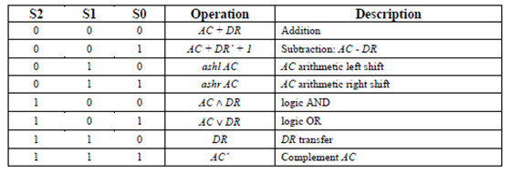

Memory
Memwrite = T9Y4 + T10Y6
CPU registers
AR_Load = T0 + T2 + T5(IR6)’ + T6(IR6)’ + T7X2
PC_Load = T8Y5
PC_Inc = T2(S)’ + T5(IR6S)’ + [DR0 + DR1 + DR2 + DR3 +DR4 + DR5 + DR6 + DR7]’S’Y6(T11 + T12)
DR_Load = T8[Y0 + Y1 + Y2 + Y3 + Y6]
DR_Inc = T9Y6
IR_Load = T3
AC_Clear = T5X1IR0
AC_Load = T9[T0 + Y1 + Y2 + Y3} + T5X1[IR1 + IR2 + IR3]
AC_Inc = T5X1IR4
OUTD_Load = T1
CPU ALU
ALU_Sel2 = T5X1IR1 + T9[Y0 + Y3] + T10Y6
ALU_Sel1 = T5X1[IR1 + IR2 + IR3] + T9Y3 + T10Y6
ALU_Sel0 = T5X1[IR1 + IR3] + T9Y2
Bus
BusSel2 = T0 + T9Y4
BusSel1 = T2 + T5 + T0 + T10Y6
BusSel0 = T8Y5 + T10Y6 + T9Y4
Control Unit
SC_Clear = T5X1 + T9[Y0 + Y1 + Y2 + Y3 + Y4] + T8Y5 + T12Y6
Halt = T5X1IR5

Software

Load A0
Complement A0
Save A0
While A0 > 0, do
M[Z] <-M[ X] +M[ Y]
M[A1] <- X + 1
M[A2]<- M[A1] + 1
M[A3] <- M[A2] + 1

3. This program calculates the Fibonacci Sequence and the numbers are added together. Counts to 144 (10th value).

4. It is practical to use indirect addressing for memory reference functions in this program because the pointers can be easily incremented, instead of having to make many sub-routines.

00: 04 %Load direct%
01: 80 %Memory pointed by address 80 %
02: 08 %Save direct%
03: AB % Memory pointed by address AB %
04: 08 %Save direct%
05: AA % Memory pointed by address AA %
06: 08 %Save direct%
07: AC % Memory pointed by address AC%
08: 04 %Load direct%
09: AC % Memory pointed by address AC%
0A: 42 %CMA %
0B: 08 %Save direct%
0C: AC % Memory pointed by address AC%
0D: 20 %ISZ direct%
0E: AC % Memory pointed by address AC%
0F: 10 %BUN direct%
10: 30 %Address 30 %
11: 60 %HLT %

30: 04 %Load direct%
31: AA % Memory pointed by address AA%
32: 82 %ADD indirect%
33: A9 % Memory pointed by address A9 %
34: 08 %Save direct%
35: AA % Memory pointed by address AA %
36: 08 %Save direct%
37: AC % Memory pointed by address AC%
38: 84 %Load indirect%
39: A9 % Memory pointed by address A9%
3A: 08 %Save direct%
3B: AB % Memory pointed by address AB %
3C: 04 %Load direct%
3D: A9 % Memory pointed by address A9%
3E: 50 %Increment the AC unit %
3F: 08 %Save direct%
40: A9 % Memory pointed by address A9%
41: 10 %BUN direct%
42: 09 %Address 09 %

80: 21 %Memory pointed by address 80%
81: B5 %Memory pointed by address 81%
82: 37 %Memory pointed by address 82%
83: 08 %Memory pointed by address 83%
84: 5C %Memory pointed by address 84%
85: 84 %Memory pointed by address 85%
86: A1 %Memory pointed by address 86%
87: 1D %Memory pointed by address 87%
88: 72 %Memory pointed by address 88%
89: FF %Memory pointed by address 8A%
8A: F6 %Memory pointed by address 8B%
8B: 43 %Memory pointed by address 8C%
8C: 03 %Memory pointed by address 8D%
8D: A9 %Memory pointed by address 8E%
8E: D4 %Memory pointed by address 8F%
8F: 19 %Memory pointed by address 90%
90: 31 %Memory pointed by address 91%
91: D9 %Memory pointed by address 92%
92: 47 %Memory pointed by address 93%
93: 82 %Memory pointed by address 94%
94: 14 %Memory pointed by address 95%
95: 52 %Memory pointed by address 96%
96:07 %Memory pointed by address 97%
97:A7 %Memory pointed by address 98%
98:04 %Memory pointed by address 9A%

A9 : 81 %Pointer to next number %
AA: 00 %Points to result %
AB: 00 %Points to last number added %
AC: 00 %Result to be complemented %

Used Components and Implementation

Part 1: Hardware

Use AND, NOT, OR and NOR gates to implement the Hardware Prelab logic expressions.

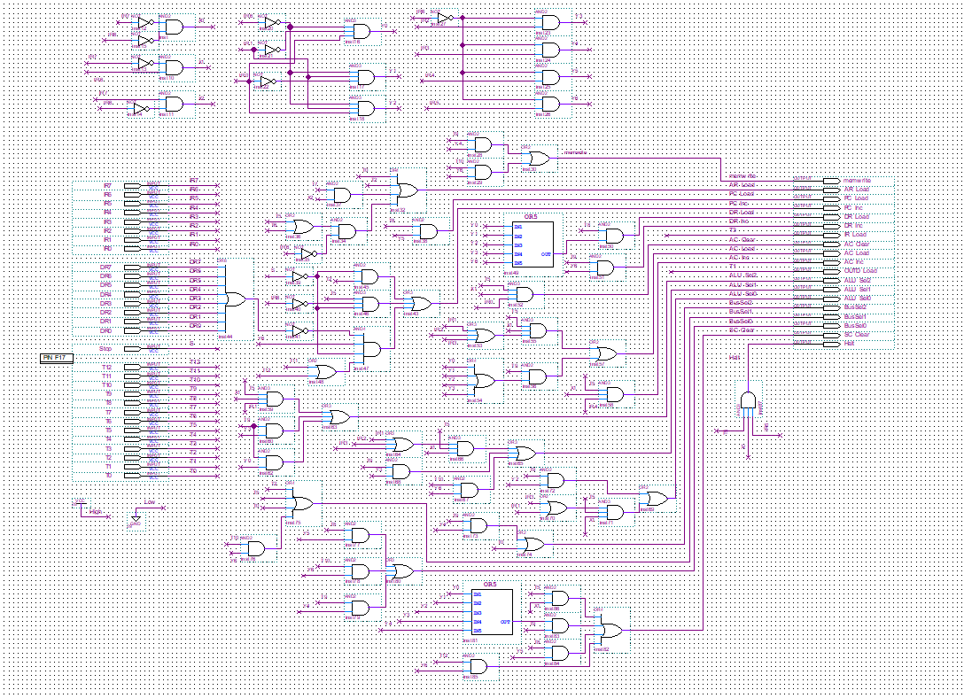
Figure 1: Logic gates for lab3controller

Compile lab3controller and set lab3top as top entity.
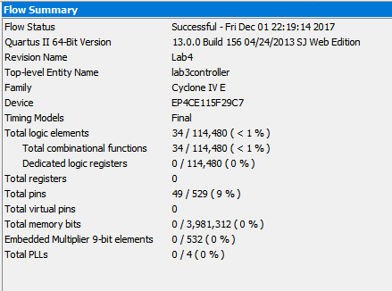
Figure 2: Compilation report of lab3controller

Assign the correct switches to each input and output pin.
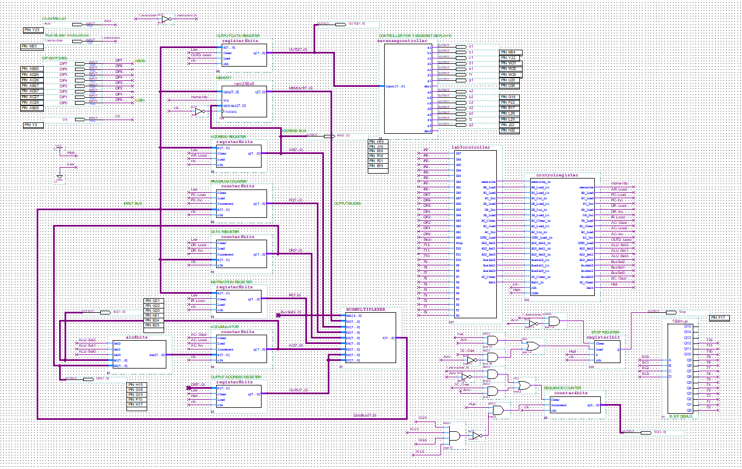
Figure 3: Block diagram of the simple computer

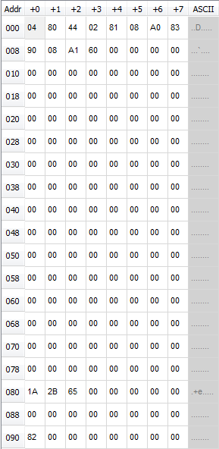
Figure 4: Memory Initialization File for addition/subtraction program

Create a Memory Initialization File and implement the program from section 4.3.

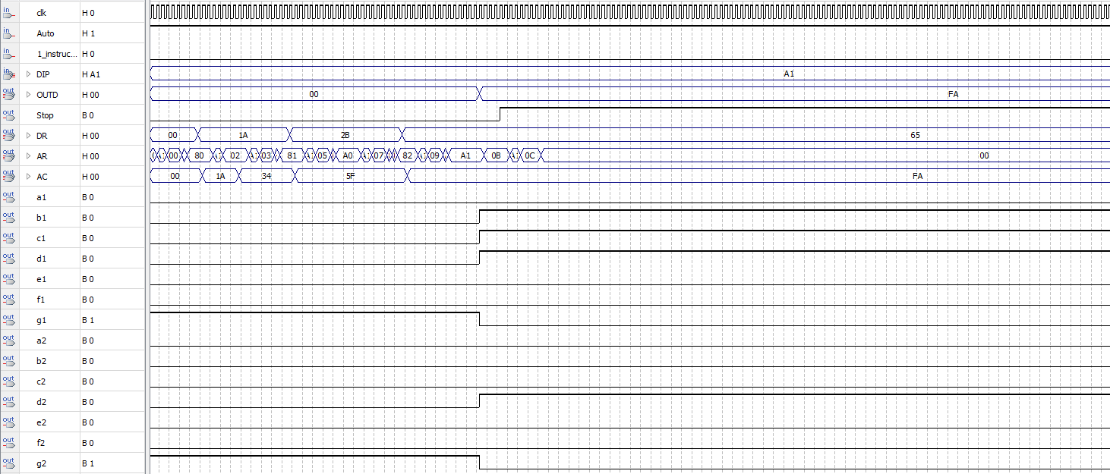
Figure 5: Simulation of the addition/subtraction program

Simulate lab3top with the updated Memory Initialization File.

Part 2: Software

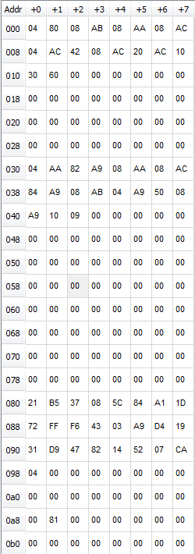
Figure 6: Memory Initialization File for the consecutive sum program

Create a Memory Initialization File and implement the program from the Software PreLab.

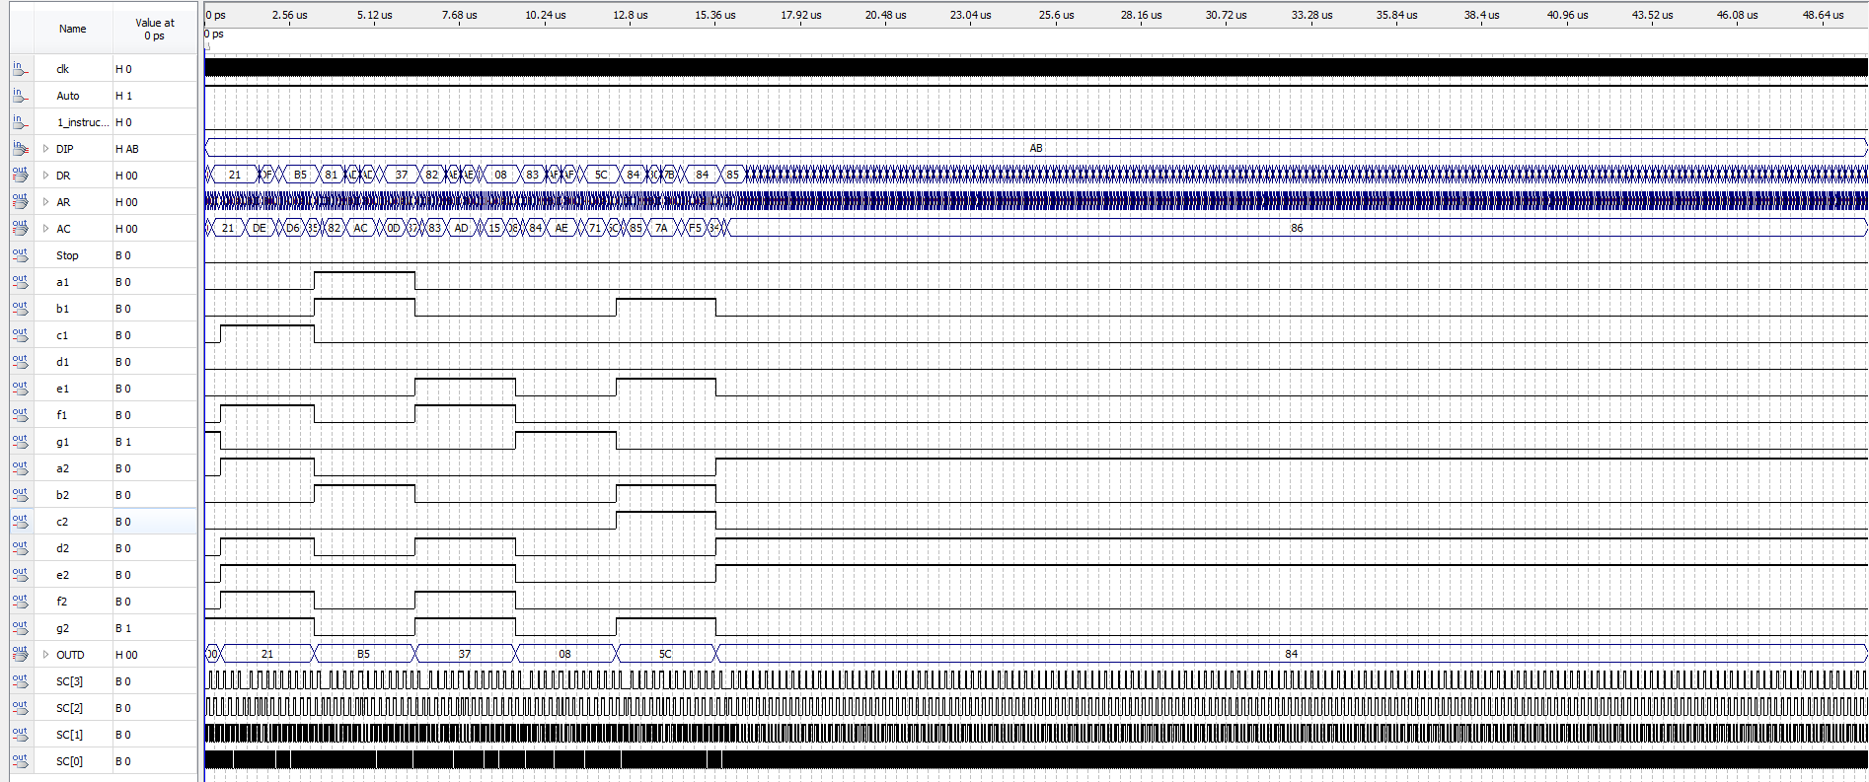
Figure 7: Simulation for the consecutive sum program

Simulate lab3top with the updated Memory Initialization File and Test the program on the Altera Board.

Conclusion

In this lab, students need to understand the controls based on the basic computer which they build during the experiment. They need to understand the control units and able to write the simple programs in machine code. After students finish the three controllers, they need to set up the memories and test it on the board. The most important part is the build of the diagram of the basic computer. We spent two-weeks on it and figured out the most of the errors, however, at last we still have some errors which blocked the operations. We thought that was the issues from the memory and we tried several methods to figured it out, we got partially works. Because we have many steps need to considered, we should be careful at the first.

