Lab 3: Arithmetic Logic Unit
CEG 2136B - Computer Architecture I
Fall 2017
School of Engineering

Group 4
TA: ?
James Duffy 8576365
Jingqian Liu 7825240
Experiment Date: 11/2/2017
Submission Date: 11/6/2017
Theory

Introduction:
This lab is about designing, simulating and testing the Arithmetic Logic Unit (ALU). We need both Quartus II and the Altera UP2 board for the environment and the operations. The ALU could perform 16 different operations on two operands of 4 bits, and will provide a 4- bit result along with 4 status bits (Overflow, Sign, Zero, Carry). For the inputs and display LEDs for the outputs, the DIP switches will be needed.

Objectives:
- Build a register, arithmetic circuit, logic and shift circuit, and status registers using the Quartus II Graphics Editor.
- Build an ALU circuit using previously built components using the Quartus II Graphics Editor.
- Run a functional simulation of the ALU circuit.
- Test the circuit on the Altera DE2-115 board.

Problem Discussion and Solution

In this lab, an ALU circuit is built by implementing an arithmetic circuit and a logic and shift circuit, five 4-bit registers and a state register. These components are implemented based off arithmetic and logic micro-operations. A simulation and a live test will be conducted for the finished ALU circuit to verify the results to the micro-operations.

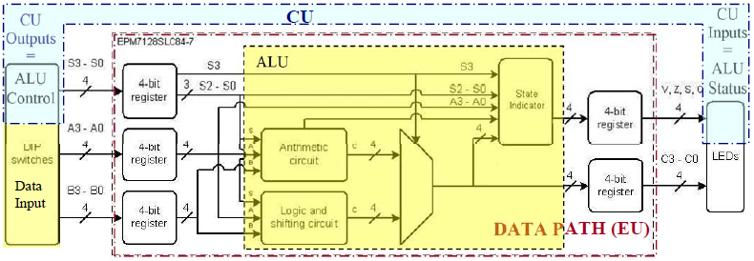
Figure 1: Data Path of ALU

The requirements to properly design and test the ALU circuit are as follows; arithmetic and logic micro-operations, block diagrams of arithmetic, logic and shift, and state register circuits, logic equations for the status bits of the status register ,Logic diagrams of each ALU component (Arithmetic circuit etc.), Quartus II Software and the Altera DE2-115 Board.

To design each ALU component using the Quartus II Graphics Editor, the following parts will be used:
- 2-1 multiplexer
- Output and input pins
- 4-bit register
  - JK Flip-Flops
  - Clock and reset input
  - 4-bit input and output
- Logic and Shift circuit
  - 8-1 multiplexers
  - AND gates
  - XOR gates
  - OR gates
  - NOT gates
  - Select Input pins
  - Logic Input pins
  - Output pins
- Arithmetic Circuit
  - 4-1 multiplexers
  - Full adders
  - NOT gates
  - Select input pins
  - Logic input pins
  - Carry-in pin
  - Sum and carry-out pins
- State register
  - XOR gates
  - NOR gates
  - OR gates
  - NOT gates
  - AND gates
  - Input and output pins

Design

Presentation of Design Methodology

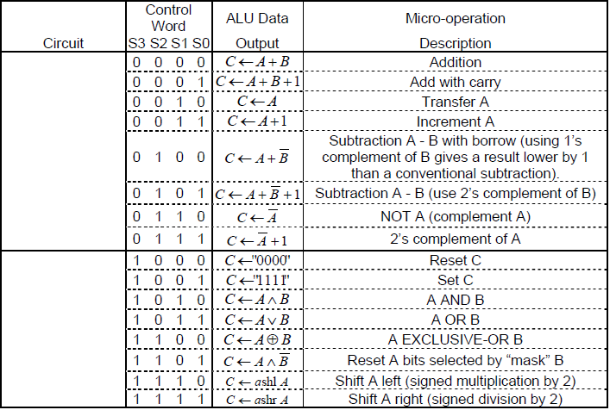
Table 1: Arithmetic and Logic micro-operations

Based on the arithmetic and logic micro-operation table, derive the block diagram for a 1-bit Logic and shift circuit.

Compile the circuit afterwards, and add it as a symbol in the project.

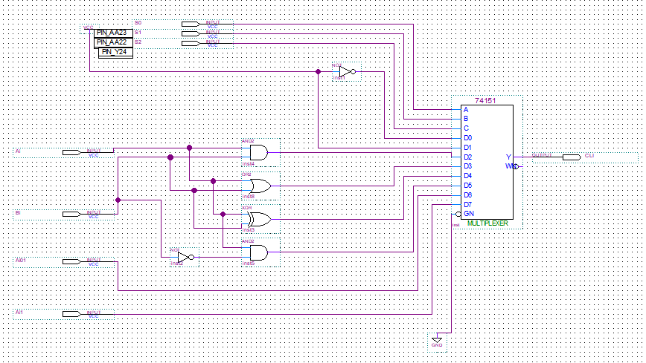
Figure 2: Block Diagram of 1-bit Logic and Shift circuit

Implement a 4-bit logic diagram of the logic and shift circuit, based on the 1-bit block diagram.

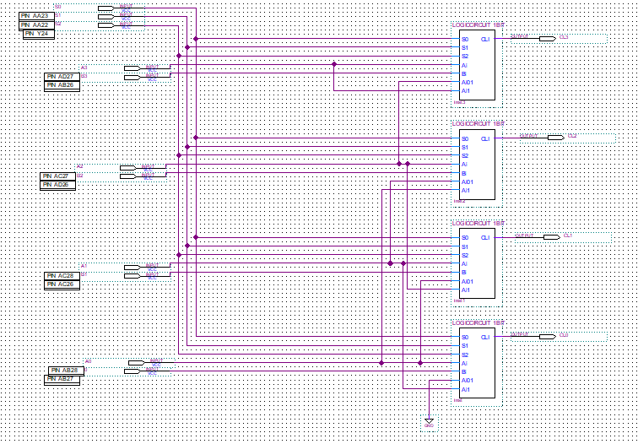
Figure 3: Block Diagram of 4-bit Logic and Shift circuit

Determine the operands for this truth table based on values from Table 1.
S2 | S1 | S0 | op1 | op2 | Cy-in | CA output
0 | 0 | 0 | A | B | 0 | CA <- A + B
0 | 0 | 1 | A | B | 1 | CA <- A + B + 1
0 | 1 | 0 | A | 0 | 0 | CA <- A
0 | 1 | 1 | A | 0 | 1 | CA <- A + 1
1 | 0 | 0 | A | B’ | 0 | CA <- A + B’
1 | 0 | 1 | A | B’ | 1 | CA <- A + B’ + 1
1 | 1 | 0 | A’ | 0 | 0 | CA <- A’
1 | 1 | 1 | A’ | 0 | 1 | CA <- A’ + 1
Table 2: Arithmetic micro-operations
Build a 1-bit Arithmetic circuit based on the values of Table 2.

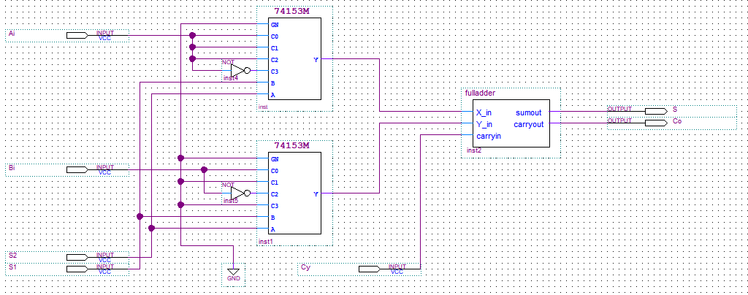
Figure 4: Block Diagram of 1-bit Arithmetic Circuit

Build a 4-bit arithmetic circuit by implementing the 1-bit arithmetic circuit.
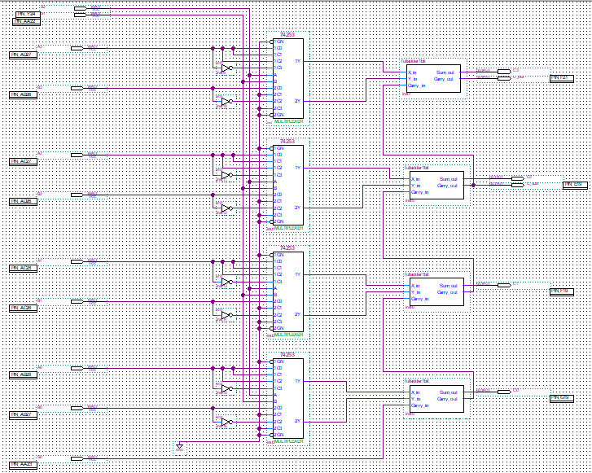
Figure 5: Block Diagram of 4-bit Arithmetic Circuit

Cy = Cout
S = C3
Z = (F3 + F2 + F1 + F0)’
V = Cout XOR C3

Design a block diagram of the state register based on the logic equations of each bit status.

4-bit ALU
S3
S2

S1

S0

B

A
V

C

Z

S

C3
Cout
F3

Figure 6: Block Diagram of 4-bit status register

Used Components and Implementation

Part 1: Design

- Six input pins: X3, X2, X1, X0, CLK, CLRN
- Four output pins: Y3, Y2, Y1, Y0
- Four JK Flip-Flops

Compile the circuit afterwards, and add it as a symbol in the project.

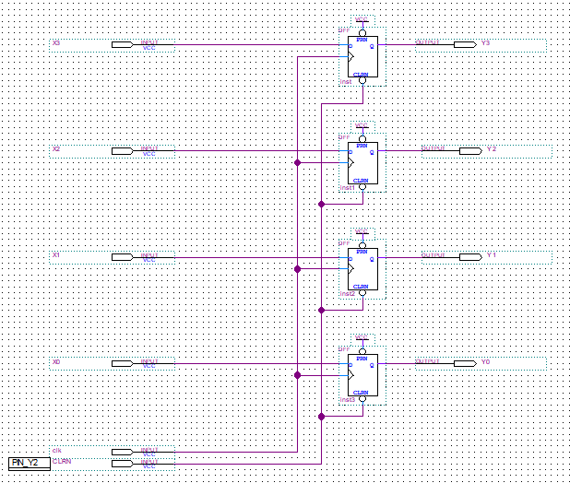
Figure 7: Logic Diagram of 4-bit register

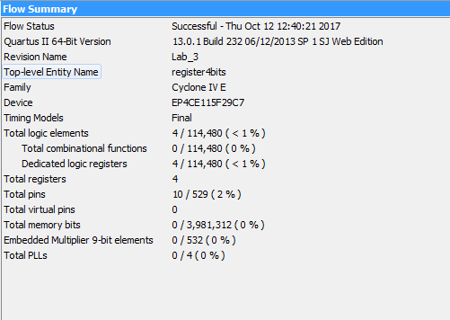
Figure 8: Compilation Report of 4-bit register

- Two XOR gates
- Two AND gates
- One OR gate
- Three input pins: X_in, Y_in, carryin
- Two output pins: sumout, carryout

Compile the circuit afterwards, and add it as a symbol in the project.

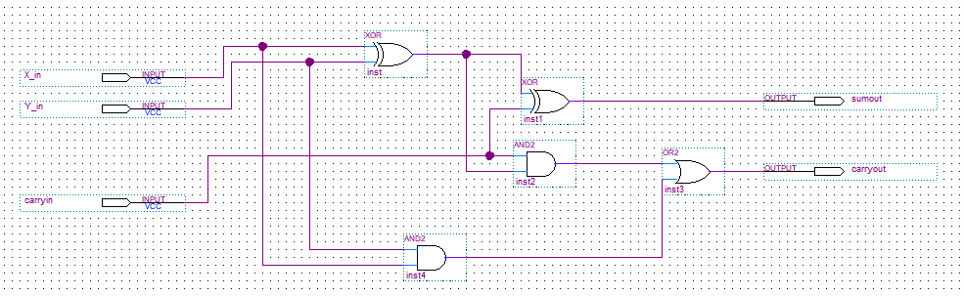
Figure 13: Logic Diagram of full adder

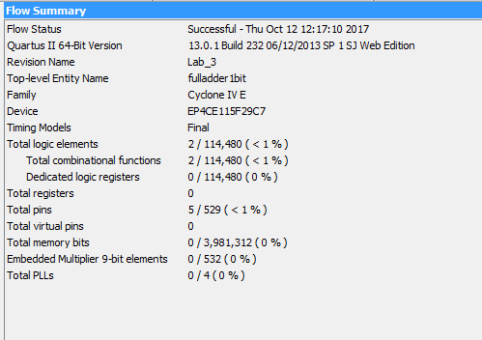

Figure 14: Compilation Report of full adder

- Eight 4-1 multiplexers
- Four full adders (made from previous circuit)
- Eight NOT gates
- A GND
- Eleven input pins: S2, S1, S0, A3, A2, A1, A0, B3, B2, B1, B0
- Six output pins: C3, C2, C1, C0, C_out, C_out2

Compile the circuit afterwards, and add it as a symbol in the project.

Figure 9: Logic Diagram of 4-bit arithmetic circuit

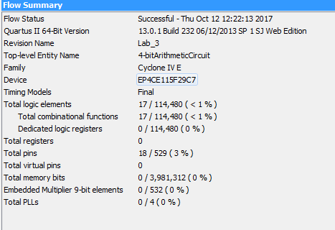
Figure 10: Compilation Report of 4-bit arithmetic circuit

- Eleven input pins: S2, S1, S0, A3, A2, A1, A0, B3, B2, B1, B0
- Four output pins: Cl3, Cl2, Cl1, Cl0
- A GND
- Four 1-bit logic and shift circuits

Compile the circuit afterwards, and add it as a symbol in the project.

Figure 11: Logic Diagram of 4-bit logic and shift circuit

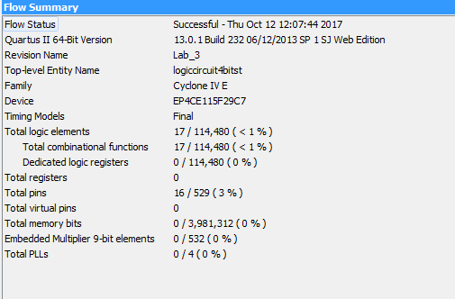
Figure 12: Compilation Report of 4-bit logic and shift circuit

- Twelve input pins: S3, S2, S1, S0, C3, C2, C1, C0, C_out, C_out2, A3, A2
- Four output pins: V, Z, S, Cy
- Two AND gates, one 5AND gate
- Two XOR gates
- One 4NOR gate
- One OR gate

Compile the circuit afterwards, and add it as a symbol in the project.
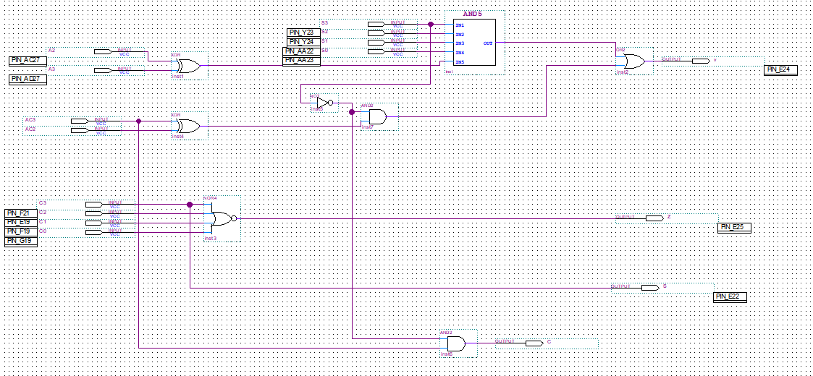
Figure 15: Logic Diagram of 4-bit status register

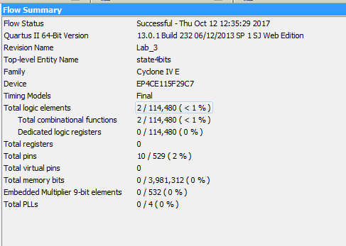
Figure 16: Compilation Report of 4-bit status register

- Fourteen input pins: S3, S2, S1, S0, A3, A2, A1, A0, B3, B2, B1, B0, CLK, CLRN
- Eight output pins: V, Z, S, Cy, C3, C2, C1, C0
- Five 4-bit registers
- One of each: Arithmetic Circuit, Logic and Shift circuit, Status register
- 2-1 Multiplexer

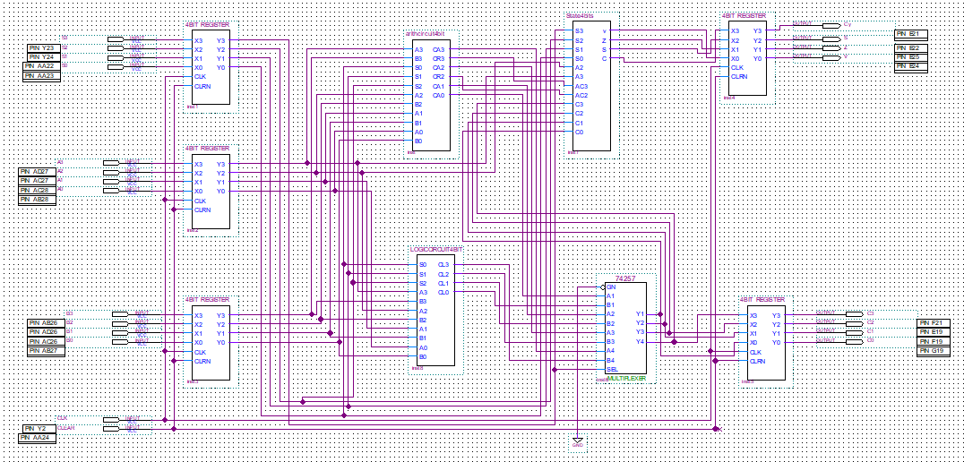
Figure 17: Logic Diagram of ALU circuit
Compile the circuit afterwards.

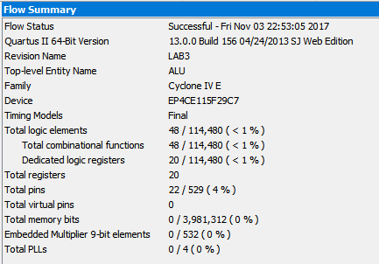
Figure 18: Compilation Report of ALU circuit

Part two: Simulation

Determine the inputs and outputs based on the RTL micro-operations given in the table.
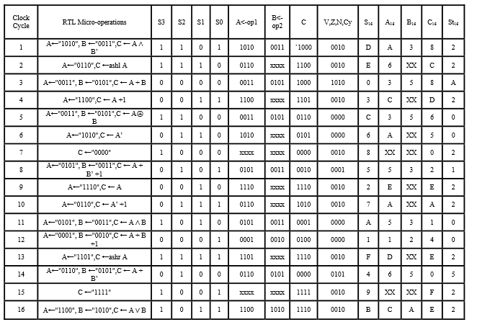
Figure 19: Sequence of micro-operations to simulate

Create a simulation of the circuit using the waveform editor.

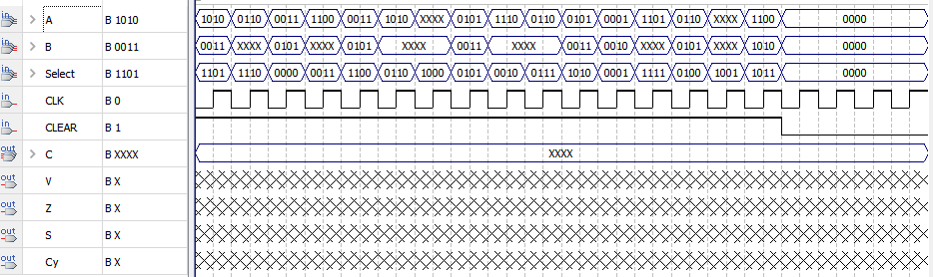
Figure 20: Waveform of ALU circuit

Assign pin locations to each input and output pin, then compile the project.

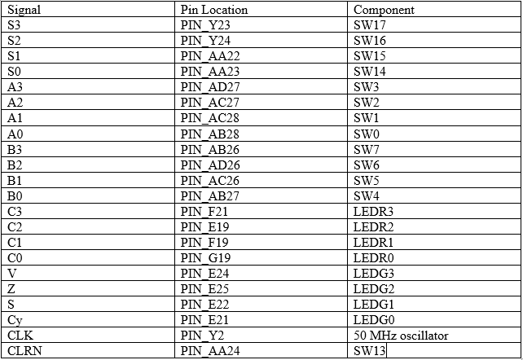
Figure 22: Pin Assignments

Part three: Testing Experiment

Upload the circuit on the the Altera Board and test the results.

Expected Results Actual Results
S₃S₂S₁S₀ | A<-op1 | B<-op2 | C | V,Z,S,Cy | C | V,Z,S,Cy
1101 | 1010 | 0011 | 1000 | 0010 | 1000 | 0010
1110 | 0110 | XXXX | 1100 | 0010 | 1100 | 0010
0000 | 0011 | 0101 | 1000 | 1010 | 1000 | 1010
0011 | 1100 | XXXX | 1101 | 0010 | 1101 | 0010
1100 | 0011 | 0101 | 0110 | 0000 | 0110 | 0000
0110 | 1010 | XXXX | 0101 | 0000 | 0101 | 0000
1000 | XXXX | XXXX | 0000 | 0010 | 0000 | 0010
0101 | 0101 | 0011 | 0010 | 0001 | 0010 | 0001
0010 | 1110 | XXXX | 1110 | 0010 | 1110 | 0010
0111 | 0110 | XXXX | 1010 | 0010 | 1010 | 0010
1010 | 0101 | 0011 | 0001 | 0000 | 0001 | 0000
0001 | 0001 | 0010 | 0100 | 0000 | 0100 | 0000
1111 | 1101 | XXXX | 1110 | 0010 | 1110 | 0010
0100 | 0110 | 0101 | 0000 | 0101 | 0000 | 0101
1001 | XXXX | XXXX | 1111 | 0010 | 1111 | 0010
1011 | 1100 | 1010 | 1110 | 0010 | 1110 | 0010
Figure 23: Expected Output versus Actual Output (results of the test)

Conclusion
In this lab we spent many efforts to understand and build the ALU. Because we had so many steps and details, it was very easy to make some mistakes and cause errors on some steps. That’s why we need three weeks to figure out everything. In the second session, we got the errors on our simulations and cannot get the results on the boards, with my friend helps, we changed the lines to connect the right place and rebuild some project box to fixed those errors. At the third session, we could overcome those errors and finished the work quickly.

