Lab 2: Design and Simulation of Sequential Logic Circuits - Synchronous Counters -
CEG 2136B - Computer Architecture I
Fall 2017
School of Engineering

Group 4

TA: ?
James Duffy 8576365
Jingqian Liu 7825240
Experiment Date: 09/28/2017 & 10/05/2017
Submission Date: 10/10/2017

Theory

Introduction:

The purpose of this lab is to build two sequential circuits in the QUARTUS II environment and to implement the circuits on the Altera DE2-115 Board. When testing the circuits, one circuit must display the counter outputs as binary values on the Altera Board LEDs, and the other circuit must use the oscilloscope to record the waveforms of the JK flip-flops.

Objectives:
Part 1 :
- Build the 4-bit BCD Counter and 3-Bit Modulo 6 Counter using the Quartus II graphics editor, and test both in a simulation.
Part 2:
- Test the 3-Bit Modulo 6 Counter using the LEDs on the Altera Board.
- Test the BCD Counter using the Oscilloscope to confirm the correct output.

Problem Discussion and Solution:

In this lab, two different synchronous circuits are implemented based on their state diagrams. A simulation and a live demonstration (two different methods) will be made for each circuit to verify that the results are the same as the state diagrams.

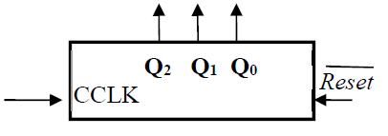
Figure 1: block diagram of Modulo 6 Counter
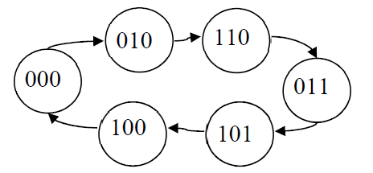
Figure 2: State Diagram of Modulo 6 Counter

0000
0001
0010
0011
0100
0101
0110
0111
1000
1001
Figure 3: State Diagram of BCD Counter

The requirements to properly design and test the Modulo 6 Counter and BCD Counter are as follows; Correct JK flip-flop truth tables, corresponding K-maps and their logic expressions derived from them, an Oscilloscope, Quartus II Software and the Altera DE2-115 Board.

To design the synchronous Circuits using the Quartus II graphics editor; AND, JK flip-flops, and NOT gates will be used, along with input and output pins.

Design

Presentation of design methodology

Part A - 3-bit synchronous modulo 6 counter

Present State Next State Synchronous Inputs
Q₂Q₁Q₀ | Q₂Q₁Q₀ | J₂K₂ | J₁K₁ | J₀K₀
000 | 010 | 0X | 1X | 0X
001 | XXX | XX | XX | XX
010 | 110 | 1X | X0 | 0X
011 | 101 | 1X | X1 | X0
100 | 000 | X1 | 0X | 0X
101 | 100 | X0 | 0X | X1
110 | 011 | X1 | X0 | 1X
111 | XXX | XX | XX | XX
Table 1: 3 bit synchronous modulo 6 counter truth table

Based on the JK flip-flop truth table, derive the K-maps and their corresponding equations based on the synchronous inputs.

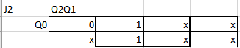
J2 = Q1

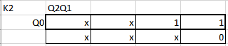

K2 = (Q0)’

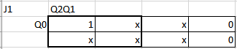

J1 = (Q2)’

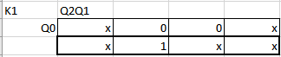

K1 = Q0

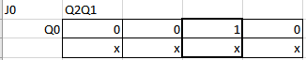

J0 = Q2Q1

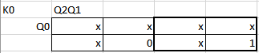

K0 = Q2

Part B - 4-bit synchronous BCD counter

Present State Next State Synchronous Inputs
Q₃Q₂Q₁Q₀ | Q₃Q₂Q₁Q₀ | J₃K₃ | J₂K₂ | J₁K₁ | J₀K₀
0000 | 0001 | 0X | 0X | 0X | 1X
0001 | 0010 | 0X | 0X | 1X | X1
0010 | 0011 | 0X | 0X | X0 | 1X
0011 | 0100 | 0X | 1X | X1 | X1
0100 | 0101 | 0X | X0 | 0X | 1X
0101 | 0110 | 0X | X0 | 1X | X1
0110 | 0111 | 0X | X0 | X0 | 1X
0111 | 1000 | 1X | X1 | X1 | X1
1000 | 1001 | X0 | 0X | 0X | 1X
1001 | 0000 | X1 | 0X | 0X | X1
1010 | XXXX | XX | XX | XX | XX
1011 | XXXX | XX | XX | XX | XX
1100 | XXXX | XX | XX | XX | XX
1101 | XXXX | XX | XX | XX | XX
1110 | XXXX | XX | XX | XX | XX
1111 | XXXX | XX | XX | XX | XX
Table 2: 4-bit synchronous BCD counter truth table

Based on the K-maps for each JK flip-flop, derive the equations for each synchronous input.

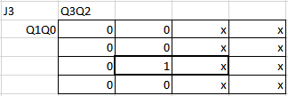

J3 = Q2Q1Q0

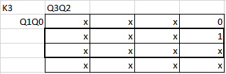

K3 = Q0

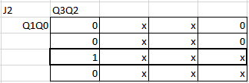

J2 = Q1Q0

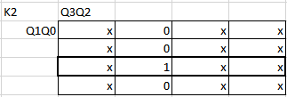

K2 = Q1Q0

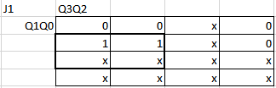
J1 = (Q3)’Q0

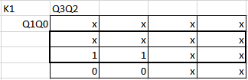

K1 = Q0

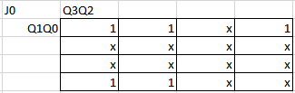

J0 = 1

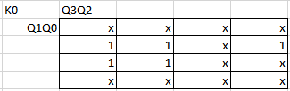

K0 = 1

Used components and Implementation

Part 1: Design and Simulation

Part A - 3-bit synchronous modulo 6 counter

- Two input pins: CLK and RESET
- 3 JK flip-flops, two NOT gates and one AND gate
- Four output pins: Q2, Q1, Q0 and CLKOUTPUT

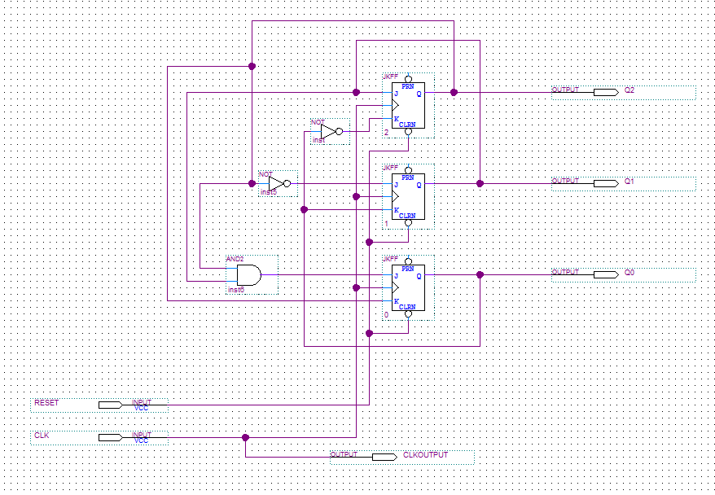
Figure 4: Logic Diagram of Modulo 6 Counter

Create a simulation of the circuit using the waveform editor. Compile the circuit afterwards.

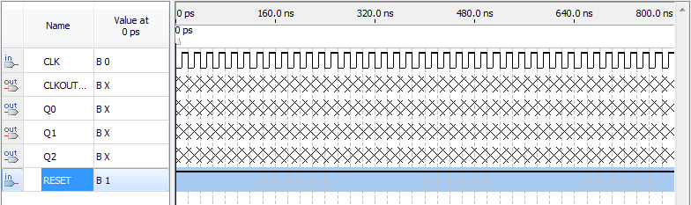
Figure 5: Waveform of Modulo 6 Counter

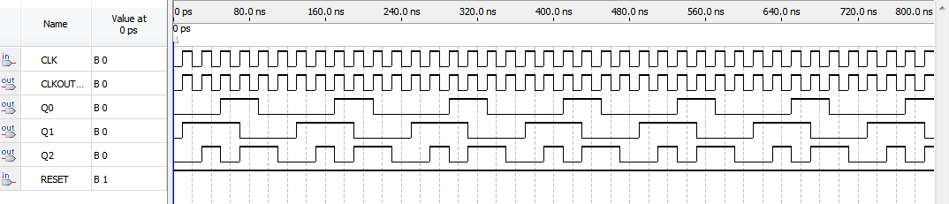
Figure 6: Simulation Waveform of Modulo 6 Counter

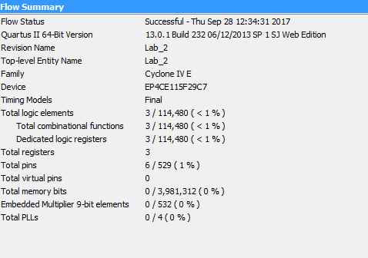
Figure 7: Compilation Report of Modulo 6 Counter

Part B - 4-bit synchronous BCD counter

- Two input pins: CLK and RESET
- 4 JK flip-flops, one NOT gate and two AND gates
- Five output pins: Q3, Q2, Q1, Q0, and CLKOUTPUT

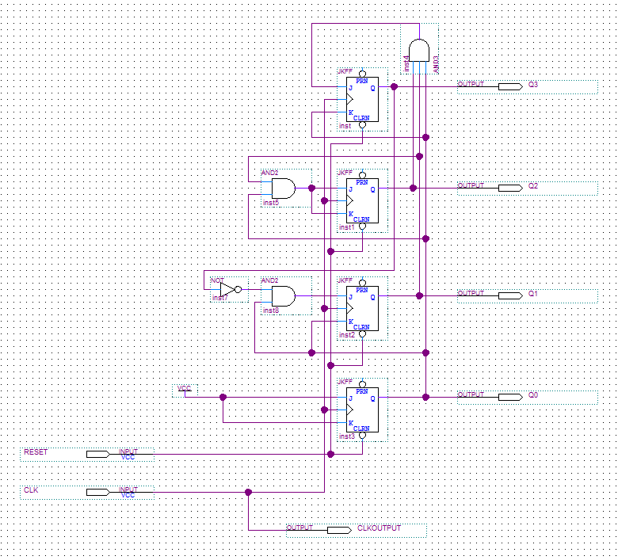
Figure 8: Logic Diagram of the BCD Counter

Create a simulation of the circuit using the waveform editor. Compile the circuit afterwards.

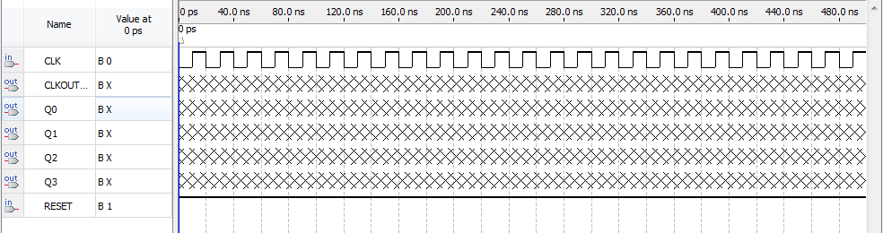
Figure 9: Waveform of the BCD Counter
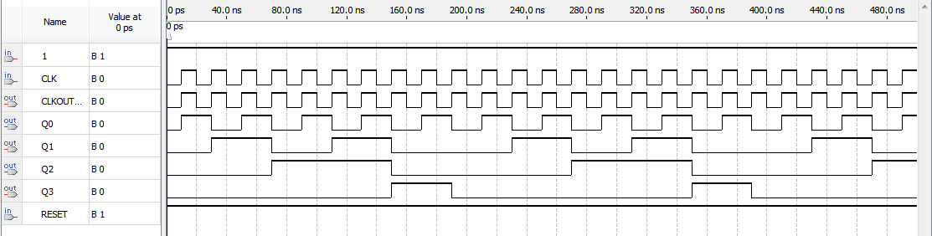
Figure 10: Simulation Waveform of BCD Counter

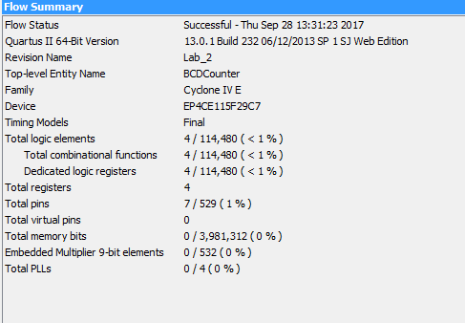
Figure 11: Compilation Report for BCD Counter

Part 2: Testing Experiment

Part A - 3-bit synchronous modulo 6 counter

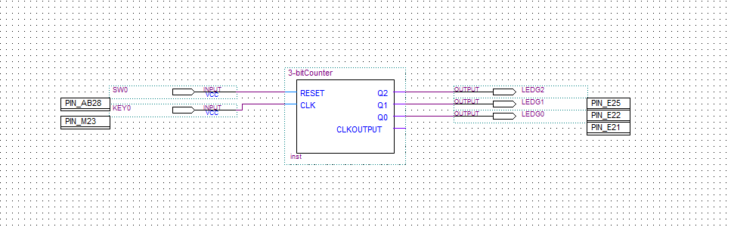
Figure 12: Block Diagram of “test” Modulo 6 Counter

Assign pin locations to each input and output pin, then compile the project.

Value | Pin Assignment | Component
CLK | PIN_M23 | KEY0
Q2 | PIN_E25 | LEDG2
Q1 | PIN_E22 | LEDG1
Q0 | PIN_E21 | LEDG0
RESET | PIN_AB28 | SW0
Table 3: Input and Output pin connections and corresponding components

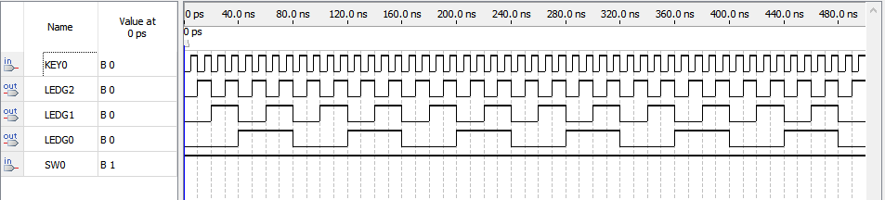
Figure 13: Waveform of “test” Modulo 6 Counter

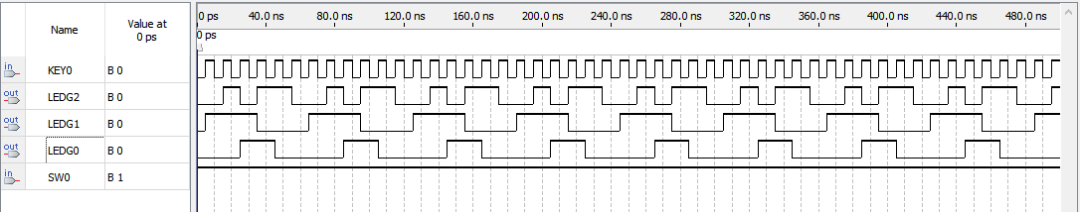
Figure 14: Simulation Waveform of “test” Modulo 6 Counter

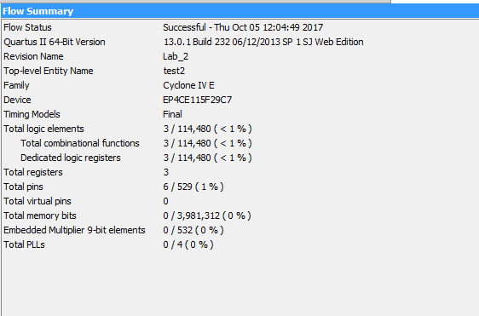
Figure 15: Compilation Report for “test” Modulo 6 Counter

Present State Expected Next State Actual Next State
Q2Q1Q0 | Q2Q1Q0 | Q2Q1Q0
000 | 010 | 010
001 | XXX | XXX
010 | 110 | 110
011 | 101 | 101
100 | 000 | 000
101 | 100 | 100
110 | 011 | 011
111 | XXX | XXX
Table 4: Expected Output vs Actual Output

Part B - 4-bit synchronous BCD counter

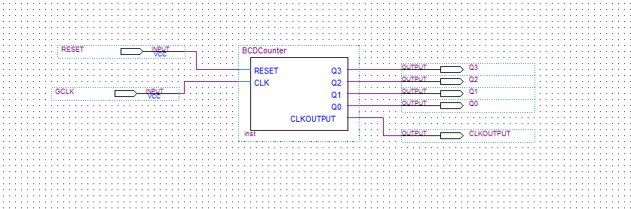
Figure 16: Logic diagram of “test” BCD Counter

Assign pin locations to each input and output pin, then compile the project.

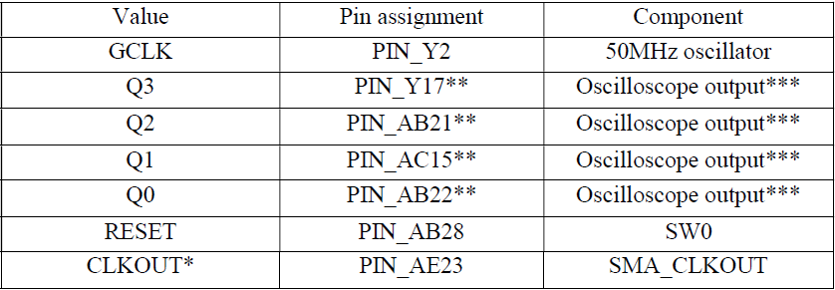
Table 5: Input and Output pin connections and corresponding components

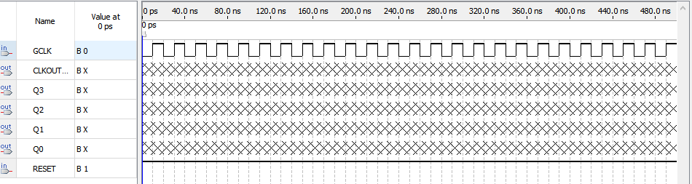
Figure 17: Waveform of “test” BCD Counter

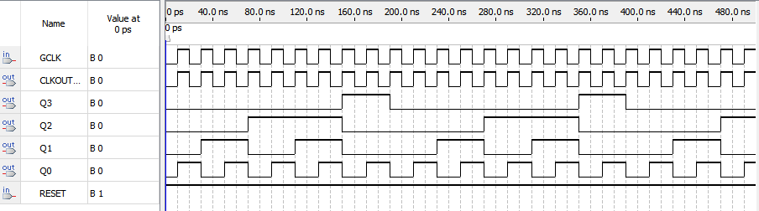
Figure 18: Simulation waveform of “test” BCD Counter

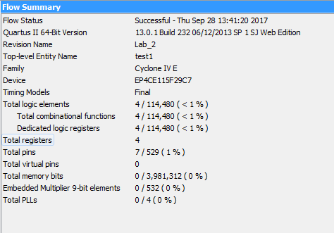
Figure 19: Compilation Report of “test” BCD Counter

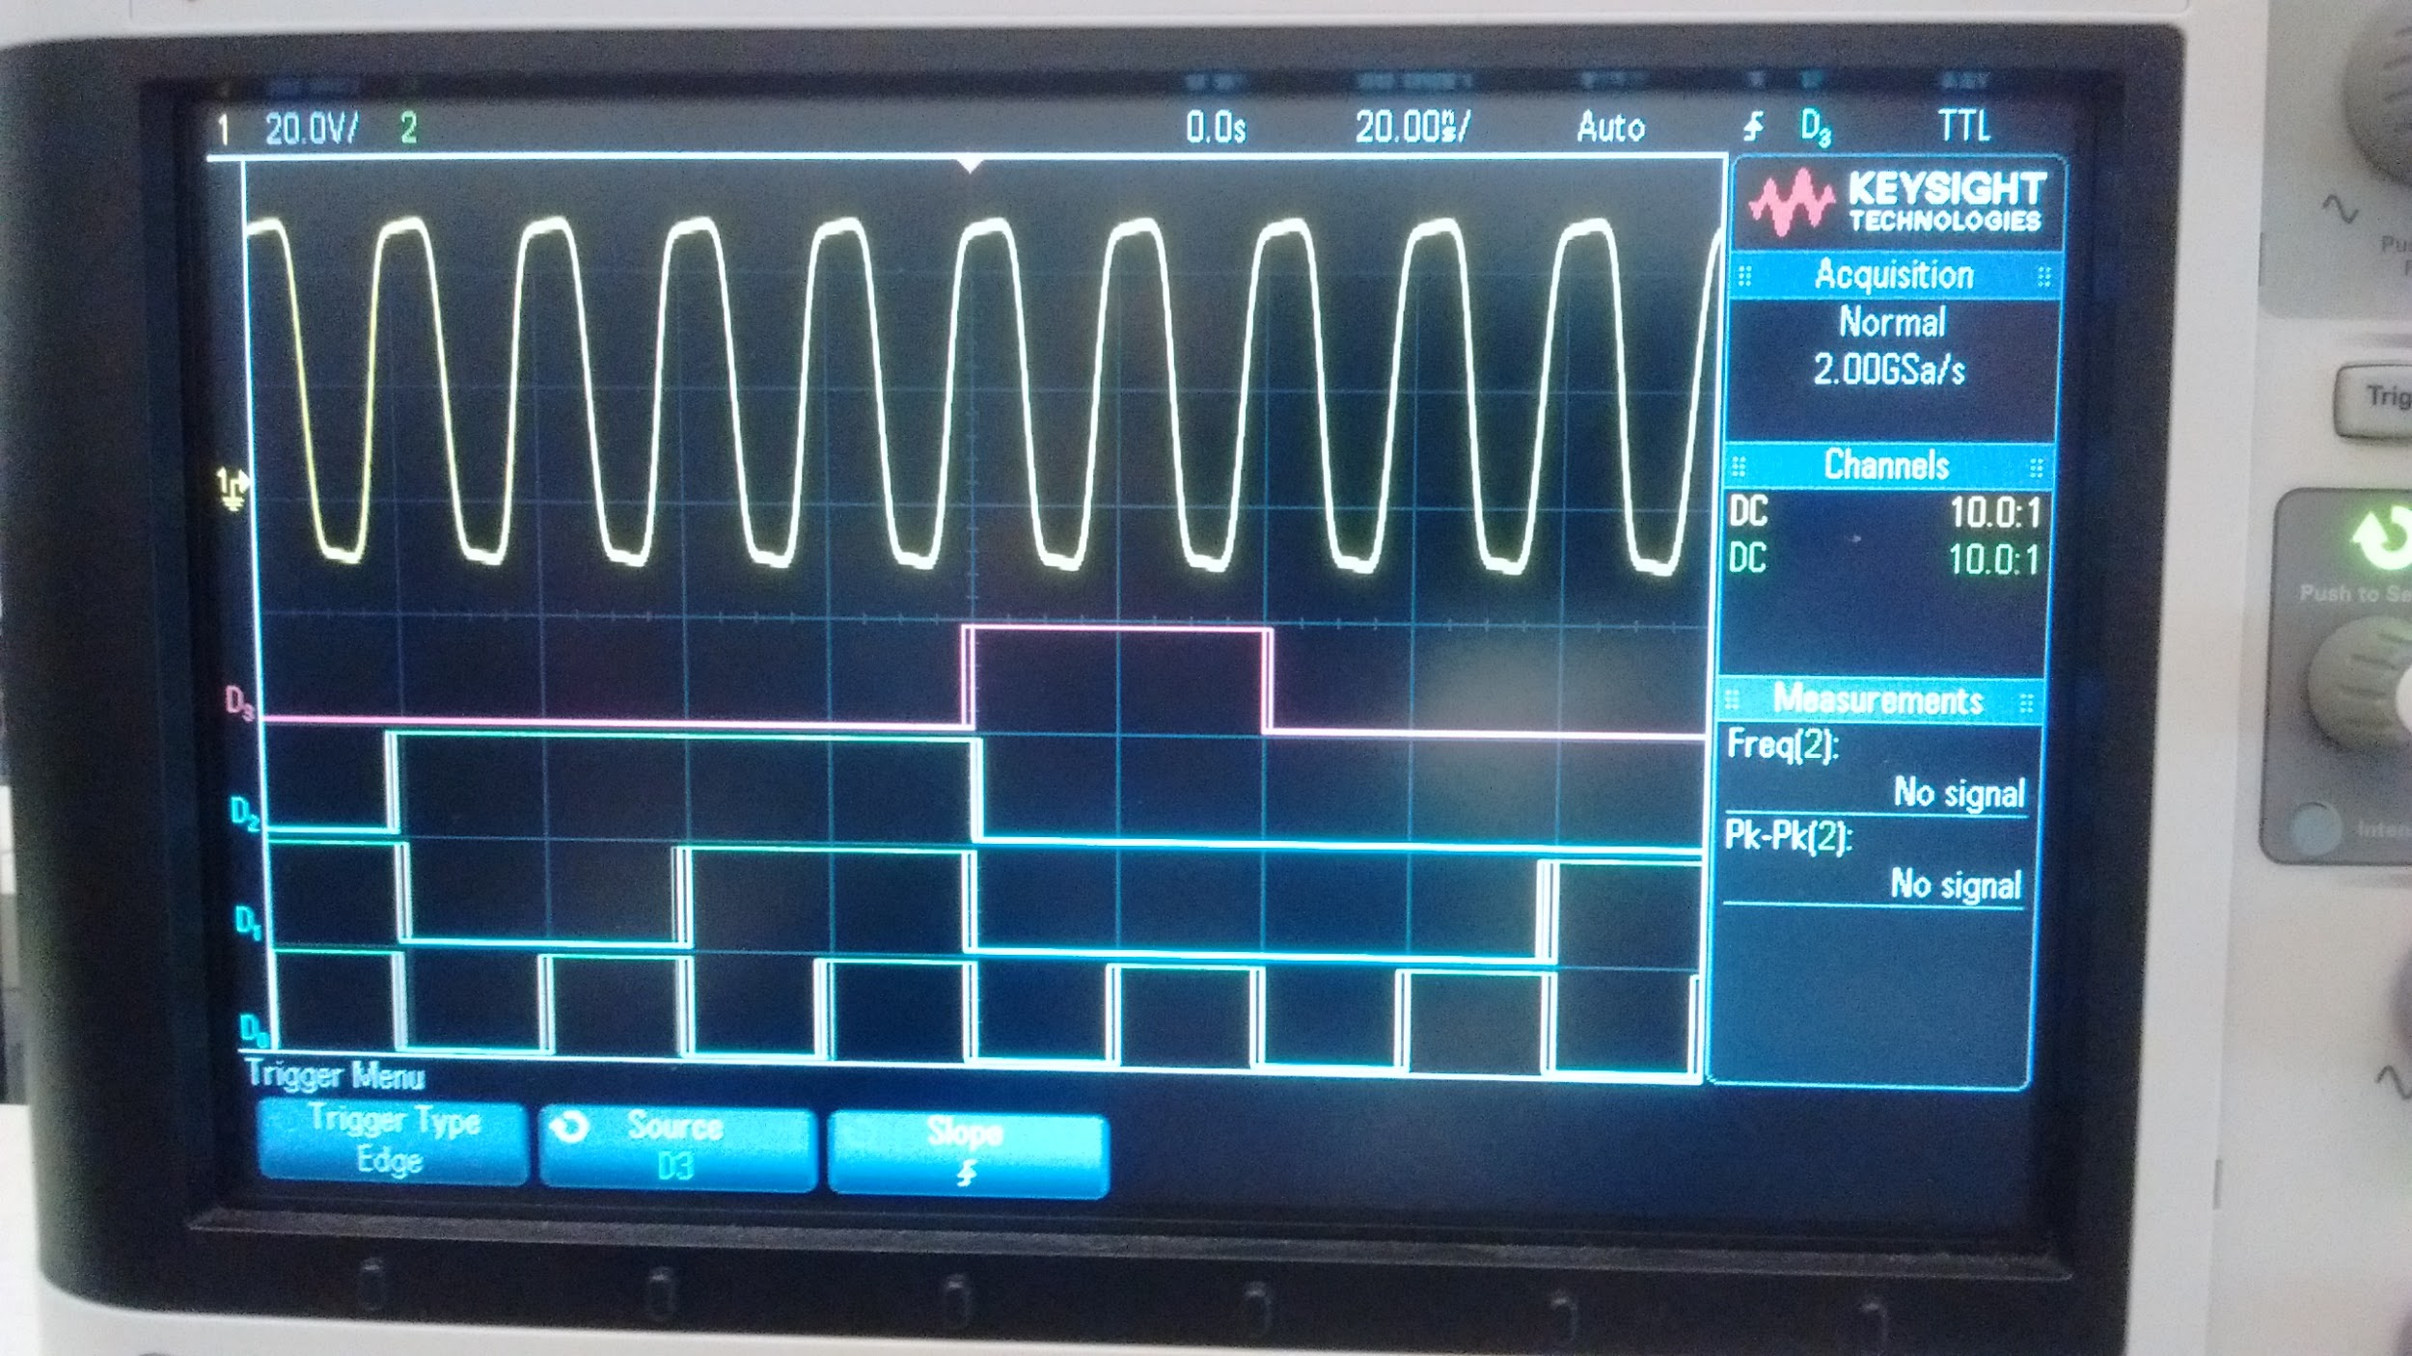
Figure 20: Results of BCD Counter on Oscilloscope

Conclusion

There were two parts in this lab and we used different devices to finished it. For part 1, the result of the logic circuit was shown on the oscilloscope, and for part 2, we used the DE2-115 board to get the final result, which the 3- bit counter. At the part 1, we finished the step before the oscilloscope quickly, however, when we tried to set up the oscilloscope and get the result, the machine showed nothing but a straight line. After we check out our pin number and TA’s help, we got the right graph of the weave diagram. Part 1 costed the most of our time, in the part 2, things were gonna be easy for us, we did the most step before one week and just need to design the 3 bit counter on the computer. However, there were some unnecessary step on the instructions, we find the quickest to build the counter and applied it on the board, finally we got the right order for our sequential diagram.

