Chapter 4
Types of Problems in steady state mode:
- Simulation Problem
Given the process flowsheet & the best operating conditions; calculate some process outputs
- Specification Problem
Given the process flowsheet & desired outputs from the process; calculate the required operating conditions.
- Optimization Problem
Given the process flowsheet; choose the desired outputs (& required operating conditions) to maximize or minimize some objective functions
- Synthesis Problem
Given the process inputs & desired outputs; choose the best process (& required operating conditions) to minimize some objective function

Chapter 5
- Selection of the processing mode: batch vs continuous (ch 9)
- Identification of process input-output structure
- Deciding on the process recycle structure
- Identification & design of process separation system

Batch/semi-batch | Continuous
Low production | High
Large residence time | Small
Manufacture of pharmaceuticals, foods, specialty chemicals, beer production | Industrial industry, oil refinement, chemical production of 5000 tonnes/y

Component Type | Classification
Reactant | Recycle
Reaction intermediate | Recycle
Reversible by-product | Recycle or Exit
Primary Product, valuable by-product, fuel by-product, waste by-product | Exit

Type | Feed | Sep. Agent | Products | Principle
Evaporation | L | Heat | L+V | Volatilities
Flash | L | Pressure Reduction | L+V | Volatilities
Distillation | L/V | Heat | L+V | Volatilities
Absorption | G | Liquid Solvent | L+G | Preferential Solubility
Stripping | L | Gas Solvent | L+V | Preferential Solubility
Extraction | L | Immiscible Liquid | L+L | Preferential Solubility
Adsorption | G or L | Solid Resin | L/G+S | Adsorbate
Leaching | S | Solvent | L+S | Preferential Solubility
Magnetic Separation | Mixed S | Magnetic Field | S+S | Magnetic Attraction
Fluidized Bed (continuous) | G/L | Fluidized Particle | G/L+S | Adsorbate
Filtration | L&S | Filter Medium | L+S | Size of Solid
Settling | L&S | Gravity | L+S | Difference in Density
Profit margin= (value of product)- (value of raw material)
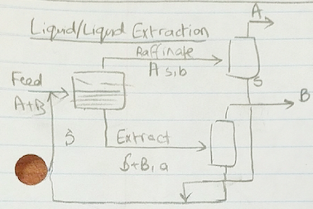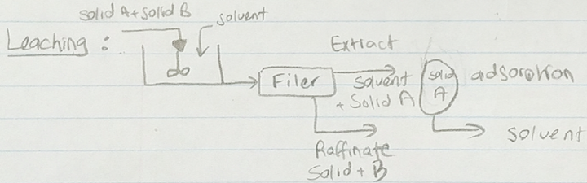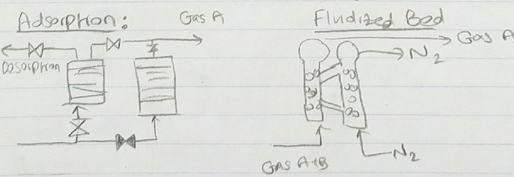
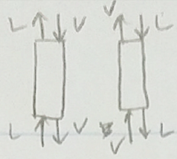

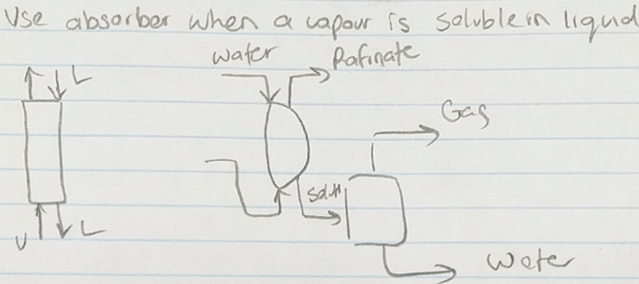
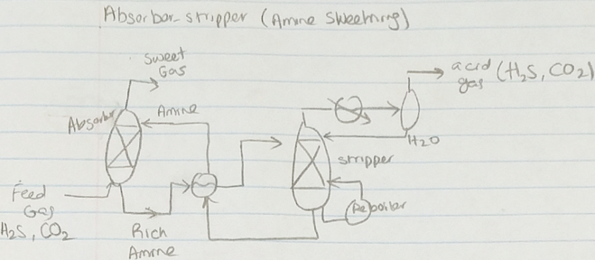
Chapter 3
Horizontal lines are dominant

Block Flow Diagram(BFD)
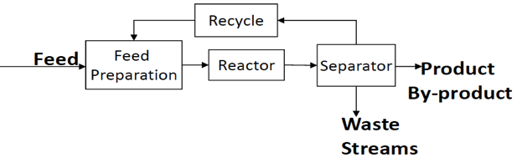
Feed Prep: Compressor, Heat-Exchanger, Pumps.
Separator: Distillation, extraction, separator

Process Flow Diagram(PFD)
C (or K) | Compressor, Turbine, or Expander | R | Reactor
E (or HX) | Heat Exchanger | T | Distillation, absorption tower
P | Pump | TK | Storage Tank
V | Vessel

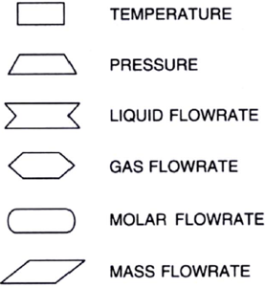
Piping & Instrumentation Diagram (P&ID)


