Solution Chemistry
Solute is the substance that is being dissolved. The solvent is what the solute is being dissolved in.
Solutions that can be mixed in any proportions are miscible; polar substances are miscible with each other, non-polar with each other. If they cannot be mixed in any proportion they are immiscible; non-polar mixed with polar.
If the solvent is water, it is an aqueous solution. For a substance to be soluble, more than 0.1 mole needs to dissolve in 1.0 litres at 25ᴼ
A saturated solution means that the solute has dissolved all that it can of a solute and no more. If it dissolves any more, than it is a supersaturated solution (done by raising temperature), when it has dissolved less than its maximum it is unsaturated.
Homogenous mixtures are where the different substance are uniformly distributed and appear as one. Heterogeneous that the distribution is different and so different regions have different properties. In a colloid the particles are suspended in the solvent.
- Breaking bonds – Requires energy (Endothermic)
- Forming Bonds – Releases energy (Exothermic)
Non electrolytes are aqueous solutions that don’t conduct electricity because ions are not present, while electrolytes do have ion and can therefore conduct electricity.
- Dissolve- simply a change of phase. The chemical structure remains the same, without forming any ions. *(molecular compounds)
C₁₂H₂₂O₁₁ C₁₂H₂₂O₁₁
- Dissociation- separation of ions as it goes into water *(ionic compounds)
NaCl_{(s)} Na⁺ + Cl⁺
- Ionization- when an acid convert to ion in water
HCl H⁺ + Cl⁺
- Do nothing: insoluble compounds (wax)

- Polyatomic ions do not break apart (SO₄²⁻, NH₄⁺)

(*Refer to Acids and Bases)
Unknown solution can be determined using different methods:
- Electrolyte/ non-electrolyte (ions or no ions)
- Flame colour test ( based on ions present, the flame color will differ)
- Acid or base (litmus) *refer to acids and bases
- Solubility (check solubility table for ionic compounds)
- Colour of solution (differs for different ions present)
Concentration of substances can be represented in different ways. Volume by Volume: %V/V
Weight by Volume: %W/V Mass by Mass: %W/W PPM: 1mg/1kg(Litre) Molarity: mol/Litre
Ion concentration (expressed by molarity) can be found using the molar ratio of the ion in the solution.
Eg. 1) HCl_{(aq)} H⁺_{(aq)} + Cl⁻_{(aq)} 2)Ba(OH)_{2(aq)} Ba²⁺_{(aq)} + 2 OH⁻_{(aq)}
2.4 mol/L 2.4 mol/L 2.4 mol/L 0.12 mol/L 0.12 mol/L 0.12 mol/L

Net Ionic Equations excludes anything that does not take part in the reaction, called the spectator ion.
- Reactants are always aqueous in these reactions
- One product must be a solid, this product will be in the net equation.
- The precipitate is written as a compound, all else are ions.
Non- ionic
BaCl_{2(aq)} + NaSO_{4(aq)} BaSO_{4(s)} + 2NaCl_{(aq)}
Total-ionic
Ba²⁺ _{(aq)} + Cl⁻_{(aq)} + SO₄²⁻_{(aq)} + 2Na⁺_{(aq)} BaSO_{4(s)} + 2Na⁺_{(aq)} + 2Cl⁻_{(aq)}
Net ionic
Ba²⁺_{(aq)} + SO₄²⁻_{(aq)} BaSO_{4(s)}
Dilution Formula: C₁V₁ = C₂V₂
Acid and Bases
- Strong bases are soluble ionic compounds containing OH⁻, everything else is weak
- Strong Base dissociate 100% Weak Base dissociates < 50%
- Strong Acids are (memorize): HCl_{(aq)} HClO_{4(aq)} HNO_{s(aq)} H₂SO_{4(aq)} HBr_{(aq)} HI_{(aq)}
- Strong Acid ionize > 99% Weak Acid ionize < 50%
Strong acids and bases ionize/disassociate 100%. Weak acids and bases only partially.
Substance Type | Empirical Definition | Theoretical Definition
Acids | - Sour  - Neutralizes bases  - Corrosive, reacts with metal to form H⁺  - Conductive, electrolyte  - Turns litmus red | Molecular compound starting with H or ending in COOH  Ionize to form H⁺ in solution
Bases | - Bitter, slippery  - Corrosive  - Neutralize acids  - Turns litmus blue  - Conductive, electrolyte | Soluble ionic hydroxides  Dissociate to produce OH⁺_{(aq)}
Neutral Substance | - Dilutes acids and bases  - No litmus change | Some ionic, some molecular  No H⁺ or OH⁻

Arrhenius Past Theories
- Ionic Compounds dissociate into anions and cations in water
- Bases dissociate into a cation and a hydroxide ion
- Acids ionize in water to produce anion and hydrogen ion
- Didn’t explain reactions with water molecules, or the basic properties of substances without OH⁻
Modified Arrhenius
- Bases are substances that dissociate to produce hydroxide ion(strong base), or react with water to produce hydroxide(weak base)
- Acids are substances that react with water to produce hydronium ion.

Modified Arrhenius Equations
- Write formula for the reactants; compound + water
- If substance is a non-metal oxide (CO₂) use two moles of water for every one mole of reactants.
- Note evidence provided
- If final solution is acidic, write hydronium as first product
- If final solution is basic, write hydroxide as first product
- Determine other product by figuring out what balances the equation
- Acids are losing the H⁺ to water to make H₃O
- Bases take H⁺ from water to leave OH⁻
*(removing/adding H⁻ changes overall charge of compound)
Eg. Acids
HCl_{(aq)} + H₂O_{(l)} H₃O⁺_{(aq)} + Cl⁻_{(aq)} NaHSO_{4(aq)} Na⁺_{(aq)} + HSO⁻_{(aq)}
HSO₄⁻_{(aq)} + H₂O_{(l)} H₃O⁺_{(aq)} + SO₄²⁻_{(aq)}
Eg. Bases
Ba(OH)_{2(aq)} Ba²⁺_{(aq)} + 2OH⁻_{(aq)} NH_{3(aq)} + H₂O_{(l)} OH⁻_{(aq)} + NH₄⁺_{(aq)}
(Strong bases) (Weak bases)
pH refers to the ‘power of hydrogen’ in a solution. Measures the concentration of hydronium ions in a solution. It is a logarithmic scale rom 0-14, and represents the negative power, so the higher the pH, the lower the [H₃O⁺]
- If pH decreases by one, the concentration is 10x higher
pOH refers to the power of hydroxide in a solution. The higher the pOH, the less basic, and the more acidic.
Formulas
pH calculations:
pH = -log[H₃O⁺_{(aq)}] (to find pH, given concentration)
[H₃O⁺_{(aq)}] = 10^{-pH} (to find concentration, given pH)
pOH calculations:
pOH = -log[OH⁻_{(aq)}] (to find pOH, given concentration)
[OH⁻_{(aq)}] = 10^{-pOH}
pOH + pH = 14
(Inverse relationship, when one increases, the other decreases, always have a sum of 14)
*with pH and pOH, sig digs are only counted AFTER the decimal point*
Indicators change colour when mixed with acids or bases. Different indicators change a colour at certain pH levels, allowing us to estimate the pH of solutions and mark the end of titrations. The indicator itself is a weak acid or base.
- The indicator changes color when it’s attached H gets removed at a certain higher pH point.
- Before the H falls off (at the lower pH) the Indicator symbol will start with H followed by its abbreviation.
- After the H falls off and the colour is changed (at higher pH) so the abbreviation will not have H in it
Eg. Bromothymol Blue: lower pH form < 6.0 – HBb_{(aq)} (yellow) higher pH form >7.6 – Bb_{(aq)}(blue)
In a titrations, a solutions unknown concentration is determined by reacting it with another solution with a known concentration. In a neutralization reaction, an acid and a base are reacted to form a salt an water.
The equivalence point is when the solutions are mixed to be the same molar proportion (remember balanced equation). It is different for each titration, so different indicators need to be used.
Strong Acid – Strong Base: Around pH 7 so Bromothymol Blue or phenol red
Weak Acid – Strong Base: pH > 7 so phenolphthalein, thymol blue or cresol red
Strong Acid – Weak Base: pH <7 so chlorophenol red or methyl red
The solution whose concentration is known is called a standardized solution. This is usually in the burette, and referred to as the titrant. The sample is the solution with an unknown concentration (pipetted into Erlenmeyer flask).
Equivalence point is when moles of H⁺ and moles of OH⁻ are equal. When indicator changes color, the endpoint is reached.
TITLE: Titration of ___________ with ____________ using ___________.
(Sample) (Titrant) (Indicator)
Monoprotic acids react with water once to produce H₃O⁺_{(aq)}
Polyprotic acids have more than one acidic (reactive) hydrogen in their formula and can react with water more than once. With each successive step it’s reaction decreases *generally weak acids (except for H₂SO_{4(aq)})
Eg. H₃PO_{4(aq)} would react with water 3 times, it would react <50% <1% ~0%
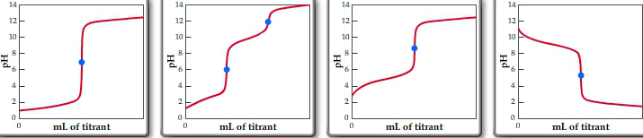
As the sample is reacting with the titrant, the pH is measured, and when recorded it creates a Titration Curve.
1 2 3 4
- Sample: Strong Acid Titrant: Strong Base Equivalence Point: 7
- Sample: Polyprotic Acid Titrant: Strong Base Equivalence Point: (2)
- Sample: Weak Acid Titrant: Strong Base Equivalence Point: >7
- Sample: Weak Base Titrant: Strong Acid Equivalence Point: <7

When drawing a Titration Curve consider:
- Whether sample is an acid or base changes where line starts
- Mono or poly determines amount of curves
- Strength of acid and base reacting to approximate the Equivalence point
- Volume (x-axis) and pH (y-axis) labelled
- With Polyprotics, the second curve is exactly double the volume of the first curve
Gasses
Properties of gasses:
- Maintain energy
- Molecules are always in motion( ↑speed ↑temp)
- Can fill any space (space between molecules can expand and contract)
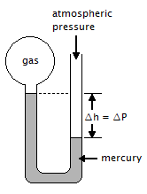
- No volume
Manometer: The difference in height of the mercury (Δh of mm Hg) is used to calculate the pressure of sealed gas sample in relation to atmospheric pressure. Δh represent the difference in the two pressures (ΔP)
- If Δh is lower then: P_{atm} – Δh mm Hg = P_{gas}
- If Δh is higher then: P_{atm} + Δh mm Hg = P_{gas}

Pressure conversions:
1.00 atm = 760 mm Hg = 760 torr = 14.7 psi = 101.3 kpa = 1.01 bar
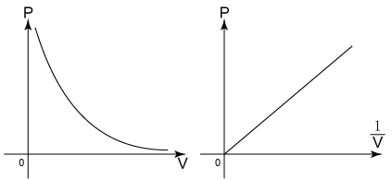
Boyle’s law shows that at a constant temperature, the pressure of a gas is inversely proportional to its volume (↑pressure ↓volume)

P₁V₁ = P₂V₂

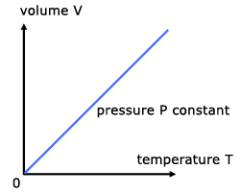
Charles Law shows that at a constant pressure, the temperature and volume of a gas are directly related (↑temp ↑volume) *temperature must be in Kelvin

V₁/T₁ = V₂/T₂

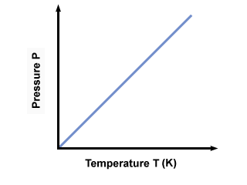
Gay-Lussac Law shows that at constant volume, as temperature increases that gas has no place to expand, therefore increasing the pressure in a direct relationship.

P_{1/}T₁ = P₂/T₂

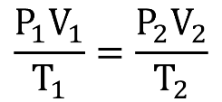
Combined Gas Law:

STP refers to Standard Temperature and Pressure: 273 K & 101.3 kPa
SATP refers to Standard Atmospheric Temperature and Pressure: 298 K & 101.3 kPa (room)
In the Ideal gas law all gasses are assumed to behave the exact same.
PV = nRT
P = pressure V = volume n = moles R=constant T = temperature (Kelvin)

Standard Pressure | R value
1 atm | 0.821
760 mm hg | 62.4
14.7 psi | 1.21
101.3 kPa | 8.312
The R value can be derived by taking the standard pressure unit, multiplying it by 22.4 Litres and dividing it by standard temperature.
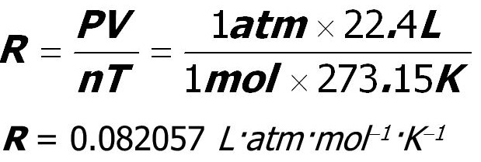
Eg. R Value for atm is:

Postulates of Kinetic Molecular Theory (KMT):
- Gas has no volume
- Constant motion, particles collision with vessel walls is the pressure
- Particles don’t attract nor repel one another
- KE_{ave} is directly proportion to Kelvin temperature

AP GAS MATERIAL

The total pressure of a mixture of gasses is equal to the sum of the partial pressures of each gas. To solve a partial pressures problem, gas laws need to be applied. P_{A} + P_{B} + P_{C…….}
At any temperature, the gas has an average kinetic energy, directly proportion to its Kelvin: KE = 3/2RT

Rearranging some formulas gives us the formula for a gas’s Root Mean Square Velocity:
µ_{rms} = $\sqrt{\frac{3RT}{M}}$
M= molar mass in kg R = 8.31 kpa T = temperature in Kelvin
This is the average speed of the molecule, and shows that it is directly related temperature and it’s mass. The average distance a particle travels between collisions is called the mean free path.
The rate of diffusion is the rate of two gasses mixing together. Effusion is when particles of gas are going through a tiny hole into an evacuated chamber (where there was none of that gas previously). The formula for effusion and diffusion is used to compare two gasses:
$$\frac{√M2}{√M1}$$

Bonding
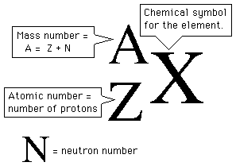
An atoms atomic number is equal to the amount of protons (p⁺) present in the nucleus of each atom. All atoms of the same element will always have the same atomic number. The mass number of an atom is the sum of the neutrons (n⁰) and protons in the nucleus.

Electronegativity is the ability of a bonded atom to attract shared electrons to itself. On the periodic table, it is a trend for the elements on the top right to have higher electronegativity’s, and the elements on the bottom left to have lower.
There are 2 main factors effecting the size of an atom:
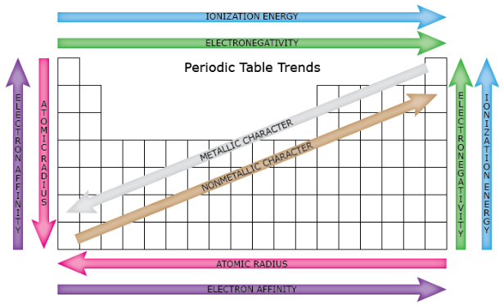
- The number of energy levels present. The more energy level, the more time the electrons spend further away from the nucleus causing an increased size.
- The attraction of the nucleus on the outer electrons. As the amount of protons and neutrons increases, it’s ‘pull’ gets stronger, effectively making the atom smaller. This is referred to as the Z_{eff} of an atom. (AP: each energy level effectively shields outer layers from the pull of the nucleus, and so the element with more levels are bigger. *even if it is an element with more electrons, it does not help to shield, that is because an element with mores electrons also has more protons/neutrons, increasing the Z_{eff} pull*. Note that the following ions all have 10 electrons, all isoelectric with neon, from largest to smallest: N³⁻ > O²⁻ > F⁻ > Ne > Na⁺ > Mg²⁺ > Al³⁺. The atom with the most electrons is largest, because the Z_{eff} nucleus is not strong enough effectively pull in all of them)
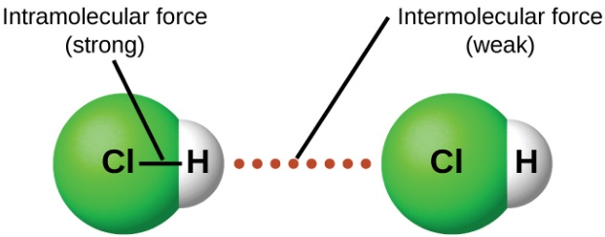
Intramolecular forces are within the molecule itself, intermolecular being the forces between other molecules. The forces that are intramolecular are always stronger, due to the bonding involved.
Intramolecular Forces:
Ionic bonds (metal & non-metal) occur when there is a transfer of electrons from a cation to an anion. This is because of metals low ionization energy and electronegativity.
- High melting temperatures because of forces present in their crystal lattice structure
- The difference in electronegativity (ΔEN) is >1.7, a result of the patterns in the periodic table where anions from the right have high EN and cations from the left side have lower EN.
- Solid at room temperature, although some are soluble
Metallic bonds are between two metals. Atoms are compacted, adjacent to each other. Properties of metals include:
- Shiny and dense
- Good at conducting heat and electricity
- Ductile(can be turned into wires) and malleable (flattened out, into different shapes)
- High melting points
In a covalent bond (non-metal & non-metal) the electrons are shared. When to atoms ‘collide’ with each other their electron clouds overlap, that is the valence electrons come together.
- ΔEN is <1.7. When it is 0, it makes it a non-polar bond.
- If one of the atoms had a greater EN, the electrons being shared would be pulled closer to that said, resulting in a polar covalent bond
- There was no electron transfer or ion formation, making the bonds neutral. The electrons in covalent bonds are always associated in pairs.
- Exist as independent molecules rather than large crystal lattices.
- Any state at room temperature

Bonding capacity is the number of electrons that an atom can lose, gain, or share to make a chemical bond
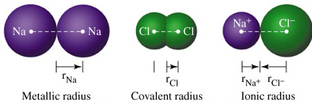

The lowercase delta δ is used to indicate a slight charges of polar molecules. The side of a molecule with higher EN pulls all the negative electrons towards it, becoming the δ⁻ side. The side that is now surrounded with less electrons is the δ⁺ side. When a molecule has both these sides, it is polar (a bond dipole), and if not it is non-polar.
The different states do not symbolize the strength of bonds, but how the molecules have become separated from each other (intermolecular). The strongest covalent bond is a network covalent bond, where the bonds are extended throughout the entire sample.
- Covalent bonds can be just as strong as ionic bonds
When drawing a Lewis dot diagram, the number of dots corresponds to the number of valence electrons in the element (last digit of group number)
- Add up the total amount of valence electrons in the compound. Each electrons must be accounted for when drawing the structure
- Construct the ‘skeleton’ of the molecule, starting with lines to show single bonds.
- Solve for the amount of dots, single, double, and triple bonds required.
- Remember the Octet Rule: each atom must have a full valence with eight electrons. The octet has some exceptions:
- Atoms after and including period three can have an expanded octet. This is because they have access to higher energy orbital (d orbital) allowing more than eight electrons. These atoms must be central.
- Be, B, and Al often have incomplete octets, having only 2 or 3 lone pairs.
- Peripheral atoms cannot break the octet rule. This does not apply to Hydrogen, which can only have 2 electrons.
- Resonance represent the fact that the multiple bonds could be a part of any of the elements at any given time, and so a Lewis structure is drawn for each possibility.
- Lewis structures for ions includes brackets and have the charge written on the outside.
- Oxygen usually has to lone pairs
Valence Shell Electron Pair Repulsion is the theory on the way atoms orient themselves around a central atom to minimize repulsion.
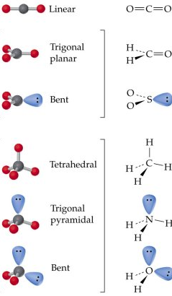
AX₂ *lone pairs repel atoms with more force

AX₃
AX₂E

AX₄

AX₃E

AX₂E₂

Intermolecular Forces:
Polar molecules differ from polar bonds. This is with the molecule as a whole, not the individual bonds within it. A polar molecule will have a δ⁻ side and a δ⁺ side due to the electronegativity. To find out if a molecule is polar check its structures symmetry; if its symmetric, the dipole cancel out and it is non-polar, if it is asymmetric dipoles do not cancel, it will be polar.
Dipole-dipole forces – Attraction only between polar molecules. This is when the δ⁺ side of one molecule is attracted to the δ⁻ of another. This network of dipole-dipole results in higher melting/boiling points because more energy is required to overcome the attractions.

Hydrogen Bonds – Strongest intermolecular force. When a hydrogen is bonded to H – F, H –O, and H – F, hydrogens low electronegativity results in a large ΔEN, making the molecule extremely polar. This means the electron density will be removed from hydrogen leaving it with a large partial positive charge, and the other side with a large partial negative charge. This super strong force makes the boiling point much higher than other compounds containing hydrogen. (Eg. GeH₄ -> -90ᴼC, H₂O -> 100ᴼC)
London Dispersion Forces – All molecules have some LDF. This is the force responsible for non-polar molecules to still be attracted to one another, existing as liquids or solids. Because the electrons in the electron are always in motion, there is a possibility that at any moment there is a higher electron density on one side, resulting in an instantaneous molecular dipole. Being polar for even a moment has an effect on neighbouring molecules, causing them to be dipole and become attracted. Molecular shapes with more surface area have more spread out electron clouds and therefore distorts neighbouring dipoles more. Its strength is based on the number of electrons it has; the more electrons the stronger the LDF. (↑ # of e⁻‘s ↑ LDF ↑melting/boiling points)
Relative strengths of bonds:
WEAKER: {Intramolecular} LDF Dipole-dipole Hydrogen Bonds
STRONGER: {intramolecular} Polar covalent non-polar covalent Ionic

AP Bonding Material
***percent abundance (pg.333)
A quanta (plural of quantum) is defined as discrete quantities, something that can only exist in whole numbers (people, tickets). In particles, energy can only be emitted or absorbed in quanta of energy.
E = hv
E = energy v = frequency h = constant (6.626 × 10⁻³⁴)
Because energy can only be emitted/absorbed in whole numbers of quanta, one quantum of energy (E = hv), two quanta (E = hv), three quanta (E = hv), etc. (It’s like marbles in a bag, you can only remove or add a whole marble, never half)
Calculating wavelengths of emission spectral lines:
The formula: 1/λ = b/hc (1/n_{l}² – 1/n_{h}²) where n_{l} is the orbit with the lower quantum number, and n_{h} is the orbit with the higher quantum number. b/hc is the of is the combination of the different constants (speed of light, planck’s constant) 1.09730 × 10⁶ m⁻¹
Calculating wavelengths of objects:
Wavelengths are smaller as the mass and speed of the object are larger: λ = h/mv
λ = wavelength h = plank’s constant 6.626 × 10⁻³² m = mass (kg) v = frequency (velocity m/s)
When a high voltage is applied across the electrodes of a sealed gas tube, the gas sample emitted light. When the light is viewed through a spectroscope, a series of bright colored lines are scene, unique to each gas. This is called the bright-line spectrum.
Bohr’s postulates for hydrogen:
- Hydrogen atoms have certain allowed energy levels, or stationary states, each corresponding to an electron orbital of a fixed size. Ground stated is the lowest allowed energy state.
- As long as an electron moved within an allowed orbit it did not absorb or emit energy.
- An electron can only move from one energy stated to another if it emitted or absorbed the exact amount of energy required
The energy emitted when an electron drops to an inner energy levels, its wavelength corresponds to that of a certain color, which is what we see in the bright-line spectrum.
***pg 337 to 355***
Principle quantum number (n) indicates relative size of the atomic orbital. It is a measure of a distance from the nucleus where the electron id most likely to be found. For example, in a 1s orbital the 1 symbolizes the size of the orbital, while the is the shape (2nd quantum #)
Second Quantum number is its angular momentum, the shape of the atomic orbital. S = a spherical shape, p = a dumbbell shape d = a double dumbbell shape. The shape is where the electron is most likely to be at a given time. S can have one orbital, p can have three orbitals, d gets five orbitals, and f gets seven orbitals.
Third quantum number is the orientation of the orbital. Whether it is on the x, y, or z axis.
Fourth quantum number tell us which of the two possible spins an electron has. When electrons are in a pair, the spins must cancel each other out, there each having a difference in their fourth quantum number. This goes under the Pauli Exclusion Principle; no two electrons can have the same set of four quantum numbers. Even if the first three match, the fourth must cancel each other out.
The total number of orbital need to add up to the principle quantum number squared n².
n= 1 1² = 1 orbital n= 2 2² = 4 orbitals n= 3 3² = 9 orbitals
As n = 3. There are three sublevels: 3s, 3p, and 3d, and a total of nine orbitals: one 3s, three 3p, and five 3d.
Each orbital has a maximum of 2 electrons in it (because the spins must cancel out)
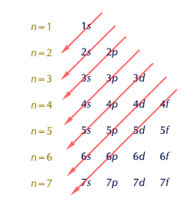
As n gets larger, its distance from the nucleus is greater, which allows for more energy in its electrons. The order of sub level energies is: s < p < d < f
Electron configurations are made by determining the number of electrons an element has and filling up the orbitals within the sublevels in order of increasing energy. In an orbital diagram, each box must first be filled up with one electron before it gets its second.
Eg. Lithium has 3 electrons 1s² 2s¹ ↑↓ ↑
Boron has 5 electrons 1s² 2s²2p¹ ↑↓ ↑↓ ↑
Oxygen has 8 electrons 1s²2s²2p⁴ ↑↓ ↑↓ ↑↓ ↑ ↑
Hund’s rules states that the most stable configuration is the one with the maximum number of unpaired electrons. Try to keep as many full sublevels as possible, even if it mean re arranging some electrons.
Core notation is used to condense electron configuration, as with some element it can get very long. To do this, take the electron configuration of the noble gas prior to the element, then add the remaining electron configuration after it.
Eg. Chorine 1s² 2s² 2p⁶ 3s² 3p⁵ [Ne] 3s² 3p⁵
More than one element can have the same electron configuration. Atoms for ions to match with its nearest noble gas; the sulfide ion, S²⁻, will have the same number of electrons as Argon. Therefore the sulfide ion is considered isoelectric to argon.
Ionization energy is the amount of energy needed to hold on to the outermost electrons. A trend is that the lowest ionization energies are associated with the largest atoms. (Pg. 385 for exceptions). Ionization energy is validation that core electrons do not take part in chemical reactions.
The electromagnetic spectrum is the entire range of energy waves that exist
Low frequency:Radio wavesinfraredvisibleUltra Violetx-ray gamma: High frequency)
***pg. 392 to 400***
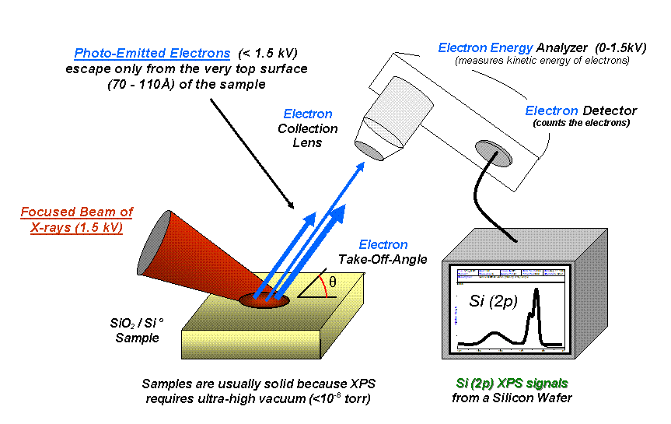
Photoelectron Spectroscopy
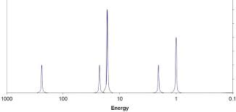

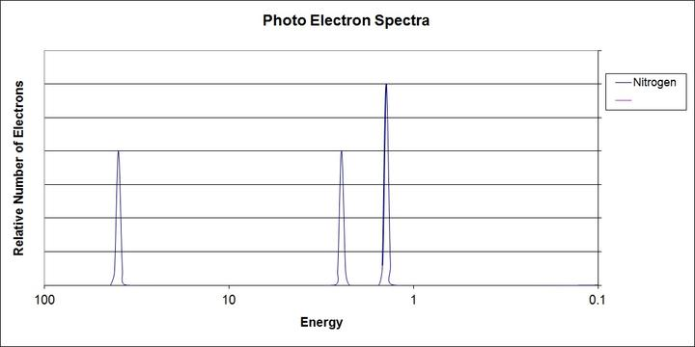
PES diagrams
1s² 1s² 2p³ 1s² 2s² 2p⁶ 3s² 3p⁴ sulphur
- Number of peaks is how many orbitals (s, p, d, f)
- Relative height of peak is the number of electrons in orbital (2s² peak will be a third of the height of an 2p⁶ peak)
- Lower energy levels have higher binding energy, and will be more left of the graph

Thermochemistry
First Law of Thermodynamics: Energy can be changed from one form to another, but it cannot be created or destroyed. The total amount of energy and matter in the Universe remains constant, merely changing from one form to another.
Energy of the universe is constant: ∆E_{universe} = 0
∆E_{universe} = ∆E_{system} + ∆E_{surroundings}
∆E_{system} = -∆E_{surroundings} (vice versa)

Heat is kinetic energy, the speed of the molecules. Temperature is a measurement of kinetic energy, a.k.a a measurement of heat.

Thermal stability: compounds ability to resist decomposition

Breaking Bonds; requires energy from surroundings endothermic
Creating bonds; releases energy into surrounding exothermic

Calorimetry
Assumptions:
- System is isolated, energy exchange with the environment id negligible
- Energy exchange with apparatus is negligible
- Density and heat capacity remains constant
- Process occurs under constant pressure

To calculate total heat of a reaction:
Q = mc∆T heat = (mass)(specific heat capacity)(∆ temperature)

Q = heat ∆t = change in temperature
∆H = change in heat n = moles
∆H_{r} = heat of reaction m = mass
c = specific heat capacity (4.19 J (g/⁰c) for water)
n∆H_{r} = mc∆t
Q= mc∆t Q = ∆H ∆H = n∆H_{r}
*If the specific heat capacity of something other than water is given, you must add mc∆t of water and the other substance together (mc∆t₁ + mc∆t₂ = mc∆t_{total})
*dilute substance (<6.00M) are assumed to have the same specific heat capacity of water
This equals the Enthalpy change of the total reaction = ∆H To find the ∆H of one mole of the reaction:

$\frac{∆H}{n}$ = $\frac{KJ}{mol}$

Reaction Notation:
- Thermochemical Equation
CH_{4(g)} + O_{2(g)} CO_{2(g)} + H₂O_{(g)} + 802.5 kJ
*if reaction is exothermic, heats is a term on the products side
*if reaction is endothermic, heat is a term on the reactants side
- ∆H Notation
CH_{4(g)} + O_{2(g)} CO_{2(g)} + H₂O_{(g)} ∆H = -802.5 kJ
*∆H (-) = exothermic *∆H (+) = endothermic

- Potential Energy Diagram
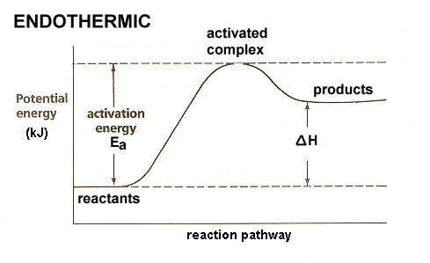
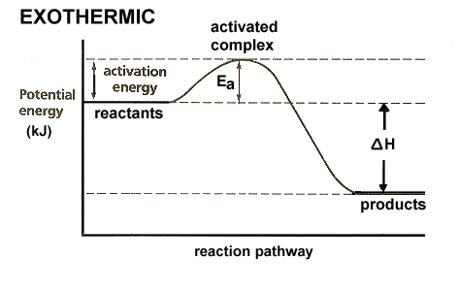
Endothermic if it ends with more energy because of the energy input from surroundings. Exothermic if it ends with less energy because of the release during reaction.

Includes: Activation Energy (Minimum amount of energy required to form product), Activated complex (total energy required for effective collision) E_{p} of reactants, E_{p} of products, and Enthalpy of reaction (∆H)
*reverse reaction has an inverse ∆H value, and a different activation energy

Catalysts: Speed up reaction without being affected itself (remains the same before and after reaction) *lowers activation energy*

Collision theory: particles must collide for a reaction to occur
4 factors: 1) nature of reactants 2) Temperature of system 3) concentration of reactants (pressure for gasses) 4) use of a catalyst
*effective collisions occur at the right angle with the right amount of energy

Energy sources:
- Physical: changes of state, intermolecular breaking and reforming bonds between molecules 10⁰ to 10² kJ/mol
- Chemical: breaking/ reforming bonds between atoms in a molecule 10² to 10⁵ kJ/mol
- Nuclear: Changes within nucleus eg. Uranium fission 2.1 × 10¹⁰ kJ/mol

Efficiency = $\frac{useful energy output}{energy input}$ × 100
Energy input: use ∆H = mc∆t & ∆H = n∆H_{r} *actual work done
Energy input: use Hess’ Law (theoretical energy) *energy in fuel (E_{p})

Under the SATP (25⁰c @ 100kPa) conditions is the molar enthalpy number (⁰)
*∆H⁰_{formation} of an element is 0

To calculate ∆H_{r} (theoretical heat of reaction):
∆H_{r}⁰ = ∑(n∆H⁰_{f} products) - ∑(n∆H⁰_{f} reactants)
The sum of molar enthalpies of formations of all compounds on the products, minus the sum of enthalpies of formation of all products on reactants side.

HESS’ LAW
Reactions occur in a series of steps called a reaction mechanism. Describes the different ‘paths to completion’ that end in the same result/product. The sum of enthalpies of the steps is equal to the overall enthalpy:
∆H_{overall} = ∆H₁ + ∆H₂ + ∆H₃……

Eg. C + ¹/₂ O₂ CO ∆H° = -110 kJ/mol
CO + ¹/₂ O₂ CO₂ ∆H° = -283 kJ/mol

C + O₂ CO₂ ∆H° = (-110)+(-283) = -393 kJ/mol

To solve using Hess’ law:
- Write balanced equation
- Write heats of formations for one mole of each compound
- Adjust equations so compounds are on the correct side of equation (change ∆H value)
- Adjust co-efficient and ∆H values to reflect number of moles
- Allow equations to cancel out and add up ∆H values

THERMODYNAMICS
ENTROPY
While enthalpy is the amount of energy doing work, entropy is the amount of thermal energy in a closed system NOT available to do work. It correlates to the disorganization/randomness of the system. Two types of disorder:
    - Positional disorder - the arrangement and distribution of particles in space
    - Thermal disorder - the distribution of energy among the particles
Substances with lower entropies are simpler because they have fewer microstates (possible configurations). Can be calculated using Hess law:
∆S⁰ = ∑(n∆S⁰ products) - ∑(n∆S⁰ reactants)

**Entropy (S) is expressed as J/K ∙ mol**
When a reaction is said to be spontaneous, it means the reaction will occur without the need of any outside intervention, not that it will occur at a rapid rate. In contrast, a non-spontaneous reaction needs some sort of assistance, when a spontaneous change occurs first.

Second Law of Thermodynamics: The entropy of universe increases with every spontaneous process.

Entropy changes in reactions involving gasses:
- Phase changes (g > l > s), because the organization of the molecules have changed
- Increased temperature raised the movement of molecules, therefore the entropy
- Sides of reaction with more moles of gas will have a higher entropy
- The more complex the molecule, the higher it’s entropy, because they have more possible microstates.

Thermodynamic Drives:
- Drive towards decreasing enthalpy
  - Objects naturally go to the lowest energy state available to them. Thus, atoms form stronger bonds with lower potential energies
- Drive towards increasing entropy
  - Being less organized requires less energy, therefore atoms will go towards sides of reaction with a higher entropy

**Pg. 143 diagram
Chemical systems move spontaneously to equilibrium

GIBBS FREE ENERGY
When the entropy and enthalpy oppose one another, the changes in the spontaneity of the reaction is less obvious. Instead the quantity for Gibbs free energy (∆G) is used, which is the maximum amount energy available to do work. A change is only spontaneous if the ∆G is negative, (a decrease of free energy)
∆G = ∆H - T∆S
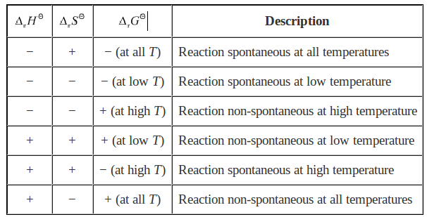
∆G at equilibrium is 0. If ∆H and ∆S are known, the temperature at equilibrium can be calculated. This is the temperature of a state change:

∆S_{system} = $\frac{∆H}{T}$

Enthalpy, Entropy, and Gibbs free energy are all state functions, a thermodynamic quantity whose value depends on its state at the moment the measurement is taken. The value is independent of the history. This means Hess law can be used to calculate standard free energy of formation:
∆G⁰ = ∑(n∆G⁰ products) - ∑(n∆G⁰ reactants)

Gibbs free energy can also be used to calculate the equilibrium constant:***
ΔG = ΔG° + RT ln K

Equilibrium
Thermal equilibrium: If the drive towards increasing entropy opposes the drive of decreasing enthalpy, an equilibrium will develop with a ‘reasonable’ amount of products and reactants.
For a system to be at chemical equilibrium:
- Constant macroscopic properties (observable by eye)
- Be closed
- Shift with change in conditions

Le Châtelier’s Principle
An equilibrium subjected to stress will shift partially to alleviate the stress and restore equilibrium. When a reactant or product is added, the system will shift to remove some of the added chemical. If a reactant or product is removed, the system will shift to replace it, restoring equilibrium. (“Shifting left” for reactants, “shifting right” for products). *When concentrations are higher at equilibrium as a result of adding a substance, the rates of forward and reverse reactions are both higher*
Equilibrium position is the relative concentrations of products and reactant, expressed a percent yield. A higher percent yield (>50%) means more products have been made, therefore the reaction favours the right side. Because of how molecules in an equilibrium are always in motion, it is also referred to as the law of mass action.
How equilibria responds to:
- Volume/Pressure: will relieve some added pressure, or replace lost pressure. Going to the side of reaction with less moles of gas will relieve some pressure, while the opposite occurs with the side with more moles. *if the system is compressed, both products and reactants will have a higher concentration/ partial pressure due to the decrease in volume* (diluting is equivalent to increasing the volume). A reaction with an equal sum of coefficients on both reactants and products side of (g) or (aq) will be disrupted by a volume change.
- Temperature: will shift to remove added kinetic energy, or replace some removed kinetic energy. (to solve, treat KJ as a term in the reaction) Cooling down a system is removing heat from products side, heating a system is adding heat to the reactants side.
The endothermic direction of a reaction is for sensitive to temperature changes because of the higher activation energy required then its reverse exothermic reaction. ↑temperature = shift in endothermic direction.
**when a gas is compressed, the increased pressure causes to temperature rise. This is because the particles gain kinetic energy as they get closer together. In a problem, assume temperature is kept constant**

The Haber-Bosch process is used to produce to create NH₃. It reveals that lower temperatures produce a higher percent yield, but at a slower rate. This means a higher temperature will make a less percent yield, but much faster. A higher pressure also pushes for a higher percent yield in this case, because 4 molecules become 2. (N_{2(g)} + 3H_{2(g)} 2NH₃)

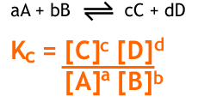
The equilibrium constant is used to calculate the concentrations of products and reactants in a system when equilibrium is achieved. The constant is calculates using the equilibrium expression:
**coefficients are used as the power of the concentration**
In an equilibrium expression, values are all concentrations ([ ]), so all substances that are (l) or (s) are not included. The only way to change a chemical equations equilibriums constant is by changing the temperature.

The greater the K value, the more a reaction has progressed to the right.
(K_{eq} < 1 = more reactants, K_{eq} > 1 = more products)
Reversing the reaction will make the Kc value the reciprocal of the forward reaction.
Stresses added to a system (adding/removing substance, changing volume) will only cause it to re-establish the original equilibrium. The only way to actually change the Kc value is to change the temperature.
The trial K_{eq} or reaction quotient (Q) is when concentrations of reactants and products are used in the equilibrium expression when the system has not yet reached equilibrium. It is used to determine which way a reaction will shift to achieve equilibrium.
Q < K_{eq} = shift to right, Q > K_{eq} = shift to left
An equilibrium expression with only one chemical concentration must completely alleviate all the stress paced in the system:
Eg. CaCO_{3(s)} ⇌ CaO_{(s)} + CO_{2(g)} K_{eq} = [CO₂]

**ICE TABLES FOR DETERMINING CONCENTRATIONS BEFORE/AFTER EQUILIBRIUM**

K_{p} is the pressure constant: K_{p} = K_{c}(RT)^{∆n}
T = temperature in Kelvin (+273.5)
∆n = difference in co-efficients for between reactant and products.
R = 0.08206 L∙atm/mol∙K
K_{c} = K_{eq}
K_{p} Expression = $\frac{[P of products]}{[P of reactants]}$

The molar solubility of a substance is the molar concentration of a solute in a saturated solution. The solubility product constant (K_{sp}) is the product of the ion concentration in a saturated solution, raised to the power of the coefficients in the equilibrium. It represents the equilibrium of the (s) and the (aq) ions present at saturation. As solubility increases, so does the ion [ ], and therefore the K_{sp}. Reactants are solid, because they are being dissolved. K_{sp} is calculated when solution is saturated:
Eg. AgCl(s) ⇌ Ag⁺(aq) + Cl¯(aq) K_{sp} = [Ag⁺] [Cl¯]
Eg. Fe(OH)₂(s) ⇌ Fe⁺² (aq) + 2OH⁻(aq) K_{sp} = [Fe⁺²] [OH⁻]²
Using the K_{sp} the solubility’s can be calculated:
For AB salts, K_{sp} = (solubility)²
For AB₂ or A₂B salts, K_{sp} = 4(solubility)³
When there is no equilibrium present in the solution, trial ion product (TIP) which is equivalent to the trial K_{eq} or reaction quotient (Q)
TIP > K_{sp} precipitate forms
TIP < K_{sp} no precipitate forms
TIP = K_{sp} solution is saturated
The solubility of a substance depends on the presence of other ions, and the temperature. Ksp depends only on temperature. If a compound (cation and anion) is put in a solution that already has some common cation present, then less of the compound will dissolve because an increased concentration of a product ion causes a shift left to reactants side (Le Chatelier’s principle). The solubility has decreased, but in the end there is more cation and less anion, maintaining the Ksp value. This is the common ion effect. To calculate: 1) ice table with starting common ion as E concentration for the ion column 2) divide Ksp with the known concentration

Acid-Base Equilibrium

Bronsted-Lowry Acid: A substance that donates an H⁺ (a proton) _{*Differs from the Arrhenius}
Bronsted-Lowry Base: A substance that accepts an H+ Acid/Base theory.
A strong acids completely ionizes in aqueous solutions, weak acids only partially ionizes.
HCl_{(aq)} , HBr_{(aq)}, HI_{(aq)}, H₂SO_{4(aq)}, HNO_{3(aq)}, HClO_{4(aq)}
A strong base completely dissociates in aqueous solutions, weak bases produce only few ions.
Hydroxides with group I or II cations, excluding Be. (eg. NaOH, KOH, Mg(OH)₂)

Weak acids and bases only produce few ions in water giving them the ability go in the reverse reaction. To represent this, an equilibrium arrow is used:
NH_{3(aq)} + H₂O_{(l)} ⇌ NH₄⁺_{(aq)} + OH⁻_{(aq)}
When a weak acid partially ionizes, releasing an H⁺, that molecule can now accept a H⁺ in the reverse reaction. This makes that molecule a Bronsted-Lowry Base. Together, the Bronsted-Lowry Acid that ionized and the base it produced (differing in one H⁺) form a conjugate acid-base pair:

NH_{3(aq)} + H₂O_{(l)} ⇌ NH₄⁺_{(aq)} + OH⁻_{(aq)}
base acid acid base

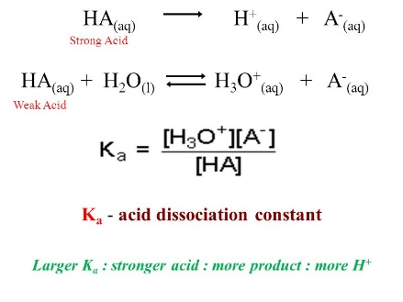
An amphiprotic substance has the ability to act as an acid or a base, depending on what it is reacting with. A common example is water, because it can accept an H⁺, forming H₃O+, or donate the proton, forming OH⁻.
K_{a} and K_{b}
The acid-base ionization constants refer to the amount of a weak acid or base will ionize/dissociate to form OH⁻ or H₃O⁺. The expression:

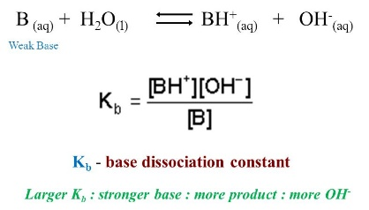
As usual, if the K value is greater than 1, products are favoured. If K is less than 1, reactants are favoured. The equilibrium position is determined by the stronger acid or base reacting. The equilibrium favours the reaction in the direction of the stronger acid or base forming the weaker acid or base. (Stronger = more ionization)
Recall: With K_{eq}, reactants favoured if < 1 < products favoured. This is the same with K_{a} and K_{b} (weak substances ionize very little, which is why their ionization constants are so small)

Water is amphiprotic (explained above). At equilibrium, one water molecule donates a proton to another, in auto-ionization. Ion product constant of water:

@25⁰, K_{w} = 1.00 × 10⁻¹⁴ = [OH⁻] [H₃O⁺]

This works because [OH⁻] and [H₃O⁺] are inversely proportional. And increase in [OH⁻] causes a decrease in [H₃O⁺], and vice versa. Water being neutral, [OH⁻] = [H₃O⁺] = 1.00 × 10⁻⁷.

Binary acid strength:
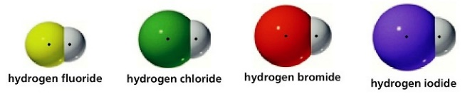
Strong Acids donate their hydrogen ions more readily, due to a weaker bond holding on to the proton. A larger atom increases the bond length between the nucleuses of the atoms.
Bigger atom = Longer bond = weaker bond = stronger acid

Binary acids containing more than one hydrogen have stronger bonds, therefore making a weaker acid.
Ternary Acid Strength:
^{*always have an oxygen atom}
Strength of ternary acids depend on: 1) number of oxygen atoms 2) EN of central non-metal atom
Oxygen atom polarize the O-H bond by pulling the electron away from the hydrogen and toward the center of them molecule. This occurs more readily when the central non=metal atom has a high electronegativity (↑oxygen ↑EN on central atom = stronger acid)
Carboxylic Acids:
A shorter carbon chain and the presence of a highly electronegative atom increase the O-H bonds, causing a stronger acid.

The levelling effect is the effect of water levelling the strengths of all strong acids and bases. Strong means that it ionizes 100%, so when a strong acid is added to solution no strong acid is actually present. The strongest acid present is actually H₃O⁺, and for strong base solution the strongest base is OH⁻.

When mixing strong acids and bases, if an excess of either hydronium or hydroxide remains, the resulting solution is NOT neutral.
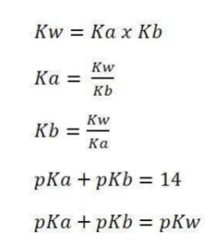
(pg. 303-310 for calculations)
With weak acids or bases, the calculations differ because they do not dissociate/ionize 100%. K_{a} and K_{b} values need to be used.
(pg. 311-324 for calculations)

Acid-Base Application
Hydrolysis is when am ion reacts with water to form the conjugate base and hydronium ions OR the conjugate acid and hydroxide ions.

Although salts are the product of many neutralization reactions, the resulting salt solutions can actually be acidic or basic. This occurs when one or both of the dissociated ions from the product salt behave as weak acids or bases.
- Neutral Salts: A salt containing the anion of a strong monoprotic acid and the cation of a strong base. Because both come from a substance that dissociates/ionizes completely, neither will form bonds with water. This will produce a neutral solution because neither ions will undergo hydrolysis
Eg. Cation: Rb⁺, Ca⁺, Ba²⁺ Anion: Cl⁻, NO₃⁻, ClO₄⁻
- Basic Salts: A salt containing the anion of a weak monoprotic acid and the cation of a strong base. This will produce a basic solution because the anion will act as a weak base, while the cation will not react. Eg. NaCH₃COO Na⁺ + CH₃COO⁻ / CH₃COO⁻ + H₂O ⇌ CH₃COOH + OH⁻
- Acidic salts: A salt whose cation is the conjugate acid of a weak base and the anion of a strong monoprotic acid. This will produce an acidic solution because the cation will act as an acid while the anion does not react. Eg. NH₃ + HClNH₄Cl / NH₄⁺ + H₂O ⇌ NH₃ + H₃O⁺
- Acidic Salts II: A salt containing the anion of a strong monoprotic acid and a small highly charged metal cation. After dissociation, the cation will hydrate and act as a weak acid producing hydronium, while the anion does not react. Happens with: Al⁺, Fe³⁺, Cr³⁺, Sn²⁺, Cu²⁺ bonding with the number of water molecules equal to double the charge on the cation.
Eg. Al(H₂O)₆ + H₂O ⇌ Al(H₂O)₅OH²⁺ + H₃O⁺
- A salt containing a weakly acidic cation and a weakly basic anion. The pH of the solution produced depends on the Ka and Kb values of the cation and anion; the one with the higher value is stronger.
Acidic if K_{a} of cation > K_{b} of anion acid / basic if K_{a} of cation < K_{b} / neutral if K_{a} = K_{b}
- A salt containing the cation of a strong base and an amphiprotic anion. Because the anion is the only what reacting, the result depends on it’s K_{a} and K_{b} values. The solution produced will be:
Acidic if K_{a} of anion > K_{b} of anion / Basic if K_{a} of anion < K_{b} of anion

Buffers
A buffer is a solution with the ability to resist drastic changes in pH following the addition of strong acids and bases. A buffer is comprised of a weak acid along with its conjugate base in significant relative amounts (approx. equal concentrations).
Acidic Buffer Eg. CH₃COOH + H₂O ⇌ CH₃COO⁻ + H₃O⁺
Adding base takes out some hydronium from the solution, so the reaction shifts to replace it by ionizing some of the conjugate acid. When a strong acid adds hydronium, the reaction shifts left by reacting some with the conjugate base. Both result in little change in the pH as the [H₃O⁺] is nearly restored.
Rearranging the K_{a} expression gives us: [H₃O⁺] = K_{a}$\frac{[HA]}{[A]}$
There for, if the ratio of HA/A = 1, then the [H₃O⁺] is equal to the weak acids K_{a} value. This also tells us that is the solution id diluted, then both concentrations are effected; diluting does not effect a buffer.
Basic Buffer Eg. NH₃ + H₂O ⇌ NH₄⁺ + OH⁻
[OH⁻] = K_{b}$\frac{[B]}{[HB]}$
The amount of acid or base a buffer can neutralize before the pH starts to change significantly is its buffer capacity. The capacity of a buffer depends on the concentration of its components; more moles in its reservoir means more substance can be neutralized before it runs out. The lower the capacity for a buffer, the more significantly the acid-base ratio will change upon addition of strong acids/bases. An effective buffer has a ratio between 10 – 0.1.

Henderson-Hasselbalch
pH = pK_{a} + log$\frac{[HA]}{[A]}$
*Used in calculating pH of a solution containing a buffer (titrations)*

Indicators are complex organic acids whose conjugate pair displays a different color. 1/10 of the indicator much change in order for a noticeable colour change. By adding acid to a solution with an indicator, the reaction shifts to the side without H₃O⁺. As a result, more of its acidic form is present, so that is the colour seen.

(acidic form) HIn + H₂O ⇌ (basic form) In⁻ + H₃O⁺
When the solution with the indicator is basic, less H₃O⁺ is present so the reaction shifts left to add some, so more of its basic form is present, showing a different colour.
When the indicator has equal concentrations of each of its forms, an intermediate colour is shown. This is its end point, or transition point.
pK_{a} of indicator = pH at its colour change
By averaging the pH’s that make the range of the indicators color change, the K_{a} and pH of transition point of the indicator can be estimated. As the pK_{a} increases as K_{a} decreases, it means the indicator acid strength decreases as it’s pH at colour change increases.
Titration Curve pH calculations:
Strong acid-Strong base:
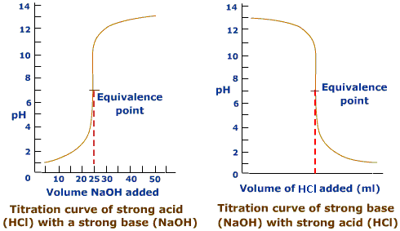
- Prior the addition of a titrant
Strong acid/base will have an initial pH either very high or very low
- Approx. halfway to equivalence point
Some of the substance has been neutralized, and the volume has changed, giving new concentrations. (ICF table)
- Equivalence point
Equal amounts of OH⁻ and H₃O⁺ had been added, pH = 7
- Beyond equivalence point
Excess OH⁻ or H₃O⁺ is added, making solution basic or acidic
Weak acid-strong base
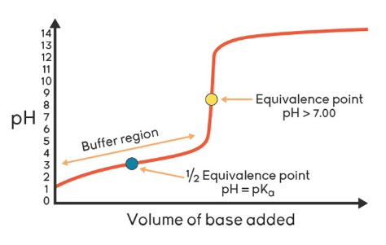
- Prior to the addition of a titrant
Weak acids ionize partially, in accordance to their K_{a} value. (ICE table & approximation method) Recall:
- Approx. halfway to equivalence point
As some acid is reacted with the strong base, some conjugate base is formed, creating a buffer region.
Eg. CH₃COOH + NaOH H₂O + NaCH₃COO
(actually in solution as Na⁺ and CH₃COO⁻)
H₃O⁺ can be calculated using ICF tables and the K_{a} expression, or the Henderson-Hasselbalch equation.
- At the halfway to equivalence point
When exactly half the amount of weak acid has been neutralized, the conjugate acid/base pair have a ratio of 1/1. Removing it from the K_{a} expression, we have K_{a} = [H₃O⁺]
- Prior to halfway point: pH > pK_{a} or K_{a} < [H₃O⁺]
- At halfway point: pH = pK_{a} or K_{a} = [H₃O⁺]
- Beyond halfway point: pH < pK_{a} or K_{a} > [H₃O⁺]
- Equivalence point
All of the weak acid is reacted with the strong base, all having turned into its conjugate base that hydrolyzes water. This means that even with the original acid being neutralized, the presence of the conjugate base makes the pH at equivalence point basic. Determining the pH is the K_{b} of the conjugate base. (ICE table, K_{b} expression)

Weak Base-Strong Acid:
*opposite of a weak acid-strong base*
- Prior to the addition of a titrant
As titration progresses, volume changes. This changes the molar concentration
pH should be above 7, but lower than that of a strong base. Solve for K_{b} (ICF table)
- Approx. halfway to equivalence point
[H₃O⁺] can be solved for using the K_{b} expression, or the Henderson-Hasselbalch
- At the halfway to equivalence point
pOH = pK_{b} or [OH⁻] = K_{b}
- Equivalence point
All the initial weak base is now its conjugate acid. Calculate pH using K_{a} expression.

Non-metal and Metal Oxides in Water
Basic anhydrides react with water to form basic solutions. They are metal oxides composed of a group 1 or 2 metal (except beryllium) and oxygen, and must be highly ionic and soluble. When reacting with water, the metals are spectator ions, while the oxide ion removes a proton from water, converting itself and the water molecule into OH⁻.
Dissociation: Na₂O(s) → 2 Na⁺(aq) + O²⁻(aq)

Net ionic: O²⁻(aq) + HOH(l) → OH⁻(aq) + OH⁻(aq)

Overall: Na₂O(s) +H₂O(l) → 2 Na⁺(aq) + 2 OH⁻(aq)

Some metal oxides are not soluble in water, not forming basic solutions. Some however, can behave as both acidic and basic, being amphoteric.

Acidic anhydrides are non-metal oxides that react with water, producing an acid. They bind together to form a molecular acid, and have high oxidation states. No non-metal oxides can form basic solutions. Less metallic oxides = more acidic solutions.

Eg. SO₃ + H₂O H₂SO₄ N₂O₅ + H₂O HNO₃ + HNO₃

Redox Reactions
LEO the lion says GER: "Loss of Electron is Oxidation" and "Gain of Electrons is Reduction"
Reduction: gain of electrons Eg; Cl_{2(g)} 2Cl⁻_{(aq)} Oxidation: loss of electrons Eg; Ca_{(s)} Ca²⁺_{(aq)}

Redox reaction always happen together; one substance becomes oxidized, while another gets reduced. When something get reduced, it causes another substance to be oxidized, therefore being an oxidizing agent. An oxidized substance causes reduction, being a reducing agent. In a disproportionation reaction, the same substance acts as a oxidizing and reducing agent.

Br_{2(g)} + 2OH⁻ BrO⁻ + Br⁻_{(aq)} +H2O_{(l)}
Oxidations number: the charge on an element that is bonded with oxygens or hydrogens. Indicate the amount of electrons shifted towards or away from an atom during a redox reaction.
- Oxygen: always has a 2- charge Exception: in peroxides has a 1- charge
- Hydrogen: always has a 1+ charge Exception: in metal hydrides 1-
- Elements in natural state: 0
V = 4+ V = 5+

To make a relative strength table: spontaneous reactions indicate that OA and RA on reactants side or stronger than on the products side. For a reaction to be spontaneous, the OA must be above the RA on the relative strengths table (implies that both are strong enough to react without added energy)
*⇌symbol tells us reaction can be read in both directions (not an equilibrium)

Balancing redox equations:
Half reaction method
- Step 1: write two half reactions for the oxidized and reduced species
- Step 2: Balance all elements except hydrogen and oxygen
- Step 3: add waters to the oxygen deficient side on each reaction to balance them
- Step 4: add hydrogens to the side with less to balance them (step 3.5: add the same amount of hydroxides to each side if in a basic solution)
- Step 5: balance charges by added electrons to the side with a higher charge on each reaction
- Step 6: Compare the electron on both reactions and multiply them ass needed to cancel out
- Step 7: add together both halves, cancelling as needed to be left with the final net reaction
*half reactions can be found in on the data chart. If present, skip first 3 steps*
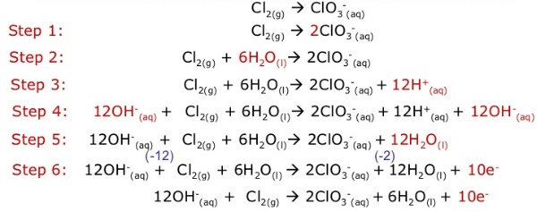
- IF BASIC: add OH⁻to both sides, equal to the number of H⁺ ions. Combine the ions to make H₂O.
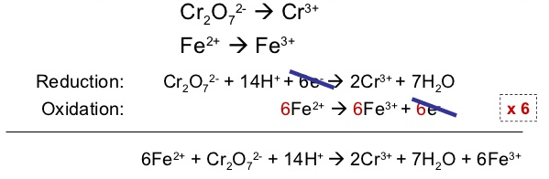

Oxidation number method
- Step 1: identify OA and RA, as well as their oxidation numbers
- Step 2: balance the number of primary atoms on each side (not O’s or H’s)
- Step 3: balance electrons gained with electron lost by changing coefficients
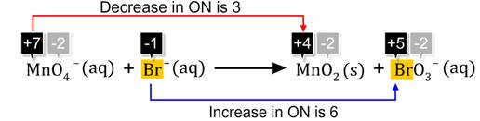
- Step 4: add waters to oxygen deficient side
- Step 5: add hydrogens ions to hydrogen deficient side

CELLS:
Electrochemical: reacts spontaneously to produce energy (voltaic/galvanic)
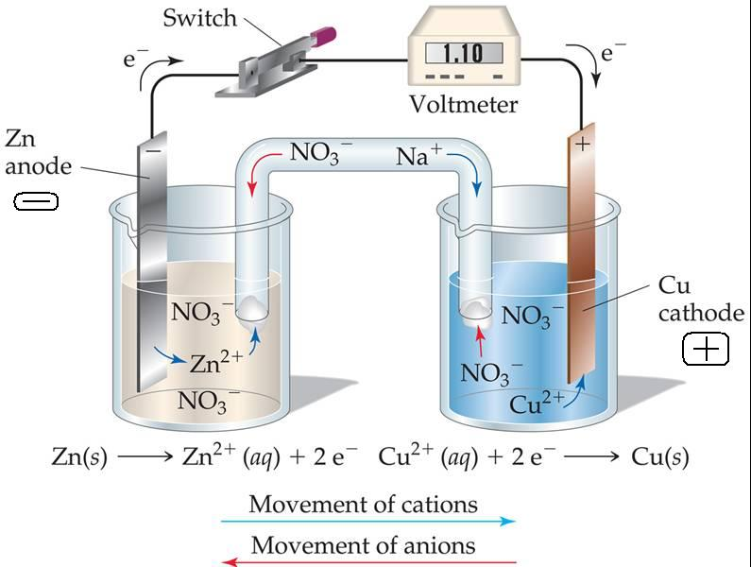
(Chemical electrical)
Battery: several cells put together

Electrodes (conduct electrons out of half-cell, with the wires make the external circuit)
- Cathode – where reduction occurs (SOA reacts). Cations move toward the cathode, causing it to gain mass.
- Anode - where oxidation occurs (SRA reacts). Anions move toward anode, towards salt bridge.
Salt bridge: Allows flow of ions between electrolyte solutions to prevent charge build up when positive ions are released from the anode into the solution. Negative ions migrate through the salt bridge to neutralize.
Electrochemical cell; 2 half cells put together with a pathways for e⁻movement and a path for ion. Results in electrical current.
Electron flow: Anode Cathode

Cell notation designated as anode|anion||cation|cathode Eg; Cd (s) | Cd²⁺ || Ag⁺ | Ag (s)
** || salt bridge ** Inert electrodes are used when there is no conducting solid in a half-reaction

Standard electrode potentials are measured relative to the hydrogen half-cell. To calculate the potential of a cell:
E⁰_{total} = ⁰E_{cathode} - ⁰E_{anode}
Even when coefficients of reactions are multiplied when balancing reactions, their E⁰ stays the same. When the E⁰_{total} of a cell is a positive number, the reaction is spontaneous.
Corrosion!!
When exposed to oxygen or hydrogen in the environment, iron can become anodic and oxidize (give up electrons) = rust!

- Coatings: Grease, oils, paints prevent exposure to oxidizing agents. Forming alloys with iron is called passivation.
- Sacrificial Anodes: Attaching strong oxidizers ( Zn, Mg) to iron structures that are more likely to lose electrons. Redirect electrons iron, making it a cathode that won’t corrode. (galvinizing)
- Impressed currents: Making the iron cathodic (?)
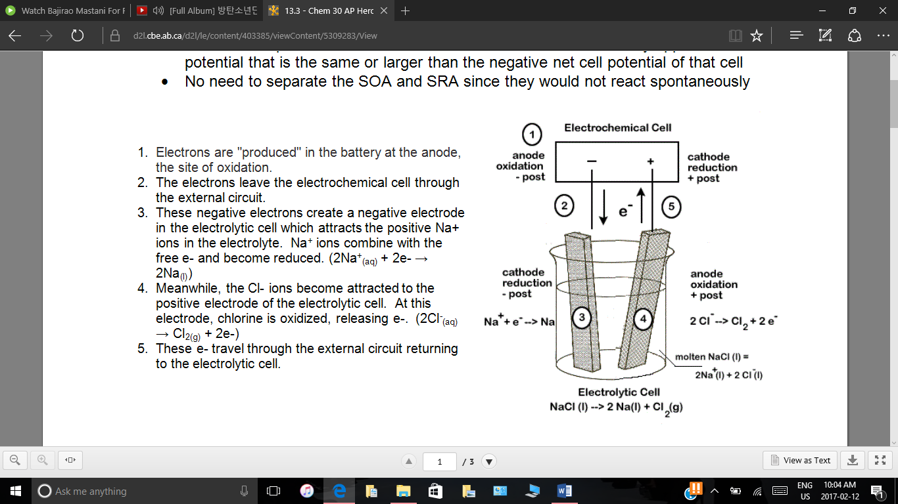
Electrolytic: electrical energy causes a non-spontaneous reaction to occur by applying a potential equal to or greater than the negative cell potential, SOA and SRA do not need to separate because they would not automatically react. (Electrical chemical)

Electrochemical | Electrolytic
Exothermic  Releases electrical energy  ChemicalElectrical | Endothermic  Requires electrical energy  Electrical Chemical
Spontaneous  E⁰ is positive | Non-spontaneous  E⁰ is negative
2 half cells | 1 cell
SRA gives away electrons to the SOA to make an electrical current | Electrical current is applied to force a weak RA to give electrons to a weak OA
The further away the half reactions are on the SRP table, the higher the voltage | The further away the half reactions are on the SRP table, the more voltage is required to run
Anode – negative  Cathode - positive | Anode – positive  Cathode - negative

Both:
- Electrons flow anode cathode
- Anions Anode, Cations Cathode
- Cathode get reduced, Anode gets oxidized
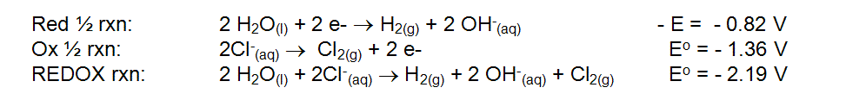
Chloride anomaly: The electrolysis of water requires a higher voltage than what is predicted by the SRP table (over-potential). As a result, chlorine ions have a tendency to react with the water molecules

AP ELECTROCHEMISTRY
Nernst Equation: used to calculate the voltage (E⁰) of an electrochemical cell whose half cells contain non-standard ion concentrations.
$$E=E^{0}- \frac{0.0592}{n}\log{Q }$$
If both concentrations are the same, E = E⁰.
When Q = K, E becomes 0
$$O=E^{0}- \frac{0.0592}{n}\log{K }$$
Or
$$E^{0}= \frac{0.0592}{n}\log{Q }$$

n = # of moles of electron being transferred, E⁰ = cell potential

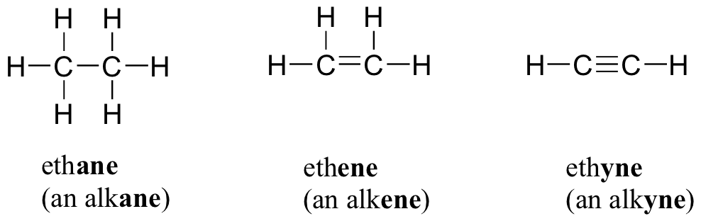
ORGANIC

Organic: Contains carbon, covalent bonds, combust, non-polar (excludes oxides and ionic compounds)
Inorganic: Anything that can combine/is combined to a metal
Alkane: contains only single bonds
Alkene: contains at least one double bond
Alkyne: contains at least one triple bond
Alkyl Groups: branches coming off a main parent chain
Isomers: same chemical formula, but different structure (IUPAC name)
Naming:
- Identify longest chain of continuous carbons; the parent chain. if a cyclo is present, it is always the parent chain.
- Start counting on the side of the parent chain that is closest to either a branch or double bond (bond > branch)
- Identify branches; meth, eth, prop, but, pent, hex, hept, oct, non, dec, -yl
Halogens: fluoro, bromo, iodo, chloro
- Name branches in alphabetical order (eg. 1-ethyl-3-methyl)
- Identify location/type of bonds; singleane doubleene tripleyne
- Add prefixes if more than one of the same branch/bond (eg. 1,3-dimethyl / 2,4 diene)

**dashes separate numbers and words**’e’ is not added unless it is the ending**

For acids: COOH is assumed to be on the ends of parent chain, and therefore do not need to be numbered. End in ‘enoic acid’
For alcohols: For molecules with an ‘OH’ the ending of the name is given an ‘ol’ (with location numbers and prefix), unless the molecule is also an acid. In this case, the OH is treated as a branch called ‘hydroxyl’
For esters: When an acid and alcohol bond and give off a water molecule. The alcohol side of the molecule is then treated as a branch, and the acid side has a changed ending to ‘oate’
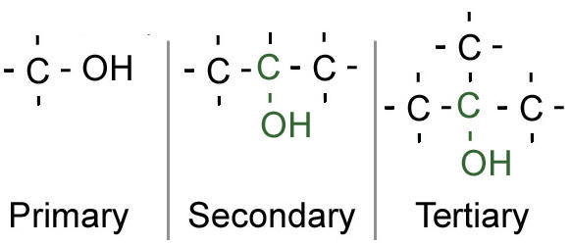

If the carbon that the hydroxyl group is bonded to 1, 2 or 3 other carbons, the alcohol is:

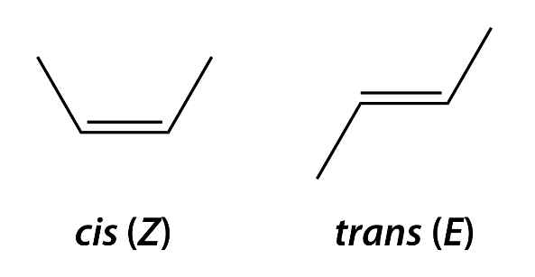
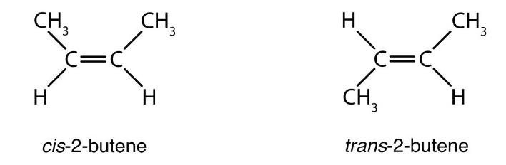
When a double bond is in the middle of the molecule, it can be cis or trans depending on its shape:

**Trans is more stable that cis, therefore they give of more heat
For a compound to be saturated, it must have the maximum number hydrogens bonded to carbons; alkanes. Anything with a double/triple bond is unsaturated. Because extra bonds are easier to break, saturated molecules ae more stable.
Units of Unsaturation:
Alkane | Single bond | 2n + 2 = H | Ethane:C₂H₆
Alkene | Double bond | 2n = H | Ethene: C₂H₄
Alkyne | Triple bond | 2n – 2 = H | Ethyne: C₂H₂
Cyclo | --- | 2n = H | Cycloethane: C₂H₄

2 hydrogens = 1 unit of unsaturations
2n + 2 0 units of saturation 2n 1 unit of saturation 2n – 2 = 2 units of saturation
The amount of 2 hydrogens away from an alkane a molecule is, that is the unit of unsaturation.
Eg. C₂₈H₅₀ 2(28) + 2 = 58 Alkane: C₂₈H₅₈ 58 – 50 = 8 8/2 = 4 4 units of saturation
Homologous series: same everything, except changes in # of carbons
Polymerization: unsaturated monomers with double/triple bonds join together to make a repeated sequence in a larger molecule
Condensation Polymers: monomers joining together while removing small molecules from functional groups (eg. Dehydration synthesis)

Structural Analogs:
Lipids | Proteins | Carbohydrates
Polyesters | Nylons | Cellulose

Hydro treating(hydrogenation): removes sulfur from gasoline by adding hydrogen gas to make H₂S_{(g)}
Fractionation: Crude oil contains a mixture of many oils. It is put in a fractionation tower where heat is supplied from the bottom, causing substances with different boiling/melting points to separate. (higher at the bottom, lower at the top)
Physical
Solvent extraction: Polar molecules dissolve in a polar solvent, likewise for non-polar solvents. Used to remove impurities or separate useful products from a mixture.
Cracking: larger molecules being broken down by heat/catalysts/high pressure to make smaller molecules 1) hydrocracking – uses hydrogen 2) catalytic cracking – releases carbon
Chemical

Catalytic reforming: converts aliphatic into aromatics, which have better burning properties

Octane rating: higher rating = more energy available 1) increase branching 2) increase aromacity

Melting/boiling points
- Longer carbon chains increase the chances of LDF forces, therefore longer molecules have higher mp/bp
C1-C4 alkanes are gasses
C5-C16 alkanes are liqueds
C6-C24 alkanes are solids
- Continuous carbon chains have an increased chance of LDF forces, and so have higher bp/mp. Branching weakens LDF force.
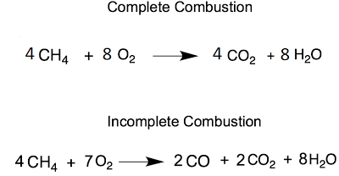
- Unsaturation of a molecule causes it to have ‘kinks’, alkenes have lower mp/bp than their corresponding alkanes
Incomplete combustion: occurs when insufficient oxygen is available.

Reactions
Addition reaction: Adding on atoms

